**README**

1. **STEPS TO RUN THE PROJECT CODE**

**Hosted Version –**

* You can also access our project at below link –

<http://smartgrocery.byethost15.com>

Our database is currently loaded with few zip codes, you can check all the available zip code data in below attached pdf. Or refer the product_table.pdf in the folder.



**If you are running locally -**

* While uploading our project we removed the node_modules folder and tmp with below command – (Ember cli project is under path **Grocery App/newgrocery**)

rm -rf node_modules bower_components dist tmp

So “Ember init” has to be run in order to populate those folders again.

* We are using MySQL as a database.
* You need to copy “**php_dataconnectivity_new.php**” file from **Grocery App/api/** folder into your server’s www or root or htdocs folder.

1. **FEATURES OF SMART GROCERY APP**
2. **Without Login/Registration:**

Users can use below features without registration.

* User can search for products and can see the price listing for selected search data.
* User can check the distance from their current location on Map
* User can toggle between distance and duration on search result just be clicking distance. (As shown below)

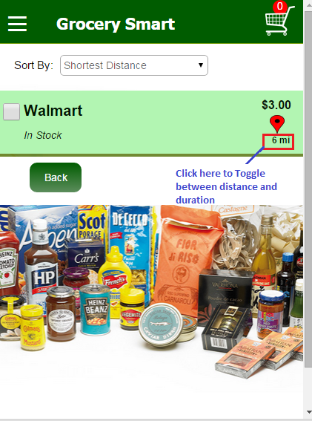

* User can sort the search list by:
  + Price: Low To high, High to Low
  + Availability: In stock first followed by Out of stock
  + Shortest Distance
  + Time (Shortest time from source)

1. **With Login / Registration:**

* **Login –** Existing users can Login using the Log In option
* **Registration - New** users can Register using New User option

Registered Users have access to all the features listed above for an unregistered user and will be able to use the following additional features as well:

* Save current search for future use.
* Load existing saved searches. (Limited to the last 5 saved searches)
* Add products from list to cart.
* Add/remove products from cart
* Save cart data as PDF and use it as a grocery checklist. The PDF is saved as Shopping_List.pdf

1. **TASKS COMPLETED**

**Milestone 1:**

|  |  |  |
| --- | --- | --- |
| **Task** | **Time Spent** | **Done by** |
| Creating a mock UI | 1.5hrs | Ashwati |
| HTML and CSS  Working on creating the html pages and CSS | 15hrs | Neha and Ashwati |
| Learning:   * Debugging the sliding menu issues * Learning to use JS or jQuery for the UI * Understanding php and mySQL | 7 hrs. | Ashwati |
| Php MySQL integration | 5 hrs | Neha |
| Jquery Ajax call to php for loading data from MySQL db | 7hr | Neha |
| Google map integration in html5 | 2hr | Neha |
| Deploying code on free domains like byethehost.com | 7hrs | Neha & Ashwati |

**Milestone 2 Onwards**

|  |  |  |
| --- | --- | --- |
| **Task** | **Time Spent** | **Done by** |
| Installation of Ember CLI | 10hr | Ashwati and Neha |
| Learning basic Ember | 12 hrs | Ashwati & Neha |
| Creating a mock UI in Ember – Login Page, Contact US, Registration and Search main page. | 7 hrs | Ashwati |
| Creating a mock UI for search result – Dynamic population of data on Search result page from php service. | 5 hrs | Neha |
| Implementation of Routes for all the pages | 8 hrs | Ashwati and Neha |
| Learning :   * Debugging the toggling menu issues | 3 hrs | Ashwati and Neha |
| Php Service integration in Ember- Ajax call in ember. | 10 hrs | Neha |
| Content Security issue while calling Ajax services in ember | 8hr | Neha |
| Ajax call in controller instead of Route | 5hr | Neha |
| Error handling and validations in whole application.   * Check for valid username – i.e. should contain a valid email id. * Check if passwords and usernames entered during registration match. * Check if it’s a valid search entry available in the database. * Check if it’s a valid username and password during registration | 10hrs | Ashwati |
| PHP File modification as per REST Standard | 2hrs | Neha |
| Add to Cart/ Remove from Cart –   1. Count increment logic on cart 2. Remove single entry 3. Remove all 4. Clear cart on logout 5. Check for duplication of entry. (If particular entry is already there in cart then error message will be shown to user.) | 20hr | Ashwati |
| Sorting Options | 10hrs | Ashwati |
| Map Issue-  Map was not loading because of CSS issue | 30hrs | Ashwati & Neha |
| Map integration-   1. Distance between user location and store 2. Distance calculation on Search List page 3. Duration on Search List Page.   (User can toggle between distance and duration on search result page by clicking distance. ) | 20hr | Neha |
| Site Deployment on Byethost – configurations and DB creation | 2hrs | Ashwati & Neha |
| Register User, Login, Logout. | 8hr | Neha |
| Manual Unit Testing of App | 6hrs | Ashwati and Neha |
| Save Cart as PDF | 5hrs | Ashwati |
| Save searches and load existing saved searches by user.  If user selects any existing search entry, then search field will be populated as per that selection. | 15hr | Neha |
| Other debugging and style issues | 5hrs | Ashwati&Neha |

1. **References and sources:**

* <http://www.ember-cli.com> - for ember installation.
* <https://developer.mozilla.org/en-US/docs/Web/Security/CSP/Using_Content_Security_Policy> - For content security issue.
* Ember LSAdapter - <https://github.com/kurko/ember-localstorage-adapter>