Architecture & Justification Document Table of Contents Introduction
1.1 Purpose of the Document
1.2 Problem Statement
1.3 Solution Overview
System Architecture Overview
2.1 Architectural Style (Event-Driven, Serverless)
2.2 High-Level Architecture Diagram
2.3 Key Design Principles
Architecture Components Description
3.1 Data Ingestion Layer
AWS Lambda (Ingestion Function)
3.2 Storage Layer
Amazon S3 (Processed Data & Reports)
3.3 Processing & Reporting Layer
AWS Lambda (Daily Report Function)
3.4 Scheduling & Orchestration
Amazon EventBridge
3.5 Monitoring & Logging
Amazon CloudWatch
3.6 Security & Access Control
AWS IAM
End-to-End Data Flow Explanation
4.1 Event Capture
4.2 Data Processing
4.3 Data Storage
4.4 Automated Daily Reporting
4.5 Monitoring and Logging Flow
Automation and Deployment Approach
5.1 Infrastructure Automation Overview
5.2 Serverless Deployment Strategy
5.3 Event-Based and Time-Based Automation
Design Justification
6.1 Choice of AWS Services
6.2 Serverless Architecture Justification
6.3 Cost Efficiency Considerations
Fault Tolerance and Reliability
7.1 Error Handling Mechanisms
7.2 Retry and Failure Management
7.3 Data Durability
Scalability Considerations
8.1 Horizontal Scalability
8.2 Handling Increased Event Volume
8.3 Storage Scalability
Security Considerations
9.1 IAM Role-Based Access
9.2 Secure Service-to-Service Communication
9.3 Data Protection
Limitations of the Proposed Architecture
Future Enhancements
11.1 Advanced Analytics
11.2 Notification and Alerting
11.3 CI/CD Enhancements
Conclusion

1. Introduction
1.1 Purpose of the Document
The purpose of this document is to describe the architecture and design justification of an event-driven data processing pipeline implemented on AWS. This document explains how the proposed system captures incoming data events, processes and stores them for analysis, and automatically generates daily summary reports. It also provides a clear justification for the chosen architectural style, AWS services, and design decisions, focusing on automation, scalability, reliability, and ease of deployment.
This document serves as a technical reference to understand the system’s structure, data flow, automation strategy, and operational considerations.

1.2 Problem Statement
Modern applications generate a large volume of event-based data such as user actions, system logs, and application events. Manually processing this data and generating reports is inefficient, error-prone, and does not scale well with increasing data volume. Traditional systems often require continuous server management, manual scheduling, and complex deployment processes, leading to higher operational overhead.
The key challenges addressed in this problem include:
- Efficiently capturing and processing incoming event data
- Storing data reliably for future analysis
- Generating summary reports on a daily basis without manual intervention
- Ensuring the system is scalable, fault-tolerant, and cost-effective
- Automating deployment and execution to minimize operational effort

1.3 Solution Overview
To address these challenges, a serverless, event-driven architecture is proposed using AWS managed services. The solution uses AWS Lambda for data ingestion and report generation, Amazon S3 for durable data storage, and Amazon EventBridge to automate daily report execution. Monitoring and logging are handled using Amazon CloudWatch, while secure access between services is enforced through AWS IAM.
The system operates as follows:
- Incoming events trigger a Lambda function that processes and stores data in Amazon S3.
- A scheduled EventBridge rule invokes a reporting Lambda function once per day.
- The reporting function aggregates stored data and generates a daily summary report.
- All executions are logged and monitored automatically.
This approach eliminates the need for server management, supports automatic scaling, and ensures full automation of the data processing and reporting workflow.

2. System Architecture Overview
2.1 Architectural Style
The proposed solution follows an event-driven, serverless architecture. In this architectural style, system components react to events rather than relying on continuously running servers. Incoming data events trigger compute functions automatically, and scheduled events initiate batch processing tasks.
A serverless approach is adopted to eliminate infrastructure management overhead. Compute resources are provisioned and scaled automatically by the cloud provider, allowing the system to handle varying workloads efficiently. This design ensures high availability, fault tolerance, and cost efficiency, as resources are consumed only when required.

2.2 High-Level Architecture Diagram
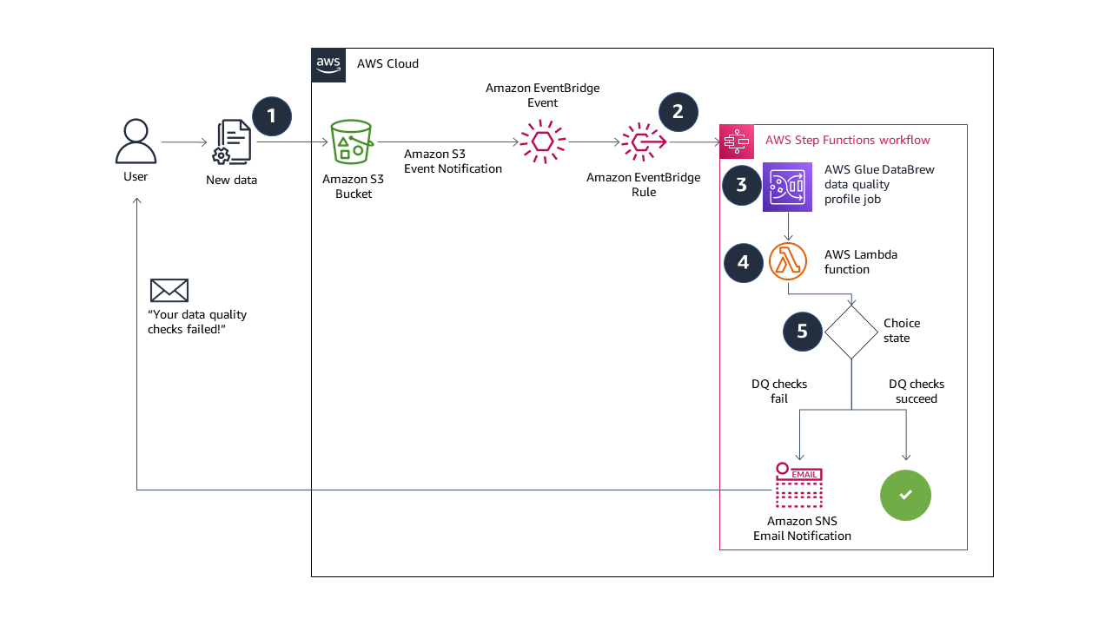
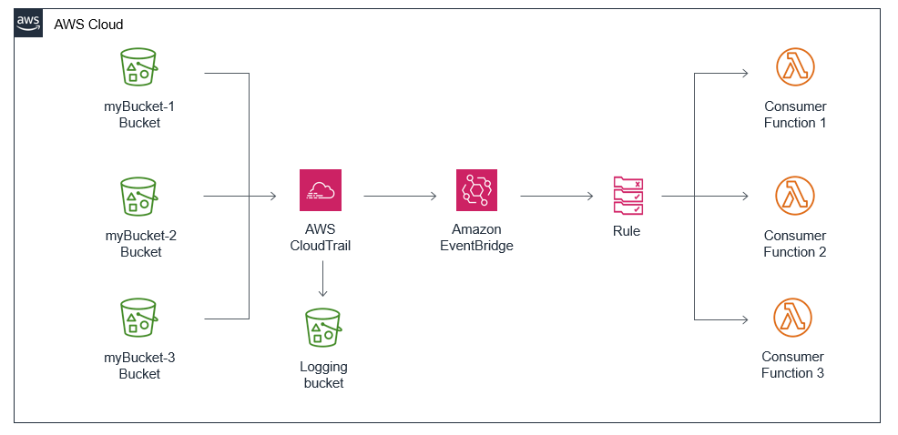
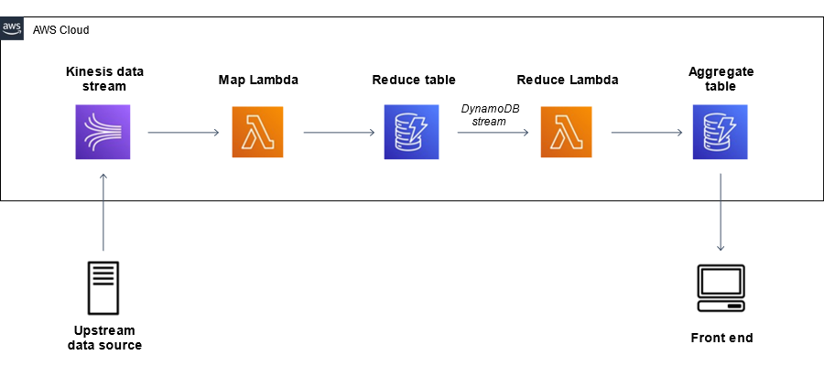
The architecture consists of multiple AWS managed services working together to form an automated data pipeline. Incoming events are processed by AWS Lambda functions, stored in Amazon S3, and summarized daily using a scheduled trigger from Amazon EventBridge. Monitoring and logging are handled centrally through Amazon CloudWatch, while access control is enforced using AWS IAM.
Note: The final architecture diagram included in the document is redrawn based on this conceptual design to ensure originality.

2.3 Key Design Principles
The architecture is designed based on the following core principles:
Event-Driven Processing
The system reacts to incoming events in real time using AWS Lambda. This enables immediate data processing without polling or manual intervention.
Serverless Computing
By leveraging AWS Lambda, the solution avoids the need for server provisioning, maintenance, or capacity planning. The system automatically scales based on the volume of incoming events.
Loose Coupling
Each component in the architecture operates independently. Data is exchanged through Amazon S3, reducing dependencies between services and improving reliability.
Automation
Time-based automation is implemented using Amazon EventBridge, ensuring that daily reports are generated automatically without manual execution.
Observability
Centralized logging and monitoring are achieved through Amazon CloudWatch, enabling easy troubleshooting and performance analysis.
Security by Design
Access between services is controlled using AWS IAM roles and policies, ensuring secure and controlled interactions without hard-coded credentials.

3. Architecture Components Description
This section explains each AWS service used, its role in the system, and why it was chosen.

3.1 Data Ingestion Layer – AWS Lambda (Ingestion Function)
The data ingestion layer is implemented using AWS Lambda. This Lambda function is responsible for capturing incoming event data and performing initial processing before storage.
When an event is received, the Lambda function validates the input, enriches it with metadata such as timestamps, and prepares it for storage. Since Lambda functions are event-driven, the ingestion process is automatically triggered whenever new data arrives.
Key responsibilities:
- Receive incoming event data
- Perform basic validation and transformation
- Add processing timestamps
- Store processed data in Amazon S3
Justification:
AWS Lambda is chosen because it provides automatic scaling, low operational overhead, and seamless integration with other AWS services. It allows the system to process events efficiently without managing servers.

3.2 Storage Layer – Amazon S3
Processed data and generated reports are stored in Amazon S3. Amazon S3 serves as the central storage layer of the architecture.
The storage is logically organized using separate folders to clearly distinguish between processed event data and generated reports.
Storage Structure:
event-pipeline-bucket/
├── processed/
│ └── event_YYYYMMDDHHMMSS.json
└── reports/
└── daily_report_YYYYMMDD.json
Key responsibilities:
- Store processed event data reliably
- Store daily summary reports
- Provide high durability and availability
Justification:
Amazon S3 is selected due to its high durability, scalability, and cost efficiency. It can store large volumes of data without performance degradation and supports easy integration with AWS Lambda.

3.3 Processing and Reporting Layer – AWS Lambda (Report Function)
The reporting layer is implemented using a second AWS Lambda function. This function is responsible for aggregating stored data and generating daily summary reports.
The report Lambda reads all processed data from Amazon S3, calculates summary metrics such as total event count, and generates a structured report file. The report is then stored back in Amazon S3 for further analysis or consumption.
Key responsibilities:
- Read processed data from S3
- Aggregate and summarize event information
- Generate daily report files
- Store reports in S3
Justification:
Using AWS Lambda for reporting ensures that report generation is scalable, cost-effective, and fully automated. The function runs only when triggered, reducing unnecessary resource usage.

3.4 Scheduling and Orchestration – Amazon EventBridge
Automation of daily report generation is achieved using Amazon EventBridge. EventBridge is configured with a scheduled rule that triggers the reporting Lambda function once per day.
Key responsibilities:
- Trigger the report generation Lambda on a fixed schedule
- Ensure consistent and reliable execution timing
- Eliminate manual intervention
Justification:
Amazon EventBridge provides a fully managed scheduling mechanism that integrates natively with AWS Lambda. It ensures reliable time-based execution and supports flexible scheduling patterns.

3.5 Monitoring and Logging – Amazon CloudWatch
System monitoring and logging are handled using Amazon CloudWatch. All Lambda executions automatically generate logs and performance metrics that are captured in CloudWatch.
Key responsibilities:
- Capture Lambda execution logs
- Monitor execution duration and memory usage
- Assist in error diagnosis and troubleshooting
Justification:
CloudWatch enables real-time visibility into system behavior, making it easier to detect failures, analyze performance, and ensure smooth operation of the pipeline.

3.6 Security and Access Control – AWS IAM
Security is enforced using AWS IAM. Each Lambda function is assigned an IAM execution role that grants only the permissions required to perform its tasks.
Key responsibilities:
- Control access to Amazon S3 and CloudWatch
- Prevent unauthorized service interactions
- Enable secure, role-based access
Justification:
IAM ensures that security best practices are followed by avoiding hard-coded credentials and enforcing least-privilege access control.

4. End-to-End Data Flow Explanation
This section explains how data flows through the system from the moment an event is generated until a daily summary report is produced and stored.

4.1 Event Capture
The data flow begins when an incoming event is generated. This event can represent user activity, application logs, or any system-generated data. The event acts as the trigger for the data processing pipeline.
Once the event is received, it automatically invokes the data ingestion Lambda function. Since the system follows an event-driven architecture, no manual polling or scheduling is required at this stage.

4.2 Data Processing
Upon invocation, the ingestion Lambda function processes the incoming event. Basic validation is performed to ensure the event structure is correct. The function enriches the data by adding metadata such as processing timestamps, which helps in tracking and auditing the data later.
This processing step is lightweight and designed to execute quickly, allowing the system to handle multiple incoming events efficiently.

4.3 Data Storage
After processing, the enriched event data is stored in Amazon S3. Each processed event is saved as a separate object in a dedicated folder, ensuring clear organization and easy retrieval.
The use of Amazon S3 provides durable and scalable storage, ensuring that all processed data is preserved for future analysis and reporting.
Example storage location:
processed/event_YYYYMMDDHHMMSS.json

4.4 Automated Daily Reporting
A scheduled rule configured in Amazon EventBridge triggers the reporting Lambda function once per day. This scheduled execution ensures that report generation happens automatically without any manual intervention.
The reporting Lambda function retrieves all processed event files stored in Amazon S3, aggregates the required metrics such as total event count, and generates a structured daily summary report. The generated report is then stored back in Amazon S3 under a separate reports folder.
Example report location:
reports/daily_report_YYYYMMDD.json

4.5 Monitoring and Logging Flow
Throughout the entire data flow, execution logs and metrics are captured using Amazon CloudWatch. Each Lambda invocation generates log entries that record execution start time, duration, memory usage, and any errors encountered.
These logs provide visibility into system behavior and help in troubleshooting issues, validating successful execution, and ensuring reliable operation of the pipeline.
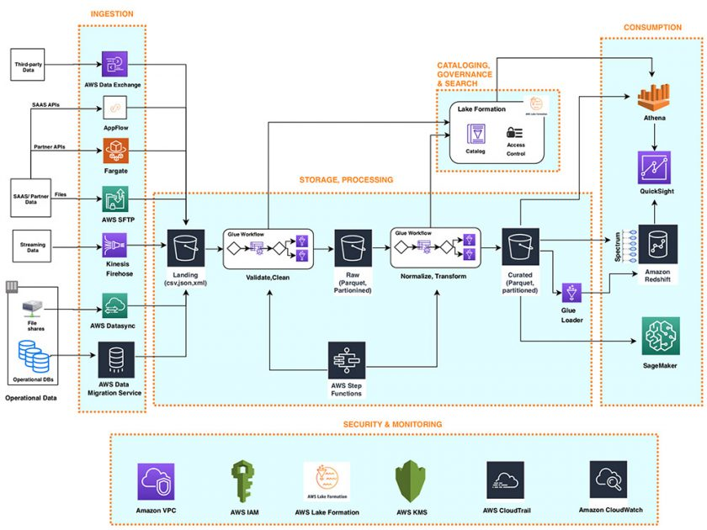

5. Automation and Deployment Approach
5.1 Infrastructure Automation Overview
The proposed system is designed to operate with minimal manual intervention by leveraging AWS managed services and automation mechanisms. Instead of relying on long-running servers or manual execution, the architecture uses event-driven and time-based triggers to automate both data processing and report generation.
Core infrastructure components such as compute, storage, scheduling, and monitoring are provisioned and managed by AWS. This approach reduces operational complexity and ensures consistency across deployments.

5.2 Serverless Deployment Strategy
The solution adopts a serverless deployment model using AWS Lambda. In this model, application code is deployed directly as Lambda functions without the need to manage servers, operating systems, or runtime environments.
Each Lambda function is deployed independently and configured with the required runtime, permissions, and execution roles. This modular deployment approach enables easy updates, faster iteration, and reduced risk during changes, as each component can be modified without impacting the entire system.
Key advantages of this strategy include:
- Automatic scaling based on workload
- Reduced deployment and maintenance effort
- Cost efficiency due to pay-per-execution pricing

5.3 Event-Based and Time-Based Automation
Automation within the system is achieved through two complementary mechanisms:
Event-Based Automation
Incoming data events automatically trigger the data ingestion Lambda function. This ensures that data is processed immediately as it arrives, without the need for polling or manual execution.
Time-Based Automation
Daily report generation is automated using Amazon EventBridge. A scheduled rule invokes the reporting Lambda function at a fixed interval (once per day), ensuring consistent and reliable report generation.
This combination of event-based and time-based automation enables the entire pipeline to operate continuously and autonomously.

5.4 Monitoring and Operational Automation
Operational visibility is provided through Amazon CloudWatch, which automatically collects logs and execution metrics from all Lambda functions. These logs enable real-time monitoring, error detection, and performance analysis without requiring additional monitoring infrastructure.
Failures, if any, are captured in logs and can be investigated using CloudWatch, allowing quick diagnosis and resolution.

5.5 Benefits of the Automation Approach
The automation strategy used in this architecture provides the following benefits:
- Eliminates manual intervention for data processing and reporting
- Ensures consistent and repeatable execution
- Improves reliability through managed service integrations
- Simplifies maintenance and future enhancements
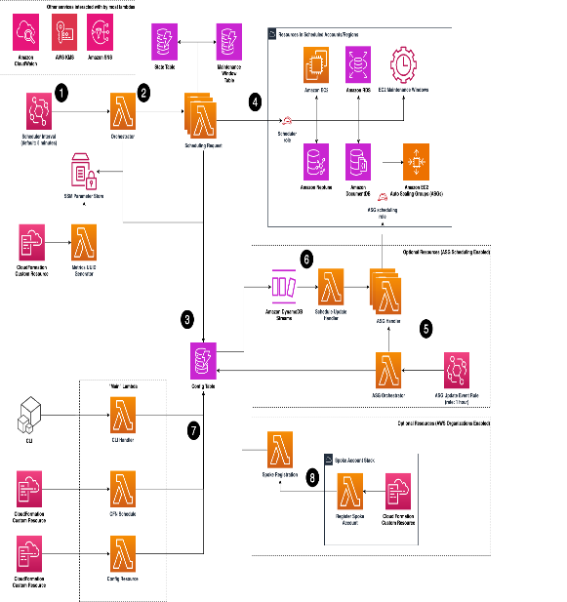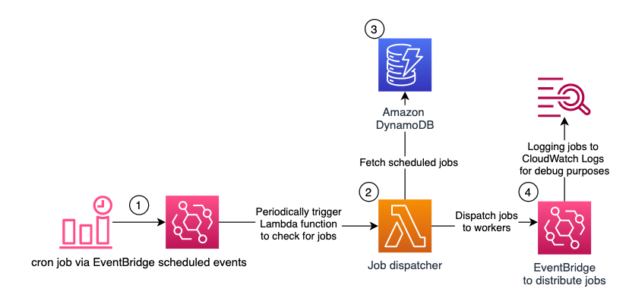

6. Design Justification
This section provides a detailed justification for the architectural and technology choices made in the proposed event-driven data processing pipeline. The design decisions focus on achieving automation, scalability, reliability, security, and cost efficiency while minimizing operational complexity.

6.1 Justification for Service Selection
The architecture leverages managed cloud services to ensure that the system remains highly available and easy to maintain.
Compute Layer (Serverless Functions)
Serverless functions are used for both data ingestion and report generation. This choice allows the system to execute code only when required, eliminating the need for continuously running servers. Event-driven execution ensures that incoming data is processed immediately, while scheduled execution enables reliable batch reporting.
Using serverless compute also simplifies development and deployment. Each function is independent, making the system modular and easier to update or extend without affecting other components.

Storage Layer (Object Storage)
Object storage is used as the central data repository for processed events and generated reports. This approach ensures that data is stored in a durable, highly available, and scalable manner.
Separating processed data and reports into logical folders improves organization, traceability, and ease of access. Object storage is also well suited for analytical workloads, as it can handle large volumes of data without performance degradation.

Scheduling and Orchestration Layer
Time-based automation is implemented using a managed scheduling service. This eliminates the need for custom cron jobs or external schedulers and ensures consistent execution of daily reporting tasks.
The scheduler integrates natively with serverless functions, enabling reliable invocation without additional configuration or custom code.

Monitoring and Observability Layer
Centralized monitoring and logging are critical for understanding system behavior and diagnosing failures. Built-in monitoring services automatically capture execution logs, metrics, and error information for each function invocation.
This design ensures that failures can be identified quickly and addressed without impacting the overall system. It also provides transparency into performance characteristics such as execution time and resource usage.

Security and Access Control Layer
Role-based access control is used to manage permissions between services. Each function is assigned a dedicated execution role that grants only the permissions required to perform its tasks.
This approach avoids hard-coded credentials, reduces security risks, and follows the principle of least privilege. Service-to-service communication is handled securely through managed identity mechanisms.

6.2 Justification for Serverless Architecture
The serverless architectural approach is selected to reduce infrastructure management overhead and improve operational efficiency. In traditional architectures, servers must be provisioned, monitored, patched, and scaled manually. These tasks increase complexity and operational cost.
In contrast, a serverless model automatically manages scaling, availability, and fault tolerance. Compute resources are provisioned dynamically in response to events, ensuring optimal resource utilization. This makes the system suitable for workloads with unpredictable or varying data volumes.
Additionally, the serverless approach promotes faster development cycles. Developers can focus on business logic rather than infrastructure concerns, leading to improved productivity and reduced risk of configuration errors.

6.3 Cost Efficiency and Resource Optimization
Cost optimization is a significant advantage of the proposed design. The system follows a pay-as-you-use model, meaning costs are incurred only when the functions execute or data is stored.
Key cost benefits include:
- No charges for idle compute resources
- Minimal operational overhead
- Scalable storage costs based on actual usage
- Efficient use of memory and execution time
By avoiding always-on servers and leveraging managed services, the architecture ensures that the solution remains economically viable while meeting functional and performance requirements.

6.4 Maintainability and Extensibility
The modular design of the system improves maintainability and supports future enhancements. Each component operates independently, making it easier to update or replace individual services without affecting the entire pipeline.
Future extensions such as advanced analytics, notification systems, or dashboard integration can be added with minimal changes to the existing architecture. This flexibility ensures that the solution can evolve as requirements grow.

6.5 Overall Design Rationale
The final design represents a balance between simplicity and robustness. By combining event-driven processing, serverless execution, automated scheduling, and centralized monitoring, the architecture delivers a reliable and scalable solution with minimal operational effort.
The design decisions align with modern cloud best practices and demonstrate an effective approach to building automated data processing systems in a cloud environment.

7. Fault Tolerance and Reliability
Fault tolerance and reliability are critical requirements for any data processing system, especially one that operates in an automated and event-driven manner. The proposed architecture is designed to handle failures gracefully while ensuring continuous and reliable operation.

7.1 Error Handling Mechanisms
Error handling is primarily managed at the application and service level. Each AWS Lambda function includes structured exception handling to capture runtime errors during execution. If an error occurs while processing an event or generating a report, the function returns an error response and logs the details for further analysis.
This approach ensures that failures do not cause silent data loss and that errors are clearly visible for troubleshooting.

7.2 Retry and Failure Management
AWS Lambda provides built-in retry behavior for certain invocation types, which helps handle transient failures such as temporary service unavailability. If a Lambda execution fails due to a recoverable error, AWS can automatically retry the execution based on the invocation configuration.
Additionally, because the system is event-driven and stateless, a failure in processing one event does not affect the processing of subsequent events. This isolation improves overall system reliability and prevents cascading failures.

7.3 Data Durability and Reliability
Data reliability is ensured through the use of Amazon S3 as the storage layer. Amazon S3 provides extremely high durability and availability for stored objects, ensuring that processed data and generated reports are not lost even in the event of infrastructure failures.
Once data is written to S3, it remains safely stored and can be reprocessed or analyzed again if needed. This makes the system resilient to temporary processing failures.

7.4 Service-Level Reliability
The architecture relies entirely on AWS managed services, which are designed for high availability and fault tolerance. Services such as AWS Lambda and Amazon EventBridge are distributed across multiple availability zones, reducing the impact of individual infrastructure failures.
Because infrastructure management is handled by AWS, the system benefits from built-in redundancy, automatic failover, and continuous service health monitoring.

7.5 Monitoring and Failure Detection
Reliability is further enhanced through continuous monitoring using Amazon CloudWatch. Execution logs, error messages, and performance metrics are automatically collected for each Lambda function.
These logs allow quick identification of failures, abnormal execution patterns, or performance bottlenecks. Monitoring enables proactive detection of issues and supports faster recovery.

7.6 Overall Reliability Assessment
By combining managed services, stateless processing, durable storage, and centralized monitoring, the proposed architecture achieves a high level of fault tolerance and reliability. The system can continue operating even in the presence of individual component failures, ensuring consistent data processing and report generation.
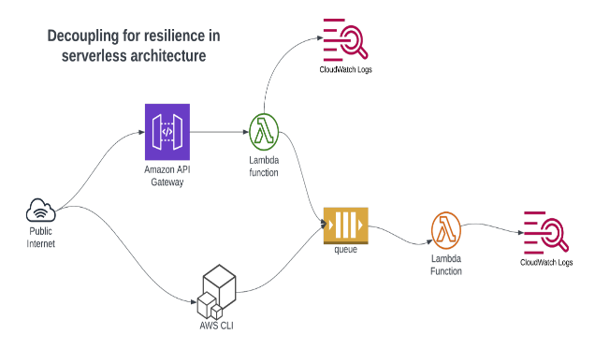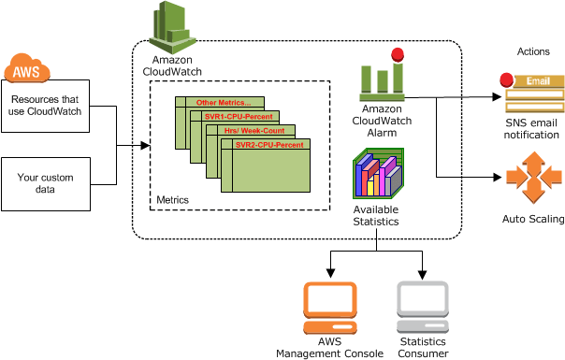

8. Scalability Considerations
Scalability refers to the ability of the system to handle increased workload efficiently without requiring major architectural changes. The proposed solution is designed with scalability as a core principle by leveraging AWS managed and serverless services.

8.1 Horizontal Scalability
The system achieves horizontal scalability through the use of AWS Lambda. Lambda functions automatically scale based on the number of incoming events. When multiple events are received simultaneously, AWS creates multiple instances of the Lambda function to process them in parallel.
This automatic scaling ensures that performance remains consistent even during traffic spikes, without requiring manual intervention or capacity planning.

8.2 Handling Increased Event Volume
As the volume of incoming data increases, the ingestion Lambda function scales seamlessly to process additional events. Since each event is handled independently, the system can manage high-throughput workloads efficiently.
The reporting Lambda function also scales based on the size of the data stored in Amazon S3. As the number of processed files grows, the reporting logic can be extended to handle larger datasets or optimized using batching techniques if required.

8.3 Storage Scalability
Data storage scalability is handled by Amazon S3, which provides virtually unlimited storage capacity. As the amount of processed data and generated reports increases, Amazon S3 can store the data without performance degradation.
This eliminates the need for manual storage management and allows the system to retain historical data for extended periods, supporting long-term analysis and auditing.

8.4 Scheduling Scalability
The scheduling mechanism implemented using Amazon EventBridge is inherently scalable. EventBridge can handle a large number of scheduled rules and trigger events reliably, even as the system grows.
This ensures that automated reporting remains consistent and reliable regardless of the scale of the system.

8.5 Scalability Through Loose Coupling
The architecture follows a loosely coupled design, where components communicate through events and shared storage rather than direct dependencies. This design allows individual components to scale independently and reduces the risk of bottlenecks.
For example, changes to the ingestion logic do not impact the reporting logic, and storage growth does not affect compute scalability.

8.6 Overall Scalability Assessment
By combining serverless compute, scalable storage, and managed scheduling, the proposed architecture can efficiently handle increasing workloads and future growth. The system can scale automatically with minimal configuration changes, making it suitable for both small-scale and large-scale data processing scenarios.

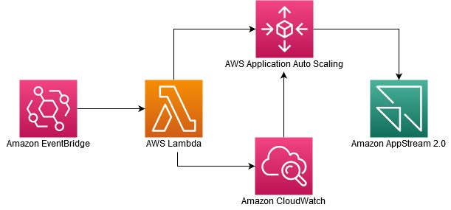

9. Security Considerations
Security is a critical aspect of the proposed event-driven data processing pipeline. The architecture incorporates multiple security mechanisms to ensure that data is protected, access is controlled, and services interact securely with each other.

9.1 IAM Role-Based Access Control
The system uses AWS IAM to manage permissions and enforce secure access between AWS services. Each AWS Lambda function is assigned a dedicated IAM execution role that defines what resources the function can access.
These roles grant only the minimum permissions required, such as access to specific Amazon S3 buckets and CloudWatch logs. This approach follows the principle of least privilege, reducing the risk of unauthorized access or misuse of resources.

9.2 Secure Service-to-Service Communication
All interactions between services in the architecture occur through AWS-managed integrations. For example, AWS Lambda accesses Amazon S3 using IAM roles rather than hard-coded credentials.
This ensures that credentials are never embedded in the application code, significantly improving security. AWS automatically handles authentication and authorization when services interact using assigned roles.

9.3 Data Protection and Storage Security
Data stored in Amazon S3 is protected through AWS-managed security controls. Access to stored objects is restricted based on IAM policies, ensuring that only authorized services can read or write data.
Logical separation of data into processed data and reports also helps in maintaining data organization and access control. Sensitive data can be further protected by applying additional security policies if required.

9.4 Monitoring and Auditability
Security monitoring is supported through Amazon CloudWatch, which captures logs for all Lambda function executions. These logs provide an audit trail that can be used to review access patterns, detect abnormal behavior, and investigate security-related incidents.
Logging enhances accountability and supports compliance by maintaining a record of system activity.

9.5 Secure Configuration Management
The architecture avoids manual configuration of credentials and sensitive information. All configuration details such as permissions and execution roles are managed through AWS services, reducing the risk of configuration errors and accidental exposure of sensitive data.
This secure configuration approach ensures that the system remains protected even as it scales or evolves.

9.6 Overall Security Assessment
By combining role-based access control, secure service integrations, protected data storage, and centralized logging, the proposed architecture provides a strong security foundation. The design aligns with cloud security best practices and ensures that the system operates securely without adding unnecessary complexity.
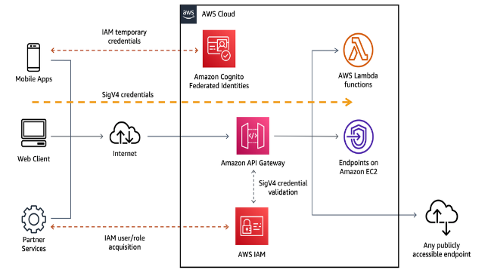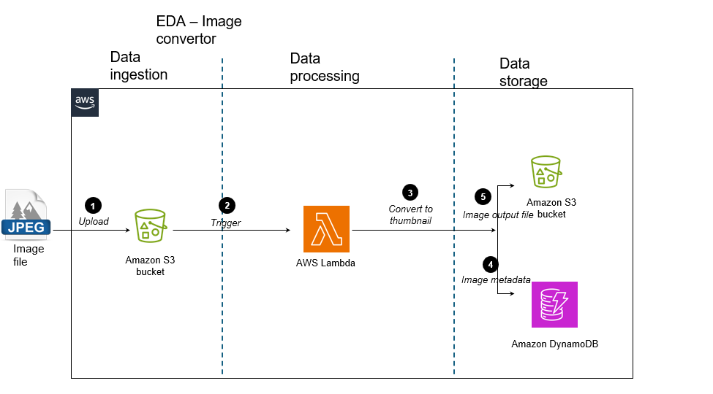

10. Limitations of the Proposed Architecture
While the proposed event-driven data processing pipeline provides automation, scalability, and reliability, it also has certain limitations that should be acknowledged. These limitations are inherent to the chosen design and technology stack and can be addressed through future enhancements.

10.1 Limited Real-Time Analytics
The current architecture focuses on event processing and daily batch reporting. Although events are processed as they arrive, the reporting mechanism is scheduled to run once per day. As a result, real-time or near real-time analytics are not supported in the current design.
For use cases that require instant insights or continuous dashboards, additional streaming or real-time analytics services would be required.

10.2 Basic Data Processing Logic
The data processing and reporting logic implemented in the Lambda functions is intentionally kept simple to ensure clarity and ease of understanding. Advanced transformations, complex aggregations, or machine learning-based analytics are not included in the current scope.
This limits the system’s ability to perform deeper analytical operations on the collected data.

10.3 Dependence on Managed Cloud Services
The architecture relies entirely on AWS managed services such as Lambda, S3, and EventBridge. While this provides significant operational benefits, it also introduces vendor dependency. Migrating the solution to another cloud platform would require redesigning certain components.

10.4 Error Notification and Alerting
Although execution logs are captured using Amazon CloudWatch, the current design does not include an automated alerting mechanism to notify administrators when failures occur. Errors must be identified manually by reviewing logs.
In production environments, automated alerts would be necessary to ensure faster response times.

10.5 Limited Access Control Granularity
For simplicity, the IAM roles used in the system grant broad permissions to Lambda functions. While this approach is acceptable for academic and demonstration purposes, it does not fully implement fine-grained access control based on strict least-privilege policies.
More granular IAM policies would be required for production-grade security.

10.6 Cost Visibility at Large Scale
Although the serverless model is cost-efficient for small to medium workloads, costs may increase with very high event volumes or long retention periods for stored data. Without detailed cost monitoring and optimization strategies, expenses could grow over time.

10.7 Summary of Limitations
The limitations identified above do not undermine the effectiveness of the proposed solution but highlight areas where improvements can be made. Understanding these limitations provides a clear foundation for future enhancements and system evolution.

11. Future Enhancements
Although the proposed architecture successfully meets the current requirements of automated event-driven data processing and reporting, there are several opportunities to enhance the system further. These enhancements can improve functionality, performance, security, and usability as the system evolves.

11.1 Advanced Data Analytics
Future versions of the system can include advanced analytics capabilities to extract deeper insights from the collected data. Instead of generating only basic summary reports, the system can be extended to support:
- Statistical analysis
- Trend detection
- Aggregation across longer time periods
This can be achieved by integrating additional analytics services or extending the reporting logic to handle more complex computations.

11.2 Real-Time Data Processing and Visualization
To overcome the limitation of daily batch reporting, the architecture can be enhanced to support near real-time data processing. Real-time dashboards can be introduced to visualize incoming data continuously.
Such enhancements would enable instant insights into system behavior and user activity, making the solution suitable for monitoring and operational use cases.

11.3 Notification and Alerting Mechanisms
Automated alerting can be added to notify administrators or stakeholders when failures or anomalies occur. Alerts can be triggered based on error logs, execution failures, or performance thresholds.
This improvement would reduce response time during failures and enhance operational reliability.

11.4 Improved Security and Access Control
Future enhancements can focus on implementing more granular access control policies. IAM roles can be refined to follow strict least-privilege principles, ensuring that each component has access only to the exact resources it requires.
Additional security measures such as encryption policies and access auditing can also be incorporated.

11.5 CI/CD and Infrastructure as Code Enhancements
The deployment process can be further automated using advanced CI/CD pipelines and Infrastructure as Code practices. This would allow seamless updates, version control, and environment replication.
Such enhancements would make the system easier to maintain, test, and deploy across different environments.

11.6 Scalability and Performance Optimization
As data volume grows, performance optimization techniques such as data partitioning, batching, and parallel processing can be implemented. These improvements would ensure efficient processing even at large scale.

11.7 Extensibility of the Architecture
The modular and loosely coupled design of the system makes it easy to add new components. Future extensions may include:
- Integration with external systems
- Support for multiple data sources
- Custom report formats
This extensibility ensures that the architecture remains adaptable to changing requirements.

11.8 Summary of Future Enhancements
The proposed enhancements demonstrate that the system is not limited to its current scope and can evolve into a more comprehensive and production-ready solution. By building on the existing architecture, these improvements can be implemented incrementally without major redesign.

12. Conclusion
This document presented the architecture and design justification for an event-driven data processing pipeline implemented using AWS managed services. The proposed solution was designed to address the challenges of automated data ingestion, reliable storage, and scheduled report generation while minimizing operational complexity.
By adopting a serverless architecture, the system eliminates the need for infrastructure management and enables automatic scaling based on workload. Incoming events are processed using AWS Lambda, stored securely in Amazon S3, and summarized through an automated daily reporting mechanism triggered by Amazon EventBridge. Monitoring and logging are handled centrally through Amazon CloudWatch, while AWS IAM ensures secure, role-based access between services.
The architecture emphasizes key cloud design principles such as loose coupling, automation, scalability, fault tolerance, and security by design. These principles ensure that the system remains reliable, cost-efficient, and easy to maintain, even as data volume and usage patterns evolve.
While the current implementation focuses on simplicity and clarity, the document also identified realistic limitations and proposed meaningful future enhancements. These enhancements demonstrate how the system can evolve to support advanced analytics, real-time processing, improved security controls, and fully automated CI/CD pipelines.
Overall, the proposed solution effectively meets the requirements of an automated, event-driven data processing pipeline. It demonstrates a practical application of modern cloud-native architectural practices and provides a strong foundation for further extension into a production-grade system.

