**DBT ASSIGNMENT-3**

**ASHWIN KRISHNA P**

**PES1201801465**

**SEM:5 , SECTION:F**

**Execution of Heterogeneous Distributed Query**

For setting up a distributed database environment, I have used Microsoft SQL Server and MySQL Server.

Initially I created a database called SAMPLEDT in MySQL server and created a table ‘books_table’, inserted some values into it.

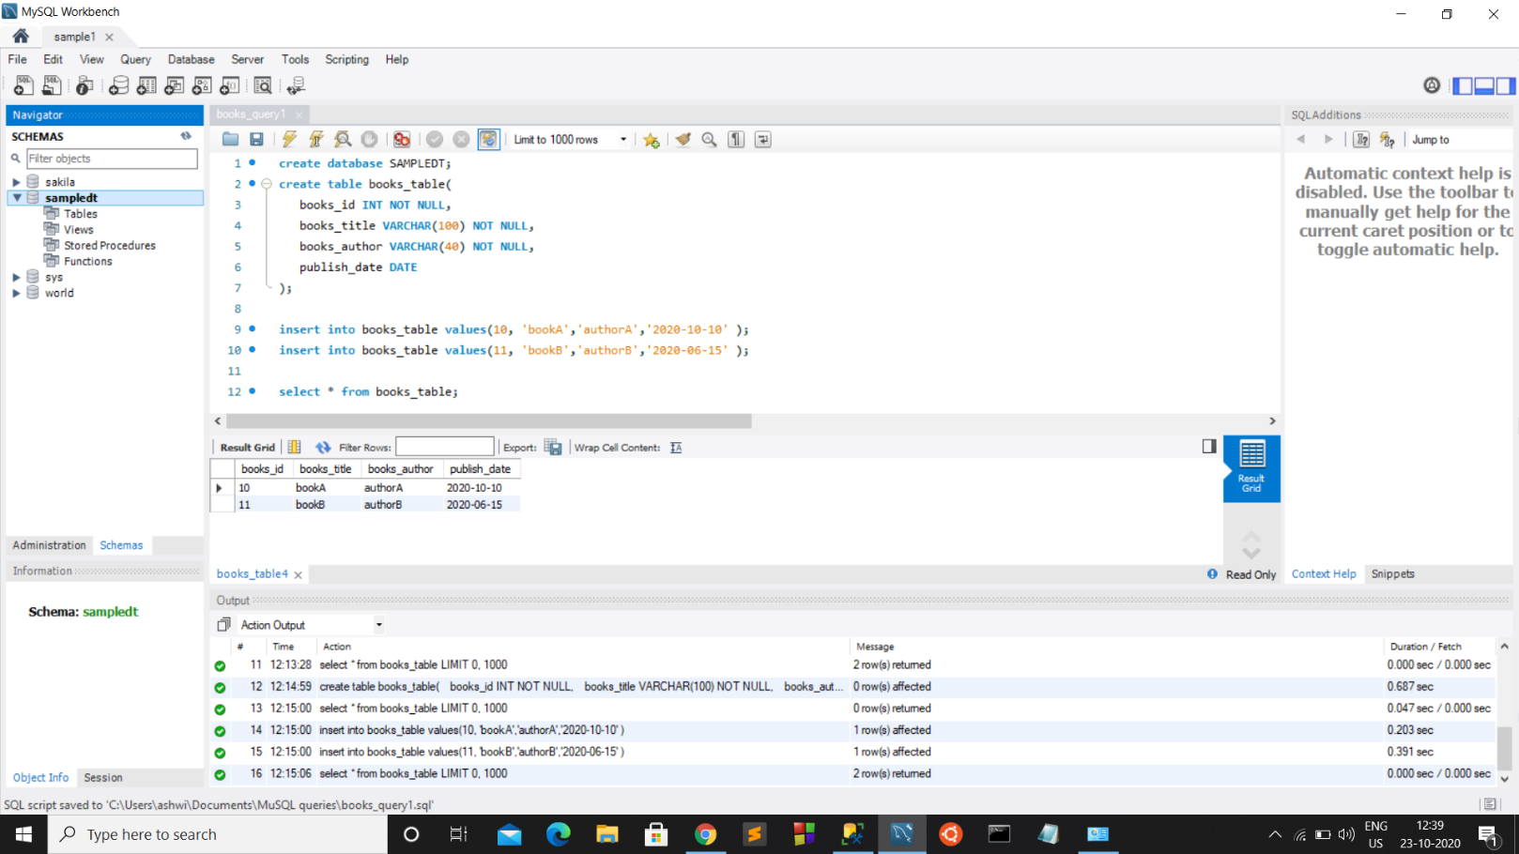

Then I created a new Linked server named ‘MYSQL’ in SQL Server using MySQL ODBC driver.

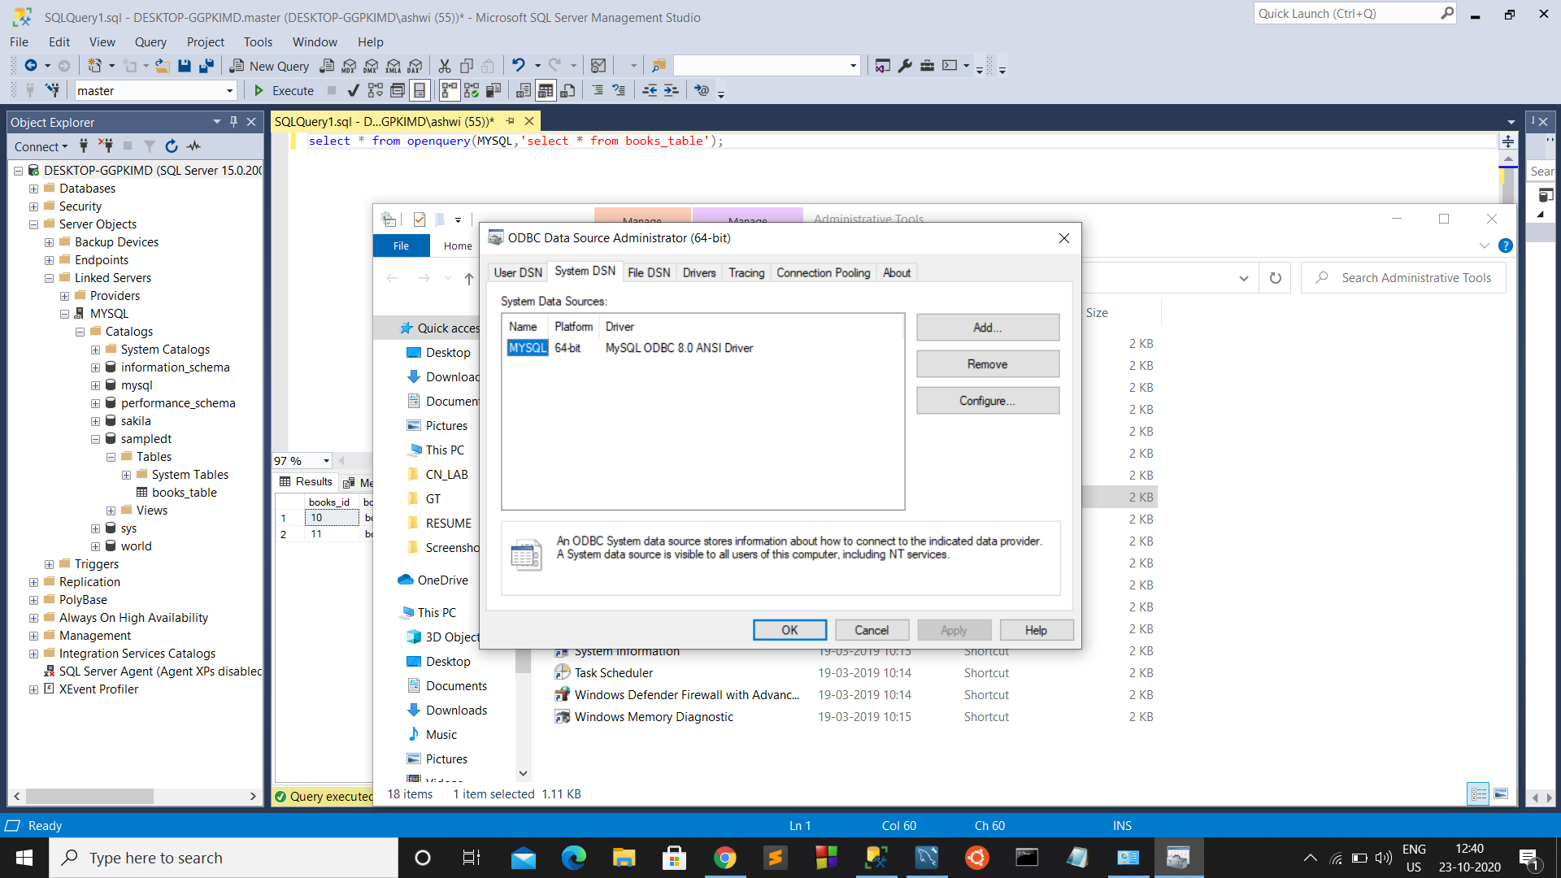

Here we can see the newly created linked-server called MYSQL and all the databases that were in MySQL are now accessible from Microsoft SQL server.

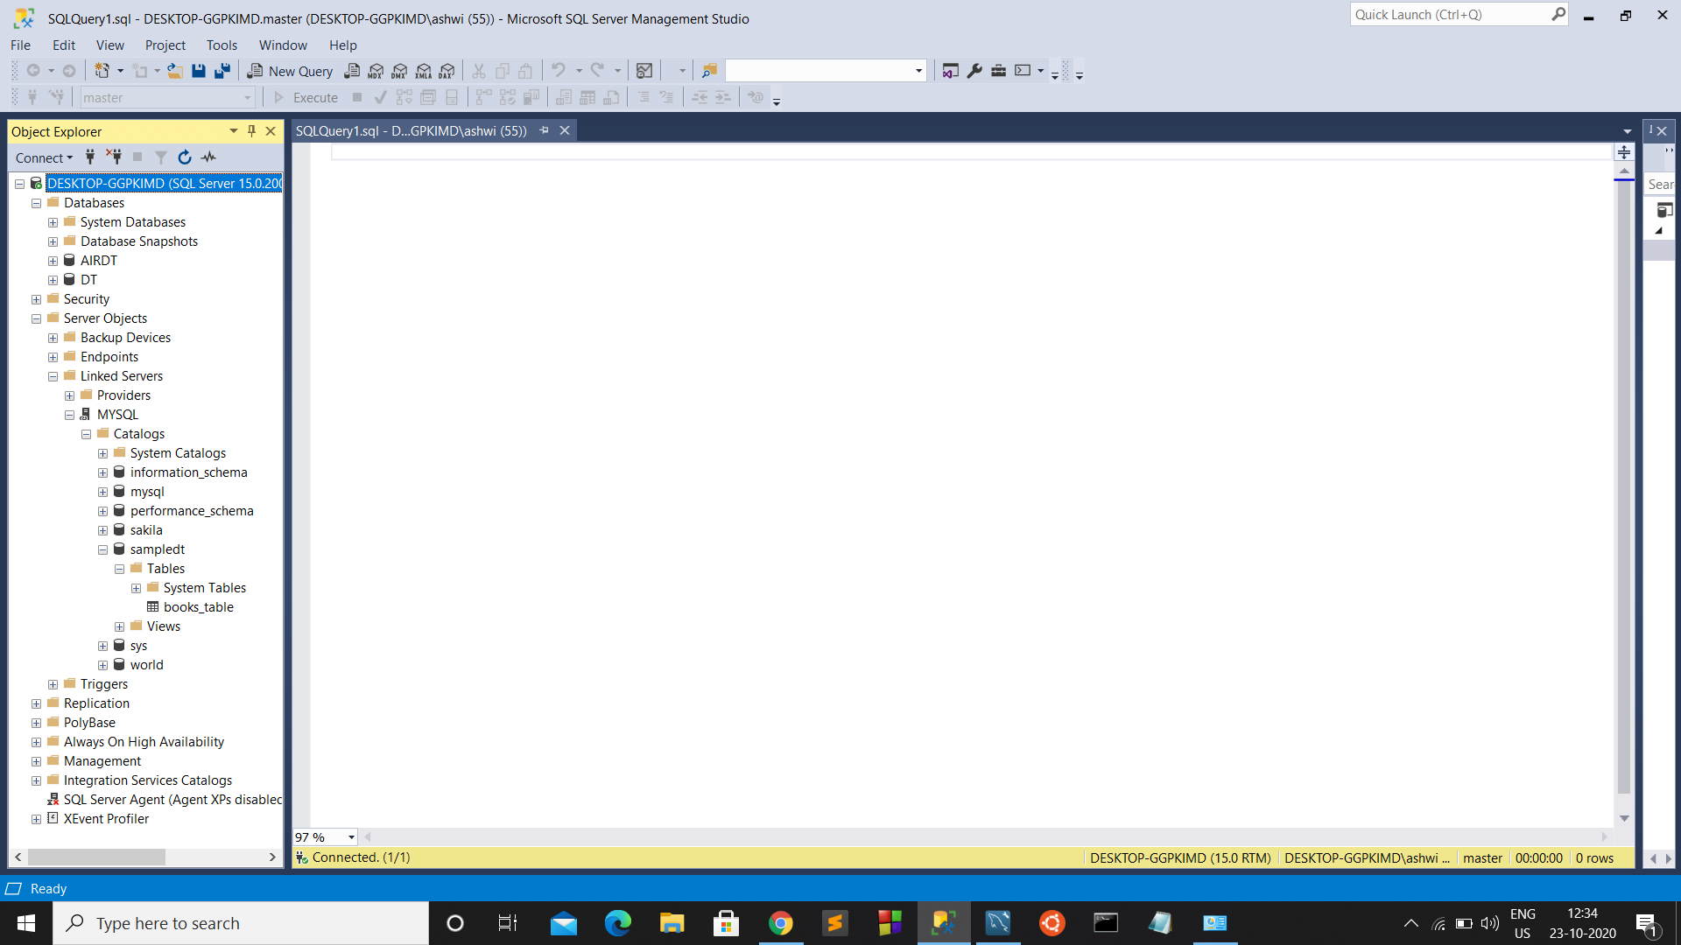

So we can write queries to access the data in the SAMPLEDT database:-

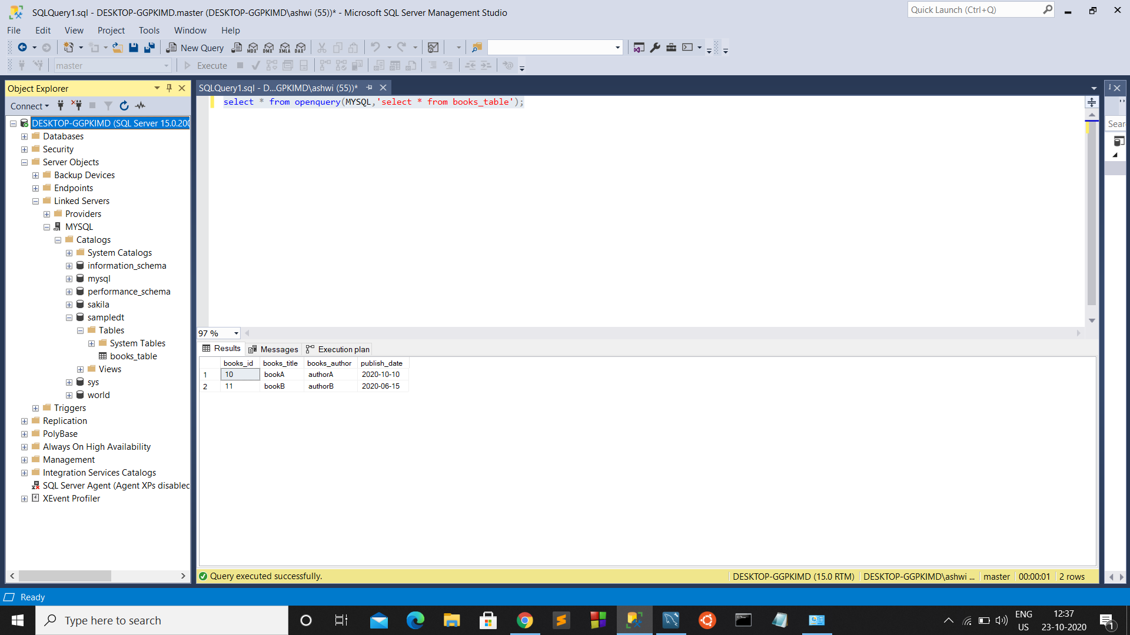

We can see the execution plan and notice that the Remote Source is MYSQL

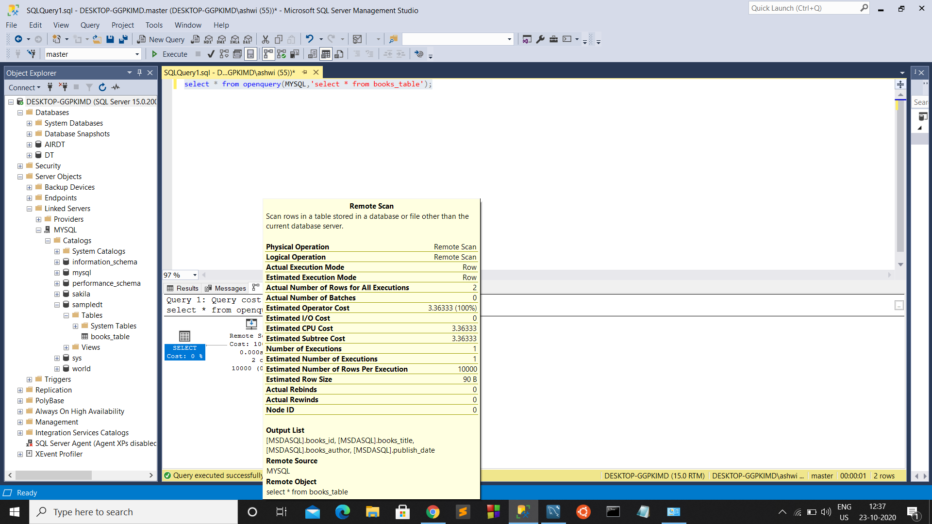

Let’s see another query:

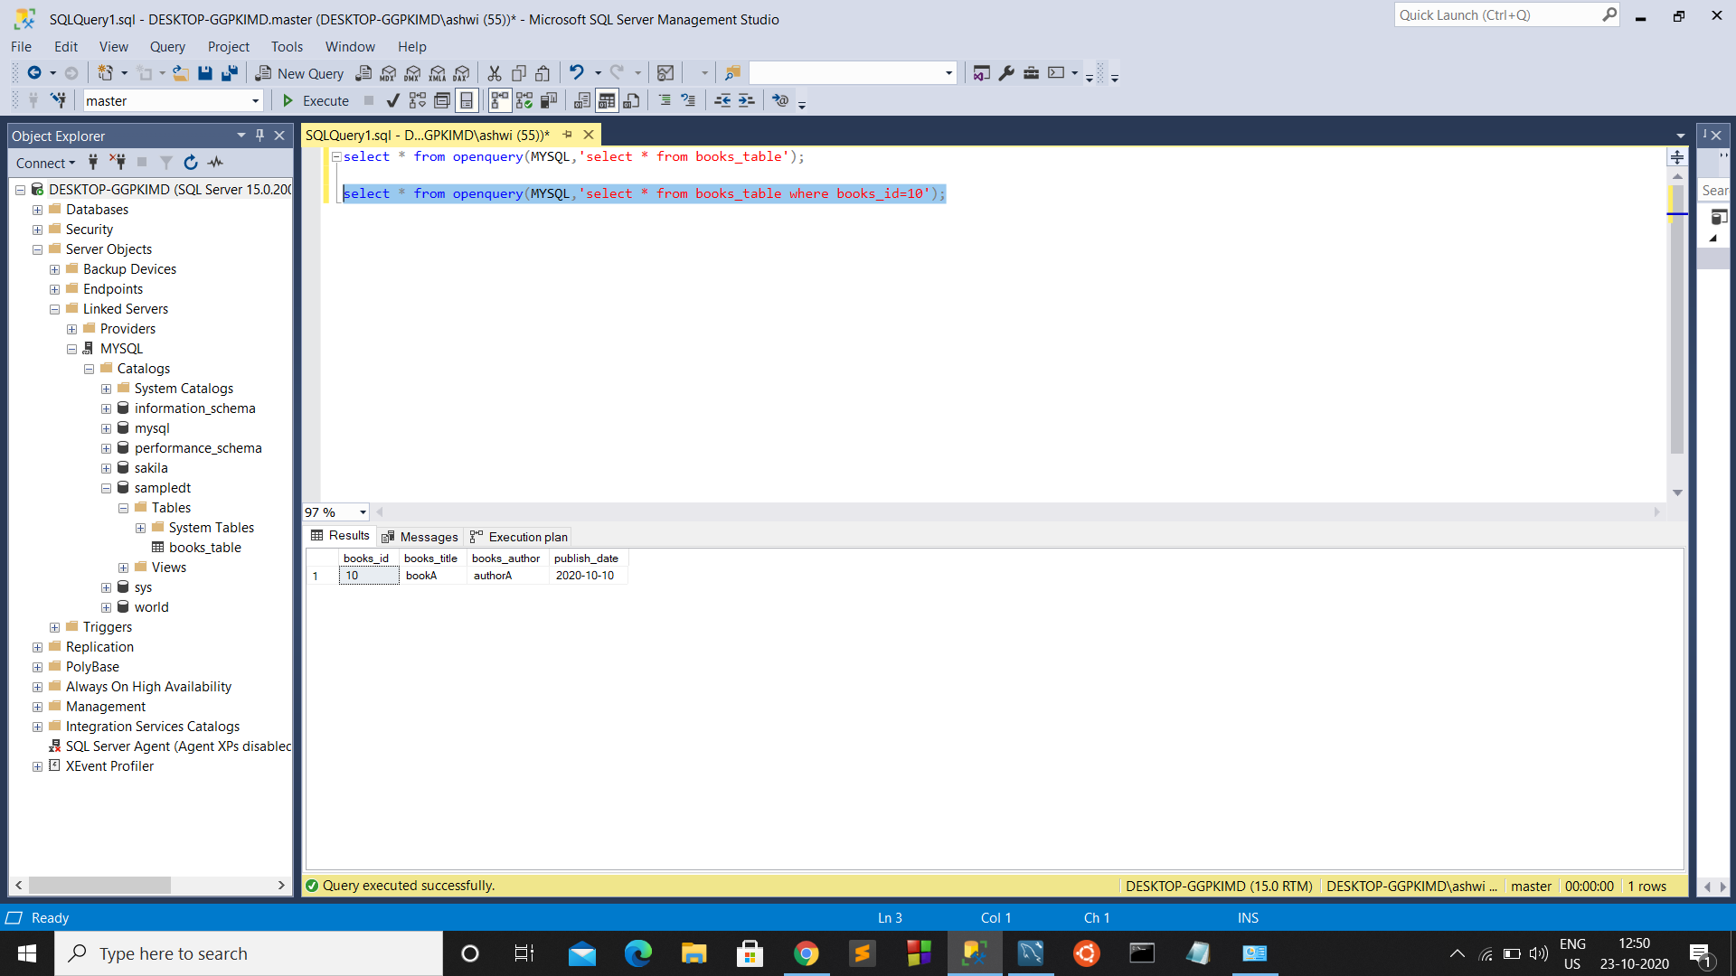

**Distributed query to Insert tuples:**

I have already inserted 3rd row,

Inserting a 4th record into the books_table

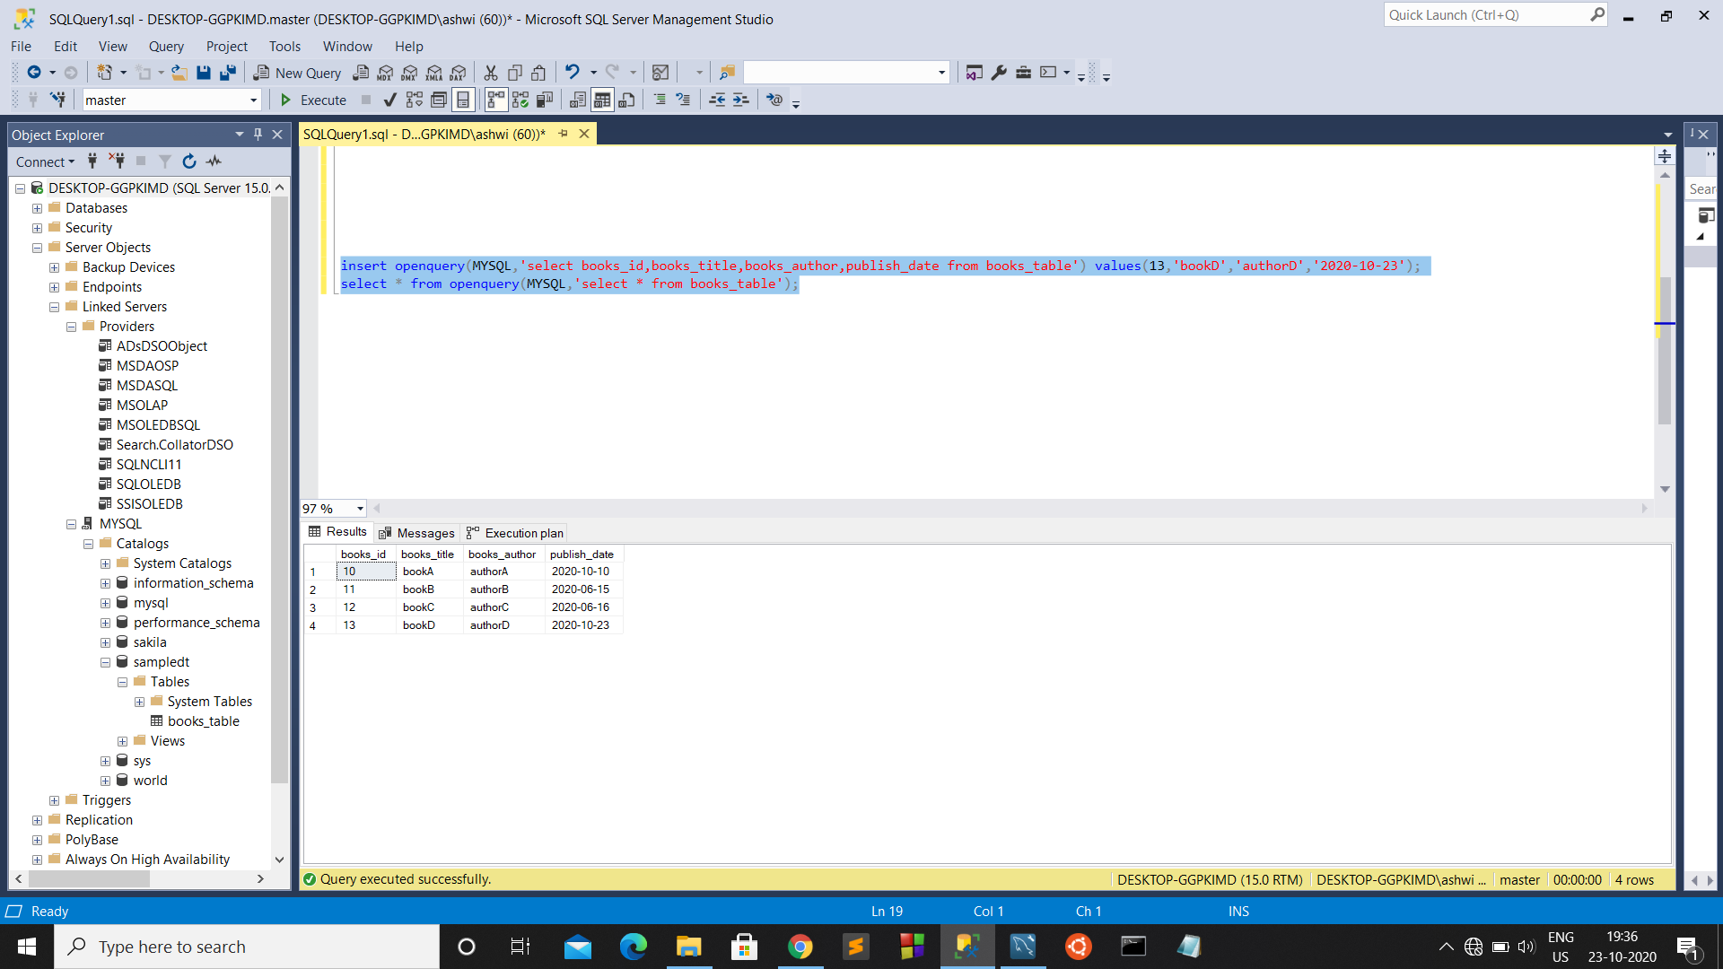

**Distributed Join queries**

I joined 3 tables CITY_PARTITION, AIRPORT, books_table for demonstration purpose.

Here CITY_PARTITION, AIRPORT tables are in database AIRDT that I created for management of Airlines, and table books_table is in SAMPLEDT (in MYSQL).

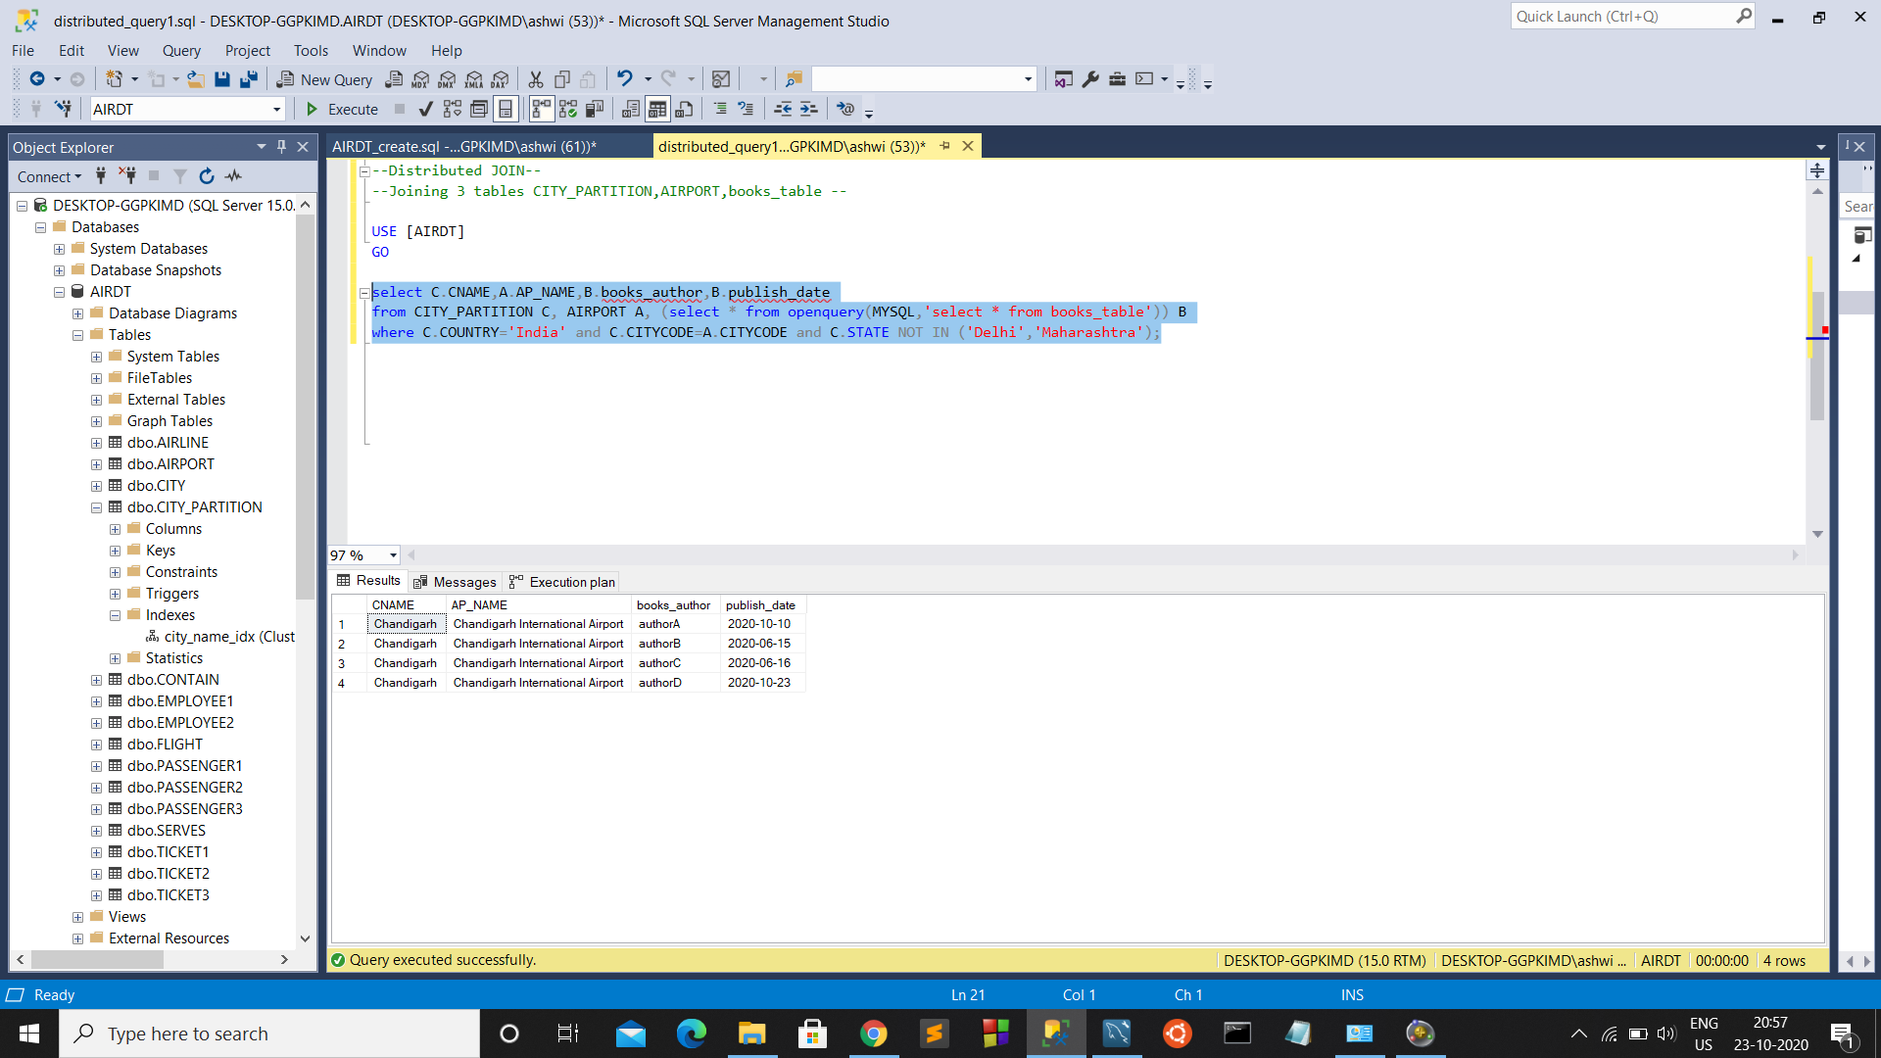

**Distributed Transactions**

Here the operation inside the transaction is to retrieve book_title and publish_date based on the books_id.

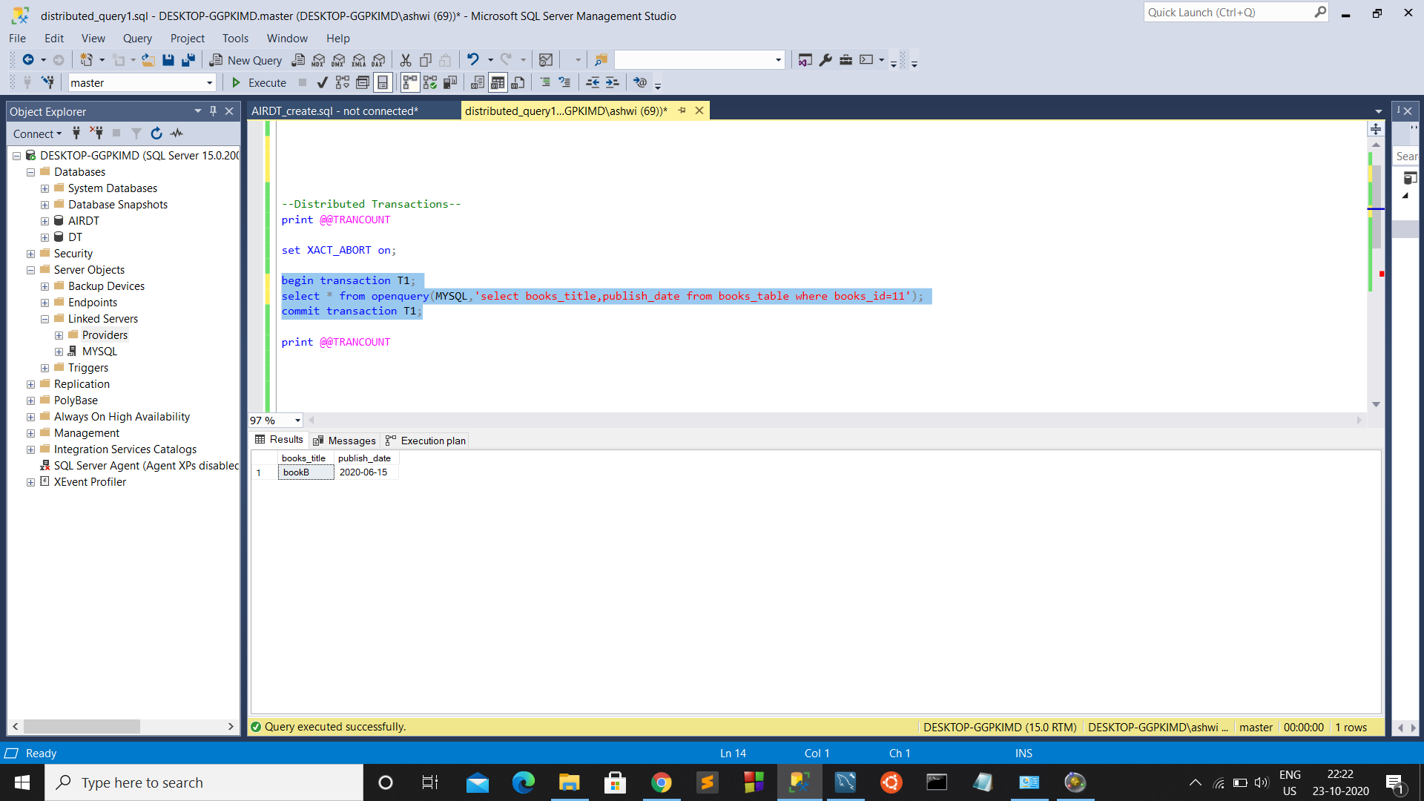

Let us analyse the execution of a similar distributed transaction:-

Initially there are no transactions running, so TRANCOUNT is 0

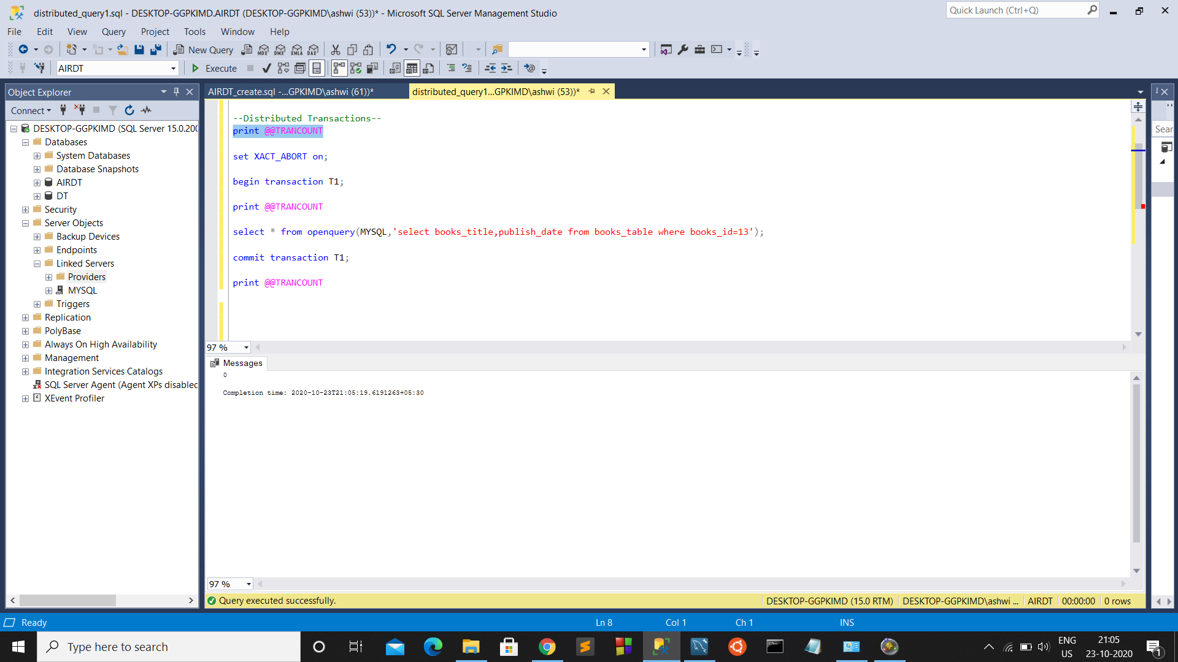

We set XACT_ABORT so that, if a transaction is unsuccessful, the changes are terminated.

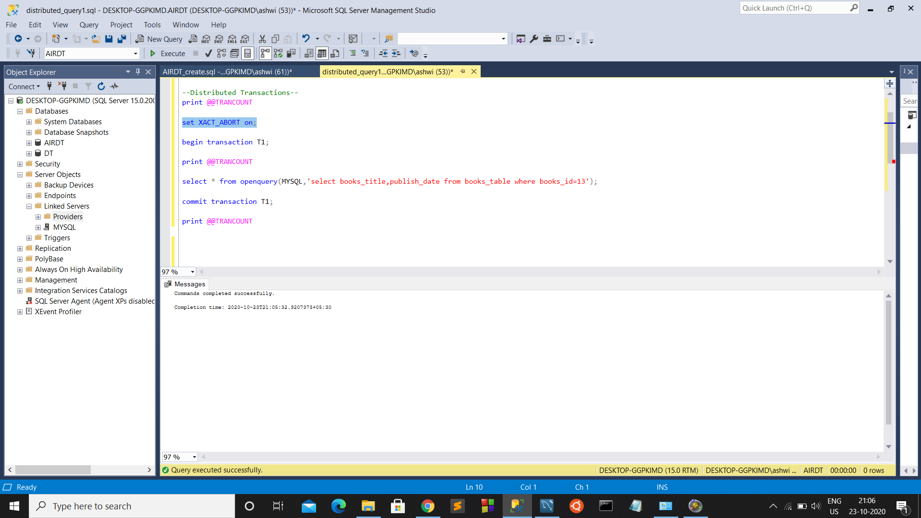

Begin the transaction

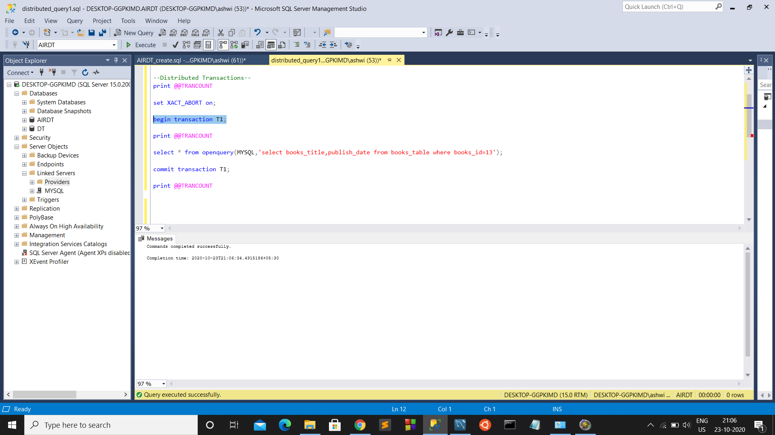

Now we can see the TRANCOUNT = 1

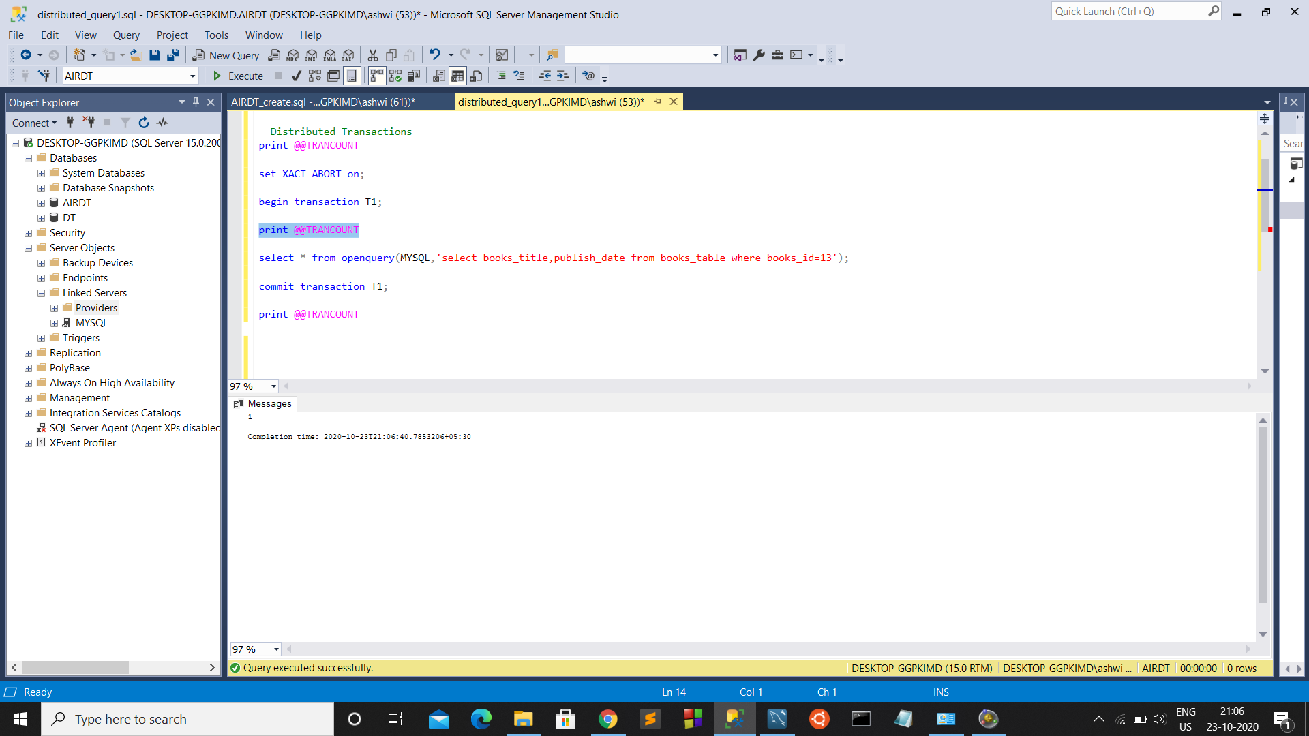

The operation inside the transaction executes, and gives the result.

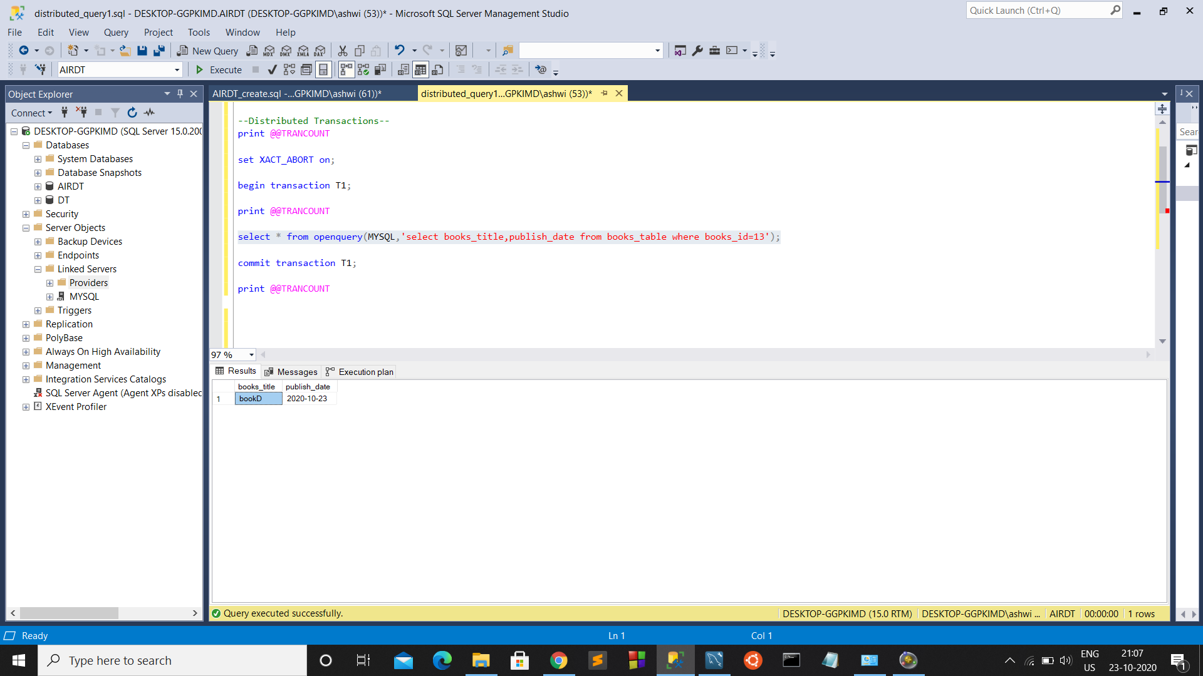

We commit the transaction to end the transaction so that the changes made during the transactions are retained.

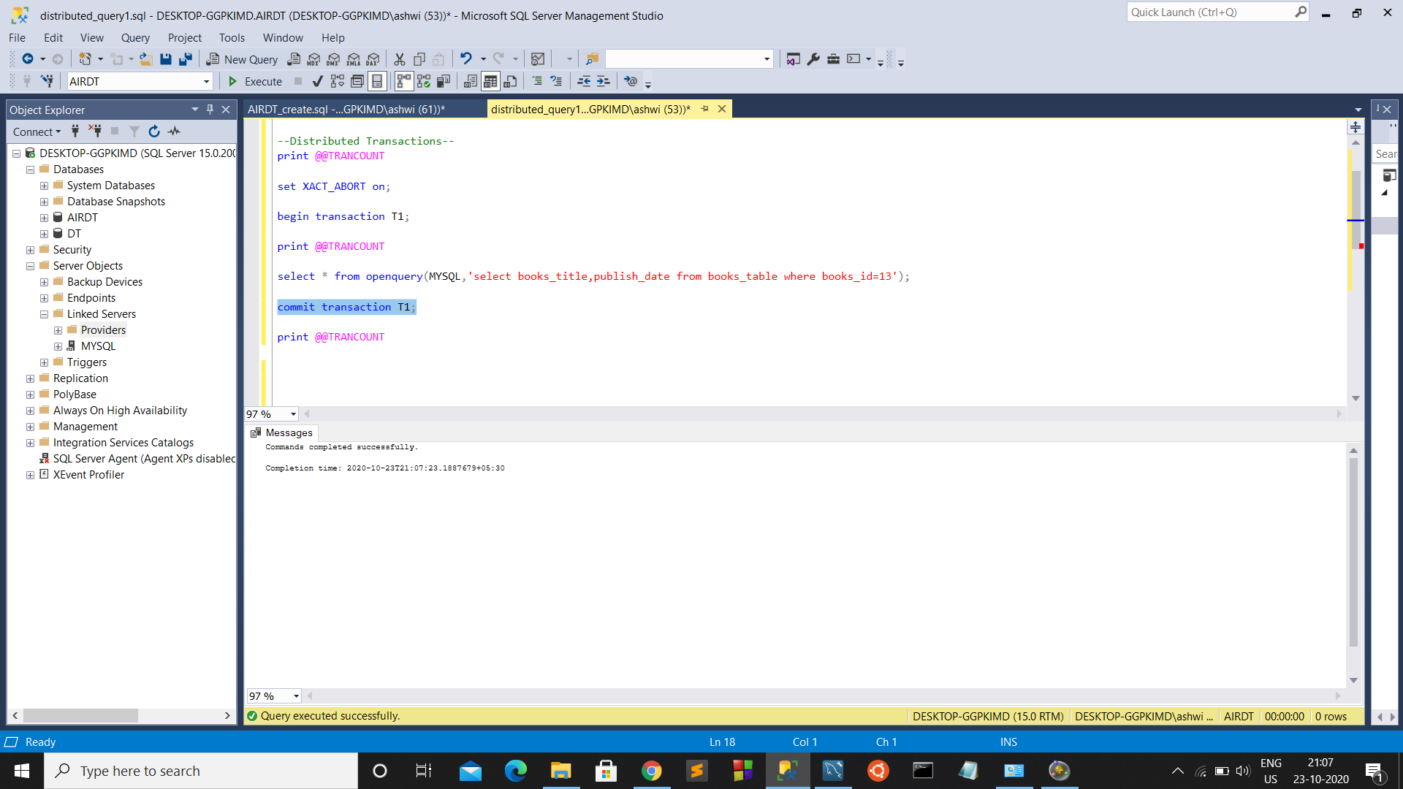

Now so that the transaction has been committed, TRANCOUNT is 0 again.

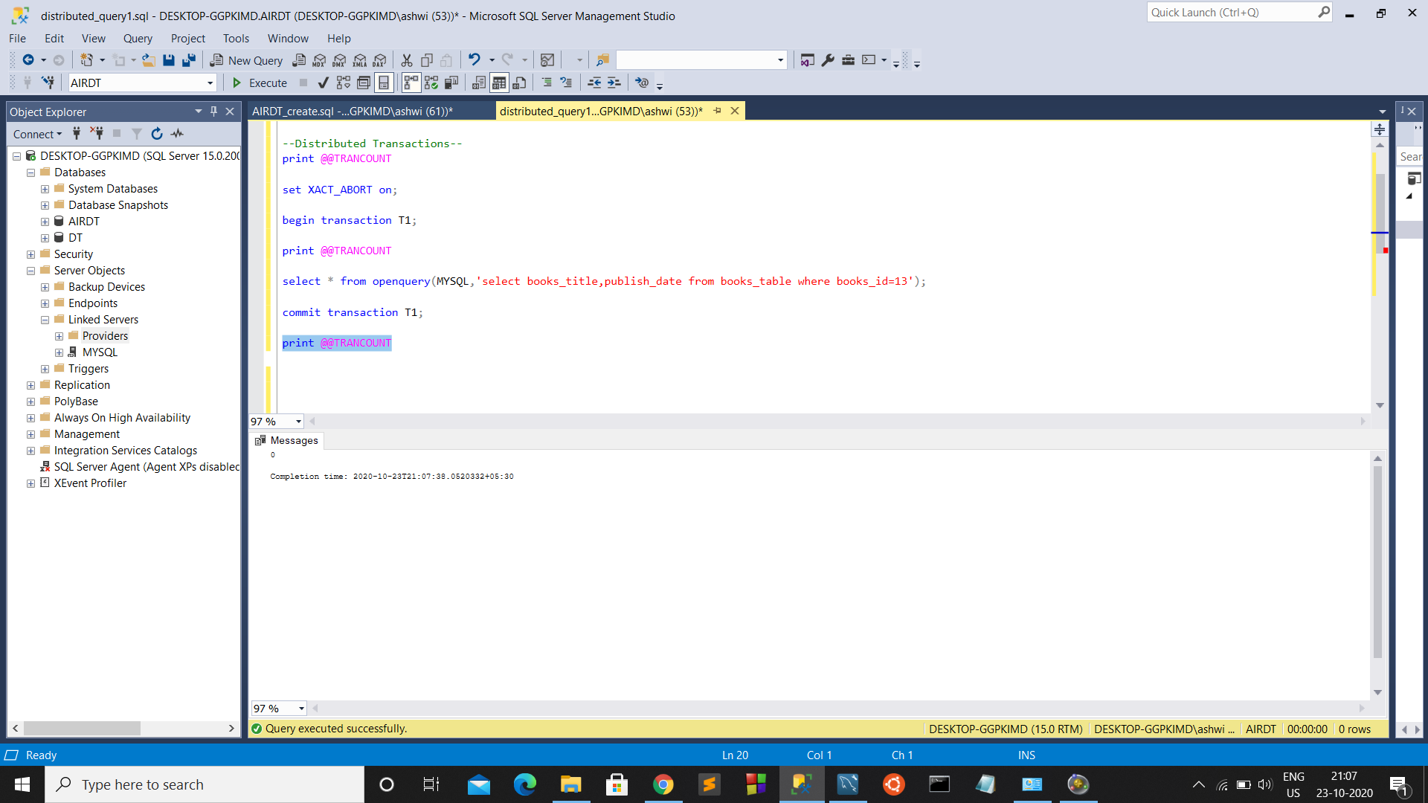

Understandings:-

* We can create a environment to run distributed queries using Linked servers
* There are many providers(MSDASQL,MSOLAP,MSOLEDBSQL etc.) that allow us to create linked servers.
* We can perform operations like Insertion, join, transactions in distributed database system
* We saw how to execute distributed queries and perform Distributed transactions.

Challenges faced:-

Could only able to perform Read-only operations inside the distributed transaction because of the limitations of OLE DB provider.

**THANK YOU**