STAYSMART AI: AN AI-POWERED VACATION RENTAL PLATFORM

A PROJECT BASED LEARNING REPORT

Submitted by
STUDENT 1 NAME (REG. NO.)
STUDENT 2 NAME (REG. NO.)
Submitted in partial fulfilment of the requirements
for the
Project Based Learning component of Machine Learning
BACHELOR OF TECHNOLOGY

in

INFORMATION TECHNOLOGY

CHENNAI INSTITUTE OF TECHNOLOGY, CHENNAI

Affiliated to Anna University, Chennai
(Autonomous)
OCTOBER 2026

Vision of the Institute:
To be an eminent centre for Academia, Industry and Research by imparting knowledge, relevant practices and inculcating human values to address global challenges through novelty and sustainability.

Mission of the Institute:

IM1. To creates next generation leaders by effective teaching learning
methodologies and in still Scientifics Park in them to meet the global challenges.
IM2. To transform lives through deployment of emerging technology, novelty and sustainability.
IM3. To inculcate human values and ethical principles to cater the societal needs.
IM4. To contributes towards the research ecosystem by providing a suitable,

DEPARTMENT OF INFORMATION TECHNOLOGY

Vision of the Department:
To lead in the evolving fields of Information Technology by fostering industry-academia collaboration, advancing research, and promoting sustainable practices, preparing students to develop innovative, technology-driven solutions for real-world challenges.

Mission of the Department:
DM1. To nurture future leaders by adopting innovative teaching methodologies, inspiring a passion for emerging technologies, and equipping students to tackle global challenges effectively.
DM2. To empower students to develop sustainable solutions that enhance quality of life, transforming communities through innovation and technology.
DM3. To instill human values, ethical principles, and professionalism in students, preparing them to contribute meaningfully to society and uphold ethical standards in the industry.
DM4. To strengthen the research ecosystem by promoting collaboration among academia, industry, and R&D establishments, enabling impactful research and technological progress.
DM5. To inspire entrepreneurship by fostering creativity, leadership, and problem-solving skills, enabling students to develop impactful solutions and successful start-ups.

BONAFIDE CERTIFICATE

This is to certify that the Project-Based Learning report titled “StaySmart AI: An AI-Powered Vacation Rental Platform” is a Bonafide record of work carried out by Student Name(s), Register No(s). of the Department of Information Technology, Chennai Institute of Technology, as part of the continuous, mentor-guided Project-Based Learning (PBL) component of the Machine Learning course during the academic year 2026–2027 under my supervision.

SIGNATURE  Dr. A. R. Kavitha, M.E., Ph.D.,  Professor and Head,  Dept. of Information Technology,  Chennai Institute of Technology,  Chennai – 69. | SIGNATURE  MENTOR<<Name>>  <<Designation>>  Dept. of Information Technology,  Chennai Institute of Technology,  Chennai – 69.

Submitted for the final review held on …………………….

Internal Examiner External Examiner

DECLARATION
I/We jointly declare that the PBL report on “StaySmart AI: An AI-Powered Vacation Rental Platform” is the result of original work done by us and, to the best of our knowledge, similar work has not been submitted to “ANNA UNIVERSITY, CHENNAI” for the requirement of the Degree of BACHELOR OF TECHNOLOGY. This PBL report is submitted in partial fulfilment of the requirement for the award of the Degree of Information Technology.

Signature

STUDENT NAME

STUDENT NAME

Place: Chennai
Date:

ACKNOWLEDGEMENT
We wish to express our sincere gratitude to our honorable Chairman, SHRI. P. SRIRAM for providing immense facilities at our institution.

We are very proudly rendering our thanks to our Principal, Dr. A. RAMESH, M.E., Ph.D., for the facilities and the encouragement given by him for the progress and completion of our project.
We would like to express special thanks of gratitude to our Dean, Dr. V. SRINIVASA RAO, M.E., Ph.D., who has been the key spring of motivation to us throughout the completion of our course and project work.
We proudly render our immense gratitude to the Head of the Department, Dr. A.R. KAVITHA M.E., Ph.D., for her effective leadership, encouragement, and guidance in the project.
We would like to extend our thanks to t h e Project Co-ordinator <NAME, DESIGNATION>., Department of Information Technology, for their valuable suggestions throughout this project.
We wish to acknowledge the help received from the class advisors <NAME, DESIGNATION>., of the Department of Information Technology, and others for providing valuable suggestions and for the successful completion of the project.

NAME 1 (REG.NO)
NAME 2 (REG.NO)

ABSTRACT

Guests on vacation-rental platforms scroll through hundreds of listings with little personalised guidance, search is limited to rigid keyword and filter forms, and trip planning and budgeting happen in separate tools disconnected from booking. This Project-Based Learning work set out to investigate whether large language models (LLMs) can be embedded into a complete booking platform as dependable features rather than a stand-alone chatbot. The team built StaySmart AI, a full-stack, Airbnb-inspired platform using Java 21, Spring Boot 3, PostgreSQL and a React 19 TypeScript frontend, organised as a modular monolith with six business modules. Seven AI features are implemented through LangChain4j against OpenAI GPT-4o-mini: property recommendation, review summarisation, a multi-turn chat assistant, a trip planner, a listing description generator, a budget planner and a natural-language Smart Search that converts free text into structured search filters. Every AI call is timed and logged; during testing the platform recorded 161 AI calls with 146 successful (90.7%), and all 22 automated JUnit/Mockito tests pass. Three build-test-refine iterations showed that grounding the model in the platform’s own data and validating its structured output matter more to result quality than the model itself, and that AI features must degrade gracefully when the provider is unavailable.
Keywords: Large Language Models, LangChain4j, Natural-Language Search, Spring Boot, Vacation Rental Platform

TABLE OF CONTENTS
CHAPTER 1 13
INTRODUCTION 13
1.1 Background 13
1.2 Driving Question 13
1.3 Objectives 13
1.4 Scope and Limitations 14
CHAPTER 2 15
LITERATURE SURVEY 15
2.1 Related Approaches 15
2.2 Summary Table 15
CHAPTER 3 17
PROJECT PLANNING AND TEAM ORGANISATION 17
3.1 Weekly PBL Progress Log 17
3.2 Requirements 18
3.3 Feasibility 18
CHAPTER 4 19
ITERATIVE DESIGN AND DEVELOPMENT 19
4.1 System Architecture 19
4.2 Iteration 1 — Baseline 20
4.3 Iteration 2 — Refinement 20
4.4 Iteration 3 — Smart Search Hardening 21
4.5 Final Approach 21
4.6 Model Configuration and Verification Procedure 22
CHAPTER 5 23
IMPLEMENTATION 23
5.1 Module Description 23
5.2 Key Code Snippets 23
5.3 User Interface / Demo (if applicable) 24
CHAPTER 6 28
RESULTS AND DISCUSSION 28
6.1 Evaluation Metrics 28
6.2 Results Across Iterations 28
6.3 Discussion 30
6.4 Limitations 31
CHAPTER 7 32
TEAM REFLECTION AND LEARNING OUTCOMES 32
7.1 Individual Reflections 32
7.2 Team Learning 32
7.3 Course Outcomes — Evidence Summary 32
CHAPTER 8 33
CONCLUSION AND FUTURE SCOPE 33
8.1 Conclusion 33
8.2 Future Scope 33
REFERENCES 34
APPENDIX 36
A.3 Self and Peer Assessment 36

LIST OF FIGURES

Figure 4.1 System architecture of StaySmart AI 19
Figure 4.2 Shared AI call pipeline 20
Figure 5.1 Home page with conventional search and the AI Smart Search bar 24
Figure 5.2 Filtered search results (city, price, room type, amenities) 25
Figure 5.3 Property details with live booking widget 25
Figure 5.4 Personalised AI recommendations 25
Figure 5.5 AI review summary: overall sentiment, pros, cons and verdict 26
Figure 5.6 Floating multi-turn AI chat assistant 26
Figure 5.7 AI-generated day-by-day trip itinerary 26
Figure 5.8 Host dashboard for managing listings and availability 27
Figure 5.9 Admin dashboard with platform-wide statistics 27
Figure 6.1 Admin AI usage dashboard (live capture) 29
Figure 6.2 AI calls per feature during testing 29

LIST OF TABLES

Table 2.1 Summary of related approaches 15
Table 3.1 Weekly PBL progress log 17
Table 3.2 Hardware and software requirements 18
Table 4.1 AI features and their grounding 21
Table 6.1 Results across iterations 28
Table 6.2 AI usage statistics by feature 28
Table 6.3 Automated unit test coverage 29
Table A.1 Self and peer assessment 36

LIST OF ABBREVIATIONS

AI — Artificial Intelligence
API — Application Programming Interface
CORS — Cross-Origin Resource Sharing
CRUD — Create, Read, Update, Delete
DTO — Data Transfer Object
JPA — Java Persistence API
JSON — JavaScript Object Notation
JWT — JSON Web Token
LLM — Large Language Model
PBL — Project-Based Learning
REST — Representational State Transfer
SPA — Single-Page Application
SQL — Structured Query Language
UI — User Interface

CHAPTER 1

INTRODUCTION

1.1 Background
Short-term vacation rentals have grown into a mainstream way to travel, and platforms such as Airbnb now list millions of homes worldwide. For a guest, the core problem has shifted from finding any place to stay to finding the right one: a typical city search returns hundreds of listings, each with dozens of attributes, photos and reviews to compare. Traditional search offers fixed filters — city, dates, guests, price — which cannot express intent such as “a quiet beach house in Goa for four people under ₹5000”.
Hosts face a similar burden on the supply side. They write listing descriptions by hand and must guess at pricing, while guests who want to plan an itinerary or a budget leave the platform for separate apps, breaking the journey from inspiration to booking. Large language models (LLMs) such as GPT-4o-mini can read and generate natural language cheaply and quickly, which makes them a natural fit for each of these gaps — provided they are connected to real platform data and do not become a single point of failure.
StaySmart AI explores this space as a Project-Based Learning exercise: rather than building an isolated AI demo, the team built a complete booking platform first and then wove AI features into the real guest, host and administrator journeys.

1.2 Driving Question
Driving question: Can large language models be embedded into a real vacation-rental booking platform so that they measurably improve discovery and planning for guests and hosts, while the platform stays correct, secure and fully usable when the AI is slow, wrong or unavailable?
The team narrowed this into a concrete, buildable task: implement an end-to-end booking platform (authentication, listings, search, booking, reviews, administration), then add seven AI features that each consume live platform data, return structured results the UI can render, and record every call for analysis. The key sub-question investigated in depth was whether an LLM can reliably translate a free-text search request into the same structured filters used by the conventional search form.

1.3 Objectives
- To design and implement a complete Airbnb-style platform — JWT authentication with USER, HOST and ADMIN roles, property management, filtered search, booking with overlap checks, and reviews — as a layered Spring Boot and React application.
- To integrate seven practical AI features into the booking journey through LangChain4j, grounding each prompt in the platform’s own data (listings, reviews, average prices, amenity catalogue).
- To build a natural-language Smart Search that converts free text into structured filters and reuses the existing search path, and to measure and fix its failure cases.
- To instrument every AI call (feature, success, latency) and evaluate the features through an admin analytics dashboard and automated unit tests.
- To ensure graceful degradation, so a missing API key or provider outage returns a clear message instead of crashing the platform.
- To document weekly progress and mentor feedback, and to reflect on the team’s design decisions and division of work across three iterations.

1.4 Scope and Limitations
In scope: a single-region web application with guest, host and admin roles; property listing with images, amenities and availability calendars; search, booking and cancellation; reviews; seven LLM-backed features; an admin dashboard with AI usage statistics; Docker Compose deployment; and a seeded demonstration dataset of 242 properties, 13 users and 16 bookings across India and other countries.
Out of scope / limitations: no real payment gateway (bookings are confirmed instantly without payment); no model training or fine-tuning — the project uses a hosted LLM through its API and focuses on prompt design, grounding and output validation; evaluation uses the seeded dataset and team testing rather than real users; and AI output quality depends on the external provider, so results are not fully deterministic.

CHAPTER 2

LITERATURE SURVEY

2.1 Related Approaches
Before choosing an approach, the team studied three themes: how large platforms personalise search and recommendations, how LLMs can be used for language tasks without training a model, and how user reviews can be condensed into useful summaries.
2.1.1 Learned ranking and recommendation at scale. Covington et al. [1] describe YouTube’s two-stage deep neural recommender: a candidate-generation network narrows millions of items to hundreds, and a ranking network orders them. Airbnb applied related ideas to stays: Grbovic and Cheng [2] learned listing embeddings from 800 million search-click sessions for real-time personalisation, and Haldar et al. [3] report that moving Airbnb search ranking to deep learning produced significant booking gains. These systems need very large interaction logs that a new platform does not have; the team adopted their two-stage idea (retrieve candidates from the database, then let a model explain and rank them) without the training cost.
2.1.2 LLMs as general-purpose language engines. Brown et al. [4] showed that GPT-3 can perform new tasks from instructions and a few examples in the prompt, with no gradient updates. Ouyang et al. [5] showed that instruction tuning with human feedback makes models follow instructions more faithfully, which is what makes prompts such as “output only a JSON object with these keys” practical. Lewis et al. [6] introduced retrieval-augmented generation, conditioning the model on retrieved documents to reduce unsupported answers; StaySmart uses a lightweight form of this by injecting real listings, reviews and prices into each prompt.
2.1.3 Review mining and summarisation. Hu and Liu [7] proposed mining product reviews to extract features and the opinions expressed about them, producing feature-based summaries of pros and cons; Liu [8] surveys sentiment analysis more broadly. Their output format — overall sentiment, pros, cons — directly shaped the structure of StaySmart’s review summariser, with an LLM replacing the hand-built extraction pipeline.
What the team chose to try and why. With no historical click data, training a recommender or ranking model was not feasible. The team instead chose a hosted instruction-tuned LLM (GPT-4o-mini [9]) accessed through LangChain4j [10], combined with retrieval from the platform’s own database for grounding and strict JSON output contracts for any result the code must act on.

2.2 Summary Table
Table 2.1 Summary of related approaches
Ref. | Approach / Model | Dataset / Context | Reported Result / Takeaway
[1] | Two-stage deep neural recommender (candidate generation + ranking) | YouTube watch history, millions of videos | Two-stage design scales to very large catalogues; adopted as retrieve-then-explain
[2] | Listing embeddings for real-time search personalisation | Airbnb, 800M search-click sessions | Embedding-based personalisation deployed in production search ranking
[3] | Deep neural networks for search ranking | Airbnb search logs | Significant booking gains over gradient-boosted trees
[4] | GPT-3 few-shot in-context learning | Diverse NLP benchmarks | New tasks solved from prompts alone, without fine-tuning
[5] | Instruction tuning with human feedback (InstructGPT) | Human-labelled prompt/response data | Outputs preferred by humans over a 100× larger base model
[6] | Retrieval-augmented generation | Open-domain QA benchmarks | Grounding on retrieved text improves factual answers
[7] | Feature-based opinion mining of reviews | Online product reviews | Pros/cons summaries per product feature

CHAPTER 3

PROJECT PLANNING AND TEAM ORGANISATION

3.1 Weekly PBL Progress Log
Table 3.1 Weekly PBL progress log
Week | Milestone / Task | Work Done | Mentor Remarks
1–2 | Problem framing and requirement gathering | Studied rental platforms, defined user roles (guest, host, admin), listed core and AI features, chose the Java/Spring Boot + React stack. | remarks
3–4 | Design and literature exploration | Designed the 12-table PostgreSQL schema, ER and UML class diagrams, REST API contract and modular-monolith package layout; reviewed recommender and LLM literature. | remarks
5–7 | Iteration 1 — baseline platform | Built auth (JWT), property, booking, review and admin modules; added all seven AI features via LangChain4j + OpenAI; React pages for guest, host and admin; 22 unit tests; Docker Compose. | remarks
8–9 | Iteration 2 — refinement | Made the LLM provider pluggable (OpenAI, Gemini, Claude); added room-type and amenity filters and an amenities admin page; redesigned the recommendations section; expanded seed data to 242 properties. | remarks
10–11 | Iteration 3 — Smart Search hardening | Allowed guests to use Smart Search without logging in; diagnosed and fixed zero-result searches caused by over-strict type mapping and phrase matching. | remarks
12 | Final evaluation, report and demo | Collected AI usage statistics from the admin dashboard, verified tests and build, prepared presentation, script and this report. | remarks

3.2 Requirements
StaySmart AI does not rely on a fixed training dataset. Its data is the platform’s own PostgreSQL database, seeded through five Flyway migrations with 242 properties across Indian and international cities, 13 users covering all three roles, 16 bookings, reviews and an amenity catalogue. The development and runtime requirements are listed in Table 3.2.
Table 3.2 Hardware and software requirements
Category | Requirement
Processor / RAM | Intel Core i5 or equivalent / 8 GB RAM (minimum); Docker Desktop recommended
Programming language | Java 21 (backend), TypeScript 5 (frontend), SQL
Libraries / frameworks | Spring Boot 3, Spring Security, Spring Data JPA, Flyway, LangChain4j, React 19, Vite, Tailwind CSS v4, TanStack Query, JUnit 5, Mockito
Database / AI service | PostgreSQL 16; OpenAI GPT-4o-mini API key (Gemini or Claude optional)
Development environment | IntelliJ IDEA / VS Code, Maven, Node.js, Docker Compose
Version control | Git — GitHub repository link

3.3 Feasibility
The project was feasible within the PBL timeframe for three reasons. First, the stack is mature and well documented, and Spring Boot and React scaffolding removed most boilerplate. Second, using a hosted LLM through LangChain4j avoided data collection, training and GPU costs entirely; GPT-4o-mini is inexpensive enough that the whole testing campaign of 161 calls cost very little. Third, the modular-monolith design let each module be built and tested independently, so the weekly plan in Table 3.1 could proceed module by module while keeping one deployable application.

CHAPTER 4

ITERATIVE DESIGN AND DEVELOPMENT

4.1 System Architecture
StaySmart AI is a three-tier web application built as a modular monolith (Figure 4.1). The React 19 single-page application talks to the backend over a JSON REST API, attaching a JWT bearer token to each request. The Spring Boot backend is split into one Java package per business capability — user, property, booking, review, ai and admin — and every module follows the same Controller → Service → Repository layering.
- Controller — exposes REST endpoints, validates request DTOs and enforces role-based access.
- Service — holds business rules and transactions, e.g. booking overlap checks or review eligibility.
- Repository — Spring Data JPA interfaces and JPA Specifications for dynamic search queries.
- Cross-cutting packages — security (JWT filter), config (CORS, OpenAPI, the LLM bean), exception (one global handler) and common (auditable base entity, response wrappers) wrap every module identically.
- PostgreSQL — 12 tables managed by Flyway migrations; LLM provider — reached only from the ai module through LangChain4j.
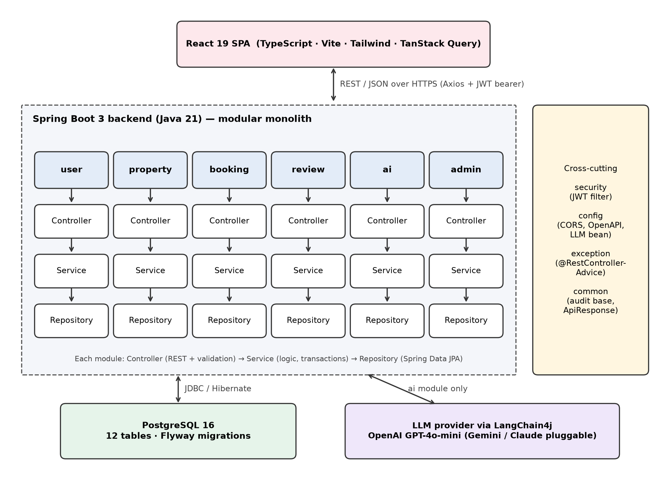
Figure 4.1 System architecture of StaySmart AI
Every AI feature shares the same request pipeline (Figure 4.2). A feature service gathers grounding data from the database and builds the prompt inputs; a shared AiCallExecutor times the call, logs success or failure to the ai_usage_logs table and converts provider errors into a friendly message; a declarative LangChain4j interface carries the prompt templates and calls the model.
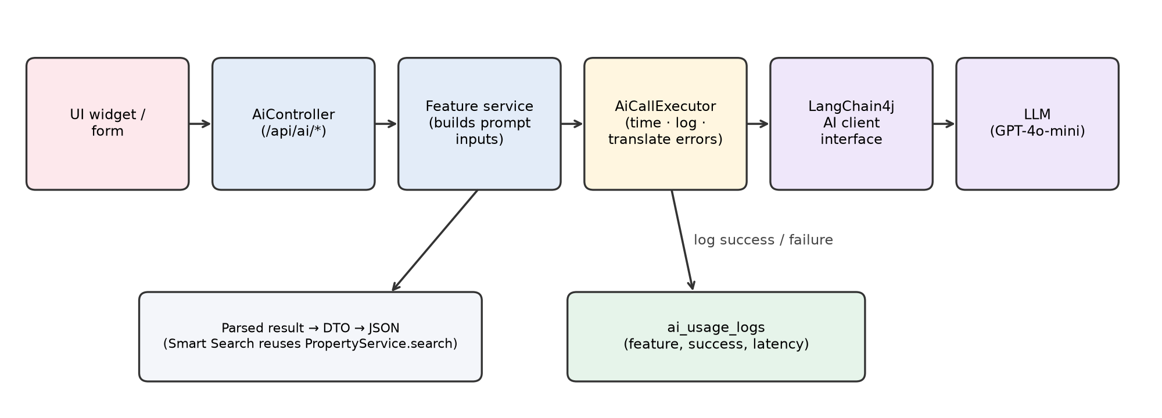
Figure 4.2 Shared AI call pipeline

4.2 Iteration 1 — Baseline
The first iteration aimed for the simplest complete version of every feature. The team built the core platform — registration and login with access and refresh tokens, property CRUD with images and availability, search by city, dates, guests and price, booking with server-side overlap checks, reviews gated to completed stays, and an admin dashboard — and then added all seven AI features as prompt templates against OpenAI GPT-4o-mini, each with a single fixed prompt and minimal post-processing.
Result: a working end-to-end application with 22 passing unit tests and a Docker Compose deployment verified against a real PostgreSQL database. Limitations observed: the platform could only use OpenAI; search could not filter by room type or amenities, so Smart Search had nowhere to put phrases such as “with a pool”; the small seed dataset made recommendations repetitive; and the recommendation output was a long paragraph that was hard to scan. Add the specific mentor feedback from this review.

4.3 Iteration 2 — Refinement
Iteration 2 addressed each limitation. The LLM bean was made provider-pluggable: an AI_PROVIDER setting now selects OpenAI, Google Gemini or Anthropic Claude, and a missing key yields a no-op client that returns a clear “not configured” error. Room-type and amenity filters were added to the search specification, and the Smart Search prompt now receives the live amenity catalogue so the model can only choose amenities that actually exist; an admin page to manage amenities was added. The recommendations section was redesigned as a bulleted summary, and the seed data was expanded in three rounds to 242 properties across global cities.
Improvement: Smart Search could now express amenity and room-type intent, recommendations became scannable, and the richer dataset made every dashboard and recommendation meaningful out of the box.

4.4 Iteration 3 — Smart Search Hardening
Testing the homepage revealed two failures. First, guests who were not logged in could not use Smart Search at all, although the homepage invites them to; the endpoint was opened to anonymous users while other AI features stay authenticated. Second, a natural query such as “cozy beach house in Goa for 2 guests under ₹5000” returned zero results even though a clear match existed.
Debugging traced the empty result to two compounding causes. (1) The model mapped the generic word “house” to the strict propertyType value HOUSE, which excluded matching villas and apartments. The prompt was revised to set propertyType only when the guest names a specific type, leaving loose words in the free-text keyword. (2) The keyword filter matched the whole phrase “cozy beach” as one literal substring, which rarely appears verbatim in listing text. It now matches when any word of the keyword appears in the title or description — a fix that also improved the manual search box. After both changes the example query returned the expected Goa listings.

4.5 Final Approach
The converged design treats the LLM as a language component inside a conventional, deterministic system, rather than as the system itself. Three ideas carry the approach:
- Grounding (retrieval before generation). In the spirit of retrieval-augmented generation [6], each feature retrieves real data first: recommendations use a candidate pool of up to eight top-rated properties in the guest’s city; review summaries receive the property’s actual reviews; the budget planner uses the platform’s real average nightly price. The model explains and organises data; it never invents listings.
- Structured output contracts. Where code must act on the answer (Smart Search, review summary, trip plan, budget), the system prompt demands a single strict JSON object with named keys and enumerated values. The service strips stray code fences, parses the JSON, maps amenity names back to database ids, and on any parse failure falls back to a plain keyword search — so a malformed answer degrades results instead of failing the request.
- Zero-shot instruction following. Following [4], [5], no model is trained; behaviour is specified through system messages with explicit rules and today’s date injected so relative phrases like “next weekend” resolve correctly. The chat assistant replays the persisted conversation history as proper message turns to support multi-turn dialogue.
This fits the problem because a new platform has no interaction logs to train a recommender, yet already holds rich structured data; an instruction-tuned LLM can bridge natural language and that data immediately. The seven features built on this approach are summarised in Table 4.1.
Table 4.1 AI features and their grounding
Feature | Input | Grounding data | Output
Property Recommendation | Guest city / preferences | Up to 8 top-rated listings in the city | Personalised picks with a bulleted explanation
Review Summarization | Property id | All reviews of the property | Sentiment, pros, cons, verdict
Chat Assistant | Chat message + session id | Persisted conversation history | Multi-turn concierge reply
Trip Planner | Destination, dates, party size, interests, budget level | Validated date range | Day-by-day itinerary
Description Generator | Structured property details | Host-entered fields | Draft listing description
Budget Planner | Destination, nights, travellers | Platform average nightly price | Category-wise trip budget
Smart Search | Free-text query | Amenity catalogue, today’s date | Structured filters → regular search

4.6 Model Configuration and Verification Procedure
Because no model is trained, there is no train/validation/test split, epochs or loss function. Instead, the model is configured through environment variables and the surrounding code is verified with automated tests:
- Model and parameters: OpenAI gpt-4o-mini (default provider), temperature 0.7, request timeout 30 seconds; the same settings exist for Gemini and Claude and are selected with AI_PROVIDER.
- Failure handling: every call runs through AiCallExecutor, which records latency and outcome and returns a friendly “temporarily unavailable” message on error; a missing API key produces a clear “not configured” response.
- Unit tests: 22 JUnit 5 tests with Mockito mocks cover authentication, property, booking, review and the trip planner AI service, with an H2 in-memory database for the application-context test (Table 6.3).
- End-to-end checks: the full stack was started with Docker Compose against PostgreSQL and each AI feature was exercised through the UI; outcomes were read from the admin AI usage dashboard.

CHAPTER 5

IMPLEMENTATION

5.1 Module Description
User and authentication module. Handles registration and login, issuing short-lived JWT access tokens and rotating refresh tokens stored in the database. Passwords are hashed with BCrypt [13] and endpoints are restricted by role (USER, HOST, ADMIN); self-registration as ADMIN is rejected.
Property module. Lets hosts create and edit listings with images, amenities, location fields and an availability calendar. Search is implemented with JPA Specifications that combine city, country, dates, guests, price range, property type, room type, amenities and keyword into one dynamic query.
Booking module. Validates each request (active listing, not the host’s own property, check-out after check-in, guest limit, dates free), snapshots the price and number of nights, confirms the booking and blocks the calendar; cancellation releases the block. A half-open date range backs both search and overlap checks.
Review module. Allows one review per completed booking, with rating, comment and photos, and keeps a cached average rating on the property in sync.
AI module. Contains the seven LangChain4j client interfaces (prompt templates), a feature service per client, the shared AiCallExecutor and AiUsageLogger, and persistence for chat messages and usage logs.
Admin module. Provides platform statistics, user and property management, amenity management, booking analytics and AI usage statistics (calls, success, failures and average latency per feature).
Frontend. A React 19 + TypeScript SPA built with Vite and Tailwind CSS; TanStack Query handles server state and caching, and route guards separate guest, host and admin pages. A floating chat widget is available on every page.

5.2 Key Code Snippets
Snippet 1 — Smart Search prompt contract (LangChain4j declarative AI service, abridged).
public interface SmartSearchAiClient {
@SystemMessage("""
You convert a natural-language vacation rental search request into a single
strict JSON object with exactly these keys: city, country, checkIn, checkOut,
guests, minPrice, maxPrice, propertyType, roomType, amenities, keyword.
- propertyType ... Only set this when the guest names a SPECIFIC type of place.
- amenities ... chosen ONLY from this exact list: {{amenityCatalog}}
- Output ONLY the raw JSON object, no markdown, no explanation.
""")
@UserMessage("Today's date is {{today}}. Convert this search request to JSON: {{query}}")
String parseQuery(@V("query") String query, @V("today") String today,
@V("amenityCatalog") String amenityCatalog);
}
Snippet 2 — shared AI call wrapper that times, logs and translates failures.
public String call(AiFeature feature, Long userId, Supplier<String> aiCall) {
long start = System.currentTimeMillis();
try {
String result = aiCall.get();
usageLogger.logSuccess(feature, userId, null, null,
System.currentTimeMillis() - start);
return result;
} catch (Exception e) {
usageLogger.logFailure(feature, userId,
System.currentTimeMillis() - start, e.getMessage());
throw new AiServiceException(friendlyMessage(e), e);
}
}
Snippet 3 — keyword matching fixed in Iteration 3 (any word, not the whole phrase).
for (String word : criteria.keyword().toLowerCase().split("\\s+")) {
if (word.isBlank()) continue;
String like = "%" + word + "%";
wordPredicates.add(cb.or(
cb.like(cb.lower(root.get("title")), like),
cb.like(cb.lower(root.get("description")), like)));
}
predicates.add(cb.or(wordPredicates.toArray(new Predicate[0])));
The complete source code, including the booking overlap logic and all seven AI services, is available in the project repository listed in Appendix A.1.

5.3 User Interface / Demo (if applicable)
The following screenshots were captured from the running application; the AI panels show live model output generated by GPT-4o-mini, not mock-ups.
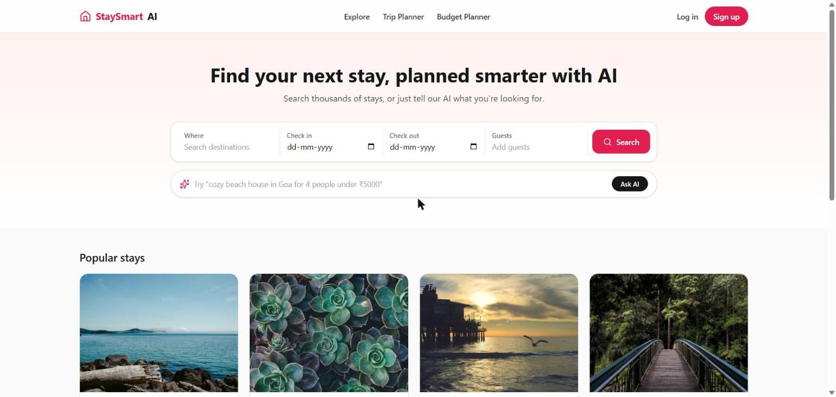
Figure 5.1 Home page with conventional search and the AI Smart Search bar
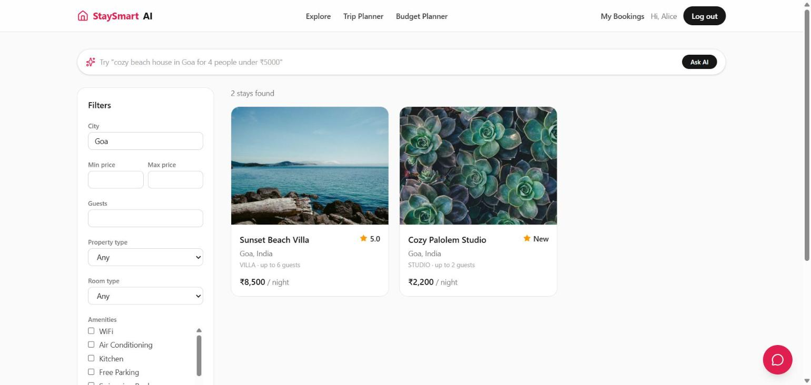
Figure 5.2 Filtered search results (city, price, room type, amenities)

Figure 5.3 Property details with live booking widget
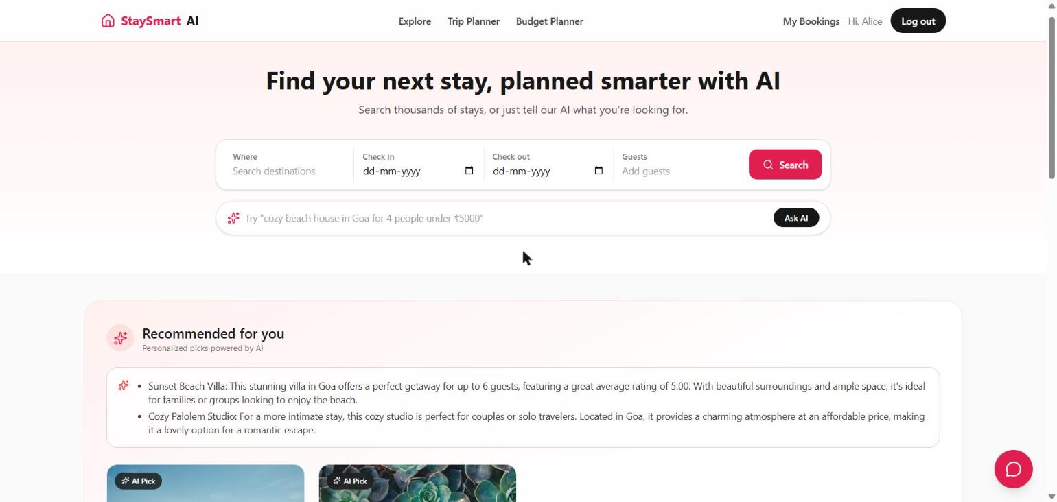
Figure 5.4 Personalised AI recommendations
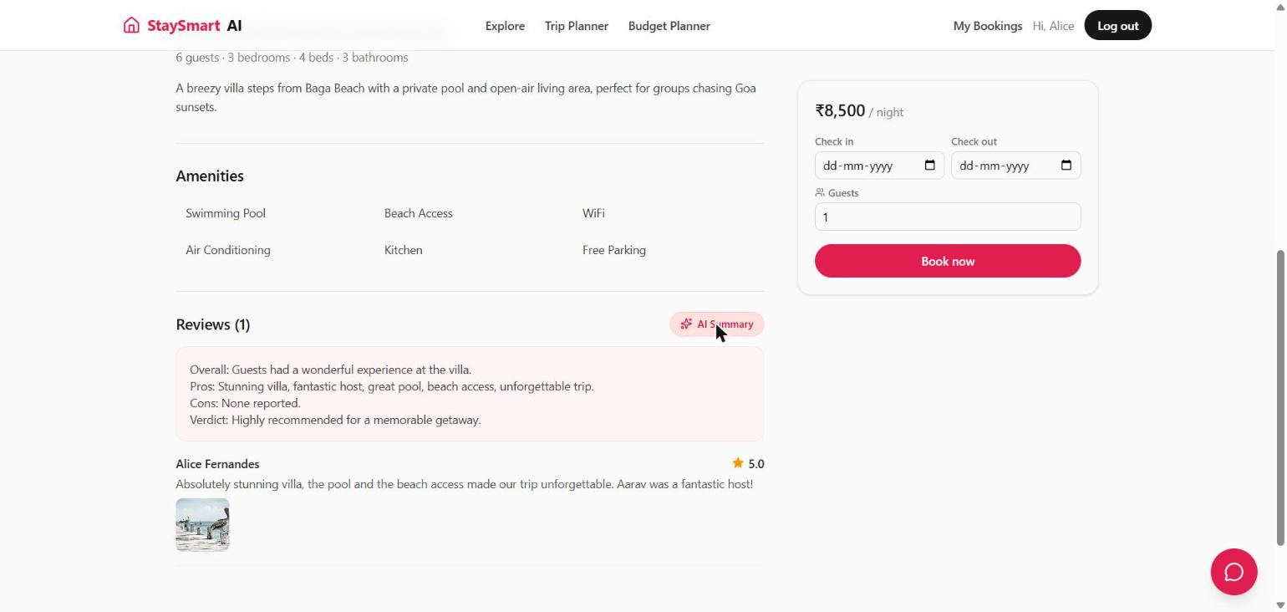
Figure 5.5 AI review summary: overall sentiment, pros, cons and verdict
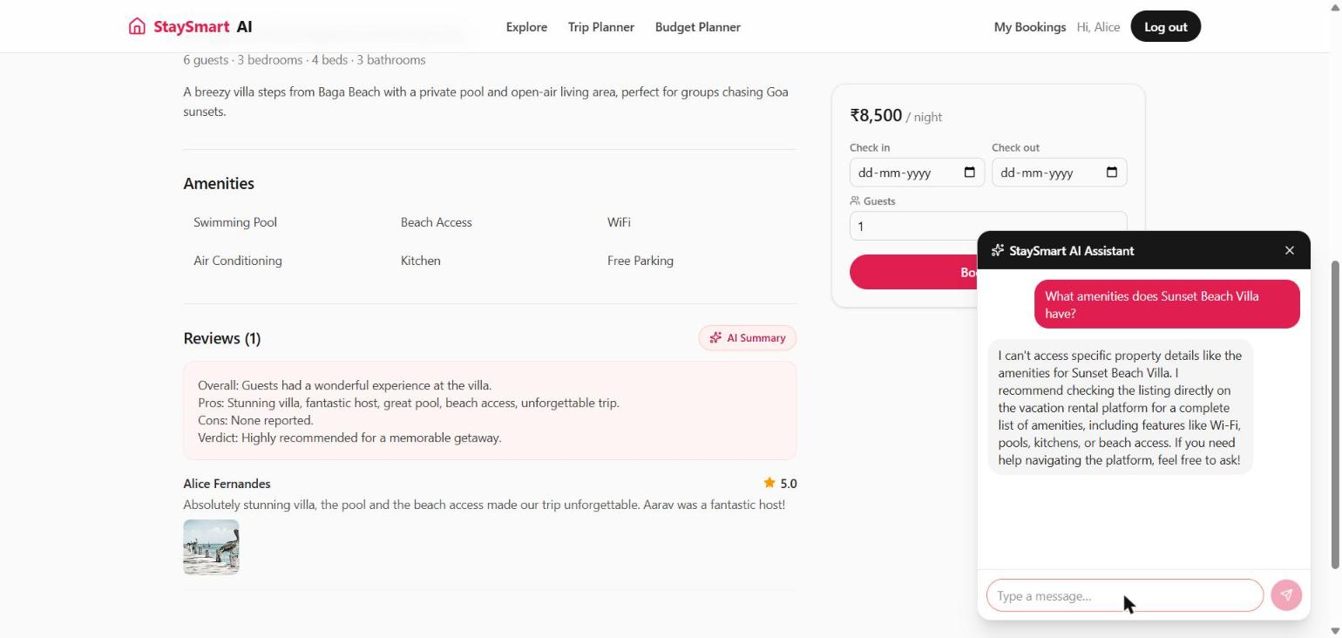
Figure 5.6 Floating multi-turn AI chat assistant
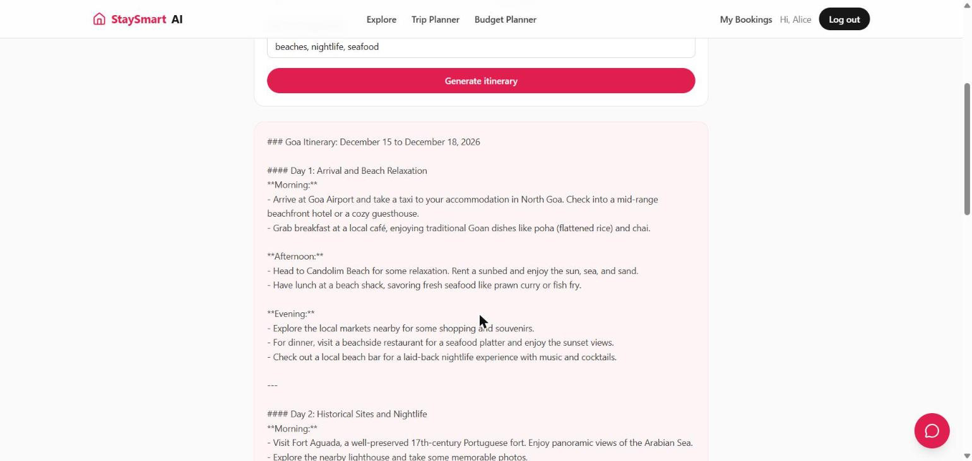
Figure 5.7 AI-generated day-by-day trip itinerary
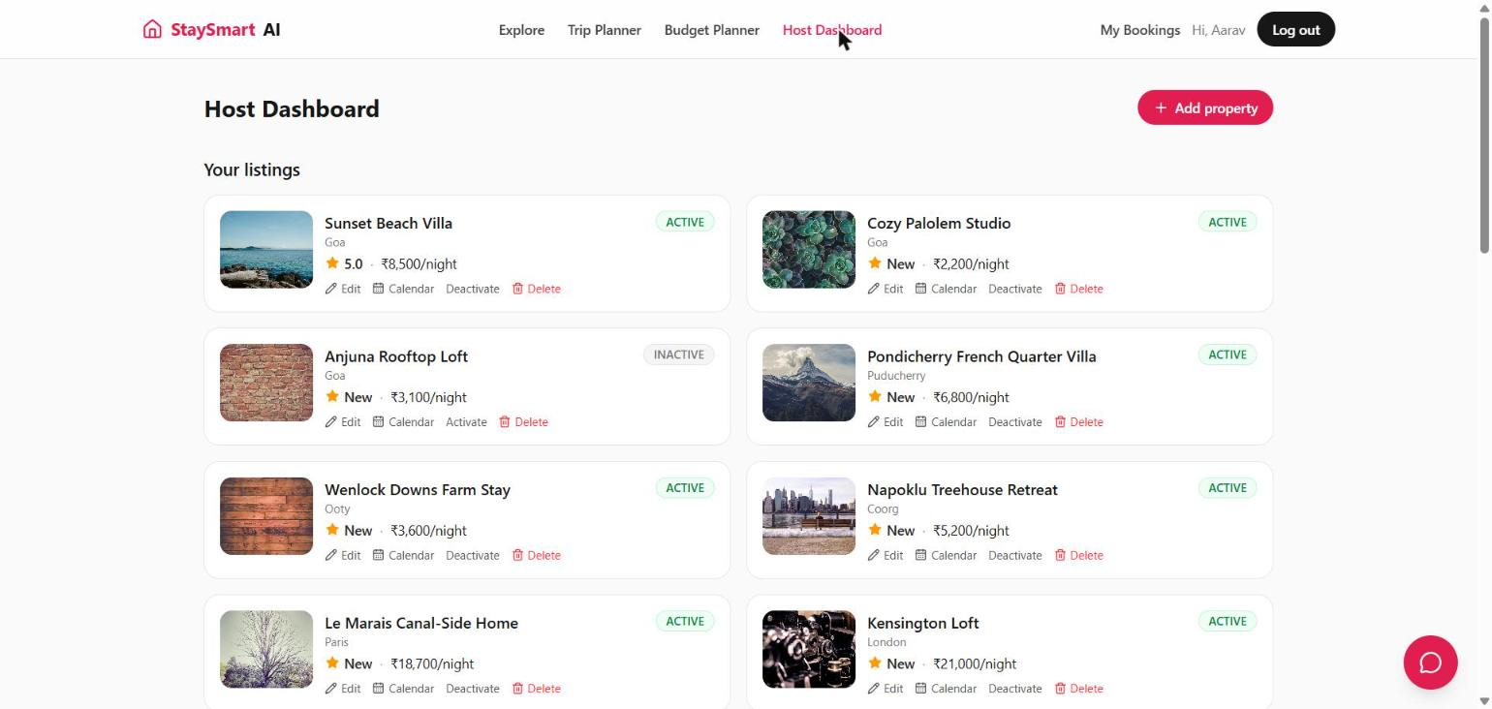
Figure 5.8 Host dashboard for managing listings and availability
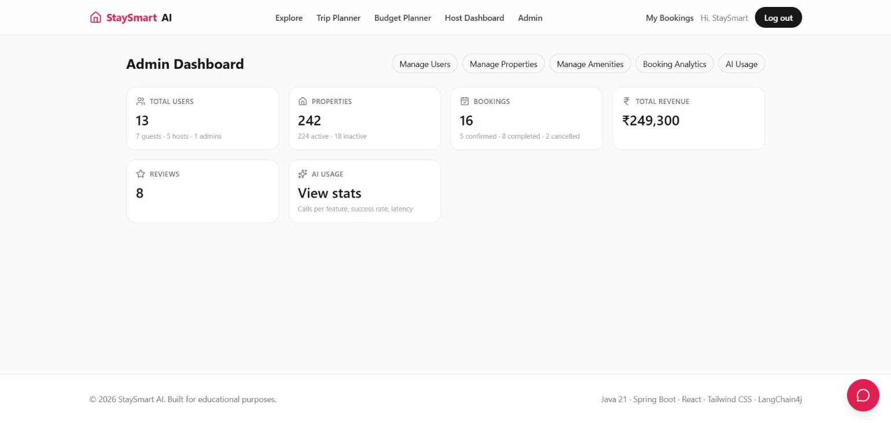
Figure 5.9 Admin dashboard with platform-wide statistics

CHAPTER 6

RESULTS AND DISCUSSION

6.1 Evaluation Metrics
Because the project integrates a hosted LLM rather than training a classifier, accuracy and F1 do not apply directly. The team used metrics that match what the platform must guarantee:
- AI call success rate — the share of AI calls that returned a usable answer, per feature, from ai_usage_logs.
- Average AI latency — mean response time per feature, which determines whether a feature feels interactive.
- Functional correctness — pass/fail of the automated JUnit/Mockito test suite and a successful production build.
- Task outcome — for Smart Search, whether representative natural-language queries return the listings a person would expect.

6.2 Results Across Iterations
Table 6.1 Results across iterations
Version | Scope delivered | Verification | Outcome
Iteration 1 (baseline) | Core platform + 7 AI features, OpenAI only | 22/22 unit tests pass; frontend build passes; Docker Compose smoke test | End-to-end platform working; search limited to basic filters
Iteration 2 (refinement) | Pluggable provider, room-type and amenity filters, 242-property dataset | Manual UI testing of search and recommendations | Smart Search can express amenity intent; richer, less repetitive results
Iteration 3 (final) | Guest access to Smart Search; type-mapping and keyword-matching fixes | Re-tested failing queries, e.g. “cozy beach house in Goa for 2 under ₹5000” | Zero-result case fixed; 161 AI calls logged, 146 successful (90.7%)

Table 6.2 lists the AI usage recorded by the admin dashboard (Figure 6.1) over the testing campaign. Per-feature success counts and latencies are shown where the dashboard capture includes them.
Table 6.2 AI usage statistics by feature
Feature | Calls | Success / Failures | Avg. latency
Smart Search | 77 | — | —
Recommendations | 44 | 40 / 4 | 3246 ms
Chat Assistant | 11 | 9 / 2 | 1784 ms
Trip Planner | 10 | — | —
Review Summary | 7 | 7 / 0 | 1427 ms
Description Generator | 6 | — | —
Budget Planner | 6 | — | —
Total | 161 | 146 / 15 | —
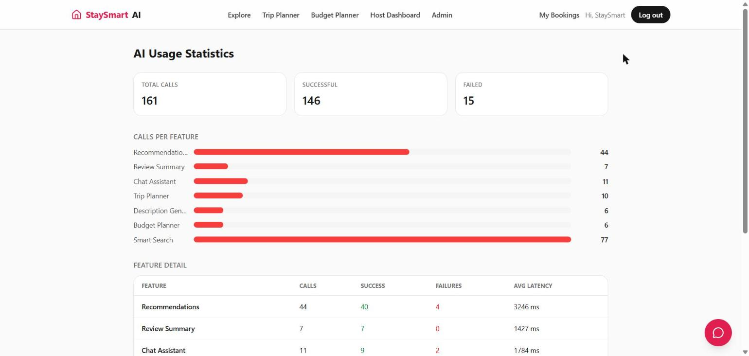
Figure 6.1 Admin AI usage dashboard (live capture)
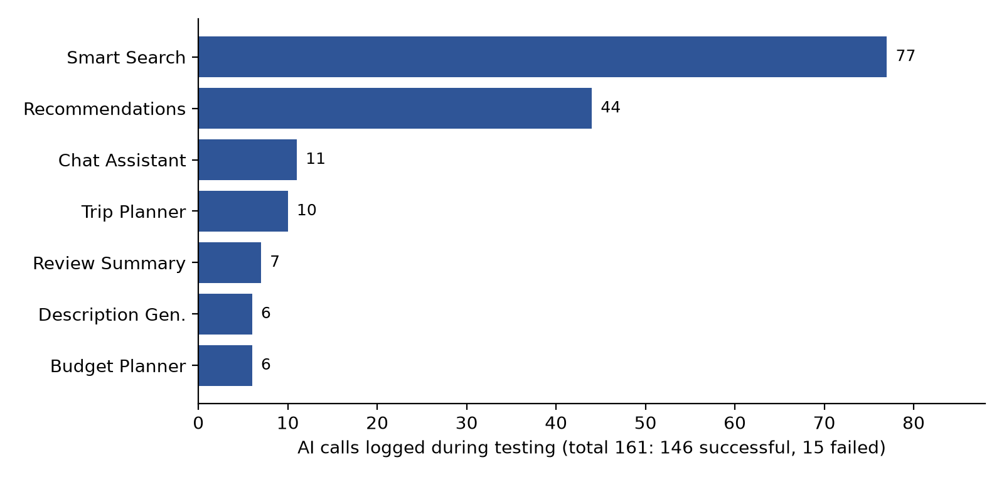
Figure 6.2 AI calls per feature during testing
Table 6.3 Automated unit test coverage
Test class | Module | Tests | What is verified
AuthServiceTest | user | 5 | Registration, duplicate email, admin self-registration blocked, bad credentials, disabled account
BookingServiceTest | booking | 6 | Booking confirms and blocks calendar; rejects unavailable dates, own property, too many guests; cancellation rules
PropertyServiceTest | property | 3 | Host creates listing, non-owner update rejected, availability overlap check
ReviewServiceTest | review | 4 | Only completed bookings by the owner; no duplicates; rating refreshed
TripPlannerAiServiceTest | ai | 3 | Calls model and returns itinerary; invalid dates rejected; AI outage propagates as AiServiceException
StaySmartApplicationTests | — | 1 | Spring application context loads (H2)

6.3 Discussion
Where the AI did well. Features whose input is already structured and grounded were the most reliable: review summarisation succeeded on every call (7/7) and was the fastest feature at about 1.4 s, because the model only has to condense text it is given. The overall 90.7% success rate shows that wrapping every call in a shared executor with logging and friendly errors kept failures visible and contained — no failure crashed a page.
Where it did poorly, and why. Recommendations were the slowest feature (about 3.2 s) and had 4 failures in 44 calls, because they send the largest prompt — eight serialised listings — and ask for the longest answer. Smart Search was the most used feature (77 calls, 48% of all traffic), which is where the Iteration 3 defect surfaced: the model obeyed the prompt literally, mapping “house” to HOUSE, and the database filter was stricter than the language it received. The lesson is that most failures came from the contract between the model and the code, not from the model’s language ability; tightening the prompt rules and relaxing keyword matching fixed the problem without changing the model.
What changed between iterations. Iteration 1 proved the architecture; Iteration 2 widened what the AI could express by giving it more filter dimensions and a closed amenity vocabulary; Iteration 3 made that expression robust to ordinary phrasing. Each step improved results by improving grounding and validation around the LLM.

6.4 Limitations
The evaluation is based on the team’s own testing against a seeded dataset rather than real users, so the 161-call sample is small and skewed toward features that were demonstrated most. The dashboard capture gives per-feature success and latency for only three of the seven features. Smart Search quality was judged on representative queries rather than a labelled test set with precision and recall. LLM output is non-deterministic at temperature 0.7, so repeated runs can differ, and each feature depends on an external provider’s availability and pricing. The unit tests mock the model, so they verify the surrounding logic, not answer quality.

CHAPTER 7

TEAM REFLECTION AND LEARNING OUTCOMES

7.1 Individual Reflections
Each member should write 2–4 sentences in their own words: which modules they built (e.g. booking and search, AI services and prompts, React pages, database and deployment), one thing they learned, and one challenge they faced (e.g. the Smart Search zero-result bug, JWT refresh rotation, booking overlap logic).
Name 1: reflection
Name 2: reflection
Name 3: reflection

7.2 Team Learning
Agreeing on one internal structure for every module (Controller, Service, Repository) early paid off: members could work on different modules in parallel and still read each other’s code easily, and cross-cutting concerns such as security and error handling were written once. Building the complete non-AI platform first also proved to be the right order, because every AI feature could then be grounded in real data and reuse existing code paths — Smart Search simply calls the same search service as the filter form.
If the team restarted the cycle, it would build a small labelled set of test queries for Smart Search at the start, so that the Iteration 3 defect would have been caught by a measurable check rather than by manual testing, and it would log per-feature latency from the first iteration to compare changes quantitatively. Reference specific mentor feedback that changed the team’s direction, if any.

7.3 Course Outcomes — Evidence Summary
Map each line to the official course outcome numbers for IT5305.
- CO1 — Problem analysis: the driving question and scope in Sections 1.2 and 1.4 frame an open problem and narrow it into buildable features.
- CO2 — Design and development of solutions: the modular-monolith architecture and shared AI pipeline in Figures 4.1 and 4.2.
- CO3 — Investigation and evaluation: Iteration 3 root-cause analysis (Section 4.4) and the metrics in Tables 6.1–6.3.
- CO4 — Modern tool usage: Spring Boot, LangChain4j, React, PostgreSQL, Flyway, JUnit/Mockito and Docker Compose (Table 3.2).
- CO5 — Teamwork and communication: the weekly log in Table 3.1, this report and the project presentation.

CHAPTER 8

CONCLUSION AND FUTURE SCOPE

8.1 Conclusion
The team built StaySmart AI, a complete vacation-rental platform with seven LLM-backed features integrated into the guest, host and admin journeys. The platform logged 161 AI calls with a 90.7% success rate, passes all 22 automated tests and degrades gracefully when the AI provider is unavailable. The driving question is answered positively, with a qualification: LLMs add real value to discovery and planning when they are grounded in platform data, bound to strict output contracts and wrapped in deterministic validation and fallbacks. All objectives in Section 1.3 were met, with the evaluation limited by the small, team-generated test sample.

8.2 Future Scope
- Integrate a real payment gateway (Razorpay or Stripe) for actual checkout, with host payouts.
- Replace the top-rated candidate pool with vector-search recommendations using embeddings over listings and reviews, as a further iteration.
- Build a labelled query set to measure Smart Search precision and recall, and track per-feature latency over time.
- Add wishlists, real-time booking notifications and AI-driven dynamic pricing suggestions for hosts.
- Deliver a native mobile app (React Native) reusing the same REST API.

REFERENCES
[1] P. Covington, J. Adams, and E. Sargin, “Deep neural networks for YouTube recommendations,” in Proc. 10th ACM Conf. Recommender Systems (RecSys), 2016, pp. 191–198.
[2] M. Grbovic and H. Cheng, “Real-time personalization using embeddings for search ranking at Airbnb,” in Proc. 24th ACM SIGKDD Int. Conf. Knowledge Discovery & Data Mining, 2018, pp. 311–320.
[3] M. Haldar et al., “Applying deep learning to Airbnb search,” in Proc. 25th ACM SIGKDD Int. Conf. Knowledge Discovery & Data Mining, 2019, pp. 1927–1935.
[4] T. Brown et al., “Language models are few-shot learners,” in Advances in Neural Information Processing Systems, vol. 33, 2020, pp. 1877–1901.
[5] L. Ouyang et al., “Training language models to follow instructions with human feedback,” in Advances in Neural Information Processing Systems, vol. 35, 2022, pp. 27730–27744.
[6] P. Lewis et al., “Retrieval-augmented generation for knowledge-intensive NLP tasks,” in Advances in Neural Information Processing Systems, vol. 33, 2020, pp. 9459–9474.
[7] M. Hu and B. Liu, “Mining and summarizing customer reviews,” in Proc. 10th ACM SIGKDD Int. Conf. Knowledge Discovery and Data Mining, 2004, pp. 168–177.
[8] B. Liu, Sentiment Analysis and Opinion Mining. San Rafael, CA, USA: Morgan & Claypool, 2012.
[9] OpenAI, “GPT-4o mini: advancing cost-efficient intelligence,” 2024. [Online]. Available: https://openai.com/index/gpt-4o-mini-advancing-cost-efficient-intelligence/
[10] LangChain4j, “LangChain4j documentation,” 2026. [Online]. Available: https://docs.langchain4j.dev/
[11] VMware Tanzu, “Spring Boot reference documentation,” 2026. [Online]. Available: https://docs.spring.io/spring-boot/
[12] M. Jones, J. Bradley, and N. Sakimura, “JSON Web Token (JWT),” IETF RFC 7519, May 2015.
[13] N. Provos and D. Mazières, “A future-adaptable password scheme,” in Proc. USENIX Annual Technical Conf., FREENIX Track, 1999, pp. 81–91.
[14] Meta Open Source, “React documentation,” 2026. [Online]. Available: https://react.dev/

APPENDIX
A.1 Full source code: GitHub repository link — repository layout: backend/ (Spring Boot API), frontend/ (React SPA), docs/ (ER, UML and sequence diagrams, API reference, deployment guide), docker-compose.yml.
A.2 Complete weekly PBL log and mentor sign-offs: attach signed weekly review sheets.

A.3 Self and Peer Assessment
Table A.1 Self and peer assessment
Team Member | Self-Rated Contribution (%) | Peer-Rated Contribution (%) | Remarks
Name 1 | % | % | remarks
Name 2 | % | % | remarks

