Table of Contents

1. Executive Summary
2. Test Objective & Scope
3. Test Environment & Architecture
4. Test Cases
5. Test Configuration
6. Detailed Performance Metrics
7. Per-Transaction Breakdown
8. Acceptance Criteria (SLAs)
9. Results vs Acceptance Criteria
10. Performance Diagrams
11. Conclusion & Recommendations

Executive Summary
This report presents the performance test results for "APIC GQL Peak Load Test" under the APIC GQL capability. The test was executed on February 16, 2026 at 16:19 and processed a total of 214,553 requests over 7 min 38 sec.

Total Requests | Avg Response Time | Throughput | Error Rate
214,553 | 18.01 ms | 468.46 req/s | 0.00%
P90 Response Time | P95 Response Time | P99 Response Time | Duration
22.00 ms | 26.00 ms | 41.00 ms | 7 min 38 sec

Overall Result: PASS (All 4 SLA criteria met)

Test Objective & Scope

Test Objective
Evaluate API Connect GraphQL proxy performance for query parsing, schema validation, depth limiting, and federated subgraph resolution.

Test Scope
- GraphQL query parsing and validation
- Query depth and complexity limiting
- Schema introspection performance
- Federated subgraph delegation and stitching
- Subscription WebSocket handling

Test Environment & Architecture

Environment Details
- GraphQL Proxy: API Connect GraphQL Module 10.0.6
- CPU: 8 vCPU
- Memory: 16 GB RAM
- Subgraph Services: 3 federated services (Node.js)
- Database: PostgreSQL 15.4
- WebSocket: Dedicated endpoint for subscriptions

Test Cases
The following 3 test cases define the performance scenarios tested for the APIC GQL capability.

# | Test Case | Description | Expected Behavior | Priority
1 | GraphQL Query Load Test | 300 concurrent users executing nested GraphQL queries with 3-level depth | Avg response time <= 600ms, zero schema validation errors | CRITICAL
2 | Schema Introspection Test | Concurrent schema introspection requests under load | Introspection completes within 1 second per request | HIGH
3 | Query Depth Limiting Test | Submit queries exceeding configured depth limits | Depth-limited queries rejected within 50ms with proper error response | MEDIUM

Test Configuration
Test Name | APIC GQL Peak Load Test
Capability | APIC GQL
Build Number | 1.0.0
Test Tool | Apache JMeter
Test Date | 2026-02-16 16:19:48
Test Duration | 7 min 38 sec
Virtual Users (Threads) | Auto-detected from JTL
File Type | JTL
Description | GraphQL performance test from apic-gql-test.jtl

Detailed Performance Metrics
Comprehensive view of all measured performance indicators from the test execution.

Metric | Value
Total Requests | 214,553
Successful Requests | 214,553
Failed Requests | 0
Error Rate | 0.0000%
Average Response Time | 18.01 ms
Minimum Response Time | 12.00 ms
Maximum Response Time | 696.00 ms
P90 Response Time | 22.00 ms
P95 Response Time | 26.00 ms
P99 Response Time | 41.00 ms
Throughput | 468.46 requests/sec
Test Duration | 7 min 38 sec
Concurrent Threads | N/A

Per-Transaction Breakdown
Performance metrics broken down by individual transaction/request type (label) from the JMeter test plan.

Label | Samples | Failures | Error % | Avg (ms) | Min (ms) | Max (ms) | P90 (ms) | P95 (ms) | P99 (ms) | Throughput
Total | 214,553 | 0 | 0.00% | 18.01 | 12 | 696 | 22.00 | 26.00 | 41.00 | 468.46
Ping Light Load | 600 | 0 | 0.00% | 20.98 | 13 | 211 | 28.00 | 44.00 | 56.00 | 18.75
Ping Endurance Load | 204,953 | 0 | 0.00% | 17.88 | 12 | 484 | 22.00 | 26.00 | 39.00 | 685.46
Ping Normal Load | 3,000 | 0 | 0.00% | 20.42 | 13 | 159 | 26.00 | 36.00 | 56.00 | 47.62
Ping Peak Load | 6,000 | 0 | 0.00% | 21.03 | 12 | 696 | 27.00 | 42.00 | 57.00 | 96.77

Acceptance Criteria (SLAs)
The following Service Level Agreements (SLAs) define the acceptance criteria for the APIC GQL capability. Test results are evaluated against each criterion to determine overall compliance.

# | Metric | Operator | Threshold | Unit
1 | Error Rate | <= | 0.5 | %
2 | Avg Response Time | <= | 600.0 | ms
3 | P95 Response Time | <= | 2500.0 | ms
4 | Throughput | >= | 80.0 | req/s

Results vs Acceptance Criteria
Comparison of actual test results against the defined acceptance criteria for this capability.

Metric | SLA Threshold | Actual Value | Result
Error Rate | <= 0.50% | 0.00% | PASS
Avg Response Time | <= 600.00 ms | 18.01 ms | PASS
P95 Response Time | <= 2.50 s | 26.00 ms | PASS
Throughput | >= 80.00 req/s | 468.46 req/s | PASS

SLA Compliance: FULLY COMPLIANT (4 passed, 0 failed out of 4 criteria)

Performance Diagrams
The following charts visualize the performance characteristics observed during the test execution.

Response Time Over Time
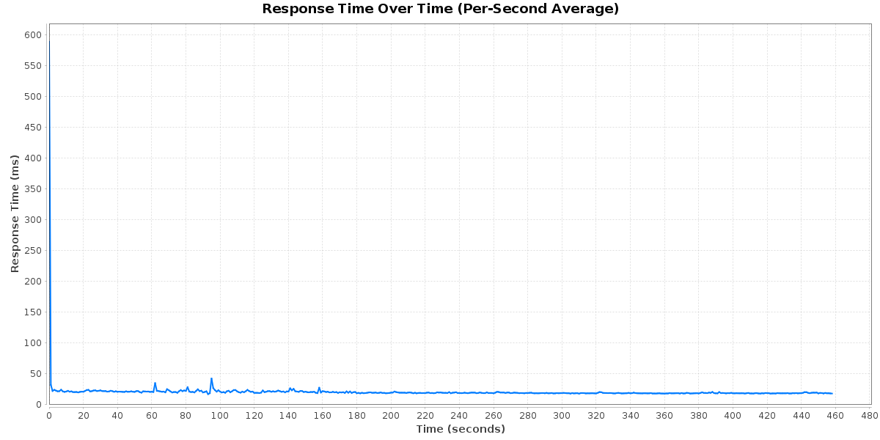

Response Time Distribution
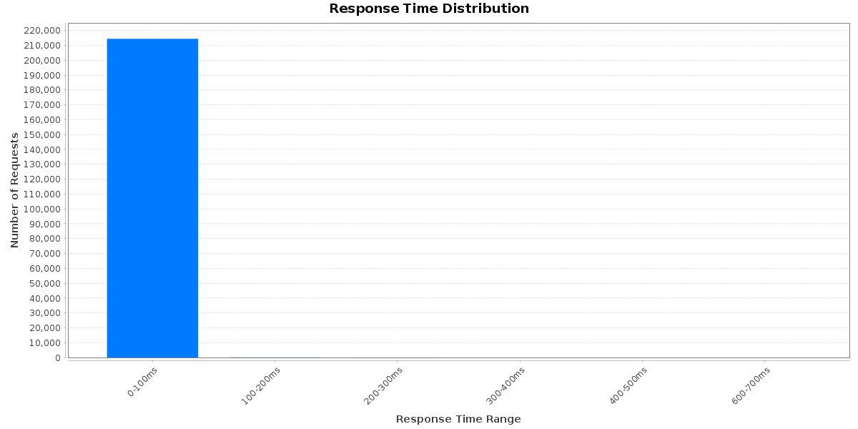

Throughput Over Time
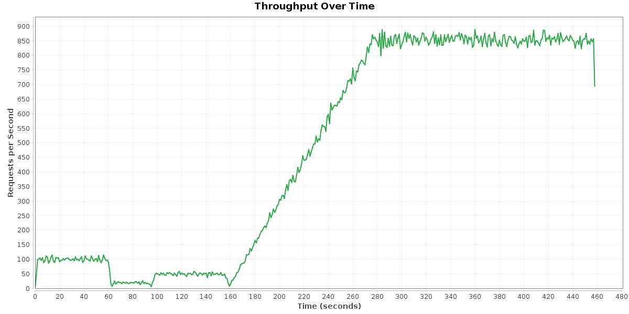

Error Rate
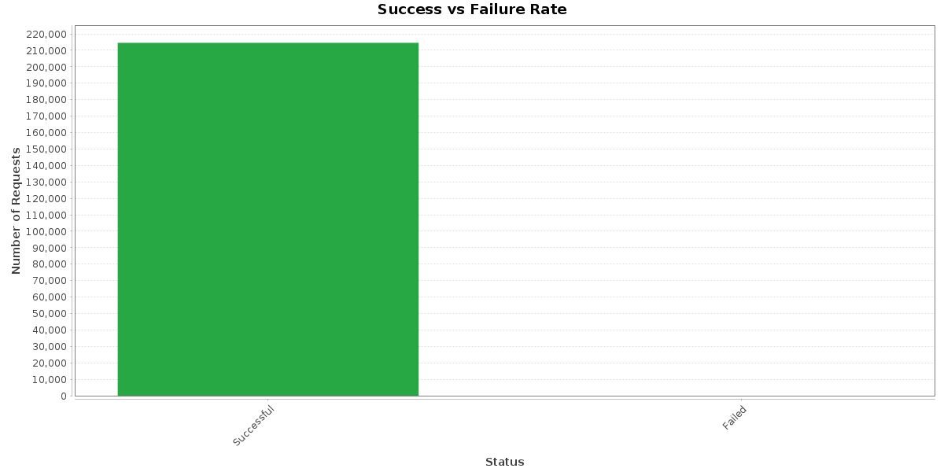

Transaction Summary
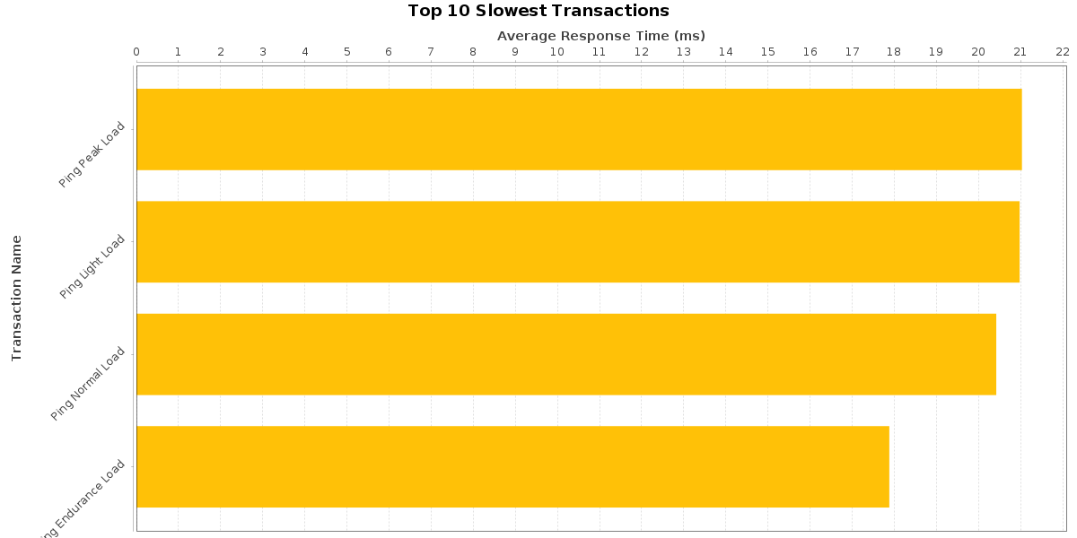

Percentile Comparison
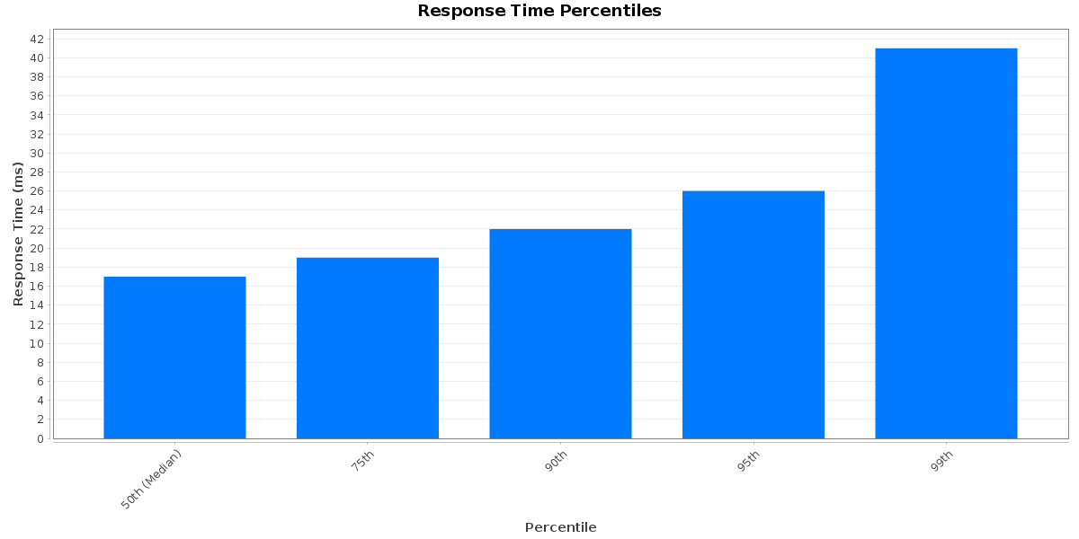

Latency Analysis
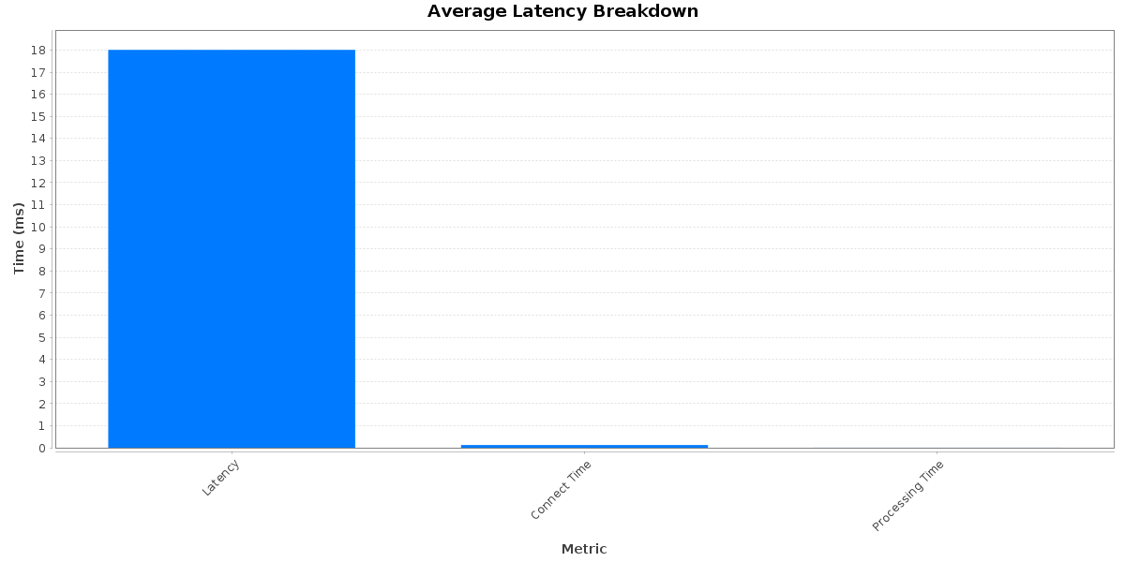

Thread Activity
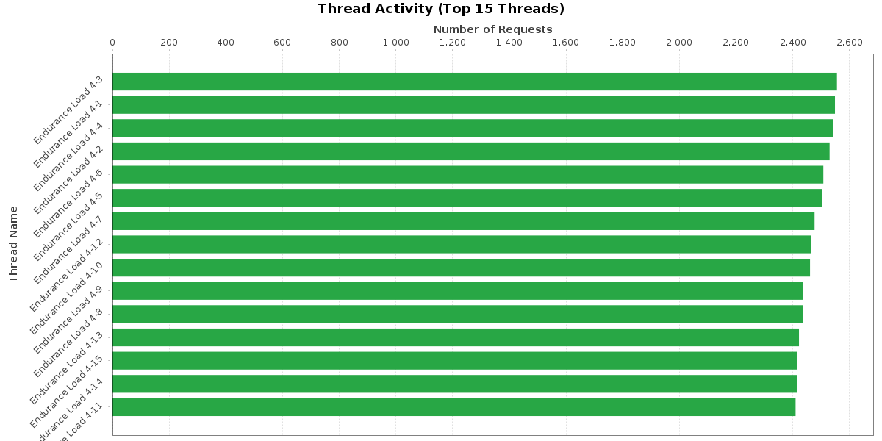

Conclusion & Recommendations

Key Findings
- The test processed 214,553 total requests with an error rate of 0.0000%.
- Average response time was 18.01 ms, with P95 of 26.00 ms and P99 of 41.00 ms.
- The system achieved a throughput of 468.46 requests/second over 7 min 38 sec.
- SLA compliance: 4 of 4 criteria met (FULLY COMPLIANT).

Recommendations
- System performance is within acceptable limits. Continue monitoring with increased load scenarios.
- Consider running stress tests and endurance tests to identify breaking points.

