1. Display the fields restaurant_id, name, borough and cuisine, but exclude the field _id for all the documents in the collection restaurant:
Query: db.restaurants.find({}, {restaurant_id:1, name:1, borough:1, cuisine:1, _id:0}).pretty()


2. Display all the restaurant which is in the borough Bronx.

Query: db.restaurants.find({"borough":"Bronx"}).pretty()
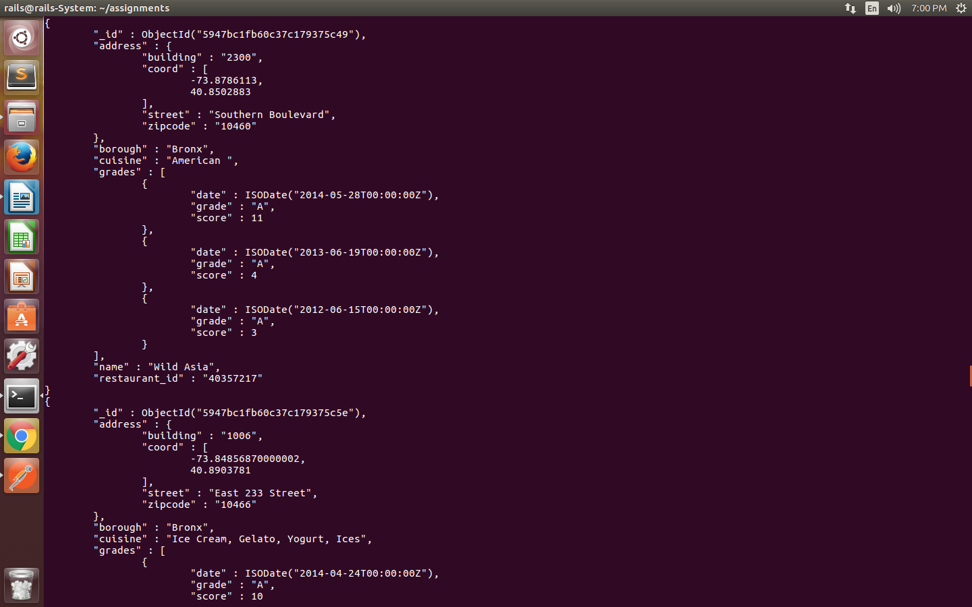
3. Find the restaurants who achieved a score more than 90.

Query: db.restaurants.find({"grades.score": {$gt:90}}).pretty()

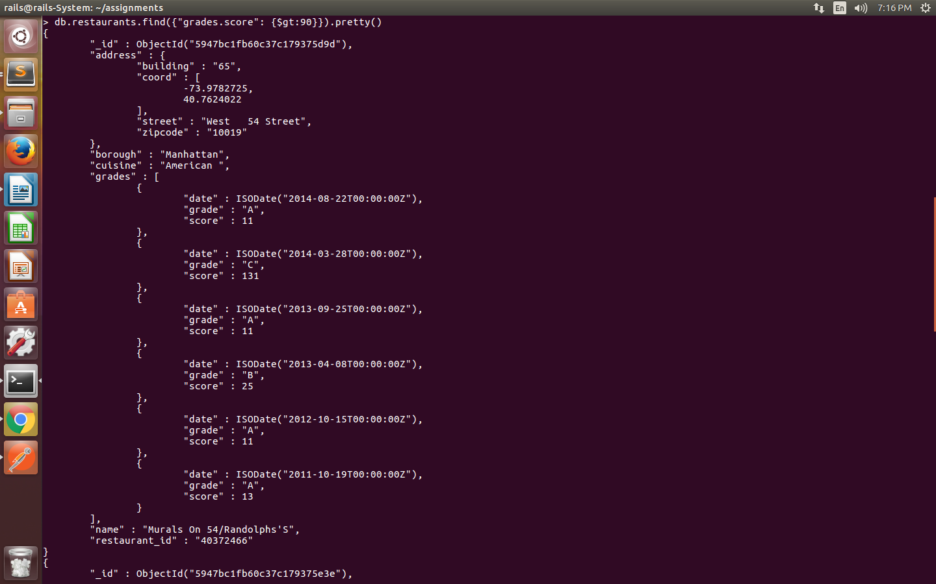
4. display the first 5 restaurant which is in the borough Bronx.

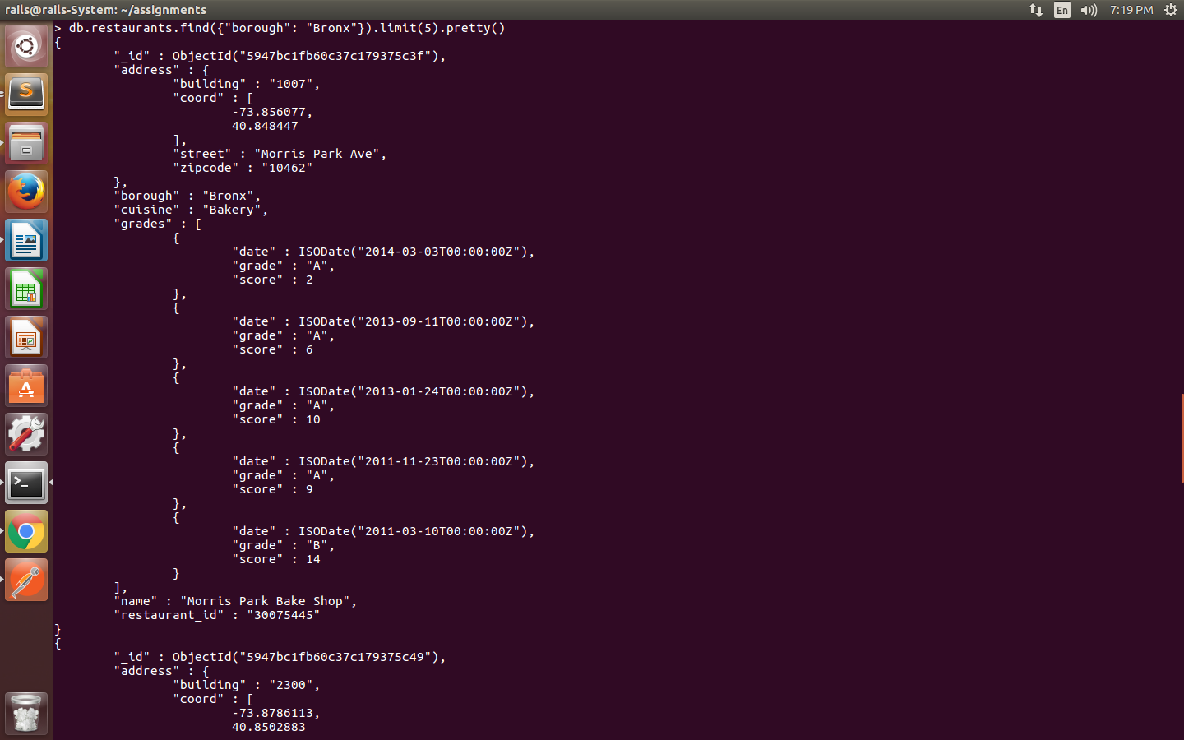
db.restaurants.find({"borough": "Bronx"}).limit(5).pretty()

5. display the next 5 restaurants after skipping first 5 which are in the borough Bronx.

Query: db.restaurants.find({"borough": "Bronx"}).skip(5).limit(5).pretty()
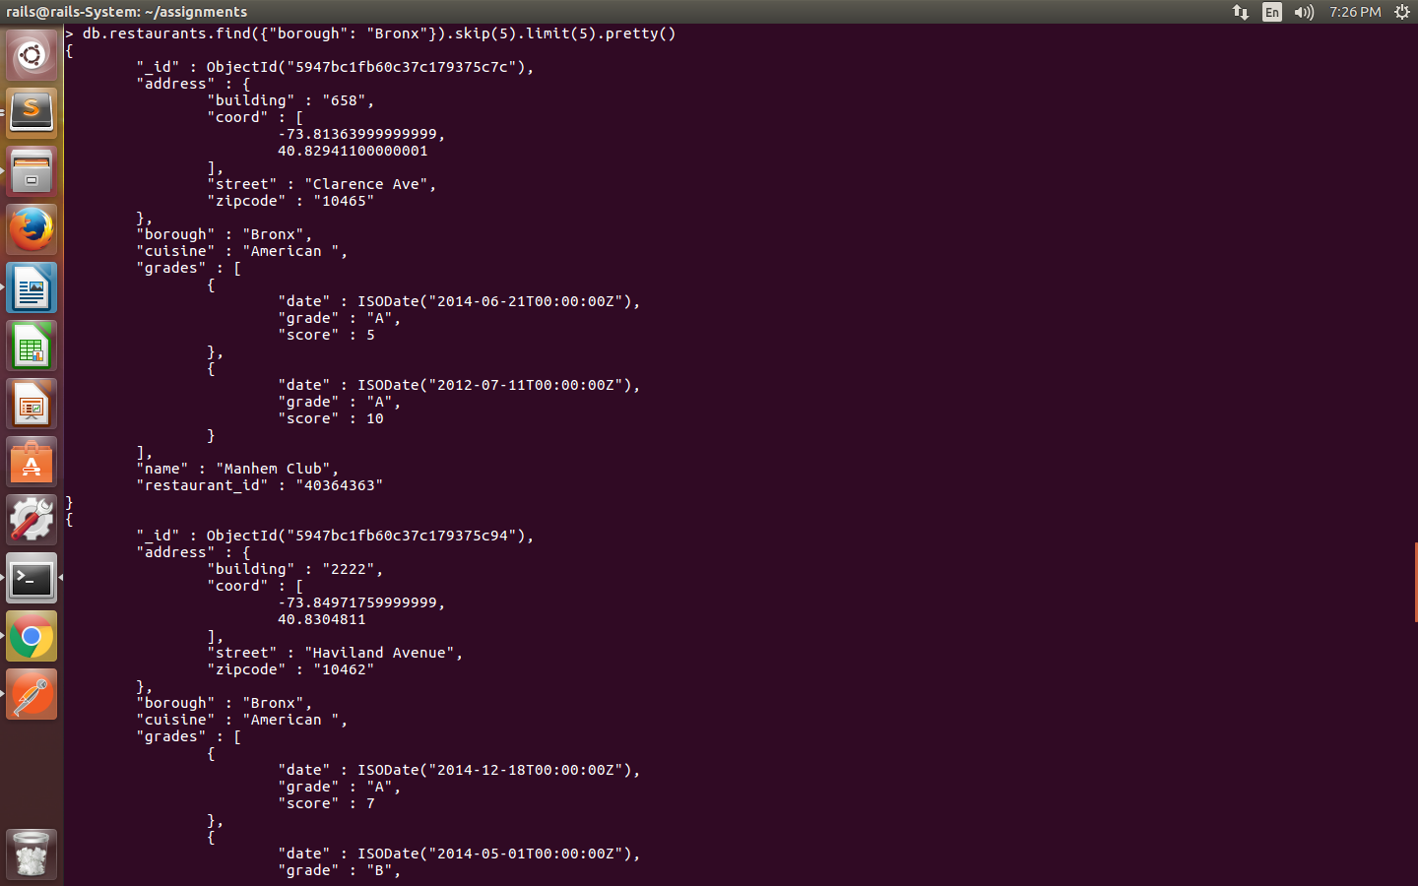

6. find the restaurants that achieved a score, more than 80 but less than 100

Query: db.restaurants.find({
$and: [
{“grades.score”:{$lt:100}} , {“grades.score”:{$gt:80}}
]
})

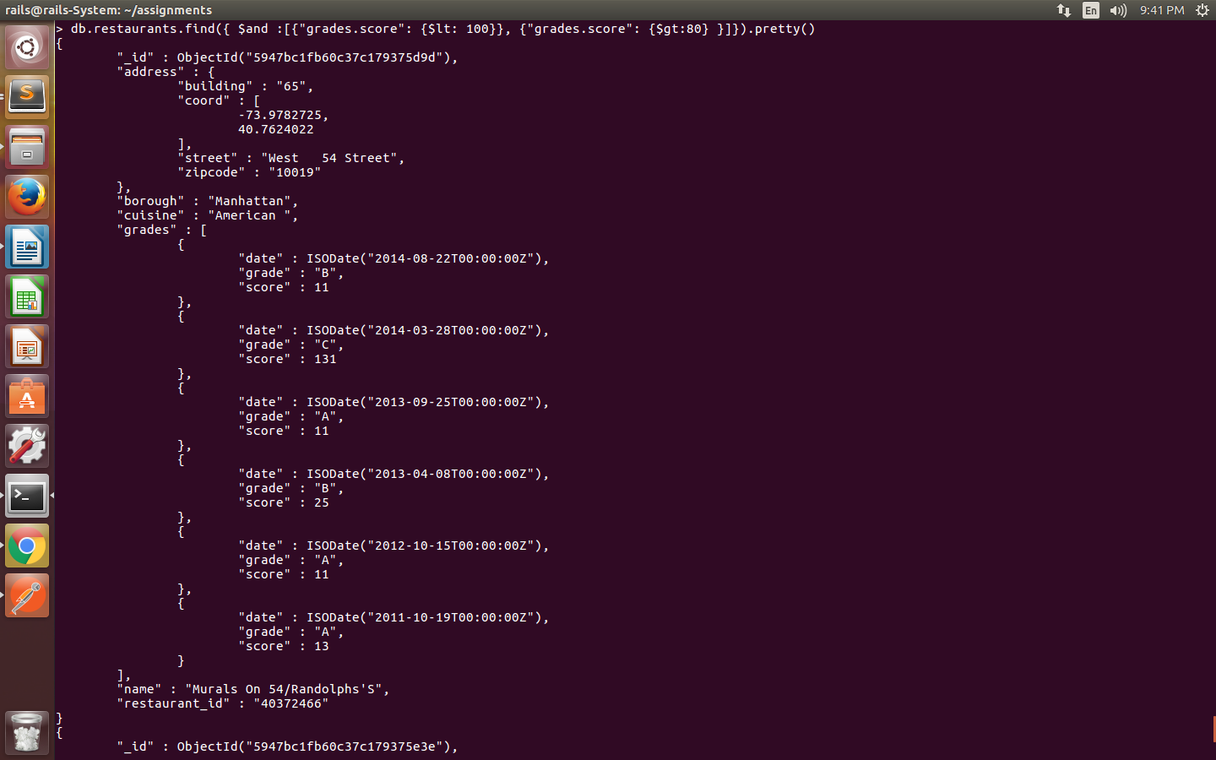

7. query to find the restaurants which locate in latitude value less than -95.754168

Query: db.restaurants.find({"address.coord.0": {$lt: -95.754168}}).pretty()

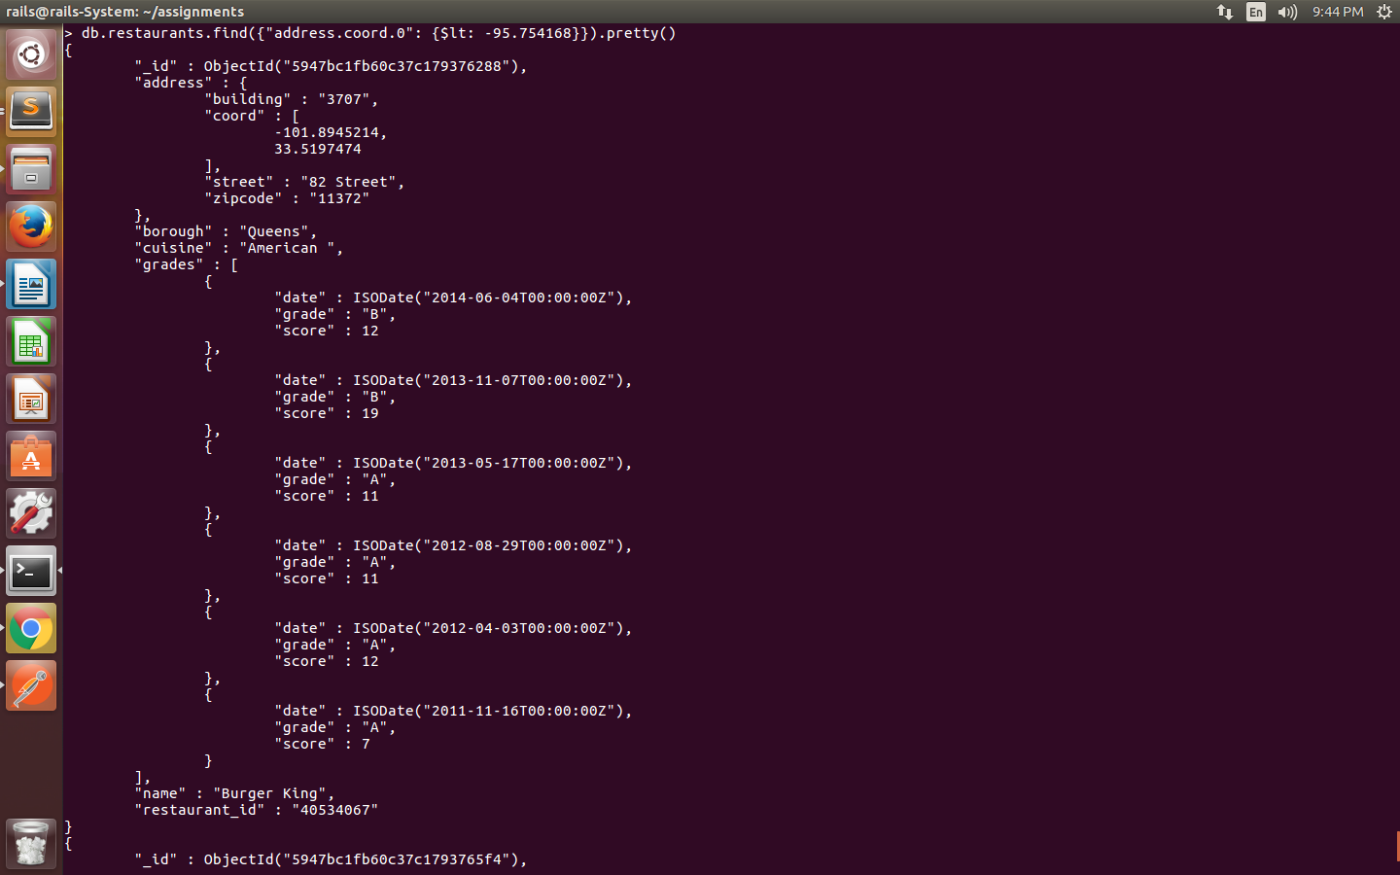

8. query to find the restaurants that do not prepare any cuisine of 'American' and their grade score more than 70 and latitude less than -65.754168

Query: db.restaurants.find( { $and: [ {"cuisine": {$ne: "American "}}, {"grades.score": {$gt: 70}}, {"address.coord.0": {$lt: -65.754168}} ] },{"cuisine": 1, "_id": 0} ).pretty()
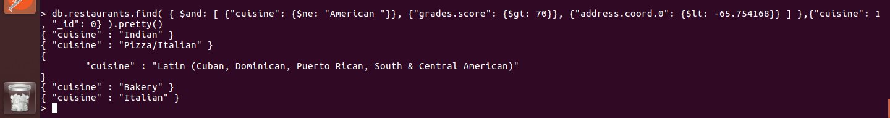

9. query to update the restaurent's grade to 'B' whose score is more than or equal to 10 (update only the first grade).

Query: b.restaurants.update({"grades.0.score":{$gte: 10}}, {$set:{"grades.0.grade": "B"}}, {multi: true})

Output of: db.restaurants.find({"grades.0.score":{$gte: 10} }).pretty()
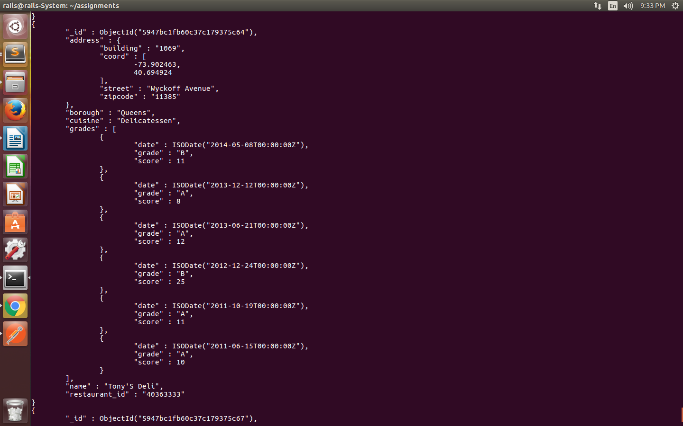

10. query to delete the restaurents in borough Bronx.

Query : db.restaurants.remove({"borough": "Bronx"})
