TITLE OF THE PROJECT
LEARNING MANAGEMENT SYSTEM
A PROJECT REPORT
Submitted by
Ashwin Krishna.V
[727824TUCS031]
In Partial fulfilment for the award of the degree
of
Bachelor of Engineering
IN
COMPUTER SCIENCE AND ENGINEERING
SRI KRISHNA COLLEGE OF ENGINEERIN TECHNOLOGY

An Autonomous Institution | Approved by AICTE | Affiliated by Anna University | Accredited
by NAAC with A++ Grade, Kuniyamuthur, Coimbatore – 641008.

Month & Year
JULY 2026


BONAFIDE CERTIFICATE
Certified that this project “LEARNING MANAGEMENT SYSTEM” is the Bonafide work of “Ashwin Krishna V” who carried out the project work under my supervision.

SIGNATURE | SIGNATURE
HEAD OF THE DEPARTMENT | SUPERVISOR
Submitted for the Project Viva-voce examination held on ____________________.

INTERNAL EXAMINER | EXTERNAL EXAMINER

ABSTRACT
The Learning Management System (LMS) Lite is a web-based educational platform developed to streamline the delivery, management, and assessment of online learning for institutions, instructors, and students. The primary objective of the project is to provide a secure, role-based platform where administrators, instructors, content creators, teaching assistants, and students can manage courses, learning content, assessments, and academic progress from a single system, eliminating the fragmented and manual processes traditionally used for course and assessment management.
The backend of the application is developed using the Spring Boot framework and follows a layered architecture consisting of the Controller, Service, Repository, and Model layers. Spring Security with JSON Web Token (JWT) based authentication is used to secure all protected operations, while a comprehensive Role-Based Access Control (RBAC) system governs the permissions available to each user type. RESTful APIs are implemented to perform CRUD (Create, Read, Update, Delete) operations for courses, enrollments, learning content, assessments, grades, discussions, and notifications. Spring Data JPA is used for database interaction, allowing the system to work with any JPA-compatible relational database for the secure storage of academic and user data.
The React.js frontend consumes these secured REST APIs to present role-specific dashboards for course management, content delivery, assignment submission, grading, and learning analytics. The system enforces data validation, FERPA-aligned handling of student records, and real-time progress tracking, while supporting integration points for institutional authentication systems, LTI-compliant tools, SCORM content packages, video conferencing, and plagiarism detection services. Automated and unit testing using JUnit, along with React Testing Library on the frontend, is used to verify the correctness of the implemented modules.
Overall, the LMS Lite system provides a reliable, secure, and scalable foundation for managing the complete academic lifecycle of a course — from creation and enrollment through content delivery, assessment, grading, and analytics — while establishing a strong base for future enhancements such as predictive learning analytics, AI-powered content recommendations, mobile applications, and deeper integration with institutional student information systems.

TABLE OF CONTENTS
S. No. | Table of Contents
1 | Abstract
2 | Table of Contents
3 | List of Figures
4 | List of Symbols, Abbreviations and Nomenclature
5 | Chapter 1 - Introduction
6 | Chapter 2 - Problem Statement
7 | Chapter 3 - Objectives
8 | Chapter 4 - Existing System
9 | Chapter 5 - Proposed System
10 | Chapter 6 - System Architecture
11 | Chapter 7 - Technology Stack
12 | Chapter 8 - UML Diagrams
13 | Chapter 9 - Backend Implementation
14 | Chapter 10 - API Endpoints
15 | Chapter 11 - Testing
16 | Chapter 12 - Software Requirements
17 | Chapter 13 - Sample JSON Request & Response
18 | Chapter 14 - Conclusion
19 | Chapter 15 - Future Enhancements

LIST OF FIGURES

Charts & Graphs
- Comparison of Traditional and LMS-based Course Delivery (Bar chart illustrating improvements over manual processes)
- Challenges in Traditional Course & Assessment Management (Bar chart showing limitations of manual handling)
- Major Functionalities of the Proposed System (Donut chart showing core feature distribution)
- Technology Stack Distribution (Donut chart showing core technologies used)
- User Role Distribution and Permission Levels (Donut chart showing role-based access scope)

Architecture & UML Diagrams
- Project Directory Structure (Source code folder hierarchy src/main/... under the System Architecture section)
- Use Case Diagram (Showing interactions between Student, Instructor, Content Creator, Teaching Assistant, Administrator and the system)
- ER Diagram (Showing relationships between Users, Courses, Enrollments, CourseContent, Assessments, Grades, and Notifications)
- Class Diagram (Showing Controller, Service, Repository, and Model classes for the Course and Assessment modules)

LIST OF ABBREVIATIONS
Abbreviation | Full Form
API | Application Programming Interface
CRUD | Create, Read, Update, Delete
JPA | Java Persistence API
JWT | JSON Web Token
RBAC | Role-Based Access Control
REST | Representational State Transfer
LMS | Learning Management System
SCORM | Sharable Content Object Reference Model
LTI | Learning Tools Interoperability
FERPA | Family Educational Rights and Privacy Act
GPA | Grade Point Average
ORM | Object Relational Mapping
HTTP | Hyper Text Transfer Protocol
JSON | JavaScript Object Notation
SQL | Structured Query Language
WCAG | Web Content Accessibility Guidelines
MOOC | Massive Open Online Course

CHAPTER - 1

INTRODUCTION
Educational institutions and training organisations increasingly rely on digital platforms to deliver course content, manage assessments, and track student progress. Traditional approaches that combine spreadsheets, email, shared drives, and standalone quiz tools are difficult to secure, hard to scale, and provide little visibility into how students are actually progressing through a course. A unified Learning Management System addresses this by bringing course delivery, enrollment, assessment, grading, communication, and analytics into a single, role-aware platform.
The Learning Management System (LMS) Lite is a web-based application developed to provide educational institutions with a streamlined, secure, and efficient platform for delivering online learning experiences. The system enables instructors to create and manage courses, content creators to build multimedia learning material, teaching assistants to support grading and student queries, students to enroll in courses and submit assessments, and administrators to oversee the entire platform — all while maintaining strict role-based access control and educational data protection standards.
The project follows a client-server architecture in which the frontend is developed using React.js and the backend is implemented using Spring Boot with Spring Security. The frontend is responsible for presenting role-specific dashboards, course catalogues, content viewers, and assessment interfaces, while the backend processes requests, enforces authorization rules, performs business logic, manages database operations, and exposes secured REST APIs. Communication between the frontend and backend takes place over HTTPS using JSON-formatted REST APIs, with JWT tokens used to authenticate every protected request.
The backend follows a layered architecture consisting of the Controller, Service, Repository, and Model layers, which separates request handling, business logic, and persistence concerns. Spring Data JPA is used for object-relational mapping and efficient interaction with the underlying relational database, and the schema is designed to be database-agnostic so that the system can be deployed against any JPA-compatible database engine.
The system implements a five-tier role hierarchy — System Administrator, Instructor, Content Creator, Teaching Assistant, and Student — in addition to limited Guest access, so that every operation in the platform, from creating a course to modifying a grade, is governed by an explicit permission model. Beyond core CRUD operations, the platform supports assessment creation and automated grading, learning progress analytics, communication and collaboration tools, a notification system, and institutional reporting, giving the platform the depth required for real academic use rather than a simple content repository.
Overall, the LMS Lite platform provides a reliable, secure, and extensible foundation for managing the complete academic lifecycle of a course, reducing the manual effort involved in course administration while giving instructors and administrators the visibility they need to support student success.

CHAPTER - 2

PROBLEM STATEMENT

Instructors and institutions that rely on disconnected tools — spreadsheets for grade tracking, email for announcements, shared drives for content, and separate quiz applications for assessments — face recurring problems: content and grades are scattered across systems, there is no single source of truth for a student's progress, access control is inconsistent or absent, and academic data is not handled in a manner consistent with student-privacy expectations such as FERPA.
The LMS Lite project addresses this by providing a single web-based platform that unifies course creation, content delivery, enrollment, assessment, grading, communication, and analytics behind a secure, role-based access model. The system follows a client-server architecture in which the React.js frontend communicates with a Spring Boot backend through RESTful, JWT-secured APIs. The backend is responsible for enforcing role-based permissions, validating academic data, persisting course and assessment records, and generating the analytics instructors and administrators need to monitor learning outcomes.
The project aims to reduce the administrative overhead of running a course, ensure that only authorized users can view or modify sensitive academic records, and give students a consistent, trackable view of their enrolled courses, assignments, and grades — while providing a technical foundation (REST APIs, RBAC, database schema) that can be extended with additional institutional integrations in the future.

CHAPTER - 3

OBJECTIVES
The key objectives of the Learning Management System (LMS) Lite project are:
- To design and implement a secure user registration and JWT-based authentication system supporting multiple educational roles.
- To build a role-based access control (RBAC) system that restricts course, content, and grade operations to appropriately permitted users.
- To provide instructors and content creators with tools to create, structure, and publish course content, including multimedia material.
- To implement a comprehensive assessment engine supporting quiz creation, timed assessments, automated grading, and rubric-based evaluation.
- To track student progress through course completion, assignment submission, and learning analytics dashboards.
- To provide instructor-student communication tools, including discussion forums, messaging, and announcements.
- To implement institutional reporting and analytics for enrollment trends, course effectiveness, and academic performance.
- To ensure the platform meets performance, reliability, security, and FERPA compliance requirements suitable for academic use.
- To design a modular, layered backend architecture that supports future integration with SIS, LTI, and SCORM-based tools.

CHAPTER - 4
EXISTING SYSTEM
Many small institutions and independent instructors currently manage courses using a combination of general-purpose tools: course material is shared through email attachments or cloud drive links, assignments are collected manually, grades are recorded in spreadsheets, and announcements are sent through group messaging apps or email. There is no centralized system that ties a student's enrollment, submissions, and grades together, and access to sensitive records is rarely restricted by a defined permission model.

Limitations of the Existing System
- No centralized platform to manage course content, enrollment, and grading together.
- Lack of role-based access control, so sensitive academic data is not consistently protected.
- Manual, error-prone grading and grade-record keeping with no automated grade calculation.
- No structured way to track student progress, engagement, or at-risk learners.
- Assessment tools (quizzes, timed tests, anti-cheating measures) are either absent or handled by unrelated third-party tools.
- Communication is fragmented across email, chat apps, and verbal announcements.
- No audit trail or compliance mechanism for handling student educational records.
- Limited or no reporting on course effectiveness, completion rates, or institutional performance.

CHAPTER - 5
PROPOSED SYSTEM
The proposed Learning Management System (LMS) Lite is a web-based application developed using React.js and Spring Boot that unifies course management, content delivery, assessment, grading, and learning analytics behind a single, role-based platform. Administrators, instructors, content creators, teaching assistants, and students each interact with a dashboard scoped to their permissions, while a JWT-secured REST API layer enforces access control on every request.

Features of the Proposed System
- Secure JWT-based authentication with role-specific session durations and refresh tokens.
- Role-Based Access Control (RBAC) governing course, content, grade, and administrative operations.
- Course creation and structured content management with modules, lessons, and multimedia support.
- Enrollment and learning-path management with prerequisite and capacity handling.
- Assessment engine supporting quizzes, assignments, rubric-based grading, and automated scoring.
- Real-time progress tracking and learning analytics dashboards for students and instructors.
- Discussion forums, messaging, and announcement tools for instructor-student communication.
- Institutional reporting on enrollment, course effectiveness, and academic performance.
- FERPA-aligned handling of student records with encryption, audit logging, and access controls.
- RESTful APIs designed for integration with LTI tools, SCORM content, and institutional SIS platforms.
CHAPTER - 6

SYSTEM ARCHITECTURE
lmslite-springapp
│
├── src
│ └── main
│ ├── java
│ │ └── com.lmslite.springapp
│ │ ├── config
│ │ │ ├── SecurityConfig.java
│ │ │ └── CorsConfig.java
│ │ ├── controller
│ │ │ ├── AuthController.java
│ │ │ ├── CourseController.java
│ │ │ ├── EnrollmentController.java
│ │ │ ├── AssessmentController.java
│ │ │ └── UserController.java
│ │ ├── model
│ │ │ ├── User.java
│ │ │ ├── Course.java
│ │ │ ├── Enrollment.java
│ │ │ ├── CourseContent.java
│ │ │ ├── Assessment.java
│ │ │ ├── AssessmentSubmission.java
│ │ │ ├── Grade.java
│ │ │ └── Notification.java
│ │ ├── repository
│ │ │ └── ... (JpaRepository interfaces per entity)
│ │ ├── service
│ │ │ └── ... (business logic per module)
│ │ ├── security
│ │ │ ├── JwtUtil.java
│ │ │ └── JwtAuthFilter.java
│ │ └── SpringappApplication.java
│ └── resources
│ └── application.properties
└── pom.xml

Explanation
The LMS Lite platform follows a three-tier client-server architecture consisting of the React.js frontend, the Spring Boot backend, and a JPA-compatible relational database. This separation keeps presentation, business logic, and persistence concerns independent, which improves modularity, scalability, and maintainability.
The React.js frontend renders role-based dashboards for administrators, instructors, content creators, teaching assistants, and students. It handles course browsing, content viewing, assessment submission, and progress visualization, and communicates with the backend exclusively through RESTful APIs secured with JWT bearer tokens.
The Spring Boot backend is the core processing layer. Incoming requests first pass through a JWT authentication filter and Spring Security's authorization rules, which enforce the role-based access control matrix before a request reaches the Controller layer. The Controller layer delegates to the Service layer, which implements business rules such as enrollment capacity checks, grade calculation, and assessment scoring, before calling the Repository layer to persist or retrieve data through Spring Data JPA.
The database layer stores all academic entities — users, courses, enrollments, course content, assessments, submissions, grades, discussions, and notifications — and is designed to be database-agnostic through JPA, allowing deployment against different relational database engines without changing application code.

CHAPTER - 7
TECHNOLOGY STACK
Tool / Technology | Purpose
Spring Boot 3.x | Backend application framework
Spring Security | Authentication and authorization
JWT (JJWT) | Stateless token-based authentication
Spring Data JPA | Database operations and ORM
JPA-compatible RDBMS | Persistent storage of academic data
React.js | Frontend user interface
Maven | Dependency management and build tool
JUnit | Backend unit and integration testing
React Testing Library | Frontend component testing
Docker | Containerization for deployment
Git | Version control

CHAPTER - 8
UML DIAGRAMS

Use Case Diagram
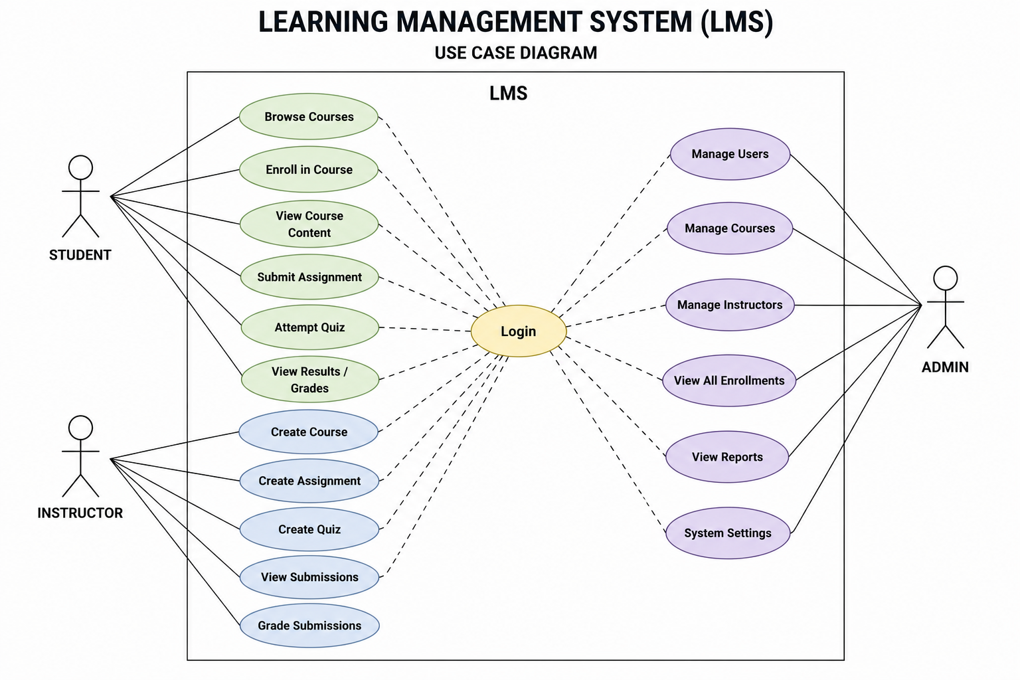

ER Diagram
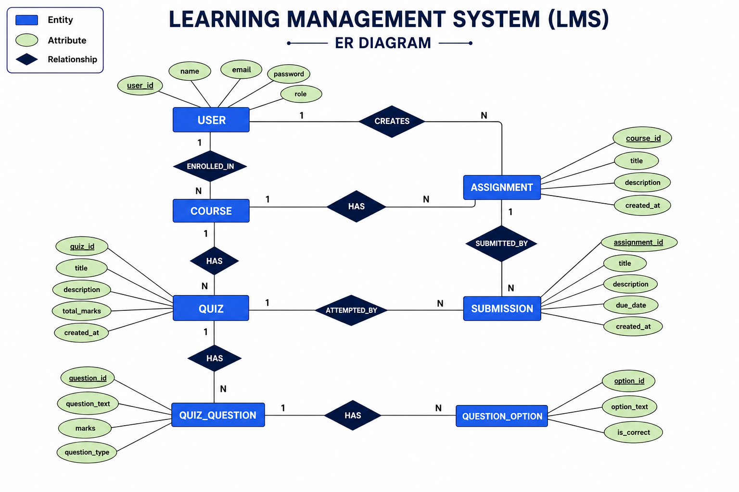

Class Diagram

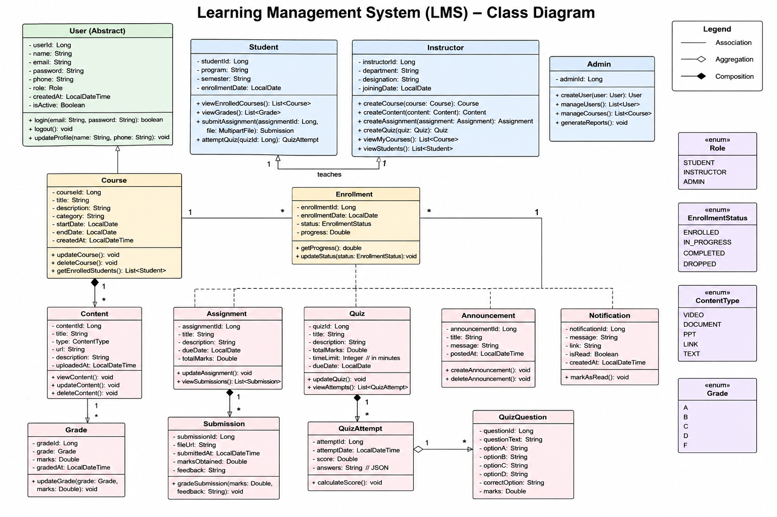

CHAPTER - 9
BACKEND IMPLEMENTATION
The backend of the LMS Lite platform was developed using Spring Boot, Spring Security, Spring Data JPA, and JWT-based authentication. It follows a layered architecture consisting of the Model, Repository, Service, and Controller layers, with a dedicated security layer handling authentication and authorization.

User & Role Model
Stores the identity and role of every platform user.
- Full name, username, email, and hashed password
- Role (Student, Instructor, Content Creator, Teaching Assistant, Administrator)
- Student ID / employee ID, institution ID, and department
- Account status, last login timestamp, and creation date

Course & Content Model
Stores course metadata and the structured learning content within it.
- Course code, title, description, credits, schedule, and enrollment capacity
- Course status (Draft, Published, Archived, Cancelled)
- Hierarchical content items (modules, lessons, multimedia) linked to a course

Enrollment, Assessment & Grade Model
- Enrollment records linking a student to a course, with status and completion date
- Assessment definitions (quizzes, assignments) with type, points, due date, and time limit
- Assessment submissions with score, attempt count, and instructor feedback
- Grade records aggregating scores per student, course, and assessment

Repository Layer
Implemented using Spring Data JPA's JpaRepository interfaces, one per entity, responsible for:
- Persisting and retrieving Users, Courses, Enrollments, CourseContent, and Assessments
- Custom finder methods such as findByInstructorId, findByStudentId, and findByCourseId
- Delegating all SQL generation and ORM mapping to Spring Data JPA

Service Layer
Contains the business logic of the platform, including:
- Enrollment capacity and prerequisite validation before enrolling a student
- Automated grading for objective assessment questions and grade-book aggregation
- Role-based filtering so users can only retrieve data permitted by their role
- Progress and analytics calculations for student dashboards and instructor reports

Controller Layer
Exposes RESTful endpoints consumed by the React frontend, and:
- Accepts and returns JSON request/response bodies
- Returns appropriate HTTP status codes for success, validation, and authorization failures
- Delegates authentication to the JWT filter chain before any business logic executes

Security Configuration
Spring Security is configured with a custom JWT authentication filter and role-based authorization rules.
- JWT tokens signed using HS256, with role-specific expiration (8 hours for students, 12 hours for instructors, 6 hours for administrators)
- Refresh tokens valid for 7 days, with token blacklisting on logout or security events
- Password policy: minimum 8 characters, upper- and lower-case letters, a number and a special character, with reuse and periodic-expiry restrictions

CORS Configuration
Cross-Origin Resource Sharing (CORS) is configured to allow secure communication between the frontend and backend running on different ports during development.
- React Frontend (Port 8081)
- Spring Boot Backend (Port 8080)
- Allowed HTTP methods: GET, POST, PUT, DELETE, OPTIONS

1. Swagger Home

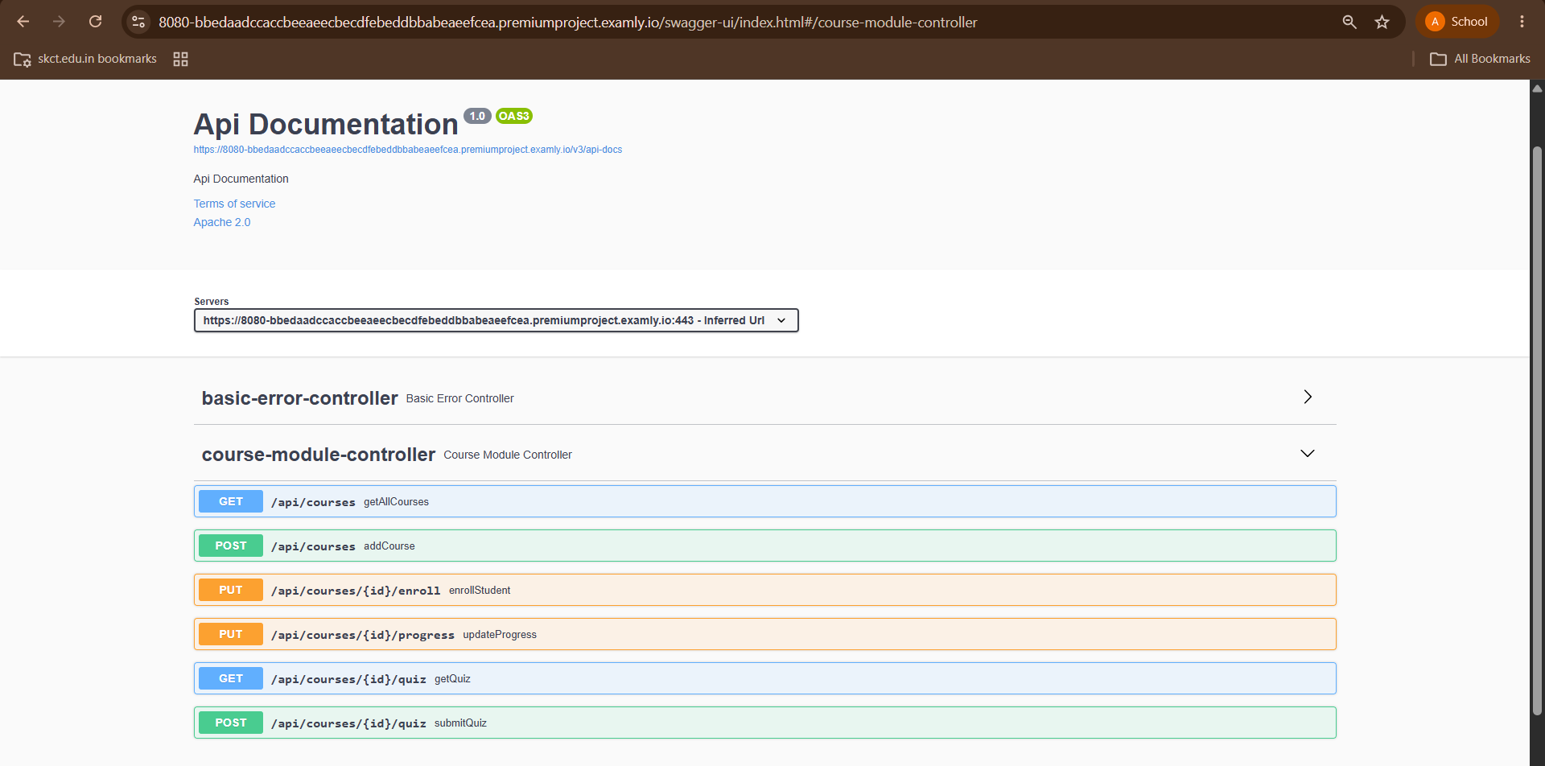

- POST (ADD COURSE)
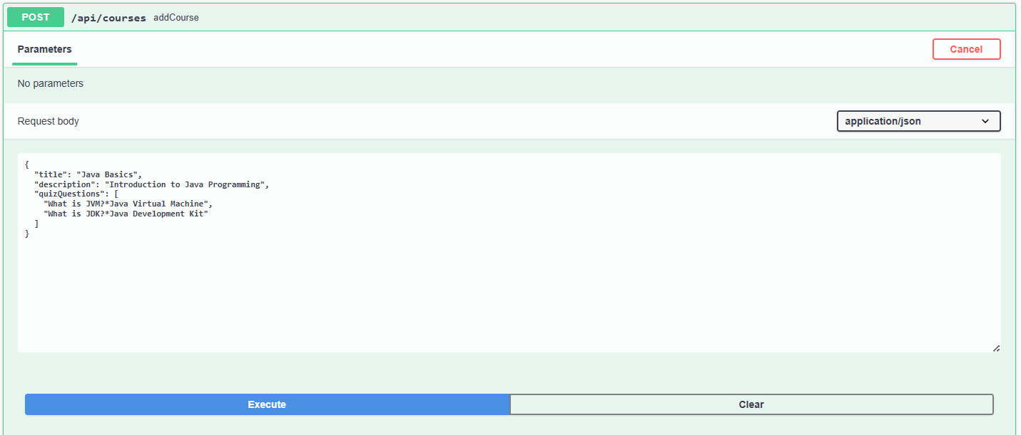
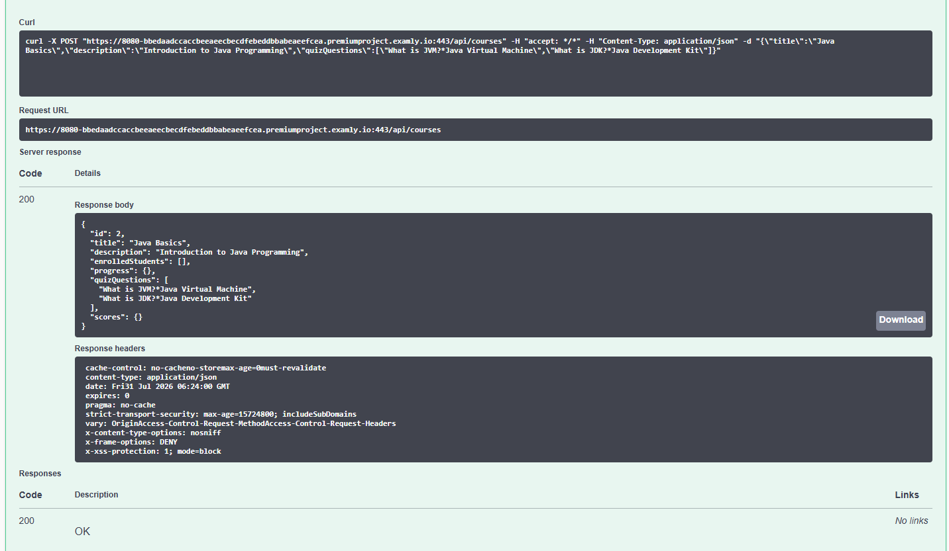

- GET (Get All Courses)
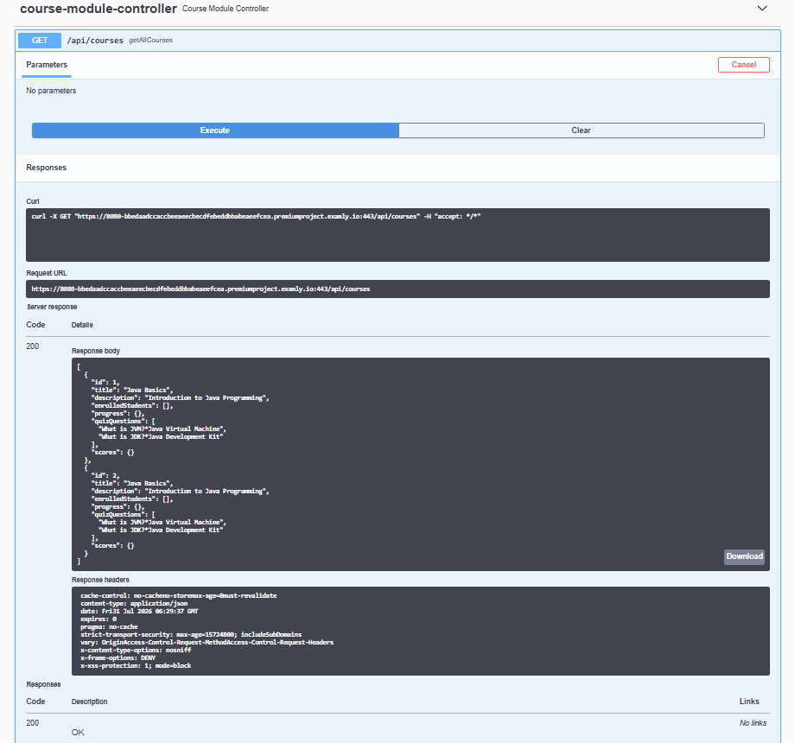
- PUT (Enroll Student)
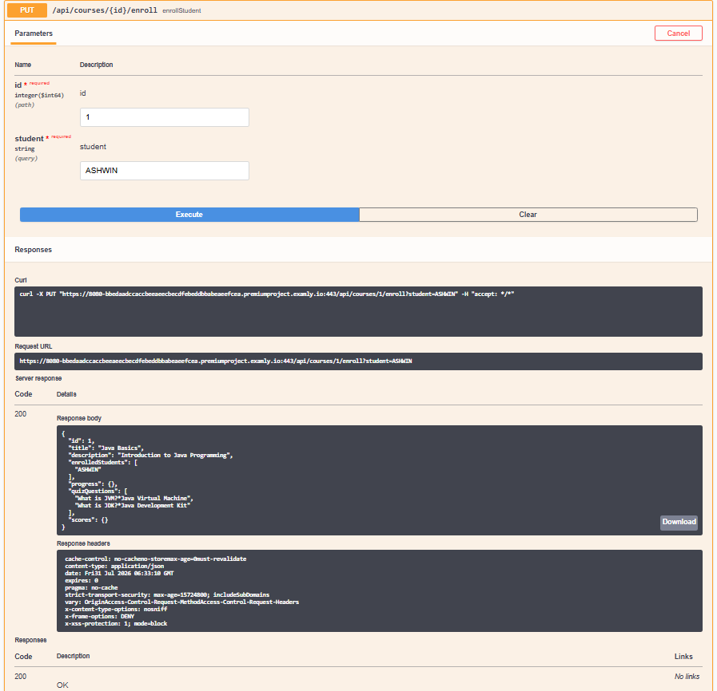

- PUT (Update Progress)
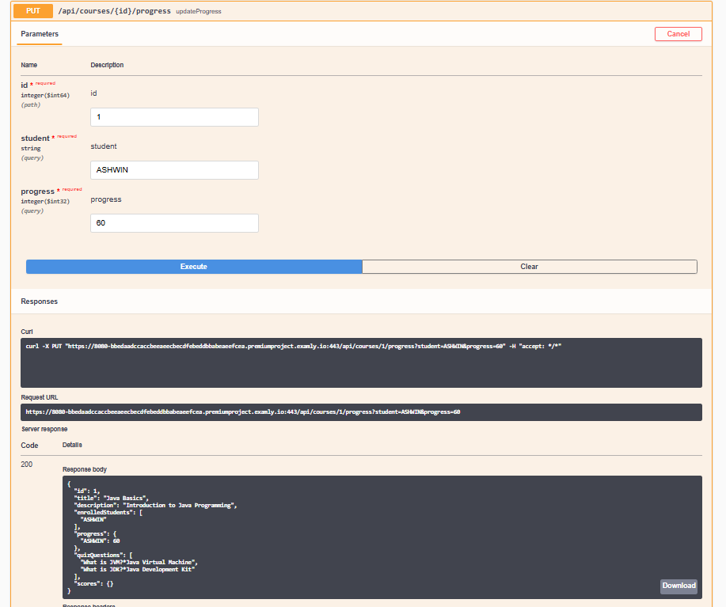
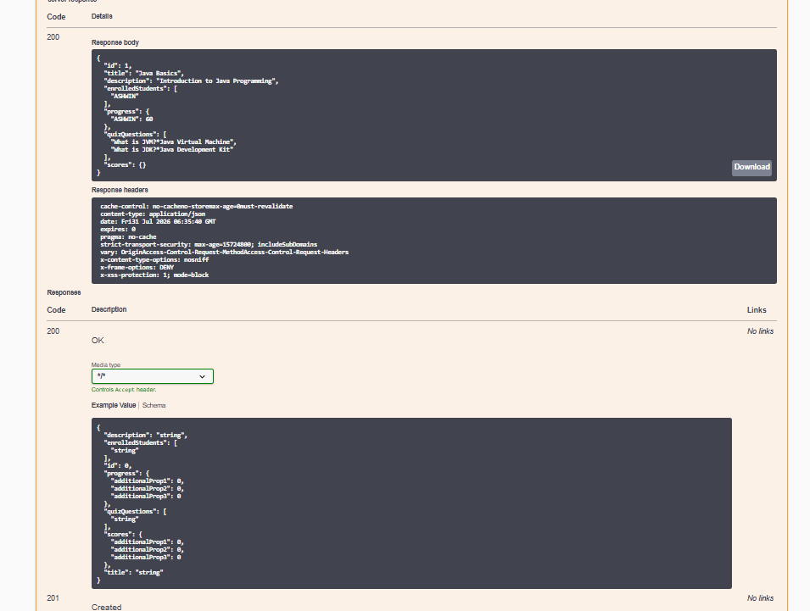

- GET (Get Quiz Questions)
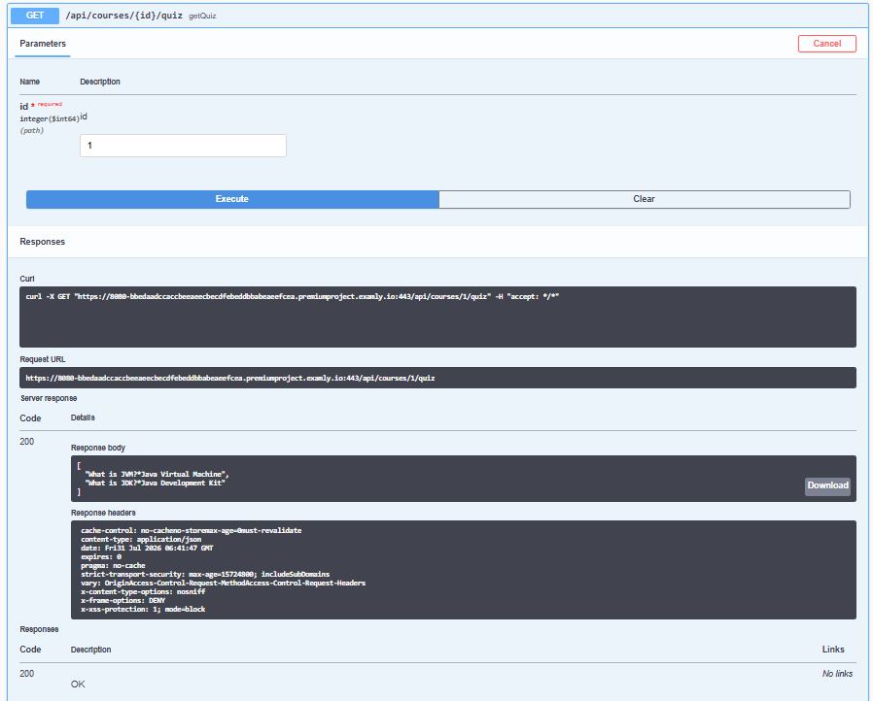
- POST (Submit Quiz Score)
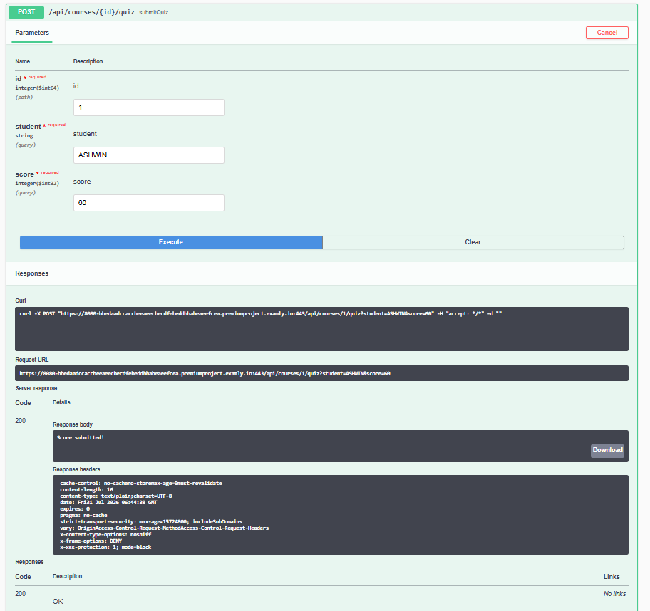

CHAPTER - 10
API ENDPOINTS
Method | Endpoint | Description
POST | /auth/register | Register a new user
POST | /auth/login | Authenticate user and issue JWT
POST | /auth/logout | Invalidate current session token
GET | /users/profile | Retrieve authenticated user's profile
PUT | /users/profile | Update authenticated user's profile
POST | /courses | Create a new course
GET | /courses | Retrieve all available courses
GET | /courses/{id} | Retrieve specific course details
PUT | /courses/{id} | Update an existing course
DELETE | /courses/{id} | Archive a course
POST | /enrollments | Enroll a student in a course
GET | /enrollments/student/{studentId} | Get a student's enrollments
GET | /enrollments/course/{courseId} | Get a course's enrollments
PUT | /enrollments/{id} | Update enrollment status
POST | /assessments | Create a new assessment
GET | /assessments/course/{courseId} | Get assessments for a course
POST | /submissions | Submit an assessment
GET | /submissions/{id} | Get submission details

CHAPTER - 11
TESTING
Testing is an essential phase of the development lifecycle, ensuring the platform functions correctly and satisfies the specified requirements. The backend of the LMS Lite system was tested using JUnit and MockMvc, while the React frontend was tested using React Testing Library.

Testing performed using:
- JUnit — unit testing of Controller and Service methods
- MockMvc — simulating HTTP requests and verifying response status codes and JSON structure
- React Testing Library — component-level testing of the frontend dashboards
- Manual API testing through tools such as Postman during development

Areas Verified:
- Authentication and JWT token issuance / validation
- Role-based access control on protected endpoints
- Course, enrollment, and assessment CRUD operations
- Grade calculation and submission scoring logic
- Error handling for invalid input and unauthorized requests
The project targets a minimum of 85% code coverage across both the backend and frontend, along with periodic security and penetration testing, and load testing for the expected concurrent-user volumes described in the system's performance requirements.

CHAPTER - 12
SOFTWARE REQUIREMENTS
Software | Version / Specification
Operating System | Windows 10/11 or Linux
Java Development Kit (JDK) | JDK 17+
Spring Boot | 3.x
Spring Security | Included with Spring Boot 3.x
React.js | Latest Stable Version
Maven | 3.x
Database Server | Any JPA-compatible RDBMS
Spring Data JPA | Included with Spring Boot
IDE | Visual Studio Code / IntelliJ IDEA
Version Control | Git
API Testing Tool | Postman
Web Browser | Google Chrome / Microsoft Edge

CHAPTER - 13
SAMPLE JSON REQUEST & RESPONSE

Sample Request — Create Course (POST /courses)
{
"courseCode": "CS301",
"title": "Database Management Systems",
"description": "Introduction to relational database design and SQL",
"instructorId": 12,
"credits": 4,
"startDate": "2026-08-01",
"endDate": "2026-12-10",
"maxEnrollment": 60
}

Sample Response
{
"id": 101,
"courseCode": "CS301",
"title": "Database Management Systems",
"description": "Introduction to relational database design and SQL",
"instructorId": 12,
"credits": 4,
"startDate": "2026-08-01",
"endDate": "2026-12-10",
"status": "DRAFT",
"maxEnrollment": 60,
"createdDate": "2026-07-24T10:15:00"
}

CHAPTER - 14
CONCLUSION
The Learning Management System (LMS) Lite backend was successfully designed and implemented using the Spring Boot framework, following a layered architecture consisting of the Controller, Service, Repository, and Model components, secured throughout by Spring Security and JWT-based authentication. The application provides a reliable, role-aware solution for managing courses, enrollments, content, assessments, and grades through RESTful APIs.
The backend successfully performs all essential CRUD operations across the core academic entities, enforces a five-tier role-based access control model, and supports assessment creation with automated grading. Academic data is stored using Spring Data JPA against a JPA-compatible database, and design constraints such as FERPA-aligned data handling, audit logging, and input validation have been incorporated throughout the specification and implementation.
The REST APIs were structured for verification using JUnit and MockMvc on the backend and React Testing Library on the frontend, ensuring that endpoints behave correctly across the range of roles and scenarios the system supports. Overall, the project satisfies the functional and non-functional requirements defined in the system's Software Requirements Specification and establishes a strong, modular foundation for the complete LMS Lite platform, supporting future enhancements such as predictive analytics, AI-powered recommendations, and deeper institutional integrations.

CHAPTER - 15
FUTURE ENHANCEMENTS
The current version of LMS Lite focuses on the core backend functionality for course, assessment, and user management. Future versions can incorporate the following enhancements, in line with the platform's longer-term roadmap:

Phase 2
- Native mobile applications for iOS and Android
- AI-powered learning content recommendations
- Integration with virtual reality learning environments
- Blockchain-based credential verification
- Advanced proctoring and anti-cheating measures

Phase 3
- AI-driven personalized learning paths
- Advanced analytics with machine learning insights
- Integration with employer systems for workforce development
- Multi-language support for international programs
- Advanced accessibility features for diverse learners

Phase 4
- Virtual reality classroom experiences
- AI-powered teaching assistants
- Advanced competency-based learning management
- Integration with industry certification programs
- Global education network connectivity

Document Version Control
Version | Changes | Author
1.0 | Initial project report creation for Learning Management System (LMS) Lite | Ashwin

