Week1- Ashwin Bhat

1. Write a simple poem and represent it as a web page. Give a title for the poem.

Make rhyming words in the poem as bold.

<!DOCTYPE html>

<html>

<head>

<title>L1Q1Poem</title>

</head>

<body>

<pre>In the deep sea, there was a smooth round <b>stone</b>

as small as a world and as large as <b>alone</b>.

For whatever we lose, whether it's you or <b>me</b>)

it's always ourselves we find in the <b>sea</b></pre>

</body>

</html>

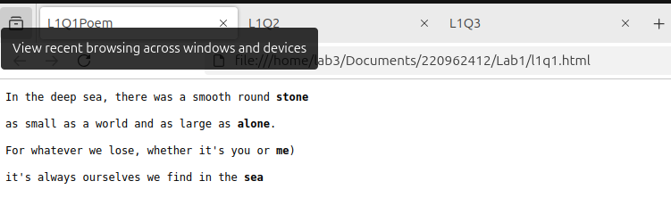

2. Assume you have brought a new car. Write down the list of additional

accessories you need for the car as an unordered list in HTML. Also, list the

travel plans on the car as an ordered list.

<!DOCTYPE html>

<html lang="en">

<head>

<title>L1Q2</title>

</head>

<body>

<h1>New Car Accessories</h1>

<h2>Accessories I need:</h2>

<ul>

<li>Seat Covers</li>

<li>Bluetooth Kit</li>

<li>Floor Mats</li>

<li>Phone Holder</li>

</ul>

<h2>Travel Plans for the Car:</h2>

<ol>

<li>Road trip to the beach</li>

<li>Visit friends in the mountains</li>

<li>Weekend getaway to a national park</li>

</ol>

</body>

</html>

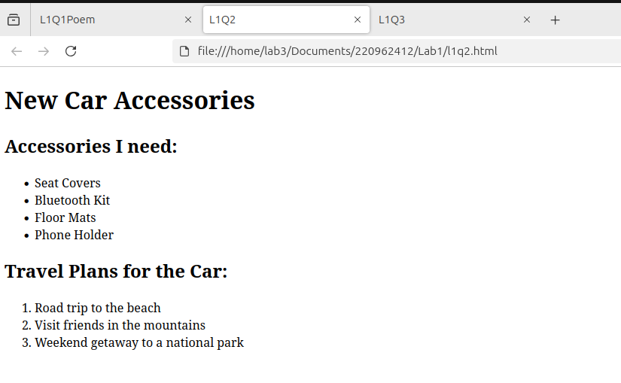

3. Complete the following website name “Share your Winter Vacation Videos”.

The required video files are located inside the compressed folder “Week 1

Assignment Files/Media/”.

<!DOCTYPE html>

<html lang="en">

<head>

<title>L1Q3</title>

</head>

<body>

<h1>Share Your Winter Vacation Videos</h1>

<p>Watch the vacation videos below:</p>

<table>

<tr>

<td><video controls>

<source src="Week 1 Assignment Files/Media/paris.mp4" type="video/mp4">

Your browser does not support the video tag.

</video></td>

<td><video controls>

<source src="Week 1 Assignment Files/Media/paris.mp4" type="video/mp4">

Your browser does not support the video tag.

</video></td>

<td><video controls>

<source src="Week 1 Assignment Files/Media/paris.mp4 " type="video/mp4">

Your browser does not support the video tag.

</video></td>

</tr>

</table>

</body>

</html>

