Q1

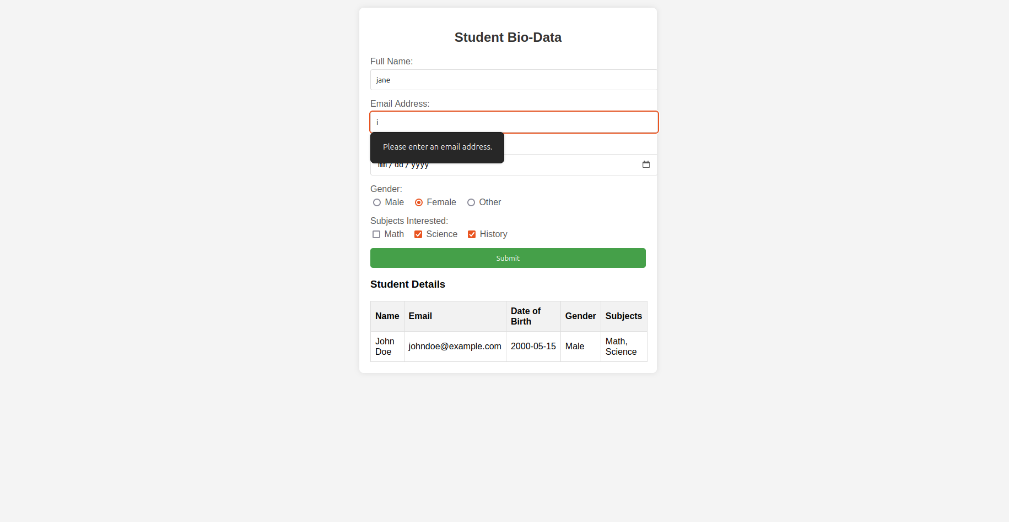

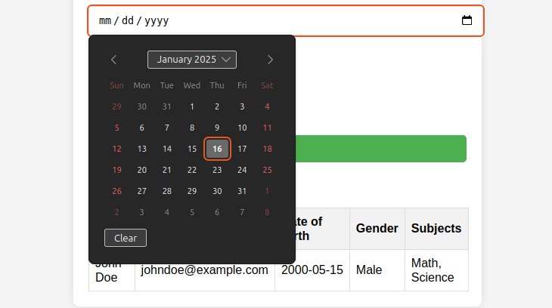

<!DOCTYPE html>

<html lang="en">

<head>

<meta charset="UTF-8">

<meta name="viewport" content="width=device-width, initial-scale=1.0">

<title>Student Bio-Data Form</title>

<style>

body {

font-family: Arial, sans-serif;

background-color: #f4f4f4;

margin: 0;

padding: 20px;

}

.form-container {

background-color: #fff;

padding: 20px;

border-radius: 8px;

box-shadow: 0 0 10px rgba(0, 0, 0, 0.1);

max-width: 500px;

margin: auto;

}

h2 {

text-align: center;

color: #333;

}

.form-group {

margin-bottom: 15px;

}

label {

font-size: 16px;

color: #555;

}

input[type="text"], input[type="email"], input[type="date"], select {

width: 100%;

padding: 10px;

margin-top: 5px;

border: 1px solid #ddd;

border-radius: 4px;

}

.radio-group, .checkbox-group {

display: flex;

margin-top: 5px;

}

.radio-group label, .checkbox-group label {

margin-right: 15px;

}

button {

background-color: #4CAF50;

color: white;

padding: 10px 20px;

border: none;

border-radius: 5px;

cursor: pointer;

width: 100%;

}

button:hover {

background-color: #45a049;

}

table {

width: 100%;

margin-top: 20px;

border-collapse: collapse;

}

table, th, td {

border: 1px solid #ddd;

padding: 8px;

}

th {

background-color: #f2f2f2;

text-align: left;

}

</style>

</head>

<body>

<div class="form-container">

<h2>Student Bio-Data</h2>

<form>

<div class="form-group">

<label for="name">Full Name:</label>

<input type="text" id="name" name="name" required>

</div>

<div class="form-group">

<label for="email">Email Address:</label>

<input type="email" id="email" name="email" required>

</div>

<div class="form-group">

<label for="dob">Date of Birth:</label>

<input type="date" id="dob" name="dob" required>

</div>

<div class="form-group">

<label>Gender:</label>

<div class="radio-group">

<label><input type="radio" name="gender" value="Male" required> Male</label>

<label><input type="radio" name="gender" value="Female"> Female</label>

<label><input type="radio" name="gender" value="Other"> Other</label>

</div>

</div>

<div class="form-group">

<label>Subjects Interested:</label>

<div class="checkbox-group">

<label><input type="checkbox" name="subjects" value="Math"> Math</label>

<label><input type="checkbox" name="subjects" value="Science"> Science</label>

<label><input type="checkbox" name="subjects" value="History"> History</label>

</div>

</div>

<button type="submit">Submit</button>

</form>

<h3>Student Details</h3>

<table>

<thead>

<tr>

<th>Name</th>

<th>Email</th>

<th>Date of Birth</th>

<th>Gender</th>

<th>Subjects</th>

</tr>

</thead>

<tbody>

<!-- Static Data Example -->

<tr>

<td>John Doe</td>

<td>johndoe@example.com</td>

<td>2000-05-15</td>

<td>Male</td>

<td>Math, Science</td>

</tr>

</tbody>

</table>

</div>

</body>

</html>

Q3

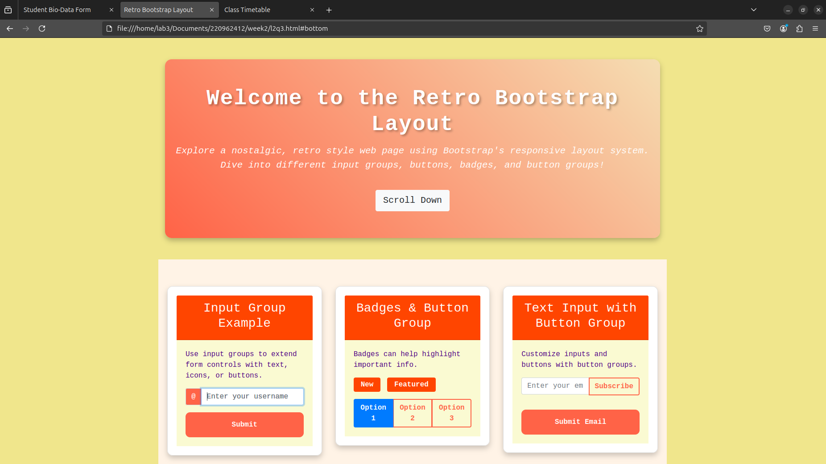<!DOCTYPE html>

<html lang="en">

<head>

<meta charset="UTF-8">

<meta name="viewport" content="width=device-width, initial-scale=1.0">

<title>Retro Bootstrap Layout</title>

<link rel="stylesheet" href="https://stackpath.bootstrapcdn.com/bootstrap/4.5.2/css/bootstrap.min.css">

<style>

/\* Body Styling \*/

body {

background-color: #f0e68c;

font-family: 'Courier New', Courier, monospace;

color: #4b0082;

margin: 0;

padding: 0;

}

/\* Top Section \*/

.top-section {

background: linear-gradient(45deg, #ff6347, #f5deb3);

color: white;

padding: 60px 20px;

border-radius: 15px;

box-shadow: 0 6px 12px rgba(0, 0, 0, 0.25);

text-align: center;

margin-top: 30px;

}

.top-section h1 {

font-size: 3rem;

font-weight: bold;

text-shadow: 3px 3px 5px rgba(0, 0, 0, 0.3);

letter-spacing: 2px;

}

.top-section p {

font-size: 1.3rem;

font-style: italic;

margin-top: 15px;

}

/\* Bottom Section \*/

.bottom-section {

padding: 60px 20px;

background-color: #fff3e6;

}

.section-heading {

font-size: 2rem;

color: #ff4500;

margin-bottom: 25px;

text-transform: uppercase;

font-weight: bold;

letter-spacing: 1px;

}

.card {

border-radius: 12px;

box-shadow: 0 6px 12px rgba(0, 0, 0, 0.2);

padding: 20px;

margin-bottom: 30px;

}

.card-header {

background-color: #ff4500;

color: white;

font-weight: bold;

font-size: 1.5rem;

text-align: center;

border-radius: 10px;

}

.card-body {

background-color: #fafad2;

}

/\* Custom Buttons and Input Groups \*/

.btn-custom {

width: 100%;

font-weight: bold;

background-color: #ff6347;

color: white;

border-radius: 10px;

padding: 15px;

}

.btn-custom:hover {

background-color: #f0e68c;

color: #4b0082;

box-shadow: 0 5px 15px rgba(0, 0, 0, 0.3);

}

.input-group-text {

background-color: #ff6347;

color: white;

font-weight: bold;

}

.badge-custom {

background-color: #ff4500;

color: white;

font-size: 1rem;

font-weight: bold;

padding: 8px 16px;

margin-right: 5px;

}

.btn-group-toggle label {

font-weight: bold;

}

.btn-outline-primary {

font-weight: bold;

border: 2px solid #ff6347;

color: #ff6347;

}

.btn-outline-primary:hover {

background-color: #ff6347;

color: white;

}

/\* Responsive Adjustments \*/

@media (max-width: 767px) {

.top-section h1 {

font-size: 2rem;

}

.section-heading {

font-size: 1.5rem;

}

.card {

padding: 15px;

}

.btn-custom {

font-size: 1rem;

padding: 10px;

}

}

</style>

</head>

<body>

<div class="container mt-5">

<div class="top-section">

<h1>Welcome to the Retro Bootstrap Layout</h1>

<p>Explore a nostalgic, retro style web page using Bootstrap's responsive layout system. Dive into different input groups, buttons, badges, and button groups!</p>

<a href="#bottom" class="btn btn-light btn-lg mt-4">Scroll Down</a>

</div>

</div>

<div id="bottom" class="container mt-5 bottom-section">

<div class="row">

<div class="col-md-4">

<div class="card">

<div class="card-header">

<h3>Input Group Example</h3>

</div>

<div class="card-body">

<p>Use input groups to extend form controls with text, icons, or buttons.</p>

<div class="input-group mb-3">

<div class="input-group-prepend">

<span class="input-group-text">@</span>

</div>

<input type="text" class="form-control" placeholder="Enter your username" aria-label="Username">

</div>

<button class="btn btn-custom">Submit</button>

</div>

</div>

</div>

<div class="col-md-4">

<div class="card">

<div class="card-header">

<h3>Badges & Button Group</h3>

</div>

<div class="card-body">

<p>Badges can help highlight important info.</p>

<div>

<span class="badge badge-custom">New</span>

<span class="badge badge-custom">Featured</span>

</div>

<div class="btn-group btn-group-toggle mt-3" data-toggle="buttons">

<label class="btn btn-outline-primary active">

<input type="radio" name="options" id="option1" autocomplete="off" checked> Option 1

</label>

<label class="btn btn-outline-primary">

<input type="radio" name="options" id="option2" autocomplete="off"> Option 2

</label>

<label class="btn btn-outline-primary">

<input type="radio" name="options" id="option3" autocomplete="off"> Option 3

</label>

</div>

</div>

</div>

</div>

<div class="col-md-4">

<div class="card">

<div class="card-header">

<h3>Text Input with Button Group</h3>

</div>

<div class="card-body">

<p>Customize inputs and buttons with button groups.</p>

<div class="input-group mb-3">

<input type="text" class="form-control" placeholder="Enter your email" aria-label="Email">

<div class="input-group-append">

<button class="btn btn-outline-primary" type="button">Subscribe</button>

</div>

</div>

<button class="btn btn-custom mt-3">Submit Email</button>

</div>

</div>

</div>

</div>

</div>

</body>

</html>

Q4

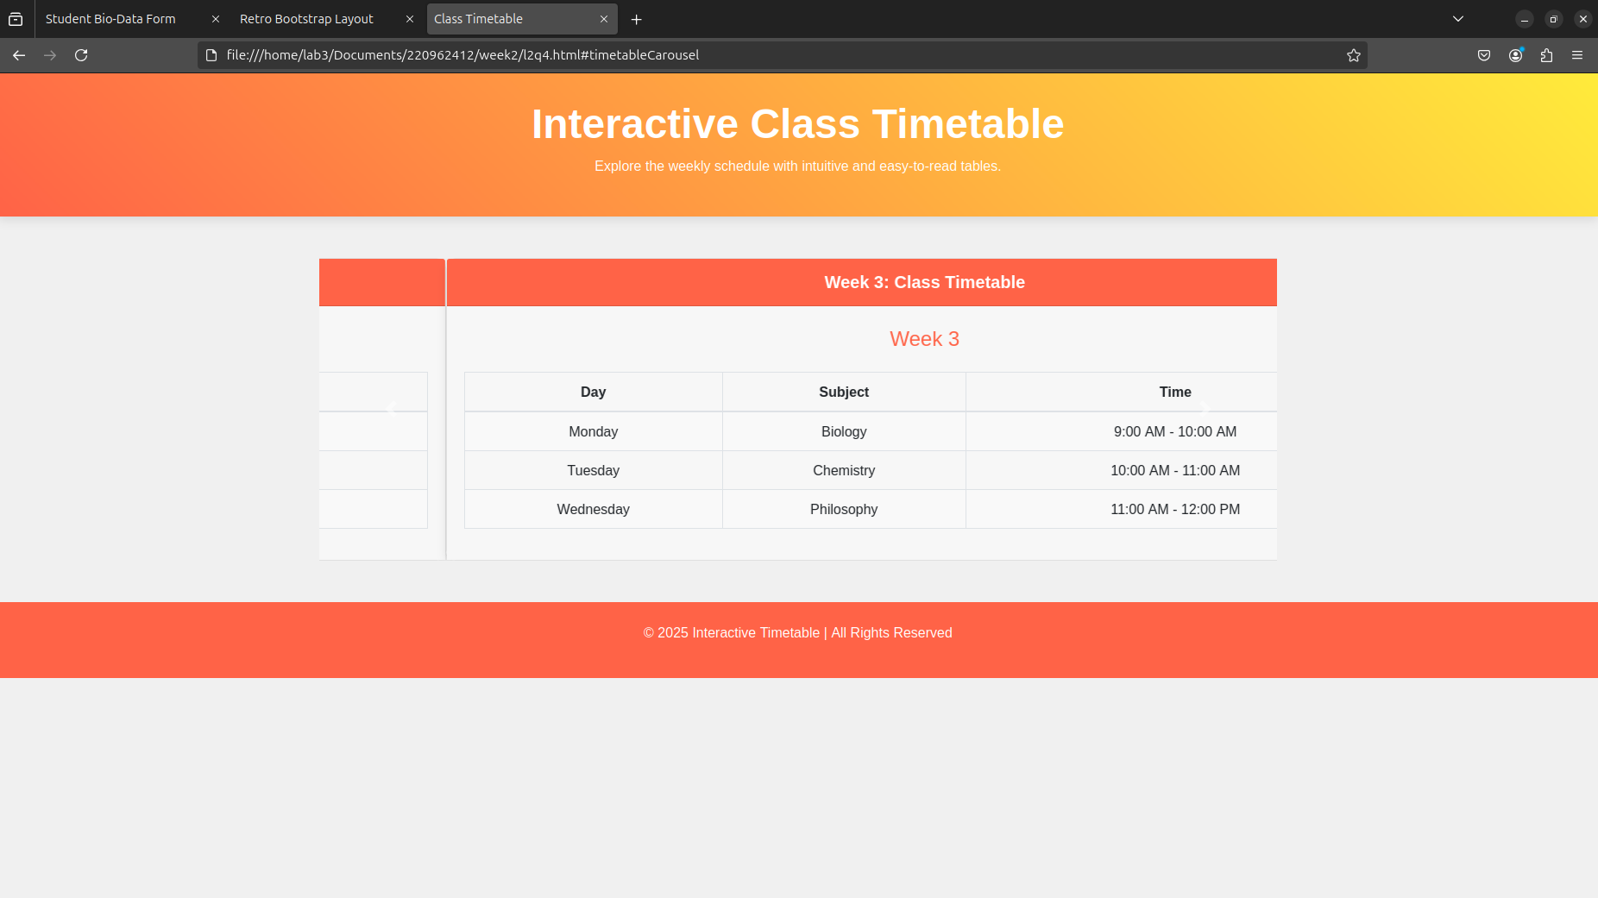<!DOCTYPE html>

<html lang="en">

<head>

<meta charset="UTF-8">

<meta name="viewport" content="width=device-width, initial-scale=1.0">

<title>Class Timetable</title>

<link rel="stylesheet" href="https://maxcdn.bootstrapcdn.com/bootstrap/4.5.2/css/bootstrap.min.css">

<style>

/\* Body styling \*/

body {

background-color: #f0f0f0;

font-family: 'Arial', sans-serif;

color: #333;

}

/\* Header styling \*/

.header {

background: linear-gradient(45deg, #ff6347, #ffeb3b);

color: white;

padding: 30px 0;

text-align: center;

box-shadow: 0 4px 12px rgba(0, 0, 0, 0.1);

}

.header h1 {

font-size: 3rem;

font-weight: bold;

}

/\* Table Styling \*/

.table-bordered th, .table-bordered td {

text-align: center;

padding: 10px;

vertical-align: middle;

}

.table-striped tbody tr:nth-child(odd) {

background-color: #f9f9f9;

}

/\* Carousel Item Styling \*/

.carousel-item {

text-align: center;

}

/\* Card Styling \*/

.card {

border-radius: 12px;

box-shadow: 0 4px 10px rgba(0, 0, 0, 0.1);

}

.card-header {

background-color: #ff6347;

color: white;

font-weight: bold;

font-size: 1.25rem;

text-align: center;

}

.card-body {

background-color: #f7f7f7;

padding: 20px;

}

/\* Week Labels \*/

.week-label {

font-size: 1.5rem;

color: #ff6347;

text-align: center;

margin-bottom: 20px;

}

/\* Responsive Layout \*/

@media (max-width: 767px) {

.week-label {

font-size: 1.2rem;

}

.table th, .table td {

font-size: 0.9rem;

padding: 8px;

}

.header h1 {

font-size: 2rem;

}

}

</style>

</head>

<body>

<!-- Header Section -->

<div class="header">

<h1>Interactive Class Timetable</h1>

<p>Explore the weekly schedule with intuitive and easy-to-read tables.</p>

</div>

<!-- Main Content -->

<div class="container mt-5">

<!-- Carousel for Timetable -->

<div id="timetableCarousel" class="carousel slide" data-ride="carousel">

<div class="carousel-inner">

<!-- Week 1 -->

<div class="carousel-item active">

<div class="card">

<div class="card-header">

Week 1: Class Timetable

</div>

<div class="card-body">

<div class="week-label">Week 1</div>

<table class="table table-bordered table-striped">

<thead>

<tr>

<th>Day</th>

<th>Subject</th>

<th>Time</th>

</tr>

</thead>

<tbody>

<tr>

<td>Monday</td>

<td>Mathematics</td>

<td>9:00 AM - 10:00 AM</td>

</tr>

<tr>

<td>Tuesday</td>

<td>Science</td>

<td>10:00 AM - 11:00 AM</td>

</tr>

<tr>

<td>Wednesday</td>

<td>History</td>

<td>11:00 AM - 12:00 PM</td>

</tr>

</tbody>

</table>

</div>

</div>

</div>

<!-- Week 2 -->

<div class="carousel-item">

<div class="card">

<div class="card-header">

Week 2: Class Timetable

</div>

<div class="card-body">

<div class="week-label">Week 2</div>

<table class="table table-bordered table-striped">

<thead>

<tr>

<th>Day</th>

<th>Subject</th>

<th>Time</th>

</tr>

</thead>

<tbody>

<tr>

<td>Monday</td>

<td>Computer Science</td>

<td>9:00 AM - 10:00 AM</td>

</tr>

<tr>

<td>Thursday</td>

<td>English</td>

<td>2:00 PM - 3:00 PM</td>

</tr>

<tr>

<td>Friday</td>

<td>Art</td>

<td>3:00 PM - 4:00 PM</td>

</tr>

</tbody>

</table>

</div>

</div>

</div>

<!-- Week 3 -->

<div class="carousel-item">

<div class="card">

<div class="card-header">

Week 3: Class Timetable

</div>

<div class="card-body">

<div class="week-label">Week 3</div>

<table class="table table-bordered table-striped">

<thead>

<tr>

<th>Day</th>

<th>Subject</th>

<th>Time</th>

</tr>

</thead>

<tbody>

<tr>

<td>Monday</td>

<td>Biology</td>

<td>9:00 AM - 10:00 AM</td>

</tr>

<tr>

<td>Tuesday</td>

<td>Chemistry</td>

<td>10:00 AM - 11:00 AM</td>

</tr>

<tr>

<td>Wednesday</td>

<td>Philosophy</td>

<td>11:00 AM - 12:00 PM</td>

</tr>

</tbody>

</table>

</div>

</div>

</div>

</div>

<!-- Carousel Controls -->

<a class="carousel-control-prev" href="#timetableCarousel" role="button" data-slide="prev">

<span class="carousel-control-prev-icon" aria-hidden="true"></span>

<span class="sr-only">Previous</span>

</a>

<a class="carousel-control-next" href="#timetableCarousel" role="button" data-slide="next">

<span class="carousel-control-next-icon" aria-hidden="true"></span>

<span class="sr-only">Next</span>

</a>

</div>

</div>

<!-- Footer Section -->

<div class="footer text-center py-4 mt-5" style="background-color: #ff6347; color: white;">

<p>&copy; 2025 Interactive Timetable | All Rights Reserved</p>

</div>

<!-- Bootstrap 4 JS and Popper.js -->

<script src="https://code.jquery.com/jquery-3.6.0.min.js"></script>

<script src="https://cdnjs.cloudflare.com/ajax/libs/popper.js/2.9.2/umd/popper.min.js"></script>

<script src="https://maxcdn.bootstrapcdn.com/bootstrap/4.5.2/js/bootstrap.min.js"></script>

</body>

</html>