Q1)

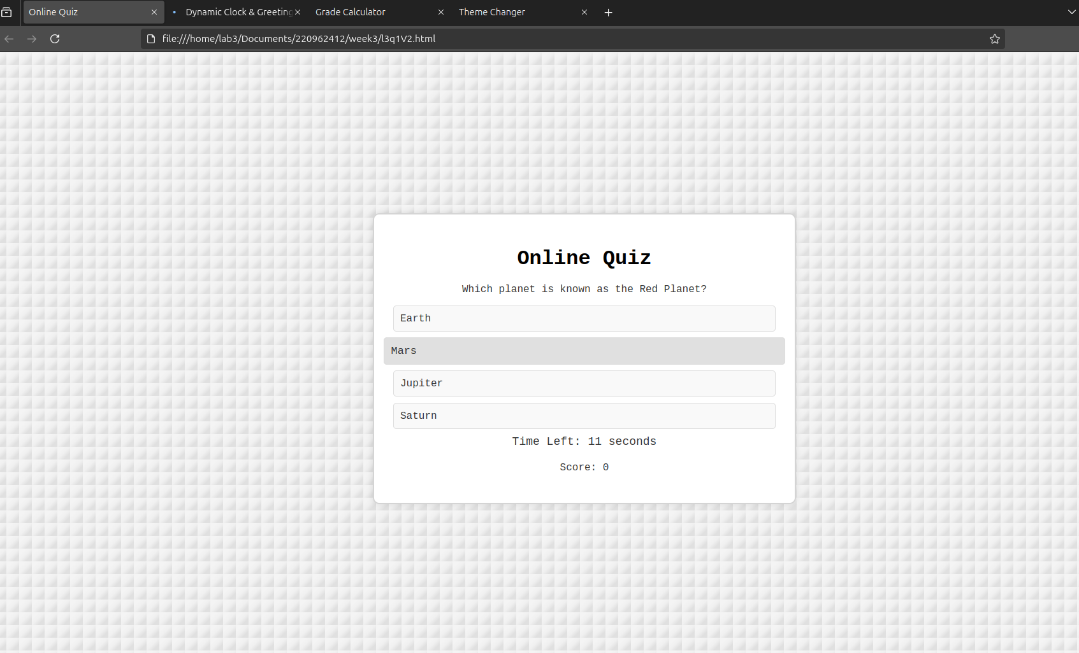<!DOCTYPE html>

<html lang="en">

<head>

<meta charset="UTF-8">

<meta name="viewport" content="width=device-width, initial-scale=1.0">

<title>Online Quiz</title>

<style>

body {

font-family: 'Courier New', Courier, monospace;

background-color: #f4f4f4;

display: flex;

justify-content: center;

align-items: center;

height: 100vh;

margin: 0;

color: #333;

background: linear-gradient(135deg, #f4f4f4 25%, #f0f0f0 50%, #e0e0e0 75%);

background-size: 20px 20px;

}

.quiz-container {

text-align: center;

background-color: white;

padding: 30px;

border-radius: 10px;

box-shadow: 0 0 10px rgba(0, 0, 0, 0.1);

width: 80%;

max-width: 600px;

border: 2px solid #d4d4d4;

}

h1 {

font-size: 2rem;

margin-bottom: 20px;

color: black;

}

#answers-list {

list-style: none;

padding: 0;

margin: 0;

text-align: left;

}

#answers-list li {

margin: 10px 0;

padding: 10px;

background-color: #f9f9f9;

cursor: pointer;

border-radius: 5px;

border: 1px solid #ddd;

transition: background-color 0.3s, transform 0.2s;

}

#answers-list li:hover {

background-color: #e0e0e0;

transform: scale(1.05);

}

button {

margin-top: 20px;

padding: 12px 25px;

background-color: #333;

color: white;

border: none;

border-radius: 5px;

cursor: pointer;

font-size: 16px;

transition: background-color 0.3s;

}

button:disabled {

background-color: #ccc;

}

button:hover {

background-color: #555;

}

#timer {

margin-top: 10px;

font-size: 18px;

color: #333;

}

#score-container {

margin-top: 20px;

}

</style>

</head>

<body>

<div class="quiz-container">

<div id="quiz">

<h1>Online Quiz</h1>

<div id="question-container">

<p id="question"></p>

<ul id="answers-list"></ul>

</div>

<div id="timer">Time Left: <span id="time-left"></span> seconds</div>

<div id="score-container">

<p>Score: <span id="score">0</span></p>

</div>

<button id="next-button" onclick="nextQuestion()">Next</button>

<button id="restart-button" onclick="restartQuiz()" style="display: none;">Restart Quiz</button>

</div>

</div>

<script>

const questions = [

{

question: "What is the capital of France?",

answers: ["Berlin", "Madrid", "Paris", "Rome"],

correct: 2

},

{

question: "Which planet is known as the Red Planet?",

answers: ["Earth", "Mars", "Jupiter", "Saturn"],

correct: 1

},

{

question: "Who wrote 'Hamlet'?",

answers: ["Shakespeare", "Dickens", "Hemingway", "Austen"],

correct: 0

},

{

question: "What is the largest ocean on Earth?",

answers: ["Atlantic", "Indian", "Pacific", "Arctic"],

correct: 2

}

];

let currentQuestionIndex = 0;

let score = 0;

let timer;

let timeLeft = 15;

function initializeQuiz() {

document.getElementById("next-button").style.display = 'none';

document.getElementById("restart-button").style.display = 'none';

loadQuestion();

startTimer();

}

function loadQuestion() {

const question = questions[currentQuestionIndex];

document.getElementById("question").textContent = question.question;

const answersList = document.getElementById("answers-list");

answersList.innerHTML = "";

question.answers.forEach((answer, index) => {

const listItem = document.createElement("li");

listItem.textContent = answer;

listItem.onclick = () => checkAnswer(index);

answersList.appendChild(listItem);

});

}

function checkAnswer(selectedIndex) {

const correctIndex = questions[currentQuestionIndex].correct;

if (selectedIndex === correctIndex) {

score++;

document.getElementById("score").textContent = score;

}

disableAnswerSelection();

clearInterval(timer);

document.getElementById("next-button").style.display = 'inline-block';

}

function disableAnswerSelection() {

const listItems = document.querySelectorAll("#answers-list li");

listItems.forEach(item => {

item.style.pointerEvents = "none";

});

}

function nextQuestion() {

currentQuestionIndex++;

if (currentQuestionIndex < questions.length) {

loadQuestion();

startTimer();

document.getElementById("next-button").style.display = 'none';

} else {

endQuiz();

}

}

function startTimer() {

timeLeft = 15;

document.getElementById("time-left").textContent = timeLeft;

timer = setInterval(() => {

timeLeft--;

document.getElementById("time-left").textContent = timeLeft;

if (timeLeft <= 0) {

clearInterval(timer);

document.getElementById("next-button").style.display = 'inline-block';

disableAnswerSelection();

}

}, 1000);

}

function endQuiz() {

document.getElementById("quiz").innerHTML = `

<h1>Quiz Completed!</h1>

<p>Your final score is: ${score} / ${questions.length}</p>

<button onclick="restartQuiz()">Restart Quiz</button>

`;

}

function restartQuiz() {

location.reload();

}

initializeQuiz();

</script>

</body>

</html>

Q2)

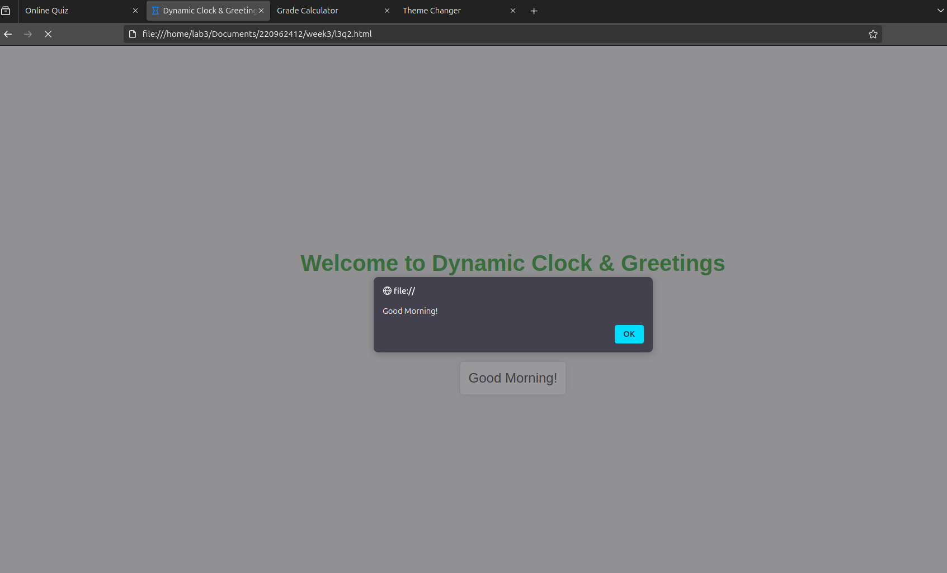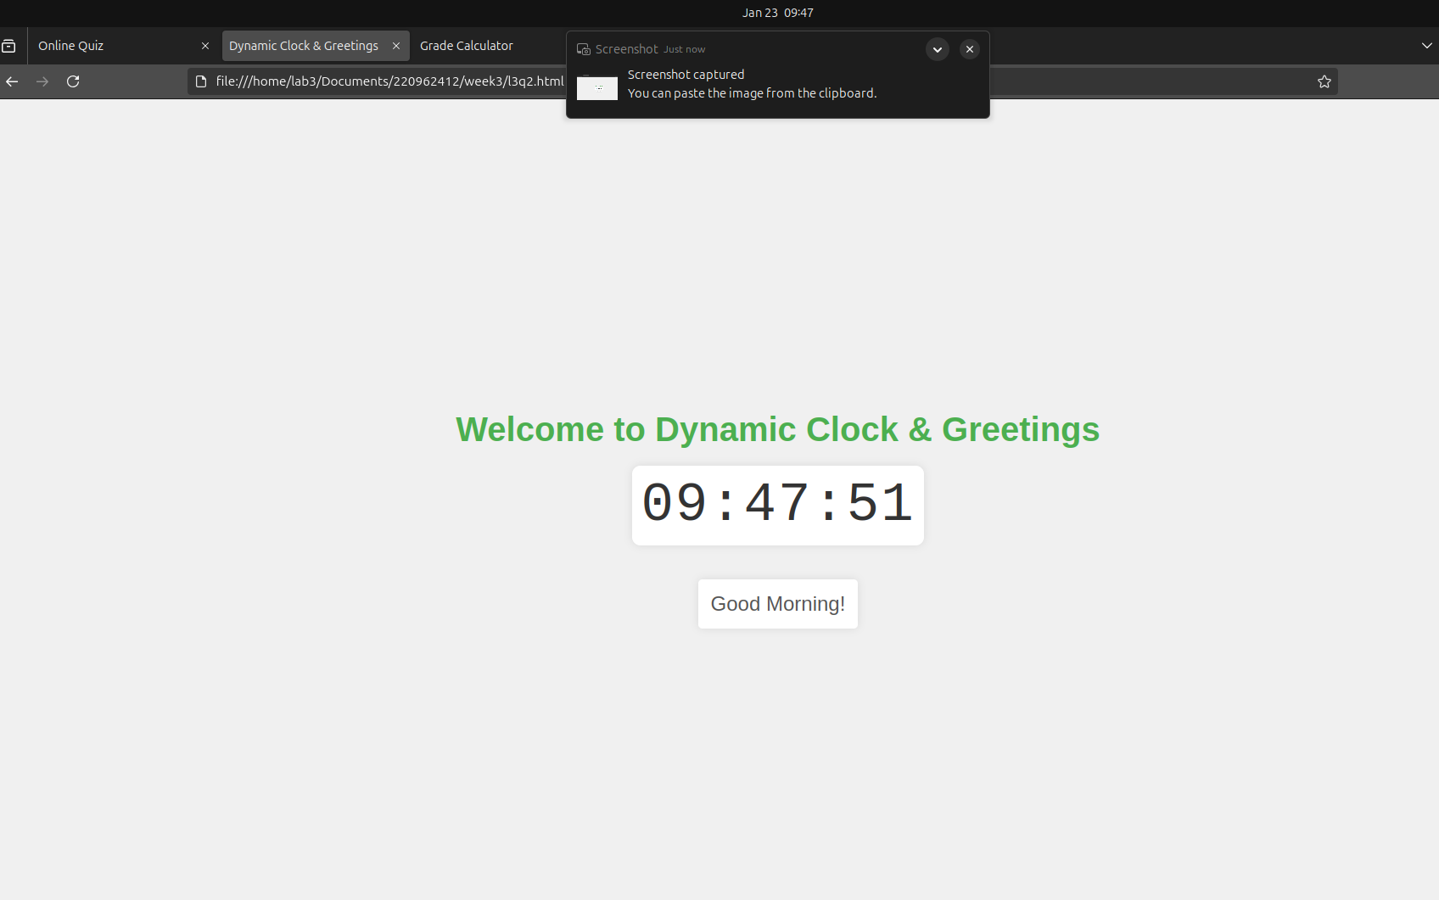<!DOCTYPE html>

<html lang="en">

<head>

<meta charset="UTF-8">

<meta name="viewport" content="width=device-width, initial-scale=1.0">

<title>Dynamic Clock & Greetings</title>

<style>

body {

font-family: 'Arial', sans-serif;

display: flex;

justify-content: center;

align-items: center;

height: 100vh;

margin: 0;

background-color: #f0f0f0;

color: #333;

text-align: center;

flex-direction: column;

}

h1 {

font-size: 2.5rem;

margin-bottom: 20px;

color: #4CAF50;

}

#clock {

font-size: 4rem;

margin-bottom: 20px;

color: #333;

font-family: 'Courier New', Courier, monospace;

letter-spacing: 2px;

padding: 10px;

background-color: #fff;

border-radius: 10px;

box-shadow: 0 0 10px rgba(0, 0, 0, 0.1);

}

#greeting {

font-size: 1.5rem;

color: #555;

}

.greeting-box {

font-size: 1.2rem;

color: #555;

padding: 15px;

margin-top: 20px;

background-color: #fff;

border-radius: 5px;

box-shadow: 0 0 10px rgba(0, 0, 0, 0.1);

display: inline-block;

}

</style>

</head>

<body>

<h1>Welcome to Dynamic Clock & Greetings</h1>

<div id="clock"></div>

<div id="greeting" class="greeting-box"></div>

<script>

function updateClock() {

const clockElement = document.getElementById("clock");

const now = new Date();

const hours = now.getHours();

const minutes = now.getMinutes();

const seconds = now.getSeconds();

const formattedTime = `${padZero(hours)}:${padZero(minutes)}:${padZero(seconds)}`;

clockElement.textContent = formattedTime;

displayGreeting(hours);

}

function padZero(value) {

return value < 10 ? '0' + value : value;

}

function displayGreeting(hours) {

const greetingElement = document.getElementById("greeting");

if (hours >= 0 && hours < 12) {

greetingElement.textContent = "Good Morning!";

alert("Good Morning!");

} else if (hours >= 12 && hours < 18) {

greetingElement.textContent = "Good Afternoon!";

alert("Good Afternoon!");

} else {

greetingElement.textContent = "Good Evening!";

alert("Good Evening!");

}

}

setInterval(updateClock, 1000);

updateClock();

</script>

</body>

</html>

Q3)

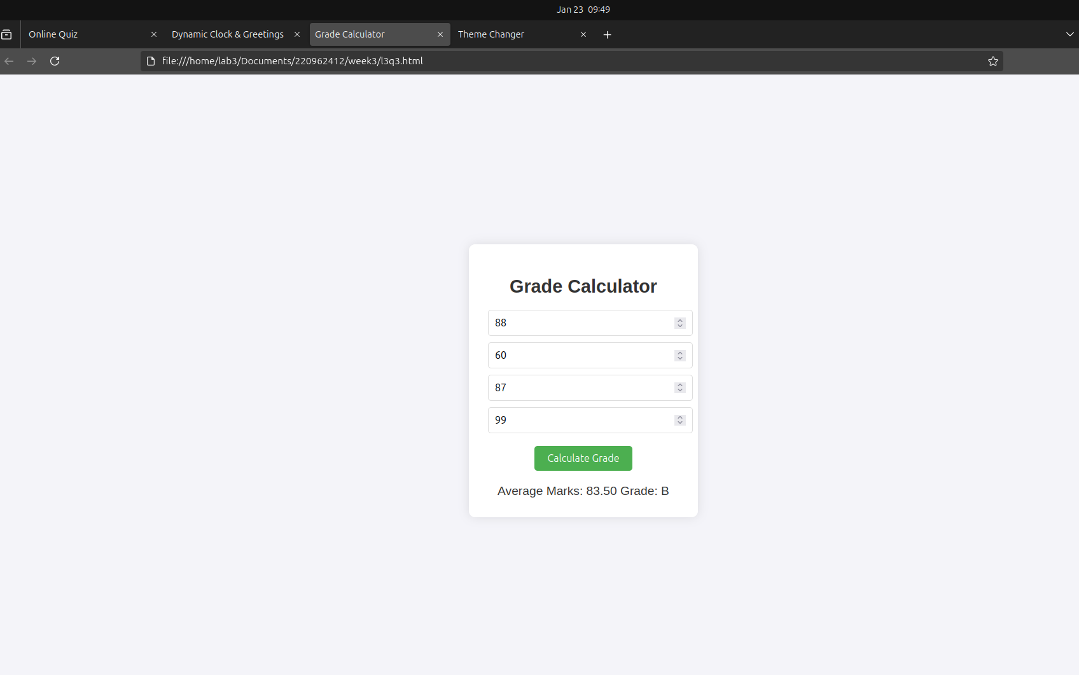<!DOCTYPE html>

<html lang="en">

<head>

<meta charset="UTF-8">

<meta name="viewport" content="width=device-width, initial-scale=1.0">

<title>Grade Calculator</title>

<style>

body {

font-family: 'Arial', sans-serif;

display: flex;

justify-content: center;

align-items: center;

height: 100vh;

margin: 0;

background-color: #f4f4f9;

text-align: center;

}

.container {

background-color: white;

padding: 30px;

border-radius: 10px;

box-shadow: 0 0 15px rgba(0, 0, 0, 0.1);

width: 300px;

}

h1 {

font-size: 1.8rem;

margin-bottom: 20px;

color: #333;

}

input {

width: 100%;

padding: 10px;

margin-bottom: 10px;

border: 1px solid #ddd;

border-radius: 5px;

font-size: 1rem;

}

button {

padding: 10px 20px;

background-color: #4CAF50;

color: white;

border: none;

border-radius: 5px;

cursor: pointer;

font-size: 1rem;

margin-top: 10px;

}

button:hover {

background-color: #45a049;

}

.result {

margin-top: 20px;

font-size: 1.2rem;

color: #333;

}

</style>

</head>

<body>

<div class="container">

<h1>Grade Calculator</h1>

<input type="number" id="subject1" placeholder="Enter marks for Subject 1" required>

<input type="number" id="subject2" placeholder="Enter marks for Subject 2" required>

<input type="number" id="subject3" placeholder="Enter marks for Subject 3" required>

<input type="number" id="subject4" placeholder="Enter marks for Subject 4" required>

<button onclick="calculateGrade()">Calculate Grade</button>

<div id="result" class="result"></div>

</div>

<script>

function calculateGrade() {

const subject1 = parseFloat(document.getElementById('subject1').value);

const subject2 = parseFloat(document.getElementById('subject2').value);

const subject3 = parseFloat(document.getElementById('subject3').value);

const subject4 = parseFloat(document.getElementById('subject4').value);

if (isNaN(subject1) || isNaN(subject2) || isNaN(subject3) || isNaN(subject4)) {

document.getElementById('result').textContent = "Please enter valid marks for all subjects.";

return;

}

const average = (subject1 + subject2 + subject3 + subject4) / 4;

let grade = '';

if (average > 90) {

grade = 'A';

} else if (average > 80) {

grade = 'B';

} else if (average > 70) {

grade = 'C';

} else if (average > 60) {

grade = 'D';

} else {

grade = 'F';

}

document.getElementById('result').textContent = `Average Marks: ${average.toFixed(2)}\nGrade: ${grade}`;

}

</script>

</body>

</html>

Q4)

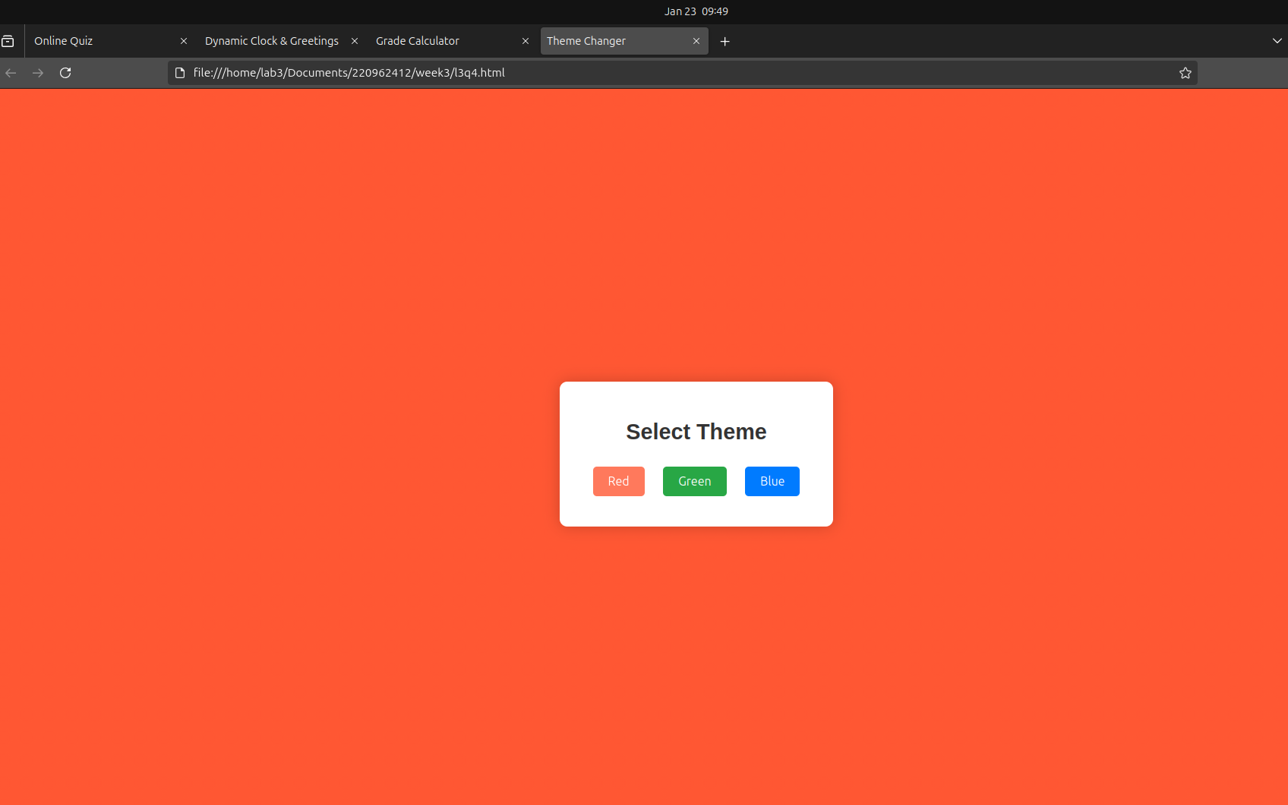

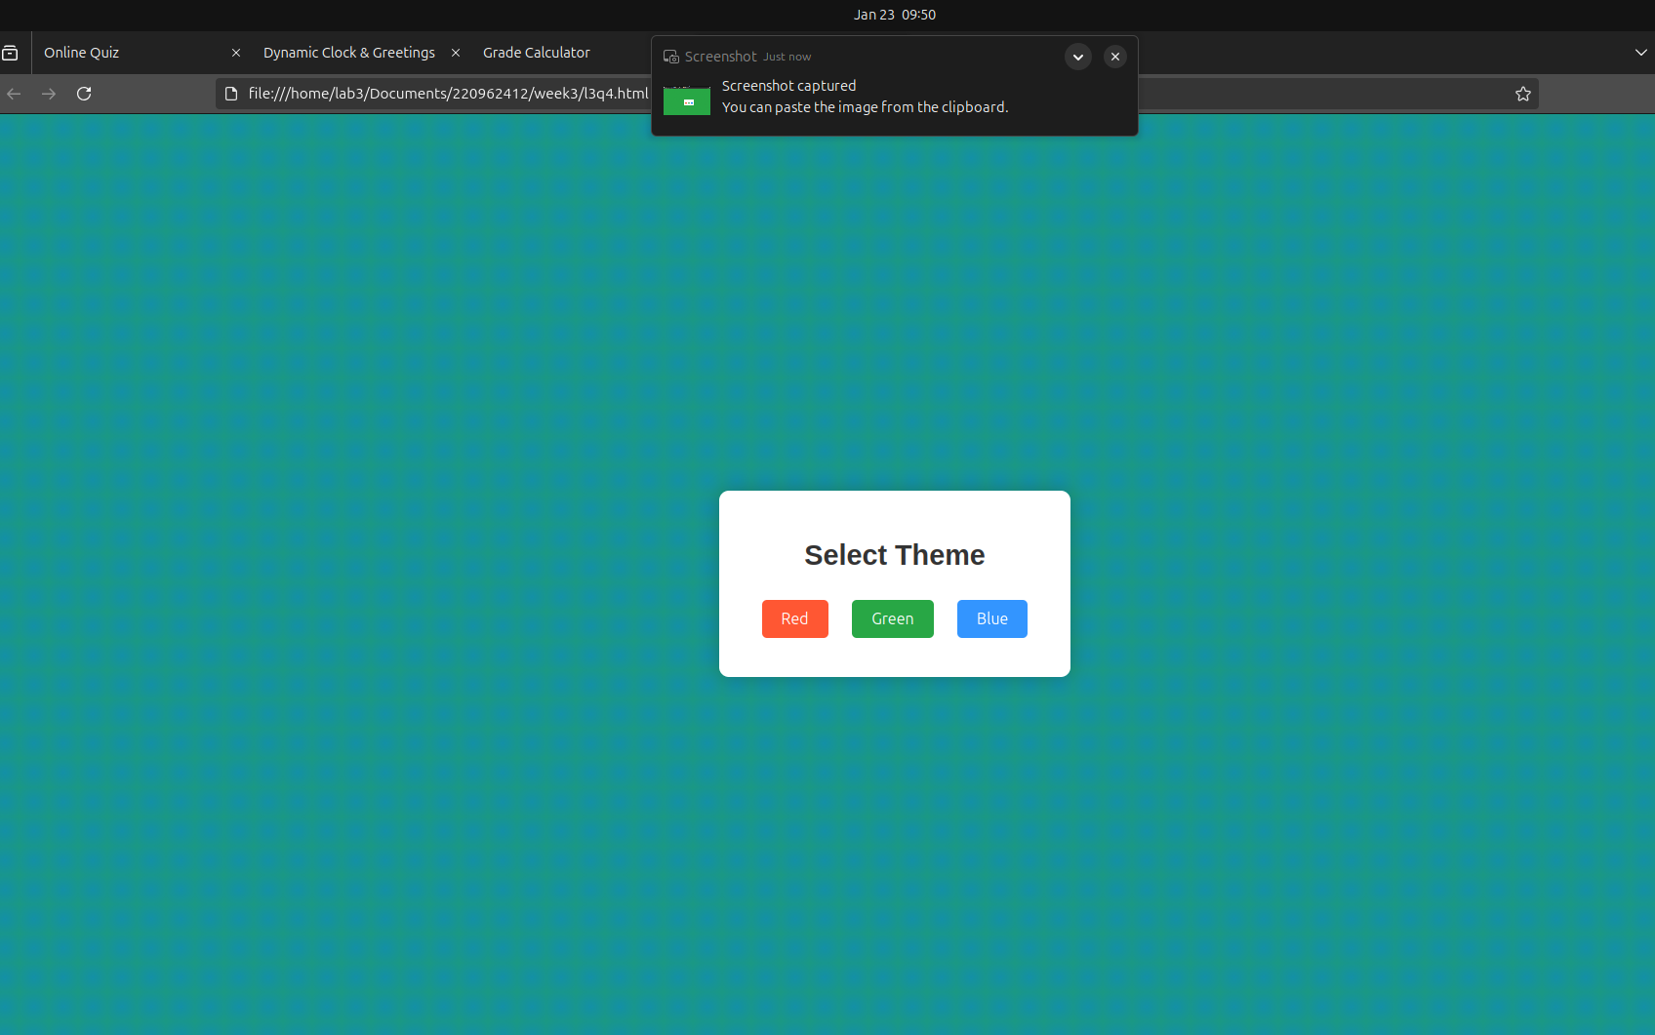

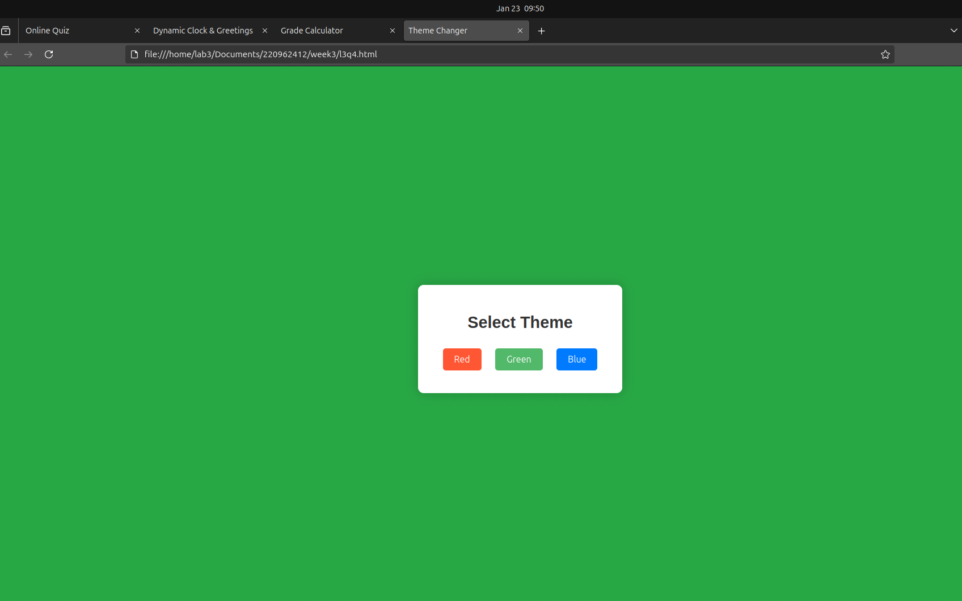

<!DOCTYPE html>

<html lang="en">

<head>

<meta charset="UTF-8">

<meta name="viewport" content="width=device-width, initial-scale=1.0">

<title>Theme Changer</title>

<style>

body {

font-family: 'Arial', sans-serif;

display: flex;

justify-content: center;

align-items: center;

height: 100vh;

margin: 0;

background: #f4f4f4;

transition: background 0.5s ease-in-out;

position: relative;

}

.container {

text-align: center;

padding: 30px;

border-radius: 10px;

box-shadow: 0 0 20px rgba(0, 0, 0, 0.2);

background-color: white;

width: 300px;

z-index: 10;

}

h1 {

font-size: 1.8rem;

color: #333;

}

button {

margin: 10px;

padding: 10px 20px;

font-size: 1rem;

cursor: pointer;

border: none;

border-radius: 5px;

transition: background-color 0.3s ease;

}

button:hover {

opacity: 0.8;

}

#red-btn {

background-color: #ff5733;

color: white;

}

#green-btn {

background-color: #28a745;

color: white;

}

#blue-btn {

background-color: #007bff;

color: white;

}

.pattern {

position: absolute;

top: 0;

left: 0;

width: 100%;

height: 100%;

background-repeat: repeat;

background-size: 30px 30px;

z-index: -1;

}

.red-pattern {

background-image: radial-gradient(circle, rgba(255, 87, 51, 0.5), rgba(255, 87, 51, 0.3));

}

.green-pattern {

background-image: radial-gradient(circle, rgba(40, 167, 69, 0.5), rgba(40, 167, 69, 0.3));

}

.blue-pattern {

background-image: radial-gradient(circle, rgba(0, 123, 255, 0.5), rgba(0, 123, 255, 0.3));

}

</style>

</head>

<body>

<div class="container">

<h1>Select Theme</h1>

<button id="red-btn" onclick="changeTheme('red')">Red</button>

<button id="green-btn" onclick="changeTheme('green')">Green</button>

<button id="blue-btn" onclick="changeTheme('blue')">Blue</button>

</div>

<div id="pattern" class="pattern"></div>

<script>

function changeTheme(color) {

const patternElement = document.getElementById('pattern');

patternElement.classList.remove('red-pattern', 'green-pattern', 'blue-pattern');

if (color === 'red') {

document.body.style.backgroundColor = '#ff5733';

patternElement.classList.add('red-pattern');

} else if (color === 'green') {

document.body.style.backgroundColor = '#28a745';

patternElement.classList.add('green-pattern');

} else if (color === 'blue') {

document.body.style.backgroundColor = '#007bff';

patternElement.classList.add('blue-pattern');

}

}

</script>

</body>

</html>