Q1)

<!DOCTYPE html>

<html lang="en">

<head>

<meta charset="UTF-8">

<meta name="viewport" content="width=device-width, initial-scale=1.0">

<title>Table and Image Move Animation</title>

<style>

body {

font-family: Arial, sans-serif;

margin: 20px;

}

/\* Container styles \*/

#container {

position: relative;

width: 100%;

display: flex;

justify-content: center;

align-items: center;

overflow: hidden; /\* To hide content that moves out of view \*/

}

/\* Table styles \*/

table {

width: 50%;

border-collapse: collapse;

}

table, th, td {

border: 1px solid #000;

}

th, td {

padding: 10px;

text-align: center;

}

/\* Alternate row colors \*/

tr:nth-child(even) {

background-color: #f2f2f2;

}

tr:nth-child(odd) {

background-color: #ffffff;

}

/\* Image styles \*/

img {

width: 200px;

height: auto;

margin-left: 20px;

}

/\* Button styles \*/

button {

padding: 10px 20px;

background-color: #4CAF50;

color: white;

border: none;

cursor: pointer;

margin-top: 20px;

}

button:hover {

background-color: #45a049;

}

/\* Table-image container (set its initial position) \*/

#table-image-container {

position: relative;

display: flex;

align-items: center;

}

</style>

</head>

<body>

<h1>Interactive Table and Image</h1>

<!-- Table and Image Section -->

<div id="container">

<div id="table-image-container">

<table>

<tr>

<th>Header 1</th>

<th>Header 2</th>

<th>Header 3</th>

</tr>

<tr>

<td>Data 1</td>

<td>Data 2</td>

<td>Data 3</td>

</tr>

<tr>

<td>Data 4</td>

<td>Data 5</td>

<td>Data 6</td>

</tr>

<tr>

<td>Data 7</td>

<td>Data 8</td>

<td>Data 9</td>

</tr>

</table>

<img src="https://via.placeholder.com/200" alt="Sample Image">

<button id="moveBtn">Move Table & Image</button>

</div>

</div>

<!-- jQuery Script -->

<script src="https://code.jquery.com/jquery-3.6.0.min.js"></script>

<script>

$(document).ready(function () {

// Move the table and image together from right to left when button is clicked

$('#moveBtn').click(function () {

$('#table-image-container').animate({

left: '-100%' // Move the container to the left

}, 2000);

});

});

</script>

</body>

</html>

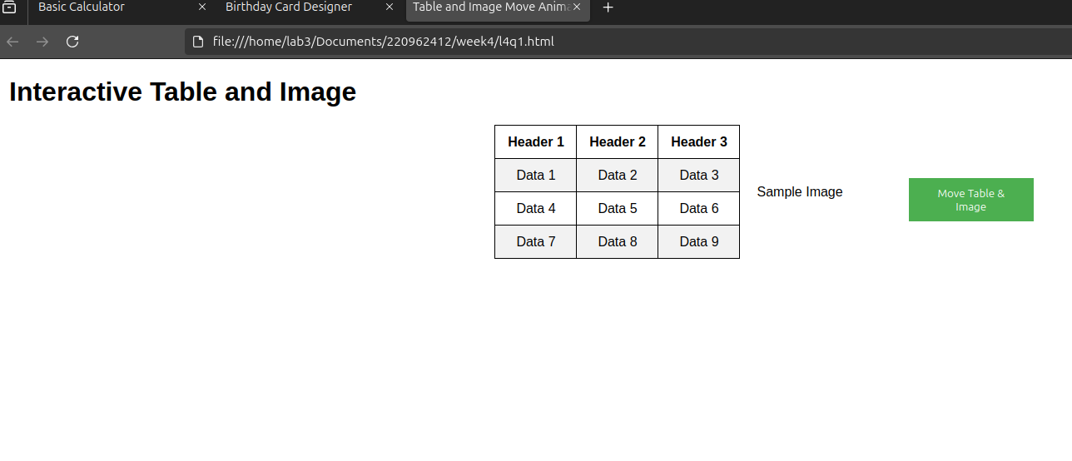

Q2)

<!DOCTYPE html>

<html lang="en">

<head>

<meta charset="UTF-8">

<meta name="viewport" content="width=device-width, initial-scale=1.0">

<title>Basic Calculator</title>

<style>

body {

font-family: Arial, sans-serif;

display: flex;

justify-content: center;

align-items: center;

height: 100vh;

background-color: #f4f4f9;

margin: 0;

}

.calculator {

background-color: #fff;

padding: 20px;

border-radius: 10px;

box-shadow: 0 4px 10px rgba(0, 0, 0, 0.1);

width: 260px;

}

#display {

width: 100%;

height: 50px;

margin-bottom: 20px;

text-align: right;

font-size: 24px;

padding: 10px;

border: 1px solid #ccc;

border-radius: 5px;

}

.button {

width: 50px;

height: 50px;

margin: 5px;

font-size: 20px;

background-color: #f0f0f0;

border: none;

border-radius: 5px;

cursor: pointer;

}

.button:hover {

background-color: #dcdcdc;

}

.button:active {

background-color: #ccc;

}

.button.operator {

background-color: #4CAF50;

color: white;

}

.button.operator:hover {

background-color: #45a049;

}

.button.clear {

background-color: #f44336;

color: white;

}

.button.clear:hover {

background-color: #e53935;

}

.button.equal {

background-color: #2196F3;

color: white;

}

.button.equal:hover {

background-color: #1e88e5;

}

.row {

display: flex;

justify-content: space-between;

}

</style>

</head>

<body>

<div class="calculator">

<input type="text" id="display" disabled>

<div class="row">

<button class="button" onclick="appendToDisplay('7')">7</button>

<button class="button" onclick="appendToDisplay('8')">8</button>

<button class="button" onclick="appendToDisplay('9')">9</button>

<button class="button operator" onclick="appendToDisplay('+')">+</button>

</div>

<div class="row">

<button class="button" onclick="appendToDisplay('4')">4</button>

<button class="button" onclick="appendToDisplay('5')">5</button>

<button class="button" onclick="appendToDisplay('6')">6</button>

<button class="button operator" onclick="appendToDisplay('-')">-</button>

</div>

<div class="row">

<button class="button" onclick="appendToDisplay('1')">1</button>

<button class="button" onclick="appendToDisplay('2')">2</button>

<button class="button" onclick="appendToDisplay('3')">3</button>

<button class="button operator" onclick="appendToDisplay('\*')">\*</button>

</div>

<div class="row">

<button class="button" onclick="appendToDisplay('0')">0</button>

<button class="button" onclick="appendToDisplay('.')">.</button>

<button class="button clear" onclick="clearDisplay()">C</button>

<button class="button operator" onclick="appendToDisplay('/')">/</button>

</div>

<div class="row">

<button class="button equal" onclick="calculateResult()">=</button>

</div>

</div>

<script>

// Function to append values to the display

function appendToDisplay(value) {

document.getElementById('display').value += value;

}

// Function to clear the display

function clearDisplay() {

document.getElementById('display').value = '';

}

// Function to calculate the result

function calculateResult() {

let expression = document.getElementById('display').value;

try {

let result = eval(expression); // Evaluates the expression

document.getElementById('display').value = result;

} catch (e) {

document.getElementById('display').value = 'Error';

}

}

</script>

</body>

</html>

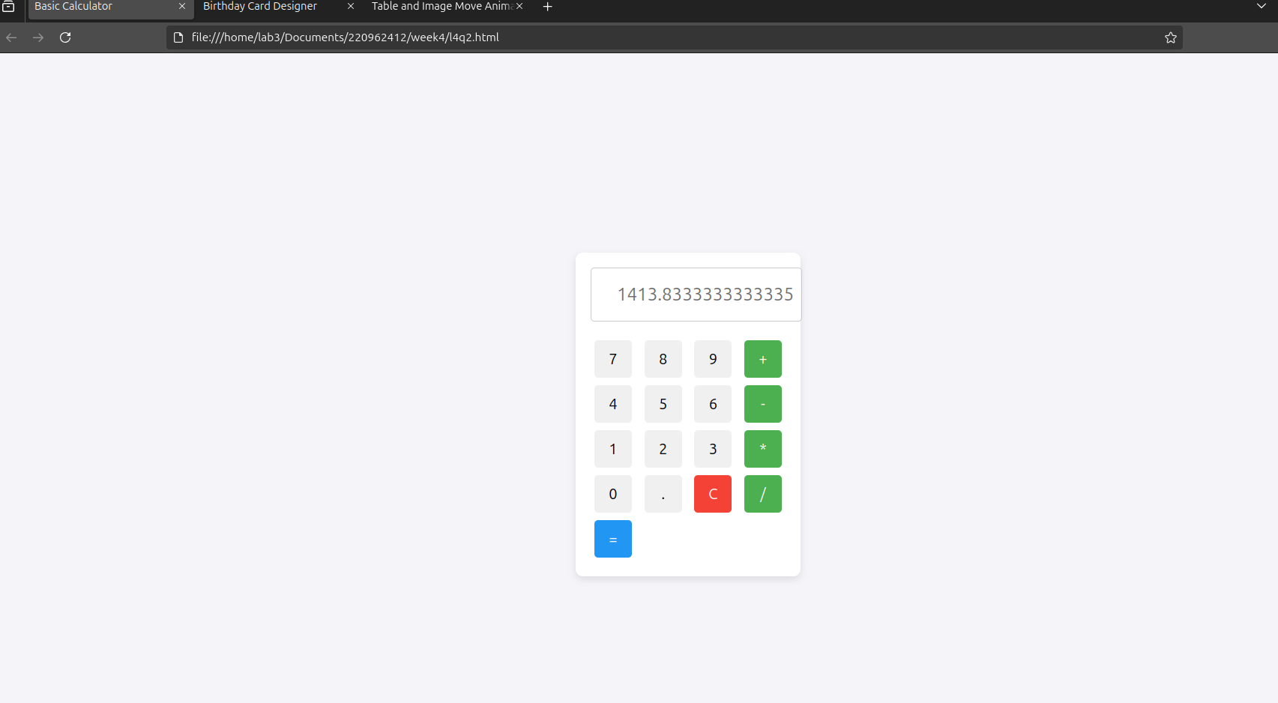

Q3)

<!DOCTYPE html>

<html lang="en">

<head>

<meta charset="UTF-8">

<meta name="viewport" content="width=device-width, initial-scale=1.0">

<title>Birthday Card Designer</title>

<script src="https://code.jquery.com/jquery-3.6.0.min.js"></script>

<style>

body {

font-family: Arial, sans-serif;

display: flex;

padding: 20px;

}

.controls {

width: 30%;

padding-right: 20px;

}

.card {

width: 300px;

height: 400px;

border: 2px solid black;

padding: 20px;

text-align: center;

}

.card img {

width: 80%;

margin-top: 20px;

}

</style>

</head>

<body>

<div class="controls">

<label>Choose a background color:</label>

<select id="bgColor">

<option value="yellow">Yellow</option>

<option value="blue">Blue</option>

<option value="green">Green</option>

</select>

<br><br>

<label>Choose a font:</label>

<select id="fontStyle">

<option value="Verdana">Verdana</option>

<option value="Arial">Arial</option>

<option value="Times New Roman">Times New Roman</option>

</select>

<br><br>

<label>Specify a numeric font size:</label>

<input type="number" id="fontSize" value="25">

<br><br>

<label>Choose a border style:</label>

<select id="borderStyle">

<option value="none">None</option>

<option value="double">Double</option>

<option value="solid">Solid</option>

</select>

<br><br>

<input type="checkbox" id="showImage" checked> Add the Default Picture

<br><br>

<label>Enter the greeting text below:</label>

<textarea id="greetingText">Happy Birthday, and many more</textarea>

<br><br>

<button id="updateBtn">Update</button>

</div>

<div class="card" id="card">

<p id="message" style="font-size: 25px; font-family: Verdana;">Happy Birthday, and many more</p>

<img id="birthdayImage" src="https://via.placeholder.com/150" alt="Birthday Cake">

</div>

<script>

$(document).ready(function() {

function updateCard() {

$("#card").css("background-color", $("#bgColor").val());

$("#message").css({

"font-family": $("#fontStyle").val(),

"font-size": $("#fontSize").val() + "px"

}).text($("#greetingText").val());

$("#card").css("border-style", $("#borderStyle").val());

$("#birthdayImage").toggle($("#showImage").is(":checked"));

}

$("#updateBtn, select, input, textarea").on("input change", updateCard);

});

</script>

</body>

</html>

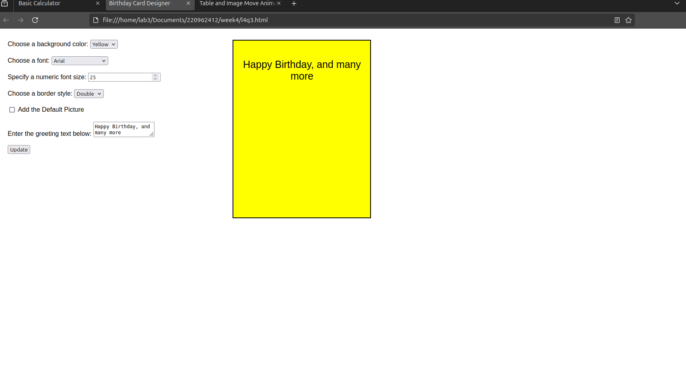Q4)

<!DOCTYPE html>

<html lang="en">

<head>

<meta charset="UTF-8">

<meta name="viewport" content="width=device-width, initial-scale=1.0">

<title>Product Bill Generator</title>

<script src="https://code.jquery.com/jquery-3.6.0.min.js"></script>

<style>

body {

font-family: Arial, sans-serif;

display: flex;

flex-direction: column;

align-items: center;

padding: 20px;

}

.container {

width: 300px;

padding: 20px;

border: 2px solid black;

text-align: center;

}

</style>

</head>

<body>

<div class="container">

<label>Choose a Brand:</label>

<select id="brand">

<option value="HP">HP</option>

<option value="Nokia">Nokia</option>

<option value="Samsung">Samsung</option>

<option value="Motorola">Motorola</option>

<option value="Apple">Apple</option>

</select>

<br><br>

<label>Choose a Product:</label><br>

<input type="checkbox" id="mobile" value="Mobile"> Mobile

<input type="checkbox" id="laptop" value="Laptop"> Laptop

<br><br>

<label>Enter Quantity:</label>

<input type="number" id="quantity" min="1" value="1">

<br><br>

<button id="produceBill">Produce Bill</button>

</div>

<script>

$(document).ready(function() {

$("#produceBill").click(function() {

let quantity = parseInt($("#quantity").val());

let total = 0;

if($("#mobile").is(":checked")) {

total += 200 \* quantity;

}

if($("#laptop").is(":checked")) {

total += 1000 \* quantity;

}

if(total > 0) {

alert("Total Amount: $" + total);

} else {

alert("Please select a product.");

}

});

});

</script>

</body>

</html>

