Ex no: 1 | Linked List
Date:

Question 1:

Aim:
To develop a C program to create and manage an audio playlist using linked list data structure. It helps to perform operations like adding, deleting and displaying songs dynamically.
Code:

#include <stdio.h>
#include <stdlib.h>
#include <string.h>

typedef struct Song {
char title[100];
struct Song *next;
} Song;

static void read_line(char *buffer, size_t size) {
if (fgets(buffer, (int) size, stdin) == NULL) {
buffer[0] = '\0';
return;
}
buffer[strcspn(buffer, "\n")] = '\0';
}

static Song *create_song(const char *title) {
Song *song = (Song *) malloc(sizeof(Song));
if (song == NULL) {
printf("Memory allocation failed.\n");
exit(EXIT_FAILURE);
}
strncpy(song->title, title, sizeof(song->title) - 1);
song->title[sizeof(song->title) - 1] = '\0';
song->next = NULL;
return song;
}

static void add_song(Song **head, const char *title) {
Song *song = create_song(title);
if (*head == NULL) {
*head = song;
return;
}

Song *temp = *head;
while (temp->next != NULL) {
temp = temp->next;
}
temp->next = song;
}

static void insert_after(Song *head, const char *after_title, const char *new_title) {
Song *temp = head;
while (temp != NULL && strcmp(temp->title, after_title) != 0) {
temp = temp->next;
}

if (temp == NULL) {
printf("Song not found in playlist.\n");
return;
}

Song *song = create_song(new_title);
song->next = temp->next;
temp->next = song;
}

static void delete_song(Song **head, const char *title) {
Song *temp = *head;
Song *prev = NULL;

while (temp != NULL && strcmp(temp->title, title) != 0) {
prev = temp;
temp = temp->next;
}

if (temp == NULL) {
printf("Song not found.\n");
return;
}

if (prev == NULL) {
*head = temp->next;
} else {
prev->next = temp->next;
}
free(temp);
printf("Song removed from playlist.\n");
}

static void display_playlist(Song *head) {
if (head == NULL) {
printf("Playlist is empty.\n");
return;
}

printf("\nPlaylist:\n");
int index = 1;
while (head != NULL) {
printf("%d. %s\n", index++, head->title);
head = head->next;
}
}

static void free_playlist(Song *head) {
while (head != NULL) {
Song *next = head->next;
free(head);
head = next;
}
}

int main(void) {
Song *playlist = NULL;
int choice;
char title[100];
char after_title[100];

while (1) {
printf("\nAudio Player Playlist Menu\n");
printf("1. Add song\n");
printf("2. Insert song after another song\n");
printf("3. Delete song\n");
printf("4. Display playlist\n");
printf("5. Exit\n");
printf("Enter your choice: ");
if (scanf("%d", &choice) != 1) {
break;
}
getchar();

switch (choice) {
case 1:
printf("Enter song title: ");
read_line(title, sizeof(title));
add_song(&playlist, title);
break;
case 2:
printf("Enter existing song title: ");
read_line(after_title, sizeof(after_title));
printf("Enter new song title: ");
read_line(title, sizeof(title));
insert_after(playlist, after_title, title);
break;
case 3:
printf("Enter song title to delete: ");
read_line(title, sizeof(title));
delete_song(&playlist, title);
break;
case 4:
display_playlist(playlist);
break;
case 5:
free_playlist(playlist);
return 0;
default:
printf("Invalid choice.\n");
}
}

free_playlist(playlist);
return 0;
}

Output:
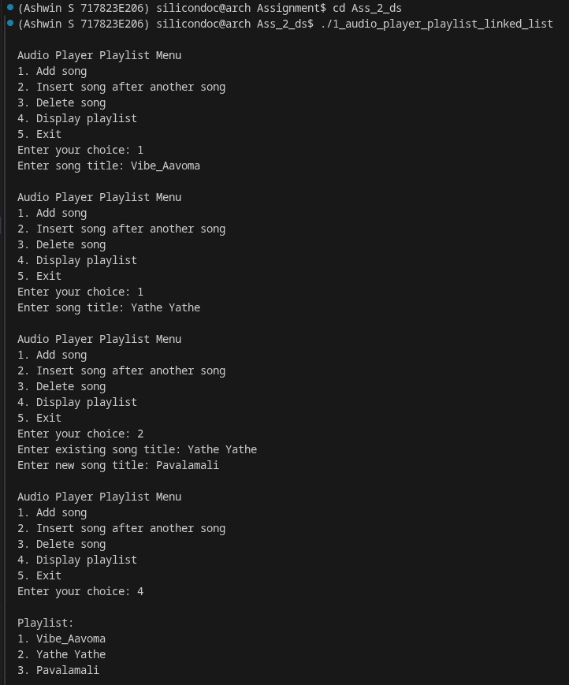

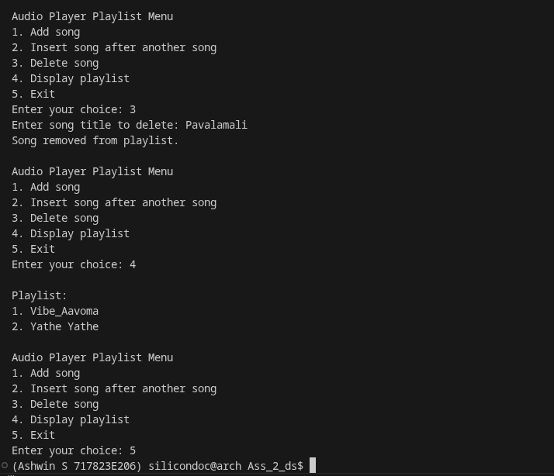

Result:
Thus the C program for audio playlist management was compiled and executed successfully. The playlist operations were performed correctly and the output was verified.

Question 2:
Write a C program to create a Congo line using linked list
Aim:
To write a C program to simulate the formation of a congo line using linked list. This program demonstrates dynamic insertion and traversal of nodes.

Code:

#include <stdio.h>
#include <stdlib.h>
#include <string.h>

typedef struct Person {
char name[100];
struct Person *next;
} Person;

static void read_line(char *buffer, size_t size) {
if (fgets(buffer, (int) size, stdin) == NULL) {
buffer[0] = '\0';
return;
}
buffer[strcspn(buffer, "\n")] = '\0';
}

static Person *create_person(const char *name) {
Person *person = (Person *) malloc(sizeof(Person));
if (person == NULL) {
printf("Memory allocation failed.\n");
exit(EXIT_FAILURE);
}
strncpy(person->name, name, sizeof(person->name) - 1);
person->name[sizeof(person->name) - 1] = '\0';
person->next = NULL;
return person;
}

static void join_end(Person **head, const char *name) {
Person *person = create_person(name);
if (*head == NULL) {
*head = person;
return;
}

Person *temp = *head;
while (temp->next != NULL) {
temp = temp->next;
}
temp->next = person;
}

static void join_front(Person **head, const char *name) {
Person *person = create_person(name);
person->next = *head;
*head = person;
}

static void remove_person(Person **head, const char *name) {
Person *temp = *head;
Person *prev = NULL;

while (temp != NULL && strcmp(temp->name, name) != 0) {
prev = temp;
temp = temp->next;
}

if (temp == NULL) {
printf("Person not found in the congo line.\n");
return;
}

if (prev == NULL) {
*head = temp->next;
} else {
prev->next = temp->next;
}
free(temp);
}

static void display_line(Person *head) {
if (head == NULL) {
printf("The congo line is empty.\n");
return;
}

printf("\nCongo line order:\n");
while (head != NULL) {
printf("%s", head->name);
head = head->next;
if (head != NULL) {
printf(" -> ");
}
}
printf("\n");
}

static void free_line(Person *head) {
while (head != NULL) {
Person *next = head->next;
free(head);
head = next;
}
}

int main(void) {
Person *head = NULL;
int choice;
char name[100];

while (1) {
printf("\nCongo Line Menu\n");
printf("1. Join at end\n");
printf("2. Join at front\n");
printf("3. Remove person\n");
printf("4. Display line\n");
printf("5. Exit\n");
printf("Enter your choice: ");
if (scanf("%d", &choice) != 1) {
break;
}
getchar();

switch (choice) {
case 1:
printf("Enter person name: ");
read_line(name, sizeof(name));
join_end(&head, name);
break;
case 2:
printf("Enter person name: ");
read_line(name, sizeof(name));
join_front(&head, name);
break;
case 3:
printf("Enter name to remove: ");
read_line(name, sizeof(name));
remove_person(&head, name);
break;
case 4:
display_line(head);
break;
case 5:
free_line(head);
return 0;
default:
printf("Invalid choice.\n");
}
}

free_line(head);
return 0;
}

Output:

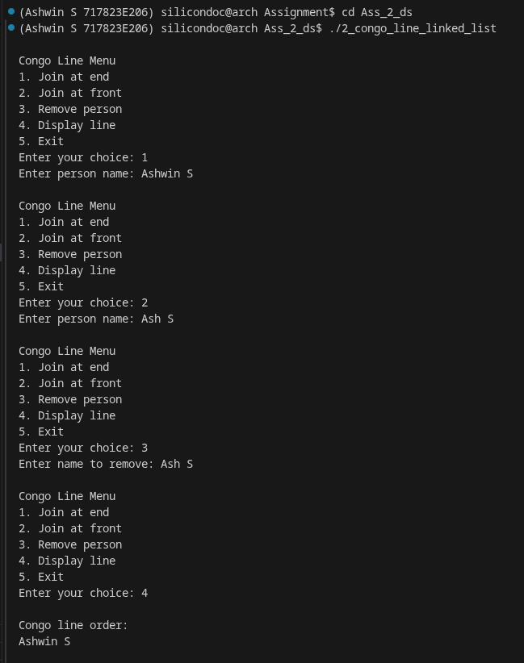
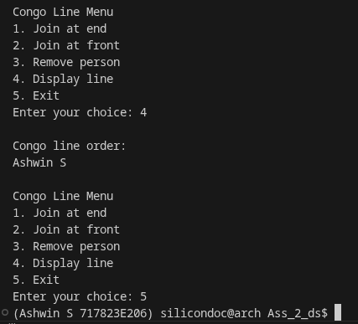

Result:
Thus the congo line simulation program was executed successfully. The members were arranged and displayed in sequence and the output was verified.
Question 3:
Write a C program to implement scavenger hunt or treasure hunt using linked list.
Aim:
To implement a scavenger hunt game by storing and accessing clues using linked list. This helps to understand sequential data access.

Code:

#include <stdio.h>
#include <stdlib.h>
#include <string.h>

typedef struct Clue {
char text[200];
int completed;
struct Clue *next;
} Clue;

static void read_line(char *buffer, size_t size) {
if (fgets(buffer, (int) size, stdin) == NULL) {
buffer[0] = '\0';
return;
}
buffer[strcspn(buffer, "\n")] = '\0';
}

static Clue *create_clue(const char *text) {
Clue *clue = (Clue *) malloc(sizeof(Clue));
if (clue == NULL) {
printf("Memory allocation failed.\n");
exit(EXIT_FAILURE);
}
strncpy(clue->text, text, sizeof(clue->text) - 1);
clue->text[sizeof(clue->text) - 1] = '\0';
clue->completed = 0;
clue->next = NULL;
return clue;
}

static void add_clue(Clue **head, const char *text) {
Clue *clue = create_clue(text);
if (*head == NULL) {
*head = clue;
return;
}

Clue *temp = *head;
while (temp->next != NULL) {
temp = temp->next;
}
temp->next = clue;
}

static void mark_next_completed(Clue *head) {
while (head != NULL && head->completed) {
head = head->next;
}

if (head == NULL) {
printf("All clues are already completed.\n");
return;
}

head->completed = 1;
printf("Completed clue: %s\n", head->text);
}

static void display_clues(Clue *head) {
if (head == NULL) {
printf("No clues available.\n");
return;
}

int index = 1;
while (head != NULL) {
printf("%d. [%s] %s\n", index++, head->completed ? "Done" : "Pending", head->text);
head = head->next;
}
}

static void find_clue(Clue *head, const char *keyword) {
int found = 0;
while (head != NULL) {
if (strstr(head->text, keyword) != NULL) {
printf("Found clue: %s\n", head->text);
found = 1;
}
head = head->next;
}

if (!found) {
printf("No clue matched the keyword.\n");
}
}

static void free_clues(Clue *head) {
while (head != NULL) {
Clue *next = head->next;
free(head);
head = next;
}
}

int main(void) {
Clue *head = NULL;
int choice;
char text[200];

while (1) {
printf("\nScavenger Hunt Menu\n");
printf("1. Add clue\n");
printf("2. Mark next clue as completed\n");
printf("3. Display all clues\n");
printf("4. Search clue by keyword\n");
printf("5. Exit\n");
printf("Enter your choice: ");
if (scanf("%d", &choice) != 1) {
break;
}
getchar();

switch (choice) {
case 1:
printf("Enter clue text: ");
read_line(text, sizeof(text));
add_clue(&head, text);
break;
case 2:
mark_next_completed(head);
break;
case 3:
display_clues(head);
break;
case 4:
printf("Enter keyword: ");
read_line(text, sizeof(text));
find_clue(head, text);
break;
case 5:
free_clues(head);
return 0;
default:
printf("Invalid choice.\n");
}
}

free_clues(head);
return 0;
}

Output:

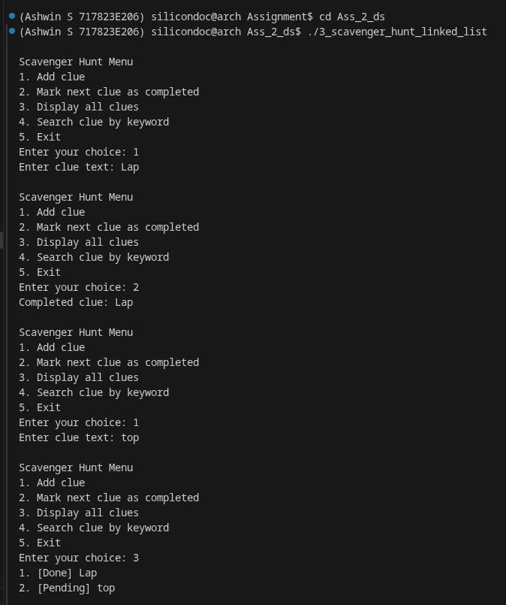
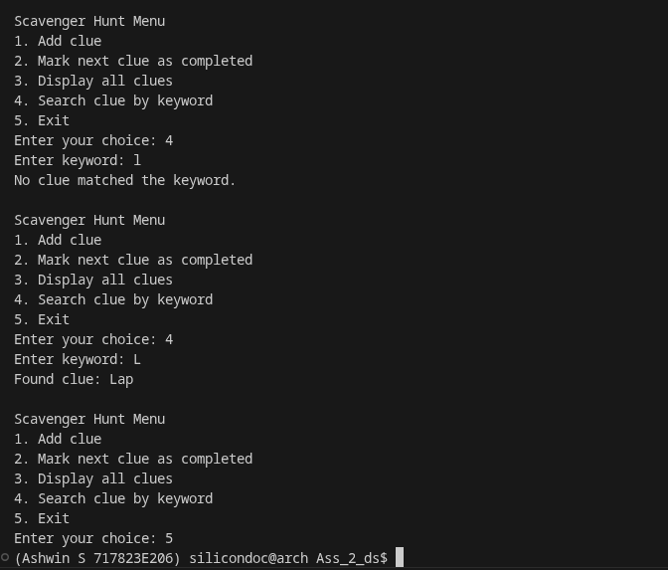

Result:
Thus the scavenger hunt program was executed successfully. The clues were stored and retrieved correctly and the output was verified.

Question 4:
A game is played by always eliminating the kth player from the last elimination and played until one player is left. Given N players where each is assigned to a number, find the number of the last remaining player. Write a C program to implement this game using linked list.

Aim:
To develop a C program to simulate the elimination game using circular linked list. The program identifies the last remaining player after repeated eliminations

Code:

#include <stdio.h>
#include <stdlib.h>

typedef struct Player {
int id;
struct Player *next;
} Player;

static Player *create_circle(int n) {
Player *head = NULL;
Player *tail = NULL;

for (int i = 1; i <= n; ++i) {
Player *node = (Player *) malloc(sizeof(Player));
if (node == NULL) {
printf("Memory allocation failed.\n");
exit(EXIT_FAILURE);
}
node->id = i;
node->next = NULL;

if (head == NULL) {
head = tail = node;
} else {
tail->next = node;
tail = node;
}
}

if (tail != NULL) {
tail->next = head;
}
return tail;
}

int main(void) {
int n;
int k;

printf("Enter number of players: ");
scanf("%d", &n);
printf("Enter elimination step k: ");
scanf("%d", &k);

if (n <= 0 || k <= 0) {
printf("N and k must be positive.\n");
return 0;
}

Player *tail = create_circle(n);
Player *prev = tail;

printf("Elimination order: ");
while (prev->next != prev) {
for (int step = 1; step < k; ++step) {
prev = prev->next;
}

Player *removed = prev->next;
printf("%d ", removed->id);
prev->next = removed->next;
if (removed == tail) {
tail = prev;
}
free(removed);
}

printf("\nLast remaining player: %d\n", prev->id);
free(prev);
return 0;
}

Output:

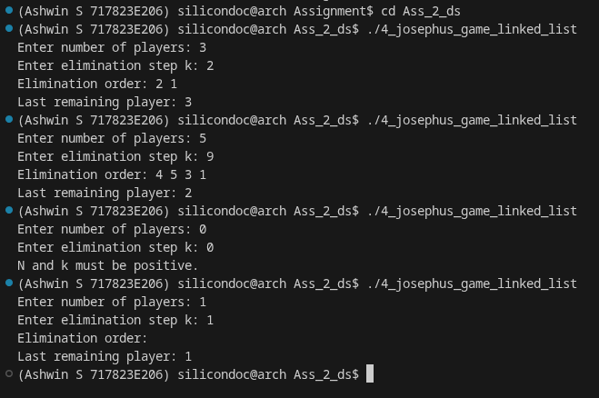

Result:
Thus the Josephus game program was executed successfully. The final remaining player was identified correctly and the result was verified.

Question 5:
Write a C program to implement the history list of the file directories, traversal to the previous or next directory using linked list.
Aim:
To write a C program to maintain directory navigation history using linked list. It allows traversal to previous and next directories.

Code:

#include <stdio.h>
#include <stdlib.h>
#include <string.h>

typedef struct HistoryNode {
char path[256];
struct HistoryNode *prev;
struct HistoryNode *next;
} HistoryNode;

static void read_line(char *buffer, size_t size) {
if (fgets(buffer, (int) size, stdin) == NULL) {
buffer[0] = '\0';
return;
}
buffer[strcspn(buffer, "\n")] = '\0';
}

static HistoryNode *create_node(const char *path) {
HistoryNode *node = (HistoryNode *) malloc(sizeof(HistoryNode));
if (node == NULL) {
printf("Memory allocation failed.\n");
exit(EXIT_FAILURE);
}
strncpy(node->path, path, sizeof(node->path) - 1);
node->path[sizeof(node->path) - 1] = '\0';
node->prev = NULL;
node->next = NULL;
return node;
}

static void free_forward(HistoryNode *node) {
while (node != NULL) {
HistoryNode *next = node->next;
free(node);
node = next;
}
}

static void visit_directory(HistoryNode **current, const char *path) {
HistoryNode *new_node = create_node(path);

if (*current == NULL) {
*current = new_node;
return;
}

free_forward((*current)->next);
(*current)->next = new_node;
new_node->prev = *current;
*current = new_node;
}

static void show_history(HistoryNode *current) {
if (current == NULL) {
printf("History is empty.\n");
return;
}

while (current->prev != NULL) {
current = current->prev;
}

printf("\nDirectory history:\n");
while (current != NULL) {
printf("%s\n", current->path);
current = current->next;
}
}

static void free_all(HistoryNode *current) {
if (current == NULL) {
return;
}

while (current->prev != NULL) {
current = current->prev;
}
free_forward(current);
}

int main(void) {
HistoryNode *current = NULL;
int choice;
char path[256];

while (1) {
printf("\nDirectory History Menu\n");
printf("1. Visit directory\n");
printf("2. Go to previous directory\n");
printf("3. Go to next directory\n");
printf("4. Show current directory\n");
printf("5. Show full history\n");
printf("6. Exit\n");
printf("Enter your choice: ");
if (scanf("%d", &choice) != 1) {
break;
}
getchar();

switch (choice) {
case 1:
printf("Enter directory path: ");
read_line(path, sizeof(path));
visit_directory(&current, path);
break;
case 2:
if (current != NULL && current->prev != NULL) {
current = current->prev;
printf("Moved to: %s\n", current->path);
} else {
printf("No previous directory.\n");
}
break;
case 3:
if (current != NULL && current->next != NULL) {
current = current->next;
printf("Moved to: %s\n", current->path);
} else {
printf("No next directory.\n");
}
break;
case 4:
if (current != NULL) {
printf("Current directory: %s\n", current->path);
} else {
printf("History is empty.\n");
}
break;
case 5:
show_history(current);
break;
case 6:
free_all(current);
return 0;
default:
printf("Invalid choice.\n");
}
}

free_all(current);
return 0;
}

Output:

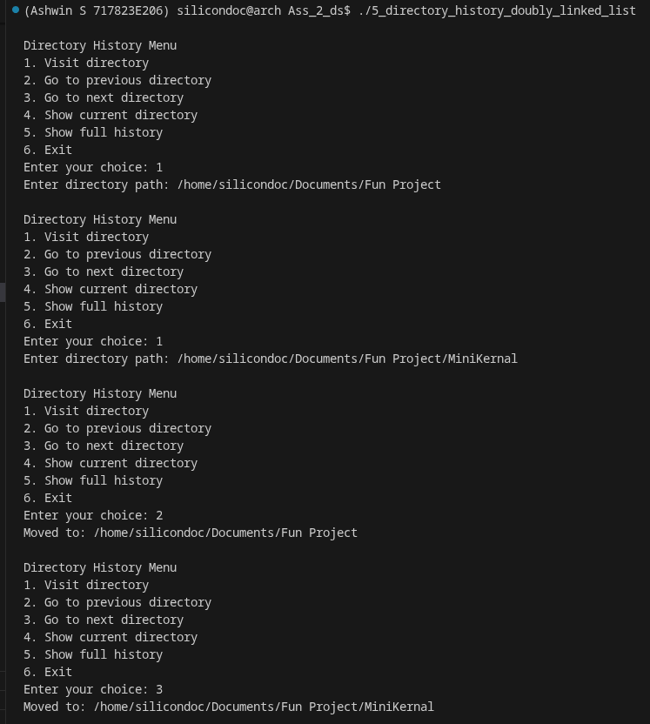
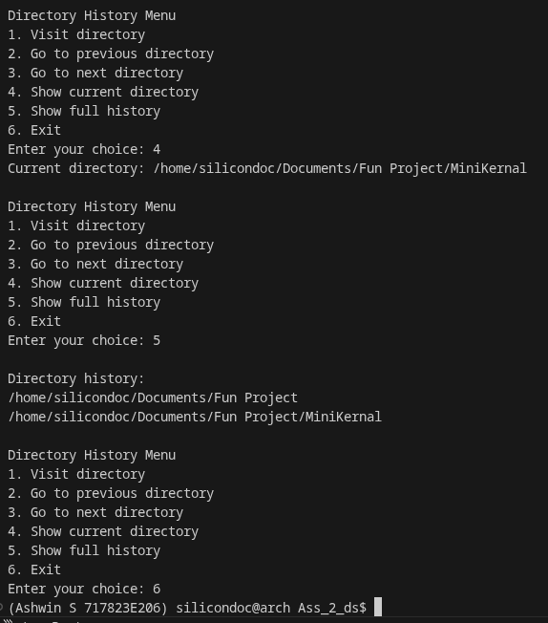

Result:
Thus the directory navigation program was executed successfully. The movement between directories was performed correctly and verified.
Question 6:
Write a C program to implementation hash tables using linked list
Aim:
To implement hashing technique using linked list to handle collisions. This program demonstrates separate chaining method.

Code:

#include <stdio.h>
#include <stdlib.h>
#include <string.h>

#define TABLE_SIZE 13

typedef struct Entry {
char key[100];
int value;
struct Entry *next;
} Entry;

static void read_line(char *buffer, size_t size) {
if (fgets(buffer, (int) size, stdin) == NULL) {
buffer[0] = '\0';
return;
}
buffer[strcspn(buffer, "\n")] = '\0';
}

static unsigned int hash_key(const char *key) {
unsigned int hash = 0;
while (*key != '\0') {
hash = hash * 31u + (unsigned char) *key++;
}
return hash % TABLE_SIZE;
}

static void insert_entry(Entry *table[], const char *key, int value) {
unsigned int index = hash_key(key);
Entry *temp = table[index];

while (temp != NULL) {
if (strcmp(temp->key, key) == 0) {
temp->value = value;
printf("Updated existing key.\n");
return;
}
temp = temp->next;
}

Entry *entry = (Entry *) malloc(sizeof(Entry));
if (entry == NULL) {
printf("Memory allocation failed.\n");
exit(EXIT_FAILURE);
}

strncpy(entry->key, key, sizeof(entry->key) - 1);
entry->key[sizeof(entry->key) - 1] = '\0';
entry->value = value;
entry->next = table[index];
table[index] = entry;
}

static void search_entry(Entry *table[], const char *key) {
unsigned int index = hash_key(key);
Entry *temp = table[index];

while (temp != NULL) {
if (strcmp(temp->key, key) == 0) {
printf("Key found. Value = %d\n", temp->value);
return;
}
temp = temp->next;
}

printf("Key not found.\n");
}

static void delete_entry(Entry *table[], const char *key) {
unsigned int index = hash_key(key);
Entry *temp = table[index];
Entry *prev = NULL;

while (temp != NULL && strcmp(temp->key, key) != 0) {
prev = temp;
temp = temp->next;
}

if (temp == NULL) {
printf("Key not found.\n");
return;
}

if (prev == NULL) {
table[index] = temp->next;
} else {
prev->next = temp->next;
}
free(temp);
printf("Key deleted.\n");
}

static void display_table(Entry *table[]) {
for (int i = 0; i < TABLE_SIZE; ++i) {
printf("[%d] ", i);
Entry *temp = table[i];
while (temp != NULL) {
printf("(%s, %d) -> ", temp->key, temp->value);
temp = temp->next;
}
printf("NULL\n");
}
}

static void free_table(Entry *table[]) {
for (int i = 0; i < TABLE_SIZE; ++i) {
Entry *temp = table[i];
while (temp != NULL) {
Entry *next = temp->next;
free(temp);
temp = next;
}
}
}

int main(void) {
Entry *table[TABLE_SIZE] = {0};
int choice;
int value;
char key[100];

while (1) {
printf("\nHash Table Menu\n");
printf("1. Insert or update key\n");
printf("2. Search key\n");
printf("3. Delete key\n");
printf("4. Display table\n");
printf("5. Exit\n");
printf("Enter your choice: ");
if (scanf("%d", &choice) != 1) {
break;
}
getchar();

switch (choice) {
case 1:
printf("Enter key: ");
read_line(key, sizeof(key));
printf("Enter integer value: ");
scanf("%d", &value);
getchar();
insert_entry(table, key, value);
break;
case 2:
printf("Enter key to search: ");
read_line(key, sizeof(key));
search_entry(table, key);
break;
case 3:
printf("Enter key to delete: ");
read_line(key, sizeof(key));
delete_entry(table, key);
break;
case 4:
display_table(table);
break;
case 5:
free_table(table);
return 0;
default:
printf("Invalid choice.\n");
}
}

free_table(table);
return 0;
}

Output:

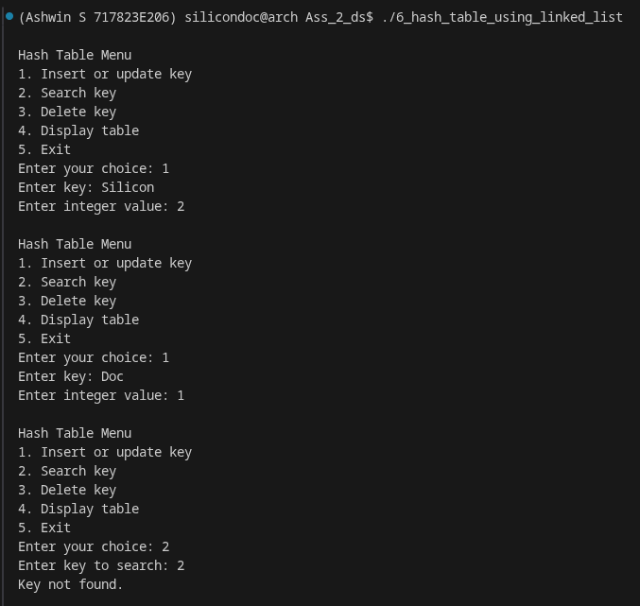

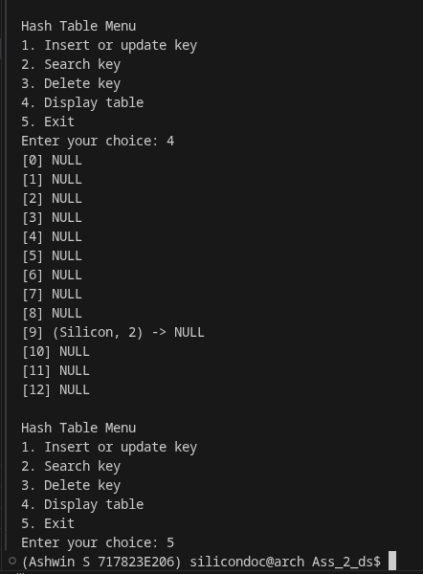
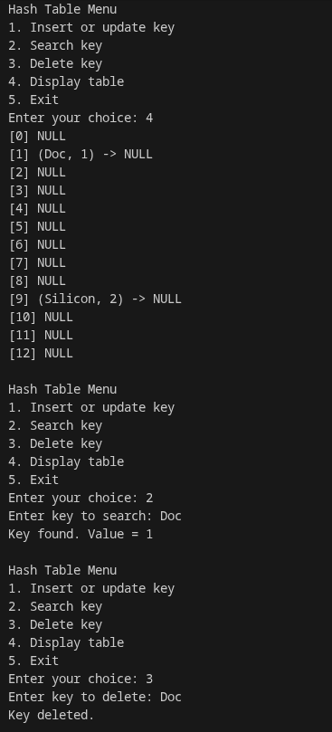

Result:
Thus the hash table program was executed successfully. The keys were inserted and displayed correctly and the output was verified.

Question 7:
Write a C program to implement a tree to identify the car manufacturer and car type by providing car name.

Aim:
To develop a C program using tree structure to identify car manufacturer and type. This shows hierarchical data representation.

Code:

#include <stdio.h>
#include <stdlib.h>
#include <string.h>

typedef struct CarNode {
char car_name[100];
char manufacturer[100];
char type[100];
struct CarNode *left;
struct CarNode *right;
} CarNode;

static void read_line(char *buffer, size_t size) {
if (fgets(buffer, (int) size, stdin) == NULL) {
buffer[0] = '\0';
return;
}
buffer[strcspn(buffer, "\n")] = '\0';
}

static CarNode *create_car(const char *name, const char *manufacturer, const char *type) {
CarNode *node = (CarNode *) malloc(sizeof(CarNode));
if (node == NULL) {
printf("Memory allocation failed.\n");
exit(EXIT_FAILURE);
}
strncpy(node->car_name, name, sizeof(node->car_name) - 1);
node->car_name[sizeof(node->car_name) - 1] = '\0';
strncpy(node->manufacturer, manufacturer, sizeof(node->manufacturer) - 1);
node->manufacturer[sizeof(node->manufacturer) - 1] = '\0';
strncpy(node->type, type, sizeof(node->type) - 1);
node->type[sizeof(node->type) - 1] = '\0';
node->left = NULL;
node->right = NULL;
return node;
}

static CarNode *insert_car(CarNode *root, const char *name, const char *manufacturer, const char *type) {
if (root == NULL) {
return create_car(name, manufacturer, type);
}

int compare = strcmp(name, root->car_name);
if (compare < 0) {
root->left = insert_car(root->left, name, manufacturer, type);
} else if (compare > 0) {
root->right = insert_car(root->right, name, manufacturer, type);
} else {
strncpy(root->manufacturer, manufacturer, sizeof(root->manufacturer) - 1);
root->manufacturer[sizeof(root->manufacturer) - 1] = '\0';
strncpy(root->type, type, sizeof(root->type) - 1);
root->type[sizeof(root->type) - 1] = '\0';
}
return root;
}

static CarNode *search_car(CarNode *root, const char *name) {
while (root != NULL) {
int compare = strcmp(name, root->car_name);
if (compare == 0) {
return root;
}
root = (compare < 0) ? root->left : root->right;
}
return NULL;
}

static void inorder(CarNode *root) {
if (root == NULL) {
return;
}
inorder(root->left);
printf("Car: %-20s Manufacturer: %-15s Type: %s\n", root->car_name, root->manufacturer, root->type);
inorder(root->right);
}

static void free_tree(CarNode *root) {
if (root == NULL) {
return;
}
free_tree(root->left);
free_tree(root->right);
free(root);
}

int main(void) {
CarNode *root = NULL;
int choice;
char name[100];
char manufacturer[100];
char type[100];

while (1) {
printf("\nCar Lookup Tree Menu\n");
printf("1. Add or update car\n");
printf("2. Search by car name\n");
printf("3. Display all cars\n");
printf("4. Exit\n");
printf("Enter your choice: ");
if (scanf("%d", &choice) != 1) {
break;
}
getchar();

switch (choice) {
case 1:
printf("Enter car name: ");
read_line(name, sizeof(name));
printf("Enter manufacturer: ");
read_line(manufacturer, sizeof(manufacturer));
printf("Enter car type: ");
read_line(type, sizeof(type));
root = insert_car(root, name, manufacturer, type);
break;
case 2:
printf("Enter car name to search: ");
read_line(name, sizeof(name));
{
CarNode *result = search_car(root, name);
if (result != NULL) {
printf("Manufacturer: %s\nType: %s\n", result->manufacturer, result->type);
} else {
printf("Car not found.\n");
}
}
break;
case 3:
if (root == NULL) {
printf("Tree is empty.\n");
} else {
inorder(root);
}
break;
case 4:
free_tree(root);
return 0;
default:
printf("Invalid choice.\n");
}
}

free_tree(root);
return 0;
}
Output:
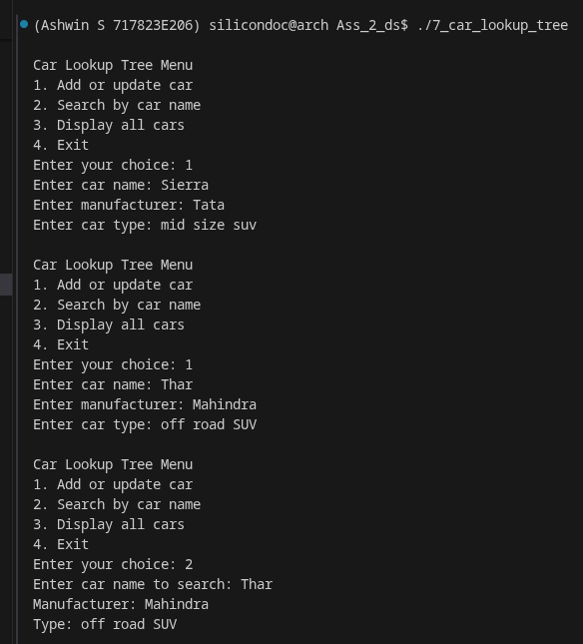
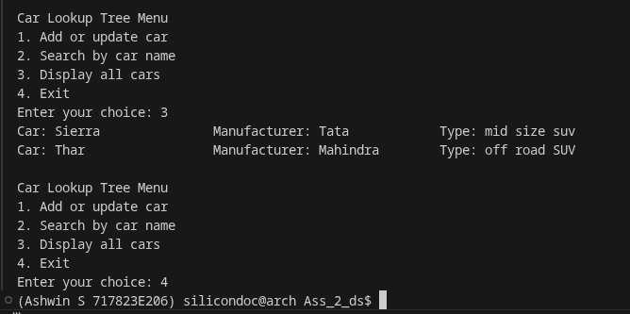

Result:
Thus the car identification program was executed successfully. The required car details were displayed correctly and verified.
Question 8:
Write a C program to implement a Graph using linked list.

Aim:
To represent and implement a graph using adjacency list representation. This program demonstrates graph traversal and storage.

Code:

#include <stdio.h>
#include <stdlib.h>

#define MAX_VERTICES 20

typedef struct AdjNode {
int dest;
struct AdjNode *next;
} AdjNode;

typedef struct {
AdjNode *head[MAX_VERTICES];
int vertices;
} Graph;

static AdjNode *create_node(int dest) {
AdjNode *node = (AdjNode *) malloc(sizeof(AdjNode));
if (node == NULL) {
printf("Memory allocation failed.\n");
exit(EXIT_FAILURE);
}
node->dest = dest;
node->next = NULL;
return node;
}

static void init_graph(Graph *graph, int vertices) {
graph->vertices = vertices;
for (int i = 0; i < MAX_VERTICES; ++i) {
graph->head[i] = NULL;
}
}

static void add_edge(Graph *graph, int src, int dest) {
if (src < 0 || src >= graph->vertices || dest < 0 || dest >= graph->vertices) {
printf("Invalid vertices.\n");
return;
}

AdjNode *node = create_node(dest);
node->next = graph->head[src];
graph->head[src] = node;

node = create_node(src);
node->next = graph->head[dest];
graph->head[dest] = node;
}

static void display_graph(const Graph *graph) {
for (int i = 0; i < graph->vertices; ++i) {
printf("%d:", i);
AdjNode *temp = graph->head[i];
while (temp != NULL) {
printf(" %d", temp->dest);
temp = temp->next;
}
printf("\n");
}
}

static void bfs(const Graph *graph, int start) {
if (start < 0 || start >= graph->vertices) {
printf("Invalid start vertex.\n");
return;
}

int visited[MAX_VERTICES] = {0};
int queue[MAX_VERTICES];
int front = 0;
int rear = 0;

visited[start] = 1;
queue[rear++] = start;

printf("BFS traversal: ");
while (front < rear) {
int vertex = queue[front++];
printf("%d ", vertex);

AdjNode *temp = graph->head[vertex];
while (temp != NULL) {
if (!visited[temp->dest]) {
visited[temp->dest] = 1;
queue[rear++] = temp->dest;
}
temp = temp->next;
}
}
printf("\n");
}

static void dfs_recursive(const Graph *graph, int vertex, int visited[]) {
visited[vertex] = 1;
printf("%d ", vertex);

AdjNode *temp = graph->head[vertex];
while (temp != NULL) {
if (!visited[temp->dest]) {
dfs_recursive(graph, temp->dest, visited);
}
temp = temp->next;
}
}

static void dfs(const Graph *graph, int start) {
if (start < 0 || start >= graph->vertices) {
printf("Invalid start vertex.\n");
return;
}

int visited[MAX_VERTICES] = {0};
printf("DFS traversal: ");
dfs_recursive(graph, start, visited);
printf("\n");
}

static void free_graph(Graph *graph) {
for (int i = 0; i < graph->vertices; ++i) {
AdjNode *temp = graph->head[i];
while (temp != NULL) {
AdjNode *next = temp->next;
free(temp);
temp = next;
}
}
}

int main(void) {
Graph graph;
int vertices;
int choice;
int src;
int dest;
int start;

printf("Enter number of vertices (max %d): ", MAX_VERTICES);
scanf("%d", &vertices);
if (vertices <= 0 || vertices > MAX_VERTICES) {
printf("Invalid number of vertices.\n");
return 0;
}

init_graph(&graph, vertices);

while (1) {
printf("\nGraph Menu\n");
printf("1. Add edge\n");
printf("2. Display adjacency list\n");
printf("3. BFS traversal\n");
printf("4. DFS traversal\n");
printf("5. Exit\n");
printf("Enter your choice: ");
if (scanf("%d", &choice) != 1) {
break;
}

switch (choice) {
case 1:
printf("Enter source and destination: ");
scanf("%d %d", &src, &dest);
add_edge(&graph, src, dest);
break;
case 2:
display_graph(&graph);
break;
case 3:
printf("Enter start vertex: ");
scanf("%d", &start);
bfs(&graph, start);
break;
case 4:
printf("Enter start vertex: ");
scanf("%d", &start);
dfs(&graph, start);
break;
case 5:
free_graph(&graph);
return 0;
default:
printf("Invalid choice.\n");
}
}

free_graph(&graph);
return 0;
}

Output:

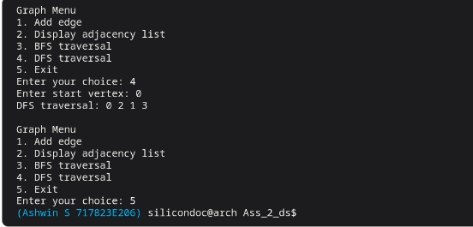

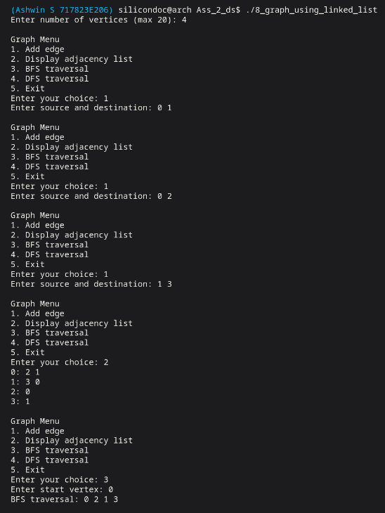

Result:
Thus the graph implementation program was executed successfully. The graph structure was created and displayed correctly.

Question 9:
Write a C program to implement a Scheduler which uses linked list
Aim:
To write a C program to simulate task scheduling using linked list. Tasks are arranged and executed sequentially.
Code:

#include <stdio.h>
#include <stdlib.h>
#include <string.h>

typedef struct Task {
char name[100];
int arrival_time;
int burst_time;
struct Task *next;
} Task;

static void read_line(char *buffer, size_t size) {
if (fgets(buffer, (int) size, stdin) == NULL) {
buffer[0] = '\0';
return;
}
buffer[strcspn(buffer, "\n")] = '\0';
}

static Task *create_task(const char *name, int arrival, int burst) {
Task *task = (Task *) malloc(sizeof(Task));
if (task == NULL) {
printf("Memory allocation failed.\n");
exit(EXIT_FAILURE);
}
strncpy(task->name, name, sizeof(task->name) - 1);
task->name[sizeof(task->name) - 1] = '\0';
task->arrival_time = arrival;
task->burst_time = burst;
task->next = NULL;
return task;
}

static void schedule_task(Task **head, const char *name, int arrival, int burst) {
Task *task = create_task(name, arrival, burst);

if (*head == NULL || arrival < (*head)->arrival_time) {
task->next = *head;
*head = task;
return;
}

Task *temp = *head;
while (temp->next != NULL && temp->next->arrival_time <= arrival) {
temp = temp->next;
}
task->next = temp->next;
temp->next = task;
}

static void run_next_task(Task **head, int *current_time) {
if (*head == NULL) {
printf("No tasks scheduled.\n");
return;
}

Task *task = *head;
*head = task->next;

if (*current_time < task->arrival_time) {
*current_time = task->arrival_time;
}

printf("Running task %s from time %d to %d\n",
task->name, *current_time, *current_time + task->burst_time);
*current_time += task->burst_time;
free(task);
}

static void display_tasks(Task *head) {
if (head == NULL) {
printf("Scheduler queue is empty.\n");
return;
}

printf("\nPending tasks:\n");
while (head != NULL) {
printf("Task: %-15s Arrival: %-4d Burst: %d\n",
head->name, head->arrival_time, head->burst_time);
head = head->next;
}
}

static void free_tasks(Task *head) {
while (head != NULL) {
Task *next = head->next;
free(head);
head = next;
}
}

int main(void) {
Task *head = NULL;
int current_time = 0;
int choice;
int arrival;
int burst;
char name[100];

while (1) {
printf("\nScheduler Menu\n");
printf("1. Add task\n");
printf("2. Run next task\n");
printf("3. Display pending tasks\n");
printf("4. Exit\n");
printf("Enter your choice: ");
if (scanf("%d", &choice) != 1) {
break;
}
getchar();

switch (choice) {
case 1:
printf("Enter task name: ");
read_line(name, sizeof(name));
printf("Enter arrival time: ");
scanf("%d", &arrival);
printf("Enter burst time: ");
scanf("%d", &burst);
getchar();
schedule_task(&head, name, arrival, burst);
break;
case 2:
run_next_task(&head, &current_time);
break;
case 3:
display_tasks(head);
break;
case 4:
free_tasks(head);
return 0;
default:
printf("Invalid choice.\n");
}
}

free_tasks(head);
return 0;
}

Output:

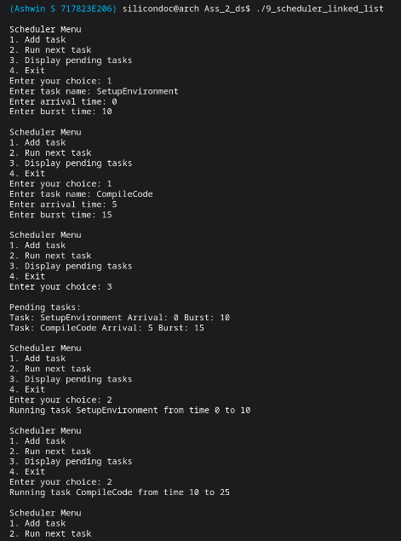
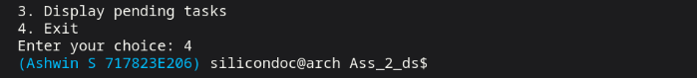

Result:
Thus the scheduler program was executed successfully. The tasks were scheduled in proper order and verified.

Question 10:
Write a C program to implement device node adding and deletion using linked list

Aim:
To develop a C program to add and delete device nodes using linked list. This helps in dynamic device management.

Code:

#include <stdio.h>
#include <stdlib.h>
#include <string.h>

typedef struct Device {
int id;
char name[100];
char type[100];
struct Device *next;
} Device;

static void read_line(char *buffer, size_t size) {
if (fgets(buffer, (int) size, stdin) == NULL) {
buffer[0] = '\0';
return;
}
buffer[strcspn(buffer, "\n")] = '\0';
}

static Device *create_device(int id, const char *name, const char *type) {
Device *device = (Device *) malloc(sizeof(Device));
if (device == NULL) {
printf("Memory allocation failed.\n");
exit(EXIT_FAILURE);
}
device->id = id;
strncpy(device->name, name, sizeof(device->name) - 1);
device->name[sizeof(device->name) - 1] = '\0';
strncpy(device->type, type, sizeof(device->type) - 1);
device->type[sizeof(device->type) - 1] = '\0';
device->next = NULL;
return device;
}

static void add_device(Device **head, int id, const char *name, const char *type) {
Device *device = create_device(id, name, type);
if (*head == NULL) {
*head = device;
return;
}

Device *temp = *head;
while (temp->next != NULL) {
temp = temp->next;
}
temp->next = device;
}

static void delete_device(Device **head, int id) {
Device *temp = *head;
Device *prev = NULL;

while (temp != NULL && temp->id != id) {
prev = temp;
temp = temp->next;
}

if (temp == NULL) {
printf("Device not found.\n");
return;
}

if (prev == NULL) {
*head = temp->next;
} else {
prev->next = temp->next;
}
free(temp);
printf("Device deleted successfully.\n");
}

static void display_devices(Device *head) {
if (head == NULL) {
printf("No devices available.\n");
return;
}

printf("\nDevice list:\n");
while (head != NULL) {
printf("ID: %-5d Name: %-15s Type: %s\n", head->id, head->name, head->type);
head = head->next;
}
}

static void free_devices(Device *head) {
while (head != NULL) {
Device *next = head->next;
free(head);
head = next;
}
}

int main(void) {
Device *head = NULL;
int choice;
int id;
char name[100];
char type[100];

while (1) {
printf("\nDevice Node Menu\n");
printf("1. Add device node\n");
printf("2. Delete device node\n");
printf("3. Display devices\n");
printf("4. Exit\n");
printf("Enter your choice: ");
if (scanf("%d", &choice) != 1) {
break;
}
getchar();

switch (choice) {
case 1:
printf("Enter device ID: ");
scanf("%d", &id);
getchar();
printf("Enter device name: ");
read_line(name, sizeof(name));
printf("Enter device type: ");
read_line(type, sizeof(type));
add_device(&head, id, name, type);
break;
case 2:
printf("Enter device ID to delete: ");
scanf("%d", &id);
getchar();
delete_device(&head, id);
break;
case 3:
display_devices(head);
break;
case 4:
free_devices(head);
return 0;
default:
printf("Invalid choice.\n");
}
}

free_devices(head);
return 0;
}

Output:

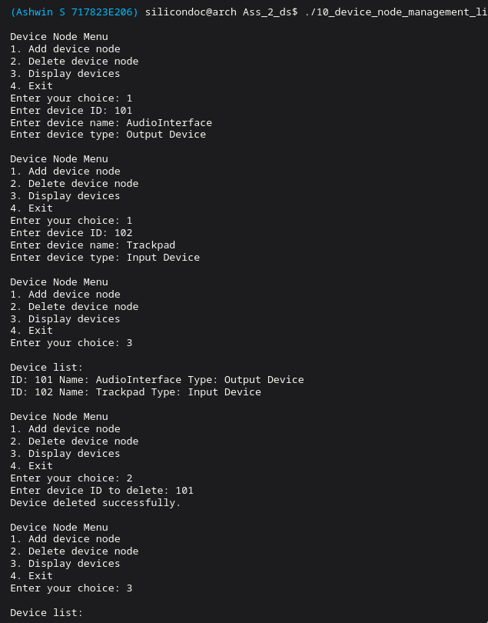
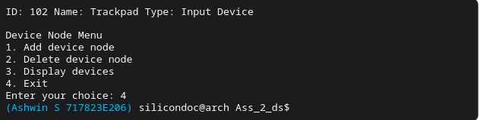

Result:
Thus the device node management program was executed successfully. The device list operations were performed correctly.

Question 11:
Write a C program to implement string reversal using stack.

Aim:
To write a C program to reverse a given string using stack data structure. This demonstrates LIFO principle.

Code:

#include <stdio.h>
#include <string.h>

#define MAX_SIZE 500

typedef struct {
char items[MAX_SIZE];
int top;
} Stack;

static void push(Stack *stack, char value) {
if (stack->top < MAX_SIZE - 1) {
stack->items[++stack->top] = value;
}
}

static char pop(Stack *stack) {
if (stack->top >= 0) {
return stack->items[stack->top--];
}
return '\0';
}

int main(void) {
char input[MAX_SIZE];
Stack stack = {{0}, -1};

printf("Enter a string: ");
if (fgets(input, sizeof(input), stdin) == NULL) {
return 0;
}
input[strcspn(input, "\n")] = '\0';

for (size_t i = 0; input[i] != '\0'; ++i) {
push(&stack, input[i]);
}

printf("Reversed string: ");
while (stack.top >= 0) {
putchar(pop(&stack));
}
printf("\n");

return 0;
}

Output:

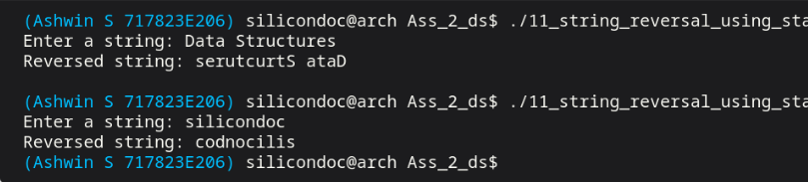

Result:
Thus the string reversal program was executed successfully. The reversed string was obtained correctly and verified.

Question 12:
Write a C program to solve maze problem with back trace using stack.

Aim:
To implement maze solving using stack and backtracking technique. This program finds a valid path from source to destination.

Code:

#include <stdio.h>

#define MAX 20

typedef struct {
int row;
int col;
int dir;
} Cell;

static int is_valid(int rows, int cols, int row, int col) {
return row >= 0 && row < rows && col >= 0 && col < cols;
}

int main(void) {
int rows;
int cols;
int maze[MAX][MAX];
int visited[MAX][MAX] = {{0}};
Cell stack[MAX * MAX];
int top = -1;
int sr;
int sc;
int er;
int ec;
int found = 0;
const int dr[4] = {-1, 0, 1, 0};
const int dc[4] = {0, 1, 0, -1};

printf("Enter number of rows and columns (max %d): ", MAX);
scanf("%d %d", &rows, &cols);
if (rows <= 0 || cols <= 0 || rows > MAX || cols > MAX) {
printf("Invalid maze size.\n");
return 0;
}

printf("Enter maze matrix (0 for open path, 1 for wall):\n");
for (int i = 0; i < rows; ++i) {
for (int j = 0; j < cols; ++j) {
scanf("%d", &maze[i][j]);
}
}

printf("Enter start cell (row col): ");
scanf("%d %d", &sr, &sc);
printf("Enter end cell (row col): ");
scanf("%d %d", &er, &ec);

if (!is_valid(rows, cols, sr, sc) || !is_valid(rows, cols, er, ec) ||
maze[sr][sc] == 1 || maze[er][ec] == 1) {
printf("Invalid start or end cell.\n");
return 0;
}

stack[++top] = (Cell){sr, sc, 0};
visited[sr][sc] = 1;

while (top >= 0) {
Cell *current = &stack[top];

if (current->row == er && current->col == ec) {
found = 1;
break;
}

int moved = 0;
while (current->dir < 4) {
int direction = current->dir++;
int nr = current->row + dr[direction];
int nc = current->col + dc[direction];

if (is_valid(rows, cols, nr, nc) && maze[nr][nc] == 0 && !visited[nr][nc]) {
visited[nr][nc] = 1;
stack[++top] = (Cell){nr, nc, 0};
moved = 1;
break;
}
}

if (!moved) {
--top;
}
}

if (!found) {
printf("No path found through the maze.\n");
return 0;
}

printf("Path found using stack backtracking:\n");
for (int i = 0; i <= top; ++i) {
printf("(%d,%d)", stack[i].row, stack[i].col);
if (i < top) {
printf(" -> ");
}
}
printf("\n");

return 0;}
Output:

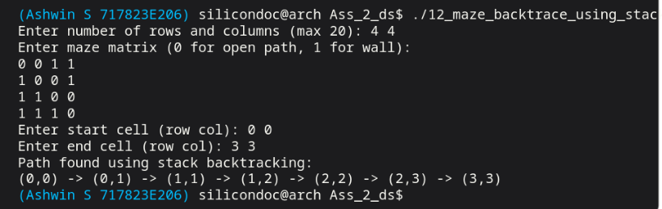

Result:
Thus the maze solving program was executed successfully. The correct path was identified and the output was verified.

Question 13:
Write a C program to implement and check balanced parentheses using stack.

Aim:
To develop a C program to check balanced parentheses using stack. This helps to validate expressions.

Code:

#include <stdio.h>
#include <string.h>

#define MAX_EXPR 500

typedef struct {
char items[MAX_EXPR];
int top;
} Stack;

static void push(Stack *stack, char value) {
if (stack->top < MAX_EXPR - 1) {
stack->items[++stack->top] = value;
}
}

static char pop(Stack *stack) {
if (stack->top >= 0) {
return stack->items[stack->top--];
}
return '\0';
}

static int is_matching(char open, char close) {
return (open == '(' && close == ')') ||
(open == '[' && close == ']') ||
(open == '{' && close == '}');
}

int main(void) {
char expression[MAX_EXPR];
Stack stack = {{0}, -1};
int balanced = 1;

printf("Enter an expression: ");
if (fgets(expression, sizeof(expression), stdin) == NULL) {
return 0;
}

for (size_t i = 0; expression[i] != '\0'; ++i) {
char ch = expression[i];
if (ch == '(' || ch == '[' || ch == '{') {
push(&stack, ch);
} else if (ch == ')' || ch == ']' || ch == '}') {
if (stack.top == -1 || !is_matching(pop(&stack), ch)) {
balanced = 0;
break;
}
}
}

if (stack.top != -1) {
balanced = 0;
}

if (balanced) {
printf("The parentheses are balanced.\n");
} else {
printf("The parentheses are not balanced.\n");
}

return 0;
}

Output:

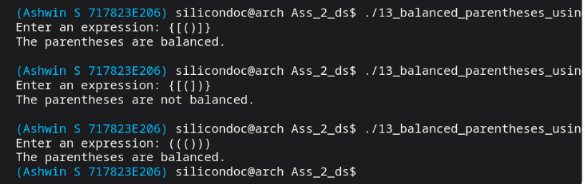

Result:
Thus the parentheses checking program was executed successfully. The expression validity was determined correctly.

Question 14:
Write a C program to implement the memory management model using stack.

Aim:
To simulate memory allocation and deallocation operations using stack. This program shows stack based memory model.

Code:

#include <stdio.h>
#include <string.h>

#define MAX_BLOCKS 100
#define TOTAL_MEMORY 1024

typedef struct {
char process_name[100];
int start_address;
int size;
} MemoryBlock;

typedef struct {
MemoryBlock blocks[MAX_BLOCKS];
int top;
int used_memory;
} MemoryStack;

static void read_line(char *buffer, size_t size) {
if (fgets(buffer, (int) size, stdin) == NULL) {
buffer[0] = '\0';
return;
}
buffer[strcspn(buffer, "\n")] = '\0';
}

static void allocate_memory(MemoryStack *stack, const char *name, int size) {
if (stack->top >= MAX_BLOCKS - 1) {
printf("Memory stack is full.\n");
return;
}

if (size <= 0 || stack->used_memory + size > TOTAL_MEMORY) {
printf("Allocation failed. Not enough memory.\n");
return;
}

++stack->top;
strncpy(stack->blocks[stack->top].process_name, name,
sizeof(stack->blocks[stack->top].process_name) - 1);
stack->blocks[stack->top].process_name[sizeof(stack->blocks[stack->top].process_name) - 1] = '\0';
stack->blocks[stack->top].start_address = stack->used_memory;
stack->blocks[stack->top].size = size;
stack->used_memory += size;

printf("Allocated %d units to %s at address %d\n",
size,
stack->blocks[stack->top].process_name,
stack->blocks[stack->top].start_address);
}

static void deallocate_memory(MemoryStack *stack) {
if (stack->top < 0) {
printf("No memory block to deallocate.\n");
return;
}

MemoryBlock block = stack->blocks[stack->top--];
stack->used_memory -= block.size;
printf("Deallocated %s of size %d\n", block.process_name, block.size);
}

static void display_memory(const MemoryStack *stack) {
if (stack->top < 0) {
printf("No memory allocations present.\n");
return;
}

printf("\nAllocated memory blocks:\n");
for (int i = stack->top; i >= 0; --i) {
printf("Process: %-15s Start: %-4d Size: %d\n",
stack->blocks[i].process_name,
stack->blocks[i].start_address,
stack->blocks[i].size);
}
printf("Used memory: %d / %d\n", stack->used_memory, TOTAL_MEMORY);
}

int main(void) {
MemoryStack stack = {.top = -1, .used_memory = 0};
int choice;
int size;
char name[100];

while (1) {
printf("\nMemory Management Menu\n");
printf("1. Allocate memory\n");
printf("2. Deallocate memory\n");
printf("3. Display memory stack\n");
printf("4. Exit\n");
printf("Enter your choice: ");
if (scanf("%d", &choice) != 1) {
break;
}
getchar();

switch (choice) {
case 1:
printf("Enter process name: ");
read_line(name, sizeof(name));
printf("Enter memory size to allocate: ");
scanf("%d", &size);
getchar();
allocate_memory(&stack, name, size);
break;
case 2:
deallocate_memory(&stack);
break;
case 3:
display_memory(&stack);
break;
case 4:
return 0;
default:
printf("Invalid choice.\n");
}
}

return 0;
}

Output:

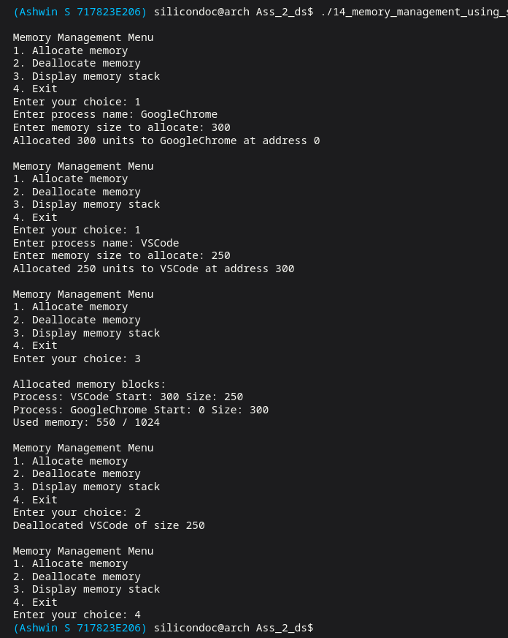

Result:
Thus the memory management program was executed successfully. The stack operations were performed correctly.
Question 15:
Write a C program to implement the undo operation using stack

Aim:
To implement undo functionality using stack data structure. This program restores previous states.

Code:

#include <stdio.h>
#include <stdlib.h>
#include <string.h>

#define MAX_TEXT 1000

typedef struct StateNode {
char state[MAX_TEXT];
struct StateNode *next;
} StateNode;

static void read_line(char *buffer, size_t size) {
if (fgets(buffer, (int) size, stdin) == NULL) {
buffer[0] = '\0';
return;
}
buffer[strcspn(buffer, "\n")] = '\0';
}

static void push_state(StateNode **top, const char *text) {
StateNode *node = (StateNode *) malloc(sizeof(StateNode));
if (node == NULL) {
printf("Memory allocation failed.\n");
exit(EXIT_FAILURE);
}
strncpy(node->state, text, sizeof(node->state) - 1);
node->state[sizeof(node->state) - 1] = '\0';
node->next = *top;
*top = node;
}

static int pop_state(StateNode **top, char *text) {
if (*top == NULL) {
return 0;
}

StateNode *node = *top;
*top = node->next;
strncpy(text, node->state, MAX_TEXT - 1);
text[MAX_TEXT - 1] = '\0';
free(node);
return 1;
}

static void free_states(StateNode *top) {
while (top != NULL) {
StateNode *next = top->next;
free(top);
top = next;
}
}

int main(void) {
StateNode *undo_stack = NULL;
char document[MAX_TEXT] = "";
char text[MAX_TEXT];
int choice;
int count;

while (1) {
printf("\nUndo Stack Menu\n");
printf("1. Append text\n");
printf("2. Delete last N characters\n");
printf("3. Undo last operation\n");
printf("4. Display document\n");
printf("5. Exit\n");
printf("Enter your choice: ");
if (scanf("%d", &choice) != 1) {
break;
}
getchar();

switch (choice) {
case 1:
push_state(&undo_stack, document);
printf("Enter text to append: ");
read_line(text, sizeof(text));
if (strlen(document) + strlen(text) < MAX_TEXT) {
strcat(document, text);
} else {
printf("Append skipped: document would exceed limit.\n");
}
break;
case 2:
push_state(&undo_stack, document);
printf("Enter number of characters to delete: ");
scanf("%d", &count);
getchar();
if (count < 0) {
count = 0;
}
if ((size_t) count > strlen(document)) {
count = (int) strlen(document);
}
document[strlen(document) - (size_t) count] = '\0';
break;
case 3:
if (!pop_state(&undo_stack, document)) {
printf("Nothing to undo.\n");
}
break;
case 4:
printf("Document: %s\n", document);
break;
case 5:
free_states(undo_stack);
return 0;
default:
printf("Invalid choice.\n");
}}
free_states(undo_stack);
return 0;}
Output:

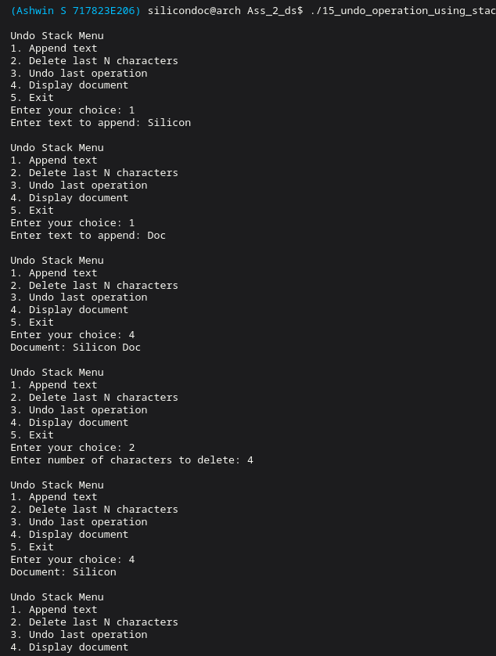
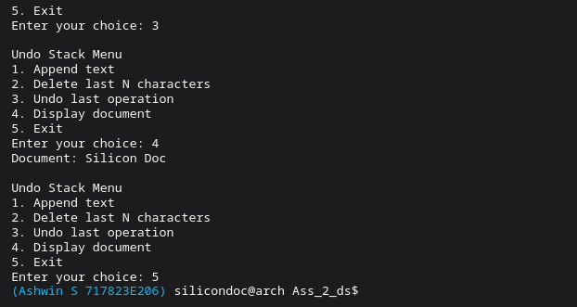

Result:
Thus the undo operation program was executed successfully. The previous data was restored correctly.

Question 16:
Write a C program to implement the stack to store and restore data using function calls.
Aim:
To simulate function call handling using stack. This helps to understand call and return mechanism

Code:

#include <stdio.h>

#define MAX_DEPTH 100

typedef struct {
char function_name[50];
int argument;
} CallFrame;

typedef struct {
CallFrame frames[MAX_DEPTH];
int top;
} CallStack;

static void push(CallStack *stack, const char *name, int argument) {
if (stack->top >= MAX_DEPTH - 1) {
return;
}
++stack->top;
snprintf(stack->frames[stack->top].function_name,
sizeof(stack->frames[stack->top].function_name),
"%s",
name);
stack->frames[stack->top].argument = argument;
}

static void pop(CallStack *stack) {
if (stack->top >= 0) {
--stack->top;
}
}

static void display_stack(const CallStack *stack) {
printf("Current call stack:\n");
for (int i = stack->top; i >= 0; --i) {
printf(" %s(%d)\n", stack->frames[i].function_name, stack->frames[i].argument);
}
}

static int sum_to_n(int n, CallStack *stack) {
push(stack, "sum_to_n", n);
printf("\nStored data while entering function call:\n");
display_stack(stack);

int result;
if (n == 0) {
result = 0;
} else {
result = n + sum_to_n(n - 1, stack);
}

printf("Restoring data while returning from %s(%d)\n",
stack->frames[stack->top].function_name,
stack->frames[stack->top].argument);
pop(stack);
return result;
}

int main(void) {
int n;
CallStack stack = {.top = -1};

printf("Enter n to calculate sum from 1 to n: ");
scanf("%d", &n);

if (n < 0) {
printf("n must be non-negative.\n");
return 0; }
printf("Result: %d\n", sum_to_n(n, &stack));
return 0;}

Output:

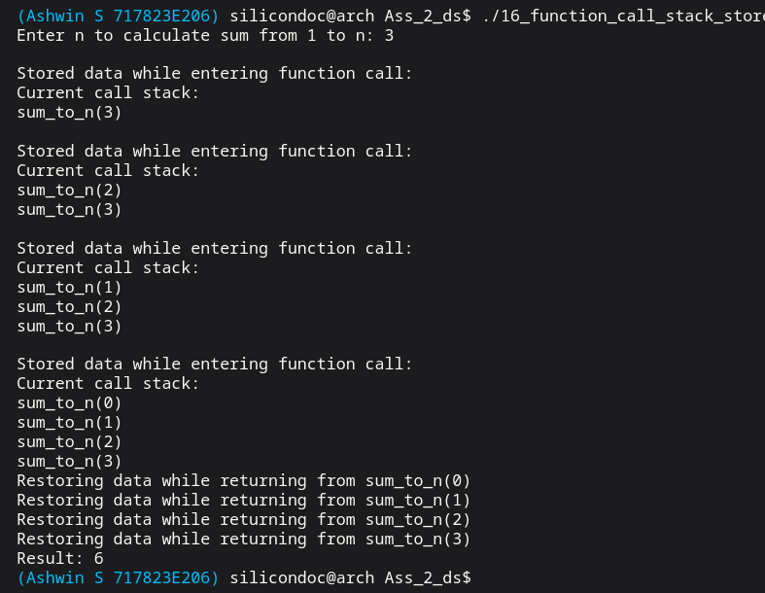

Result:
Thus the function call stack program was executed successfully. The data was stored and restored correctly.

Question 17:
Write a C program to implement token number announcement system model for Banks and Hospitals using Queue

Aim:
To develop a C program to simulate token system using queue. This program follows FIFO principle.

Code:

#include <stdio.h>
#include <stdlib.h>
#include <string.h>

typedef struct TokenNode {
int token_number;
char counter_name[100];
struct TokenNode *next;
} TokenNode;

typedef struct {
TokenNode *front;
TokenNode *rear;
int next_token;
} TokenQueue;

static void read_line(char *buffer, size_t size) {
if (fgets(buffer, (int) size, stdin) == NULL) {
buffer[0] = '\0';
return;
}
buffer[strcspn(buffer, "\n")] = '\0';
}

static void enqueue(TokenQueue *queue, const char *counter_name) {
TokenNode *node = (TokenNode *) malloc(sizeof(TokenNode));
if (node == NULL) {
printf("Memory allocation failed.\n");
exit(EXIT_FAILURE);
}
node->token_number = queue->next_token++;
strncpy(node->counter_name, counter_name, sizeof(node->counter_name) - 1);
node->counter_name[sizeof(node->counter_name) - 1] = '\0';
node->next = NULL;

if (queue->rear == NULL) {
queue->front = queue->rear = node;
} else {
queue->rear->next = node;
queue->rear = node;
}

printf("Issued token %d for %s\n", node->token_number, node->counter_name);
}

static void dequeue(TokenQueue *queue) {
if (queue->front == NULL) {
printf("No tokens waiting.\n");
return;
}

TokenNode *temp = queue->front;
printf("Now serving token %d at %s\n", temp->token_number, temp->counter_name);
queue->front = temp->next;
if (queue->front == NULL) {
queue->rear = NULL;
}
free(temp);
}

static void display_queue(const TokenQueue *queue) {
if (queue->front == NULL) {
printf("No tokens in queue.\n");
return;
}

printf("\nWaiting tokens:\n");
TokenNode *temp = queue->front;
while (temp != NULL) {
printf("Token %d -> %s\n", temp->token_number, temp->counter_name);
temp = temp->next;
}
}

static void free_queue(TokenQueue *queue) {
while (queue->front != NULL) {
TokenNode *next = queue->front->next;
free(queue->front);
queue->front = next;
}
queue->rear = NULL;
}

int main(void) {
TokenQueue queue = {NULL, NULL, 1};
int choice;
char counter_name[100];

while (1) {
printf("\nToken Announcement Queue Menu\n");
printf("1. Generate token\n");
printf("2. Announce next token\n");
printf("3. Display waiting queue\n");
printf("4. Exit\n");
printf("Enter your choice: ");
if (scanf("%d", &choice) != 1) {
break;
}
getchar();

switch (choice) {
case 1:
printf("Enter service counter name (Bank/Hospital desk): ");
read_line(counter_name, sizeof(counter_name));
enqueue(&queue, counter_name);
break;
case 2:
dequeue(&queue);
break;
case 3:
display_queue(&queue);
break;
case 4:
free_queue(&queue);
return 0;
default:
printf("Invalid choice.\n");
}
}

free_queue(&queue);
return 0;
}

Output:

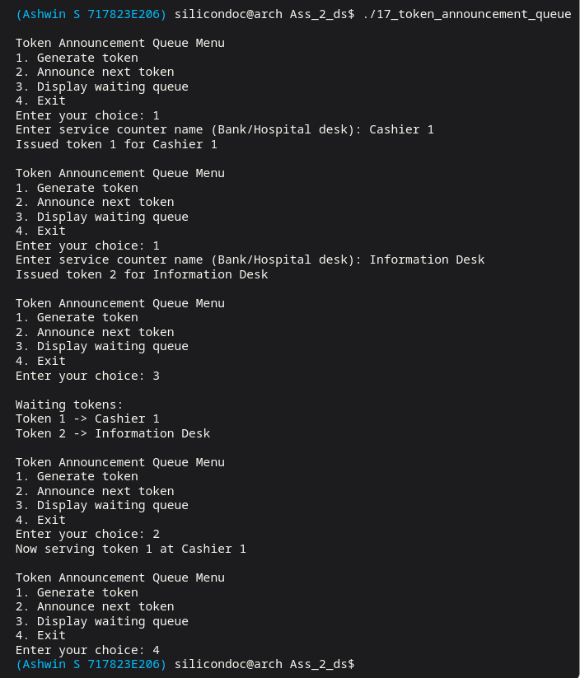

Result:
Thus the token system program was executed successfully. The tokens were processed in correct order.

Question 18:
Write a C program to implement reservation or ticket counter model using Queue.

Aim:
To implement ticket reservation model using queue data structure. Customers are served sequentially.

Code:

#include <stdio.h>
#include <stdlib.h>
#include <string.h>

typedef struct Customer {
char name[100];
int tickets;
struct Customer *next;
} Customer;

typedef struct {
Customer *front;
Customer *rear;
} Queue;

static void read_line(char *buffer, size_t size) {
if (fgets(buffer, (int) size, stdin) == NULL) {
buffer[0] = '\0';
return;
}
buffer[strcspn(buffer, "\n")] = '\0';
}

static void enqueue(Queue *queue, const char *name, int tickets) {
Customer *customer = (Customer *) malloc(sizeof(Customer));
if (customer == NULL) {
printf("Memory allocation failed.\n");
exit(EXIT_FAILURE);
}

strncpy(customer->name, name, sizeof(customer->name) - 1);
customer->name[sizeof(customer->name) - 1] = '\0';
customer->tickets = tickets;
customer->next = NULL;

if (queue->rear == NULL) {
queue->front = queue->rear = customer;
} else {
queue->rear->next = customer;
queue->rear = customer;
}
}

static void serve_customer(Queue *queue) {
if (queue->front == NULL) {
printf("No reservation requests pending.\n");
return;
}

Customer *customer = queue->front;
printf("Booking %d ticket(s) for %s\n", customer->tickets, customer->name);
queue->front = customer->next;
if (queue->front == NULL) {
queue->rear = NULL;
}
free(customer);
}

static void display_queue(const Queue *queue) {
if (queue->front == NULL) {
printf("Ticket queue is empty.\n");
return;
}

Customer *temp = queue->front;
while (temp != NULL) {
printf("Customer: %-15s Tickets: %d\n", temp->name, temp->tickets);
temp = temp->next;
}
}

static void free_queue(Queue *queue) {
while (queue->front != NULL) {
Customer *next = queue->front->next;
free(queue->front);
queue->front = next;
}
queue->rear = NULL;
}

int main(void) {
Queue queue = {NULL, NULL};
int choice;
int tickets;
char name[100];

while (1) {
printf("\nTicket Counter Menu\n");
printf("1. Add reservation request\n");
printf("2. Serve next customer\n");
printf("3. Display queue\n");
printf("4. Exit\n");
printf("Enter your choice: ");
if (scanf("%d", &choice) != 1) {
break;
}
getchar();

switch (choice) {
case 1:
printf("Enter customer name: ");
read_line(name, sizeof(name));
printf("Enter number of tickets: ");
scanf("%d", &tickets);
getchar();
enqueue(&queue, name, tickets);
break;
case 2:
serve_customer(&queue);
break;
case 3:
display_queue(&queue);
break;
case 4:
free_queue(&queue);
return 0;
default:
printf("Invalid choice.\n");
}
}

free_queue(&queue);
return 0;
}

Output:
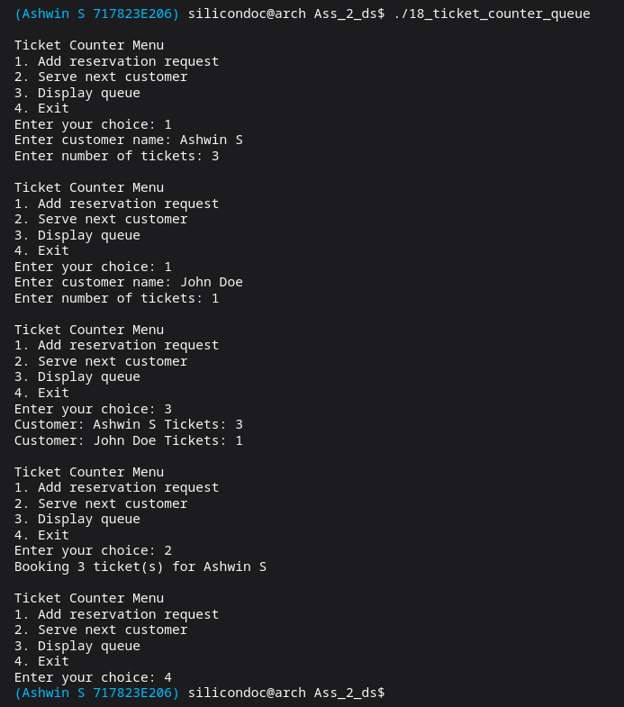

Result:
Thus the reservation system program was executed successfully. The booking process was performed correctly.

Question 19:
Write a C program to implement the task queue model.

Aim:
To write a C program to manage tasks using queue. Tasks are executed in arrival order.
Code:

#include <stdio.h>
#include <stdlib.h>
#include <string.h>

typedef struct Task {
char name[100];
int duration;
struct Task *next;
} Task;

typedef struct {
Task *front;
Task *rear;
} Queue;

static void read_line(char *buffer, size_t size) {
if (fgets(buffer, (int) size, stdin) == NULL) {
buffer[0] = '\0';
return;
}
buffer[strcspn(buffer, "\n")] = '\0';
}

static void enqueue(Queue *queue, const char *name, int duration) {
Task *task = (Task *) malloc(sizeof(Task));
if (task == NULL) {
printf("Memory allocation failed.\n");
exit(EXIT_FAILURE);
}
strncpy(task->name, name, sizeof(task->name) - 1);
task->name[sizeof(task->name) - 1] = '\0';
task->duration = duration;
task->next = NULL;

if (queue->rear == NULL) {
queue->front = queue->rear = task;
} else {
queue->rear->next = task;
queue->rear = task;
}
}

static void process_next(Queue *queue) {
if (queue->front == NULL) {
printf("Task queue is empty.\n");
return;
}

Task *task = queue->front;
printf("Processing task %s for %d unit(s)\n", task->name, task->duration);
queue->front = task->next;
if (queue->front == NULL) {
queue->rear = NULL;
}
free(task);
}

static void display_queue(const Queue *queue) {
if (queue->front == NULL) {
printf("No tasks in queue.\n");
return;
}

Task *temp = queue->front;
while (temp != NULL) {
printf("Task: %-15s Duration: %d\n", temp->name, temp->duration);
temp = temp->next;
}
}

static void free_queue(Queue *queue) {
while (queue->front != NULL) {
Task *next = queue->front->next;
free(queue->front);
queue->front = next;
}
queue->rear = NULL;
}

int main(void) {
Queue queue = {NULL, NULL};
int choice;
int duration;
char name[100];

while (1) {
printf("\nTask Queue Menu\n");
printf("1. Add task\n");
printf("2. Process next task\n");
printf("3. Display task queue\n");
printf("4. Exit\n");
printf("Enter your choice: ");
if (scanf("%d", &choice) != 1) {
break;
}
getchar();

switch (choice) {
case 1:
printf("Enter task name: ");
read_line(name, sizeof(name));
printf("Enter task duration: ");
scanf("%d", &duration);
getchar();
enqueue(&queue, name, duration);
break;
case 2:
process_next(&queue);
break;
case 3:
display_queue(&queue);
break;
case 4:
free_queue(&queue);
return 0;
default:
printf("Invalid choice.\n");
}
}

free_queue(&queue);
return 0;
}

Output:

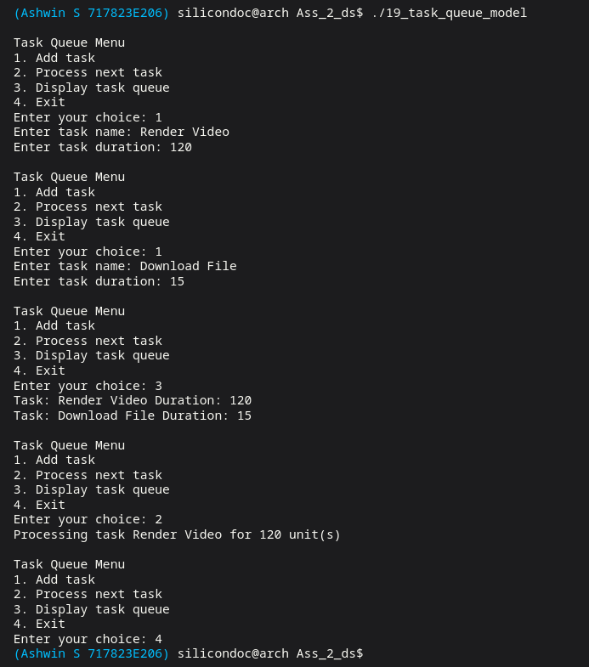

Result:
Thus the task queue program was executed successfully. The tasks were processed correctly.

Question 20:
Write a C program to implement the shared resources allocation with fist come first serve basis model.

Aim:
To simulate shared resource allocation using FCFS scheduling. This ensures fair resource usage.

Code:

#include <stdio.h>
#include <stdlib.h>
#include <string.h>

typedef struct Request {
char process_name[100];
int requested_time;
struct Request *next;
} Request;

typedef struct {
Request *front;
Request *rear;
} Queue;

static void read_line(char *buffer, size_t size) {
if (fgets(buffer, (int) size, stdin) == NULL) {
buffer[0] = '\0';
return;
}
buffer[strcspn(buffer, "\n")] = '\0';
}

static Request *create_request(const char *name, int time) {
Request *request = (Request *) malloc(sizeof(Request));
if (request == NULL) {
printf("Memory allocation failed.\n");
exit(EXIT_FAILURE);
}
strncpy(request->process_name, name, sizeof(request->process_name) - 1);
request->process_name[sizeof(request->process_name) - 1] = '\0';
request->requested_time = time;
request->next = NULL;
return request;
}

static void enqueue(Queue *queue, Request *request) {
if (queue->rear == NULL) {
queue->front = queue->rear = request;
} else {
queue->rear->next = request;
queue->rear = request;
}
}

static Request *dequeue(Queue *queue) {
if (queue->front == NULL) {
return NULL;
}

Request *request = queue->front;
queue->front = request->next;
if (queue->front == NULL) {
queue->rear = NULL;
}
request->next = NULL;
return request;
}

static void display_queue(const Queue *queue, const Request *current) {
if (current != NULL) {
printf("Resource currently allocated to %s for %d unit(s)\n",
current->process_name,
current->requested_time);
} else {
printf("Resource is currently free.\n");
}

if (queue->front == NULL) {
printf("No waiting requests.\n");
return;
}

printf("Waiting queue:\n");
Request *temp = queue->front;
while (temp != NULL) {
printf("Process: %-15s Time: %d\n", temp->process_name, temp->requested_time);
temp = temp->next;
}
}

static void free_queue(Queue *queue) {
while (queue->front != NULL) {
Request *next = queue->front->next;
free(queue->front);
queue->front = next;
}
queue->rear = NULL;
}

int main(void) {
Queue queue = {NULL, NULL};
Request *current = NULL;
int choice;
int time;
char name[100];

while (1) {
printf("\nShared Resource FCFS Menu\n");
printf("1. Request resource\n");
printf("2. Release current resource holder\n");
printf("3. Display allocation status\n");
printf("4. Exit\n");
printf("Enter your choice: ");
if (scanf("%d", &choice) != 1) {
break;
}
getchar();

switch (choice) {
case 1:
printf("Enter process name: ");
read_line(name, sizeof(name));
printf("Enter requested time units: ");
scanf("%d", &time);
getchar();
if (current == NULL) {
current = create_request(name, time);
printf("Resource allocated immediately to %s\n", current->process_name);
} else {
enqueue(&queue, create_request(name, time));
printf("Resource busy. Request added to waiting queue.\n");
}
break;
case 2:
if (current == NULL) {
printf("No process is holding the resource.\n");
} else {
printf("Releasing resource from %s\n", current->process_name);
free(current);
current = dequeue(&queue);
if (current != NULL) {
printf("Resource allocated next to %s\n", current->process_name);
}
}
break;
case 3:
display_queue(&queue, current);
break;
case 4:
free(current);
free_queue(&queue);
return 0;
default:
printf("Invalid choice.\n");
}
}

free(current);
free_queue(&queue);
return 0;
}

Output:

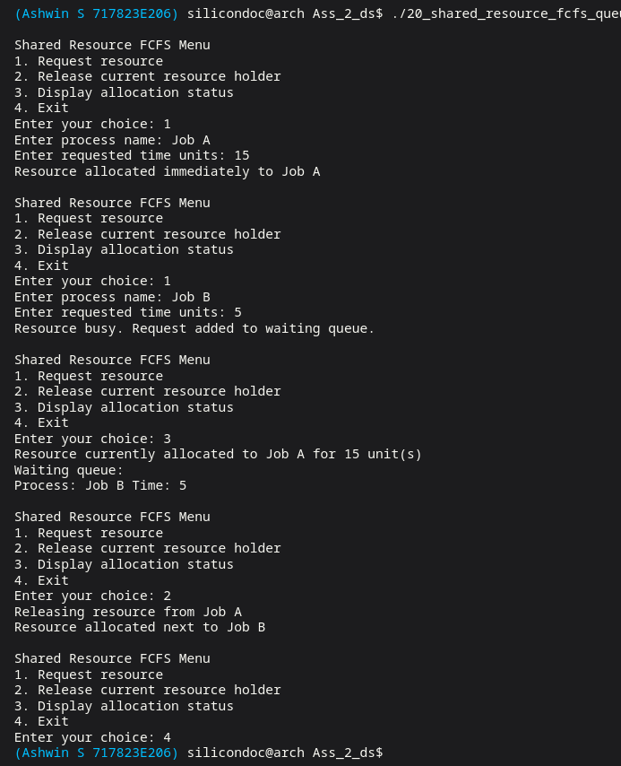

Result:
Thus the resource allocation program was executed successfully. The resources were assigned correctly.

Question 21:
Write a C program to implement message queue, buffered I/O and pipes model using queue

Aim:
To implement message passing system using queue. This program simulates buffered communication.

Code:

#include <stdio.h>
#include <stdlib.h>
#include <string.h>

typedef struct Message {
char text[200];
struct Message *next;
} Message;

typedef struct {
Message *front;
Message *rear;
} Queue;

static void read_line(char *buffer, size_t size) {
if (fgets(buffer, (int) size, stdin) == NULL) {
buffer[0] = '\0';
return;
}
buffer[strcspn(buffer, "\n")] = '\0';
}

static Message *create_message(const char *text) {
Message *message = (Message *) malloc(sizeof(Message));
if (message == NULL) {
printf("Memory allocation failed.\n");
exit(EXIT_FAILURE);
}
strncpy(message->text, text, sizeof(message->text) - 1);
message->text[sizeof(message->text) - 1] = '\0';
message->next = NULL;
return message;
}

static void enqueue(Queue *queue, Message *message) {
if (queue->rear == NULL) {
queue->front = queue->rear = message;
} else {
queue->rear->next = message;
queue->rear = message;
}
}

static Message *dequeue(Queue *queue) {
if (queue->front == NULL) {
return NULL;
}

Message *message = queue->front;
queue->front = message->next;
if (queue->front == NULL) {
queue->rear = NULL;
}
message->next = NULL;
return message;
}

static void display_queue(const char *label, const Queue *queue) {
printf("%s:\n", label);
if (queue->front == NULL) {
printf(" Empty\n");
return;
}

Message *temp = queue->front;
while (temp != NULL) {
printf(" %s\n", temp->text);
temp = temp->next;
}
}

static void free_queue(Queue *queue) {
while (queue->front != NULL) {
Message *next = queue->front->next;
free(queue->front);
queue->front = next;
}
queue->rear = NULL;
}

int main(void) {
Queue message_queue = {NULL, NULL};
Queue pipe_buffer = {NULL, NULL};
int choice;
char text[200];

while (1) {
printf("\nMessage Queue and Pipe Buffer Menu\n");
printf("1. Send message to message queue\n");
printf("2. Move one message to pipe buffer\n");
printf("3. Receive message from pipe buffer\n");
printf("4. Display queues\n");
printf("5. Exit\n");
printf("Enter your choice: ");
if (scanf("%d", &choice) != 1) {
break;
}
getchar();

switch (choice) {
case 1:
printf("Enter message text: ");
read_line(text, sizeof(text));
enqueue(&message_queue, create_message(text));
break;
case 2:
{
Message *message = dequeue(&message_queue);
if (message == NULL) {
printf("Message queue is empty.\n");
} else {
enqueue(&pipe_buffer, message);
printf("Message moved into pipe buffer.\n");
}
}
break;
case 3:
{
Message *message = dequeue(&pipe_buffer);
if (message == NULL) {
printf("Pipe buffer is empty.\n");
} else {
printf("Consumer received: %s\n", message->text);
free(message);
}
}
break;
case 4:
display_queue("Message queue", &message_queue);
display_queue("Pipe buffer", &pipe_buffer);
break;
case 5:
free_queue(&message_queue);
free_queue(&pipe_buffer);
return 0;
default:
printf("Invalid choice.\n");
}
}

free_queue(&message_queue);
free_queue(&pipe_buffer);
return 0;
}

Output:

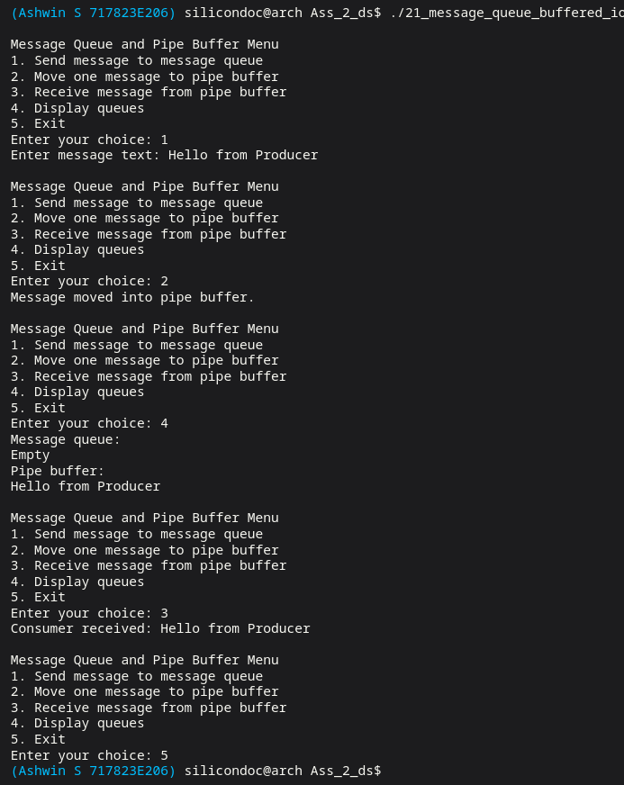

Result:
Thus the message queue program was executed successfully. The messages were transmitted correctly.

Question 22:
Write a C program to read the table from the NAND Flash, perform selection sort and rearrange the names in ascending order and store the table back to the NAND Flash. Note: When the write operations are extremely expensive then the read operations, then selection sort could be ideal.

Aim:
To sort data stored in memory using selection sort algorithm. This reduces write operations.

Code:

#include <stdio.h>
#include <string.h>

#define MAX_ITEMS 100
#define MAX_NAME 100

static void swap_names(char names[][MAX_NAME], int i, int j) {
char temp[MAX_NAME];
strcpy(temp, names[i]);
strcpy(names[i], names[j]);
strcpy(names[j], temp);
}

int main(void) {
int n;
char names[MAX_ITEMS][MAX_NAME];

printf("Enter number of names in NAND Flash table: ");
scanf("%d", &n);
getchar();

if (n <= 0 || n > MAX_ITEMS) {
printf("Invalid number of entries.\n");
return 0;
}

printf("Enter %d names:\n", n);
for (int i = 0; i < n; ++i) {
fgets(names[i], sizeof(names[i]), stdin);
names[i][strcspn(names[i], "\n")] = '\0';
}

printf("\nOriginal table:\n");
for (int i = 0; i < n; ++i) {
printf("%s\n", names[i]);
}

for (int i = 0; i < n - 1; ++i) {
int min_index = i;
for (int j = i + 1; j < n; ++j) {
if (strcmp(names[j], names[min_index]) < 0) {
min_index = j;
}
}
if (min_index != i) {
swap_names(names, i, min_index);
}
}

printf("\nRearranged table stored back in ascending order:\n");
for (int i = 0; i < n; ++i) {
printf("%s\n", names[i]);
}

return 0;
}
Output:

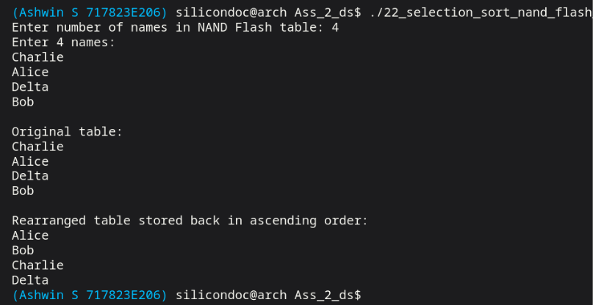

Result:
Thus the selection sort program was executed successfully. The data was arranged in ascending order.

Question 23:
Write a C program to perform bubble sort whenever new flight arrival details are added in the arrival table.

Aim:
To maintain sorted arrival details using bubble sort. This program updates sorted list dynamically.

Code:

#include <stdio.h>
#include <string.h>

#define MAX_FLIGHTS 100

typedef struct {
char flight_number[20];
int arrival_time;
} Flight;

static void bubble_sort(Flight flights[], int n) {
for (int i = 0; i < n - 1; ++i) {
for (int j = 0; j < n - i - 1; ++j) {
if (flights[j].arrival_time > flights[j + 1].arrival_time) {
Flight temp = flights[j];
flights[j] = flights[j + 1];
flights[j + 1] = temp;
}
}
}
}

static void display_flights(const Flight flights[], int n) {
if (n == 0) {
printf("Arrival table is empty.\n");
return;
}

printf("\nArrival table:\n");
for (int i = 0; i < n; ++i) {
printf("Flight: %-10s Arrival time: %04d\n", flights[i].flight_number, flights[i].arrival_time);
}
}

int main(void) {
Flight flights[MAX_FLIGHTS];
int count = 0;
int choice;

while (1) {
printf("\nFlight Arrival Menu\n");
printf("1. Add new flight arrival\n");
printf("2. Display sorted arrival table\n");
printf("3. Exit\n");
printf("Enter your choice: ");
if (scanf("%d", &choice) != 1) {
break;
}

switch (choice) {
case 1:
if (count >= MAX_FLIGHTS) {
printf("Arrival table is full.\n");
break;
}
printf("Enter flight number: ");
scanf("%19s", flights[count].flight_number);
printf("Enter arrival time in HHMM format: ");
scanf("%d", &flights[count].arrival_time);
++count;
bubble_sort(flights, count);
printf("Flight added and table sorted using bubble sort.\n");
break;
case 2:
display_flights(flights, count);
break;
case 3:
return 0;
default:
printf("Invalid choice.\n");
}
}

return 0;
}

Output:

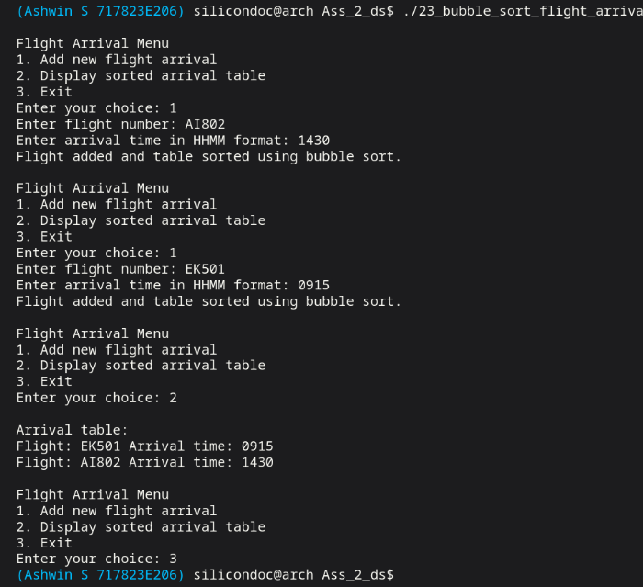

Result:
Thus the bubble sort program was executed successfully. The flight records were arranged correctly.

Question 24:
Write a C program to sort the media file according to the file names using insertion sorting.

Aim:
To sort media files based on file names using insertion sort. This program maintains ordered list.

Code:

#include <stdio.h>
#include <string.h>

#define MAX_FILES 100
#define MAX_NAME 100

int main(void) {
int n;
char files[MAX_FILES][MAX_NAME];
char key[MAX_NAME];

printf("Enter number of media files: ");
scanf("%d", &n);
getchar();

if (n <= 0 || n > MAX_FILES) {
printf("Invalid number of files.\n");
return 0;
}

printf("Enter the file names:\n");
for (int i = 0; i < n; ++i) {
fgets(files[i], sizeof(files[i]), stdin);
files[i][strcspn(files[i], "\n")] = '\0';
}

for (int i = 1; i < n; ++i) {
strcpy(key, files[i]);
int j = i - 1;
while (j >= 0 && strcmp(files[j], key) > 0) {
strcpy(files[j + 1], files[j]);
--j;
}
strcpy(files[j + 1], key);
}

printf("\nMedia files sorted using insertion sort:\n");
for (int i = 0; i < n; ++i) {
printf("%s\n", files[i]);
}

return 0;
}

Output:

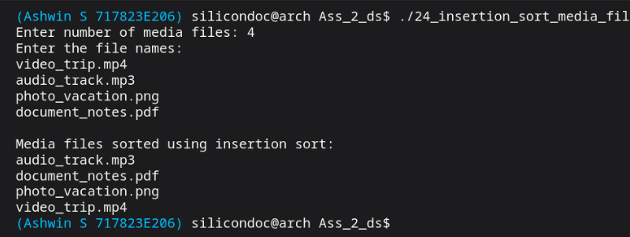

Result:
Thus the insertion sort program was executed successfully. The file names were sorted correct

Question 25:
Write a C program to sort the product list according to their price using merge sorting.

Aim:
To implement merge sort to arrange products based on price. This demonstrates divide and conquer method.

Code:

#include <stdio.h>
#include <string.h>

#define MAX_PRODUCTS 100

typedef struct {
char name[100];
float price;
} Product;

static void merge(Product products[], int left, int mid, int right) {
Product temp[MAX_PRODUCTS];
int i = left;
int j = mid + 1;
int k = left;

while (i <= mid && j <= right) {
if (products[i].price <= products[j].price) {
temp[k++] = products[i++];
} else {
temp[k++] = products[j++];
}
}

while (i <= mid) {
temp[k++] = products[i++];
}

while (j <= right) {
temp[k++] = products[j++];
}

for (i = left; i <= right; ++i) {
products[i] = temp[i];
}
}

static void merge_sort(Product products[], int left, int right) {
if (left >= right) {
return;
}

int mid = left + (right - left) / 2;
merge_sort(products, left, mid);
merge_sort(products, mid + 1, right);
merge(products, left, mid, right);
}

int main(void) {
Product products[MAX_PRODUCTS];
int n;

printf("Enter number of products: ");
scanf("%d", &n);
getchar();

if (n <= 0 || n > MAX_PRODUCTS) {
printf("Invalid number of products.\n");
return 0;
}

for (int i = 0; i < n; ++i) {
printf("Enter product %d name: ", i + 1);
fgets(products[i].name, sizeof(products[i].name), stdin);
products[i].name[strcspn(products[i].name, "\n")] = '\0';
printf("Enter product %d price: ", i + 1);
scanf("%f", &products[i].price);
getchar();}
merge_sort(products, 0, n - 1);

printf("\nProducts sorted by price using merge sort:\n");
for (int i = 0; i < n; ++i) {
printf("%-20s %.2f\n", products[i].name, products[i].price); }
return 0;}

Output:

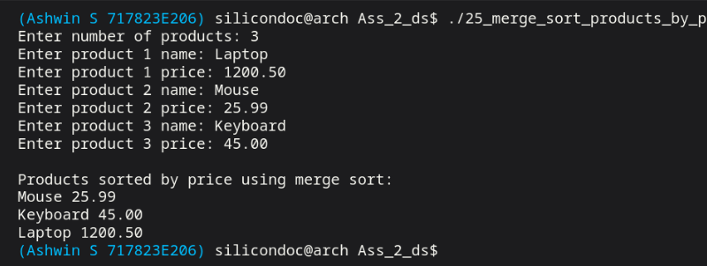

Result:
Thus the merge sort program was executed successfully. The product list was sorted correctly.

Question 26:
Write a C program to sort the hazardous or dangerous material / chemicals in the lab using quick sorting.

Aim:
To sort dangerous materials using quick sort algorithm. This program ensures efficient arrangement.

Code:

#include <stdio.h>
#include <string.h>

#define MAX_CHEMICALS 100

typedef struct {
char name[100];
int hazard_level;
} Chemical;

static void swap(Chemical *a, Chemical *b) {
Chemical temp = *a;
*a = *b;
*b = temp;
}

static int partition(Chemical chemicals[], int low, int high) {
int pivot = chemicals[high].hazard_level;
int i = low - 1;

for (int j = low; j < high; ++j) {
if (chemicals[j].hazard_level >= pivot) {
++i;
swap(&chemicals[i], &chemicals[j]);
}
}

swap(&chemicals[i + 1], &chemicals[high]);
return i + 1;
}

static void quick_sort(Chemical chemicals[], int low, int high) {
if (low < high) {
int pivot_index = partition(chemicals, low, high);
quick_sort(chemicals, low, pivot_index - 1);
quick_sort(chemicals, pivot_index + 1, high);
}
}

int main(void) {
Chemical chemicals[MAX_CHEMICALS];
int n;

printf("Enter number of hazardous materials: ");
scanf("%d", &n);
getchar();

if (n <= 0 || n > MAX_CHEMICALS) {
printf("Invalid number of materials.\n");
return 0;
}

for (int i = 0; i < n; ++i) {
printf("Enter chemical %d name: ", i + 1);
fgets(chemicals[i].name, sizeof(chemicals[i].name), stdin);
chemicals[i].name[strcspn(chemicals[i].name, "\n")] = '\0';
printf("Enter hazard level for %s: ", chemicals[i].name);
scanf("%d", &chemicals[i].hazard_level);
getchar();
}

quick_sort(chemicals, 0, n - 1);

printf("\nChemicals sorted by hazard level using quick sort:\n");
for (int i = 0; i < n; ++i) {
printf("%-20s Hazard Level: %d\n", chemicals[i].name, chemicals[i].hazard_level);
}

return 0;
}

Output:

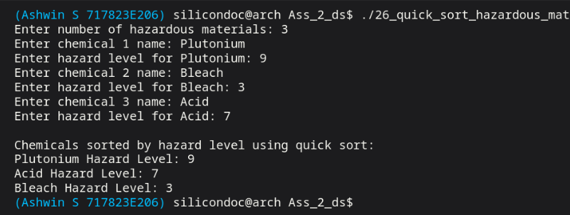

Result:
Thus the quick sort program was executed successfully. The materials were arranged correctly.

Question 27:
Write a C program to rearrange the task list based on the task priority.
Aim:
To rearrange tasks according to their priority values. This helps to execute important tasks first.
Code:

#include <stdio.h>
#include <stdlib.h>
#include <string.h>

typedef struct Task {
char name[100];
int priority;
struct Task *next;
} Task;

static void read_line(char *buffer, size_t size) {
if (fgets(buffer, (int) size, stdin) == NULL) {
buffer[0] = '\0';
return;
}
buffer[strcspn(buffer, "\n")] = '\0';
}

static Task *create_task(const char *name, int priority) {
Task *task = (Task *) malloc(sizeof(Task));
if (task == NULL) {
printf("Memory allocation failed.\n");
exit(EXIT_FAILURE);
}
strncpy(task->name, name, sizeof(task->name) - 1);
task->name[sizeof(task->name) - 1] = '\0';
task->priority = priority;
task->next = NULL;
return task;
}

static void insert_by_priority(Task **head, const char *name, int priority) {
Task *task = create_task(name, priority);

if (*head == NULL || priority > (*head)->priority) {
task->next = *head;
*head = task;
return;
}

Task *temp = *head;
while (temp->next != NULL && temp->next->priority >= priority) {
temp = temp->next;
}
task->next = temp->next;
temp->next = task;
}

static void display_tasks(Task *head) {
if (head == NULL) {
printf("No tasks available.\n");
return;
}

printf("\nTask list rearranged by priority:\n");
while (head != NULL) {
printf("Task: %-15s Priority: %d\n", head->name, head->priority);
head = head->next;
}
}

static void free_tasks(Task *head) {
while (head != NULL) {
Task *next = head->next;
free(head);
head = next;
}
}

int main(void) {
Task *head = NULL;
int choice;
int priority;
char name[100];

while (1) {
printf("\nTask Priority Menu\n");
printf("1. Add task\n");
printf("2. Display rearranged task list\n");
printf("3. Exit\n");
printf("Enter your choice: ");
if (scanf("%d", &choice) != 1) {
break;
}
getchar();

switch (choice) {
case 1:
printf("Enter task name: ");
read_line(name, sizeof(name));
printf("Enter task priority: ");
scanf("%d", &priority);
getchar();
insert_by_priority(&head, name, priority);
break;
case 2:
display_tasks(head);
break;
case 3:
free_tasks(head);
return 0;
default:
printf("Invalid choice.\n");
}
}

free_tasks(head);
return 0;
}

Output:

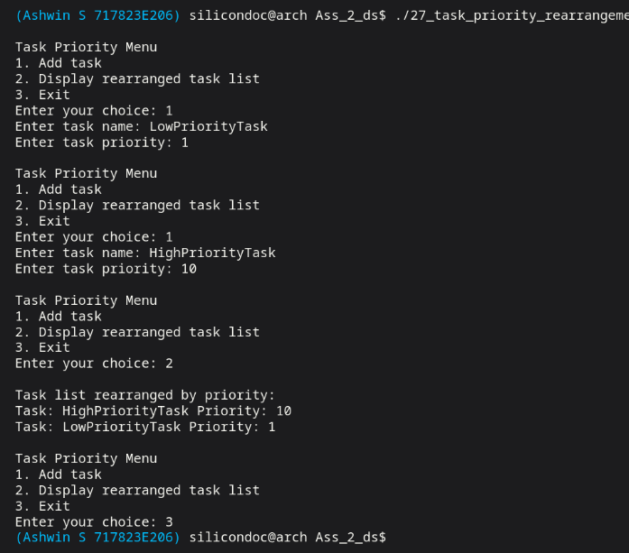

Result:
Thus the task priority program was executed successfully. The tasks were reordered correctly.

Question 28:
Write a C program to implement priority-based scheduling using heap sort.
Aim:
To implement priority based scheduling using heap sort. This program organizes tasks efficiently.

Code:

#include <stdio.h>
#include <string.h>

#define MAX_PROCESSES 100

typedef struct {
char name[100];
int priority;
int burst_time;
} Process;

static void swap(Process *a, Process *b) {
Process temp = *a;
*a = *b;
*b = temp;
}

static void heapify(Process processes[], int n, int index) {
int largest = index;
int left = 2 * index + 1;
int right = 2 * index + 2;

if (left < n && processes[left].priority > processes[largest].priority) {
largest = left;
}
if (right < n && processes[right].priority > processes[largest].priority) {
largest = right;
}

if (largest != index) {
swap(&processes[index], &processes[largest]);
heapify(processes, n, largest);
}
}

static void heap_sort(Process processes[], int n) {
for (int i = n / 2 - 1; i >= 0; --i) {
heapify(processes, n, i);
}

for (int i = n - 1; i > 0; --i) {
swap(&processes[0], &processes[i]);
heapify(processes, i, 0);
}
}

int main(void) {
Process processes[MAX_PROCESSES];
int n;

printf("Enter number of processes: ");
scanf("%d", &n);
getchar();

if (n <= 0 || n > MAX_PROCESSES) {
printf("Invalid number of processes.\n");
return 0;
}

for (int i = 0; i < n; ++i) {
printf("Enter process %d name: ", i + 1);
fgets(processes[i].name, sizeof(processes[i].name), stdin);
processes[i].name[strcspn(processes[i].name, "\n")] = '\0';
printf("Enter priority for %s: ", processes[i].name);
scanf("%d", &processes[i].priority);
printf("Enter burst time for %s: ", processes[i].name);
scanf("%d", &processes[i].burst_time);
getchar(); }
heap_sort(processes, n);
printf("\nPriority-based scheduling order using heap sort:\n");
for (int i = n - 1; i >= 0; --i) {
printf("Process: %-15s Priority: %-4d Burst: %d\n",
processes[i].name, processes[i].priority, processes[i].burst_time); }
return 0;}

Output:

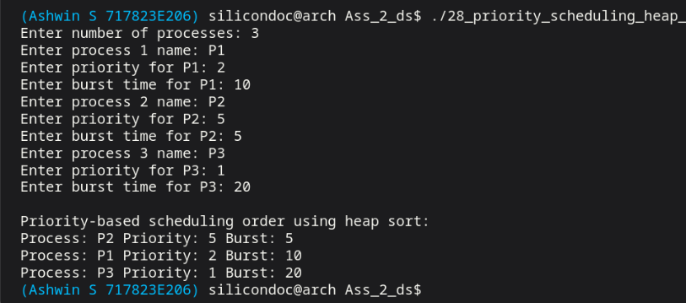

Result:
Thus the heap sort scheduling program was executed successfully. The priority order was maintained.

Question 29:
Write a C program to find the most frequent used words from a file
Aim:
To develop a C program to identify most repeated words in a file. This helps in text analysis.

Code:

#include <ctype.h>
#include <stdio.h>
#include <stdlib.h>
#include <string.h>

#define MAX_WORDS 5000
#define MAX_WORD_LEN 64

typedef struct {
char word[MAX_WORD_LEN];
int count;
} WordEntry;

static int compare_frequency(const void *a, const void *b) {
const WordEntry *left = (const WordEntry *) a;
const WordEntry *right = (const WordEntry *) b;

if (right->count != left->count) {
return right->count - left->count;
}
return strcmp(left->word, right->word);
}

static void add_word(WordEntry entries[], int *size, const char *word) {
for (int i = 0; i < *size; ++i) {
if (strcmp(entries[i].word, word) == 0) {
++entries[i].count;
return;
}
}

if (*size >= MAX_WORDS) {
return;
}

strncpy(entries[*size].word, word, MAX_WORD_LEN - 1);
entries[*size].word[MAX_WORD_LEN - 1] = '\0';
entries[*size].count = 1;
++(*size);
}

int main(void) {
char path[256];
FILE *file;
WordEntry entries[MAX_WORDS];
int entry_count = 0;
char word[MAX_WORD_LEN];
int length = 0;
int ch;

printf("Enter file path: ");
if (fgets(path, sizeof(path), stdin) == NULL) {
return 0;
}
path[strcspn(path, "\n")] = '\0';

file = fopen(path, "r");
if (file == NULL) {
printf("Unable to open file.\n");
return 0;
}

while ((ch = fgetc(file)) != EOF) {
if (isalnum((unsigned char) ch)) {
if (length < MAX_WORD_LEN - 1) {
word[length++] = (char) tolower((unsigned char) ch);
}
} else if (length > 0) {
word[length] = '\0';
add_word(entries, &entry_count, word);
length = 0;
}
}

if (length > 0) {
word[length] = '\0';
add_word(entries, &entry_count, word);
}

fclose(file);

if (entry_count == 0) {
printf("No words found in the file.\n");
return 0;
}

qsort(entries, (size_t) entry_count, sizeof(entries[0]), compare_frequency);

printf("\nMost frequent words:\n");
int limit = entry_count < 10 ? entry_count : 10;
for (int i = 0; i < limit; ++i) {
printf("%-20s %d\n", entries[i].word, entries[i].count);
}

return 0;
}

Output:

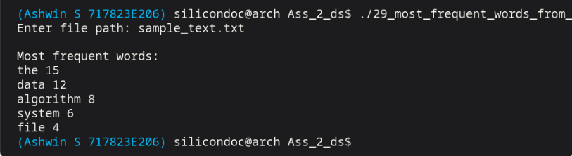

Result:
Thus the word frequency program was executed successfully. The frequent words were found correctly.

Question 30:
Write a C program to use Pthread for binary search to identify the specific name.

Aim:
To search a specific book from large collection using efficient searching method. This helps in fast retrieval.

Code:

#include <pthread.h>
#include <stdio.h>
#include <stdlib.h>
#include <string.h>

#define MAX_NAME 100

typedef struct {
char (*names)[MAX_NAME];
int count;
char target[MAX_NAME];
int result;
} SearchArgs;

static int compare_names(const void *a, const void *b) {
const char *left = (const char *) a;
const char *right = (const char *) b;
return strcmp(left, right);
}

static void *binary_search_thread(void *arg) {
SearchArgs *args = (SearchArgs *) arg;
int left = 0;
int right = args->count - 1;
args->result = -1;

while (left <= right) {
int mid = left + (right - left) / 2;
int compare = strcmp(args->target, args->names[mid]);

if (compare == 0) {
args->result = mid;
break;
}
if (compare < 0) {
right = mid - 1;
} else {
left = mid + 1;
}
}

return NULL;
}

int main(void) {
int n;
pthread_t thread;
SearchArgs args = {NULL, 0, "", -1};

printf("Enter number of names: ");
scanf("%d", &n);
getchar();

if (n <= 0) {
printf("Invalid number of names.\n");
return 0;
}

args.names = malloc((size_t) n * sizeof(*args.names));
if (args.names == NULL) {
printf("Memory allocation failed.\n");
return 0;
}
args.count = n;

printf("Enter %d names:\n", n);
for (int i = 0; i < n; ++i) {
fgets(args.names[i], MAX_NAME, stdin);
args.names[i][strcspn(args.names[i], "\n")] = '\0';
}

qsort(args.names, (size_t) n, sizeof(*args.names), compare_names);

printf("Enter name to search: ");
fgets(args.target, sizeof(args.target), stdin);
args.target[strcspn(args.target, "\n")] = '\0';

if (pthread_create(&thread, NULL, binary_search_thread, &args) != 0) {
printf("Unable to create thread.\n");
free(args.names);
return 0;
}

pthread_join(thread, NULL);

printf("\nSorted names:\n");
for (int i = 0; i < n; ++i) {
printf("%d. %s\n", i, args.names[i]);
}

if (args.result >= 0) {
printf("Name found at sorted index %d\n", args.result);
} else {
printf("Name not found.\n");
}

free(args.names);
return 0;
}

Output:

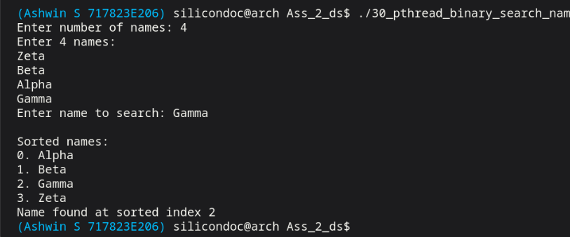

Result:

Thus the library search program was executed successfully. The required book details were obtained correctly.

Question 31:
In a library, there are thousands of books to go through. Write a C program to to find the exact book, implement search program.

Aim:
To search a specific book from large collection using efficient searching method. This helps in fast retrieval.

Code:

#include <stdio.h>
#include <stdlib.h>
#include <string.h>

#define MAX_BOOKS 1000

typedef struct {
char title[100];
char author[100];
int id;
} Book;

static int compare_books(const void *a, const void *b) {
const Book *left = (const Book *) a;
const Book *right = (const Book *) b;
return strcmp(left->title, right->title);
}

static int binary_search_books(const Book books[], int n, const char *title) {
int left = 0;
int right = n - 1;

while (left <= right) {
int mid = left + (right - left) / 2;
int compare = strcmp(title, books[mid].title);

if (compare == 0) {
return mid;
}
if (compare < 0) {
right = mid - 1;
} else {
left = mid + 1;
}
}

return -1;
}

int main(void) {
Book books[MAX_BOOKS];
int n;
char target[100];

printf("Enter number of books: ");
scanf("%d", &n);
getchar();

if (n <= 0 || n > MAX_BOOKS) {
printf("Invalid number of books.\n");
return 0;
}

for (int i = 0; i < n; ++i) {
printf("Enter title of book %d: ", i + 1);
fgets(books[i].title, sizeof(books[i].title), stdin);
books[i].title[strcspn(books[i].title, "\n")] = '\0';
printf("Enter author of %s: ", books[i].title);
fgets(books[i].author, sizeof(books[i].author), stdin);
books[i].author[strcspn(books[i].author, "\n")] = '\0';
printf("Enter ID of %s: ", books[i].title);
scanf("%d", &books[i].id);
getchar();
}

qsort(books, (size_t) n, sizeof(books[0]), compare_books);

printf("Enter exact book title to search: ");
fgets(target, sizeof(target), stdin);
target[strcspn(target, "\n")] = '\0';

int index = binary_search_books(books, n, target);
if (index >= 0) {
printf("Book found.\n");
printf("Title : %s\n", books[index].title);
printf("Author: %s\n", books[index].author);
printf("ID : %d\n", books[index].id);
} else {
printf("Book not found.\n");
}

return 0;
}

Output:

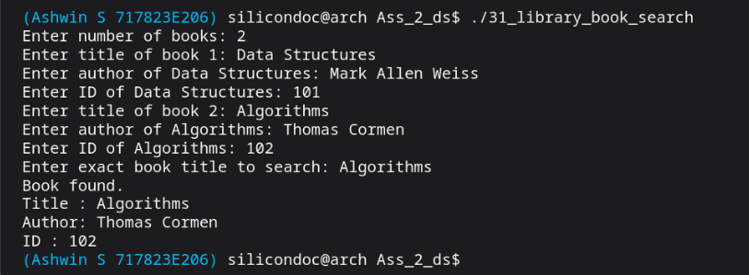

Result:

Thus the library search program was executed successfully. The required book details were obtained correctly.

Question 32:
Write a C program to use binary search to find out the file or directory by giving the name.

Aim:
To search a file or directory name using binary search technique. This reduces searching time.

Code:

#include <dirent.h>
#include <limits.h>
#include <stdio.h>
#include <stdlib.h>
#include <string.h>
#include <sys/stat.h>

#ifndef PATH_MAX
#define PATH_MAX 4096
#endif

typedef struct {
char name[256];
int is_directory;
} Entry;

static int compare_entries(const void *a, const void *b) {
const Entry *left = (const Entry *) a;
const Entry *right = (const Entry *) b;
return strcmp(left->name, right->name);
}

static int binary_search_entries(const Entry entries[], int count, const char *target) {
int left = 0;
int right = count - 1;

while (left <= right) {
int mid = left + (right - left) / 2;
int compare = strcmp(target, entries[mid].name);

if (compare == 0) {
return mid;
}
if (compare < 0) {
right = mid - 1;
} else {
left = mid + 1;
}
}

return -1;
}

int main(void) {
char directory_path[PATH_MAX];
char target[256];
DIR *directory;
struct dirent *record;
Entry *entries = NULL;
int count = 0;
int capacity = 0;

printf("Enter directory path to search in: ");
if (fgets(directory_path, sizeof(directory_path), stdin) == NULL) {
return 0;
}
directory_path[strcspn(directory_path, "\n")] = '\0';

directory = opendir(directory_path);
if (directory == NULL) {
printf("Unable to open directory.\n");
return 0;
}

while ((record = readdir(directory)) != NULL) {
if (strcmp(record->d_name, ".") == 0 || strcmp(record->d_name, "..") == 0) {
continue;
}

if (count == capacity) {
capacity = capacity == 0 ? 16 : capacity * 2;
Entry *new_entries = realloc(entries, (size_t) capacity * sizeof(*entries));
if (new_entries == NULL) {
free(entries);
closedir(directory);
printf("Memory allocation failed.\n");
return 0;
}
entries = new_entries;
}

snprintf(entries[count].name, sizeof(entries[count].name), "%s", record->d_name);

char full_path[PATH_MAX];
struct stat path_info;
size_t dir_len = strlen(directory_path);
size_t name_len = strlen(record->d_name);

if (dir_len + 1 + name_len < sizeof(full_path)) {
memcpy(full_path, directory_path, dir_len);
full_path[dir_len] = '/';
memcpy(full_path + dir_len + 1, record->d_name, name_len + 1);

if (stat(full_path, &path_info) == 0 && S_ISDIR(path_info.st_mode)) {
entries[count].is_directory = 1;
} else {
entries[count].is_directory = 0;
}
} else {
entries[count].is_directory = 0;
}

++count;}
closedir(directory);
if (count == 0) {
free(entries);
printf("No files or directories found.\n");
return 0; }
qsort(entries, (size_t) count, sizeof(*entries), compare_entries);
printf("Enter file or directory name to search: ");
fgets(target, sizeof(target), stdin);
target[strcspn(target, "\n")] = '\0';
int index = binary_search_entries(entries, count, target);
if (index >= 0) {
printf("%s found. Type: %s\n",
entries[index].name,
entries[index].is_directory ? "Directory" : "File");
} else {
printf("Entry not found.\n");}
free(entries);
return 0;}

Output:

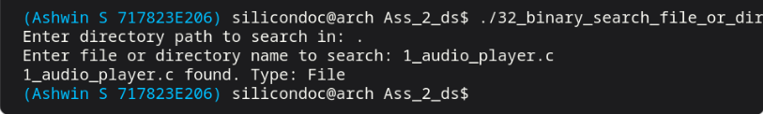

Result:
Thus the binary search program was executed successfully. The file or directory was located correctly.

PREPARATION | 30
LAB PERFORMANCE | 30
REPORT | 40
TOTAL | 100
INITIAL OF FACULTY

