LOOPS:

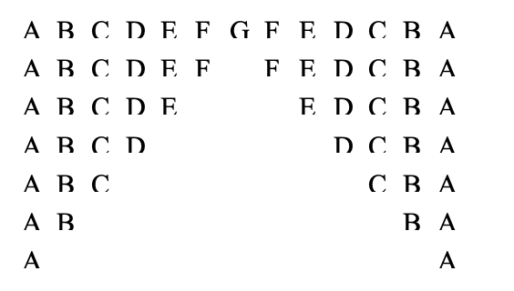
1)Write a program to produce the following output:

2) Write a program to produce the following output:
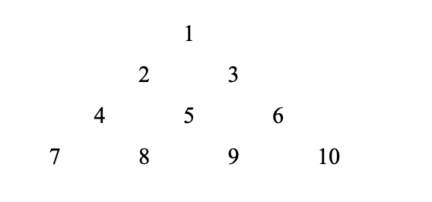

3)Write a program to produce the following output:
to produce the following output:
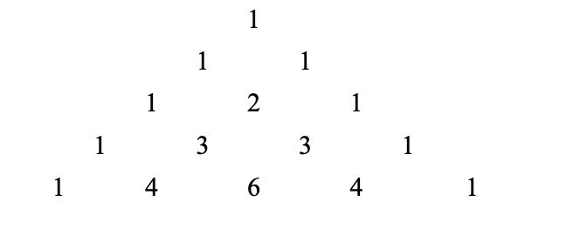

4)Write a program to fill the entire screen with diamond and heart alternatively. The ASCII value for the heart is 3 and that of diamond is 4.

LEETCODE QUESTIONS:

LeetCode #20 Valid Parentheses
LeetCode #121 Best Time to Buy and Sell Stock

Problem no:231
Given an integer n, return true if it is a power of two. Otherwise, return false.
An integer n is a power of two, if there exists an integer x such that n == 2^x.
Example 1:
Input: n = 1
Output: true
Explanation: 2^0 = 1
Problem no:1281
Given an integer number n, return the difference between the product of its digits and the sum of its digits.
Example 1:
Input: n = 234
Output: 15
Explanation:
Product of digits = 2 * 3 * 4 = 24
Sum of digits = 2 + 3 + 4 = 9
Result = 24 - 9 = 15

