Name: Ashwin Kumar fawade
Internship Name: ApexPlanet Software pvt.Ltd.
Date:20/07/2026
Objective
"The objective of this task is to analyze the sales dataset, identify patterns, trends, and generate meaningful business insights using data analysis and visualization techniques."
Dataset Description
"The dataset contains sales transaction details including Order ID, Order Date, Customer ID, Customer Name, Age, Gender, City, Product, Category, Quantity, Unit Price and Total Sales."
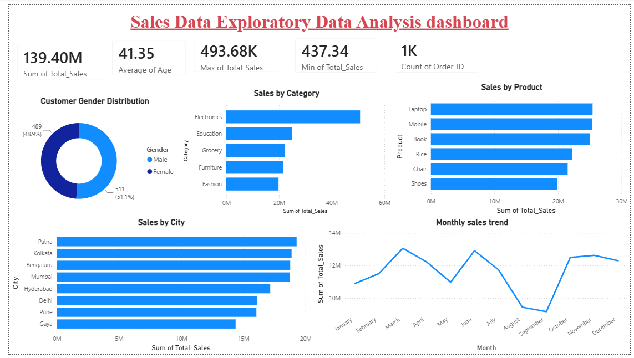
Basic Statistical Analysis (KPI Metrics)

Customer Gender Distribution
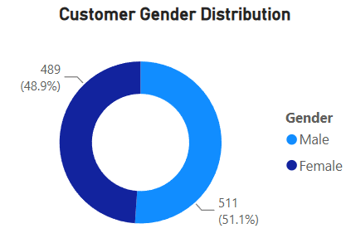

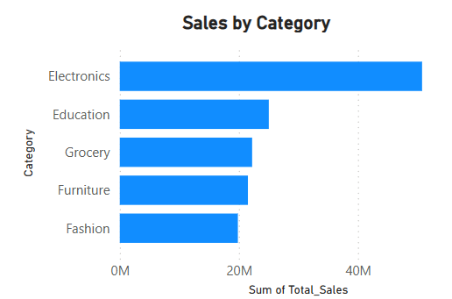
Sales by Category

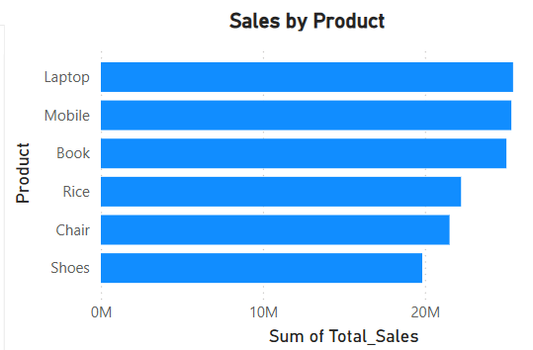
Sales by Product

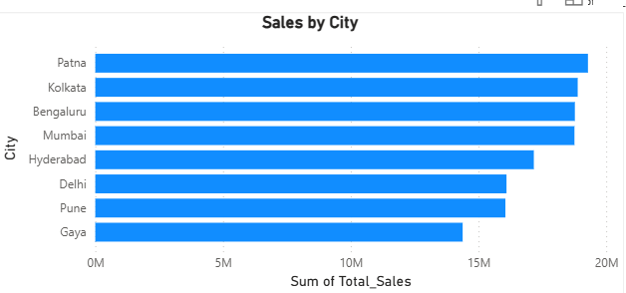
Sales by City

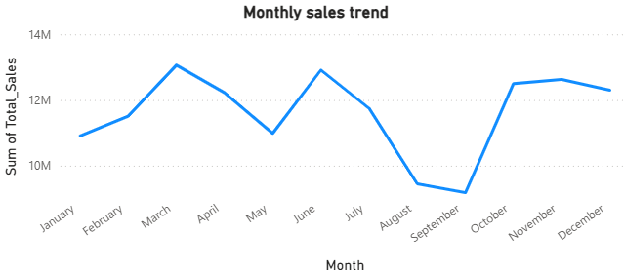
Monthly Sales Trend

Key Business Insights
- Sales performance varies across different categories.
- Some products contribute more revenue than others.
- City-wise analysis helps identify high-performing locations.
- Monthly sales trend shows changes in customer demand.

Conclusion
"The EDA analysis helped to understand sales patterns, customer behavior, and business performance using data visualization techniques."

