1.github link

<https://github.com/ashwin31081999/EKS-CICD.git>

2.application deployed through eks cluster

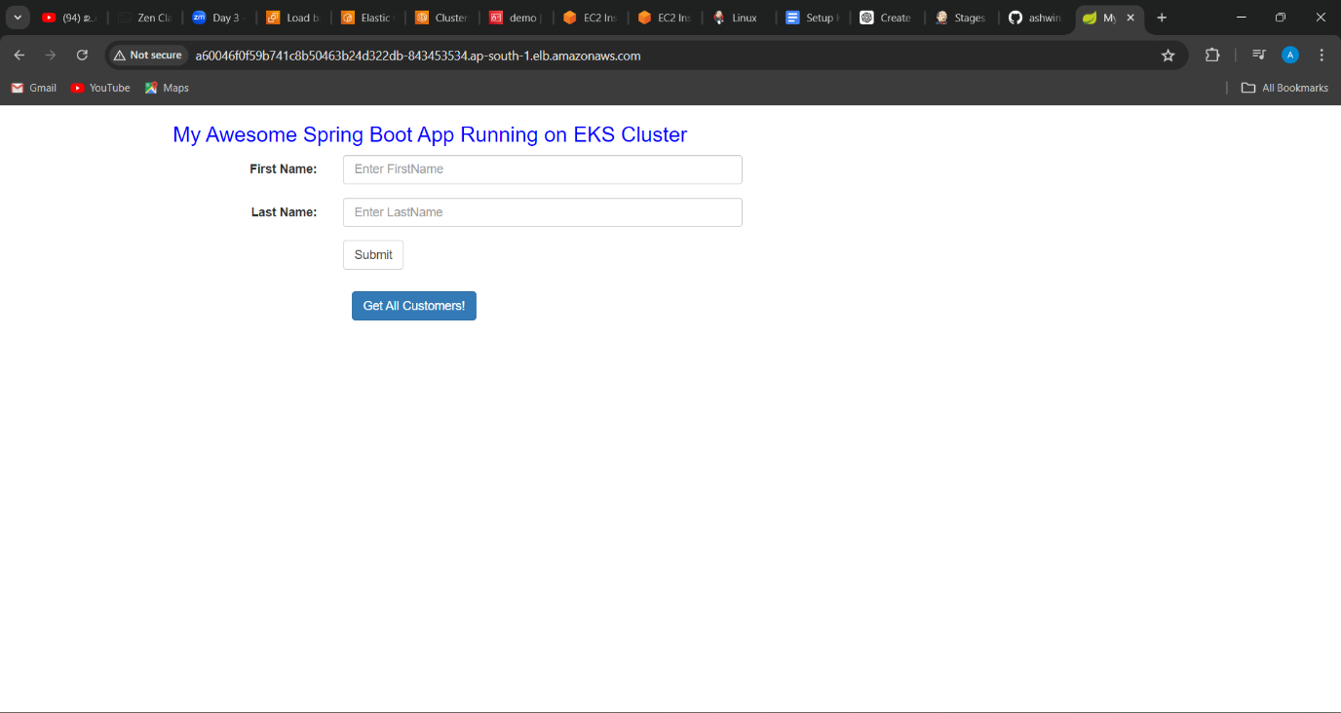

3.configured aws and created a eks cluster in Jenkins user

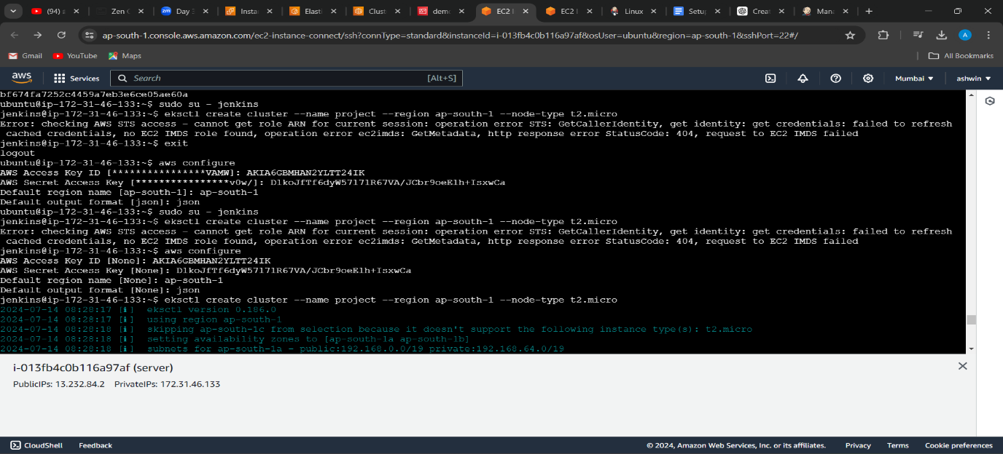

4.created ec2 master machine and cluster nods

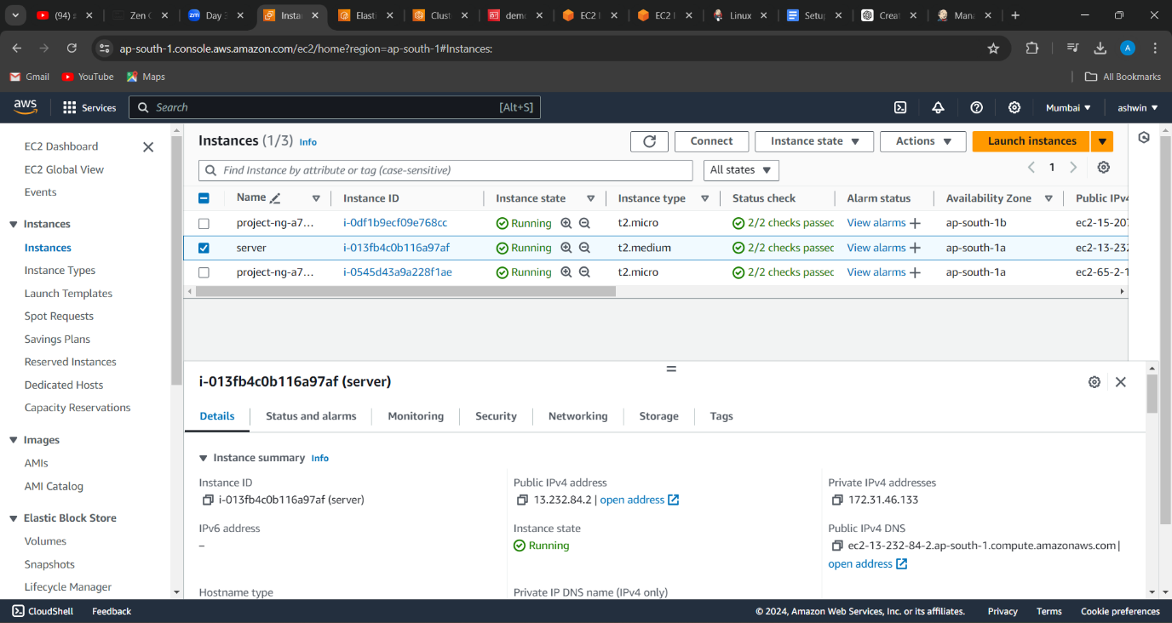

5.nodes

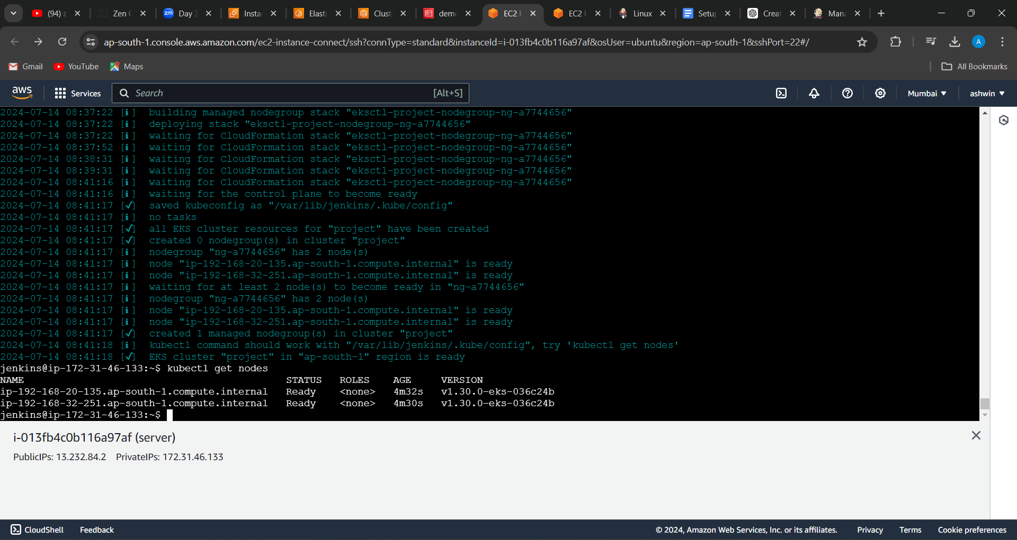

6.kube-config file

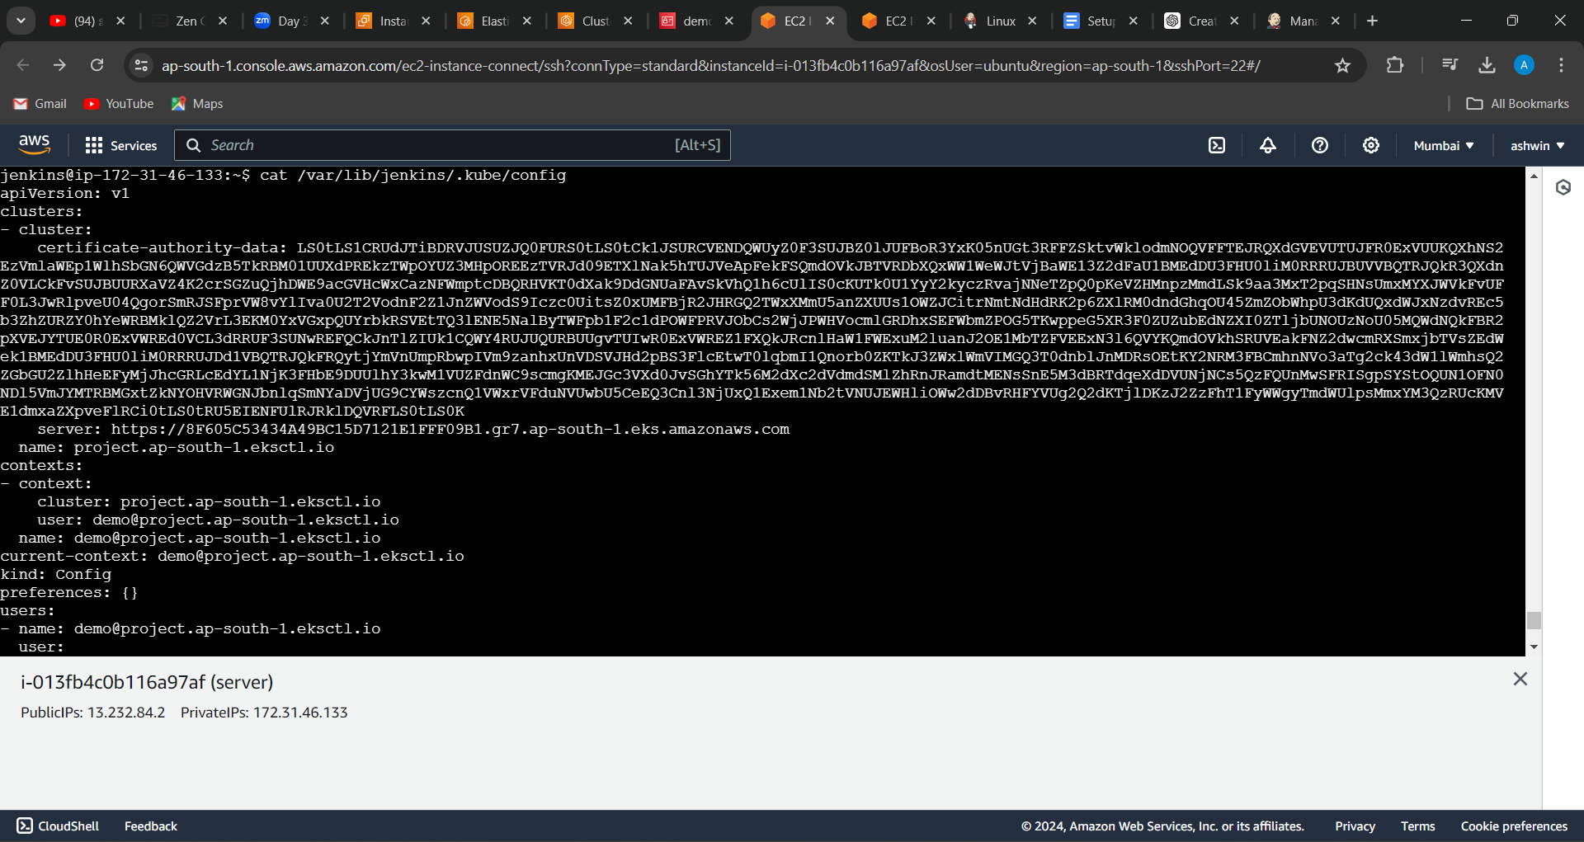

7.created a secret file in global credentials in Jenkins

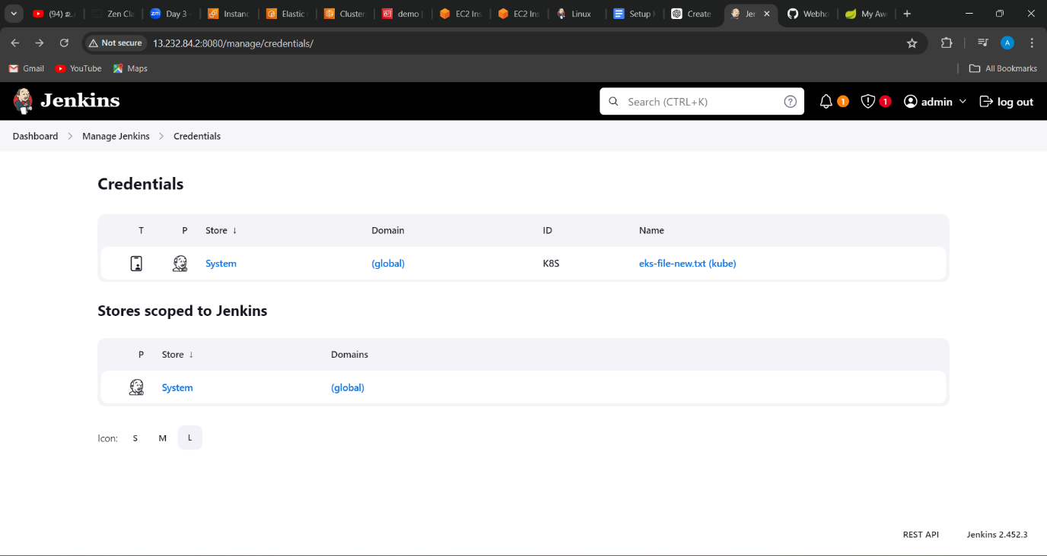

8.created tool configuration maven in jenkins

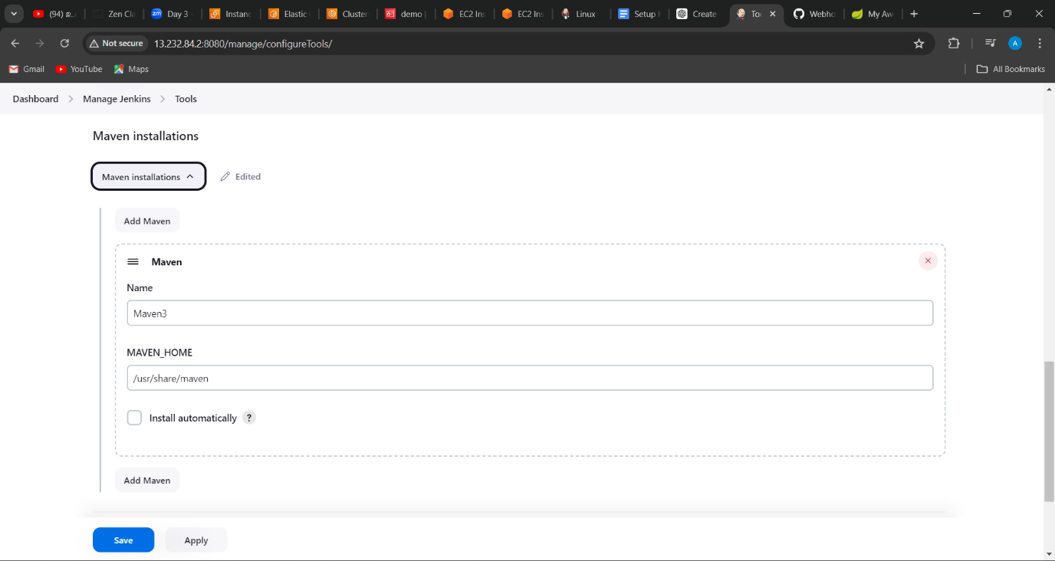

9.created a job and configuring in Jenkins -1

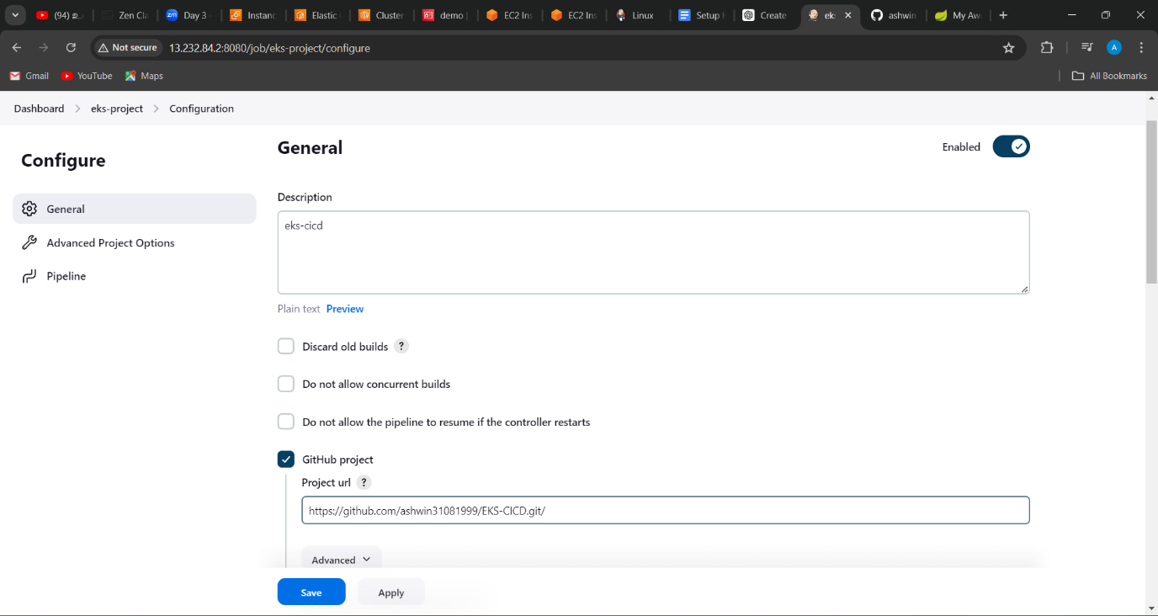

10. created a job and configuring in Jenkins -2

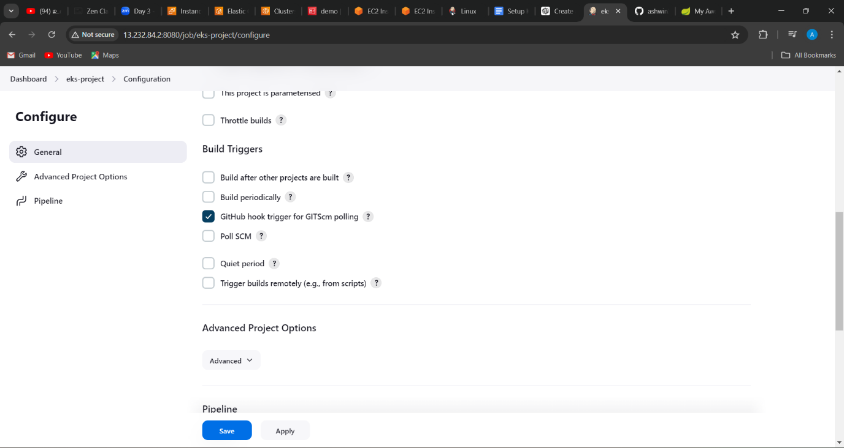

11. created a job and configuring in Jenkins -3

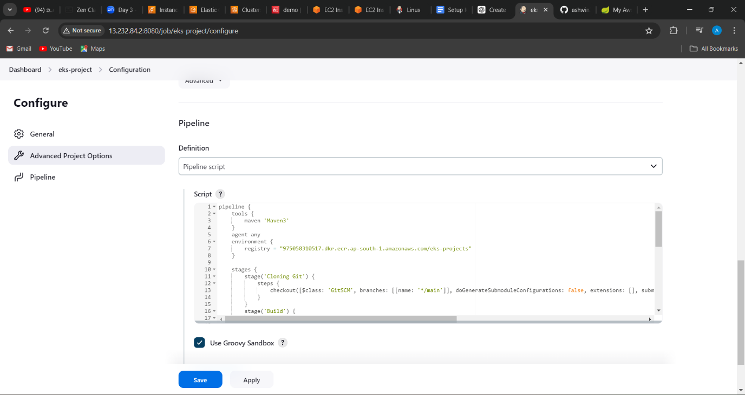

12.configured webhooks in github repository

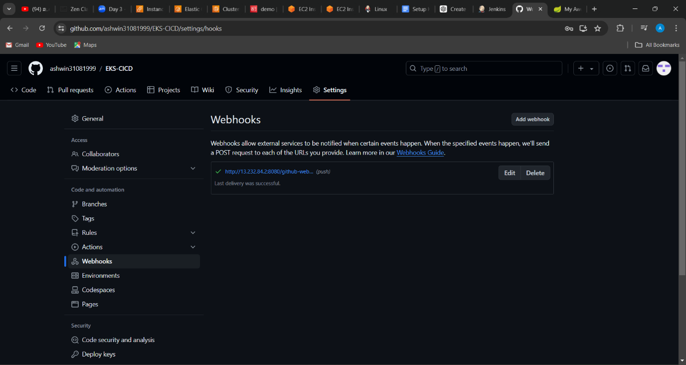

13.stagging output

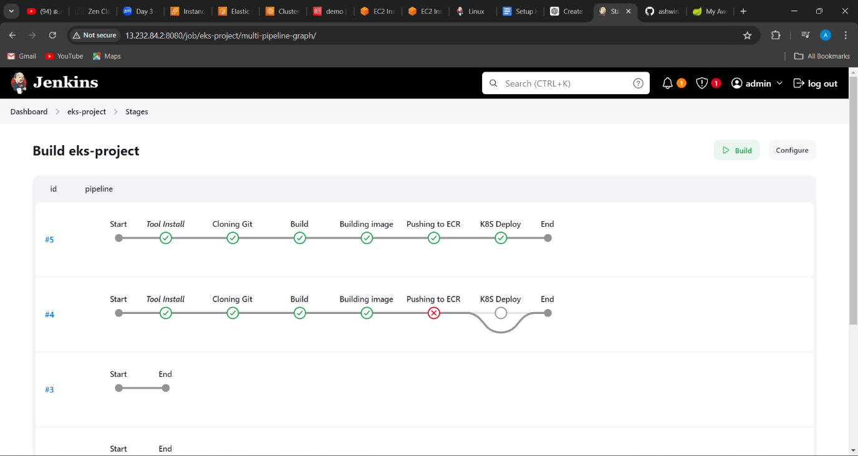

14.pods, deployments, services and replicas created.

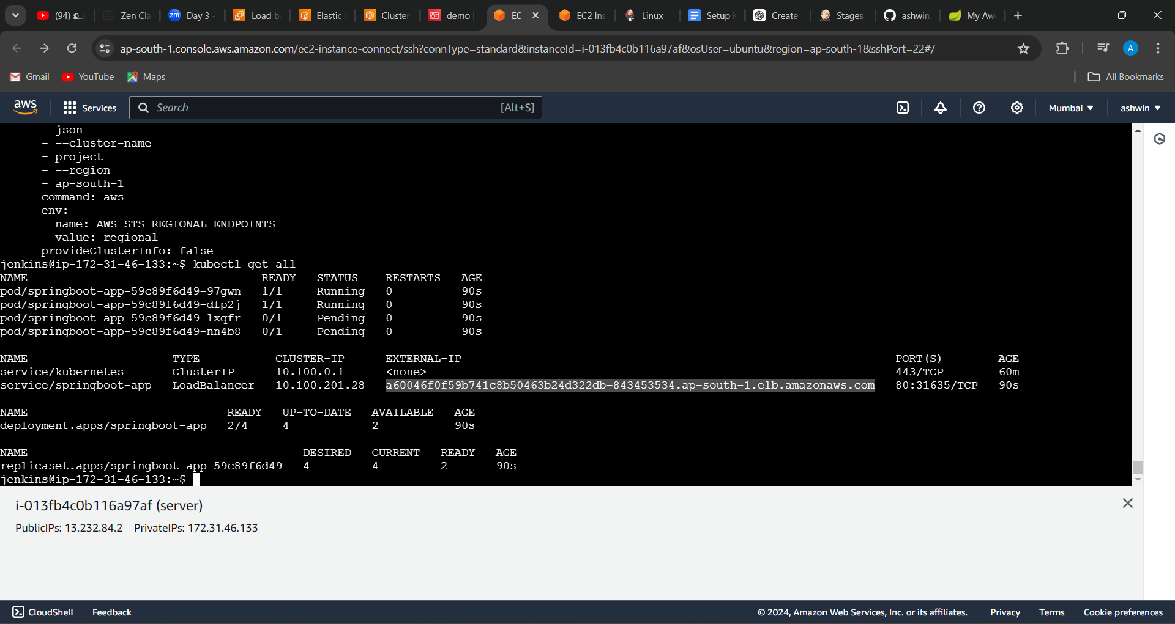

15.created a ECR registry and pushed the image to it.

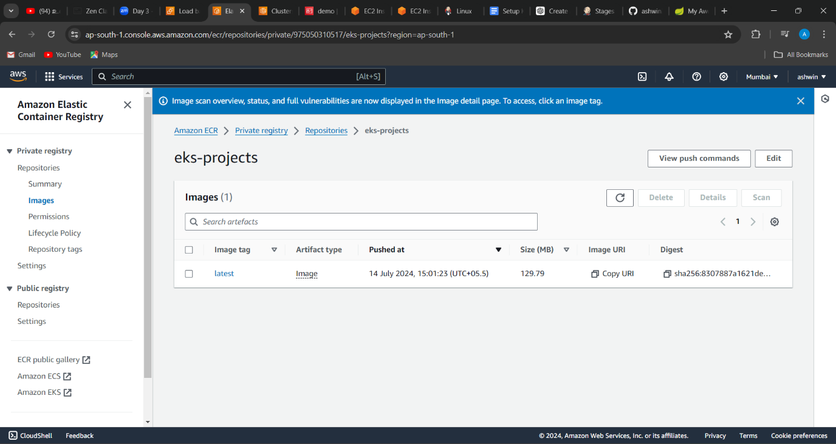

16.EKS cluster created

