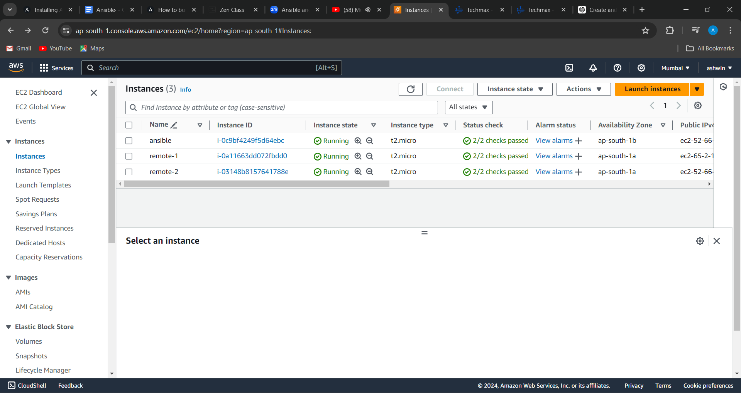

1.created a ansible machine and two remote machine

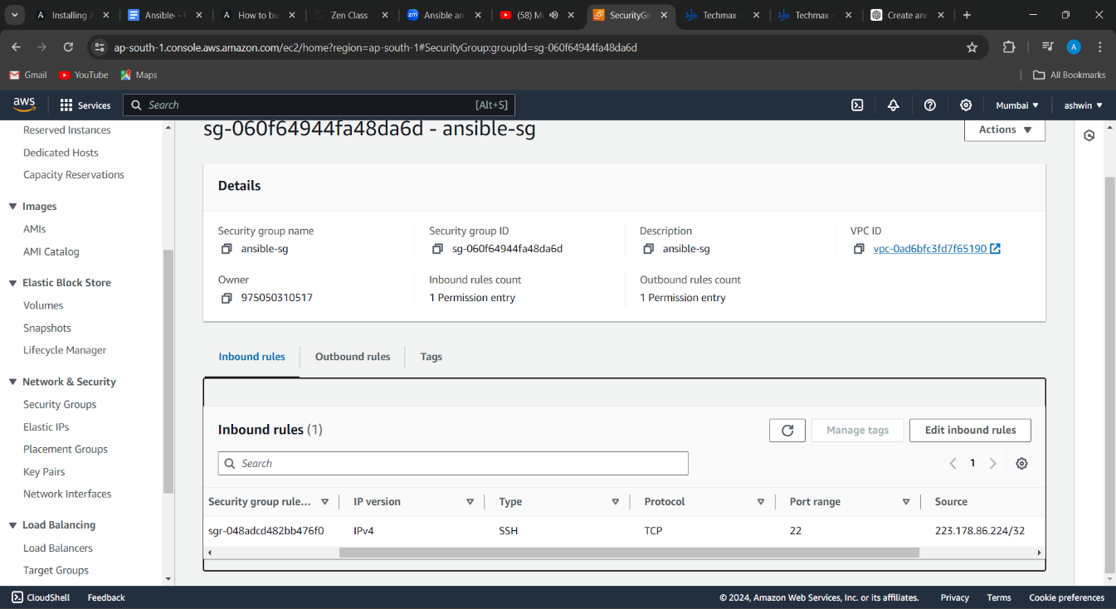

2.created sg for ansible with my ip inbound rule

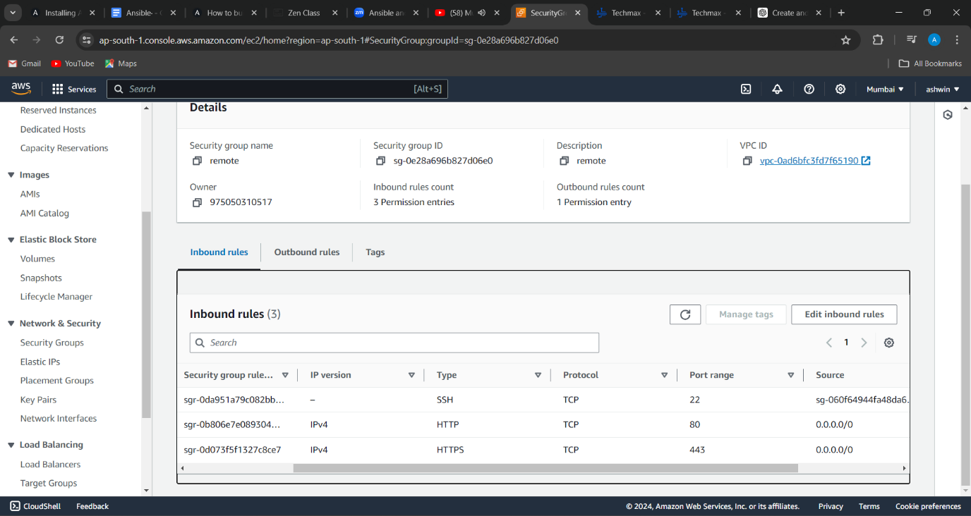

3. created sg for remote machine with inbound sg of ansible machine and http,https ports

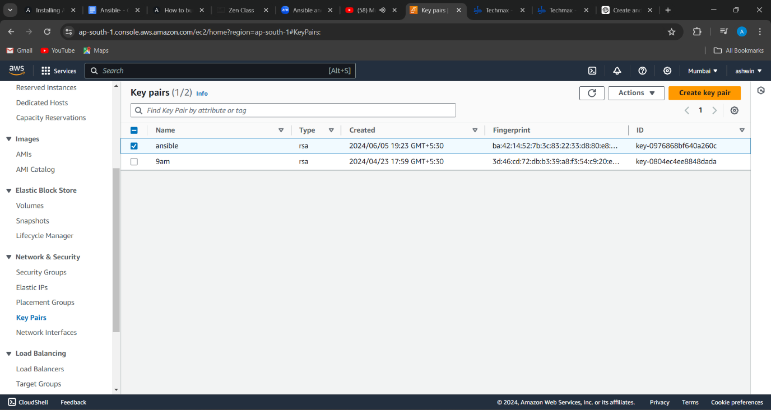

4. imported key from ansible machine and used it to remote machines key

ssh-keygen -t rsa -b 2048 to generate key in ansible machine

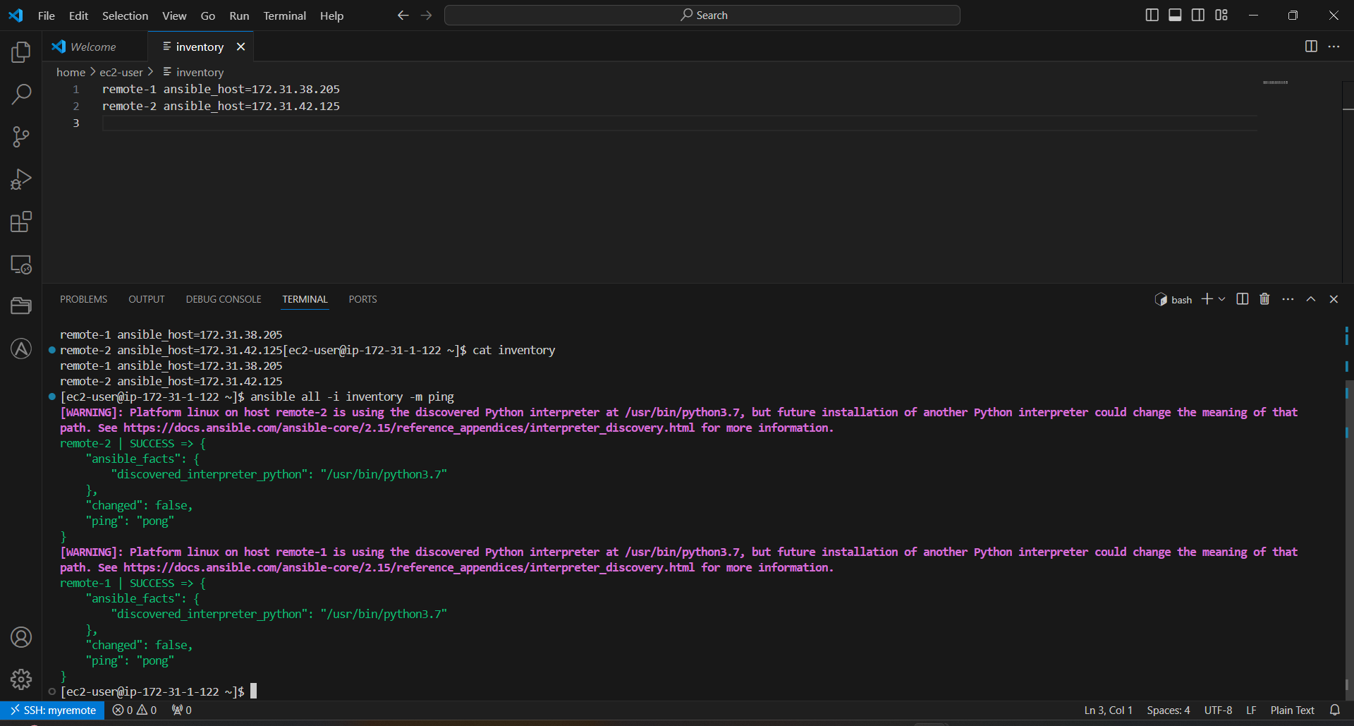

5. created inventory file and checked ping command

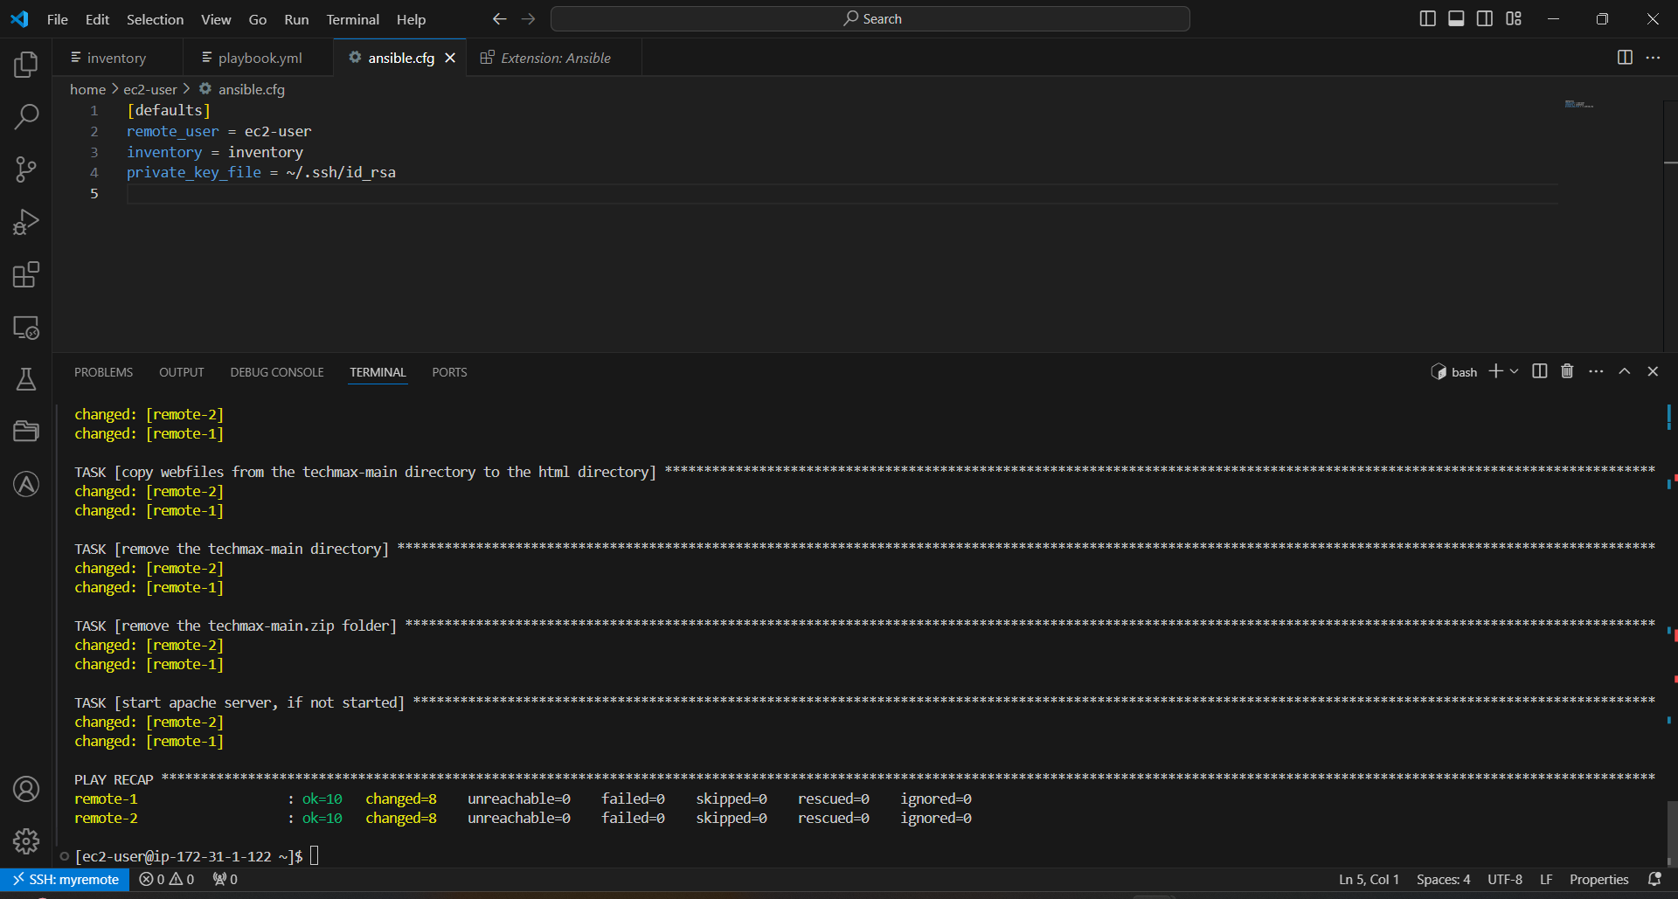

6. ansible.cfg file

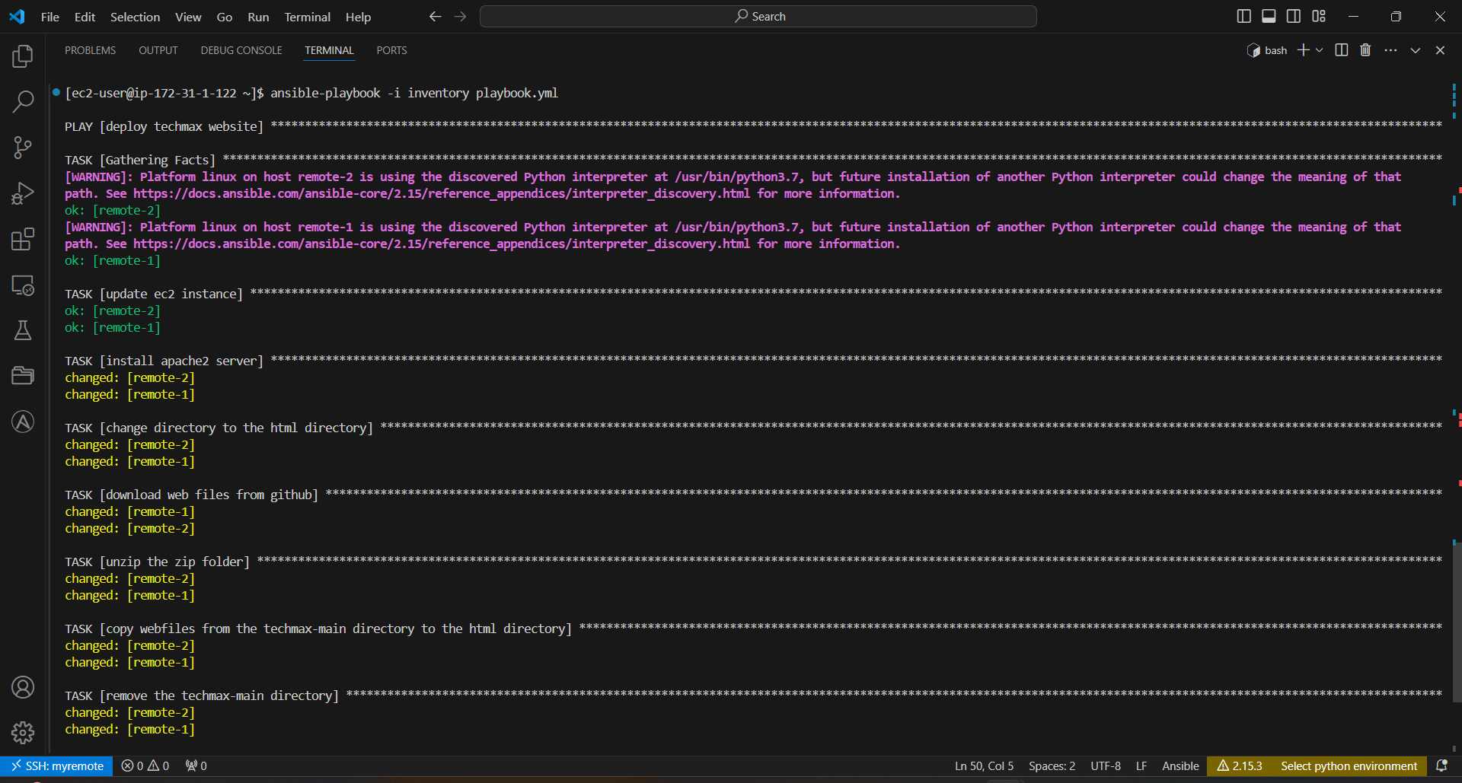

7.terminal output for playbook.yml file



8.output of remote 1



9. output of remote 2