An introduction to a couple of Staples

*Ashwin Ahuja [the opinion and tone of the article does not necessarily represent my opinions]*

2015

Contents

The Shop 1

History 1

Marketing 2

Analyst opinions 3

Vince Staples 3

A brief biography 3

A review of his music 4

Bibliography 5

# The Shop

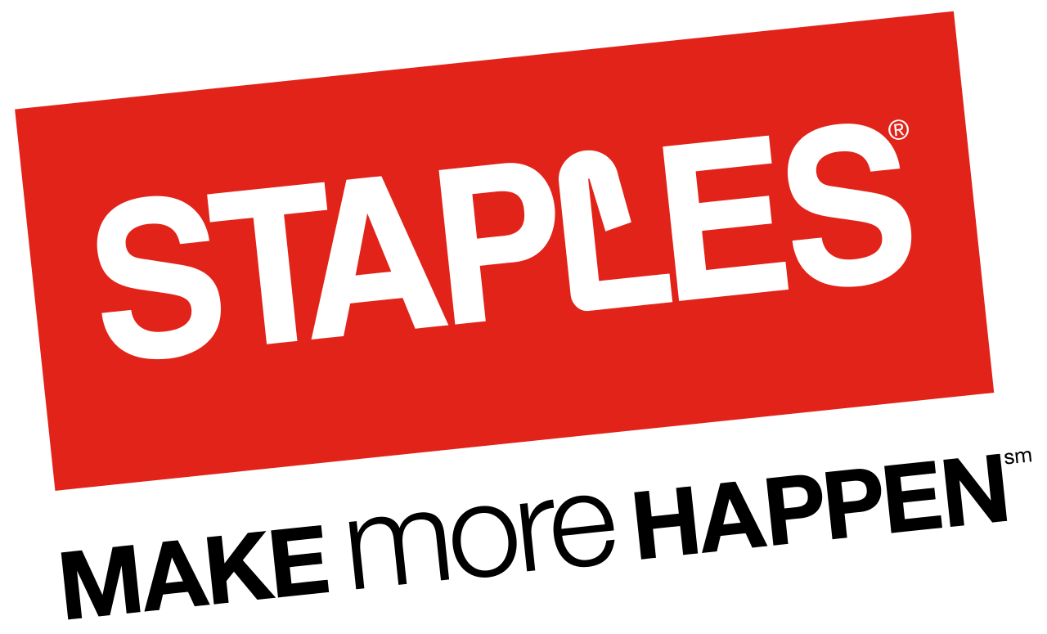

*Figure 1: Staples Logo**[1]*

## History

The American stationary shop was founded in 1986[2], though in fact the idea originated in 1985[3], when one of the cofounders, Thomas Stemberg was working on a proposal for a different business (citation).[4] Needing to get stationery in a time constrained basis, he was irritated by the small stationery stores, which were all closed (it was Independence Day) or did not meet his requirements[5]. Thus was born the idea of an office superstore. With help from Bain Capital[6], Stemberg and his partner Leo Kahn (who in fact used to be a rival of Stemberg’s), the first staples store was founded in Boston.[7]

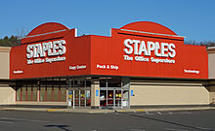

*Figure 2: The first staples store in Boston, 1986*

Since then, the brand has expanded, first in 1991, forming a Canadian subsidiary, known as ‘The Business Depot’,[8] before being renamed as ‘Staples’ only a decade later[9]. This rapid expansion continued into Europe a year later, and in fact the first store outside of North America was in the second cleanest city in the UK[10] & the wettest British city[11], you guessed it, Swansea[12]. Staples’ stratospheric rise was epitomised by its entering the elite group of Fortune 500 companies in only its 10th year[13], with sales of over $3bn.[14] Recently, however, the number of Staples’ branded stores have begun to reduce, as they closed over 225 stores in North America[15]. However, the losses in the Western markets have been countered with increasing investment oversees, opening a store in India in 2008[16], for example.

## Marketing

From the beginning, the slogan of Staples echoed the ‘Just do it’ of Nike, with: ‘Yeah, we’ve got that’[17], finally being replaced in 2003 with ‘That was Easy’[18], with the advertisement of a fake button, labelled ‘Easy’ (which was actually sold after lots of enquiries by customers[19]. The sale of the buttons reached over 1.5million by the end of 2006.

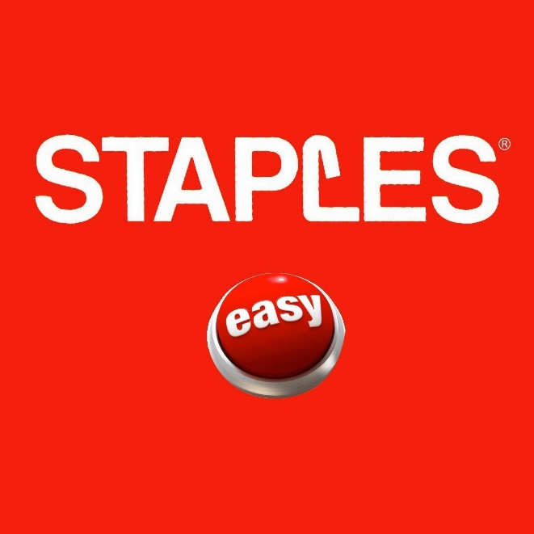

*Figure 3: ‘Easy’ button sold by Staples, after the success of their marketing scheme[20]*

Staples has also become famous for interesting television adverts including their annual Christmas advert, first made famous by the appearance of SnowBot[21], which reportedly increased sales, and led to an increase in money invested into marketing by Staples.

[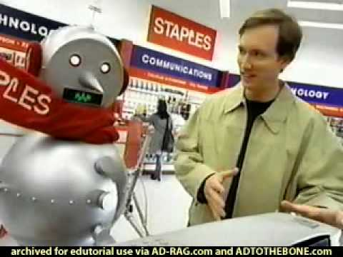](https://www.youtube.com/watch?v=k2vXgKCUZ3c)

*Figure 4: Staples Holiday Advert 2000[22]*

## Analyst opinions

Despite having lost more than half of its value between 2011 and 2013, and failing to effectively recover, the majority of analysts are predicting a successful period for Staples[23], with the four major reports easily available online (published this year) predict a successful period[24], in fact them all upgrading their reviews from previous years. In fact, the Telsey Advisory Group actually upgraded their advisement directly from Underperform to Outperform in the space of a year.[25]

# Vince Staples



*Figure 5: Vince Staples[26]*

## A brief biography

In contrast with Staples, the shop which in fact predated Vince by almost a decade (Vince being born in 1993[27], and Staples founded in 1986[28]), Staples is part of a new generation, beginning to hit its prime today. He is a ‘rapper’, from California[29], part of the rather vulgar group ‘Cutthroat Boyz (sic)’[30], as well as a solo artist, with 2 published albums (his EP – ‘Hell Can Wait’ and ‘Summertime ‘06’)[31] with the latter published to critical acclaim. Staples’ biography is spotty at best, with him having grown up in tough conditions, in a ‘ghetto’ as he says on his twitter[32], and with a successful grandfather having gone from ‘got (getting) medals, was in the Marines, came home and he started gangbangin’’[33]. Yet, Vince appears to be something of a success in this regard, saying he ‘don’t fuck with people. I be on my own shit. You’re never gonna see me at no release party, you’re never going to see me at the club. You’re never going to see me do none of that. I’m not with none of that. I ain’t never got high. I ain’t never got drunk. That just ain’t my shit. I just always stayed to myself. Even since I was younger.’[34] (If you failed to understand that – and I don’t blame you a translation of this in real English is in the footnotes) However, he would still not be mistaken for a member of the British upper class. To a person who does not identify as part of the ‘Urban Youth’[35], I cannot understand a single of Staples’ numerous tweets[36], in fact cringing at the sight of usually unutterable racist terminology being used more often than prepositions. He ought to remember that 140 characters is still enough for some class to be shown!

## A review of his music

As a self-confessed hater of so-called rap music (if one can call it that), I was fully prepared to dislike Staples’ music. Yet, as it transpired, I had come across nothing yet. Of the most popular track on Spotify, ‘Norf Norf’[37], I barely understood one sentence (perhaps he does not even know of their existence), with the few words I picked up likely being words that I would prefer not to report of here, with an antiquated slur describing black people being used in excess of 25 times that I could hear, in addition to almost every rude word that I have come across in my rather sheltered life. How 4,000,000 people[38] have endured it is beyond me! However, as a true reviewer, I continued, hoping he had experienced a revelation through his recording of this album. Yet, rather predictably, one had not existed. The second track ‘Lemme know’ (with a mere 2,800,000 listens[39]) was audible at the least, though one still could not identify any particular punctuation, in many ways evidence that education in deprived areas of America is still lacking. This understandability (as those with his education levels may term it) however, further alienated me, as thinly veiled innuendoes masked any metaphorical meaning. At this point, I had encountered my fill of profanity for the year, and thus was forced to turn the racket off, thus, if an epiphany was reached midway through this album, my apologies, I missed it.

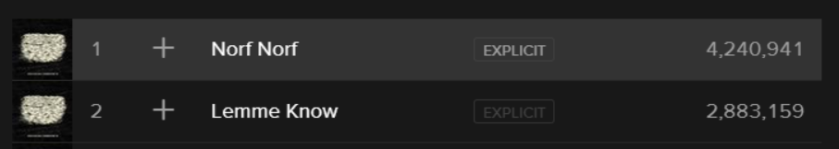

*Figure 6: Screenshot from Spotify[40]*

# Bibliography

BBC, 2014. *Staples to close 225 North American stores.* [Online]   
Available at: http://www.bbc.co.uk/news/business-26475437  
[Accessed 04 10 2015].

Discogs, 2015. *Vince Staples.* [Online]   
Available at: http://www.discogs.com/artist/1971480-Vince-Staples  
[Accessed 04 10 2015].

Famous Birthdays, n.d. *Vince Staples.* [Online]   
Available at: http://www.famousbirthdays.com/people/vince-staples.html  
[Accessed 04 10 2015].

Fortune, n.d. *Staples.* [Online]   
Available at: http://fortune.com/fortune500/staples-133/  
[Accessed 04 10 2015].

Iconshut, n.d. *Staples.* [Online]   
Available at: https://www.google.co.uk/url?sa=i&rct=j&q=&esrc=s&source=images&cd=&cad=rja&uact=8&ved=0CAcQjRxqFQoTCOmqjbWCqsgCFYJWFAodbTYCPA&url=http%3A%2F%2Fwww.iconshut.com%2Fmotorola-androids-icons%2F&bvm=bv.104317490,d.d24&psig=AFQjCNE_SmJ2wdP09223VwAx8xguotVVbw&us  
[Accessed 04 10 2015].

Johnson, O. C., 2012. *Urban Youth.* [Online]   
Available at: http://www.urbandictionary.com/define.php?term=Urban+Youth&defid=6834982  
[Accessed 04 10 2015].

Montes, P., 2013. *Cutthroat Boyz (Joey Fatts, Aston Mathews, Vince Staples).* [Online]   
Available at: http://blogs.ocweekly.com/heardmentality/2013/01/cutthroat_boyz_joey_fatts_asto.php  
[Accessed 04 10 2015].

Pitchfork, n.d. *Rising: Vince Staples.* [Online]   
Available at: http://cdn.pitchfork.com/features/9489/30bedd30.jpg  
[Accessed 04 10 2015].

Retail Human Resources, n.d. *Staples.* [Online]   
Available at: http://www.retailhumanresources.com/job-seekers/retailers-we-work-with/staples  
[Accessed 04 10 2015].

Shapiro, T. R., 2011. *The Washington Post.* [Online]   
Available at: https://www.washingtonpost.com/local/obituaries/leo-kahn-entrepreneur-who-helped-found-staples-office-supply-business-dies-at-94/2011/05/13/AFGKEi3G_story.html  
[Accessed 04 10 2015].

Smackdog13, 2009. *Staples - Snowbot.* [Online]   
Available at: https://www.youtube.com/watch?v=k2vXgKCUZ3c  
[Accessed 04 10 2015].

Soniak, M., 2012. *Bain Capital and Staples.* [Online]   
Available at: http://mentalfloss.com/article/29654/how-involved-was-mitt-romney-founding-staples  
[Accessed 04 10 2015].

Staples Canada, n.d. *Our Story.* [Online]   
Available at: http://www.staples.ca/sbdca/en_CA/cre/programs/media_information/#our-story  
[Accessed 04 10 2015].

Staples Inc, n.d. [Online]   
Available at: https://www.google.co.uk/url?sa=i&rct=j&q=&esrc=s&source=images&cd=&cad=rja&uact=8&ved=0CAcQjRxqFQoTCLujmNH6qcgCFQGXFAodqOkKrQ&url=http%3A%2F%2Fcasamoncada.com%2Famazon-fire-tv%2F&psig=AFQjCNGDGkJfhhQUeieRYC1Tmn2u13KouA&ust=1444087279705422  
[Accessed 04 10 2015].

Staples Inc, n.d. *Our Story.* [Online]   
Available at: http://www.staples.com/sbd/cre/marketing/about_us/our-story.html  
[Accessed 04 10 2015].

Staples, n.d. *International Operations.* [Online]   
Available at: http://www.staples.com/sbd/cre/marketing/about_us/international-operations.html  
[Accessed 04 10 2015].

Staples, n.d. *Staples Easy Button.* [Online]   
Available at: http://www.staples.co.uk/staples-easy-button-paperweight/cbs/383829.html  
[Accessed 04 10 2015].

Staples, V., 2014. *Vince Staples Thinks You Should Go To College & Why You Can't Trust Barack Obama* [Interview] (08 10 2014).

Swansea Indoor Market, n.d. *Why visit Swansea City Centre? - Key Facts and Figures.* [Online]   
Available at: http://www.swanseaindoormarket.co.uk/group-travel/  
[Accessed 04 10 2015].

Taube, A., 2014. *Staples Has Finally Axed Its 'That Was Easy' Slogan.* [Online]   
Available at: http://www.businessinsider.com/staples-axes-that-was-easy-slogan-2014-1?IR=T  
[Accessed 04 10 2015].

Twitter, 2015. *Vince Staples.* [Online]   
Available at: https://twitter.com/vincestaples  
[Accessed 04 10 2015].

VinceStaplesVEVO, 2015. *Vince Staples - Norf Norf (Explicit).* [Online]   
Available at: https://www.youtube.com/watch?v=mb6Jc4juSF8  
[Accessed 04 10 2015].

Wales Online, 2013. *Swansea names UK's wettest city.* [Online]   
Available at: http://www.walesonline.co.uk/news/wales-news/swansea-named-uks-wettest-city-2440540  
[Accessed 04 10 2015].

Yahoo Finance, 2015. *Staples, Inc.* [Online]   
Available at: http://finance.yahoo.com/q/ao?s=SPLS+Analyst+Opinion  
[Accessed 04 10 2015].

1. (Staples Inc, n.d.)
2. (Staples Inc, n.d.)
3. (Staples Inc, n.d.)
4. (Staples Inc, n.d.)
5. (Staples Inc, n.d.)
6. (Soniak, 2012)
7. (Staples Inc, n.d.)
8. (Staples Canada, n.d.)
9. (Staples Canada, n.d.)
10. (Swansea Indoor Market, n.d.)
11. (Wales Online, 2013)
12. (Retail Human Resources, n.d.)
13. (Fortune, n.d.)
14. (Fortune, n.d.)
15. (BBC, 2014)
16. (Staples, n.d.)
17. (Staples Inc, n.d.)
18. (Taube, 2014)
19. (Staples, n.d.)
20. (Iconshut, n.d.)
21. (Smackdog13, 2009)
22. (Smackdog13, 2009)
23. (Yahoo Finance, 2015) – 4 out of 4 analysts this year recommend buying or holding the stock
24. (Yahoo Finance, 2015) – Jefferies, UBS, Telsey Advisory Group
25. (Yahoo Finance, 2015)
26. (Pitchfork, n.d.)
27. (Famous Birthdays, n.d.)
28. See 2
29. (Famous Birthdays, n.d.)
30. (Montes, 2013)
31. (Discogs, 2015)
32. (Twitter, 2015)
33. (Staples, 2014)
34. (Staples, 2014)
35. (Johnson, 2012)
36. (Twitter, 2015)
37. (VinceStaplesVEVO, 2015)
38. See Figure 6
39. See Figure 6
40. Screenshot from Spotify Windows Application – Accessed 04/10/2015