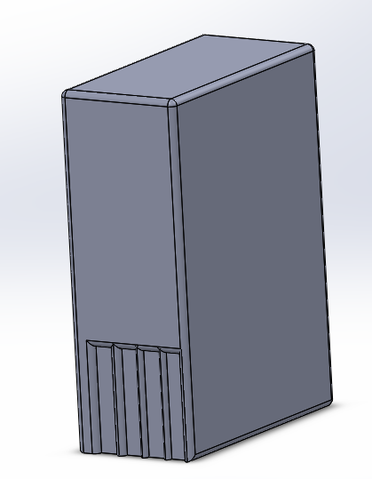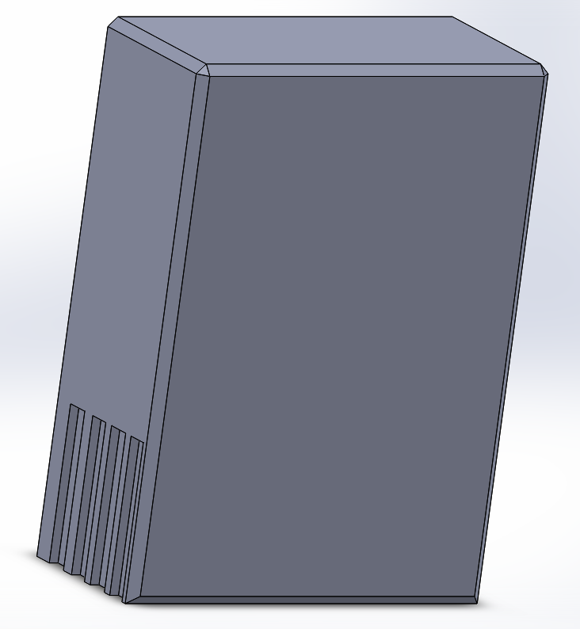v

* In this I learned how to complete different edges such as the use of champhering and filleting

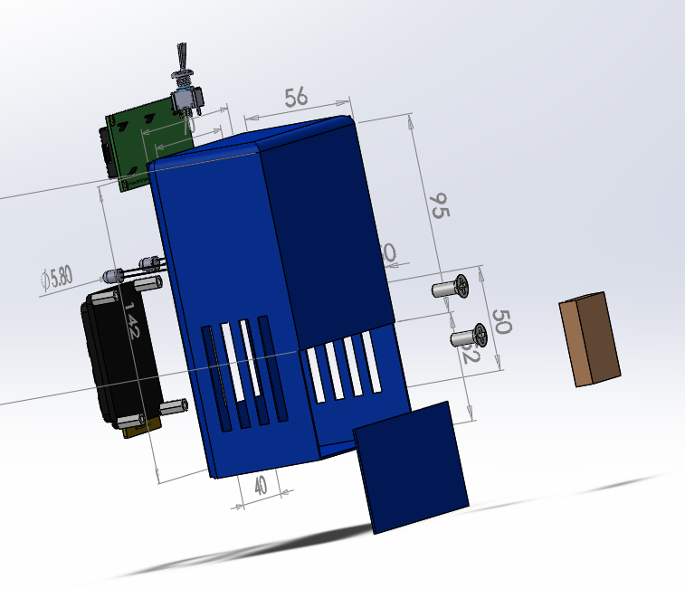

* This shows my abilities to produce 3D explorded views – I have also produced an animated video to show the order and mechanism by which components are removed

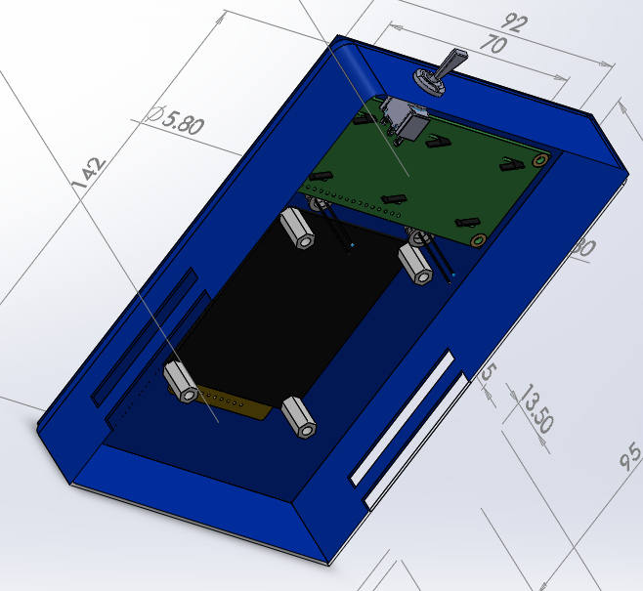

* This shows my ability to use Section views to see inside a componnt and investigate it

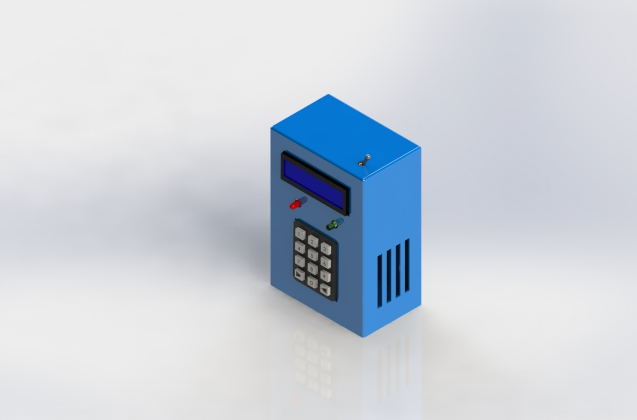

* In this I learned appearance settings, for example setting specific plastics and their colours as well as the setting. I also learned how to use PhotoView 360 to help to render designs easily
* I also learned how to create more planes to help to replicate one side on the other side of the produce to save time.

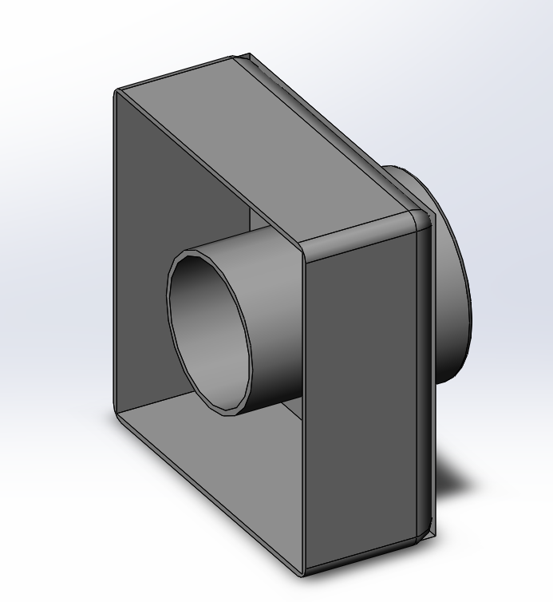

* In this I learned how complete shells, as well as complex filleting

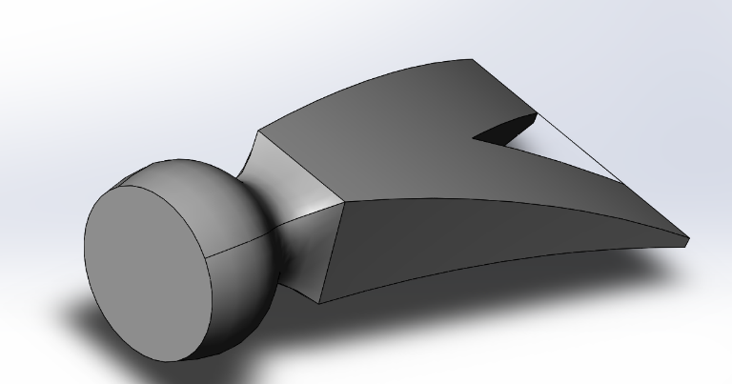

* In this, I learned how to create lofts, and how to create flexes, such as the bend in the hammer head

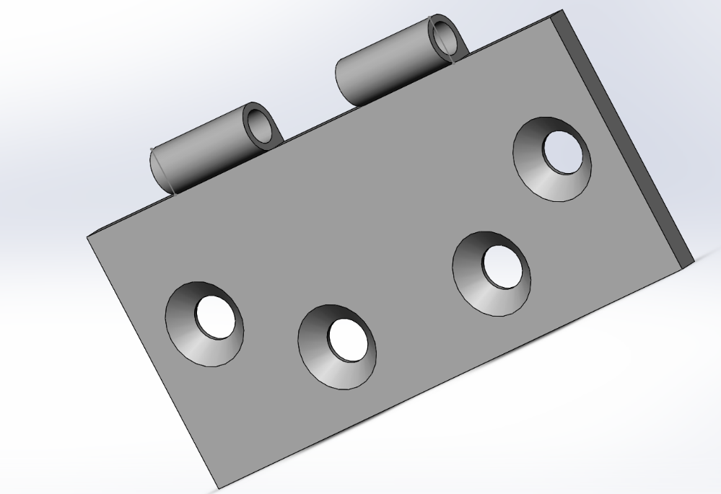

* In this I learned how to use the hole wizard for creating holes of the correct size. I also learned how to use the mirror feature, to replicate two holes (on the left of the front plane) to create another two (on the right side of the front plane)
* I also learned how to use equations to form a relationship between different dimensions to allow for continuous updating
* I also learned little more about trimming entities, such to allow only certain parts of a 2d sketch to be converted into 3d.