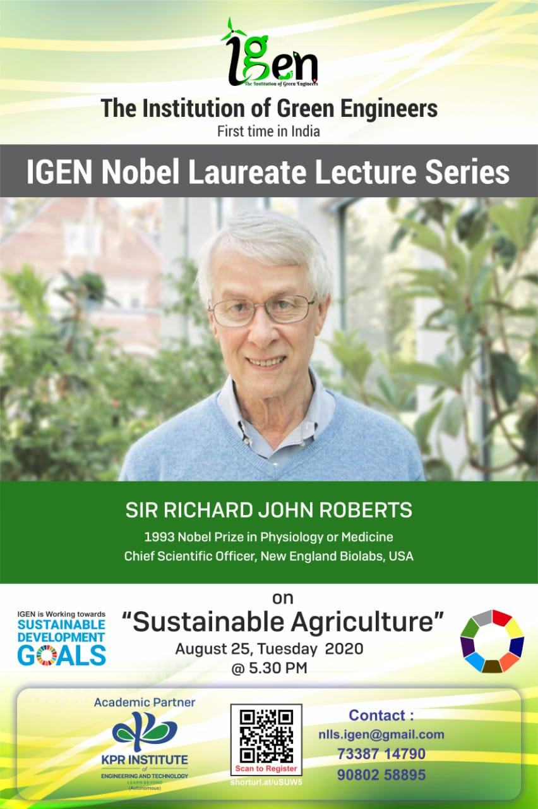
Stay Home Stay Safe

An Awe-Inspiring International Multifold Competition about Nobel Laureate (YOUR THOUGHTS YOUR CREATIVITY)

RULES
- Portrait your ideas and imagination on a piece of paper. Use your skills and creativity to show us what you think.
- Topic for Painting/Coloring: “Sustainable Agriculture”
- Medium of Art: Water colors, Crayons, Oil Pastels, Acrylics, Brushes, Pencil Colors, Face Painting, Oil Paints, Pastel Painting, Wall painting/Murals and etc.
- Eligibility criteria – School Students (All grades)
AWARDS
A medal and a certificate holding the Signature of Nobel Laureate Sir Richard John Roberts will be given to best 3 entries. Winning entries will be showcased during the live stream of the event and also will be published on “IGEN Nobel Laureate Lecture Series” website.

For more information on the above, contact Mr. Rahul Raman [7218372360] and Mr. P. Kankakraj [9095353643]

