Write Up – FlyAway

**Project objective:**

As a Full Stack Developer, design and develop an airline booking portal named as FlyAway.

**Software used:**

* Eclipse
* Tomcat Server

**Program Flow**

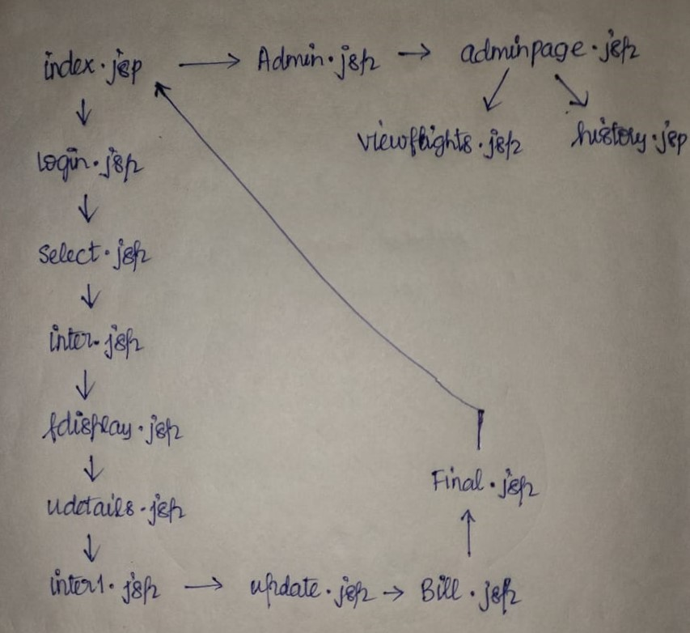

index.jsp: redirects to User or Admin based on user input

**USER**

Login.jsp: Prompts to enter username and password

Select.jsp: Prompts to enter From and To location

inter.jsp: redirects to fdisplay.jsp

fdisplay.jsp: stores the From and To location into the database and displays the flight available with respect to From & To location

udetails.jsp: prompts the user to enter personal details and flight number and number of seats

inter1.jsp: passes the extracted value to update.jsp

update.jsp: It updates the seat availability and booked seats in the database

Bill.jsp: It displays the seats booked by the user and prompts the user to pay the amount for the flight ticket

Final.jsp: Displays the final transaction and prompts back to index.jsp( First page)

**ADMIN**

Admin.jsp: Prompts the user to enter username and password

adminpage.jsp: Redirects to viewflights.jsp or history.jsp based on user option

viewflights.jsp: Displays the flights available which is extracted from the database

history.jsp: Displays the users previously accessed and their booking transaction

StoreData: POJO class

FlightData: hibernate save

hibernate.cfg.xml: JDBC connection

FlightData.hbm.xml: connects with hibernate.cfg.xml

Name: B.Ashwin

ID: 2528736