INPUT

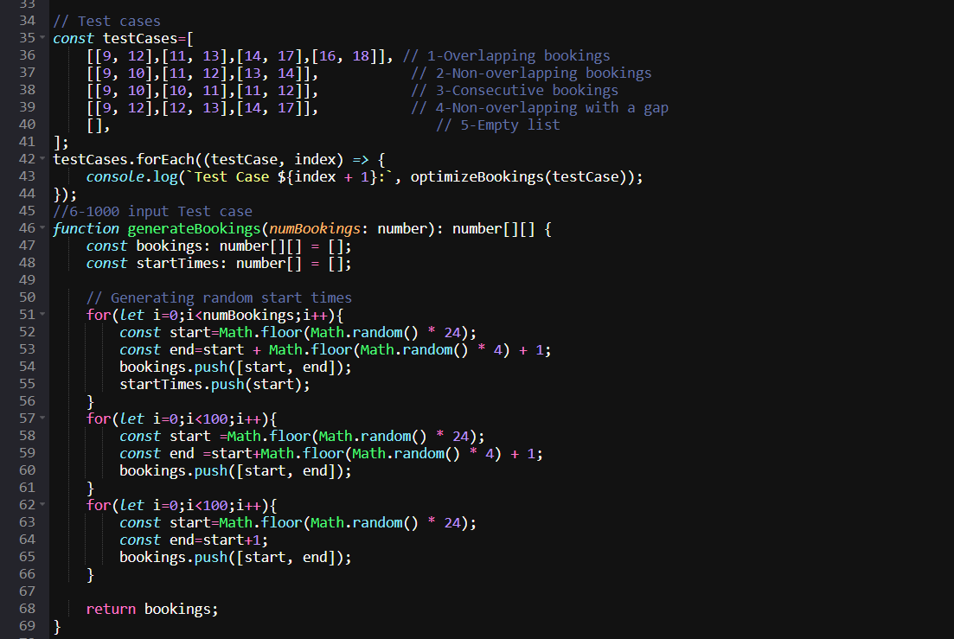

It includes test cases for Non-overlapping bookings,Consecutive bookings that just touch each other end-to-start,Bookings that are already non-overlapping,An empty list of bookings,Overlapping bookings and a sizde 1000 input.

OUTPUT

