**SCREENSHOTS AND WALKTHROUGH**

**TASK-2**

A folder called hotel-room-service was created and initialized a Node.js project with a package.json file using npm init -y using command line.

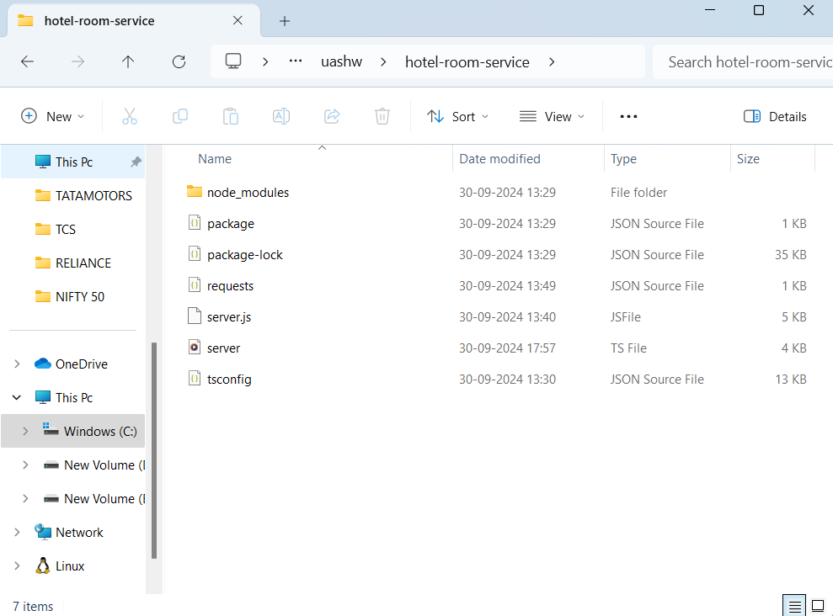

**Code Used(in cmd)**

**npm install express body-parser fs-extra  
npm install --save-dev typescript @types/node @types/express @types/fs-extra**

These commands installed:

* express: Web framework for handling routes and requests.
* body-parser: Middleware to handle JSON request payloads.
* fs-extra: File system module for reading/writing files.
* typescript: TypeScript compiler and types for Node.js, Express, and fs-extra.

**npx tsc –init**

This created a tsconfig.json file in theproject directory. This file contains configurations for how TypeScript should compile the code.

Using Notepad++ a new file called requests.json was created in the root of the project folder (hotel-room-service/)

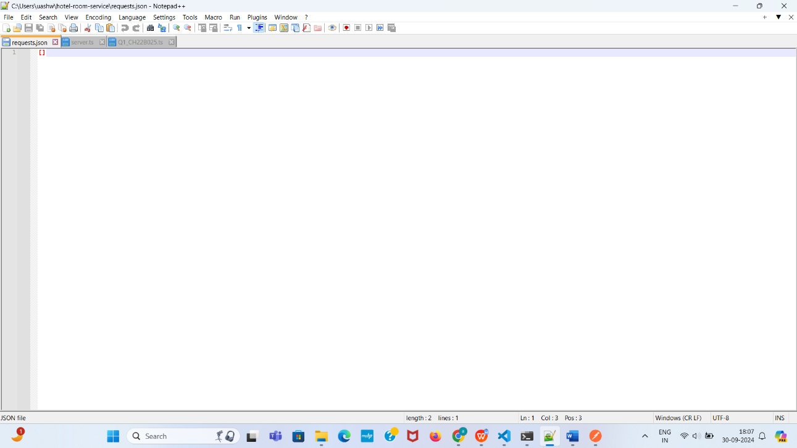

A file named server.ts was created inside the root of the folder.It had the following code

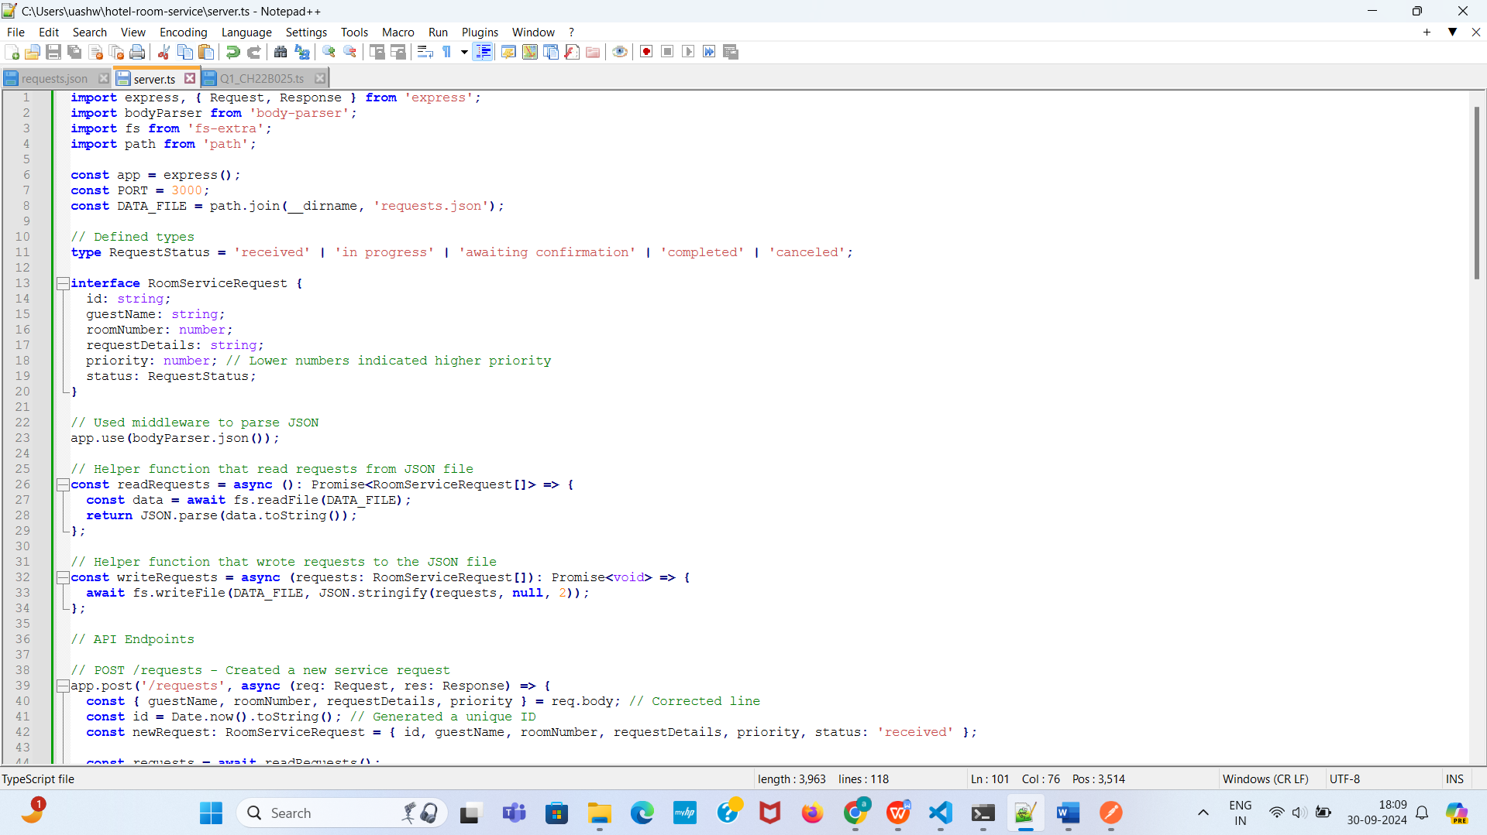

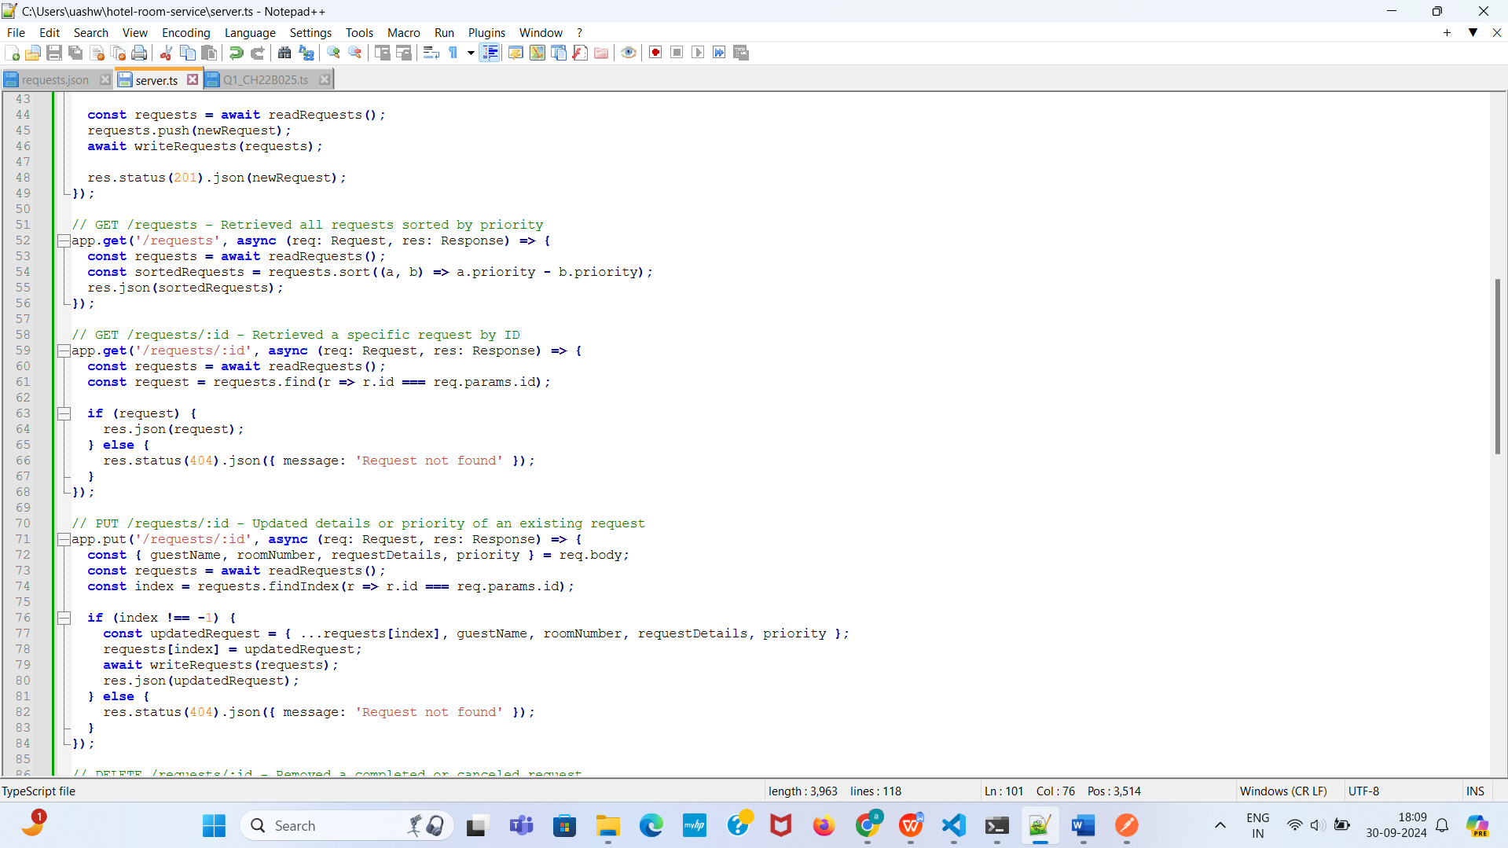

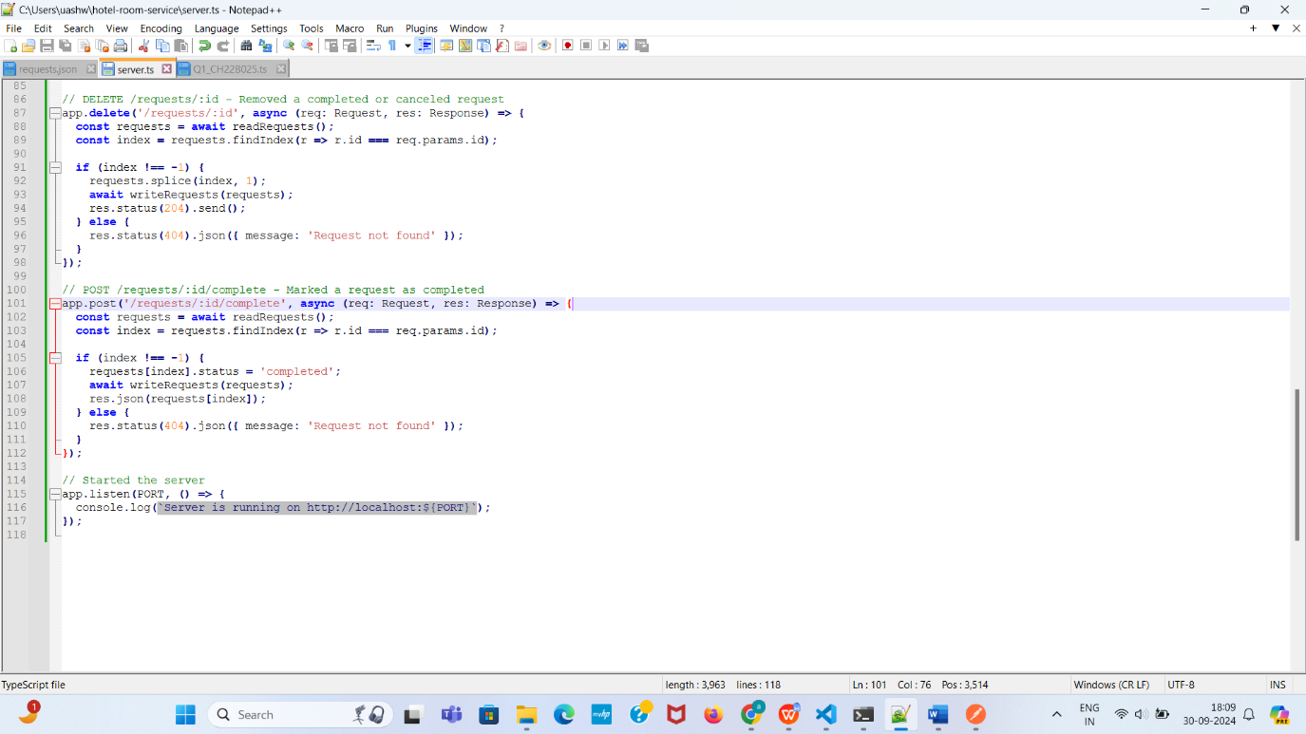

**npx tsc**

TypeScript code needed to be compiled into JavaScript.The following command compiles all .ts files in the project

**node server.js**

To run the server.js file

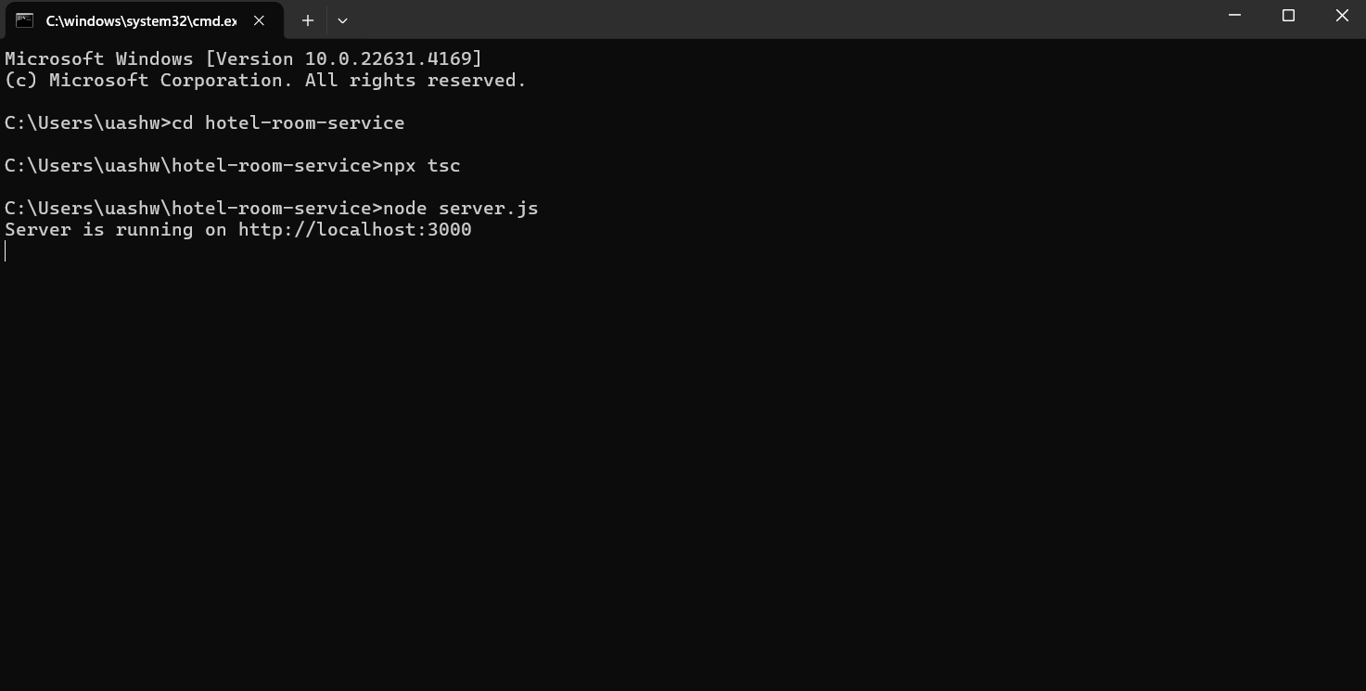

**TESTING USING POSTMAN**

1. **Adding a New Room Service Request (POST /requests)**

**INPUT**

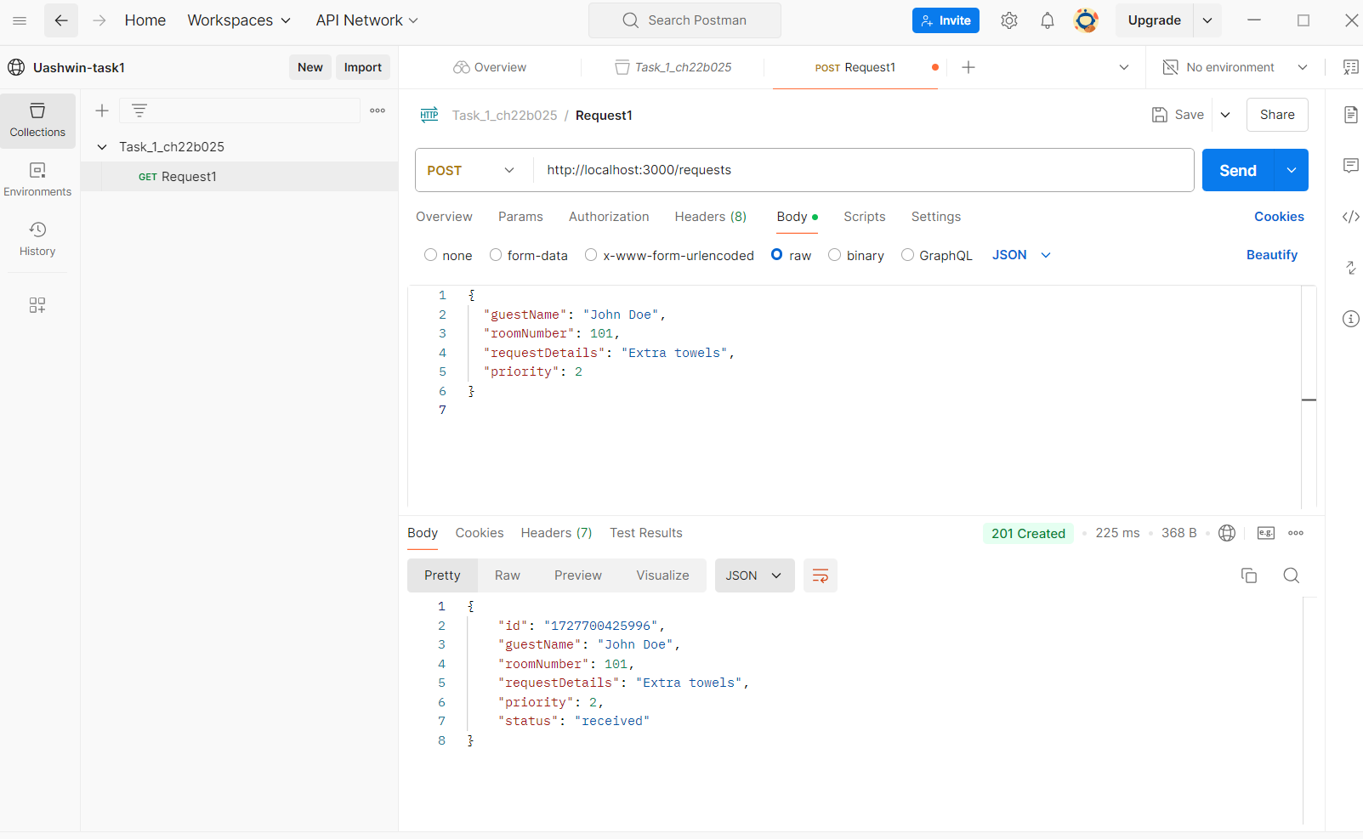

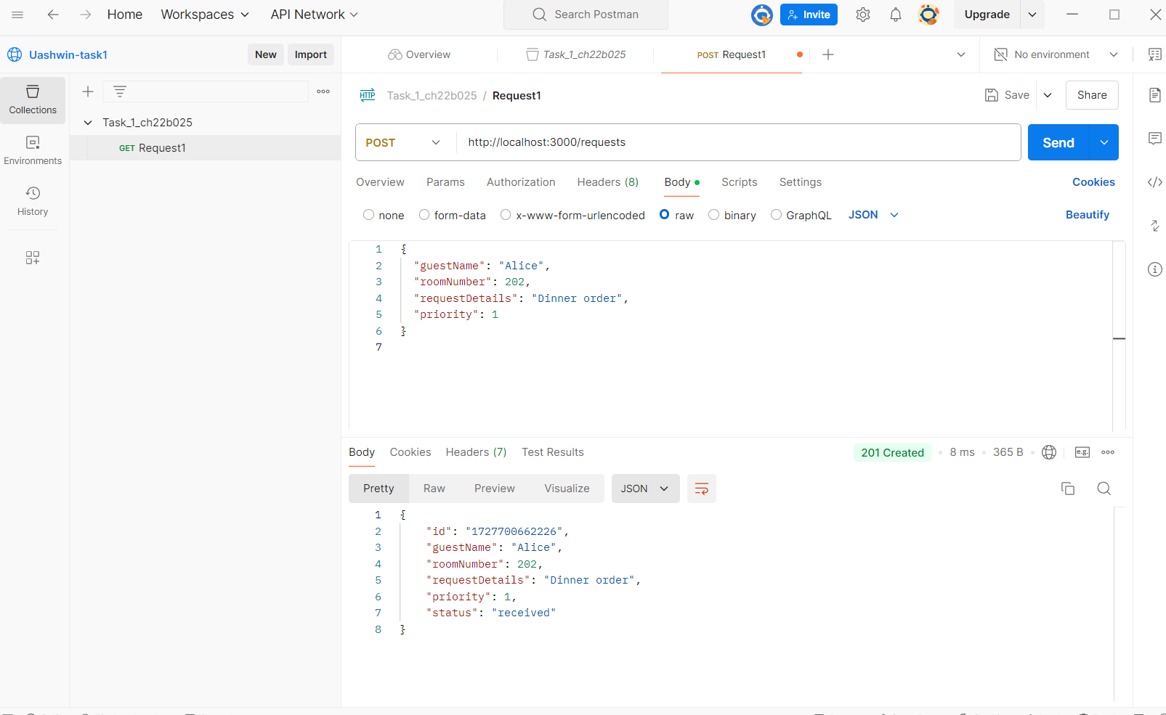

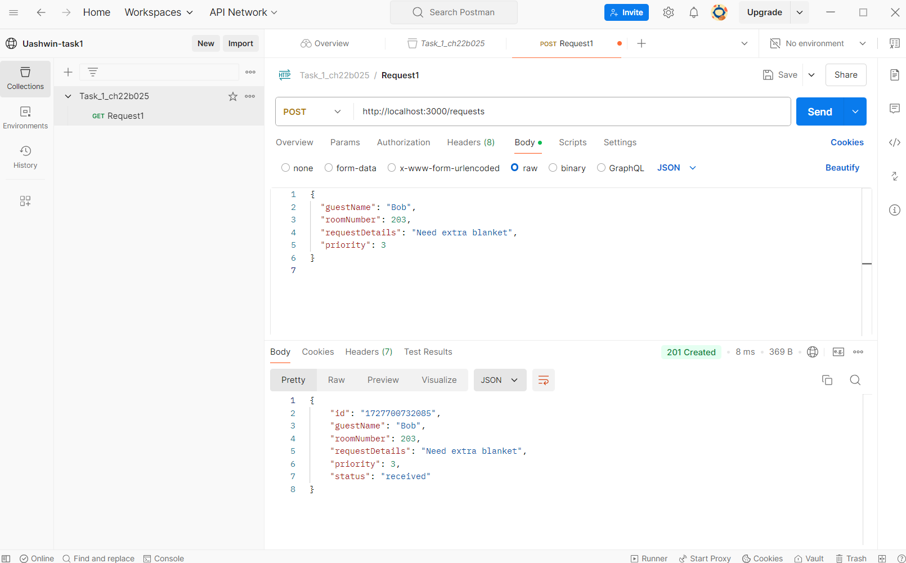

1. **Retrieve All Requests (GET /requests)**

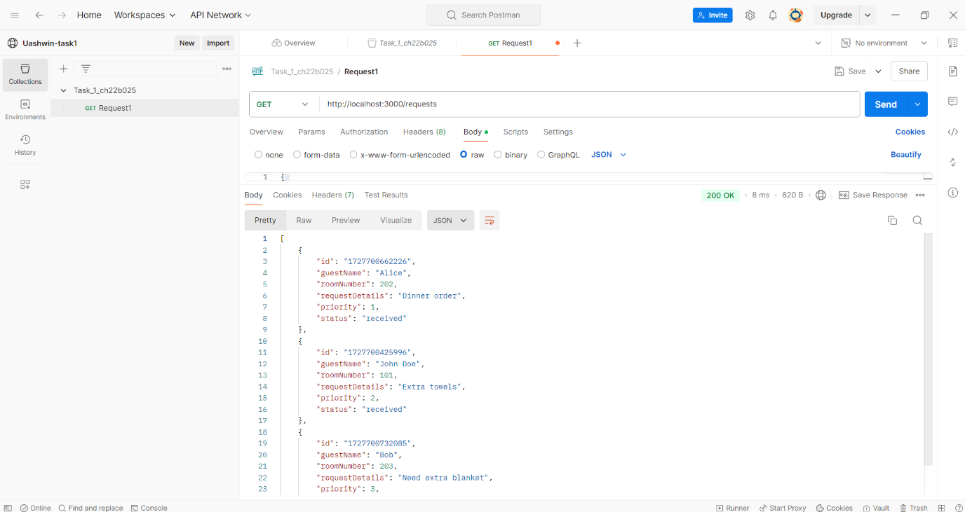

**Retrieve particular request  
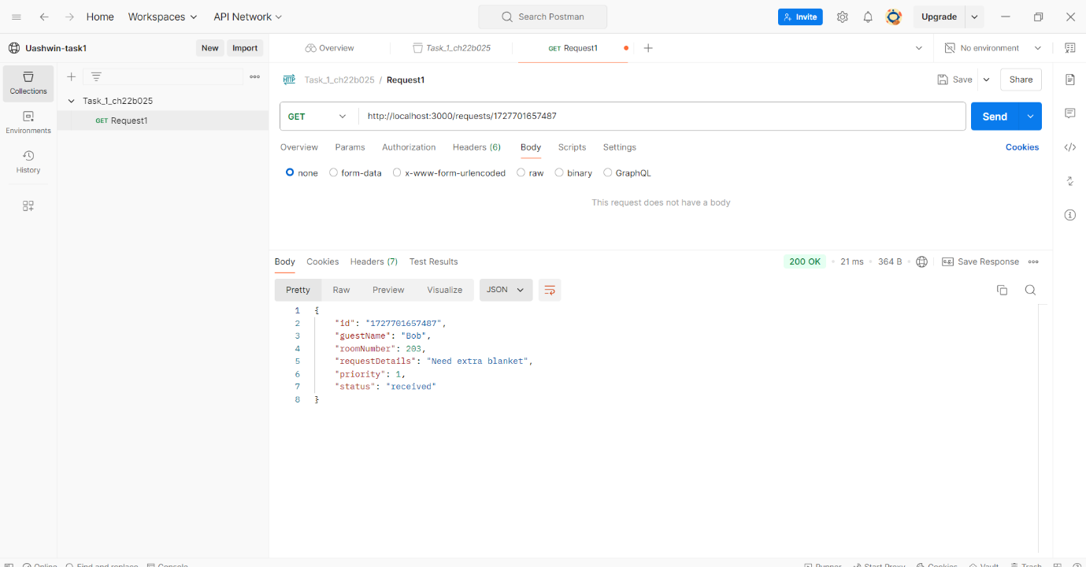**

**3-Deleting a Request(DELETE/requests/id)**

**We will take the case for deleting bob  
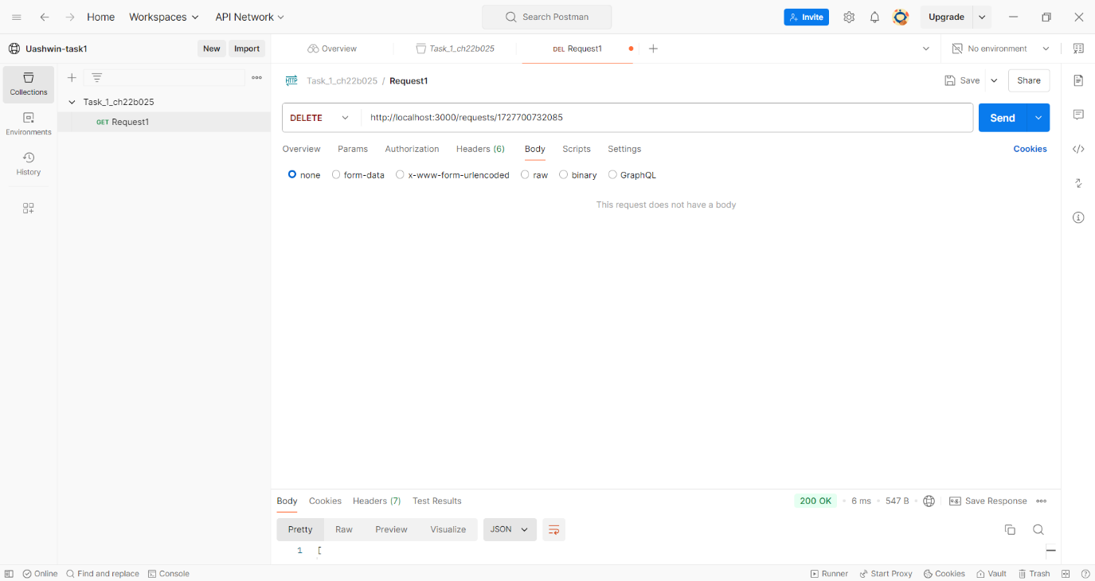**

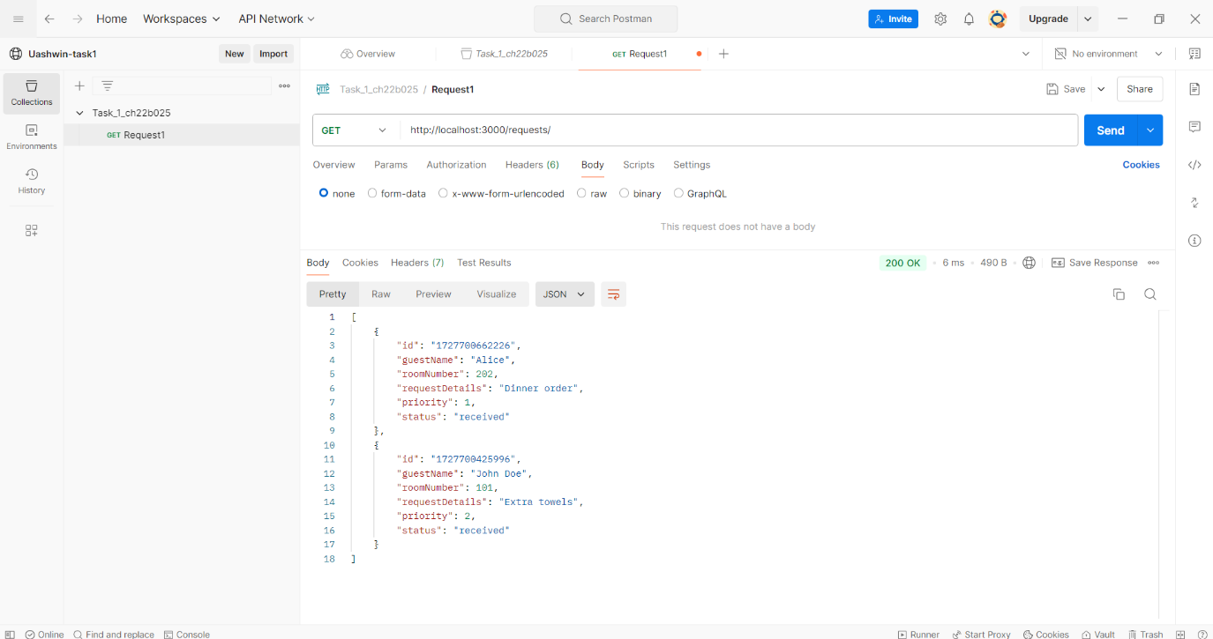

**We will add bob once again for testing further operations**

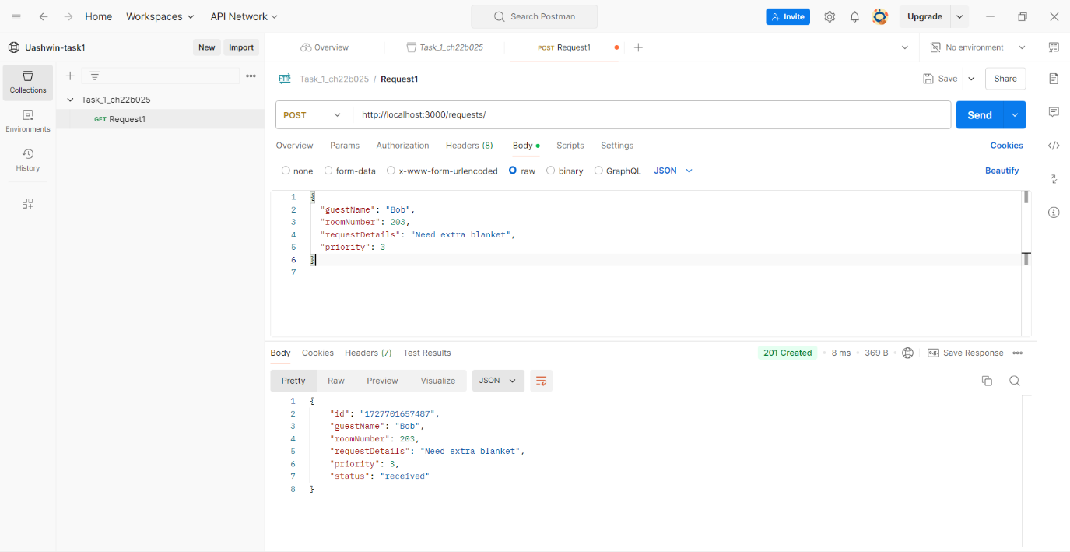

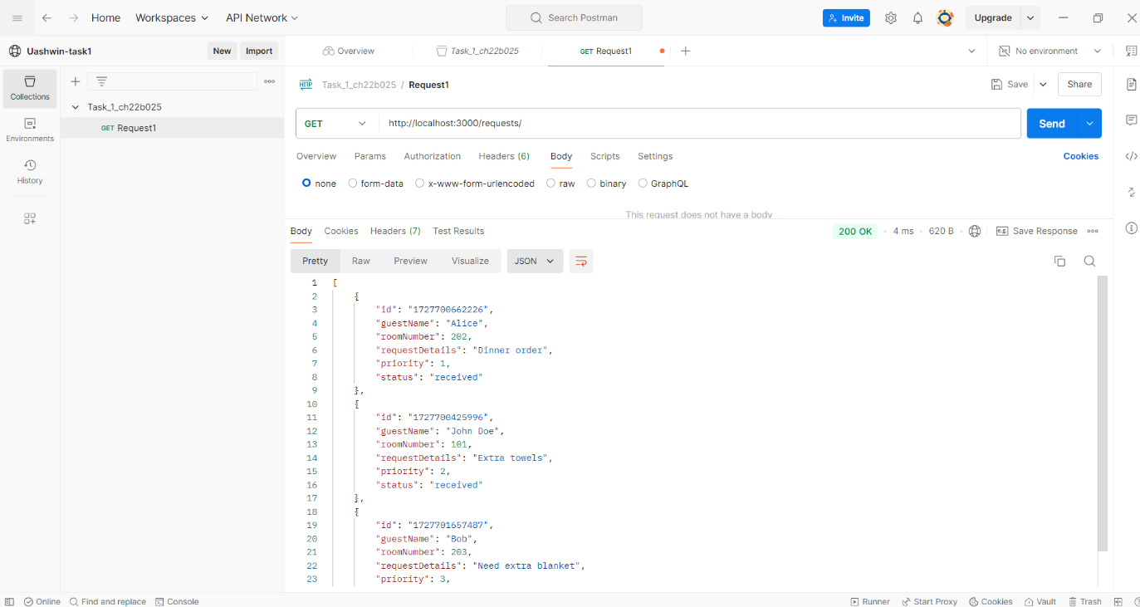

**3-Update a Request (PUT /requests/id)**

**Let's say Bob's request (priority 3) needs to be prioritized due to an emergency.**

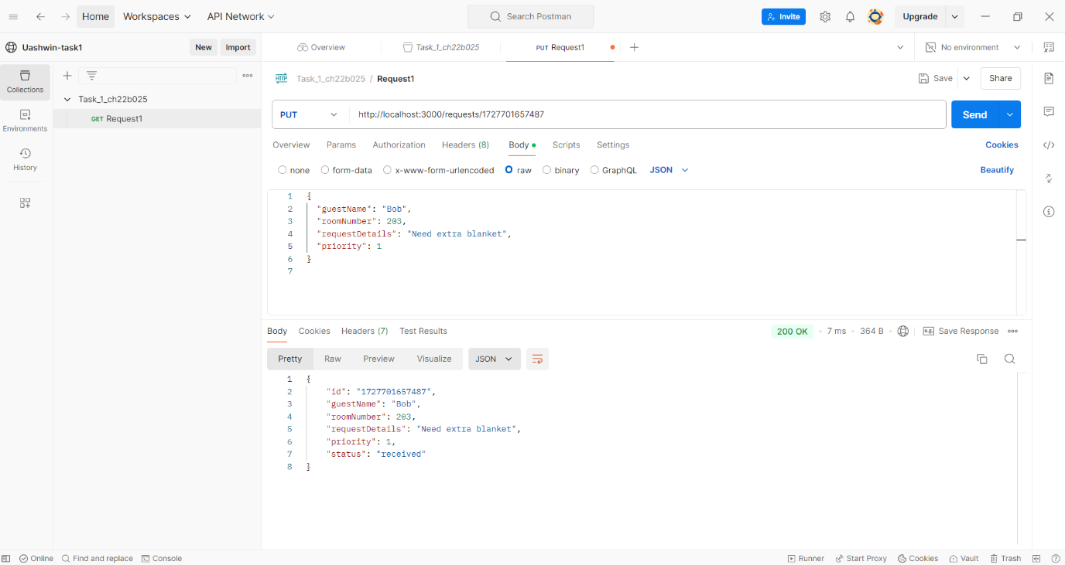

**4-Mark a Request as Completed (POST /requests/{id}/complete):**

**We are marking bob’s request as completed**

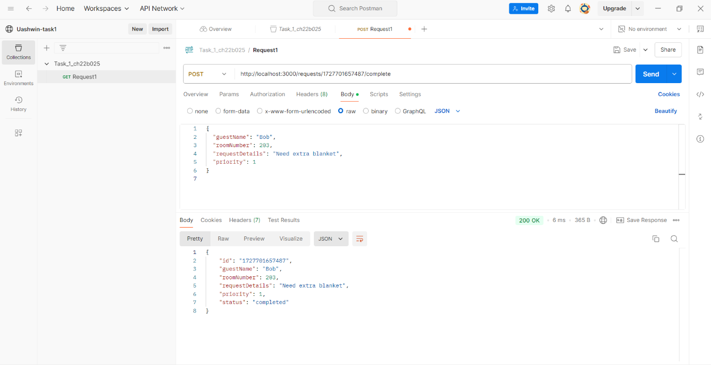

**5-Retrieving all requests**

