- Collect the Cubes
Collect the Cubes
Feb 2020 - Jun 2020Feb 2020 - Jun 2020
In grade 4, I have created a 3d game called "Collect the cubes" in which you have to collect cubes as fast as possible to gain coins. I have coded the game in C# in unity and modeled the game in 3ds Max.

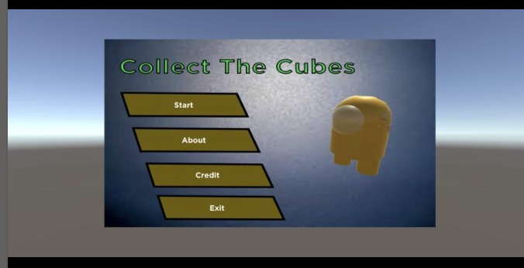

- Analysis Deck on Titanic Ship - its included in whatsapp
- Mars result and New York Times featured
- Certificates ..( this should be added in main menu)
  - Need to divide into three
    - Social and Impact on Society
    - Education Certificate
    - Research and Project
- About Ashiwn - Need to highlights first few paragraphs more on Robotics/Maths/Education and then social service(cheri foundation)

