IT13: ADBMS
Chapter 2:SQL
Practical Assignment 1 Solution Template

Practical 1. Implementation of DDL & DML commands in SQL with suitable examples
Create the following tables. (Primary Keys are underlined)
Employee ( emp_id ,emp_name, City, bdate)
Investor ( inv_no, inv_name, inv_date, inv_amt, emp_id)
Create a Primary key constraint on emp_id in the Employee table and inv_no in the Investor table.
Write the SQL query and paste a screenshot of the output below the question.
- Create a database and two tables in it.
create database Assignment;
use Assignment;
show databases;
create table Employee(emp_id INT PRIMARY KEY ,emp_name VARCHAR(100), City VARCHAR(100), bdate DATE);
create table Investor(inv_no INT PRIMARY KEY, inv_name VARCHAR(100), inv_amt INT);
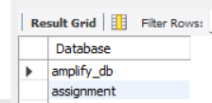
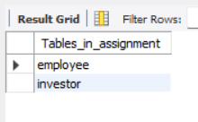

- Insert at least 5 rows into the table.
insert into Employee values
(101,'Ashwini Gund','Pune','2005-10-31'),
(102,'Sanika Kale','Pune','2006-03-27'),
(103,'Isha Bhagat','Pune','2005-02-26'),
(104,'Sushant Kende','Pune','2005-08-23'),
(105,'Vaishnavi Gund','Pune','2000-03-12');
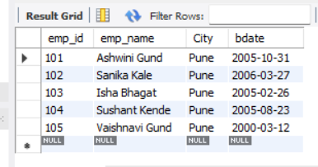
Insert into Investor values
(1,'MutualFunds',20000),
(2,'MutualFunds',700650),
(3,'FixedDeposit',564340),
(4,'MutualFunds',20000),
(5,'FixedDeposits',20000);
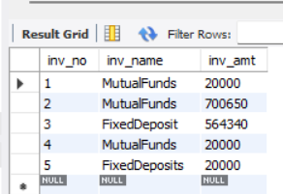
- Display all the information in the Employee table.
select * from Employee;

- Add columns ‘Age’ and ‘Salary’ to the Employee table; apply check constraints for (Age<=50 and Salary>=10000).
alter table Employee add column age INT check(age<=50);
alter table Employee add column salary INT check(salary>=10000);
desc Employee;
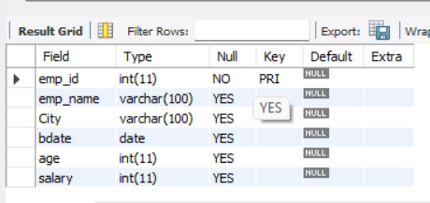

- Add a column ‘Age’ to the Investor table.
alter table Investor add column age INT;
desc Investor;
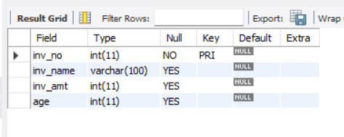

- Change the data type of inv_name from varchar to text in the Investor table
alter table Investor modify column inv_name text;
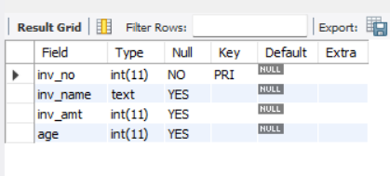

- Change the name of the column/field Emp_id to E_id.
alter table Employee rename column emp_id to e_id;

- Update the city of Emp_id-4 to the current city, Nagpur.
update Employee set city='Nagpur' where emp_id = 104;
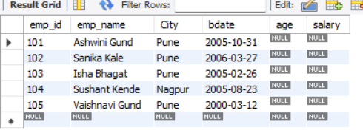
- Delete one record from the Investor table.
delete from Investor where inv_no = 1;
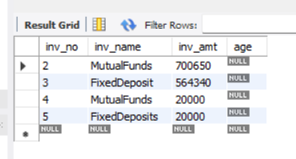

- Drop the column ‘Age’ from the Investor table.
alter table Investor drop column age;
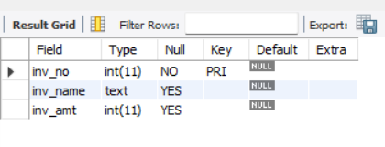

- Drop the CHECK constraint on the ‘Age’ column from the Employee table.

- Create foreign key constraints between the Employee and Investor tables.
alter table Investor add constraint e_inv foreign key(emp_id) references Employee (emp_id);
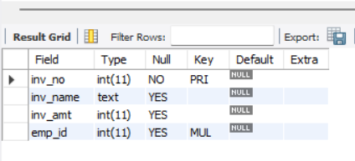

- Display any 4 columns from the Investor table.
select inv_no,inv_name,inv_amt,emp_id from Investor;
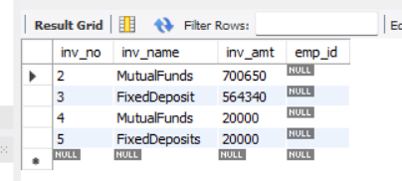

- Rename a table.
alter table Employee rename Emp;

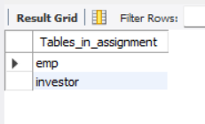

- Delete all the records using the TRUNCATE command.
truncate table Investor;
truncate table emp;

- Drop both tables from the database.
drop table Investor;
drop table emp;

