LINUX FUNDAMENTALS

Basic Linux Commands:

- Check the present working directory – pwd
- Check the list of files – ls
options:
-l - Long Listing
-a - Hidden files
-r - Print in reverse order
-R - Print recursively
-i - Check the inode value
- Create a new directory - mkdir <dir>
options:
-p - mkdir -p <dir1>/<dir1.1>/<dir1.2> - Recursively create directories
- Change directory - cd <dir1>
- Move/rename a file or directory – mv <dir1> <dir2>
mv <file1> <dir1>
- copy files/directories - cp <file1> <dir2> - Creates a copy of the file
options:
-r - copy files recursively in the directory
-p - Preserve permissions during copy
-f - Forcefull copy of the files/folders
- delete a file or directory - rm <file1> or rm -r <dir1>
options:
-r - delete recursively
-f - delete forcefully
- Check the contents of the file - cat <file1>
- Create a empty file - touch <file1>

Shell:
Shell is an interface that allows the user to communicate with the linux kernel, There are many types of shell’s in linux but bash shell is the most popular
Other types of shells are:
1. C-Shell (csh)
2. K-Shell (ksh)
3. Z-Shell (zsh)
4 .Bourne Shell(sh)

- In order to find the shell currently being used - echo $SHELL
- In order to change the shell – just type-in the shell name
- Features of Bash
- Maintains history
- Ability to create alias
- Auto-Completion on commands
- Check environment variable in bash - env
- Export a environment variable - export name=”John”
- In order to persist the change in every terminal update it in ./bashrc or ./bash_profile
- Check the path for default binaries to load - echo $PATH
In order to persist change in the PATH variable add below in ./bash_profile to the PATH variable
export PATH=$PATH:/new/path1
- Check for the a binary installed in the linux VM - which <name>

Linux Core Concepts:

Linux Kernel:

Its an interface between the computer hardware and processes running in the operating system.

Its responsible for 4 major tasks:
1. Memory Management
2. Process Management
3. Device Drivers
4. System Calls and Security

Identify the linux kernel:
uname - Shows only the kernel name
uname -a - Prints the kernel version

There are two areas dedicated to access the resources.
a. Kernal Space:
This space is dedicated to the kernel with unlimited access to the system resources/hardware. This is a managed by the kernel or administrators

b. User Space:
This are is dedicated to the process defined by the user, if the user wants to access any resource using system calls, they go through the kernel space which validate the request and then aquire/allocate the hardware resource to that request

- Understanding how linux kernel detects a hardware devices and attaches it to the userspace to be read
Once a USB device is attached to the system --> It gets detected by the device driver in the kernel --> This inturn will generate uevents which are consumed by the udev device manager in the user space --> this automatically creates a device file system that can be accessed by the user

- In order to check the events generated by hardware devices and troubleshooting them during boot up we can check the command - dmesg
- This command displays kernel messages from the kernel ring buffer.

- In order to check the uevents sent by the kernel on the harware devices attached in the userspace we can use the commands
udevadm info –query=path –name=/dev/sda5
udevmonitor - This monitors the uevents generated for the devices attached in removed

- In order to check for the events on Peripheral component Interconnect(PCI) we use : lspci
It lists all the PCI devices – Ethernet interface, Graphic cards

- List the block storage devices attached to the VM – lsblk
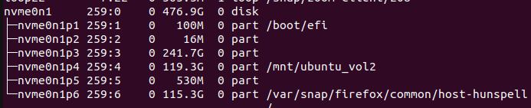
- List the detailed CPU Information - lscpu
- Check the free ram - free -m

Linux Boot Sequence:

- Linux boot sequence is divided into four steps which include

1. BIOS POST – BIOS Power of Self Test performs for diagnostic tests on the system hardware as soon as the boot is initialized or the system is restarted. This steps has no relationship with the underlying OS.
2. Boot Loader (GRUB2) – Boot loader is loaded on to the memory from the 1st sector of hardisk which provides the options to boot the Operating Sytems installed on it. Boot loader can be accessed from /boot file system on the linux OS, This loads the kernel onto the memory.
3. Kernel Initialization – Once the kernel is initialized onto the memory, it gets decompressed and runs diagnostic checks with the hardware and initializes the INIT process.
4. INIT Process (systemd) – INIT function loads the services in the systemd daemon which makes the Linux System usable to the users

RunLevels:
Run levels get initialised as soon as the init process is loaded, It check for the default run level set on the OS, which defines whether the OS should load in a graphical user mode or command line mode. There are multiple levels that can be set as run level, they are mentioned below:

runlevel 0 --> poweroff.target
runlevel 1 --> rescue.target
runlevel 2 & 3 & 4--> multiuser.target
runlevel 5 --> graphical.target
runlevel 6 --> reboot.target

We can check the default run level using the command, Here the run level indicates that the OS
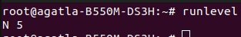
loads in graphical user mode

We can also change the default run level by change the default target value in /etc/systemd/system/default.target

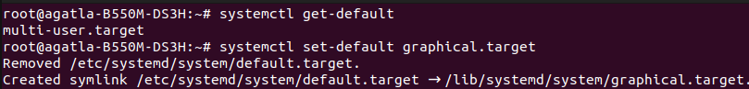
File Types:

Everything is a file in linux, There are 3 file types in it

Regular File

