PYTHON

- Python is a programming and scripting language extensively used in machine learning, data analytics and automation
- Python is a open source software that can be run on any flavour of operating system

Fundamentals:

- Python has some inbuilt-function that allow it to perform some task, some of them are

In Built Functions:
- print
- end
- sep

data types:
- String
- Boolean
- Integer
- Float

Operator:
- Addition (+)
- Substraction (-)
- Division with quotient as a floating point number (/)
- Division with quotient as integer (//)
- Multiplication (*)
- Exponent (**)
- Modules (%) - Return a remainder value
- Precedence - (),**, *, /,%, //,+, -

Variables:
- A variable stores a value and can be declared as
var1 = 10
- It cannot be any of the python’s reserve words and a number to start with
- Variables allow to use them in any in built pythons to fetch the value stored in them

Comments:
- A comments makes the code more readable and describes the piece of code and if the comment is specified at the start of the code, then it is not executed

Input:
- Input function allows the user to provide the value of the variable during execution
- Input values are always of the data type string, they can be changed using the respective data type
var1 = input(“What is your name? ”)
var2 = int(input(“what is your age? ”) Change the string data type to integer
String Methods:
- We can use multiplication operator * to multiply a string with a number and repeat the string
- We can convert a integer to a string using “str” function and concatenate with another string

Comparision Operators:
- comparision operators allow to compare two integers and return a boolean value, Below are the comparision operators specified
- Equal to (==)
- Not Equal to (!=)
- Less than (<)
- Greater than (>)
- Less than equal to (<=)
- Greater than equal to (>=)

Conditional Statements:
- conditional statements allows to evaluate a condition and returns a boolean value , based on the boolean value we can give the statement to be evaluated
- Indentation plays a major role here
- here we can use if, if-else, nested-if, if-elif-else

Syntax:
If block
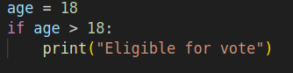

If-else block
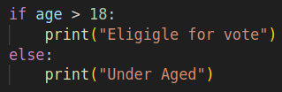

Nested-If Block
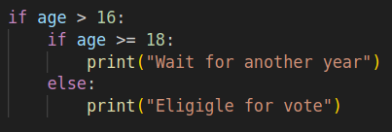

If-Else-If Block
