OCI FOUNDATIONS

OCI ARCHITECTURE:

Introduction:

OCI Architecture is the foundation that Oracle cloud is built on. It comprises of Regions, Availability Domains, Fault Domains.

Regions: Its a geographical area which consists of one or more availability domains

Availability Domain(AD) : Its a collection of one or more fault tolerant datacenters that are inter-connected with each other with low latency but at a physical level they are isolated

Fault Domains(FD) : Its logical grouping of hardware within a data center. Each AD has 3 FD’s.

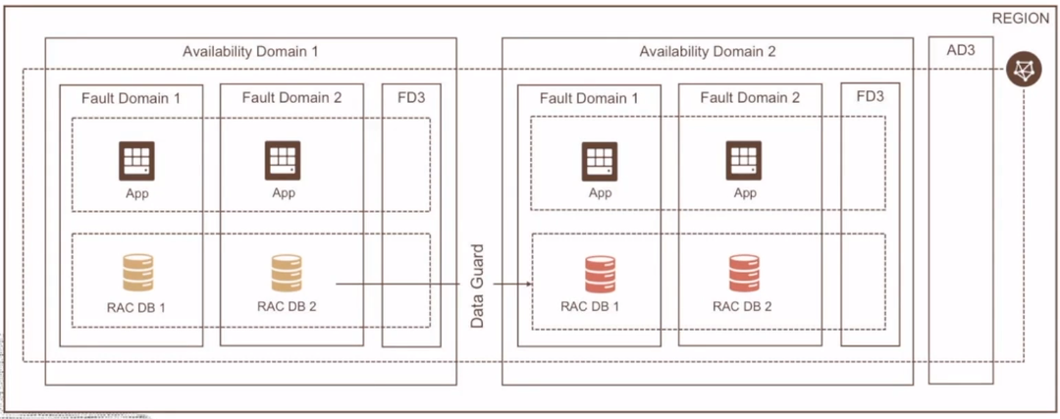
At a high level, an application can achieve high availability and be fault tolerant by distributing the application across multiple FD’s , AD’s and Regions.

A region can be selected on the basis on 3 factors.

1. Location : The region selected must be closer to the user base that the application is accessed
2. Data Residency and compliance : Being complaint with the regulations of the government body in that country.
3. Available services : The number of OCI services available in that particular region.

OCI Distributed Cloud:

OCI offered distributed cloud in 4 different ways from which you can access the OCI Services

1. Public Cloud : This is the generic oracle cloud that is spread across multiple regions and is shared by multiple users.

2. Hybrid Cloud : This brings OCI cloud services on-premise at the customer location and also allows to isolate the network from outside network. This hybrid cloud consists of 4 types:

a. Dedicated Region Cloud@Customer :
Run OCI services in Customer Data Center.
b. Oracle Cloud@VMware :
All the users to migrate exiting VM’s to OCI through VM Ware offering.
c. Autonomous DB on Exadata cloud@customer:
Cloud autonomous DB running at the Data Center.
d. Roving Edge Infrastructure :
OCI Compute and Storage for remote edge location which is disconnected from outside network.

3. Dedicated Cloud : As name indicates, this allows customers to have a dedicated OCI cloud space that is not shared by other users or other cloud providers.

4. Multicloud : Multi-cloud is a concept where a cloud service can collaborate with another cloud provider. Here in our case, Oracle and Microsoft share the cloud services. Where you can access Azure VM offerings through OCI Interconnect service which is configured using a OCI Database.

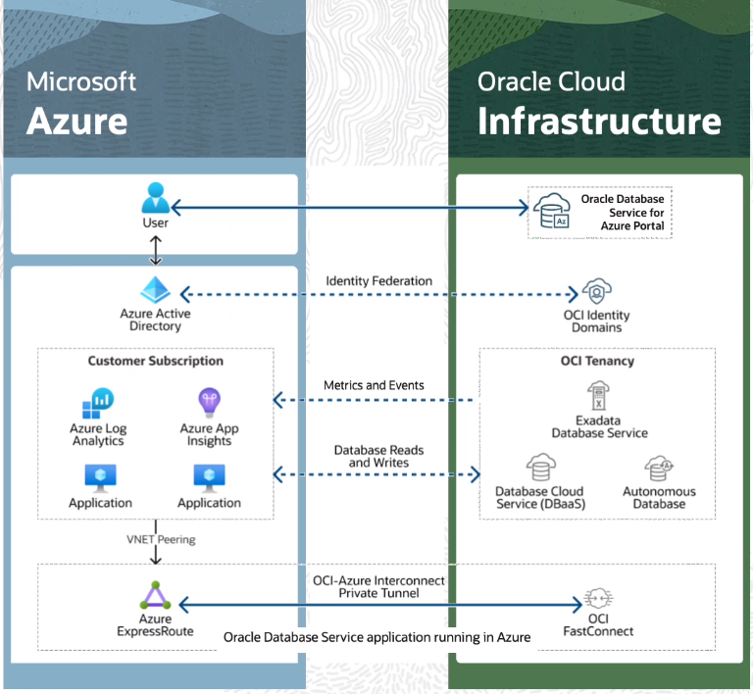

Identity And Access Management

Introduction:

This is a service that allows to authorise and authenticate a user to use OCI services through a Fine-grained access control method or Role based access control method. This is a Global Level Service.

All these user and group creation,access and the configurations related to them are logically grouped under a domain called Identity Domain.

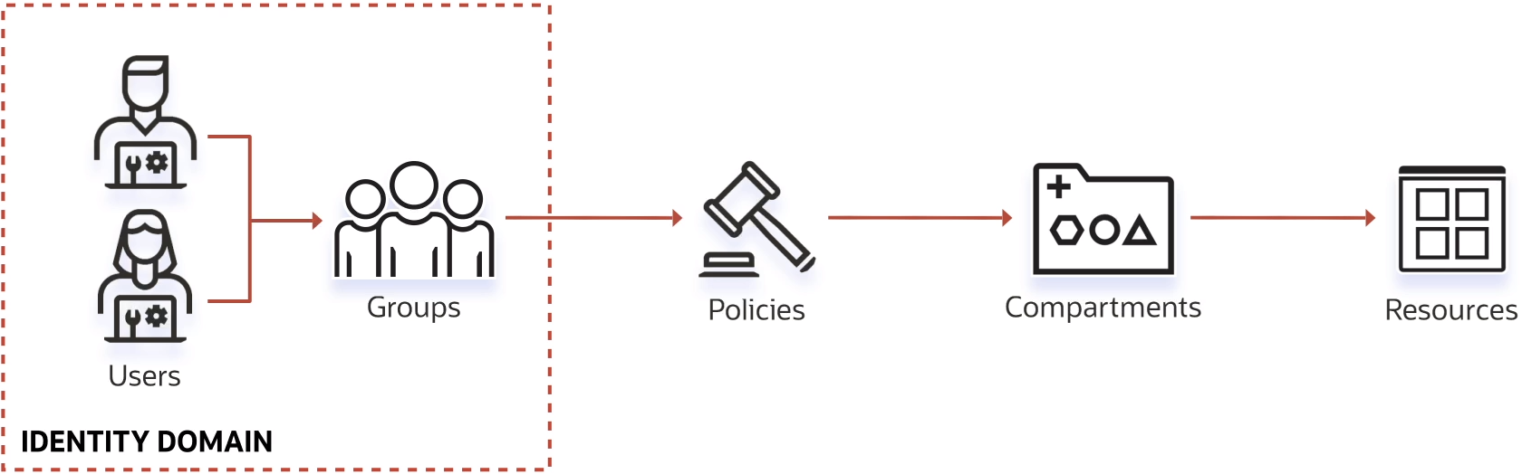
Here resources indicate the cloud objects/services that are provided by the OCI, Each resource is assigned a unique OCID – Oracle Cloud ID based on which that resource can be accessed from Oracle Cloud Shell/CLI.

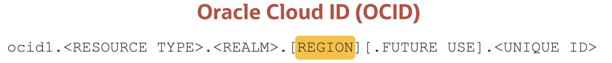
Compartments:

Compartment is a logical grouping of resources within an OCI account. By default there is a default root compartment/tenancy for each OCI account. It gives the user flexiblity to create number of compartments for each category of resources(Networking, Storage, Compute, etc.). This helps in better isolation of resources.

In each compartment we can create a maximum of 6 nested child compartments.

Each resource belongs to a single compartment and cannot be shared with other compartments though they can be accessed from any compartment.

Using compartments gives the user more control over the access of a resources in that compartment by restricting the access to the compartment.
Since compartment is a part of Identity and access management, it is visible accross all the OCI regions.

We can also fine grain the quotas and budgets allocated to a respective compartment.

Authentication & Authorization:

OCI has identites called as prinicpal which denotes a user or a resource to which interact with OCI resources.

These resource principal or a user can be grouped into different groups to which roles and permissions can be assigned.

Authentication is basically authorizing a user use a resource. There are 3 type of Authentications.

1. Using a username and password.
2. Using API signing keys
3. Using Authentication Tokens – These are required for 3rd party API’s which dont support OCI API Signing Keys

Authorizations is basically permissions assigned to a principal, this is done by using policies.

A policy can restrict the usage of a resource based on the action specified on a group in a compartment or tenancy(root compartment)

A policy cannot be applied on a user level. By default all the permissions are denied by default.

Syntax :
Allow group <group name> to <verb> <resource type> in compartment <compartment> where <condition>

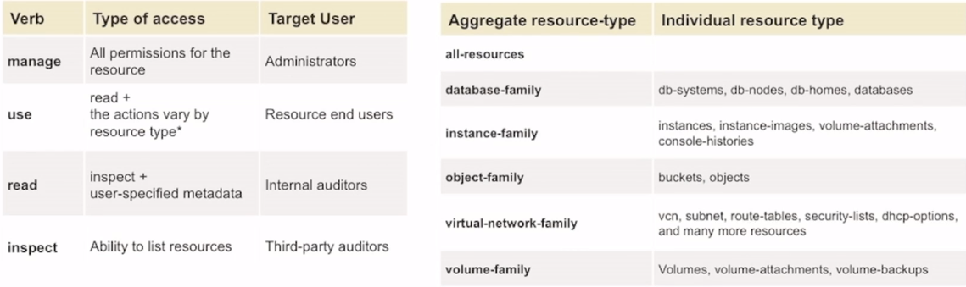
Best Practices:

1. Create OCI users and assign them to an OCI admin group instead of the using root user.
2. Create individual compartments to isolate resources
3. Enforce Multi Factor Authentication on users
4. Allow default Policies on admin users as all the access to resource is denied by default.

Default Policies for Admin users:

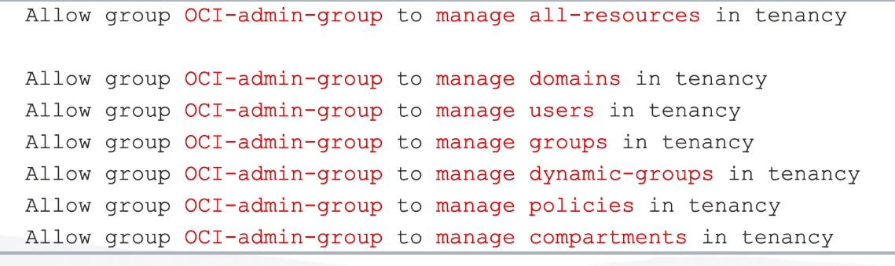

NETWORKING

VCN Introduction:

VCN is software defined network that allows the OCI resources to communicate to the outside network(internet) through communication gateways.

VCN is region specific and lives with the OCI environment.

It comprises of an IPV4/ IPV6 address space which consists of a IP range, which is further divided into subnets in which the OCI instances are assigned and each one gets a IP address based on the subnet its attached to.

Using this IP address and gatways , communication is established with the internet.

There are multiple gateways such as
1. Internet Gateway : Allows traffic to flow in and out of the VCN, its bidirectional
2. NAT Gateway : Allows traffic flow from instance to internet, Its Unidirectional
3. Service Gateway : Allows communication with OCI resources in other OCI region
4. Dynamic Routing Gateway: Allows a dedicated network communication with On premises OCI resources avoiding the Internet traffic.

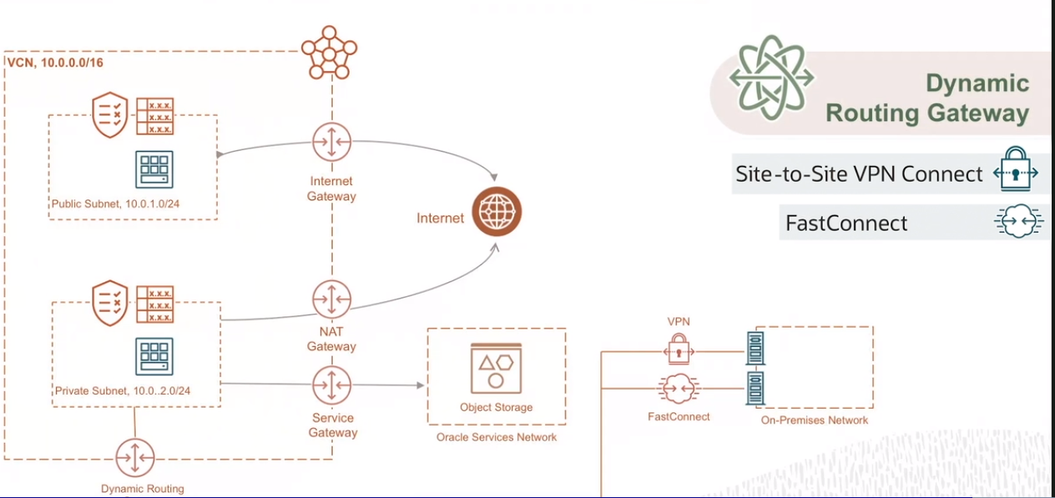
VCN Routing:

VCN routing using route tables to control the flow of traffic from VCN to Internet, On Premises and other VCN’s

Route table consits of Destination CIDR and Route Target, Based on specific CIDR notation, the traffic is routed to that destination 1st.

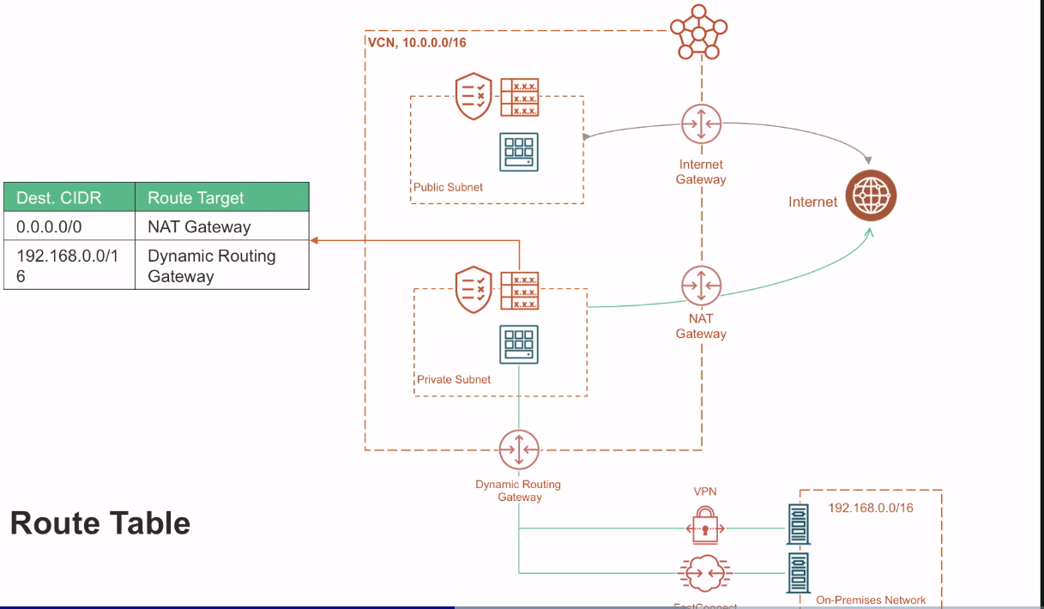
In above scenario, we are able to see that based on the route table on private subnet, the traffic goes from Server to Internet via a NAT Gateway and to an On-premise network through Dynamic routing Gateway.

VCN Peering:

VCN peering is communication between two VCN’s, There are two types of peering:

Local Peering Gateway(LPG) : This allows the communication between VCN to VCN within the same region. This establishing one on one connection.

Dynamic Routing Gateway(DRG) : This allows the communication between VCN to VCN which are in different regions

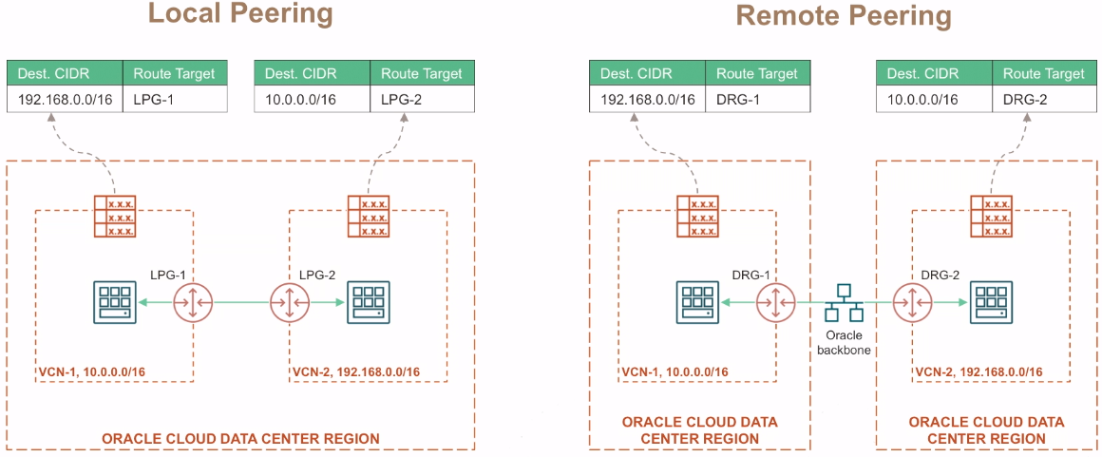
Dynamic Routing Gateway V2 : This allows to connect multiple VCN’s or upto 300 VCN’s in the same region.

VCN Security:

VCN Security Consists on 2 security concepts

Security Lists : These existing within the VCN at the Subnet level which allows the traffic in and out of the subnet. These rules define the Subnet range and the ports from which the traffic can flow.

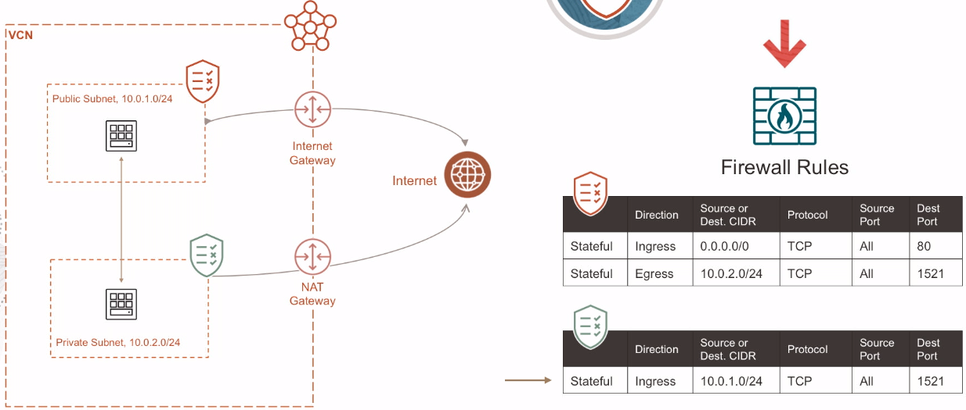

Network Security Groups: These are security rules defined at the VNIC level that is associated with a instance, Here we can also specify a NSG as a CIDR unlike Security rules where we can only specify a CIDR.

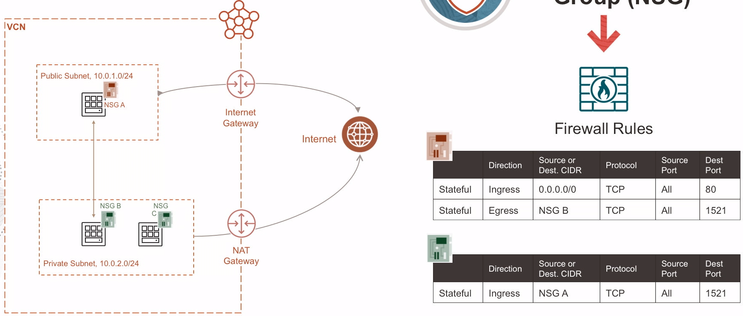

Load Balancer:

A load balancer acts as a reverse proxy that taken in the traffic from the internet and distributes it to that backend servers associated with it. This helps in High Availability and Scalability as it has the capability to monitor health of the servers, Encryption, intelligence to add additional servers based on the traffic flow.

There are type of load balancers in OCI:

1. HTTP/Layer 7 Load Balancer:
Its understand HTTP traffic, It can also scale based on the traffic flow to flexible shape or Dynamic shape.

Where flexible shape you can define the min/max range you want the load balancer to accomodate and it will shape accordingly.

Where as in dynamic shape you can scale the number of servers to accomodate the traffic.

It can also be made in a public/private load balancer.

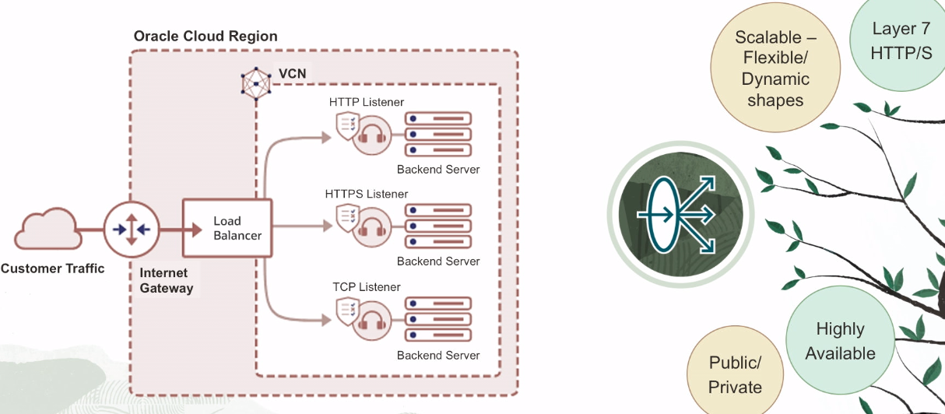

2. Network Load Balancer:

In Addition to the features in HTTP LB, This is a layer 3 and 4 Load Balancer and mainly focuses on performance. It supports TCP,UDP and also ICMP.
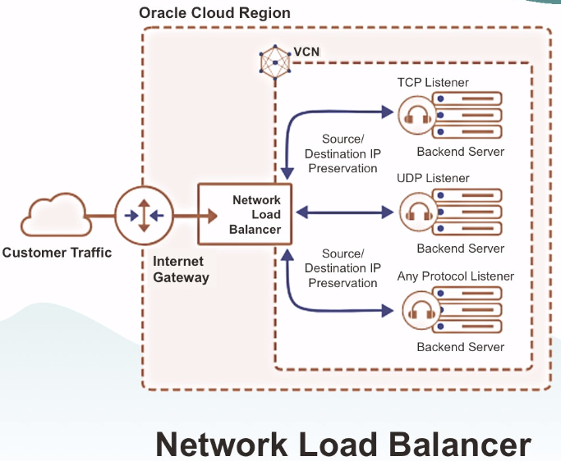

COMPUTE

OCI Compute offers Virtual Machines, Bare metal and dedicated host servers on the fly with pleothora of customizations to choose from, They come in different shapes such as Flexible, Compute Optimized, Memory Optimized.

This flexibility in shape allows a user to get the right machine for the application. OCI Compute supports Intel, AMD based processor and also Oracle own Ampere(Arm) processors.

The Architecture outline of Instance creation has dependency on Network and Storage as they are seperate entities with which you can configure an instance.

Every virtual machine connects with a network and gets an IP address using a VNIC(Virtual Network Interface Card) and inorder to install an operating system and storage it connects with a remote storage volume such as a block volume.
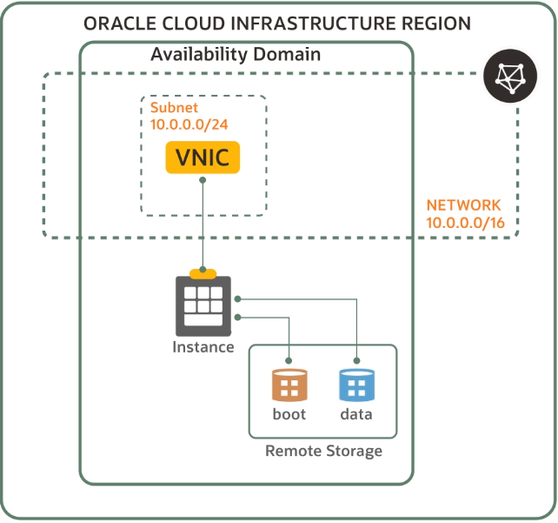

OCI provides an additional feature called as Live Migration, Where in incase the host that has the compute instance fails OCI automatically moves the entire application setup into an another host without user intervention.

Scaling:

The term scaling referes to increase in the size or number of instances based on the number of incoming requests or load on the CPU. This helps in high availability, Scalability and Throughput

There are two types of scaling in OCI:

1. Vertical Scaling : This scaling increases or decreases the number of resources(CPU, Memory) on instances based on the scaling metric. Everytime a resize of the instance is required it comes with a downtime of the application as a new shape has to be allocated.

2. Horizantal Scaling/Auto Scaling:
This scaling is widely used as it increase the number of instances based on the scaling metric and there is no down time. Based on the scaling metric it scales in or scales out.
In order to configure autoscaling there are few steps involved.

1. Create a configuration file based on the desired Instance shape.
2. Create a pool of nodes based on the configuration file(shape, OS, Storage, VNIC, NSG)
3. Create a scaling rule which defines the scaling policy.
Eg: If load on CPU > 70% then scale out
If load on CPU < 20% then scale in

OKE Cluster Overview:

OKE also refers to as Oracle Kubernetes Engine, Kubernetes is a container orchestration platform that allows to create, manage, delete mulitple containers and nodes providing features such as scalability, availability, containerization, Security, Auto-Heal.

A Kubernetes Cluster basically consists of a Control plane and Worker Nodes, where in Control plane consists of Scheduler, Controller, Api Server, Kubelet, Etcd which are together deployed on a master node that oversees the operation of the cluster and on worker nodes the containers are deployed.

OKE offers to create this kubernetes cluster as a service, greatly simplifying and maintaing the
containers in kubernetes environment. OKE has 2 components:

1. Oracle Managed : Here, OCI manages the control plane components of kubernetes cluster.

2. Customer Managed : Here, Customers create the NodePool --> Nodes --> Pods on which containers are deployed.

OKE comes with two type of cluster creation.

1. Basic OKE : They support the core functionality of the cluster and comes with a defined SLO(Service Level objective – It defines the quantifiable limit of a Service Level Indicator(SLI)).
Here, all the nodes created are managed by the customer, all the patches or upgrade to the nodes are taken care by the customer.

2. Enhanced OKE : They support enhanced features of OKE where in a SLA is agreed based on the SLO defined. Nodes created are virtualized and are maintained by OCI. This allows the customer to maintain the containers on the Kubernetes Cluster.

Container Workloads:

This offering is only limited to deploy containers on OCI Managed Virtual machines. This eliminates the need to maintain the infrastructure, Patching Operating systems or update the container runtimes. It comes close to what serverless platforms offer.

Serverless:

Serverless platform is something that offers to deploy a piece of code without the overheads of maintaining – VM, Clusters, containers. Its a pay-as-use service giving it a significant advantage over other cloud offerings

This feature is called as Function as-a service model, Where in the developer modifies the code and pushes the image in a registry and based on triggers/events configured the code is invoked and gets charged only till the time the code runs on the service.

Functions are divided into two types:
1. Function Integrations : Once the function runs it invokes other services that are configured to run
2. Function Triggers: Based on the API call, CLI or OCI events a function gets triggered.

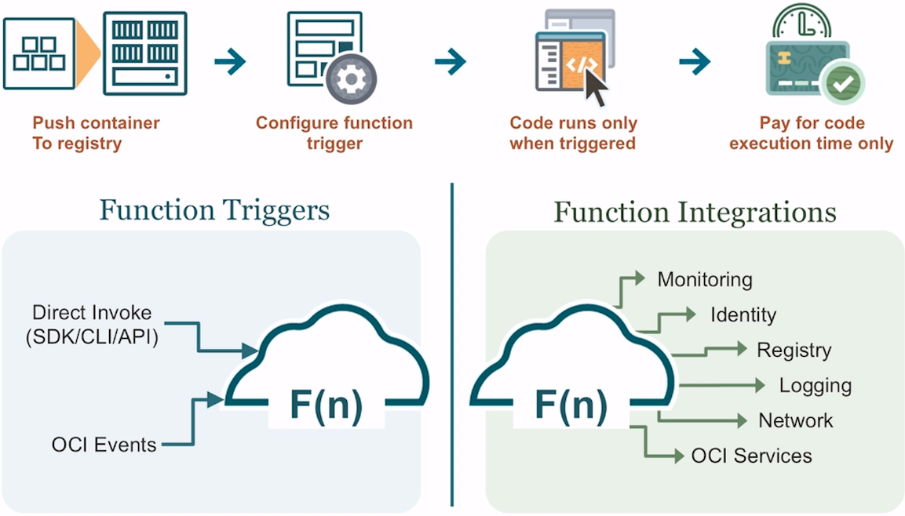
STORAGE

Storage basically means to save data persistently, securely on a storage disk which can be attached to a compute instance in order to access it.

OCI Provides 4 types of storage options:

1. NVMe : These are locally attached storage to a compute instance that have high IOPS and can be used to run performance sensitive applications.

2. Block Volumes:
Block Volumes Network attached storage to a compute instance that can persist data even after the compute instance is terminated, This comes with multiple storage tiers.

1. Lower cost : Large seqential I/O workloads with 2 IOPS/GB
2. Balanced : Balanced Choice for Random I/O with 60 IOPS/GB
3. Higher Performance: Most I/O demanding workloads with 75 IOPS/GB
4. Ultra High Performance: Highest I/O with 90-225 IOPS/GB

This also comes with auto tune performance that manages the ideal storage tier

Encryption can be customer managed or Oracle Managed and it supports encryption at rest and In-transit.

Block volume can be shared with multiple VM’s through read/write shareable feature.

Block volumes can be re-sized on the fly and they can be group into volume groups that allow easy replication of a categorised set.

3. File System Storage:
This stores data in a heirarchical structure, This storage can be accessed by multiple VM at a time.The File Storage service supports the Network File System version 3.0 (NFSv3) protocol. The service supports the Network Lock Manager (NLM) protocol for file locking functionality.
Following are the use cases of File storage:
- General Purpose File Storage: Access to an unlimited pool of file systems to manage growth of structured and unstructured data.
- Big Data and Analytics: Run analytic workloads and use shared file systems to store persistent data.
- Lift and Shift of Enterprise Applications: Migrate existing Oracle applications that need NFS storage, such as Oracle E-Business Suite and PeopleSoft.
- Databases and Transactional Applic ations: Run test and development workloads with Oracle, MySQL, or other databases.
- Backups, Business Continuity, and Disaster Recovery: Host a secondary copy of relevant file systems from on premises to the cloud for backup and disaster recovery purposes.
- MicroServices and Docker: Deliver stateful persistence for containers. Easily scale as your container-based environments grow.

4. Object Storage :
Object storage is a regional service which stores data as objects inside a logical entity called buckets.

It is ideal for unstructured data such as videos, music files, content repository. It can be used for archiving long term data.

It has multiple stages of life cycle management of data.

This also allows versioning of the data once the option is enabled.

Its ideal way of sharing data to a large audience with pre-authenticated URL’s.

Basically Data is stored in the form of objects which is a key-value pair, these objects are stored inside something called buckets which have a unique name accross regions and follows a flat heirarchy. To top it on these these objects-->buckets are contained inside a namespace which is a top level logical container.

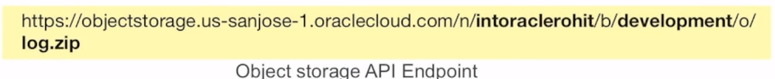
Object Storage Tiers:
These represent how the data should be stored and retrived. There are 3 types of object storage tiers

1. Standard Tier:
Its ideal for storing most recent copies of data and retrival is instantaneous. This can be downgraded.

2. In-frequent Access Tier:
Its ideal for storing not so frequently used data, There is a retrival fees on data retrival and minimum time for data retrival is 31 days. The storage costs are lower than standard tier.Ideal for backups.

3. Archive Tier:
This is for long term storage of data and is the cheapest option available. There is a retrival fees along with the a time interval to access and download the data. In order to restore the data it take 1 hr and to download the data it takes 24 hrs.

4. Auto-Tiering:
This option allows to intelligently move the data between the storage tiers based on the data retrival patterns.

Life CycleManagement:
Using this option you can define policies that allows a user to shift the data between storage tiers after a certain time period.

In order to transfer data from On-Premises to OCI, Oracle provides us with data migration services.

1. Data Transfer Disk

2. Data Transfer Appliance

3. Storage Gateway

