KUBERNETES

Its a Open source container orchestration system designed by google to manage, scale,log, monitor and automate application deployment on containers
Containers are light weight virtual machine that shares the same kernel as the OS, Containers only contains the required libraries and binaries to initalise the application. Docker is one of the most prominent container tools available.
In order to create containers, we need to use the images of the operating systems uploaded in the repository of the docker hub platform
Using containers helps in replicating any application setup across environments

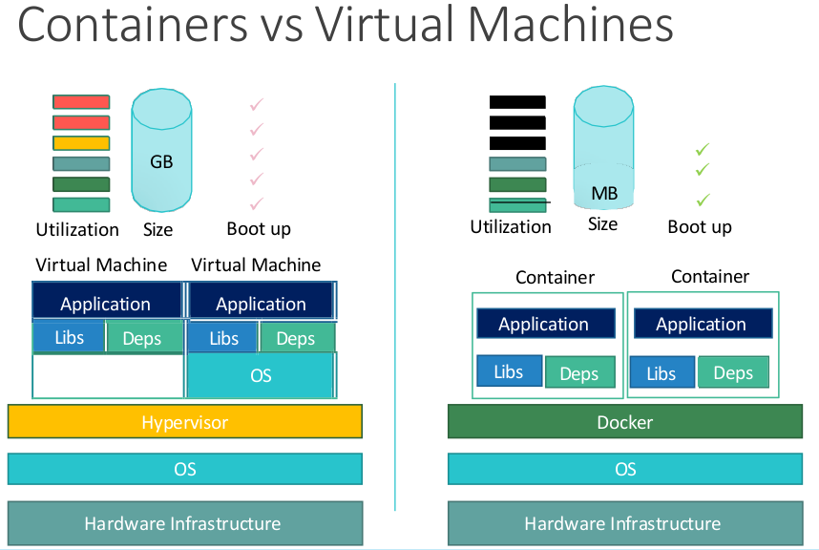
You wont be able to run a windows container on a linux host as the kernel won’t support it.

Container orchestration is a system that allows to create, manage and scale the containers based on the load. Kubernetes is one such technology. There are other container orchestration technologies like docker swarm by docker, Mesos by apache.

Kubernetes uses a declarative approach to create a cluster which allows to integrate multiple containers with many interfaces for networking, services, storage, authentication, Communication.
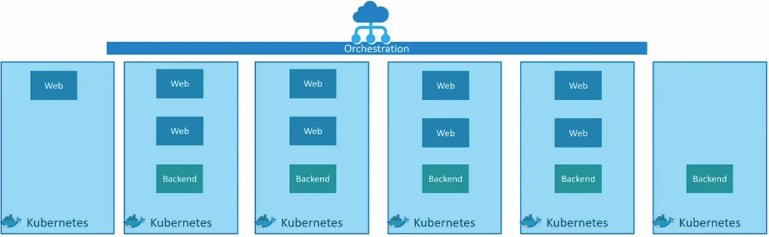
Docker vs Containerd:

Initially kubernetes supported only docker. Due to this lack of support to other container tools, Kubernetes came up with an interface called CRI(Container Runtime Inteface) which follows a set of standards called OCI(Open Container Initiative) which contains of below Specs

1. Image Spec : Its a specfication/set of rules with which an image has to be built

2. Runtime Spec : Its a set of rules which defines standards on how a container runtime should be developed.

Containers other than docker : HyperV, PodMan, Vagrant, containerd, LXC, Rkt

Kubernetes now has stopped supporting docker from version 1.24 as it does not follow the OCI Standards but the docker runtime (runc) which is managed by the daemon containerd which is CRI compatible.

Since the docker runtime is still compatible through containerd we can still docker through that excluding other features of docker such as build, volume, API, CLI, AUTH, but the users can interact with exiting docker images using containerd and its cli tool nerdctl

nerdctl supports:
1. Supports docker CLI for container D
2. Supports docker compose
3. Encrypted container images
4. Lazy Pulling
5. P2P Image distribution
6. Image signing and verifying
7. Namespaces in Kubernetes

nerdctl syntax is similar to that of docker.

Syntax:
create a container : nerdctl run --name=local <image>
expose port : nerdctl -dt run –name=webserver -p 8040:8080 nginx

crictl utility client:

CRICTL utility client is kubernetes client that is compatible to operate on multiple container tools, its mostly used to inspect and debug container runtimes.

Syxtax:
pull images : crictl pull <image>

list containers: crictl ps -a

List the pods on a cluster : crictl pods

Command Line Reference : https://kubernetes.io/docs/reference/tools/map-crictl-dockercli/

Kubernetes Architecture:

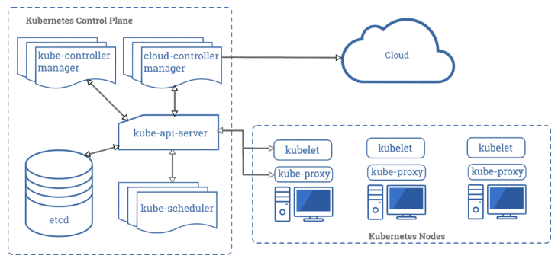
Components of Kubernetes cluster:

Master Node:

1. API Server : It performs all the administrative tasks on the master node. A user sends the rest commands as YAML/JSON format to the API server, then it processes and executes them. The Kube API-server is the front end of the Kubernetes control plane.All the services which includes users, management devices and CLI using API Server to interact with kubernetes.

2. etcd : It is a distributed key-value store that is used to store cluster state. Kubernetes stores the file in a database called etcd. Besides storing cluster state, etcd is also used to store the configuration details such as the subnets and the config maps.

3. Scheduler : It is used to schedule the work to different worker nodes. It also manages the new requests coming from the API Server and assigns them to healthy nodes.

4. Controller: Its task is to obtain the desired state from the API Server. If the desired state does not meet the current state of the object, then the corrective steps are taken by the control loop to bring the current state the same as the desired state.

5. Control Plane: A control plane oversees the entire cluster, it consists of API Server, etcd, Scheduler, Controller, This control plane can also be reffered to as master node.

Worker Node:

1. Container Runtime:It is the software that is responsible for running containers. Kubernetes supports several container runtimes: Docker, containerd.

2. Kube-proxy: It is used to communicate between the multiple worker nodes. It maintains network rules on nodes and also make sure there are necessary rules define on the worker node so the container can communicate to each in different nodes.

3. Kublet : It is an agent that runs on each worker node and communicates with the master node. It also makes sure that the containers which are part of the pods are always healthy. It watches for tasks sent from the API Server, executes the task like deploy or destroy the container, and then reports back to the Master.

4. Pod : It is a group of one or more containers that are deployed together on the same host. Pod is deployed with a shared storage/network, and a specification for how to run the containers. Containers can easily communicate with other containers in the same pod as though they were on the same machine.

7. Node : A node is a physical or virtual machine which has kubernetes installed on it, also known as worker node.

A node consists of a pods which in turn contains single or multiple containers.

A group of nodes form a cluster, This helps with high availability and load balancing.

A Node consists of Container runtime engine, Kublet, Kuber- proxy and Cadviser

In order to manage multiple nodes in a cluster, we need a master node.

Kubectl:
It is a agent that runs on the worker nodes to deploy, manage applications, get information of the nodes on a kubernetes cluster

Kubeadm:
kubeadm performs the actions necessary to get a minimum viable cluster up and running. By design, it cares only about bootstrapping, not about provisioning machines. Likewise, installing various nice-to-have addons, like the Kubernetes Dashboard, monitoring solutions, and cloud-specific addons, is not in scope.

Kubernetes Cluster:

Cluster is a combination of a master node and two or more worker nodes. There are multiple ways to create a kubernetes cluster.

1. Minikube
2. Kind
3. K3s
4. Kubeadm
5. Cloud Kubernetes Cluster

For creating a local/personal cluster setups we can use MiniKube, Kind and K3s

Kubeadm is used for creating a production grade kubernetes Cluster

Cloud Kubernetes clusters are also used for creating production grade kubernetes cluster but these are managaed by cloud providers such as
Amazon – EKS (Elastic Kubernetes Service)
Azure – AKS (Azure Kubenetes Service)
Google – GKE (Google Kubernetes Engine)
Oracle - OKE (Oracle Kubernetes Engine)

Creating a Cluster:

Prequisites:
1. Kubectl
2. Minikube
3. Docker

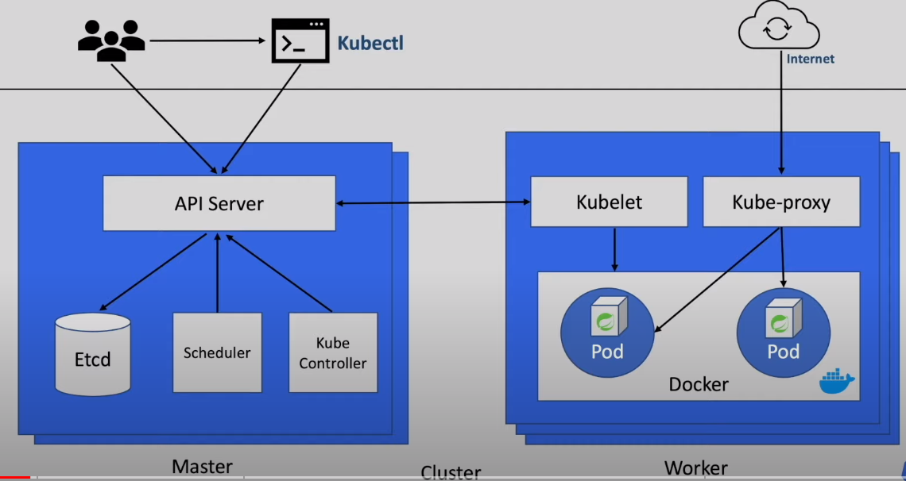
1. Installing kubectl using the installation guide from
https://kubernetes.io/docs/tasks/tools/install-kubectl-linux/

2. Installing Minikube using
https://minikube.sigs.k8s.io/docs/start/

Once these are installed you can validate by checking out the version on them

minikube version
kubectl version

Cluster Creation using Minikube

1. create cluster with 2 nodes and name of the cluster – k8_learning and driver as docker
syntax : minikube start --nodes 2 -p <cluster_name> --driver=<driver>
minikube start –nodes 2 -p k8-learning –driver=docker

2. Check the cluster status,
minikube status -p <clustername>

3. You can also get the list of clusters created using
minikube profile list
a. delete a profile – minikube delete <clustername>

4. using kubectl to interact with the cluster:
Syntax : kubectl [command] [type] [name] [flag]

5. Get nodes info on the cluster : kubectl get nodes

6. List the clusters : kubectl config get-contexts

7. Switch between the cluster : kubectl config set-context <cluster-name>
kubectl config use-context <cluster-name>

8. Adding a new node to the cluster : kubectl node add --worker -p <clustername>

a. Deleting a node - minikube node delete <node name> -p <clustername>

9. Get Dashboard for the minikube Cluster

minikube dashboard --url -p <cluster name>

10. Creating pods on the cluster

kubectl run <pod name> --image=<location of the image>

11. Describe/Inspect pod

kubectl describe pod <pod-name>

12. Delete Pod

kubectl delete pod <pod-name>

13. List pods on the cluster

kubectl get pods

a. Gives a more detailed description : kubectl get pods -o wide
KUBERNETES RESOURCES

PODS:

Pod is the smallest object in kubernetes cluster, its acts as a encapsulation for a container which is created from a image, Ideally a pod should only a single container but there is no restriction to the number of containers in a pod.

Creating Pods in YAML:

Pod creation can also be done in yaml which consists of labels, services, replica sets and deployments in the definition file.

Sample definition File:
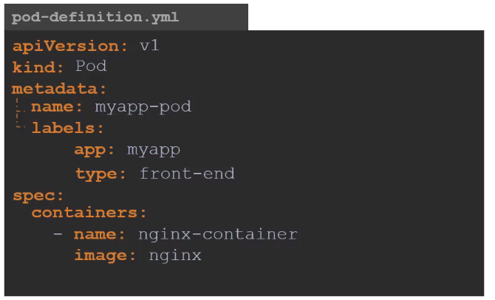
In order to apply this yaml file, we need to run

kubectl create -f pod-definition.yml

A sample definition file consists of four sections:

1. apiVersion : This defines the version of object being used.

Kind | Version
POD | v1
Service | v1
Replica Sets | apps/v1
Deployment | apps/v1

2. kind : Type of object (POD, Service, Replica Set, Deployment)
3. metadata : Defines the name of the pod, label assigned to the pod
4. spec : Its the specification section, where in we define the containers, networks, volumes

Kubernetes Controllers:

Controllers are master processes that monitor/manage kubernetes objects. One of the kubernetes object is replication controller/Replica set

Replication Controller/Replica set:

Replication Controller is used to create a copy of the pod or scale the number of pods or maintain a desired state of the number of pods in a cluster. This controller enables High availablity, scalability and load balancing on cluster

Replication controller and replica set perform the same operation but with subtle differences when it comes to selectors or labels. Replica set being the new way of doing replication
In replication controller labels are selected on one basis as in key=value pair, where in replica sets a user can specify multiple values for the key.

Replication Set syntax:
This is similar to that of the previous yaml file to create a pod but here we add new properties such as template(contains the way the pod has to be created), replicas, selectors (Matches Labels)
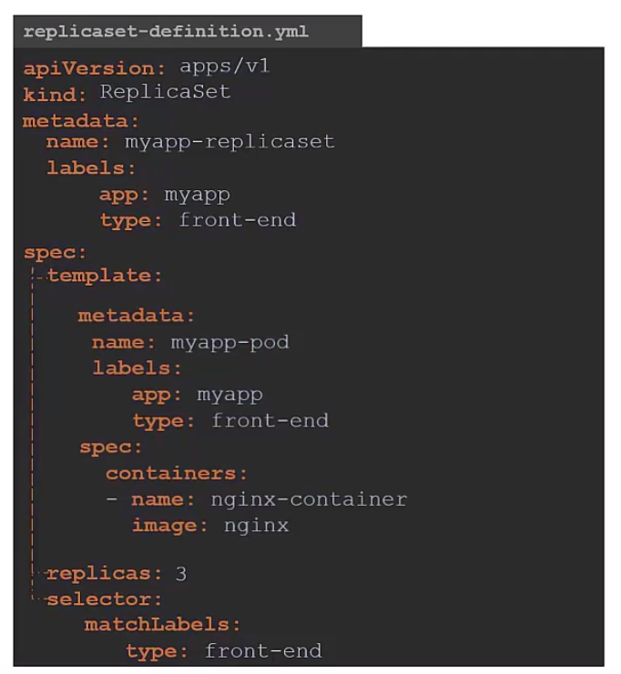

Commands:

Create a new replica set : kubectl create -f replica-set.yaml

Get the exiting replica set : kubectl get replicaset

Delete the replica set : kubectl delete replicaset <replica name>

Scale the replica set after updating the yaml file : kubectl replace -f replica-set.yml

Scale the replica set with “replicas” argument along with the file name

kubectl scale --replicas=4 replica-set.yaml

Scale the replica set with “replicas” argument with the replica set name

kubectl scale --replicas=4 replicaset <replica name>

Edit existing replica set : kubectl edit replicaset <replica set name>

Deployments:

Deployment in general terms is to update an existing version of the application with a newer version.

Similarly in kubernetes, deployment is considered as an object that updates/deploys the newer version on the application/image from container repositories on to PODS. Since there are multiple pods we can perform rolling updates, undo changes on the pods.
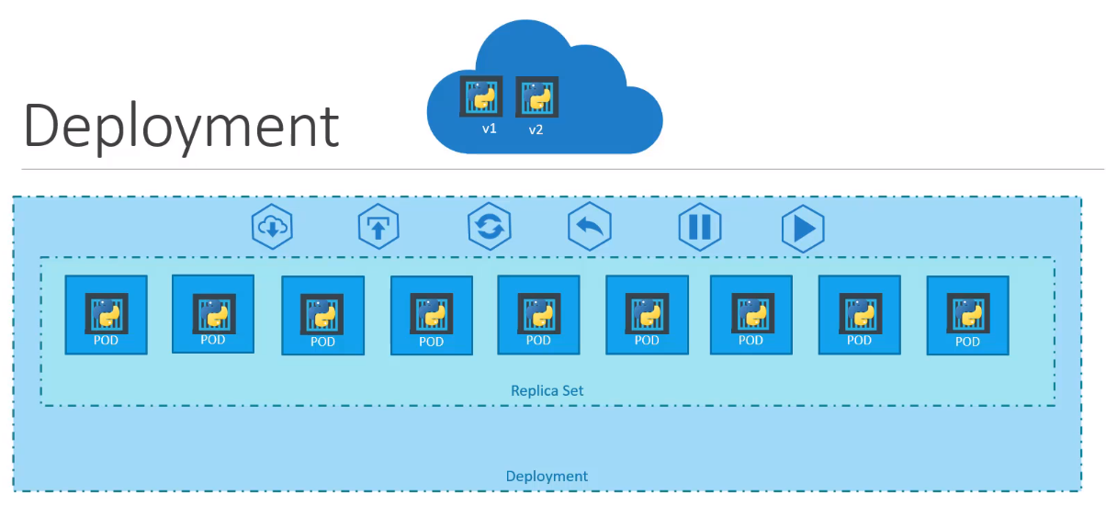
As seen in above image, Containers are enclosed inside pods, pods are enclosed inside a replica set which scales or maintains availability of the pods and the replica set is created into the deployment object for rolling updates of the newer application versions.

Deployment Definition File

Deployment definition file is similar to that of a replica set, here we have replace the KIND parameter with Deployment
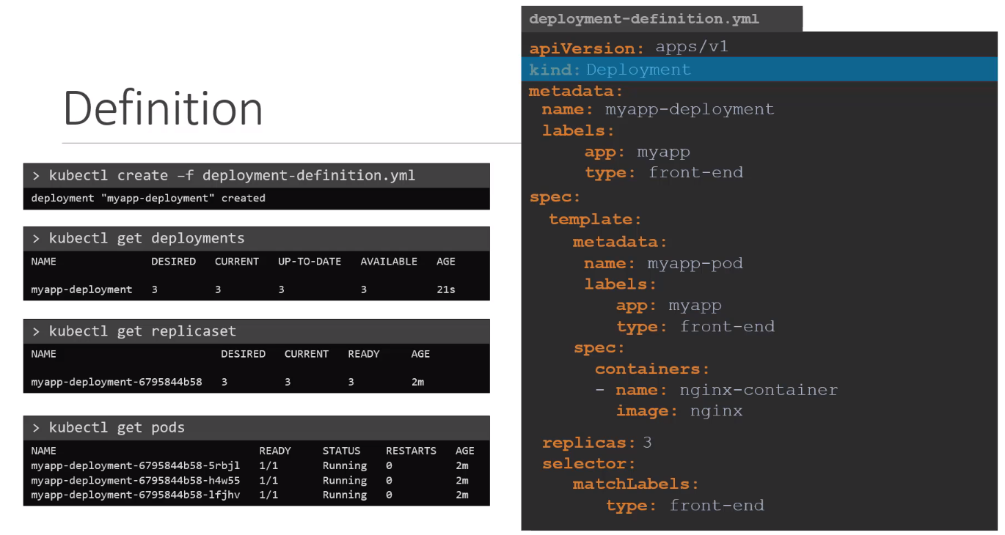
In order to create a deployment object using the yaml file, we can run

kubectl create -f deployment-definition.yaml

Creating a deployment in imperitive way :
kubectl create deployment <name> --image=<name> --replicas=<number of replicas>

Get all the deployment objects inside the cluster - kubectl get deployments

Get all the objects created inside a cluster - kubectl get all

Inspect the deployment object created - kubectl describe deployment <deployment name>

A deployment object can be assigned to an existing replica set using label filters

There are different types of deployment strategies:

1. Recreate : In this mode each time a new version gets deployed, the whole set of instances are taken down and recreated with the newer version of it. This type of deployment leads to downtime of the application

2. Rolling Update: In this, each time a new version of the application is pushed to repository a new rollout deployment happens, where in the deployment happens in a sequential manner where, for each pod destroyed a new version of deployment pod is created there by maintaining the application availablity at all times.

This is the default deployment strategy
Commands to verify a rolling update:

1. Create a deployment object : kubectl create -f deployment-definition.yaml

2. Run rolling out status update, this brings the defined number of replicas one at time

kubectl rollout status deployment <deployment-name>

3. Records the events occuring in a deployment object

kubectl create -f deployment-definition.yaml --record
kubectl rollout history deployment <deployment name>

4. Make a change to the container image used in the deployment and track the changes using “rollout status”, This causes the deployment object to retire the old pod and bring up new pods

kubectl edit deployment <deployment name> --record
kubectl rollout status deployment <deployment name>

use “describe” to get a detailed output of the deployment object

5. Get all the deployments - kubectl get deployments

6. Update the deployments - kubectl apply -f deployment-definition.yaml
or
kubectl set image deployment <deploymentname> <container name>=<image name>

7. undo a deployment - kubectl rollout undo deployment <deployment name>

8. Delete a deployment - kubectl delete deployment <deployment name>

Imperative and Declarative Approach:

Most of the tools go with Imperative and Declarative approaches.
Imperative: In an imperative approach we use step by step instruction to perform a task to get a desired result, Where we verify if the instruction has been successfully executed.
Also the instructions run are only stored in command history so it is difficult to track the changes made to the particular object.

In terms of kubernetes some of the imperative instructions are:

kubectl create -f <definition-file>.yaml
kubectl edit deployment <deployment name>
kubectl set image deployment <deployment name> --image=<image name>
kubectl expose deployment <deploymentname> --port 80
kubectl scale deployment <deployment name> --replicas=3
kubectl run <pod> --image=<image name>
kubectl delete deployment <deployment name>
Declarative Approach:

These approach is mostly followed by infrastucture as a code tools such as ansible,Terraform, Docker and Kubernetes.

Here the user has to specfic the expected desired state of the output in the form of a definition file and this is later applied on the nodes. The tool/software takes care of the approach that it should take to get the expected output.

In Kubernetes, we define a definition file to create a pods, Replicasets or deployments and use apply command to execute them on to the nodes. Below command falls under this approach

kubectl apply -f <definition file>

Kubernetes Namespaces:

Namespaces are used to create isolation among objects, they allow to group multiple kubernetes objects and assign resources quotas to them.

Such as you can create multiple namespaces inside a cluster and within these name spaces you can create deployments/pods which are contained within that name space and they can communicate with pods in another namespace using the below format

here we are trying to communicate with a db service in another name space called dev

mqsql.connect(“db-service.dev.svc.cluster.local”)

In Order view the pods in another name space
kubectl get pods --namespace=<name>

To create a pod definition in another name space
kubectl create -f pod-definition.xml --namespace=<name>
This can be also implement at the pod definition level using the namespace tag in metadata section
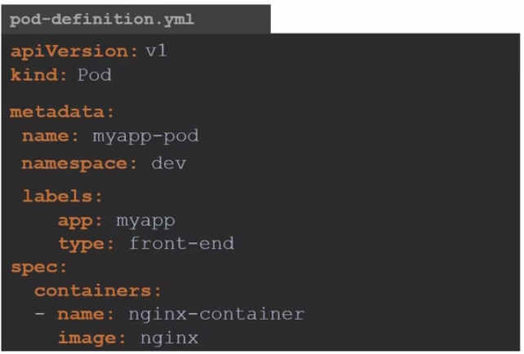

In order to create a name space using a definition file

kubectl create -f namespace-definition.yaml
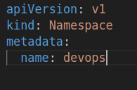

In order view the list of name spaces - kubectl get namespace

In order to view the currently namespace
kubectl config get-contexts
In order to switch name spaces, we can do
kubectl config set-context <kubectl config current-context> --namespace=<name>

In order view pods in other name space
kubectl get pods --namespace=<name>

In order to view pods in all namespaces
kubectl get pods –all-namespaces

We can also provide resource quotas to the namespaces using definition files and apply them using
kubectl create -f resource-definition.yaml

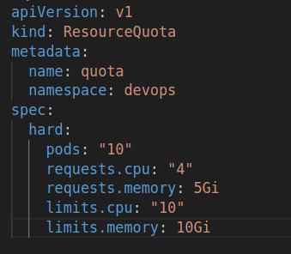

We can also create a name space in an imperative approach using
kubectl create namespace <name>
We can also inspect a namespace using the below command
kubectl describe namespace <namespace>

Services:

A service is a virtual server created inside a kubernetes node which enables communication with the internal applications within the cluster and also enables users to access the application outside the kubernetes environment.

Each service has its own cluster IP assigned to it

There are different types of services available:
1. NodePort : This service enables user to expose a port on the pod to the service which inturn exposes the port on the node.

2. Cluster IP : Enables a virutal IP inside a cluster allowing the services to communicate with each other.

3. Load Balancer: Creates a load balancer in supported cloud providers

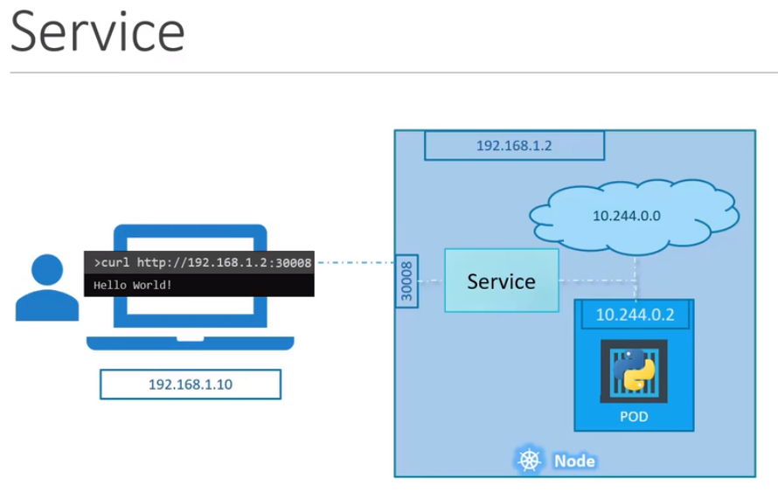

Node Port:
This Service contains 3 ports :

Target port : Port on the Pod
Port : This is a port on the service
nodePort : This is the port on kubernetes node and the port range varies from 30008 to 32767

Creating a service-definition file for node port service:

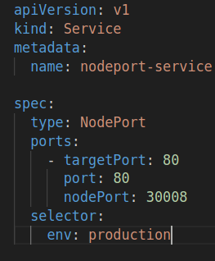

Using a selector and pod label specified, the service maps the port to the Pod

In order to implement this we can run the below commands

Create a service : kubectl create -f service-definition.yaml
Decribe a service : kubectl describe service <service name>
View all the services in the cluster : kubectl get services

Kubernetes services can also scale automatically if there are multiple pods running the same application in the node and this is the same scenario if the pods are distributed accross multiple nodes in the cluster. Service uses the same port number to connect to the pods and acts like a load balancer

Once the service is created, we can access the pod using the IP address of the node and the service of the node port. In order to get the URL through minikube , we can run

minikube service <service name> --url -p <profile>

Cluster IP:

This service allows to group multiple pods of an application module and enables interaction among such multiple modules.
This is the default service created during a kubernetes cluster creation

Every service has a unique name and a defined IP address which the pods the used to communicate with each other across applications

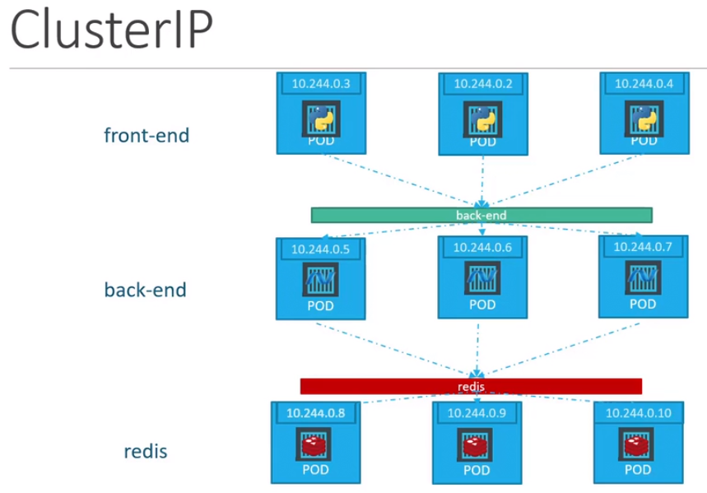

Cluster IP Service Definition File
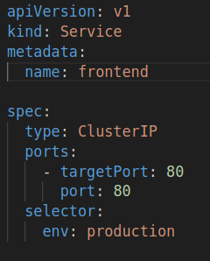

Load Balancer:

Load Balancer is a cloud native service where a user can levarage the cloud offerings on load balancer with the Kubernetes engine

Using a Load Balancer provides a single point entry to the underlying application pods which are exposed via a Node Port

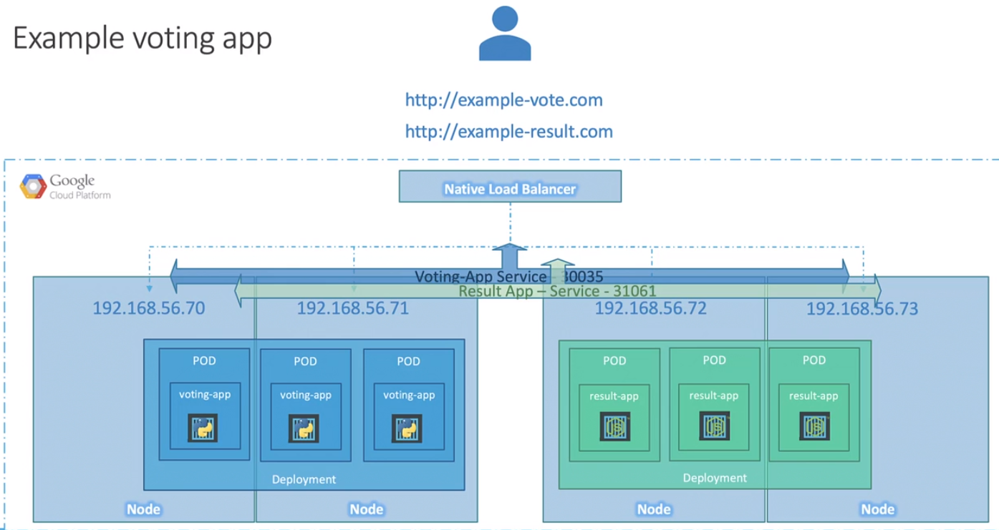
Load balancer Definition file:

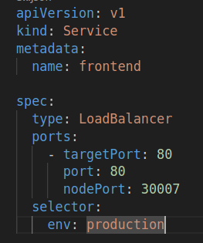

SCHEDULING

Manual Scheduling:

Manual Scheduling is required when a scheduler is not enabled or used. This allows a user to assign a pod to a specific node in the cluster

Usually Scheduler assigns a pod to a node if the parameter “nodeName” is not specified in the definition file , If a pod has to be assigned a particular node, if have to specify this parameter(nodeName) parallel to containers section in Spec.
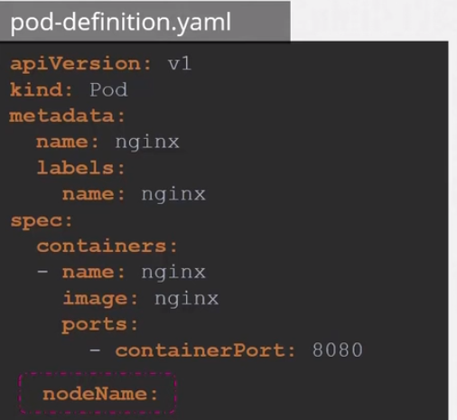

We can also create a binding object with the target node’s name and send a post requests to the pod’s binding API

If the pod is not assigned any node, then they would be in a pending state

Labels and Selectors:

Labels are used to group objects in kubernetes, a pod/replicaset/deployment can have muliple labels assigned to them. This allows to group them based on the attributes assigned to them, therefore it becomes easy to access or track the changes in them.

Selectors on the other hand allow other resources to filter the objects created based on the labels assigned. These selectors are used in ReplicaSets, Deployments, Services, Etc

Taints and Tolerations:

Taint is basically a key:value attribute assigned to a node to place a restriction on the pods being assigned to it.

We can taint a node using the command

kubectl taint nodes <node name> <key>=<value>:<taint-effect>

Similarly we can also remove a taint by specifying a hypen at the end of the taint

kubectl taint nodes <node name> <key>=<value>:<taint-effect>-

Taint effect defines what happens to the pod which do not tolerate the taint of the node, there are 3 type of taint effects

NoSchedule: Does not allow the pods to be scheduled on this node

PreferNoSchedule: Scheduler will try to avoid placing the pod on this node but it is not guranteed

NoExecute: New pods will not be scheduled and any existing pods in the pods would be evicted if they don’t tollerate

An example on the node to add taint

kubectl taint nodes node1 app=blue:NoSchedule

An example on the node to remove taint

kubectl taint nodes node1 app=blue:NoSchedule-

Toleration is an attribute assigned to a pod to get an access to be assigned to a tainted node with a specific key:value attribute

The key parameter to be added to the pod definition file is “tolerations” and the taint values in it as specfied in the node

An example on the pod-definition file to add a toleration

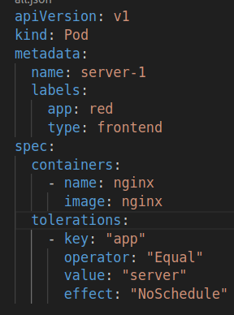

Node Selectors:

This property allows a pod to be deployed on a desired node based on the label assigned to that node.
But this feature is on restricted to a single label assigned to a node if the user want a more complex label assignment where conditions come into play then we can go with Node Affinity

Assigning a label to a node

kubectl label node <node name> <key>=<value>

In the Pod Definition, we can add nodeSelector property with the desired key:value pair

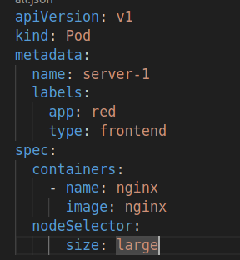

Node Affinity:

Node Affinity feature allows a pod to be placed in a particular node with advanced expressions.

affinity: #Property
nodeAffinity: #Property Name
requiredDuringSchedulingIgnoredDuringExecution: #Type
nodeSelectorTerms:
-matchExpressions: # List of expressions to match
- key: <key name> # defined node key
operator: In/NotIn/Exists # expression used
value: # List of values assigned
- value1
- value2

Type of Node Affinity:

There are 2 type of node affinity:

1. requiredDuringSchedulingIgnoredDuringExecution:
With this type , a label expression must be matched or present during scheduling inorder to assign the pod to that node, once assigned if the label is later removed from the node, it wont affect the pod placement.

2. preferredDuringSchedulingIgnoredDuringExecution
With this type , if the label expression not matched or present during scheduling it ignores the node affinity rules and assigns to any available node, once assigned if the label is later removed from the node, it wont affect the pod placement.

Resource Limits:

Resource limits property is used in a pod to define the resources that are required and maximum limit of the resources of the node that should be used. If the pod keeps using the resources beyond the limit, the pod would be terminated.

We can use the resource property in the below way

resources:
requests:
cpu: 1
memory: “1G”
limits:
cpu: 2
memory: 2G

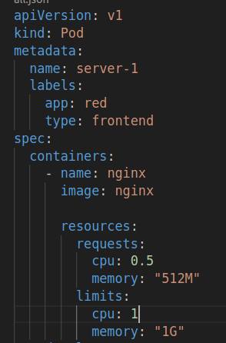

Daemon Sets:

Daemon set is similar to replicat set/deployments but here as the name suggests daemon set runs as a default agent in a existing or a newly created node with a single pod. Since its is deployed on every node, scheduler is ignored here.

The basic use case of this set is to run any monitoring applications or a log viewer in the background to get the status of the application.

A daemon set can be create similar to deployment but the kind as “DaemonSet” and no replicas
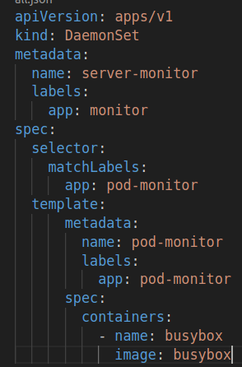

Static Pods:

Static pods are standalone pods created by a kubelet if the control plane components are missing such as api-server, Etcd, Scheduler, Controller.

Since the api-server is not installed we cannot create a pod using kubcetl command line tool, instead we upload the pod definition files in /etc/kubernetes/manifest folder, This folder is monitored by kubelet periodically and if any pod definition files are found, it creates them as a static pod.

We can only place pod definition files in the folder /etc/kubernetes/manifest, placing replica sets or deployments wont be accepted as they require control plane components.

Static pod is ideal for creating control plan components by placing the the respective definition files in the folder, as kubelet monitors the status of the pods and creates them automatically if they get terminated.

Multiple Schedulers:

By default we have a scheduler defined in the control plane which validates and assigns the pods to the repective nodes based on namespace, nodeName, NodeSelector, Taints and tolerations and nodeAffinity but kubernetes gives us the flexibility to create an additional/custom scheduler for any additional checks that a pod needs to have.

Earlier we used to run a custom/default scheduler as a service but a better approach is to deploy a custom scheduler as a pod, we can define a custom scheduler profile in a custom config yaml file where we define our own algorithm and assign it to the pod using a --config key word with the location of the file

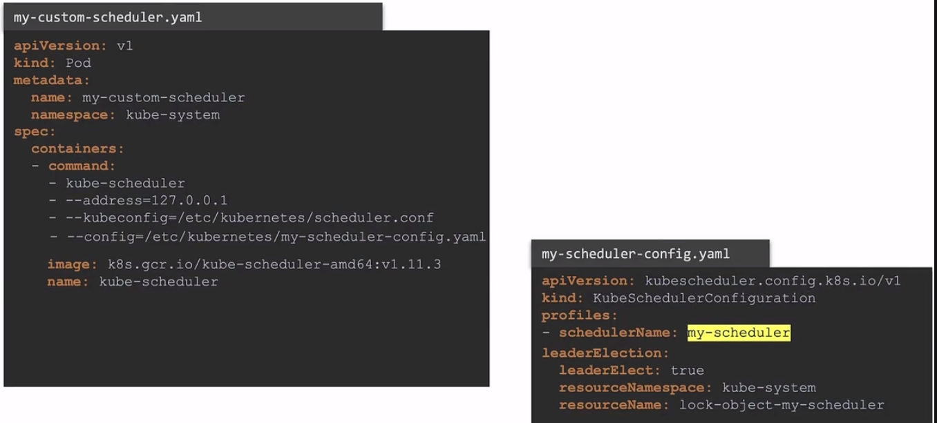
Here LeaderElection defines which scheduler has to be active inorder to validate the pods
This custom scheduler can also be deployed as a deployment, We can use this as a reference
https://kubernetes.io/docs/tasks/extend-kubernetes/configure-multiple-schedulers/

Once the scheduler is deployed on the control plane, we can see the status using

kubectl get pods --namespace=kube-system

In new pods that get created, inorder for them to be validated by a specific scheduler we can definer a parameter - schedulerName

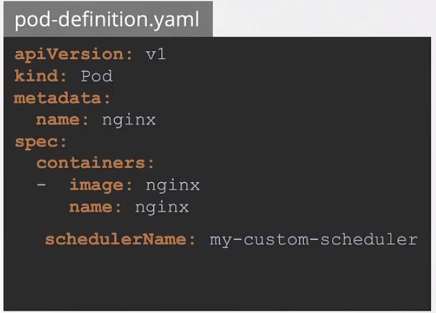
Configuring Multiple schedulers:

Scheduler mechanism basically has 4 stages which decide in which node does a pod go into, In order to achieve the desired result in each phase we have multiple plugins which validates the outcomes

Each phase has certain extensions defined which allow us to create our own custom plugins and add them to validations

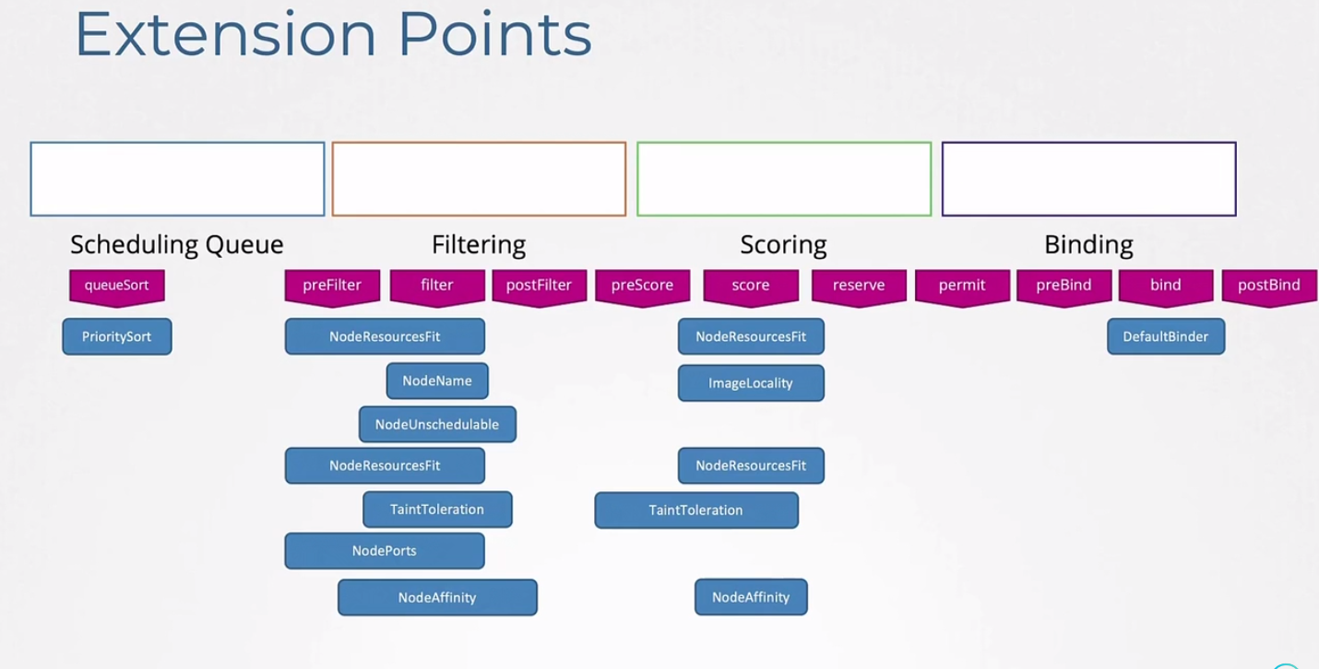
Scheduler Queue:

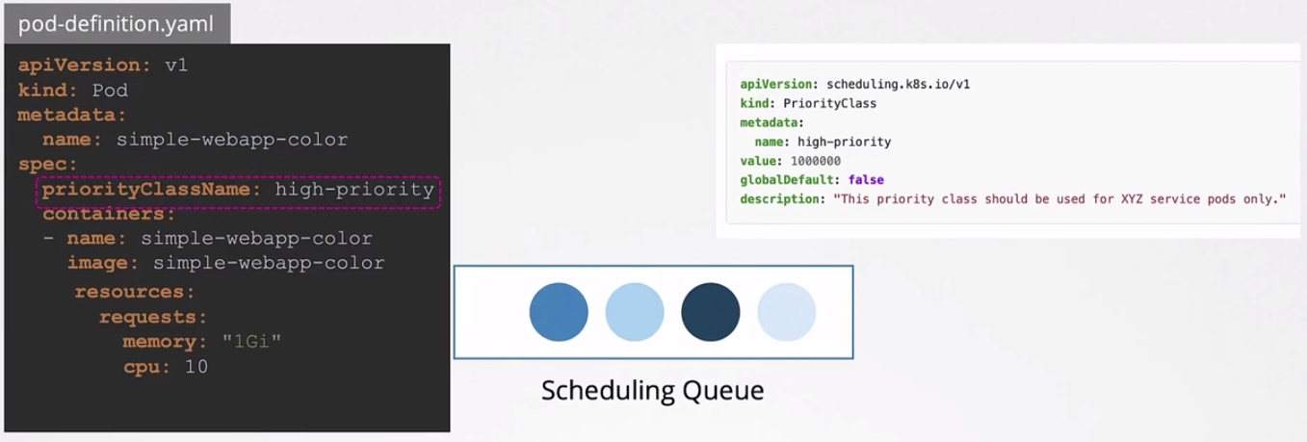
This queue is responbile of sorting the pods based on the priority class defined the definiton file with the parameter - priorityClassName

Filtering:

This filters based on the resources allocation allocated to the pod and the resources available on the node where the pod can be deployed

Scoring:

Here, the nodes are scored based on the pod resources if it gets allocated to that node. The higher the score more priority it would be given

Binding:

This is last phase where the pod gets assigned and bound to the node based on the above factors.

Earlier we have deployed multiple schedulers as services or pods due to this there might be a race condition between them as if a scheduler is assigning a pod onto a node and at the same time there is another scheduler validating a node inorder to assign a pod.

With 1.18 version of kubernetes, we introduced to multiple profiles in a single scheduler. So under each profile we can configure the scheduler extensions and mention the plugins to be enabled or disabled.

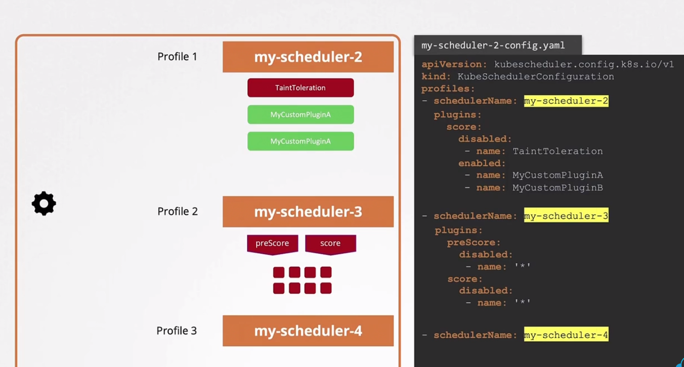

SECURITY

Authentication:

There are two types who require access to kubernetes cluster - Users and Services

By Default kubernetes uses a thirdparty identity service like LDAP to manage user accounts

All the user access is managed and authenticated by the Kube-apiserver
There are 4 ways to authenticate users

1. Static password file - Contains a list of usernames and passwords

This is a csv file which has password, username, UserID and groups. Once the file is created its should be placed either in kube-apiserver.service or in the /etc/kubernetes/manifests/kube-apiserver.yaml with the token
--basic-auth-file=user-details.csv
In order to access the apiserver we have to pass basic details in below format

curl -v -k https://master-ip:6443/api/v1/pods -u "username:password"

2. Static Token file - Contains a list of usernames and tokens

Similar to password file ,this has tokens, username, UserID,group. Once the file is created its should be placed either in kube-apiserver.service or in the /etc/kubernetes/manifests/kube-apiserver.yaml with the token
--token-auth-file=token-details.csv
In order to access the apiserver we have to pass token details in below format

curl -v -k https://master-ip:6443/api/v1/pods --header "Authorization: Bearer <token>"

3. Certificates
4. Identity Services - Ldap, Kerberos
5. Service accounts

Kube Config:

Usually using static passwords or token file is discouraged as passwords are saved in plain format, hence it better to go with a certificate authentication or ldap approach.

Using certificates we have 4 key components in it and is represented in the below way to be authenticated.

kubectl get pods --server <master ip:6443> --client-key <user.key> --client-certificate <client.crt> --certificate-authority <ca.crt>

so instead of specifying these 4 parameters everytime we run a command, we can store the values in kubeconfig configuration file and set the default context to that user, by default kubectl looks for the default configuration file in the path $HOME/.kube/config path.

The kubeconfig file is a yaml representation with kind - config and has 3 sections
1. Cluster
2. Contexts
3. Users

In Clusters section we can have multiple cluster profiles in an array format with properties

clusters:
- name: <name of cluster>
cluster:
server: <master ip:6443>
certificate-authority: <path/ca.crt>

In Users section, we can have multiple user profiles in an array format with properties

users:
- name: <username>
user:
client-key: <path/client.key>
client-certificate: <path/certificate.crt>

In Contexts section, we link both the cluster and user together and we can have multiple such profiles as it is a array
contexts:
- name: <name-context>
context:
cluster: <cluster name>
user: <user name>
namespace: <name>

Once these details are mentioned, you can mention a default context to used by adding
current-context: <context name>

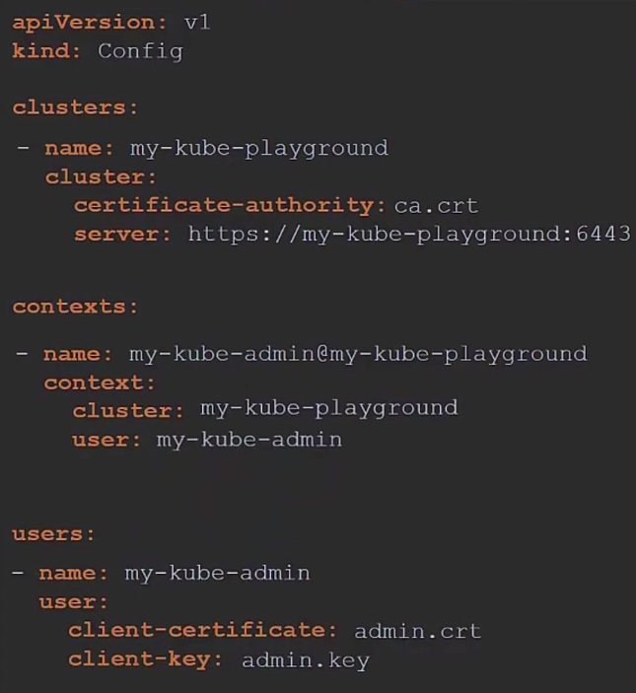

In order to view the config file we can use
kubectl config view

Also you can view other kube-config files also

kubectl config view --kubeconfig=<config file>

You can also change the context to be used by specifying, this would also update the config file

kubectl config use-context <context name>

We can also explore more on the config commands by navigate to

kubectl config --help

API Groups:

All the resources in kubernetes are grouped into 2 groups, At the top level we have Core and Named.

Under the core, we have one API group called V1 and there are multiple resources in them such as pods, services, bindings, endpoints, namespace, config

Under Named group which would used going foward as it is more organised, Here we have multiple API groups such as apps, extension, networking.k8s.io, storage.k8s.io, authentication.k8s.io, etc.
Check for the API groups : kubectl api-versions
Check for API Resources in API groups : kubectl api-resources
Under each groups there are multiple resources and each resource has list of actions.

Here is a sample description on the Named API group
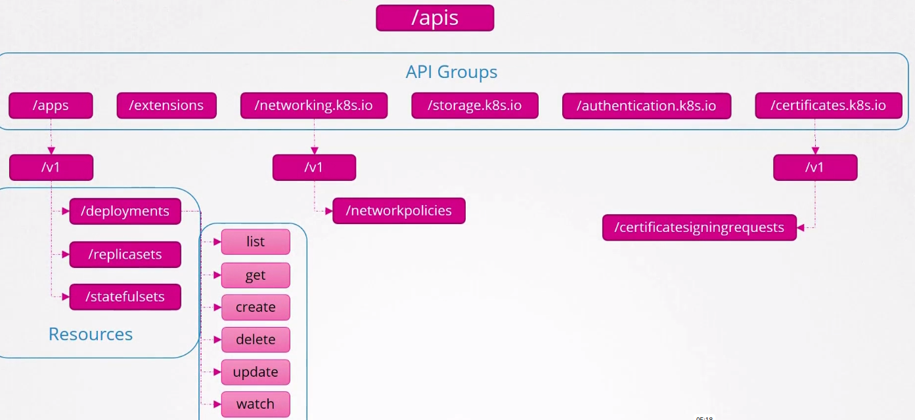
We can get the list of api groups by invoking the rest api of the master node

curl -k <https://masterip:port> -k --cert keyname.key --cert certificate.crt --cacert ca.crt

Authorization:

Authorization comes into play once a user is authenticated, what role or permission does a user have inorder to perform operation on that node.

There are 4 type of authorizations:

1. Node Authorizer

This is used to provide only node access within the cluster, when a kubelet accesses the apiserver to get the details or perform tasks on the node, the kubelet should be part of the “system:nodes” group in order to be authorized by the node-authorizer to get access to the node.

2. Attribute based authorization

Attribute based is basically assigning permission to each user/bot indivdually in the form of policies, the disadvantage in this is once the userbase grows it becomes difficult to maintain the permissions of all the users.

3. Role based authorization

Role based authorization basically groups the users/bots into role and we assign the permissions to this role. So any user associated with this role inherits the permissions of that role.

4. Webhooks

This is a third party authorization tool, where in once the user/ bot requests for a action on a pod or any object, it gets checked in the third party tool policy and gets use authorized.

Apart of these 4 authorization mechanisms, we also have 2 additional default mechanisms which get specified in the kube-apiserver configuration file if the above ones are missing.

Always allow and always deny, so these as the name suggest allows all the requests made by the users and if set deny denies the requests.

Also we can specify --authorization-mode property with multiple mechanisms which gets executed in a sequential manner.

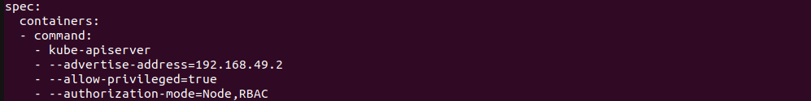
Role Based Access Controls:

In this we have 2 parts to get the user/bot authorized to access a resource. First we have to create role definition and the create a role binding to authorize the user.

Role based access controls are by default assigned to the default namespace, but we can also limit the role to a specific namespace by giving the namespace property in the role definition file.

Here we have given the role authorization to all pods resources, this can be restricted to a select few by specifying the resourceNames property.
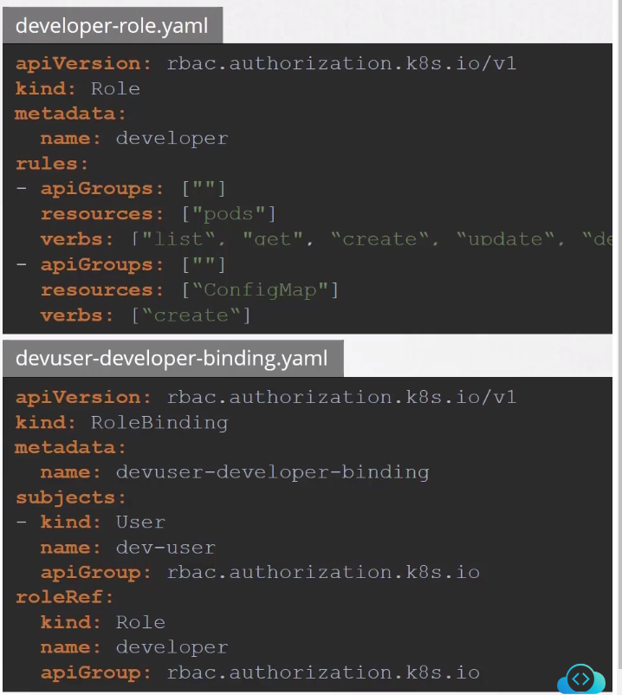
We can also view the details of roles

kubectl create -f developer-definition.yaml – create a role

kubectl get roles

kubectl get role-binding

kubectl describe role <role name>

kubectl describe rolebinding <role-binding name>

kubectl auth can-i <create deployments/delete nodes> - check if you have access to the resource

kubectl auth can-i <resource action> --as <user> - Check if that user has access to the resource

Cluster Roles:

Cluster roles are not restricted to a specific namespace, some of the resources here are nodes, Persistent Volumes, Certificate signing requests, namespaces.

Cluster roles allows a user to access cluster wide resources with the help of cluster roles and cluster role bindings.

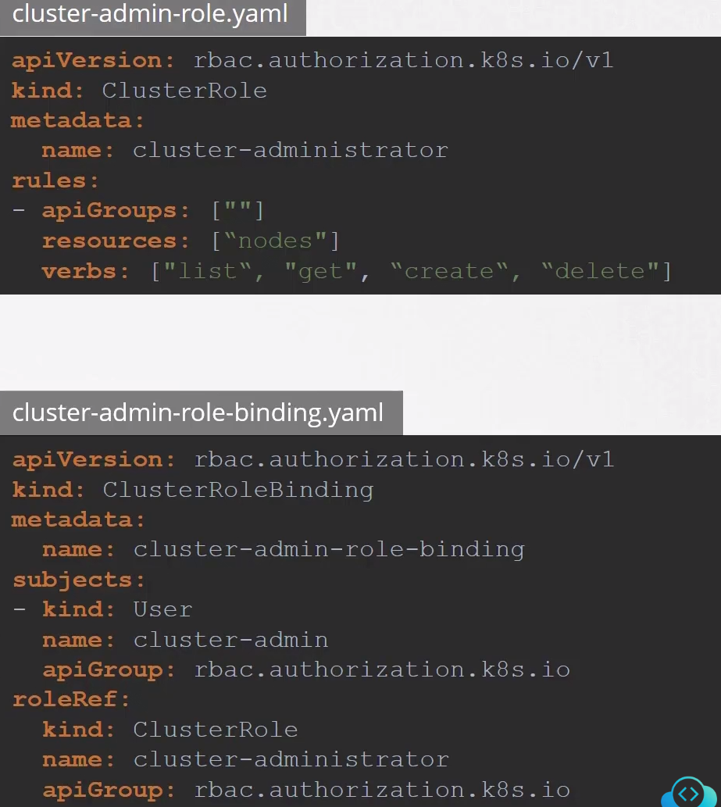
A cluster role can be created using
kubcetl create -f cluster-role-def.yaml

Image Security:

Image security is used to download the container image from a secure registry.

We have multiple secure registries such as docker, google container registry,(gcr), aws container registry(acr)

So when ever we provide the image name in the pod definition file we can specify the image name as below to get the image from a specific registry

-image : <registry>/<username>/<image name>

Usually in docker inorder to login into the repository we run below command to connect to the docker registry with the required credentials
docker login

Similarly, if the user/company has there own docker private repository where the image has to be downloaded, we have create a secrets object and specify it in the pod definition file

A secrets object can be created using below command

kubectl create secret docker-registry <secret-name> --docker-server=<server> --docker-user=<username> --docker-password=<password> --docker-email=<email-id>

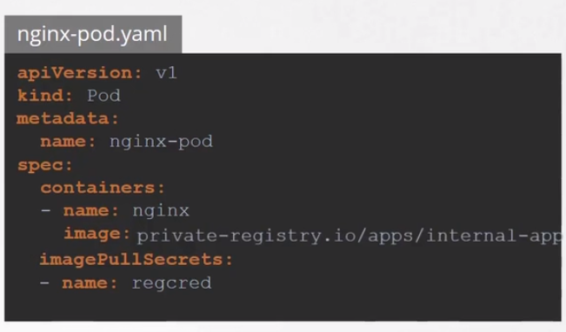

Security Contexts:

These are arguments that are passed during the container creation such as running a container as a specific user, adding a role to the container, These can be done using security context in kubernetes at pod level or container level.

You can run the below code to add the user to the pod

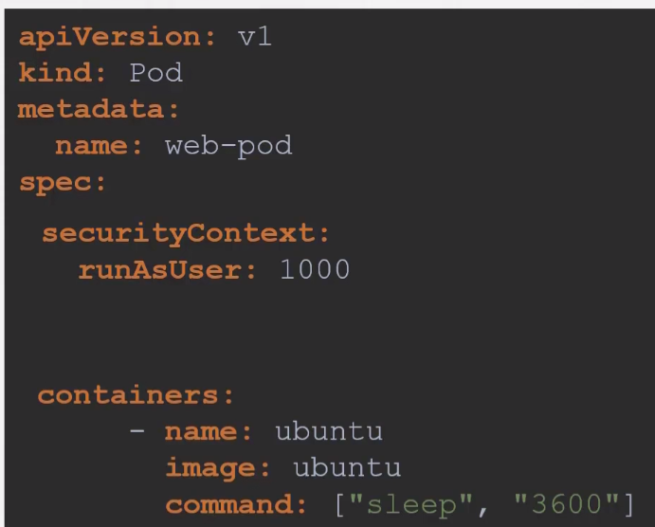

Network Policies:

There are two types of traffic in networking on which policies can be enabled, They are Ingress(Incoming Traffic) and Egress(Outgoing Traffic), By default kubernetes allows Ingress and Egress traffic for all the pods

In order to restrict this traffic we need network policies, This can be acheived by creating a network policy definition file associated with the pod.

This policy contains the properties

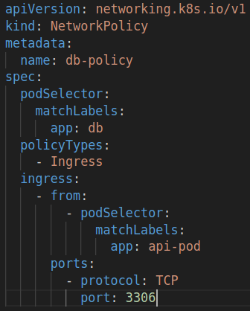

This policy can be created using – kubectl create -f <network-policy.yaml>

There are some network solution that can be implemented in kubernetes which support network policies
Network solution that support network polices:
Calico
Romana
Weave-net
Kube-Router

Network solution that do not support network polices:
Flannel

Service Accounts:

There are two types of account User account used for such as admin tasks and development tasks and a Service account is used by services such as monitoring applications, CI tools to access or deployment of applications

These services need to be authenticated in order access the cluster or applications in the pods. For this we need to create a service account and map it to the service

Creating a service account - kubcetl create serviceaccount <service-account-name>

If you want to create in a namespace, we can add --namespace property to the above

This creates a an service account and creates a token which inturn has a secret mapped to it

get the list of service account - kubectl get serviceaccount

describe a service account - kubectl describe serviceaccount <service-account-name>

Check the secret token - kubectl describe secret <service-token from describe>

This token can be used authenticate the service through a rest api call

curl -k <https://apiserver:6443>/api --headers “Authentication: Bearer <secret token>”

By default every namespace in the cluster has a default service account, If a 3rd party application is deployed in a pod of that namespace it automatically inherits the default service account.

This service account is mounted on /var/lib/secrets/kubernetes.io/ which can be checked with
kubectl describe pod <podname>

You can also explicitly specify a service account during pod creation using the property
serviceAccountName
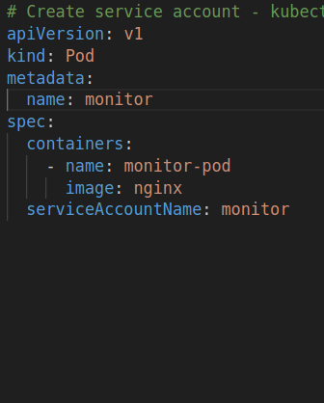

These service account tokens that are generated are not timebound and have security or scalability issues. In Order to overcome this kubernetes has introduced “token requests api” in version 1.22 which are timebound .

Also in version 1.24, when a service account is created, by default no token is created and assigned to it. In order to create a token we have run – kubectl create token <serviceaccount>

NETWORKING

Cluster Networking:

In order to configure a kubernetes cluster we need to need to have few dedicated ports open on the each nodes

On the Master Node:

API Server : 6443
Controller : 10257
Scheduler : 10259
Kubelet : 10250
Etcd : 2379 and 2380 (Intercommunition of etcd client on multiple master node)

On the Worker Node:

Kubelet : 10250
External Port: 30000 – 32767

If you have multiple master nodes, then you require port 2380 for etcd client to communicate among each other.

Pod Networking:

Connecting the pods in kubernetes cluster which is spread across multiple nodes. Currently kubernetes does not provide any in built solution to establish such a pod network. We have to rely on a networking solution such as Flannel, Weave Net, Cilium.

In order to establish a pod networking, the should satisfy below conditions

1. Every Pod should have a IP Address
2. Every pod should be able to reach other pods on the same node
3. Every pod should be able to reach other pods in another node without NAT.

Manually we can establish a basic networking through ip tables and routes.

When a pod is created it is assigned to a namespace. After that we need to create a network with network type (bridge/nat/etc..) and have subnet range assigned to it and which the pods created in this have a unique IP assigned to them.

This can be automated using a script which will be called by a CNI(container network interface) to assign a network as soon as pod is created.

The CNI configuration is stored in the kubelet service file, we can get this information by running

ps -aux|grep -i “kubelet” or from the kubectl.service

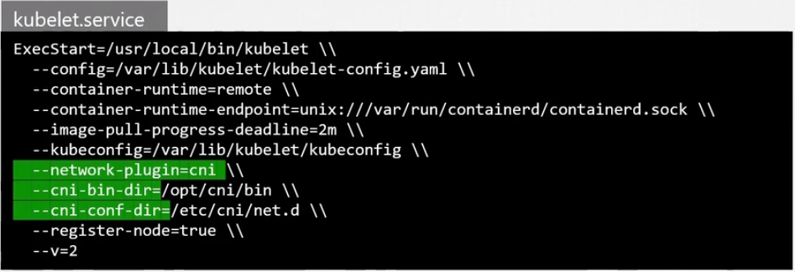
The CNI Bin directory (/opt/cni/bin)consists of the CNI Plugins as executables such as bridge,dhcp, flannel, etc..

where as the config directory (/etc/cni/net.d) contains the configuration files of the CNI Plugins.

Sample Bridge configuation file.
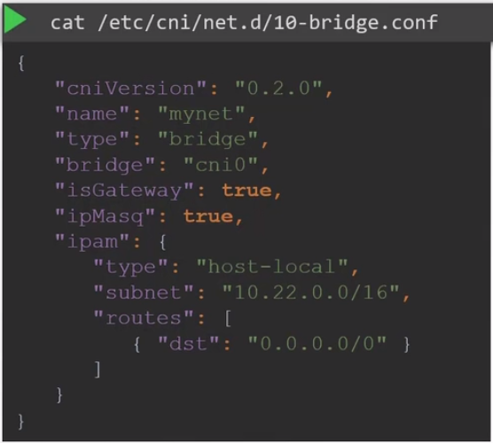

Here , some of the properties defined dictate as per below

isGateway : Checks if IP address assigned to bridge network can be used as a gateway
ipMasq : Checks if a nat rule be assigned to the bridge network
ipam : IP Managment decides if address defined should be from a specific subnet
Type : host-local indicates that the IP address would be assigned from the specified subnet

CNI Weave:

Weave is a network solution that can be implemented across a kubernetes cluster just like a kubernetes object(Pods, deployments, services). It is deployed as agent on each node as a daemon set.

Each agent consists a complete topology of the cluster and each pod can have multiple bridge networks and which route does the network traffic take on pod depends on the IP Router configured

In order to deploy weave we can do as

kubectl apply -f <weave.yaml>

DNS Clustering:

Kubernetes has an inbuilt dns server once a cluster is created. This dns server stores the records of the services and pods in specific format using which a pod/service can reach each other across the cluster with multiple namespaces.

By default a DNS server stores the records of the services and for the pods we need to enable this feature explicitly.

Also usually the hostname of the service type is usually the service name, whereas in the case of the pods it is the Ipaddress replaced with Hypens(-)

A pod can access a service in a namespace using

hostname.namespace.type.root

web-service.apps.svc.cluster.local

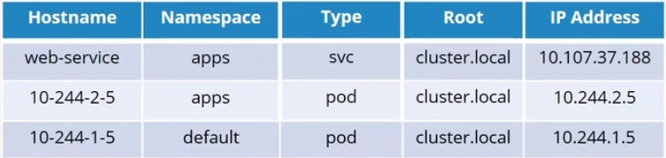
Ingress:

Ingress is a layer 7 loadbalancer at the kubernetes cluster level. Using ingress eliminates the use of mulitple load balancers if there are multiple sub domain in the same application or multiple query paths and also simplifies by allows us to configure SSL and routing based solution at the Ingress controller.

Typical Setup with load balancer:

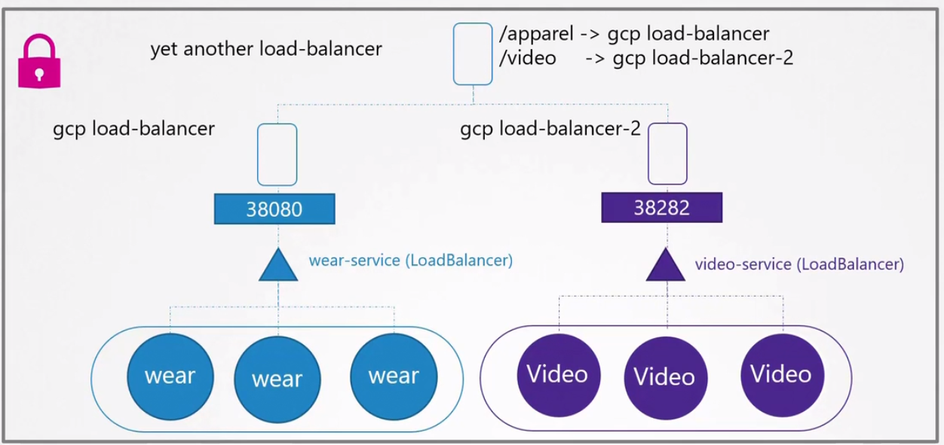
With Ingress Load Balancer:
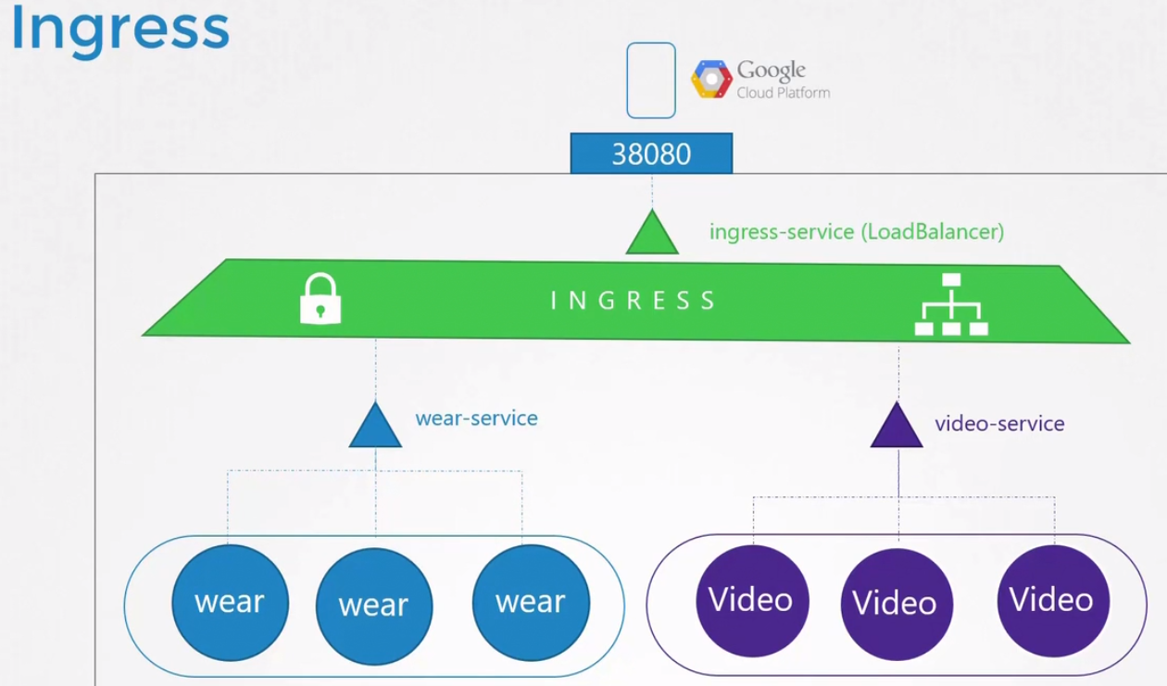

Using Ingress:

In order to use Ingress we deploy it like any other pod with an image that supports the configuration of Ingress controller. Eg: Nginx, HAProxy, Traefik

Ingress has two sections to it.

1. Ingress Controller : This is the network solution that we implement by deploying the pod with the image that supports the controller configuration. This evaluates the rules mentioned in the ingress resources and manages the redirection requests

2. Ingress Resources : This consists set of rules that define the routes, Query paths, services names

Creating a ingress controller:

You can use the images from GCE, nginx, Haproxy, Contour, Traefik, Istio.
GCE and nginx images are maintained by kubernetes project.

To configure a Ingress Controller, we have to create the below objects and link them together

1. Deployment-definition file : Create a deployment definition file with the image that supports ingress controller (nginx).

Here the arg property consists the path to start the nginx controller binary and config map has the configuration related to the additional features/properties nginx has.
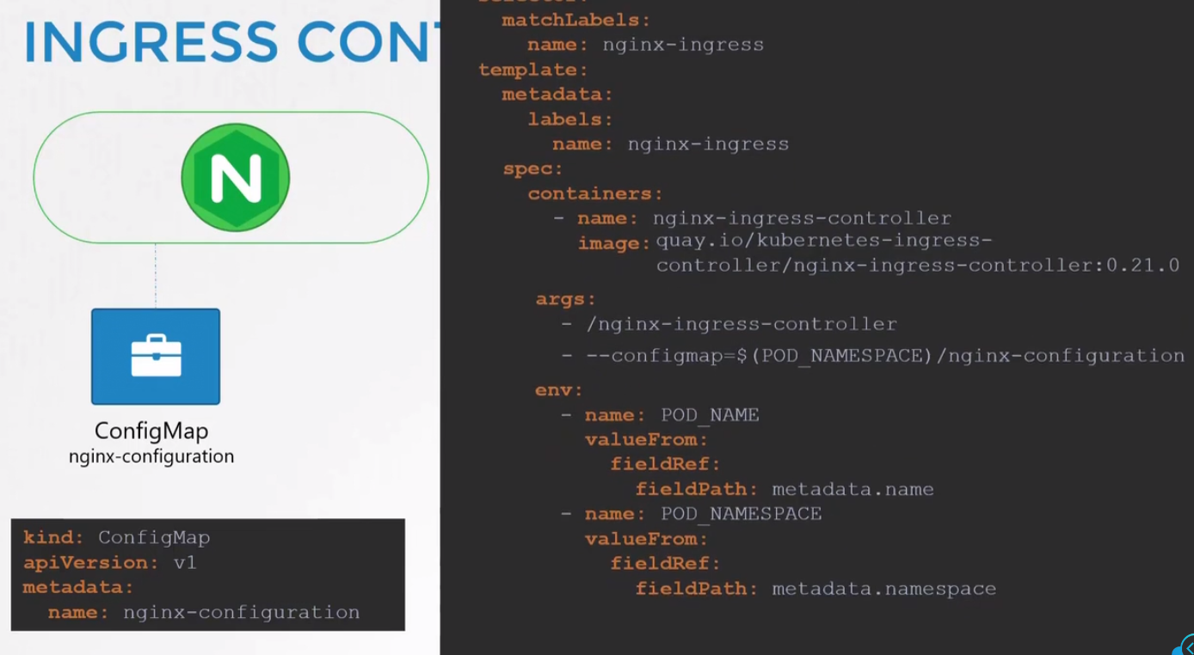

2. Create Service File:

Create a service file to expose the controller to the outside world with a node port and link the controller with the service using a selector.
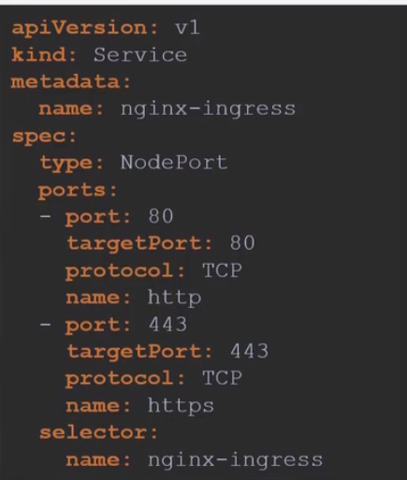

3. Service Account:

Controller needs access to the pods and services deployed on the cluster with right set of roles, cluster roles and bindings. For this we need to create a service account.

Ingress Resources:

These are set of rules that are applied on the ingress controller to route certain section of traffic. Here some same definition files that indicate routing based on
Query Path:
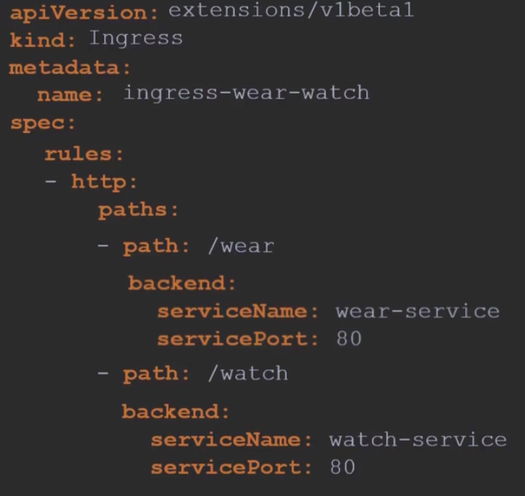

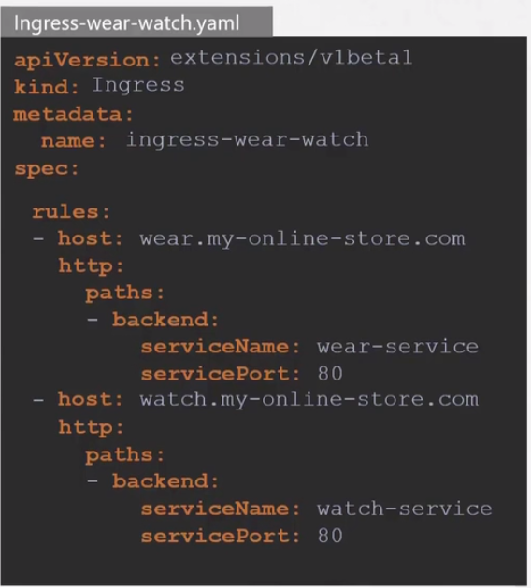
Domain Path:
Service Mesh
Side Cars:

Its a name given to the container which supports the main container in a pod. Usually a side car container supports by providing logging, monitoring, authentication,security, etc. Where as the main container has the business logic.
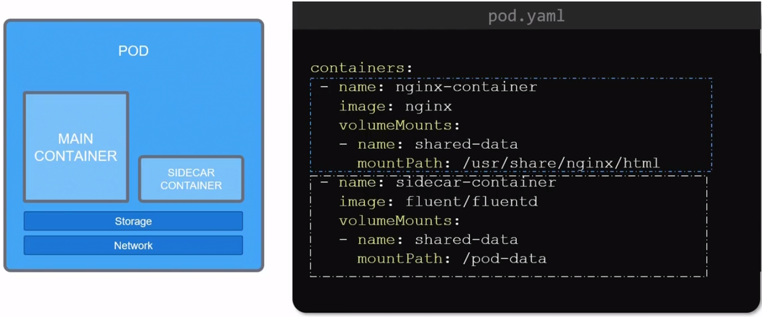
Envoy:

It acts as a proxy and communition bus which is deployed as side-car on pods, This usually handles communication attributes of the main container where the application is deployed such as SSL, Monitoring, Logging, Authentication.

This was 1st started in LYFT as a opensource project and then it was accepted by CNCF where is reached a graduation level in 2018, It is one of the most common proxy service used in service mesh

Monoliths vs Microservice Architecture:

Monolith architecture is where a software modules are tightly coupled which means they are interdependent on each other, Any change to a single module require the entire application to be re-deployed.

This causes a delay in testing changes, pushing any new modules to a certain section of users.

In a microservice architecture each module is indepently deployed and communitcation between modules happens to through api’s, This gives us the advatage to

1.The modules are updated dependently
2. More Frequently updates can be rolled out.
3. System resilency and isolation
4. Platform and software independent
The main problem in a microservice architecture is the complexity of the network, observabilty as their are many containers to monitor, authentication and networking that it is built on.

As seen earlier in micro service architecture we seperate the application business logic from the communiton funcationalities such as, authentication, authorization, logging, monitoring, networking, tracing and create services for each one them.

Service Mesh:

Service mesh is a mechanism where the non-business logic requirements such as authentication, authorization, logging, monitoring, networking, tracing services are combined and deployed as a proxy side-car container in a cluster.

The communication between these proxies happens through data plane and the communication to the server side happens through control plane. Control Plane manages the traffic in and out of the services through proxies. This abstracts the networking from the business logic. This is called service mesh

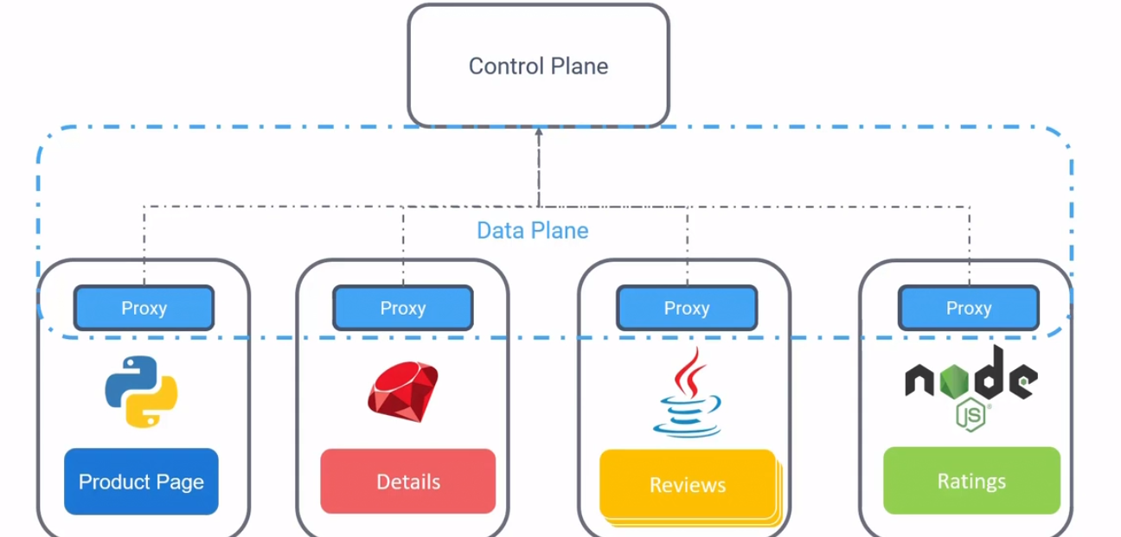
Service mesh on a high level is responsible for

1. Traffic Management : Traffic flow b/n the proxies through dataplane and control plane
2. Security : Secure communition between the proxies
3. Observability : Helps in application flows and issues
4. Service Discovery
1. Health : Check for failed or unhealth services
2. load balancing : Reroutes the traffic from unhealth services
3. discovery : Checks for the service endpoints and helps the proxies to communicate with them.

Istio:

Istio is a mechanism that supports service mesh in kubernetes.

A service mesh contains proxies as side-car and communication between them is done through data plane and these proxies also communitcate with the service side component through control plane. Here istio used envoy as a proxy and the control plane earlier had 3 components

1. Citadel - Manage Certification generation
2. Pilot - Discovery of services
3. Galley - Validation of configuration files.

Later these 3 components were combined in to a single daemon called istiod.

Each pod has a istio agent deployed on it along with the envoy proxy which shares the configuration with proxy.

Istio can be installed onto a cluster using a installer by running the below command

istioctl install --set profile=demo -y

In order to verify installation

istioctl verify-install

In order to apply istio on a application, we can do the following

enable isito injection on the namespace where the application would be deployed

kubectl label namespace default istio-injection=enabled

then deploy the application and verify the istio setup on it

istioctl analyze

We can verify by checking the pods that have the application deployed along with proxy container in each pod

STORAGE

When docker is installed on a machine it creates a storage to store the files created by docker in the path /var/lib/docker

Docker follows layered architecture which each instruction in a docker file forms a layer, the advantage of the layered architecure is that if any other docker file contains similar instructions but differs in few then it uses the existing layers and create a new layer of the remaining instructions there by reducing the size of the image.

Once the docker file is built it creates a image layer which is ready-only. Once we build a container out of this image layer it read-write layer called container layer where modification to the files are possible, Any changes made to the existing file from the image layer creates a copy of that file in the container layer. This is called copy-on write mechanism

The container layer exists only till the container is alive, once it gets deleted the changes made in the container layer are lost.

Volume Mounting
In order preserve the data stored on these containers, we can create a persistent volume using the command

docker volume create <volume-name> - This creates a volume under /var/lib/docker/volumes

Below command creates a new container and attaches the volume created earlier to it

docker run –name=<containername> -v <volume-name>:<container_path> <image>

using -v option also creates the volume on the file in /var/lib/docker/volumes

Bind Mounting

In bind mounting, we can use a specific location on the host that should be linked to the container other than the default volume location.

docker run –name=<containername> -v <host-path>:<container_path> <image>

Instead of using -v option which would be deprecated eventually, its good practice to use mount option

docker run –name=<container-name> --mount type=bind,source=<host-path>,target=<container-path> <image-name>

Docker uses storage drivers to enable layered architecture, This storage drive is choosen automatically based on the operating system. Some of the storage drivers
AUFS
ZFS
BTRFS
Device Mapper
Overlay
Overlay2

VolumeDriver Plugins:

Volume driver allows a user to create volumes, When you create a local volume it uses a local volume driver. There are many volume drivers.

Eg: Local, Azure File Storage, Convoy, Digital Ocean Block Storage, Flocker, gce-docker, Gluster FS, Net app, Rexray, Portwax, VMWare vSphere Storage.

Container Storage Interface:

This is a standard storage solution which allows kubernetes to communicate with 3 rd party storage solution with storage drivers.

A CSI defines a set of remote procedure calls(RPC) that is called by the container orchestrator and which should be implemented by the storage driver on the storage solutions.

Kubernetes Volumes:

In Kubernetes, Volumes can be attached to the pod with the property volumeMounts, here we need to create a volume with the path on the node, But in a large environment where there are multiple pods its difficult to configure volume storage
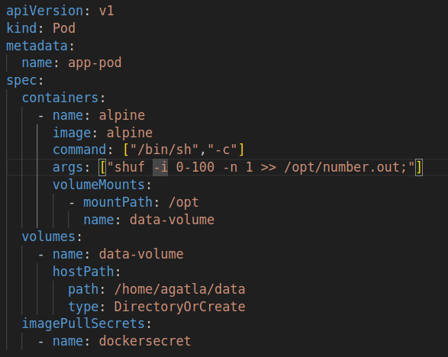

Persistent Volumes:

Persistent volume is a cluster wide deployment of volume from which a user can carve out the required volume for the respective pod. This can be done with a request called persistent volume claims.

Here we create a Persistent Volume using a definition file, Instead of hostPath we can also use a cloud storage such as aws.
There are 3 different access modes available while defining a volume
1. ReadOnlyMany
2. ReadWriteOnce
3. ReadWriteMany

awsElasticBlockStorage:
volumeID: <volume Id>
fstype: <filesystem>
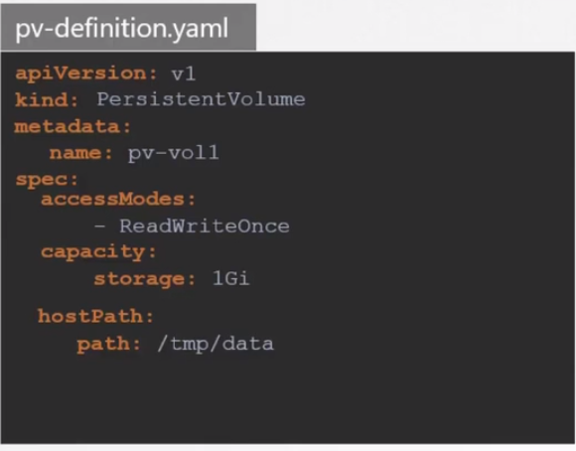
Get the persistant storage volume in the cluster

kubectl get persistentvolume

Creating a Persistent Volume Claims

we can create a claim which will craved out from the persistent volume and be bound to it.
We can also view the claims using

kubectl get persistentvolumeclaim

The persistent volume can be deleted - kubectl delete persistentvolumeclaim <claimname>
Once a claim is deleted, based on the claim policy property mentioned in the PV, it would be decided if a PV should be deleted or retained.

There are 3 policies mentioned in the Claim policy

PersistantVolumeClaimPolicy: Delete - Deletes the PV once the PVC is deleted
PersistantVolumeClaimPolicy: Retain - Retains the PV once the PVC is deleted
PersistantVolumeClaimPolicy: Recycle - Scrubs the data and retains the PV once the PVC is deleted

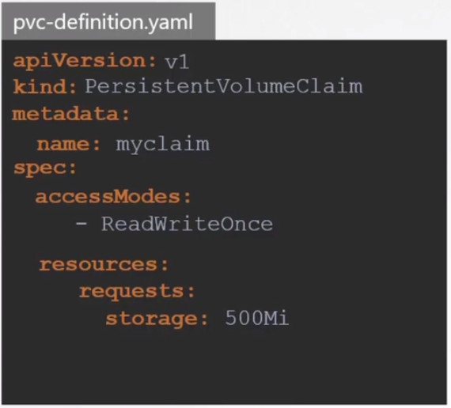
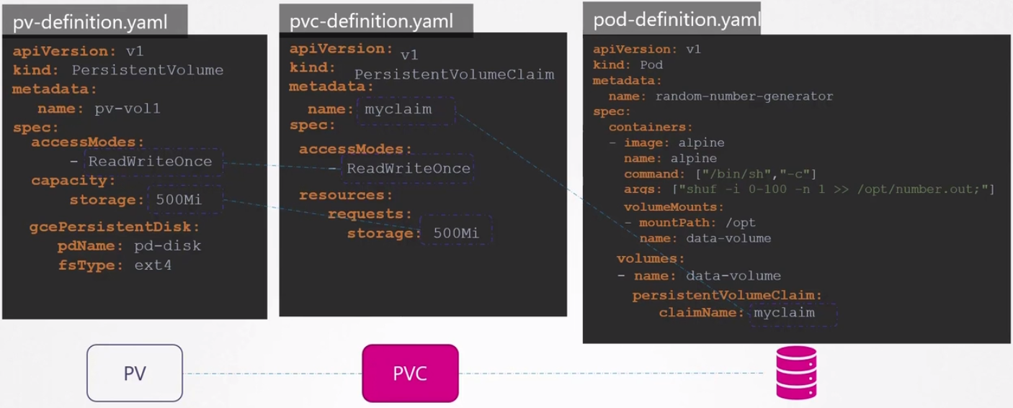

Storage Classes:

With use of storage classes, we can eliminate the use of PV as the storage classes provisioner based on the PVC made would create a volume on the cloud storage and assign it to the pod.

There are many storage provisioners that can be used on kubernetes

Eg : AWSEBS, Azure File, Azure Disk, Flocker, GCEPersistent Disk

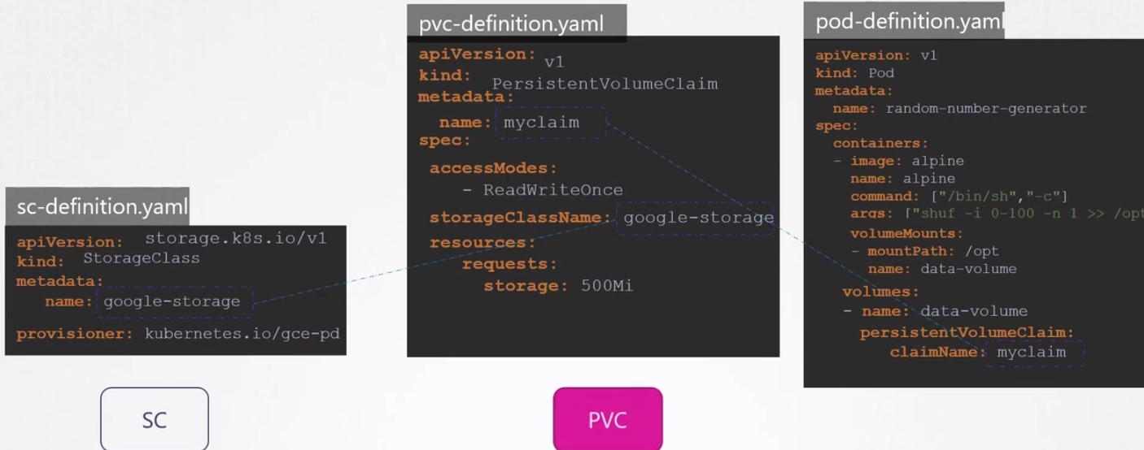

kubectl get sc – get the storage class details

CLOUD NATIVE CLOUD FOUNDATION

Cloud Native Computing Foundation (CNCF) is an open source software foundation under the Linux Foundation umbrella dedicated to making cloud native computing universal and sustainable.CNCF serves as a vendor-neutral home for many of the fastest-growing projects on GitHub, including Kubernetes, Prometheus, and Envoy, fostering collaboration between the industry's top developers, end users and vendors.

Cloud Native computing uses an open source software stack to deploy applications as microservices, packaging each part into its own container, and dynamically orchestrating those containers to optimize resource utilization.

Cloud Native Architecture

sCloud native architecture can provide solutions for the increasing complexity of applications and the growing demand by users. The basic idea is to break down your application in smaller pieces which makes them more manageable. Instead of providing all functionality in a single application, you have multiple decoupled applications that communicate with each other in a network.

Characteristics:
1. High Level of Automation:
This can be achieved by using modern automation tools and Continuous Integration/Continuous Delivery (CI/CD) pipelines

2. Self healing
Applications and infrastructure fail from time to time. This is expected, and therefore cloud native application frameworks and infrastructure components include health checks which help monitor your application from the inside and automatically restart them if necessary

3. Scalable
Scaling your application describes the process of handling more load while still providing a pleasant user experience.

4. Cost-Efficient
Scaling your application up/down based on the network traffic would help minimize the costs

5. Easy to Maintain

6. Secure by default

AutoScaling:

This helps in automatically adjusting the resources based on the incoming load to the application. It would automatically scale in or scale out based on the traffic. Kubernetes has 3 type of autoscaling:

Horizontal Pod Autoscaler:
When the load increases it deploys pods from the deployment onto the cluster, Based on the incoming requests it adjusts the number of pods if they should be increased on decreased. This decision is taken based on the mertics servers input. Metrics server can be deployed as a pod using the yaml file from git hub

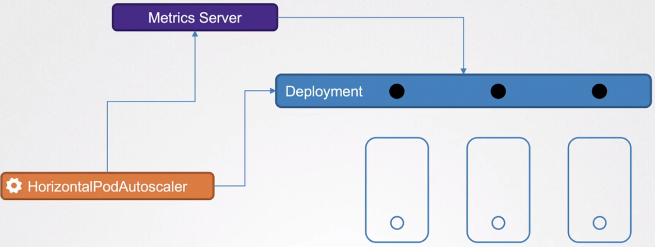
Sample Horizontal Pod Autoscalar definition file
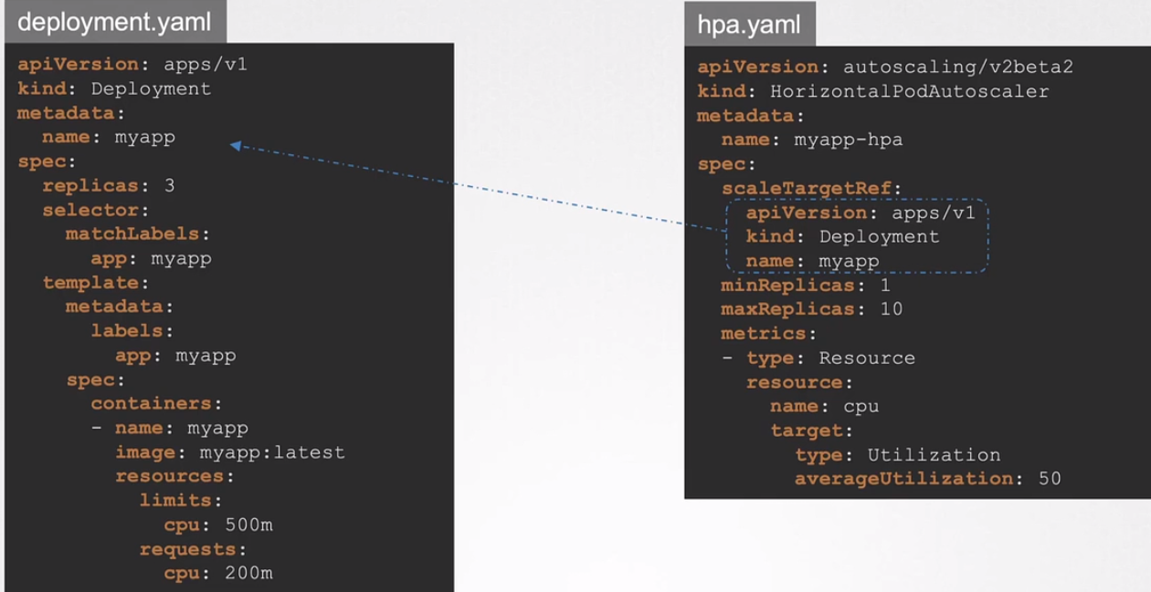

We can create a Horizontal Pod Autoscalar: kubectl create -f hpa-definition.yaml
Also view the hpa : kubectl get hpa

Vertical Pod AutoScaler:
In VPA autoscaler, based on the metrics the autoscaler decides whether to increase or decrease the capacity of the pod. This is done through few components in the VPA

1. VPA Recommender:
Based on the metrics, this recommends the VPA the desired values to be provisioned to the POD.

2. VPA Updater:
This updates the POD resources to that of the recommendations provided. Also this component has a update policy which decides where the update should be implemented on the pod or not.
Update Policy:
Off : This mode would recommend the change to be made to the pod and its up to the administrator whether to apply the changes or not.
Initial : This would update the changes to the pod settings but would only be applied only the newly created onces
Auto : This would update the pod settings by evicting the existing pod and creating a new pod.
3. VPA Admission Controller:
This controls the POD changes based on the recommendation and the update policy that has been set.

VPA Auto scaler is not present by default in kubernetes , It has to be download from the git repo
git clone https://github.com/kubernetes/autoscaler.git
cd autoscaler/vertical-pod-autoscaler/
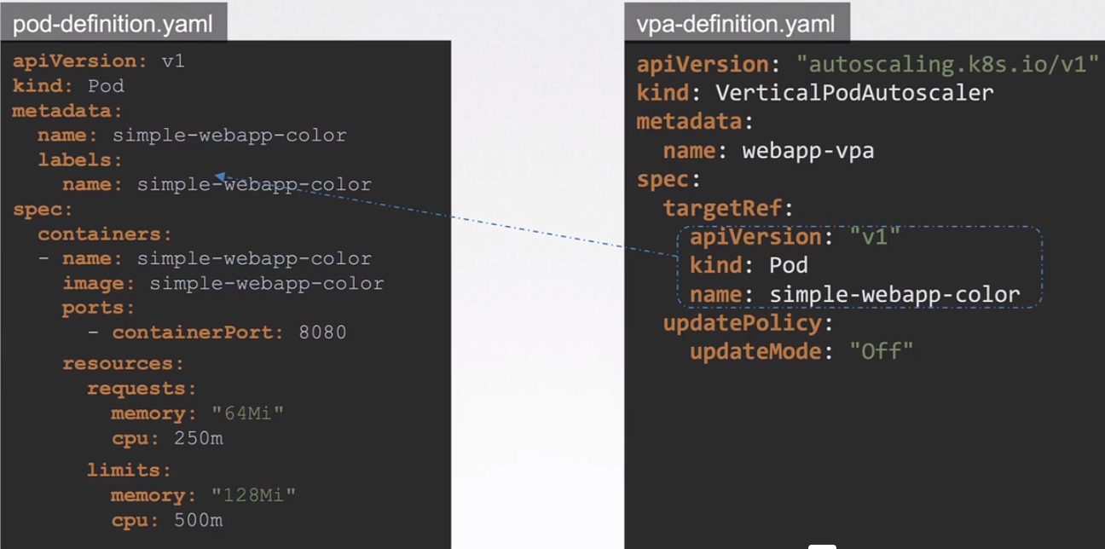
./hack/vpa-up.sh
The vpa and its recommendation can be viewed using
kubectl describe vpa <vpa-name>
Cluster AutoScaler:

Cluster autoscaler basically works on the entire cluster level, Based on the metrics it increases or decreases the number nodes to be allocated. This is mostly dependent on the cloud providers like AWS, Azure, GCP, Etc.

Serverless:

Serverless is a model where the infrastructure mangement is completly taken care by the cloud provider, this service is called Function as a Service(FAAS) and its pricing model depends on the amount of the time you use this service.

Some of the cloud providers that provide serverless computing platforms are
AWS - Lamba and Fargate
Azure - Azure Functions
Google- Google Cloud Functions

Kubernetes also provides platforms for such serverless workloads – knative and openfaas

In order to standardize the data that should be structured in Serverless offering, cloud events project was founded.Events are the basis for scaling serverless workloads or triggering corresponding functions.

CloudEvents is a specification for describing event data in a common way. CloudEvents seeks to dramatically simplify event declaration and delivery across services, platforms, and beyond!

KEP(Kubernetes enhancement proposal):

KEP is a way to document kubernetes enhancements and put forward your idea to the kubernetes community, This allows others to contribute their efforts to develop kubernetes in a more structure and open format.

KEP’s follow a specific format where the title has the following format

Title : KEP-<4 digit number>-<Description>
Summary
Goals
proposal
UserStories
Risks and mitigations
Design Document
Test Plan
Graduation Criteria

Keps are grouped by SIGs(Special Interest Groups) that have their own area of expertise in kubernetes such as Application, Cluster Lifecycle, Datamanagement, Networking, Storage and Security. When ever a KEP is submitted , once its reviewed it would be categorised into a KEP

Below are lifecycle of a KEP

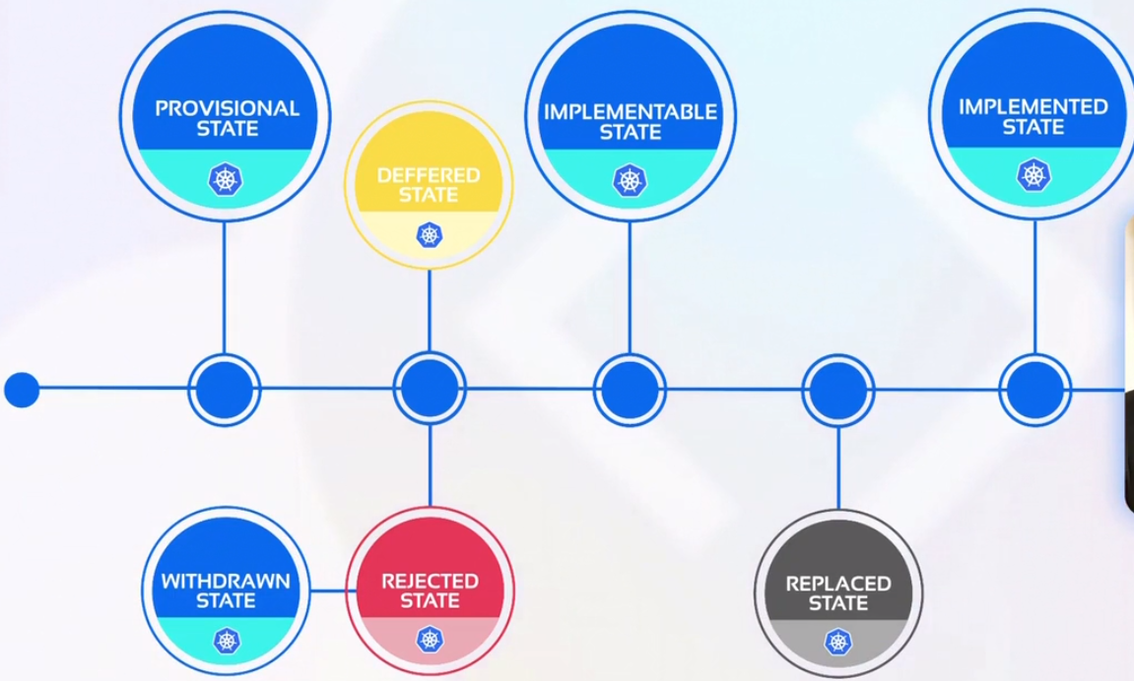
Kubernetes was 1st developed in Google and was accepted/graduted into CNCF(Cloud Native and Cloud Foundation) in the year 2016. Kubernetes is now over looked by a Community Governance Model which comprises of the hierarchy level:

Steering Committee - Overseas the overall kubernetes community

Working Group - This group has expertise on multiple areas in kubernetes and come into play when different areas of kubernetes come accross.

Special Interest Group - They are expertise in a particular area of kubernetes and are elected by a nomitation and voting process within the SIG

They are involved in six key aspects of kubernetes:
1. Code Development
2. Testing and Validation
3. Documentation
4. Community out reach and education
5. Release Management
6. Architecture and Design

Open Standards:

Open standards helps in standardizing different products to work with each other seemlessly which promote interoperability, Portability and Vendor Neutrality.

This standards are being implemented in Cloud native technologies to promote health competition and give the end user the flexibility to integrate with multiple technologies.
OCI(Open Container Initiative):

Its a group that creates specifications and standards for container images, run times and distributions.
There are three types of standards that have been created as part of this OCI:

1. Image Spec : Defines how a filesystem bundle should be packaged into an image.
This has enabled various image vendors to come up with new images
eg : buildkit, Podman, builder , docker

2. CRI(Container Runtime Initiative):
Defines the standard of downloading, unpacking and running the file system using an OCI complaint runtime.
Eg: Docker, Containerd, kata containers, CRI-O, Gvisor, firecracker

3. Distribution Spec:
Defines the standards and API Protocols that should be used to standardize the container images.
Eg : AWS ECR, Azure ACR, Docker Hub, Google GCR

This has been implemented in kubernetes creating a modular architecture

1. Service Mesh - Uses the standard SMI( Service Mesh Interface)
2. Storage - Uses the standard CSI( Container Storage Interface)
3. Networking - Uses the standard CNI( Container Network Interface)
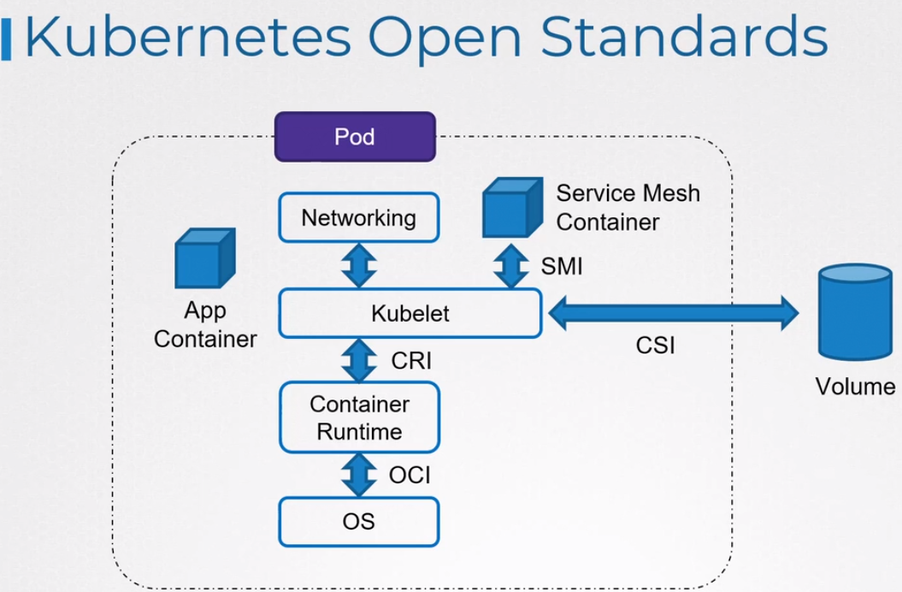
4. Runtime - Uses the standard CRI( Container runtime Interface)
Observability
Fundamentals:

Observability : The ability to understand and measure the state of a system based upon data generated by the system.

This allows the user to generate actionable outputs from unexpected scenarios in dynamic environments

It helps in:
1. Better insight into the internal workings of a system/application
2. Speed up trouble shooting
3. Detect hard to catch problems
4. Monitor Performance of an application
5. Improve cross-team collaboration

There are 3 Pillars to achieve observalibity

1. Logging:
Logs are records of events that have occured with a timestamp and encapsulate information of a specific event.

However logs are not the best way to analyse a system due to lack of verbosity and number of events that occur due interaction with multiple area of a system. It becomes complex to find the error, like find a needle in a haystack.

2. Traces:
They allow you to follow operations as they traverse through various systems and services. Here one can follow a individual request based on the trace ID.

Its helps to connects the how the process and services connect with eath other

Each trace has a traceID that is used to identify a specific request, whenever a trace ID hits a service/Process it creates a span, which gives us the below details:
1. Start Time
2. Duration
3. Parent-ID

3. Metrics:
It provides information about the entire system using numerical values.

Overtime it allows us to take advatage of these numerical values and create a graph from the data collected creating a better visual representation and trends.

Usually metrics are
1. CPU Load
2. Latency
3. Number of Requests and Responses
4. Number of Errors

Metrics have 4 parts to it
1. Metric name: Name of the metric
2. TimeStamp: At what time intervals did this metric occur
3. Metric Value: Denotes the value of the metric
4. Dimensions: Info of the metric which is denoted by label in the form of Key-Value Pair
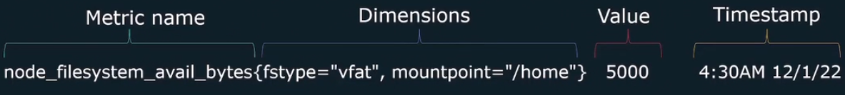
SLI/SLO/SLA:

When designing a system or applications, its important for teams to set specific measurable targets/goals to help organizations strike the right balance between product development and operational work.

There are 3 levels of indicators that determine the systems reliability.

1. SLI (Service level indicator):
Quantitative measure of some aspect of the level of service that is provided

Common SLI:
1. Request Latency
2. Availability
3. Throughput
4. Saturation
5. Error Rate

2. SLO(Service Level Objective):
The target value or range of SLI, It is directly related to customer experience. Basically it shows the percentage or numeric analysis of the SLI which would define the availability or performance of the application.

The higher the SLO the more costly it becomes to maintain that SLI.

3. SLA(Service Level Agreement):
Contract between a vendor and a user that guarantees a certain SLO.

Prometheus:

Its is a open source monitoring solution that uses only Metrics to collect, store and evalute the data and provide tools to visualize the collected data.

It collects data from multiple data centers and represent the metrics in form of a visual representation.
It has an alerting system that is allows to notify users if a certain metric crosses a defined thershold limit.

It collects metrics by scrapping targets who expose there metrics through an HTTP endpoint.

Scraped metrics are then stored in a timeseries databased and then the user interacts with the prometheus UI to query the data using a built in query language PROMQL.

Prometheus follows are pull based mechanism where in the monitoring tool queries for data.

Prometheus Architecture:

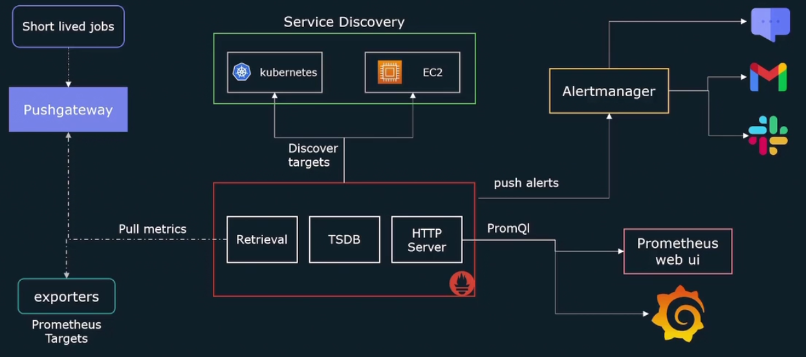
Prometheus has 3 main components:

Retrival : This sends out a request to target’s /metrics http endpoint & collects metrics
Time Series DB : Once the metrics are collected it get store in this Time Series DB
HTTP Server : This serves as endpoint for user to interact with the Time series DB.

Exporters: These are agents or plugin that are installed on the target machine that collects data from the application and formats them in a way that prometheus expects.

Push Gateway : This pushes the data into the prometheus from short lived jobs.

Service Discovery: Since prometheus is a pull based mechanism, It needs to discover targets by reaching to them

Client Libraries : using client libraries, it allows us to expose any application metrics you need to track in prometheus.

Push based metrics : Log Stash, Graphite, Open TSDB

Alert Manage : It send out the alerts to the users/systems using a SQS, SNS once the threshold is reached.

Prometheus UI : This allows the user to interact with the prometheus data by using a query language called PROMQL.

Node Exporter:

This is an exporter which is installed on a node which collects metrics from the node and sends it back to prometheus.

In order to install node exporter, we can download it from the prometheus.io/download, Once downloaded extract the binary and run it which will generate the metrics of the node on port 9100, Now prometheus can scrap this data and store it a time series database.

eg: http://localhost:9100/metrics

Once the node exporter is installed, up and running. We need to configure this node on prometheus configuration yaml file in /etc/prometheus/prometheus.yml.

Under scrape_configs create a new job as shown in the below image and restart the prometheus using systemctl restart prometheus.

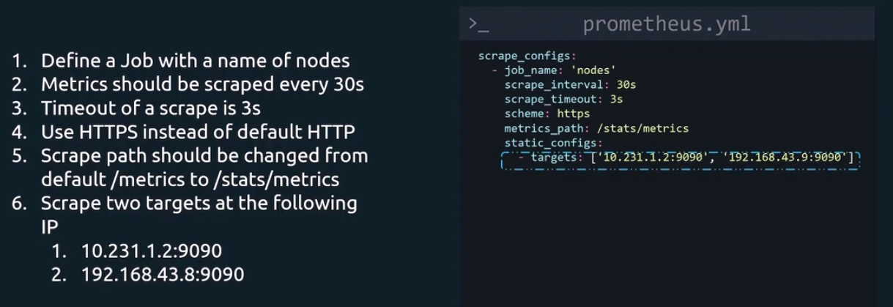
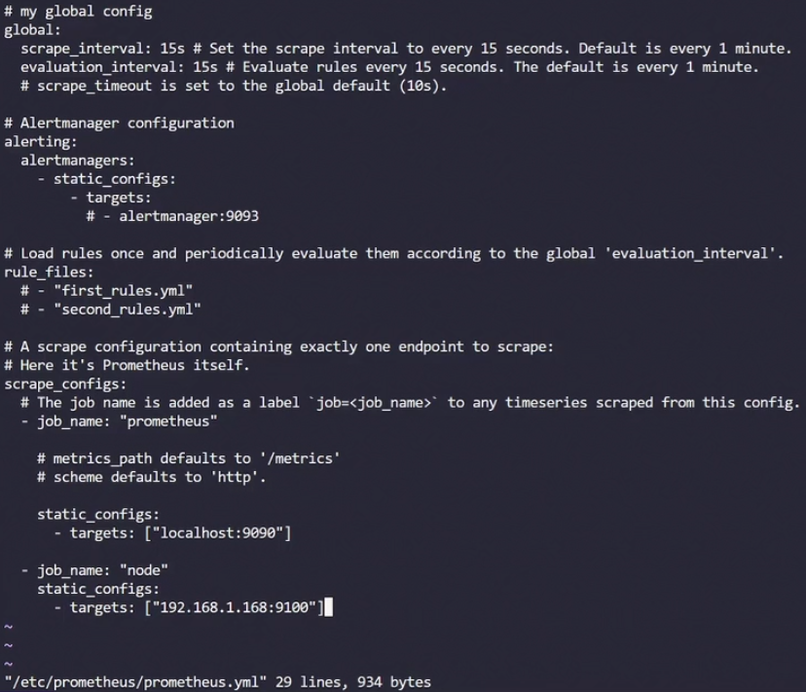
you can check the updated node through prometheus URL : http://localhost:9090/

Status --> Targets

Metrics:

A metrics are a combination of Metrics Name, Dimensions (Labels), Metric Value, Time Stamp.
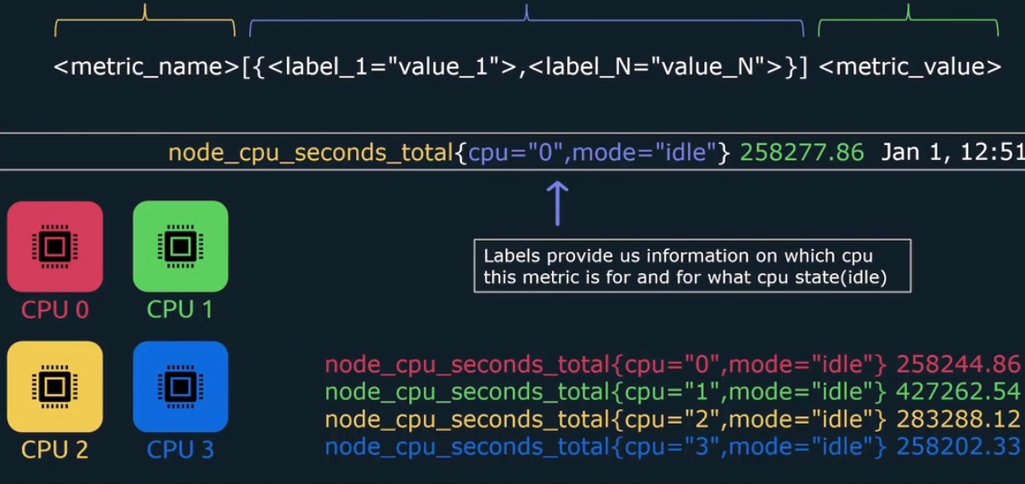

When prometheus scrapes a target and retrieves the metrics , it also stores the time at which the metric was scraped as well.

Time series in prometheus defines a stream of timestamped values sharing the same metric but with a set of labels
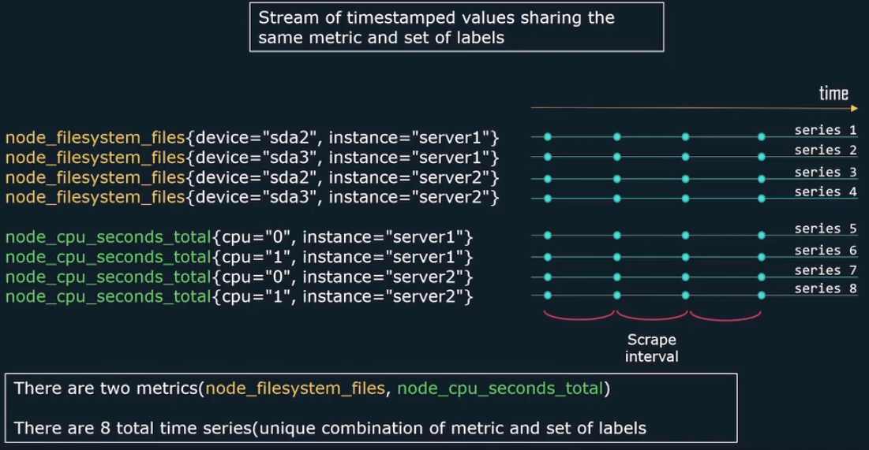
There are 4 different type of metrics

1. Counter metric : This metrics defines values/occurences in a system which can only go up.
Eg : Total no. of requests, Total no exceptions or executions
2. Gauge : It measures the value of a system request which can go up and down.
Eg: CPU Usage time, Number of requests in queue.
3. Histogram : This gives a better visual representation of the metric but placing them in buckets.
4. Summary : Overall summary of a metric in percentages

Labels:

Labels help in defining new metrics and refining them also. For example, we have metric which scrapes the data from a path and the relevant metric for that is

Path - /auth
Metric name : requests_auth_total

Similarly we have multiple such requests from /app, /db, /user. We can create metrics such as
requests_total{path=/auth}
requests_total{path=/app}
requests_total{path=/user}

and we can take a cumulative of these metrics using the sum function – sum(requests_total)

Prometheus with Containers:

Prometheus can be configured on a docker and scrape the metrics of the Docker Engine using Daemon file and Container Metrics using cadvisor image.

In order to enable in docker engine:

we create a daemon file : /etc/docker/daemon.json
{
“metrics-addr” : “ip address:port”,
“expertimental” : true
}

and restart docker : systemctl restart docker , Once restarted the metrics can be accessed on http://host:port/metrics

In order to enable for the container:

Create a container with cadvisor image and expose the port
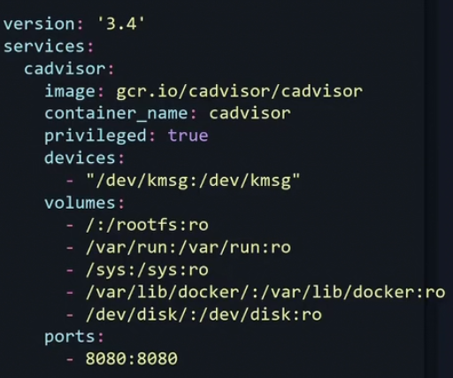

Similarly now add the metrics path of both the docker engine and container engine in /etc/prometheus/prometheus.yaml file

scrape_configs:
- job_name : ‘docker_metric’
metrics_path : ‘/metrics’
static_configs:
- targets : [“host:port”]

- job_name : ‘containers’
metrics_path : ‘/metrics’
static_configs:
- target : [‘host:port’]
and restart prometheus
Prometheus on Kubernetes:

In prometheus we can get the metrics of below components of kubernetes:

1. Kube-state-metrics - Cluster level metrics - pods, deployment and services
2. Node-exporter - Nodes of the cluster
3. Control Components - Scheduler, Controls, Core dns
4. Kubelet(cadvisor) - Container metrics

In order to get the cluster level metrics, we need to deploy the container with kube-state-metrics image.

In order to get the node metrics we need node exporter metrics installed on all the nodes of the cluster which can be done through a daemon set.

Best way to deploy prometheus on kubernetes cluster is by using helm charts which is a package manager for kubernetes which takes care of the setting the services, config maps, secrets, alerting system, push gateway.

Helm chart is a collection of template and YAML files that convert into kubernetes manifest files.

We can use the helm chart - kube-prometheus-stack to install on kubernetes, which comes with an operator.

This operator allows k8s to extend the functionality of control plane API components to create/configure and manage instances of complex applications like prometheus.

This allows customization in promethus componets just like kubernetes objects
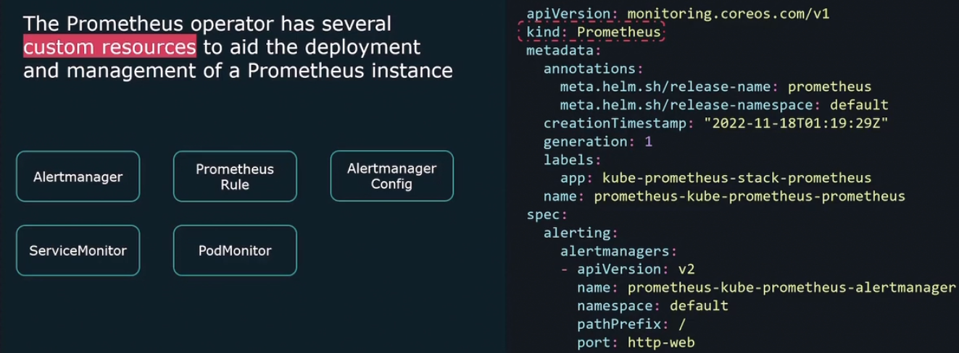

CLOUD NATIVE APPLICATION DELIVERY

Traditionally when a application was built and delivered it involved manual intervention which was error prone and IT teams had to spent a lot of time stablizing the infrastructure incase there was any unknown change done manually.

This was overcome by a process called CI(Continuous Integration) and CD(Continous delivery), This involved bring in tools and processes in place which maintained the application code, built, packaged, tested and then deployed the artifacts to Intermittent environments and eventually to production environments. This approach was called DEVOPS and bought a more stable approach to keep the environments in desired state at all the times.

Jenkins was one such tool which provide fulfilled the Devops approach.

Going a step further GITOPS approach follows the same concept but also adds infrastucture as code concept, there by bringing in application software and infrastructure under the same umbrella. This is done with a combination of tool – git, jenkins, argoCD, Kubernetes,prometheus

GITOPS – It is using centralised repositories like GIT as single source of truth for application code and infrastructure code, so that all changes to infrastructure are tracked or versioned and making it easy to identify issues or roll back changes.

In case a discrebancy, alerts are generated by a monitoring tool and kubernetes reconcilers (argo cd) are automatically triggered to either update or roll back the cluster.

GitOPS tools :

1. Flux : Its kubernetes-native application that syncs kubernetes state with config files in a GIT repository. This is a pull based model which checks for the manifest file changes in the GIT repo and updates the k8s cluster.

This is developed by WeaveWorks and graduated into CNCF. It is focused only on Continous delivery and can watch only one GIT repo and One kubernetes cluster or namespace at a time.

2. Argo CD : This is similar to FLUX but its can monitor multiple repositories and multiple K8S clusters. Its developed by intuit and its a declarative approach.

3. Jenkins X : This also a kubernetes focused tool which supports both CI/CD.

GITOPS is governed by a working group under the CNCF project which defines the standards that should be followed on GITOPS and creates vendor neutrality and interoperability.
The working group operates under the CNCF App delivery SIG . There are 4 principles of GIT OPS

1. The entire system is declarative
2. The changes made to the infrastructure are versioned in GIT.
3. All the changes made to the infrastructure files are automatically deployed or applied on the environment with the help on CD tools such as Flux, Argo CD, Jenkins X.

4. Monitor the Process – This is follows a pull based approach so it involves observe the repo, Check for diff in the code, apply them with any intervention and keep the environment in desired state.

Push and Pull based Deployment:

In a push based deployment a CI/CD tool initiates a deployment process which will deploy the changes to the kubernetes cluster, the disadvantage here is that the credentials/access to the kubernetes cluster have to be store in a CI/CD tool which can pose a security risk as the access to this CI/CD tool should be restricted in order to secure the credentials.

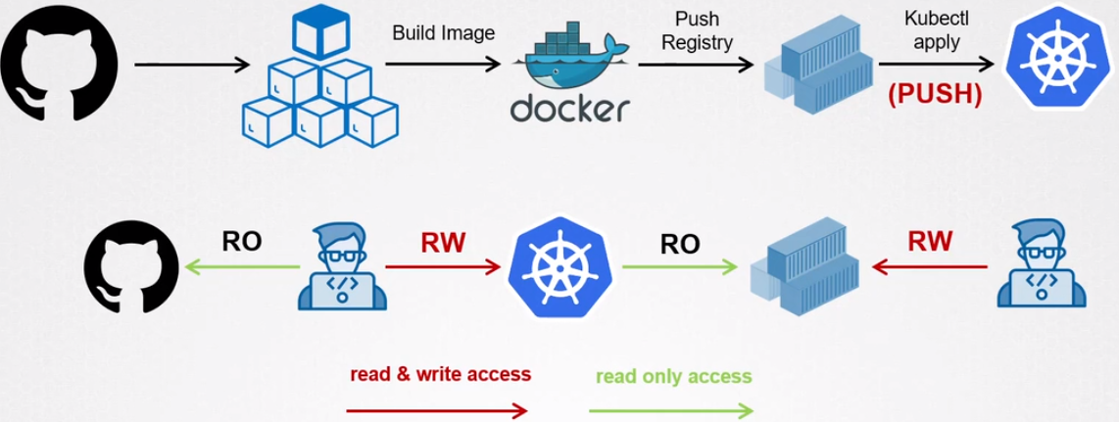
In a pull based deployment, we eliminate the problem of securing the cluster credentials externally as the Kubernetes Cluster initiates the deployment with the help of a operator which is deployed within the cluster which scans the git repos and container registries for changes, and if a change is detected the operator updates the cluster accordingly.

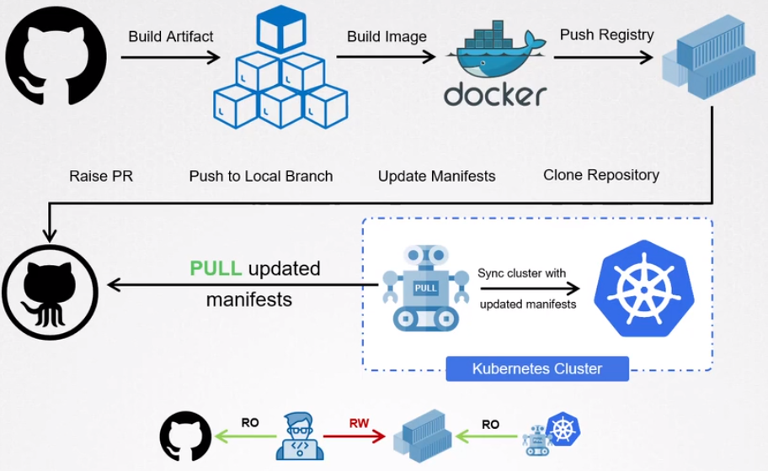
Dc

Implementation of GITOPS with GIT, Jenkins, Argo CD operator and Kubernetes

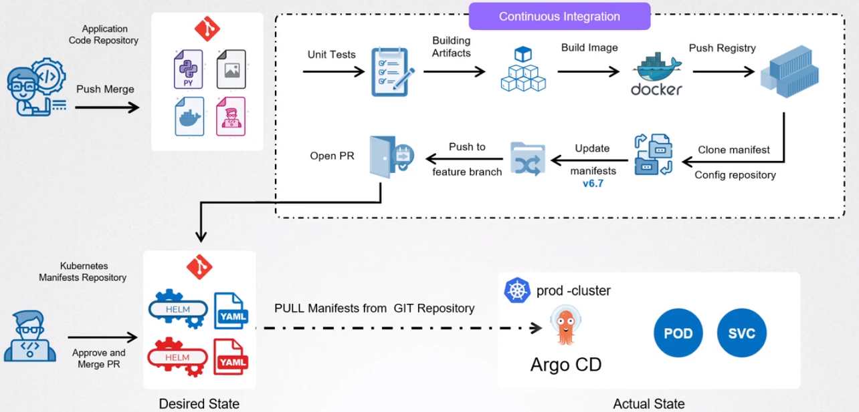
Kubernetes Commands:

kubectl explain pod - Explains the properties in pod

kubectl explain pod.spec.containers.ports - explain how to use the ports

kubectl logs pod <podname> -c <container> - Check the logs of the container inside the pod

kubectl expose deployment/d1 –name=svc1 –type=NodePort –port=80 -n <namespace> - Create a Node Port in deployment to be accessed publically

kubectl expose deployment/d1 –name=lbsvc1 –type=LoadBalancer –port=80 -n <namespace>
Create a load balancer in deployment to be accessed publically

Once the metrics server is deployed, we can use below commands
kubectl top nodes – gives information on the nodes CPU, Memory

kubectl top pods – gives information on the pods CPU and Memory

