STOCK MARKET FUNDAMENTALS

Tools For Stock Market
1. Screener.in - Stock Analysis

How does one make money in stock market?

1. Identifying a Good Business
2. Power of compounding
3. Re-investing profits gained in a company
4. Getting Dividends
5. Fundamental Analysis – Understanding the business, economy and sector

Why do people lose money in the stock market?

1. Understanding Order Book – https://www.nseindia.com/
- Order book show the buy price, quantity and sell price, quantity
- It shows the last traded price that has been agreed by buyer and seller

2. Understanding Impact Cost
- In order to make it to the nifty-50 the impact cost per trade should be less than 0.5% in the last 90 days
- It shows the liquidity of the stock, Low impact cost represents good liquidity and vice versa

Precautions to be taken in stock market
1. Do not get into trading without proper technical analysis
2. Do not collaborate with brokerage companies for stock suggestions and tips
3. Do not blindly take advices from peers
4. Diversify stocks to various sectors
5. Maintain multiple stocks instead of investing in a single stock
6. Do not take a leverage in order to trade a stock
7. Always be patient on buying or selling a stock, do not buy or sell with implusive nature

TECHNICAL ANALYSIS

Technical Analysis gives us the trends of the stocks

There are 3 types of trends
1. Uptrend – When the price of a stock consistently makes higher peaks(Highs) and troughs(lows), Where in each peak is above than the previous peak and each trough is higher than the previous trough

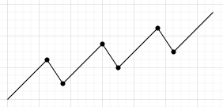

2. DownTrend – When the price of the stock creates a sequences of lower troughs and peaks, Where in each peak is lower than the previous peak and each trough is lower than the previous one

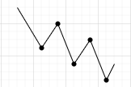

3. Side Ways Trend – Here the supply and demand are equal and the trends of peaks and troughs are equal to the previous levels, Here we see that the stock price remains stable for a certain interval of time.

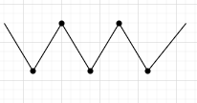

In order to create these charts we need to identify the price points of the stock which are categorised as
1. Open Price – This is the price of the stock for the day once the market opens
2. Closing Price - This is the price of the stock for the day once the market closes
3. Low Price – This is the price of the stock for the day where its traded at its lowest value
4. High Price – This is the price of the stock for the day where its traded at its highest value

Based on this price point we can create different types of charts
1. Line Chart – Here based on certain time interval, we need to consider only the closing price of the stock and connect it with previous closing price, It creates a line chart which shows the trend of the stock. This is the most basic chart, where Y axis – price of stock and X-axis – time interval
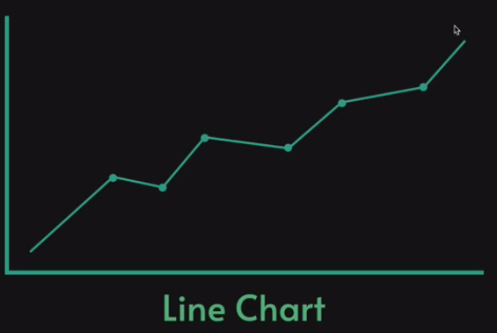

2. Bar Chart – This chart contains all the 4 price points of a stock where in the top indicates high price, bottom shows low price and on the right we would have closing price and left we have the open price, It shows the pattern of volume traded in that session
Bullish bar chart Bearish bar chart
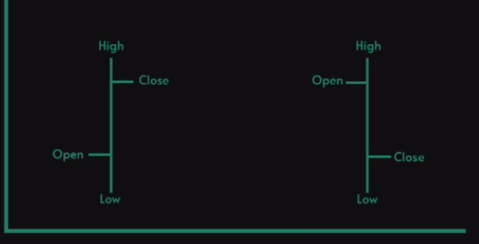

3. Candle Chart – This is similar to bar chart but gives the visual representation in the form of candlesticks which are color coded and makes easy to understand, The length of the candle stick shows the amount of variation that occured in the stock price for that session

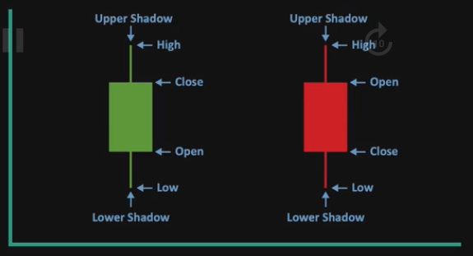

ds

