GIT INTRODUCTION

1. Git has two repositories

a. Local Repository :
This repository is limited to local changes and is limited to only that specific use.

b. Remote Repository :
This repository is hosted on a remote server (eg : Git Hub, Bit Bucket) which can be accessed by multiple users in order to pull the changes from remote repo to local repo or push the changes from local repo to remote repo.

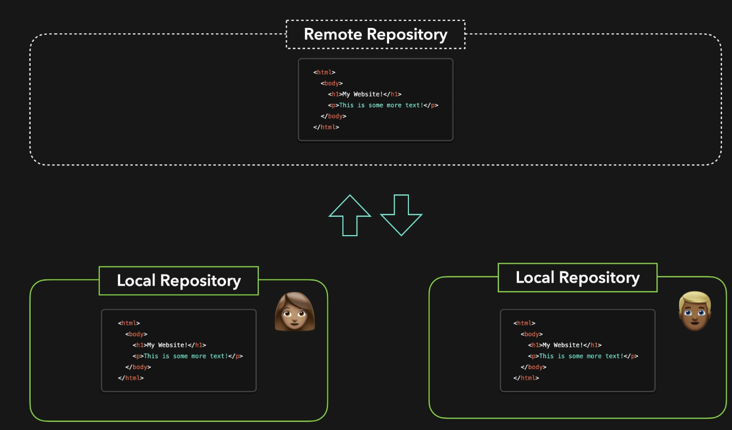
2. Local Repository:

Local repository contains 3 stages
1. Working Area - This is the place where the new/ existing files are created or modified.
2. Staging Area - Once the new/modifed file is created, in order for the file to be commited/saved they have to be moved to the staging area.
3. Committed Area - This is the final stage which commits the changes to local repo and a commit id is created on the change.

3. Git installation on linux can be made using the below commands

yum install -y git
git --version (Once the installation is completed, we can check the git installed version)

4. Git Basic Commands:

1. git init – Initialises git repository on folder
2. git add <file> - adds a file to staging area
3. git status – get the status of the file
4. git commit -m “comment” – commits the changes of the file to the local repo
5. git config - -global user.name “username” – sets the username who is commiting the changes
6. git config - -global user.email “email” – sets the email who is commiting the changes
7. git restore <filename> - restores the file reverts the file to previous version by reverting the changes

Its a good practice to keeps the commits atomic, In the sense we need keep a commit relatable to a specific user story so that if the changes are to be reverted it wont be effecting the multiple story commits.

9. git rm <file.txt> - deletes the file from the local repo
10. git rm --cached <file> - Moves the file from staging area to local area

If a particular file has to be ignored, we can create a .gitignore file and add the files to it, This .gitignore file can be commited to the repo.

11. git log – Shows all the git commits
12. git log --oneline – Show the commits in a compressed format
13. git log --name-only – shows the commits along with the file name
14. git log -n <number> - Limits the number of commits shown

5. Git Branches:

1. git branch <branchname> - Creates a new branch
2. git checkout <branchname> - switches to desired branch
3. git checkout -b <branch> - This option help in creating and checking out the branch
4. git branch – This option show which branch you are currently in
5. git branch -a – This option is to show the branches in local and remote
6. git branch -d <branchname> - Deletes a branch

“HEAD” in commit log always points to the current branch that it is shifted into

6. git merge <branchname> - Merges the branch specified on the current checked out branch
eg : If you want to merge a feature branch on master, you can checkout master branch and run
git checkout master
git merge <branchname>
git log – check for the commits

6. Initializing Remote Repositories:

1. git remote add <alias> <Remote Repo URL> - Adds the remote repository connection string to local repo alias.
2. git remote -v – Lists the remote repository aliases
3. git push <remotealias> branch – Pushes the changes from local repo to remote repo
4. git clone <remoterepo URL> - Get a copy of the remote repository to local along with the commit history
5. git fetch <remote alias> branch – This fetches the latest changes from remote repo to local repo after that we need to be on the master branch and run git merge <remote alias> into to be in sync with the remote repo.
6. git pull <remote alias> branch – This fetches the latest code changes and merges them on to local repo branch.

Pull Request : Ideally no user should directly push or merge changes to the master branch instead they have to push the changes to remote repo branch and then raise a Pull request(PR) which would be reviewed by the peers and then merged into the master branch

Merge Conflicts : If our local repo has changes behind remote repo and we modifed a file that is already updated in the remote repo , we encounter merge issues when try to push the changes to remote repo. These merge issues have to resolved manually based the files that were modified and then add and commit them before pushing to the remote repo.

Forking : Forking is a concept where a user can clone/fork another users repository instead of directly making changes in them. This is how collaboration among open source community happens

7. Rebasing:

This allows the user who has been working on their own branch to be in sync with the master branch without creating a commit log, This can also be done using git merge master but that creates a commit log

Run this command from the user branch which needs to be in sync with master
git rebase master

git rebase -i HEAD~4 – git rebase with the i argument allows the user to edit the commits made in the branch, Here HEAD~4 signifies the changes to be made to the 1st four commits.

there are few options that are available to make the changes to commits such as
pick – allows the user to use the commit
squash – merges the commit to the previous commit
reword – use the commit but change the commit messages

git chery-pick <commit hash> - This allows to merge changes from a specific commit in a branch.

8. Revert and Reset:

1. git revert <commit id> - This creates a new commit by reverting the changes made in the commit id specified as an argument.

2. git reset –soft HEAD~1 – this resets the change made to the last commit and pushes the changes to working area and head points to the previous commit.

3, git reset –hard HEAD~1 – This reset hard resets the changes made to the last commit(based on the HEAD value the number of commits are decided), All the changes are lost if hard reset flag is used.

git reset –hard <commit id from reflog> - Reverts the commit to that specific commit id

4. git stash – This allows the user to move the files from staging area to stash allowing to maintain a clean working area. This is required if the user has to switch to working on a different branch but maintain a clean working area on the branch where he was earlier making changes

git stash list – Shows the list of stashes currently in the stash
git stash show <stash id> - shows the files that were being modified in the stash
git stash pop <stash id> - moves the file from stash to working area

5. git reflog – This show the commit history of all the changes made in the repository which includes HARD reset changes.

JENKINS

Jenkins is a an open source Continous integration/Continuous Delivery/Deployment tool used for Automating Tasks, Deploying application, running Unit tests and generating build metrics.

Continous Integration : It is a process in which the code is merged from multiple contributors and added to a single repository from their it gets validated by Unit tests, Integration tests and security checks(such as sonar cube) and then gets packaged into a war, ear or jar file which is later passed on to the CD(Continous delivery) process.

Continous Delivery: It is a process where the packaged artifact gets deployed onto a container/server.

Continous Delivery: Its is a process where CI and CD process are completely automated for every release cycle.

Installing Jenkins in VM:

1. Create a instance from AWS/AZURE
2. Connect to the VM using SSH (See to it that you have open ssh port in Security groups on the VM)s
3. sudo apt-get update -y
4. sudo apt install -y openjdk-11-jdk
5. Add the GPG keys -
curl -fsSL https://pkg.jenkins.io/debian-stable/jenkins.io.key | sudo tee /usr/share/keyrings/jenkins-keyring.asc > /dev/null
6. Add the repository -
echo deb [signed-by=/usr/share/keyrings/jenkins-keyring.asc] https://pkg.jenkins.io/debian-stable binary/ | sudo tee /etc/apt/sources.list.d/jenkins.list > /dev/null
7. sudo apt install -y jenkins
8. sudo systemctl start jenkins
9. sudo systemctl status jenkins
10. Allow fire wall – sudo ufw allow 8080
sudo ufw status
sudo ufw enable
11. Access the Jenkins link – http://localhost:8080 (On local machine)
http://publicip:port (On AWS/Azure instances)

Trouble shooting during installation:

Issue : Job for jenkins.service failed because the control process exited with error code. See "systemctl status jenkins.service" and "journalctl -xe" for details.

Resolution : Update the jenkins port in the file /usr/lib/systemd/system/jenkins.service and restart the systemctl daemon.
vi /usr/lib/systemd/system/jenkins.service
Change JENKINS_PORT and save the file
sudo systemctl daemon-reload
sudo systemctl start jenkins
sudo systemctl status jenkins

Enabling Jenkins CLI:

1. Jenkins CLI can be enabled by downloading the jenkins-cli.jar from ManageJenkins --> Jenkins CLI

2. Then Go to People --> Select user --> Configure -->Add a new API token (copy the token value)

Linux_instance – 11bdc1bd4350abff35a10492c1e17dd1b5

3. From the Terminal run the command
java -jar jenkins-cli.jar -s http://localhost:8080/ -auth user:API Token

eg : java -jar jenkins-cli.jar -s http://localhost:8080/ -auth \admin:11bdc1bd4350abff35a10492c1e17dd1b5

Sample Jenkins Command Line
1. List Various command line options available

java -jar jenkins-cli.jar -s http://localhost:8080/ -auth \ admin:11bdc1bd4350abff35a10492c1e17dd1b5 -webSocket

2. List Jenkins Jobs

java -jar jenkins-cli.jar -s http://localhost:8080/ -auth \ admin:11bdc1bd4350abff35a10492c1e17dd1b5 -webSocket list-jobs

3. java -jar jenkins-cli.jar -s http://localhost:8080/ -auth \ admin:11bdc1bd4350abff35a10492c1e17dd1b5 -webSocket build <jobname>

Jenkins Plugins:

Jenkins plugins are add-on’s that enables jenkins to integrate with a software/service. If a users wants to integrate builds with github, jenkins has a github integration plugin which help to connect with the remote repo and get the source code.

From GUI:
Manage Jenkins --> Manage Plugins --> Search for Plugins

Plugins can also be downloaded and installed through jenkins, in the downloaded format they are available in .hpi format.

From CLI:
For the changes to reflect we need to restart jenkins
service jenkins restart

1. To list the jenkins cli commands
java -jar jenkins-cli.jar -s http://localhost:8085 -auth 'admin:Adm!n321'

2. Install a plugin
java -jar jenkins-cli.jar -s http://localhost:8085 -auth 'admin:Adm!n321' install-plugin <plugin>

We can get the name of the plugin from https://plugins.jenkins.io/

3. Update Plugin

java -jar jenkins-cli.jar -s http://localhost:8085 -auth 'admin:Adm!n321' update-plugin <plugin>

4. Disable Plugin

java -jar jenkins-cli.jar -s http://localhost:8085 -auth 'admin:Adm!n321' disable-plugin <plugin>

Manage Users:

1. Creating a user:
ManageJenkins ---> Manage Users ---> Create user

2. Role Based Strategy
If you want to use this option then we need to use the plugin “Role-based Authorization Strategy”

ManageJenkins ---> Manage and Assign Roles

3. Adding roles to users:

1. Manage Jenkins --> global security --> enable role based strategy
2. Manage Jenkins --> Manage and Assign Roles --> Create role (developers) --> assign priviledges
3. Manage Jenkins --> Manage and Assign Roles --> Assign Roles --> add the user to desired role

4. Project-based Matrix Authorization Strategy
This strategy is mostly used for users if there are individual jobs.

ManageJenkins --> Manage Plugin --> Project-based Matrix Authorization Strategy
ManageJenkins --> Configure global security --> select strategy --> add user and assign permissions

Backup and Restore:

We need to keep a backup of Jenkins home folder which is /var/lib/jenkins, this folder contains config.xml and build job configuration files along with other jenkins configuration files.

Backups can be made using Plugins, Shell scripts or File system backups.

Thin backup plugin can be used for the same

Manage Jenkins ---> Manage Plugins ---> Thin Backup ---> Install

In Order to initiate the backup

Manage Jenkins ---> Thin Backup ---> Settings ---> Add the directory to backup(save) ---> backup

In Order to restore, you can do

Manage Jenkins ---> Thin Backup ---> Restore from backup

Monitoring:

Monitoring in jenkins is crucial for collecting the build metrics and other usefull information, this can be done via plugin of which the most used are datadog, Prometheus and Grafana.

Here we are going with Prometheus Plugin

Manage Jenkins --> Manage Plugins --> Prometheus metrics

Promethus logs the jenkins data in the URL - http://localhost:8080/prometheus/ which will later scrapped by Promethus to prepare the metrics

Installing Prometheus in Linux Instance:
https://linuxopsys.com/topics/install-prometheus-on-ubuntu

On Prometheus, Jenkins can be configured by updating the /etc/prometheus/prometheus.yml .

Changes to be added
- job_name: ‘jenkins’
metrics_path: ‘/prometheus’
static_configs:
- targets: [“localhost:8080”]

Prometheus has to be restarted once the changes are made.
systemctl restart jenkins

Access the jenkins logs from prometheus using the URL – localhost:9090

Grafana is also a Monitoring tool that is used for data visualization based on the inputs of log monitoring tool such as Prometheus

Jenkins PipeLine:

Jenkins file is a text file that contains definitions/template that has a list of instructions to be performed to complete a job.

Sample Jenkins File with multi stage pipeline
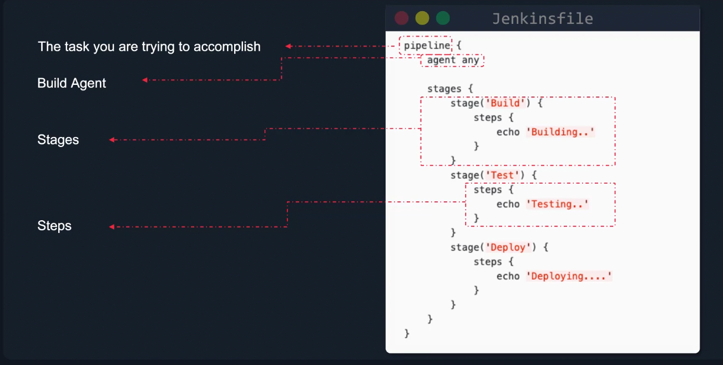

Creating Jenkins Pipe Line Job
New Job ---> Pipeline --->

