DOCKER

What is Docker?

Docker is a software platform that allows you to build, test, and deploy applications quickly. Docker packages software into standardized units called containers that have everything the software needs to run including libraries, system tools, code, and runtime.

What is a Container?

Containers are isolated environments just like virtual machine but unlike them containers share the OS Kernel of the hostmachine and on it they have container engine installed which inturn interacts with the containers created on that machine.

A Container run a process and exists immediately once the required output is acheived

Containers and Virtual machines go hand-in hand as in a large Infrastructure you can provision a virtual machine and on it we can have multiple containers running on them

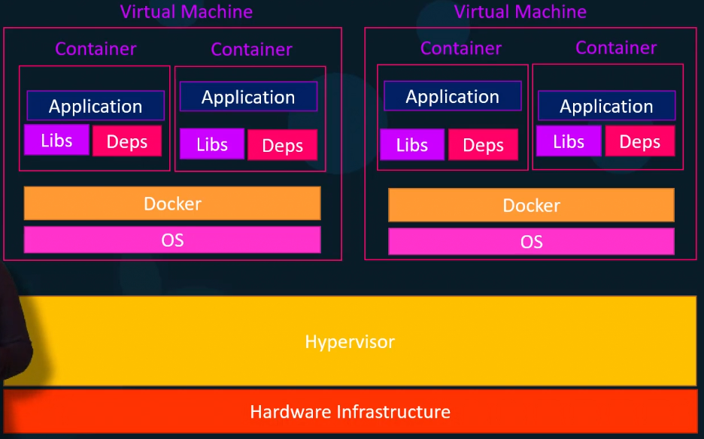
There are pre-defined container images for docker stored on a public repository docker hub - https://hub.docker.com/

Container vs Images:

Image is a template of application/software setup that is used to create containers, Where as container is a running instance of an image which are isolated from other containers in the same machine. The advantage of having a containerized application is it can be replicated in any environment without any configuration changes required on the machine.

Installing Docker:

Docker can be installed by following the instuctions on docker home page
https://docs.docker.com/engine/install/ubuntu/#set-up-the-repository (for ubuntu)

There is a also a convience script that can be used

curl -fsSL https://get.docker.com -o get-docker.sh
sudo sh ./get-docker.sh

Once the docker installation is completed, we need to add the user to docker group in order to access docker commands
sudo usermod -aG docker <user>

Docker Commands:

1. docker run <image name> - It would download the nginx image from docker hub repository if there is no local copy of it and create a container
eg: docker run nginx

Flags:
-t - Allocates a Terminal inside the container
-d - Runs the docker container in the background mode
docker run -dt <image>
-it -Allows the user to interact and attach to a terminal of the container as soon as its created
docker run -it <image>
--name - Create a docker container with the specified name
docker run -d --name=<name> <image>
You can download a specified version of an image from docker hub repo by providing a imagename with a tag
docker pull image:tag

2. docker ps - Lists all the running containers

3. docker ps -a - Lists all running/stopped containers

Here,
Container ID – is the Unique ID of the container
Image - This is the template on which the container was created
Command – default command given during the container start up
Created – Container creation date
Status – Status of the container
Port – If there are any ports running on the container
Name – Name given to the container

4. docker stop <container id> - stops the running container

5. docker rm <container id> - Removes the container

6. docker container prune – Removes all the stopped containers

7. docker images – List of the images available locally

8. docker rmi <image id> - Removes the image from local machine

9. docker image prune -a – Removes images on which there are no containers associated

10. docker pull <image> - Only Downloads the image from docker hub repository

11. docker exec <container id> <command> - This runs a command in a running container

12. docker attach <container> - Connects into the container

13. docker run -dt -p <exposed_port>:<docker_port> <image> - (-p) option exposes a port on the host machine and links with the port running in the container, this allows the user to access the webapp outside the docker container

14. docker run -dt -v /data:/var/lib/mysql <image> - This allows to map a volume of the container with that of the host machine directory, this allows us to store the data outside the container preventing any data loss incase the container is removed

15. docker inspect <container id> - Displays the container information

Installing Jenkins Container

16. Exposing a Port
You can download the jenkins image from docker hub repo
docker run -dt -p 8000:8080 jenkins/jenkins

Once the container is installed you can access the container jenkins using the hostmachine ip and the exposed port
<Host Machine IP>:<exposed port>

17. Creating Volumes:
If you want the data to persist which will save the trouble of reconfiguring jenkins and the jobs in it incase the container is deleted we can do volume mapping

This Type of Volume mounting is called host volumes

docker run -dt -p 8000:8080 -v /home/jenkins:/var/jenkins_home jenkins/jenkins

This will mount the /var/jenkins_home directory on to /home/jenkins directory of the host machine

There is another of of volume mounting which based on name called as named volumes
docker volume create data
docker run -dt -v data:/var/lib/jenkins jenkins/jenkins
You can do a
docker volume ls - To list the volumes
docker volume inspect <volume> - To inspect volume details

Creating Docker Image:

This is required if a user wants to create his own image, An image can be created using a docker file

A docker file consists of an Instruction and Argument

Sample Instructions are –
FROM - This is to indicate the base image used to the custom docker image
eg: FROM <image>

ENV - This sets the environment variable and persists them in the docker image
eg: ENV USER=”linux” PASSWORD=”hello123”

ARG - This instruction defines a variable that users can pass at build-time. Also it can have a default value if no build argument is passed
FROM <image>
ARG user1
During build – docker build –build-arg user1=”linux” -t reponame/<image_name> .
Also default Argument as passed in the docker file
ARG user=”linux”

These ARG changes passed do not persist once the image is created

RUN - it will execute any shell command passed in as argument inside the container
eg : RUN echo “Hello World” && apt-get update
eg: RUN mkdir -p /home/user/jenkins

COPY - Copies the content/directory from source(hostmachine) to destination(docker container)
eg: COPY test.txt relativeDir/

CMD - There can be only one CMD instruction in a dockerfile

It is used to execute the default command during container start up, But if the user use docker run <image> <cmd> then the CMD instruction is overwritten.

CMD [“./start.sh”]

ENTRYPOINT- This is similar to CMD but this entry persists during container start, Any parameter passed during docker run <image> <cmd> becomes an argument to the ENTRYPOINT

An Entry point can be overridden during the container start if we using the –entrypoint flag during docker run

Also CMD can be used with ENTRY POINT as CMD can pass parameters to ENTRYPOINT

ENTRYPOINT [./start.sh]
CMD [‘var1’,’var2’]

LABEL - This add meta data to the docker image
LABEL AUTHOR=”Code”

This can be verified using docker inspect <image name>

USER - sets the user name prior to running the commands
USER username

WORKDIR - Set the working directory during image creation

EXPOSE - This instruction does not actually publish the port. It exists just of the purpose of documentation, as it to indicate on which port the process inside the container is running.
This information can be used to expose the port during docker run with -p flag
docker run -p -dt <host_machine>:<container exposed port> <image_name>

VOLUME - Volumes are basically used for data persistence

Building an Image

An image can be built using the build command with the below syntax, Also the default docker file would be name as ‘Dockerfile’

docker build dir -t ImageName:TagName
-t – tag to be used
dir – directory where the docker file is present

docker build . -t <reponame>/<image_name>:version

eg: docker build . -t academy/tomcat_mod:1.0

If a custom docker file is to be passed
docker build -f <dockerfile> <dir> <reponame>/<image_name>:version

