AWS SOLUTIONS ARCHITECT ASSOCIATE

ASHWIN GATLA

Introduction:

AWS Region: Its Cluster of Datacenters located in a geographic location, Present AWS has more than 35+ regions all over the world.

Choosing a regions:
1. Check the compliance with the country
2. In order to reduce latency choose the region closer to the users
3. Select region which has all the services required for the application
4. Pricing varies from region to region

Availability Zone: This have one or more datacenters that are located within a region, A region can have minimum 3 and maximum 6 AZ’s in a region. They are isolated from each other with their own redundant power, network and conectivity.

IAM:

Identity and Access management is a global service which allows the account owner to manage, create, delete users, groups, roles and policies.

Users can belong to multiple groups

There are no nested groups

Policies are json documents that define the authorizations required to access the services

Policies assigned to specific users are called inline policies

Policies attached to groups can be inherited by users if they are add to the groups, Users can inherit multiple policies by getting attached to multiple groups.

Policy Structure:
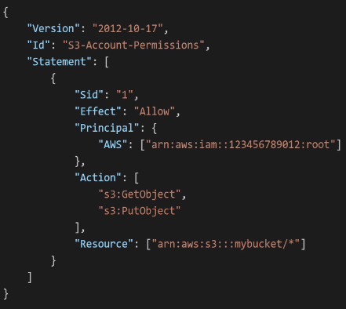
version : Version of the policy document
ID : Name of the policy
Statement : contains the body of the policy
SID: Identifier of the statement
Effect : Where the policy should allow or deny
Principal : User/Group/Role to whom this policy is assigned.
Action : Actions can be carried out by the principal.
Resource: Which service the policy be applied to
Condition : Any condition for the policy to be applied.

MFA is a password policy that allows an additional security along with the password. It is combination of password and a security code that is generated from the authenticator app or device(Yubi Key).

AWS can be accessed in 3 ways.
1. Through AWS Console
2. Using CLI with accesskeys
3. Using SDK with accesskeys

AWS IAM Roles are required by aws services that need to perform actions on other aws services without the intervention of the users by attaching a policy on them.

IAM Security Tools:
This generates reports on the access permissions for the users and the service that were last accessed by them.

Access Advisor: Shows the permissions granted to a user to a service and when was it last accessed.

Credential Report: Generate a report on the access levels for all the users in a account.

IAM Labs:

1. Create group with admin readonly policy attach and now create users and attach it the group.
2. Create User with inline policy
3. Create password policy and include users with MFA(Multi factor Authentication)
4. Create access keys and using AWS CLI and try some aws commands
5. Create roles by assigning a IAM readonly access role for EC2 Instance.
6. Create a credential report and access advisor.
7. Create Zero budget for AWS to restrict usage

EC2

EC2 is on demand computing power that is offered by aws , It allows the user to customize CPU Shape, Storage, access, OS, Load balancer, Security Ports, Auto Scaling, Networking, Bootstraping user data

User Data: This option allows user to pre-run scripts after OS has been installed and before we get access to the instance.

Instance Type: There many types of instances that can be filtered, such as memory, general purpose, Computing power, GPU, Storage based, Accelerated computing

Naming convention of the Instance Type: m5.2xlarge
m – Instance class
5 - Generation of the instance class
2x – Size of the instance class

General Purpose: This type of instance gives a balance in Memory, Compute, Networking and ideal for workload such as webservers or code repos.

Compute Optimized: This is ideal for tasks that need computing power. Such as Gaming Servers, high end webservers, Media Transcoding, Batch Processing, HPC, Machine Learning

Memory Optimized : This is ideal for processing large sets of data in memory(RAM) such as In-memory databases, Web-cache stores, High performance relational/non-relational databases, Realtime application processing unstructed data

Storage Optimized: Great for storage intensive tasks that required high IOPS such as in-memory databases(Redis), OLTP, OLDP, Analytical processing, Relational & Non-relational Databases

Security Groups:
They control networking inbound and out-bound traffic of the EC2 instance, They only support ALLOW rules where you can define IP Address or other security groups.
A inbound security rule defines the Type, Port, Protocol, Source of the request
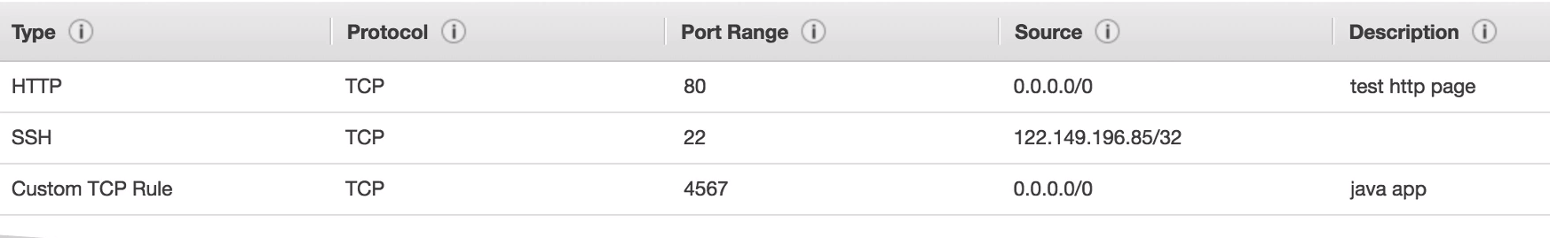

A outbound security rule defines the Type, Port, Protocol, destination of the request

1. A security group can be connected to multiple EC2 instances
2. All inbound traffic is block by default
3. All outbound traffic is allows by default
4. SG is bound to the specific region and VPC
5. A SG group can contain another SG in its source or destination
6. In case a EC2 instance is not reachable through ssh, then SSH protocol must have been blocked in the SG for the EC2 instance attached

Some Ports to remember:
22 – SSH
21 – FTP
80 – HTTP
3389 – Windows RDP port
443 – Secure Port for HTTPS

EC2 Purchasing Options:

On Demand - Pay for what you use or hourly billing, Good for general purpose, short term and uninterrupted workloads.
Reserved - You reserve the instance up front to a limited time period(1yr to 3 yrs), ideal for databases. These reservation is done for AZ, Region, Tenancy, OS).

You can Buy and sell reserved instances at market place, Also there is a option for convertible reserve instance which allows you to change the OS, Instance family and tenancy

Spot Instances - These offer highest discounts but with the caveat that instance can to taken aways without any intimation, This is preferred to run temporary non-critical jobs – Batch jobs

Saving Plans - Here you commit to a specific instance family for long term and you cannot change the instance family but you can change the OS, Size of the instance class, Tenancy
This is locked to specific region where the instance family is selected

Dedicated hosts - This dedicates a physical server to a EC2 instance which gives you complete customization over it. These are costliest EC2 offering in EC2.
These type of EC2 types are ideal
1. When there is a strict compliance requirement by the company to host dedicated hardware.
2. When you have your own Software Licenses
Dedicated Instances-This allows a user to host a instance on a dedicated hardware. The user has complete access over the instance but cannot control the placement of the instance

Capacity Reservation: As the name suggests there is no limit to reservation of EC2 instances, All of them are on-demand instances which you can reserve on specific AZ.

Public IP vs Private IP:
Private IP is used for internal communication within a network.

Private IP can used in a private network only.
Private IP can be duplicated in two different Private network
Private IP must be unique in a single private network
In order to reach the web, they must connect through NAT Gateway

Whereas public IP allows a instance or a machine to communicate with the internet.

Public IP must be unique across the web
Public IP can be geo located
Public IP can be reached from anywhere through the web
Public IP does not persist its address in case the instance is restarted.

Elastic IP allows an instance to persist the public IP during restarts
Elastic IP can be re-allocated to any instance, if the instance goes down
There are only 5 elastic IP per account
Once a elastic IP is created they are charged even if you do not allocate it to any VM.

Placement Groups:

This allows the user to get the flexibility to place the EC2 instances in a AZ, There are of 3 types Cluster, Spread and Partition

Cluster:
Here all the EC2 instances are placed in the same rack of the AZ, This allows for a greater bandwidth and low latency between the EC2 instances but if the single rack fails then all the EC2 instances on it fail.
Thus, this can be used on applications that require low latency but can handle any interruptions

Spread:
This allows each EC2 instance to be deployed on separate hardware in multiple AZ’s, thus allowing high availability and fault tolerance, But the caveat here is that there is a limitation of 7 instances per AZ per placement group.

Partition:
This combines the features of both Cluster and Spread. Each partition can have any number of EC2 instances and Each AZ can host upto to 7 partitions. This partition can span across multiple availability zones.
Here, partition represents a rack. This allows high availability, scalability and fault tolerance
Use cases: Hbase, Casandra, Kafka

ENI(Elastic Network Interface):
This is a virtual network interface card(VNIC).
This can be created individually and be assigned to any EC2 instance or switched to any EC2 instance
This can have multiple private IP’s attached to it as primary and secondary address
These are bound to a specific AZ
An ENI can have one public IP or one elastic IP
A security group is assoicated with an ENI
Each ENI has one MAC address

EC2 Labs:
1. Create EC2 instance with httpd server installed and create a index file which can be accessed publically and the EC2 instance should be accessible from CLI – Terminal/Cloud Shell
2. Create a IAM role with IAMReadOnly Policy for EC2 instance to access iam through CLI
3. Create a Elastic IP address and associate it with EC2 instance and restart the EC2 instance to check if the public IP persists(Dis-associate the Elastic IP from EC2 and delete it once the task is completed as it is charged)
4. Create Placement groups – Cluster, Spread & Partition and place a EC2 in them
5. Create ENI and associate with an existing EC2 instance

Instance Storage

EBS:

1. Elastic Block Store is a network drive that stores instance data.
2. It is bound to AZ
3. one EBS volume cannot to be attached to a multiple instances at a time, but with multi attach feature this can be extended to multiple instances
4. EBS allows to persist data even after the instance is deleted
5. By default when a instance is created a default EBS volume is attached to it, So when the instance is deleted this EBS volume also gets deleted due to the feature “delete on termination”
6. Allows a user to define capacity and IOPS with the type of EBS volume to be used on a instance
7. Only GP2/GP3 and IO1, IO2 can be used a boot Volumes
8. EBS mutli-attach feature is only available in Provisioned IOPS, Allows only to attach 16 EC2 at a time.
9. It is bound to specific AZ

There are types in EBS:
1. GP2/GP3(General Purpose):
This is a general purpose SSD volume that gives a balance between cost, throughput and IOPS.
This is basically categorized based on size, through-put and IOPS
GP3:
1. size - 1GiB to 16TiB
2. base IOPS – 3000, through-put - to 125Mib/s
3. Can increase upto 16000 IOPS and through put of 1000 Mib/s independently

GP2:
1. Size – 1GiB to 16TiB
2. reaches an IOPS of 3000 in small intervals
3. Reach a maximum IOPS of upto 16000
3. Here the IOPS is directly related to the size of the volume, Where 3 IOPS per GB which mean the IOPS size max’s out at 5333 GB

2. IO1/IO2 (Provisioned IOPS)
Provisioned IOPS gives the highest IOPS and through put, It gives us sub-milli latency and used for workload that require low latency and high-through put.
IO2:
- Size : 4GiB – 16TiB
- IOPS: 6400 IOPS for ec2 nitro and for others its 32000OPS
IO2 Block Express:
- size ; 4GiB – 64TiB
- Submilli-second latency
- IOPS – 256000 IOPS

3. SC1 (Cold HDD):
This is a low cost HDD volume that is designed for frequently accessed and workloads that require high through put.
Use cases: Big Data, Log processing
Max throughtput – 500 MiBs and IOPS – 500

4. st1 (Throughput optimized HDD):
This is the lowest cost HDD volumes which is designed for less frequent accessed workloads
- Max through – put – 250MiB’s
- Max IOPS – 250IOPS

EBS Snapshot:
This allows to take a backup of the exiting EBS volume.
Since EBS volume is AZ specific we cannot copy the data to another other region, Using snapshot we can create a copy of the EBS volume and create the volume in another AZ/region
There are few features in snapshot that allows to store and restore the snapshots
1. EBS Snapshot Archieve Tier:
This allows to store the snapshot for long duration at quite low cost
In order to restore the snapshot it might take 24-72 hrs

2. Recycle Bin:
This protects the snapshot from accidental deletion, Any snapshot that is deleted is store temporarily in the recycle bin based on the retention policy configured between (1day to 1 year)

3. Fast Snapshot restore:
This allows to restore a snapshot instantly but using this service is costly

AMI:

AMI is an Amazon machine image, That creates a blue print of the EC2 instance.
Using this AMI we can recreate any number of EC2 instances and this AMI is region specific by can be shared across multiple regions by copying it

EC Instance Store:
- This storage is directly attached to the EC2 instance instead of a network drive like EBS, thus providing highest IOPS and throughput.
- The caveat is that this storage is ephemeral meaning when even the EC2 instance is goes done all the data in this instance store is lost.
- It is ideal for non-critical, low latency, application that require high throughput/IOPS
- its the responsibility of the user to backup the storage data.

EBS Encryption:
Encryption is handled by default in EBS, Data is encrypted at rest and also in transit. When ever a EBS volume is created from a encrypted snapshot its also inherits the encryption tag

EFS:
- Elastic File system is a network file system that is 3 times the cost of EBS GP2 volumes.
- EFS can be attached too multiple EC2 instances at a time
- EFS requires its own security group
- EFS is multi AZ, which means ec2 instances in other AZ can access the EFS
- It only works with Linux OS
- Data is encrypted at rest using AWS KMS
- As the name elastic, the capacity scales based on the amount of data begin stored

Performance:
Scale:
- Has 1000’s of NFS clients and gives 10GB/s througput
Performance Mode:
- GP – Latency sensitive use cases (webservers , content management system)
- Max I/O – Higher latency, throughput and IOPS
Througput Mode:
- Bursting – 1TB = 50MiB/s + burst of upto to 100Mib’s
- Provisioned
- Elastic - Scales based on the throughput loads

Storage Classes:
Standard : Great for multi AZ and frequently accessed files
OneZone AZ : Good for less frequently accessed files and limited to only one AZ
Standard – Infrequent Access – This is a life cycle management policy that allows data to transaction to Standard -IA after a certain period of time

Instance Storage Labs:
1. Create EBS volume and attach to a EC2 instance, Create a partition, file system for the newly allotted disk space and mount it on the EC instance
2. Create a snapshot of EBS Volume and copy it to another AZ, Recreate a EBS volume from the snapshot in another AZ
3. Create retention rules in recycle bin for deleted snapshot (Retention rule for 1day) and restore a snapshot from recycle bin
4. Create a AMI from a EC2 instance and recreate a EC2 instance using this AMI in another region/AZ.
5. Create a EFS file system and assign it to EC instances in multiple regions

Scalability & High Availability

Scalability is the term used when you want to upgrade an existing instance to a highcapcity or to add multiple instances to accommodate the incoming requests.

There are two types of scaling options:

Vertical Scalability : Here the existing instance is upgrade to accomodate a much larger instance, In AWS terms it is scale up/down.

Horizontal Scalability : Here there are additional instances deployed or removed inorder to accommodate the load/requests, In AWS terms it is called scale in/scale out
eg: Auto Scaling Group

High Availability:
This is designing a architecture that is resilent to failures and keeps the infrastructure available and scalable all the times, such as deploying in multiple AZ/regions
eg: Load Balancers

Load Balancers:
- This is a server that redirects the requests to underlying instances that are connected to it.
- Performs Health checks on instances
- Maintains stick sessions with cookies
- Separeate public traffic and private traffic
- Provide SSL termination on the websites
- Provides a single point of access to the application deployed on multiple instances

Elastic Load Balancers
- ELB is an AWS loadbalancers offering
- It seemlessly integrates with AWS Services (ASG, EC2, EKS,Route53,ECS, AWS WAF, ACM, Cloud watch)
- Health Check on instances using a protocol and port to verify whether the route can be routed to the instance or not

There are 4 types of Load Balancers
1. Application Load Balancer
- This is Layer7 Load Balancer.
- Supports HTTP, HTTPS, WebSocket
- Supports redirection from the protocol HTTP to HTTPS
- Supports route routing based on the query path(/users, /search) and domain path(wear.cliq.com, watch.cliq.com) and Parameter based (?platform=mobile)
- Great for ECS, EKS and docker
- It has fixed hostname
- Application server does not see the IP of the client as the client request is terminated by the ALB, In order to check the Client IP details, check the http request for the below parameters
X-Fowarded-for – IP adress
X-Forwarded-Port – Port number
X-Forwarded-Proto – Protocol

- Health Checks are performed on target groups
- ALB can route traffic to multiple target groups
- ALB redirected traffic to entities created inside a target groups.
- Target Groups:
- EC2 Instances
- ECS
- Lamda functions
- IP Adresses

2. Network Load Balancer:
- This is a high performance Load Balancer
- This operates at layer 4 (Transport Layer -TCP and UDP)
- It has one static public IP per AZ and supports elastic IP
- Similar to ALB they are also connected to target groups to redirect network traffic
- Does not have security group as the incoming traffic is redirected to EC2 security group

3. Gateway Load Balancer:
- This operates at layer 3(network Layer)
- This routes the network traffic to target groups where 3 party security applications(Intrution detection, Packet Inspection,..) are installed which inspect the traffic before they are sent to the application target group.
- It uses GENEVE protocol on port 8081
- Route table in VPC have to be updated to be redirected to Gateway Load Balancer
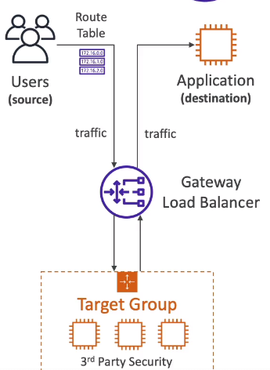

4. Classic Load Balancer – This is deprecated

Sticky Sessions:

- These are used to create session affinity for a user, Where once the session is established between a user and the application, Load balancer redirects the requests from that user to the specific instance to maintain session affinity.
- This protects the session data
- The caveat is that this causes the load to be sent to the same instance
- There session affinity is maintained based on the cookie.
There are two type of Cookies
1. Application Based Cookie
Custom Based Cookie:
- This cookie is generated by the target
- We cannot used any names such as AWSALBAPP, AWSALBTG,AWSALB
- We can specify any custom cookie name
Application Based Cookie:
- This cookie is generated by the Load Balancer with cookie name AWSALBAPP

2. Duration Based Cookie:
- This is generated by the LB with the name AWSALB
- This specifies the time interval for the cookie to be valid

Cross -Zone Load Balancing:

- With cross-zone load balancing, LB distributes traffic evenly across all instances in multiple AZ’s
- With-out cross-zone load balancing, LB distributes traffic evenly across all instances within the AZ’s
- Cross-zone load balancing is enabled by default in ALB and disabled in NLB and GWLB
- By traffic between AZ’s through ALB is not charged, where as it is charged if enabled through NLB and GWLB
- Cross-zone load Balancing can be disabled at target group level in a ALB

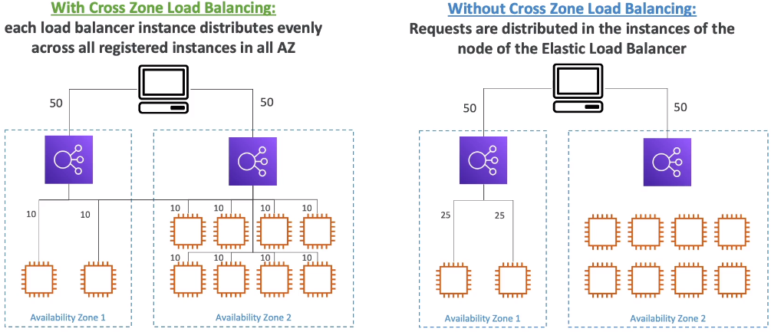
SSL/TLS Certificates:
- SSL helps to encrypt data during transit, This is a called in-flight encryption
- SSL stands for secure socket layer
- TLS (Transport Layer Security) is the newer form of Secuity
- Public SSL certificate is issued by a Certificate Authority such symantec, Godaddy, Comodo
- SSL Certificate comes with a certain expiration date to which time period it is valid.

- SSL certificates are managed by storing in ACM
- We can define our own custom SSL Certificated and store in ACM
- ALB/NLB uses the the x.509 SSL certificate
- ALB/NLB interpret the HTTPS protocol request from the user and send the request to the instances over the private IP.
- In order to route to multiple SSL certificates to multiple domains, ALB/NLB uses SNI(Server Name Indication)
- Basically SNI allows the LB to identify the exact SSL certificate based on the domain name specified by the requester from the ACM

Connection Draining:
- This allows a de-registration delay on a the instance that is going down meaning if there are any request running on the instance, LB allows for the requests to complete on that instance before taking it out and it wont allow any new requests to be assigned on the instance

Auto Scaling Group:
- Auto scaling refers to automatically scaling in and scaling out EC2 instances based on the incoming requests
- There is no charge in create a ASG
- Scale-In is the term used to remove addtional instances if the load is below the threshold
- Scale-Out is the term used to adding addtional instances if the load is above the threshold
- ASG’s can be linked to Load Balancers
- ASG automatically remove instances if the health check fails on them
- ASG’s is region specific
- ASG’s maintains the number of EC2 instances based on the scaling policies and cloud watch alarms.

Scaling Policies:
There are 4 type of scaling polices
1. Target Tracking Scaling
This is triggered based on the average CPU usage on the ASG
2. Simple/Step Scaling
This is triggered based on the Cloud watch metric defined
(CPU < 40% scale in)
(CPU > 40% scale out)
3. Scheduled Actions
This defines a time interval when the scaling should happened based on the peak load during specific hours
4. Predictive Scaling
This is triggered based on the pattern that has been generated over the period of the time

- Metrics to be considered are Average CPU, Requests count per target, Average Network in/out or any custom metric
- Once the scaling happens there is a cool down period called scaling cooldown which would create a time interval of default 300 sec(5 mins) before scaling happens again.

Labs:

1. Create and integrate ALB, TargetGroups, Health Checks, EC2, Security Group(restrict access to EC2 instances only from ALB), Add a condition to redirect a query path
2. Create a NLB with target groups on EC2 instances(Delete as soon as testing is done it is charged)
3. Understand how a Gateway load balancer works
4. Create session stickiness with ALB
5. Understand what is Cross-zone load balancing and try disabling it in ALB
6. Enable SSL certificate on ALB/NLB
7. Create ASG and assign it to ALB
8. Create and try multiple scaling polices on ASG

AWS Database services (RDS – AURORA – Elastic Cache)

RDS:
- Relational Database Service is DB service offered by AWS
- RDS supports Oracle, Microsoft sql server, Mysql, Postgres SQL, Maria DB, Aurora
- RDS Provisioning and OS patches are automated
- RDS scales automatically if its low on storage
- Monitoring Dashboards
- Support read replicas and Multi AZ
- Supports Scaling
- A user cannot SSH into the instance
- RDS provides storage autoscaling can be increased dynamically but you can set a maximum threshold limit on it.
- If the storage goes below 10 %
- If in the last 6 hrs there is no modification
- If the storage is low for more than 5 mins

Read Replicas:
- Read replicas are copies of the master database that can be accessed by the application
- These are in async replication with the master database, This means the data would eventually be consistent on them
- Read replicas are helpful when there are applications that want to access the master DB but since the master DB would be overload with the read calls, we can create a read replica and assign it to the application
- Read replicas allows on select queries and no other edit operations can be run on them.
- There can be upto 15 read replicas
- It can be spread within AZ, cross AZ and cross region
- Data within the AZ and cross AZ within the region is not charged, Where as cross region is charged
- Point in time back backup

MultiAZ:
- Multi AZ is used for disaster recovery
- There is a always a standby copy of the master DB which sync replication
- The data is commited only when it gets saved in both the master DB and standby copy
- In Multi AZ, both the master DB and standby copy are assigned only one DNS name which interacts with the application, so in case of switching the DB it become seemless for the application.
- Even Read replicas can also be setup as multiAZ
- Stand-by database is created using DB snapshots from the master DB and enabling sync replication between them

RDS Custom:
1. It is only for oracle and microsoft sql server
2. It gives all the options as RDB servic e
3. It give access over the infrastructure and Oss

Aurora:
- Aurora is propritary database of AWS
- It supports the driver of Mysql and postgres sql
- It can scale its storage automatically from 10GBto 128TB
- It can have upto 15 read replicas and has submilli second replication
- These 15 read replicas are further complemented by auto scaling which makes sure to keep these desired number of read replicas available at all times based on metric
- It has only one master DB which can be accessesd using a writer end-point, and aurora takes care of failover if case the master DB goes down
- Since there are multiple read replicas an application can access them using a reader-endpoint which does connection load balancing on the read replicas
- At any given point in time aurora creates 6 replicas across 3 AZ’s
- Minimum of 4/6 read replicas should be available to write
- Minimum of 3/6 read replicas should be available to read
- It also supports cross region read replication and cost more than RDS
- Support point in time restore using backtrack
- An aurora cluter contains one master DB and multiple read replicas

Aurora AutoScaling:
- Enabling auto scaling feature in aurora allows to extend the read replicas based on the target value metric, And the reader endpoint extend its connection to the additional read replicas

Aurora Custom-Endpoint
- You can create multiple sets of read replicas based on the instance size and define your own custom endpoint on each set to access them

Aurora Serverless
- As the name indicates, AWS manages the aurora databases through proxy fleet feature and the user only accesses the DB and pays per second

Aurora Multi-Master
- Here all the DB nodes created are master nodes which allow read-write using write endpoint

Global Aurora
- This allows cross region replication of the aurora DB’s
- There is primary region where the master node(r/w) exists.
- There can be upto 5 secondary region, where we can create 16 read replicas in each secondary region
- There is a less than 1 second lag for the replication to happen across the read replicas
- Once the primary region fails then a DB node in the secondary region is promoted as new master node with RTO of less then 1 minute

Aurora Machine Learning
- It supports AWS machine learning services and integrates with them seemlessly
- AWS sage maker and AWS comprehend are two machine learning services that aurora can connect to
- It help in fraud detection, ads targeting, sentiment analysis

RDS Backups:
- There are daily backup for RDS
- Backup can be stored upto 1-35 days, when its set to 0 the backup is disabled
- Transaction logs are backed up every 5 mins
- Manually you can also create a backup using snapshots and store its for any amount of time
- Since even if the DB is stopped aws charges us for the storage, its better to take a snapshot of the DB and restore the DB when it would be used again.

Aurora Backups:
- Supports daily backups and cannot be disabled
- you can restore to any point in time
- Supports snapshots to be created on the existing DB

RDS & Aurora Restore Options:
- On-premise DB can be backed up and be placed on aws s3 which can be restored on the new RDS DB
- In order to restore on a aurora cluster, On premise DB can be backed up using Percona Xtra backup and placed on S3, from there it can be restored onto a Aurora DB

Aurora Database Cloning:
- Aurora DB cloning using a feature copy-on-write which allows it clone a DB by using these same underlying storage volume and create an additonal storage on newly added data on the database

RDS/Aurora Security:
- Supports Encryption at rest
- During the Cluster creation you can select the master and read replicas to be encrypted using the KMS
- If the master DB is unencrypted then the read replicas would also be unencrypted
- If you want to encrypt the DB after it has been created then you have use the snapshot feature to recreate the DB and encrypt it
- Supports In-Flight Encryption
We have to use the AWS TLS root certificates provided by AWS
- SSH access is disabled for the DB
- Security groups can be modified to restrict access
- Audit logs can be enabled and send to Cloud Watch for longer retention
- IAM roles can be enabled to connect to the DB instead of username and password

RDS Proxy:
- This is basically pools and redirects the incoming connections to the RDS and a proxy service which inturn will send the requests to the RDS.
- This feature does not overload the DB and reduces fail over by 66%
- This proxy is not accessible from outside the network and is accessible within the VPC
- It enforces IAM authentication for DB and securly stores the credentials in AWS Secrets manager

Elastic Cache:
- there are two type of elastic cache technologies provided by AWS – Redis and Memcached
- This are called as In-Memory Databases
- They make your application stateless
- They take the load of the databases by storing frequently used data in there cache
- Elastic cache requires multiple coding changes to be done
- Cache must have an invalidation strategy to retrieve the most current data.
- Elastic Cache can also be used to maintain the session data
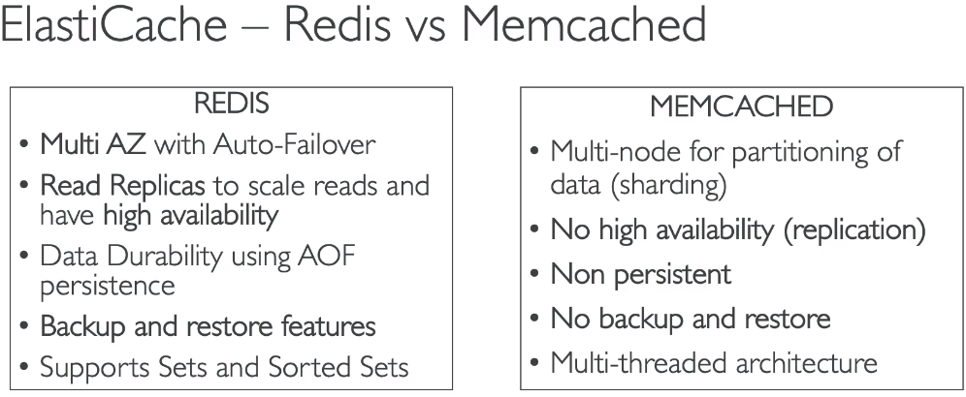

Elastic Cache Security:
- It supports IAM roles for authentication
- Redis authentication can be done using Redis username and token and it supports SSL in-flight encryption
- Mem-cache support SASL-based authentication
- Redis uses sorted sets technique which makes it ideal to using gaming leader boards
- There are 3 pattern for elastic cache
- Lazy Loading – All the read data is cached, Data can become stale in cache
- Session store – User session data can be stored in cache
- write Through – Adds or updates the data in cache when written to DB

Labs:
1. Create a RDS database service
2. Create a Aurora Database service
3. Create a redis cluster using elastic cache

ROUTE 53

DNS:
- DNS is domain naming service
- It translates the address to IP
- DNS Structure – www.example.com
- Terminologies in DNS
- Domain Register – Providers which provide the DNS names – Godaddy, Route53,..etc
- DNS Records – There are records inside the DNS – Alias, CNAME, A, AAAA, NS
- Name servers – Resolves the DNS queries
- Zone file – Contains DNS records
- Top Level domain - .com, .org, .in
- Sub-level domain – amazon.com, facebook.com
- DNS Structure
www.api.amazon.com.
- . - root
- .com – TLD (Top level domain)
- amazon.com – SLD (Second level domain)
- api.amazon.com – sub domain
- www.api.amazon.com – FQDN (Fully Qualified Domain Name)
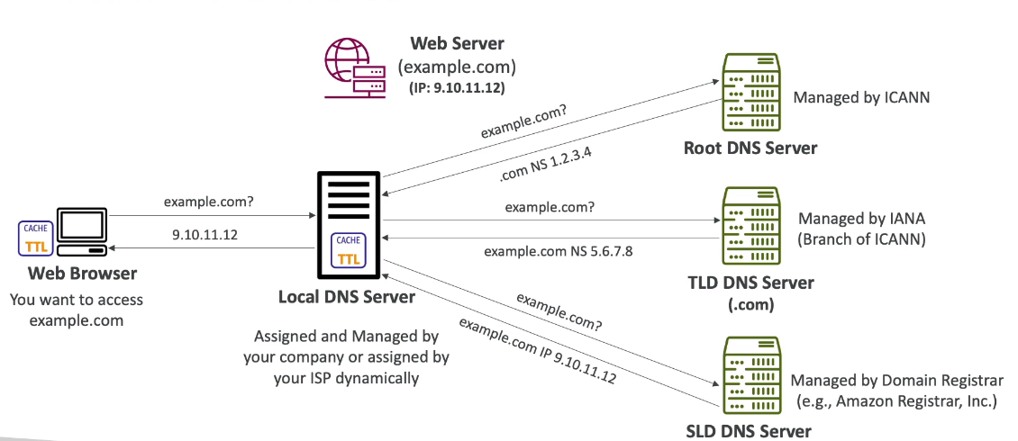
Route 53:
- This is a DNS Service provided by amazon. It is contains the records of the domain that can be reach from the internet
- It also acts as a domain register
- This is the only service in aws that give 100% availability
- It can also perform health checks on the underlying resources
- A DNS server contains the following sections
- Domain name – name of the website being hosted
- IP Address – IP address mapping to the host name
- TTL(Time to Live) – amount of time the request stays in the domain cache
- Routing Policy – how the route is based
- Record type – A, AAAA, Cname, Alias

- Record Types:
- A record – This has a hostname mapping to IPV4
- AAAA record – it is a mapping to hostname and IPV6
- Cname – Its a hostname to other hostname mapping
- Name server – It contains the name servers of the hosted zone, Using these name servers, we can identify the route to domain
- Hosted Zone:
A hosted zone contains records to route the traffic to the domain or sub-domain.
There are two type of hosted zones
1. Public Hosted Zone:
Public Hosted zone contains the records that can route traffic on the internet
2. Private Hosted Zone:
This contains records that can route traffic to the domain within the VPC’s
- Route 53 service charges .50$ per domain name
- TTL (Time to live) – This is keeps the result of the DNS record cached in client for a specific
time period (default – 300sec), This reduces traffic on the route 53.
There are two type of TTL
- high TTL – With a high TTL(eg. 24Hrs) the traffic on route53 is lot less and the possibility of user accessing outdated records is high
- Low TTL - With a low TTL(eg. 60sec) the traffic on route53 is high which increases the cost and the user gets all the latest records

CNAME vs ALIAS:
- CNAME – This record maps hostname to another hostname (which is a non-root domain)
- Alias
- This record maps hostname to AWS resource (can be non-root domain and root domain)
- This has no TTL defined on it
- Free of charge
- It has native health check on the resources
- It cannot be mapped to a EC2 instance
- It can be mapped to aws resource such as – LB, Elastic Bean stalk environments, VPC endpoints, Cloud front, S3, Amazon API gateway
- It always the type A or AAAA
- It is a extention to DNS functionality in AWS
- It automatically detects the changes in IP address

Routing Policies:
- Routing policies decides how to respond to the DNS queries, There are multiple policies that can be considered in route 53
1. Simple
- Route traffic to a single resource
- Can’t have health checks
- Can contain multiple IP addresses in the value
- Client chooses single record if the query returns multiple values from the DNS query
2. Weighted
- Control the percentage of traffic to be sent to a specific resource
- The DNS record name and type should be same
- Traffic% = Weight of the record/ Sum of the weigh of all the records
- It can have health checks associated with the resources
- In order to stop sending records we need to set the weight to 0
3. Failover
- This is based on health check result i
- It contains two records- primary and secondary , if the primary record is deemed unhealthy it would redirect the traffic to the secondary record
4. Latency
- Routes the traffic based on the latency between the users and AWS resource
- Can be associated with health checks
- You have to associate the AWS resource with the Region
5. Geo-location
- Routing is based on the user location
- Can be associated to health checks
- It should have a default record in case the users proximity does not come under the specified location
6. Geo-proximity
- Routing is based on the bias value associated with the geographic region
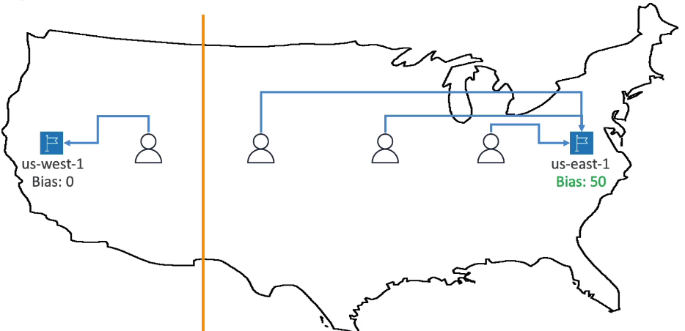

7. IP-Based Routing
- Routing is based on the CIDR’s of the users
8. Multi-value Answer
- It returns multiple healthy records to the clients
- It is associated with health checks
- Upto 8 healthy records are returned for each multi value query

Health Checks:
- They perform health checks by sending out a HTTP request and check for 2** or 3** response codes
- There are multiple Health Check mechanisms to monitor resources in route 53
- Health check on the resource
- About 15 global Health checkers will check for the endpoint health
- If health checkers return more than 18 % as health then route 53 will consider it healthy
- It supports HTTP, TCP, HTTPS
- Firewall on the VPC needs to configured to allow the health checkers
- Health checks can be setup to pass/fail based on the text in the first 5120 bytes of response
- Define a region where the health checks should be performed

- Health check on the Health checks (calculated health checks)
- This monitors Health checks that monitors resource
- It can monitor upto 256 Health checks
- you can use AND, OR and NOT to combine the results of the health checks

- Health checks using cloud watch
- Since Health checks are public, they cannot access private subnets on VPC, Here we can configure Cloud watch alarms on the resources in private subnets and create a health check that monitors cloud watch alarms

3rd party Domain register & DNS Service
- We can create a domain name in a 3rd party domain register and use it through route 53
- Similarly we can used route 53 DNS records and name servers in 3rd party DNS service

Labs:
1. Register a domain
2. Create records in the hosted zone
3. Create a EC2 instance and link it to a LB
4. Try TTL with different time intervals
5. Create CNAME and Alias records
6. Apply all the routing policies
7. Configure health checks

Amazon S3(Simple Storage Service)

- Amazon S3 is a storage service that can scale infinitely
- S3 is used to store large data, Archive data, hosting media, application hosting
- S3 is a global service
- S3 stores in the from of buckets and objects
- Buckets cannot have a name starting with upper case, numbers, _ and IP address
- Buckets should have unique name globally
- Buckets should be defined at a region level
- Buckets contain objects which hold the data, they have a key which is the name of the file
- Buckets dont have a concept of directories
- We cannot upload files beyond 5 GB at a time, In order to upload a large file like 50GB we have use the feature “multi-part upload”
- Objects can be versioned if versioning is enabled
- Static Hosting can be enabled on S3 to host static content

Versioning
- Versioning is enabled at bucket level
- Any object that is not versioned before would be having ‘null’ version
- Versioning helps in keeping track of the changes in objects and help from unintended deletion

S3 Security:
- User Level
Within the IAM policy we can define whether to access the user can access the bucket or not.

- Bucket level
- Bucket Policy – Here you can define the access to the user or principal of the access to the buckets
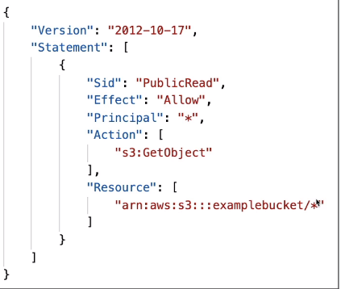

- Bucket ACL – Access control list on the buckets (granular access)
- Object ACL – Acccess control list on the Objects (granular access)

- Encryption
- encrypt the S3 objects using encryption key

Replication
- S3 supports two types of replication – Cross Region Replication and Same Region Replication
- Replication requires versioning to be enabled
- Replication happens in async mode
- Buckets can be in different AWS Accounts
- Only new objects are replicated after versioning is enabled
- In order to replicate existing objects we need to use S3 batch replication
- There is no chain replication
- Delete markers are not replicated by default, in order enable it, we need to use the feature ‘delete marker replication’
- Use Cases
CRR – Compliance, Lower Latency access, Replication across accounts
SRR – Log aggregation, live replication between production and test accounts

S3 Storage Classes
S3 storage multiple classes within it in order to access and storage
1. S3 Standard Tier – This for instant retrival and the costliest storage tier
2. S3 Standard-Infrequent Access – This is for less frequently accessed data and mostly used for storage backup and disaster recovery, minimum storag duration – 30 days
3. S3 Standard – one zone IA – This is used for secondary backup and available on only one AZ
4. S3 Glacier Instant Retrival – This is for archiving storage that is used once in a quarter and retrival is instant, where minimum storage is 90 days
5. S3 Glacier Flexible Retrival – Here also the minimum storage is 90 days but retrival of data comes in three types
Expedited – 1 to 5 mins
Standard - 3 to 5 hrs
Bulk - 5 to 12 hrs
6. S3 Glacier Deep Archive – Here the minimum storage period is 180days and retrival comes in standard – 12hrs and Bulk – 48 hrs
7. S3 Intelligent Tier – This is a auto-tiering mechanism than places the objects automatically in the repective storage tiers

Life Cycle Rules:
Life cycle rules allows S3 bucket to configures objects to be transitioned into storage tiers based on the duration specified by the user
Life cycle rules provide two actions
1. Transition Actions – Configures objects to transition to another storage class
2. Expiration Actions – Configures object to expire after a certain time period

- S3 Analytics – This analysis the objects in the bucket and gives an suggestion in which storage class can the object be placed, this analysis can take up to 48 hrs. It shows recommendations on only Standard and Standard IA

- S3 requester pay:
- Ideally AWS bills the owner for S3 storage and for the networking cost associated during the downloads
- requester pay option allows the owner to configure the networking cost to be borne by the requester, for this requester must have account with AWS

Event Notifications
As the name indicates S3 event notification allows any events such as new object creation, deletion, modification of version, storage class modification to be published to 4 AWS services for notifying the owners or users on the changes done on the bucket
1. SNS
2. SQS
3. Lamda
4. Event Bridge – This feature allows S3 events to be extended to 18 other AWS services

- In order to access these services we need to recreate a resource policy in (SNS,SQS,Lamda) to allow S3 to access the resources

S3 Performance
S3 has be a baseline performance of 3500 PUT/COPY/DELETE/POST or 5500 GET/HEAD requests per second per prefix in a bucket

S3 uses multi-part upload feature to upload files to which more than 5GB

S3 used Transfer Acceleration feature to upload the file to the nearest edge location of the user and from that edge location file can be uploaded to S3 target region using aws private network

S3 byte-range feature allows to parallelize get requests by requesting specific byte ranges, This feature can also be used to get a certain part of the file

S3 Select & Glacier Select

If there a specific set of data to download from a large file in S3, Instead of filtering the data after downloading, we can use S3 select on standard storage class and Glacier select on glacier storage class to filter the data at s3 and downloading the required file

Batch Operations:
- Batch operations allow to perform a operations on a set of objects.
Eg : Encrypt all unencrypted objects
Copy objects between S3 buckets
Restore Objects from S3 glacier
Invoke lamda function to perform custom action on each object
- Batch operation includes collecting the objects, Filtering the objects on which operations should be performed and applying the operations

- In order to perform the above steps, we can use the featues S3 provides
S3 Inventory - Create a list of objects in the bucket
S3 Select & Glacier Select - Filter the objects using S3 select and Glacier Select
S3 Batch Operations

S3 Security:
- S3 Offers security to Objects in two ways
Server-Side Encryption:
Server-Side Encryption S3-Managed Keys:
- This encryption is completely managed by AWS owned keys
- It uses the encryption AES256
- Use the header (“x-amz-server-side-encryption”:”AES256”)
- Enabled by default for all buckets and objects
Server-Side Encryption S3-KMS:
- This uses the keys from KMS keystore to encrypt the object
- You need to use the header while uploading the object – “x-amz-server-side- encryption”:”aws-kms”
- User can choose the key from aws KMS key store and attach an audit to the key using cloud trail
Limitations:
- When ever a object is upload it calls the “generate data key” api from KMS
- When ever a object is downloaded it calls the “decrypt” api from KMS
- There is a quota assigned to the number of api calls made per second to KMS

Server-Side Encryption S3-Customer Managed:
- This encryption exists outside AWS
- AWS does not maintain the key so the client has to provide the client key to read the object
- HTTPS must be used in every request made to aws

Client-Side Encryption:
- Here file encryption is completely taken care by the client.
- Encryption and decryption of the file is done at the client end and only the encrypted file is directly upload on to S3
- Can be implemented through client libraries using AWS S3 client-side encryption library

Encryption in transit:
- This is also called SSL/TLS
- S3 has exposed two endpoints
HTTP – This is a unsecured
HTTPS – This is secured
- We need to implement HTTPS when addressing a URL, This can be implemented in S3 using a bucket policy where the parameter, which forces HTTPS endpoint
aws:SecureTransport

- By default SSE S3 encrytion is applied on all new buckets
- Using bucket policies one can enforce encryption on the new requests by checking the headers of the requests with the encryption being used
- Bucket policy are always evaluted before default encryption

CORS (Cross Origin Resource Sharing):

- here the origin consists of – Protocol + host + port
http://www.example.com
- This follows a web browser mechanism that allows to access any crosss origin using CORS headers
- In S3, if the client wants information from the cross origin, then it must be configured with CORS of the origin server, this allows the client to get a response from the cross origin with proper CORS headers
- You can allow for a specific ORIGIN or for all origin using *

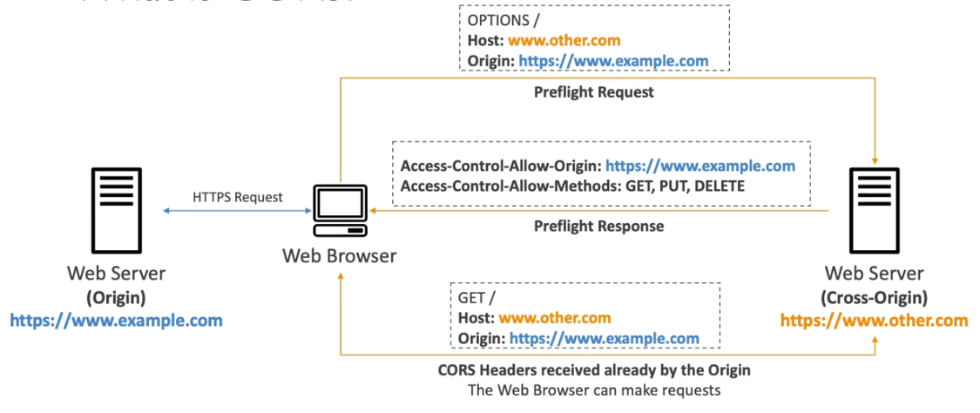

MFA Delete:

- MFA is multifactor authentication which when enabled restricts any unauthorized access to make changes to the files, This requires an authentication from authenticator app or a MFA device to make the changes to a object
- MFA delete can be enabled on preventing
1. Deleting an object
2. Suspending version on the bucket
- In order to enable MFA on a bucket we need versioning to be enabled
- Only the bucket owner can enable/disable MFA delete through CLI or SDK

Access Logs:
- As the name indicates, Access logs are enabled to log any activity, requests made to the S3 bucket
- Both the Access log bucket and the bucket on which access logs are enabled must be in the same region
- This logs can be later analysed using AWS athena
- Access log should not be enabled on bucket which is logging, this creates a infinte loop

Pre-Signed URLs
- We can enable a pre-signed URL using S3 console, AWS CLI, AWS SDK
- When a pre-signed URL is generated through
Console – we can set the expire to 12 hrs
CLI – the expiration can be set to 168 hrs
- When a pre-signed URL is generated and shared to the user, the user inherits the permissions of the bucket owner to PUT/GET the objects

S3 Glacier Vault Lock and Object Lock:
- Glacier Vault Lock
- Glacier vault lock follows Write Once and Read Many model
- This is used for strict compliance and longer retention periods
- A vault lock policy is applied on the Glacier to prevent any user(even root) to make any
changes to the bucket
- Object Vault Lock
- This vault is applied on a object level and follows WORM model
- Similar to glacier vault lock, this restricts anyone other than user to make changes to the object
- This is allows for strict compliance and retention on an object
- There are 2 retention modes that can be applied on it
- Retention mode – Compliance
- This follows a strict compliance mode where other than the object owner no one else can modify the object
- Object retention mode cannot be changed and retention period cant be shortened
- Retention mode – Governance
- This allows some users to make changes to the objects and its settings
- Only specific users can change the object retention mode and retention period
- Retention Period allows a object to be retained to a specific period
- Legal Hold
- This holds the object to a undefined time period or till the purpose of the object is served
- This can be placed or removed by users who have the IAM permission set to S3:PutObjectLegalHold

S3 Access Points:
- Access point allows to manage security for prefixes in a bucket
- Access point has its own DNS name which can be reached over the internet or within the VPC origin
- Access point has its own access point policy
VPC Origin
- This allows the S3 access point to be accessed from within the VPC
- This can be done by creating a VPC endpoint with a endpoint policy that allows access to the Access point VPC origin which contains the access point policy to the S3 bucket
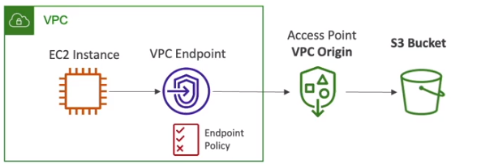

S3 Object Lambda:
- This calls AWS lambda function to modify the object while retriving it from the S3 bucket and providing it to the requesting application
- This uses access points to connect S3 bucket with Lambda functions and Object lambda access points to the end user/application
Usecases:
- Redacting personal information for analytics
- Converting across data formats, such as converting XML to JSON
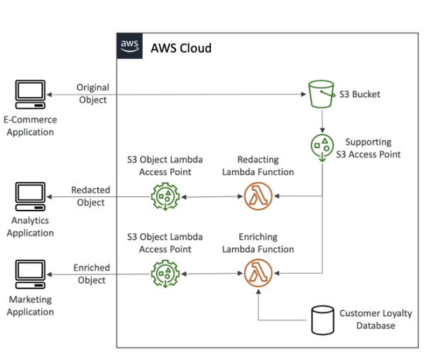

Labs:
1. Create buckets in S3 and add objects
2. Create a bucket policy and allow users public access
3. Enable Static Hosting in S3
4. Enable Versioning in S3
5. Enable replication on s3
6. Enable and understand S3 Storage Tiers
7. Enable life cycle rules for a bucket
8. Enable requester pay option
9. Create S3 Event Notifications on a bucket
10. Try Batch Operations
11. Create S3 buckets using different encryptions
12. Enable CORS headers in S3
13. Try MFA Delete
14. Try enabling access logs on a bucket
15. Generate a Pre-signed URL

Cloud Front & AWS Global Accelerator

Overview:
- Cloud front is a Content Delivery Network
- This uses the AWS private network to cache the request from the client in the nearest edge location and serve the content from there
- This uses OAC(Orgin Access Control) to get access to S3 buckets and update the bucket policy in S3 to add the CF
- It help in DDOS protection, AWS WAF as the content is distributed along the edge locations
- It retains the content to the specified TTL
- Cloud Front can be used on custom origin - S3 static Website, ALB, EC2 instance
- Clound Front can be used as an ingress (To upload files to S3)
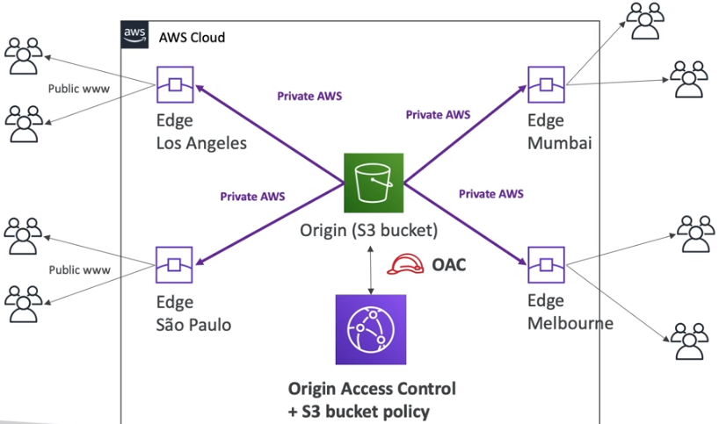

EC2 & ALB as Origin
- An HTTP on EC2 Instance can be accessed using Cloud Front provided EC2 instance has a pulic IP as Cloud front cannot access instances on private VPC
- If an ALB is used, then since it can be accessed publically we can used it with cloud front and that ALB can be connected to a private EC2 instance
- Security group must be configured to all traffic from Cloud front distributions
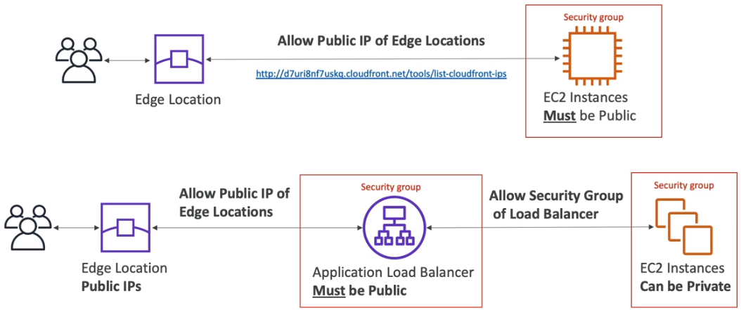

Geo-Restriction:
- This allows to place a restriction on user from using the CF distribution
- We can place a allow list or deny list from geo-restrictions to limit the geo-graphical users from accessing the edge location
- Based on the Geo-IP tagging, users can be filtered

CF-price classes:
- So everytime the data is served from a edge location, it will cost some money
- In order to reduce the cost to a cloud front distribution, we can make use of the price classes
1. Price Class 100 – This filter out the least priced edge locations
2. Price Class 200 – This filter out the most expensive edge locations
3. Price Class All – It includes all locations, which gives best performance but its the costliest

Cloud Front Cache Invalidation:
- Since Cloud front caches the content from the origin, if there is an update at the origin cloud front wouldnt be knowing it as it retain the cache to a specific TTL
- In order to overcome this issue, we can make use of cache invalidation. This allows the user to invalidate partial cache or clear complete cache.
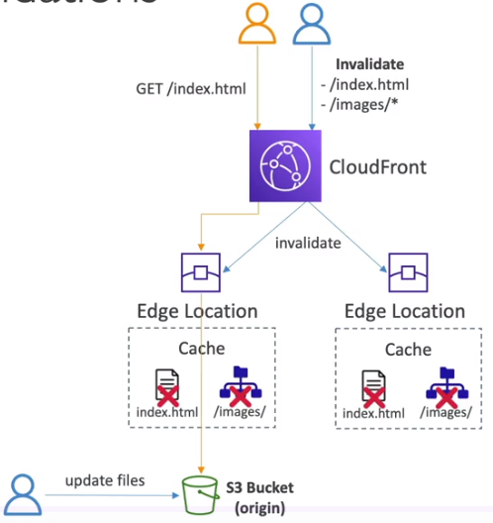

AWS Global Accelerator:
- This allows a user to access an ALB deployed on remote AWS region over the AWS network rather than traversing the internet
- This can be achieve using ANY Cast IP which reserves 2 ANYcast IP address for your application which can be accessed by the clients and this redirects the requests from the edge location to your application
- This makes use of the edge locations of AWS network
- This can be associated with EC2, ALB, NLB,Elastic IP
- Consistent Performance:
- Intelligent routing for low latency and fast failover
- No issue with cache
- make use of AWS network
- Health Check:
- Provides health checks on the application
- This is great for disaster recovery
- Security:
- DDOS protection with AWS Shield
Labs:
1. Create a Cloud Front Distribution to access S3 bucket
2. Create a Cloud Front Distribution to access ALB & EC2 Instance
3. configure Global Accelerator on EC2 Instances

AWS Storage Extras
AWS snow family:
- AWS provides a storage devices that helps in offline data migration and edge computing.
- Below are the classification of devices that support them
Data Migration : SnowCone, SnowBall Edge, Snow Mobile
Edge Computing : Snow Cone, SnowBall Edge

- Data Migration : SnowBall Edge
- This is physical device that can be rented from AWS and connected to on premise network
- This allows to copy the data to the snow ball edge device using a CLI or AWS OPS hub
- Then it can be shipped back to AWS Data Center and upload content to S3
- This can be used when there is TB’s or PB’s of data to be migrated in and out of AWS
- There are two types of snow ball edge devices
Storage Optimized:
- This provides storage of 80 TB HDD of block volume or object storage
Compute Optimized:
- This provides storage of 42 TB or 28TB NVMe block volume or object storage
- Use Cases : Large data cloud migrations, DB decommission, disaster recovery

- Data Migration : SnowCone or Snow Cone SSD
- This is a light weight storage device that can support from 8TB HDD(snow cone) to 14 TB SSD(snow cone ssd)
- This can be used for data migration and edge computing
- Apart from shipping it to AWS DC, It can be connected to a internet and transfer data using AWS DataSync Service

- Data Migration : Snow Mobile
- This is a actual truck that has its own cooling systems
- It can support upto 100 PB of data per truck

Data Migration Process using AWS snow Family:
- We can request for a snow family device from AWS console
- Connect the device to the DC and access it using a snow ball client/ AWS OPS hub
- Transfer the data to the device
- Ship the device back to AWS DC
- AWS uploads the data to S3 buckets
- AWS deletes the data on the snow device with highest level of security measures

Edge Computing
- This allows to perform any analytics or compute operation on the data while its at the edge location
- This feature is supported by SnowCone and SnowBall Edge
- SnowCone & SnowCone SSD have 2CPU’s and 4 GB RAM
- SnowBall Edge – Compute optimized
- 104 vCPu’s, 416GiB of RAM
- 28 TB NVMe or 42 TB HDD
- SnowBall Edge – Storage Optimized
- 40 vCPu’s, 80GiB of RAM
- 80 TB HDD
- Pricing is determined based on the leasing period between 1-3 years
- EC2 Instance can be loaded

Trivia:
Snowball cannot directly load data to S3 glacier, In order to move data to glacier we need to upload data to S3 and create a life cycle policy to push data to glacier

Labs:
1. Configure Snow Family

