JENKINS

Jenkins is a an open source Continous integration/Continuous Delivery/Deployment tool used for Automating Tasks, Deploying application, running Unit tests and generating build metrics.

Continous Integration : It is a process in which the code is merged from multiple contributors and added to a single repository from their it gets validated by Unit tests, Integration tests and security checks(such as sonar cube) and then gets packaged into a war, ear or jar file which is later passed on to the CD(Continous delivery) process.

Continous Delivery: It is a process where the packaged artifact gets deployed onto a container/server.

Continous Delivery: Its is a process where CI and CD process are completely automated for every release cycle.

Installing Jenkins in VM:

1. Create a instance from AWS/AZURE
2. Connect to the VM using SSH (See to it that you have open ssh port in Security groups on the VM)s
3. sudo apt-get update -y
4. sudo apt install -y openjdk-11-jdk
5. Add the GPG keys -
curl -fsSL https://pkg.jenkins.io/debian-stable/jenkins.io.key | sudo tee /usr/share/keyrings/jenkins-keyring.asc > /dev/null
6. Add the repository -
echo deb [signed-by=/usr/share/keyrings/jenkins-keyring.asc] https://pkg.jenkins.io/debian-stable binary/ | sudo tee /etc/apt/sources.list.d/jenkins.list > /dev/null
7. sudo apt install -y jenkins
8. sudo systemctl start jenkins
9. sudo systemctl status jenkins
10. Allow fire wall – sudo ufw allow 8080
sudo ufw status
sudo ufw enable
11. Access the Jenkins link – http://localhost:8080 (On local machine)
http://publicip:port (On AWS/Azure instances)

Trouble shooting during installation:

Issue : Job for jenkins.service failed because the control process exited with error code. See "systemctl status jenkins.service" and "journalctl -xe" for details.

Resolution : Update the jenkins port in the file /usr/lib/systemd/system/jenkins.service and restart the systemctl daemon.
vi /usr/lib/systemd/system/jenkins.service
Change JENKINS_PORT and save the file
sudo systemctl daemon-reload
sudo systemctl start jenkins
sudo systemctl status jenkins

Enabling Jenkins CLI:

1. Jenkins CLI can be enabled by downloading the jenkins-cli.jar from ManageJenkins --> Jenkins CLI

2. Then Go to People --> Select user --> Configure -->Add a new API token (copy the token value)

Linux_instance – 11bdc1bd4350abff35a10492c1e17dd1b5

3. From the Terminal run the command
java -jar jenkins-cli.jar -s http://localhost:8080/ -auth user:API Token

eg : java -jar jenkins-cli.jar -s http://localhost:8080/ -auth \admin:11bdc1bd4350abff35a10492c1e17dd1b5

Sample Jenkins Command Line
1. List Various command line options available

java -jar jenkins-cli.jar -s http://localhost:8080/ -auth \ admin:11bdc1bd4350abff35a10492c1e17dd1b5 -webSocket

2. List Jenkins Jobs

java -jar jenkins-cli.jar -s http://localhost:8080/ -auth \ admin:11bdc1bd4350abff35a10492c1e17dd1b5 -webSocket list-jobs

3. java -jar jenkins-cli.jar -s http://localhost:8080/ -auth \ admin:11bdc1bd4350abff35a10492c1e17dd1b5 -webSocket build <jobname>

Jenkins Plugins:

Jenkins plugins are add-on’s that enables jenkins to integrate with a software/service. If a users wants to integrate builds with github, jenkins has a github integration plugin which help to connect with the remote repo and get the source code.

From GUI:
Manage Jenkins --> Manage Plugins --> Search for Plugins

Plugins can also be downloaded and installed through jenkins, in the downloaded format they are available in .hpi format.

From CLI:
For the changes to reflect we need to restart jenkins
service jenkins restart

1. To list the jenkins cli commands
java -jar jenkins-cli.jar -s http://localhost:8085 -auth 'admin:Adm!n321'

2. Install a plugin
java -jar jenkins-cli.jar -s http://localhost:8085 -auth 'admin:Adm!n321' install-plugin <plugin>

We can get the name of the plugin from https://plugins.jenkins.io/

3. Update Plugin

java -jar jenkins-cli.jar -s http://localhost:8085 -auth 'admin:Adm!n321' update-plugin <plugin>

4. Disable Plugin

java -jar jenkins-cli.jar -s http://localhost:8085 -auth 'admin:Adm!n321' disable-plugin <plugin>

Manage Users:

1. Creating a user:
ManageJenkins ---> Manage Users ---> Create user

2. Role Based Strategy
If you want to use this option then we need to use the plugin “Role-based Authorization Strategy”

ManageJenkins ---> Manage and Assign Roles

3. Adding roles to users:

1. Manage Jenkins --> configure global security --> enable role based strategy
2. Manage Jenkins --> Manage and Assign Roles --> Create role (developers) --> assign priviledges
3. Manage Jenkins --> Manage and Assign Roles --> Assign Roles --> add the user to desired role

4. Project-based Matrix Authorization Strategy
This strategy is mostly used for users if there are individual jobs.

ManageJenkins --> Manage Plugin --> Project-based Matrix Authorization Strategy
ManageJenkins --> Configure global security --> select strategy --> add user and assign permissions

Backup and Restore:

We need to keep a backup of Jenkins home folder which is /var/lib/jenkins, this folder contains config.xml and build job configuration files along with other jenkins configuration files.

Backups can be made using Plugins, Shell scripts or File system backups.

Thin backup plugin can be used for the same

Manage Jenkins ---> Manage Plugins ---> Thin Backup ---> Install

In Order to initiate the backup

Manage Jenkins ---> Thin Backup ---> Settings ---> Add the directory to backup(save) ---> backup

In Order to restore, you can do

Manage Jenkins ---> Thin Backup ---> Restore from backup

Monitoring:

Monitoring in jenkins is crucial for collecting the build metrics and other usefull information, this can be done via plugin of which the most used are datadog, Prometheus and Grafana.

Here we are going with Prometheus Plugin

Manage Jenkins --> Manage Plugins --> Prometheus metrics

Promethus logs the jenkins data in the URL - http://localhost:8080/prometheus/ which will later scrapped by Promethus to prepare the metrics

Installing Prometheus in Linux Instance:
https://linuxopsys.com/topics/install-prometheus-on-ubuntu

On Prometheus, Jenkins can be configured by updating the /etc/prometheus/prometheus.yml .

Changes to be added
- job_name: ‘jenkins’
metrics_path: ‘/prometheus’
static_configs:
- targets: [“localhost:8080”]

Prometheus has to be restarted once the changes are made.
systemctl restart jenkins

Access the jenkins logs from prometheus using the URL – localhost:9090

Grafana is also a Monitoring tool that is used for data visualization based on the inputs of log monitoring tool such as Prometheus

Jenkins PipeLine:

Jenkins file is a text file that contains definitions/template that has a list of instructions to be performed to complete a job.

Sample Jenkins File with multi stage pipeline
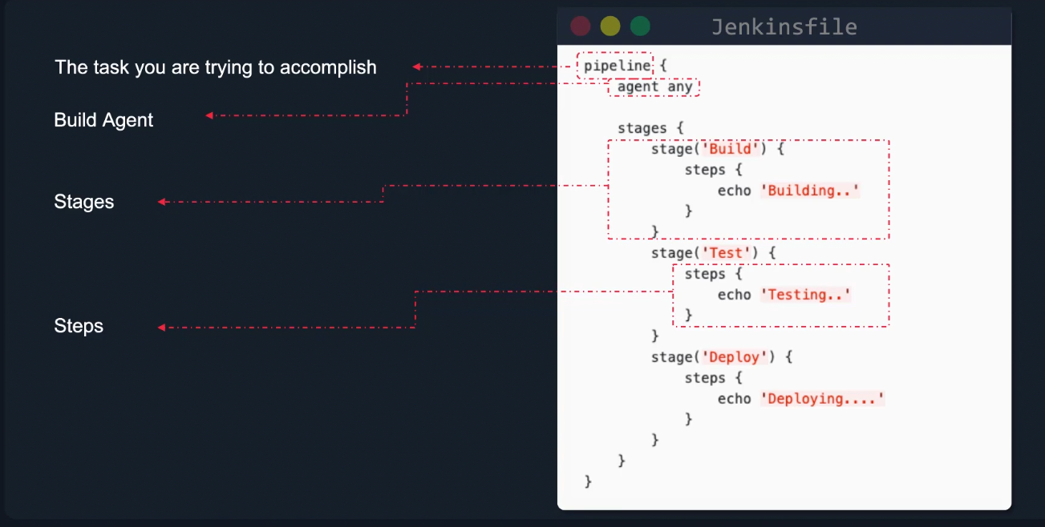

Creating Jenkins Pipe Line Job
New Job ---> Pipeline ---> Add the default hello world pipeline script and save to run the pipeline job

Building a multistage Pipeline is similar where in you can add more stages to your pipe line to be executed

Sample Multistage pipeline

pipeline{
agent any
stages{
stage('DEV'){
steps{
echo "Hello World from Dev Team"
}
}
stage('UAT'){
steps{
echo "Hello World from UAT Team"
}
}
}
}

Build a full CI/CD Pipe Line Jobs

Here we have taken a sample go lang based web app, using jenkins pipeline we would be using git to fetch the code and docker to build the docker image

Prerequisite Plugins
1. github integration
2. Go Plugin
3. docker API Plugin
4. docker commons plugin
5. docker pipeline
6. docker plugin

Install Go in the linux host machine using the link:
https://www.digitalocean.com/community/tutorials/how-to-install-go-on-ubuntu-20-04

Configure GO home directory in jenkins with the name “GO_HOME”

ManageJenkins ---> Global Tool Configurations ---> Add GO ---> name – GO_HOME
Path -/usr/local/go

Install docker on linux host machine
sudo apt update -y
sudo apt install docker

Add jenkins user to docker group
usermod -aG docker jenkins

Now go to jenkins and create a pipeline for the GO webapp

New Item --> Pipeline --> Paste below pipeline script

pipeline{
agent any
tools{
go 'GO_HOME'
}
environment{
GO111MODULE='on'
}
stages{
stage('BUILD'){
steps{
git 'https://github.com/kodekloudhub/go-webapp-sample.git'
//sh 'go test ./..'
}
}
stage('Building Image using docker'){
steps{
script{
app = docker.build("adminturneddevops/go-webapp-sample")
}
}
}
}
}

Build Agents

Build agents are task executors,they are host machines which run the jenkins pipelines/jobs

Creating a Agent and adding it to the Jenkins Controller

Pre-requisite:
1. Create a ubunut instance on AWS cloud with a jenkins user
2. Install java on the instance – you can use userdata to boot strap java installation
sudo apt install -y openjdk-11-jdk
3. Enable ssh port in security groups
4. install ssh build agents plugin

At the Controller Jenkins

1. Create the Credentials for the jenkins user created at aws instance

ManageJenkins ---> credentials

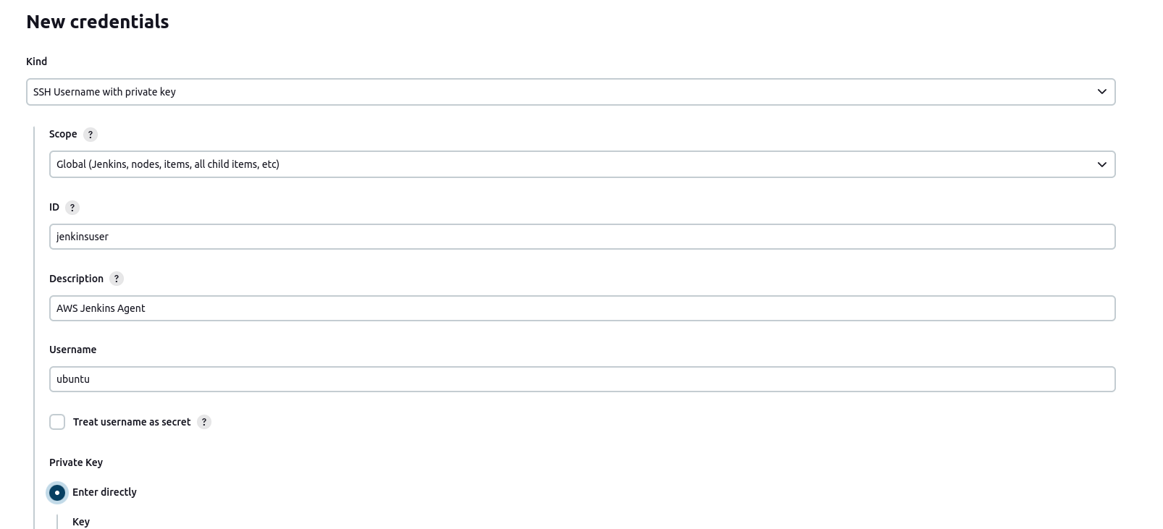
For private key, paste the .pem file that was downloaded during the creation of EC2 Instance.

2. Add the Agent

Managejenkins ---> Manage Nodes and Clouds --> Add New Node

Node Name : Jenkins aws Agent (Permanant Node)

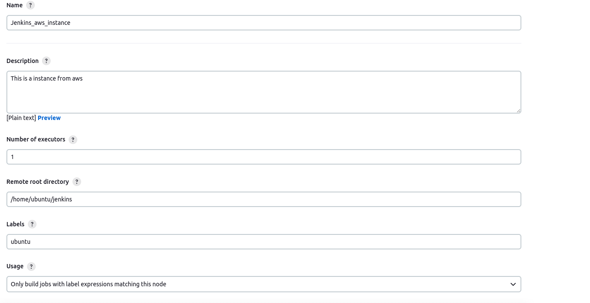
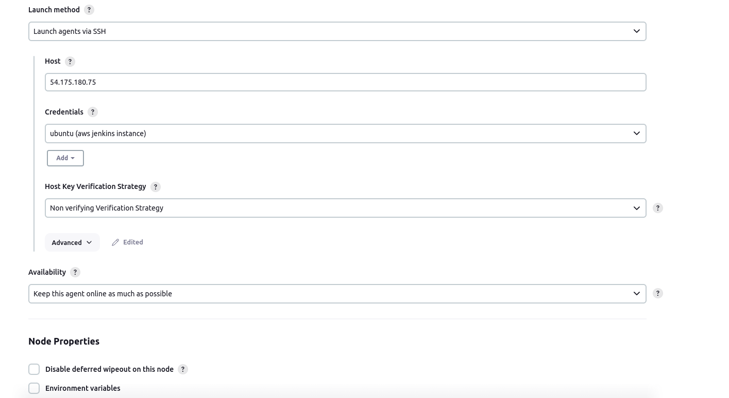

Once the details are entered, Save the node and check for the connection.

3. In Order to use this build agent to run the jobs, update the below option in the build job and enter the label expression used during agent creation.

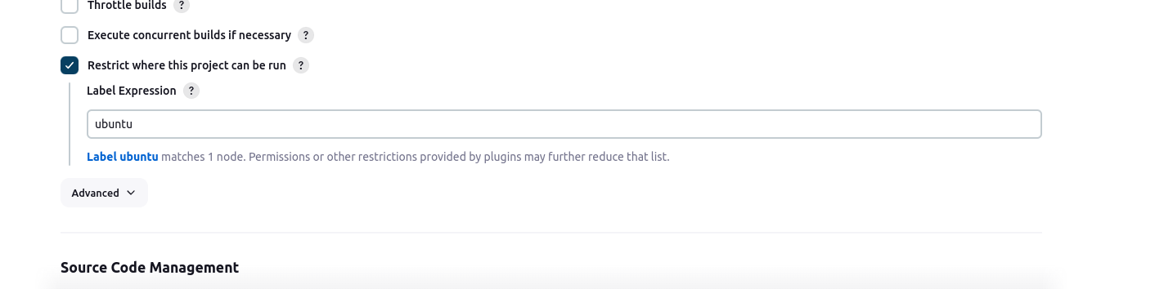

4. If you want to use this newly added agent in the jenkins pipeline you can use below sample syntax which outputs hello world
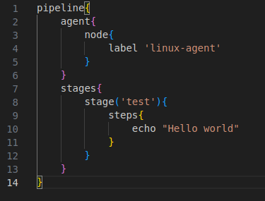

5. If tyou want to use Docker as an agent instead of creating or managing nodes, we can use the below pipeline syntax to configure docker

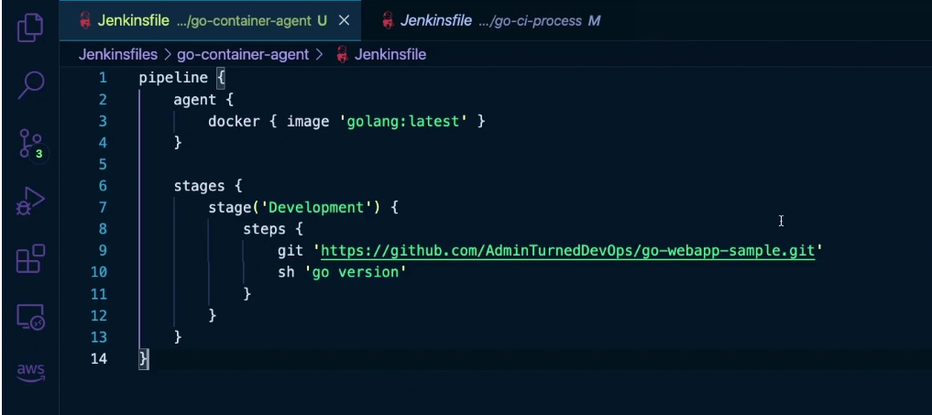

Blue Ocean

Blue Ocean is a plugin of jenkins that improve the look and feel of jenkins, it enhances the visual appearance making it easier to browse through the options.

Installing Blue Ocean

Manage Jenkins ---> Manage Plugins ---> blue ocean

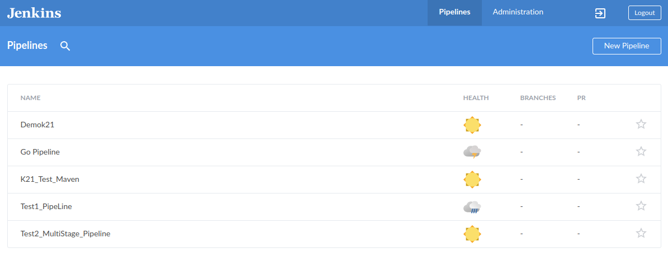
Using this plugin allows the users to create pipeline with a visual representation instead of fumbling through the groovy syntax

Project : Jenkins PipeLine

Building a PipeLine project which pull code from git, compiles/test the code and runs it

Prequisite:
1. Install ssh-agent, git, go plugins
2. Create 2 agent nodes with dev and production labels
3. Create a Pipeline Job
