**Activation Functions Explained**

* Activation functions are used to activate the neurons in the model.
* Activation functions are used to learn the non-linearity in the data.
* Following properties are considered while selecting the activation functions:

1. Non-Linear
2. Differentiable
3. Computationally Inexpensive
4. Zero-Centered (**Normalized or mean=0, balanced in +ve and -ve**)
5. Non-Saturating (should not squash in specific range)

**Reference**:

<https://www.youtube.com/watch?v=7LcUkgzx3AY> (part1)

<https://www.youtube.com/watch?v=2OwWs7Hzr9g> (part2)

1. NOTE: For relu, leaky relu, PReLU , eLU, SeLU watch part2 of video

**Types of Activation Function:**

1. Sigmoid
2. Tanh
3. ReLU
4. Leaky ReLU
5. PReLU (Parametric relu)
6. eLU
7. SeLU
8. Softmax

**1. Sigmoid (aka Logistic Activation Function):**

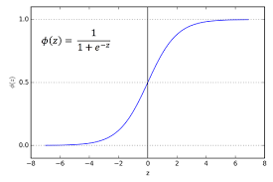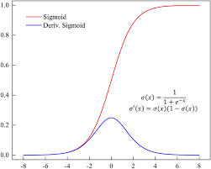

* The Sigmoid Function curve looks like an S-shape.
* This function takes any real value as input and outputs values in the range of 0 to 1.
* The larger the input (more positive), the closer the output value will be to 1.0, whereas the smaller the input (more negative), the closer the output will be to 0.0
* Mathematically sigmoid function can be written as,

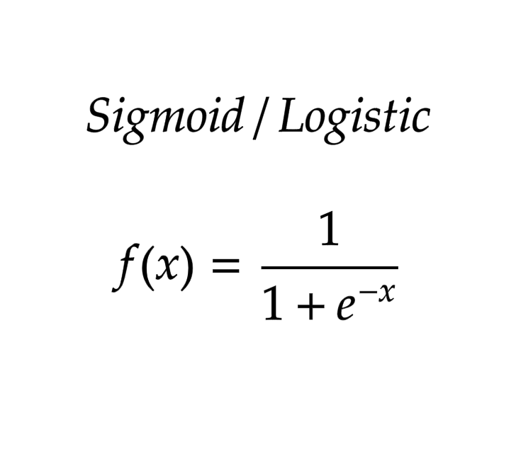

**Pros:**

* This sigmoid function is differentiable.
* As it ranges in (0, 1) so it can be used in binary classification use case.
* It adds non-linearity while learning the data pattern.

**Cons: ￼**

* Squashing function, saturating function (in certain range), which leads to Vanishing Gradient Problem.
* Computationally expensive due to exponential term in it.
* Not zero centered.
* Leads to “**Vanishing gradient**” problem

**2. Tanh (aka Hyperbolic Tangent):**

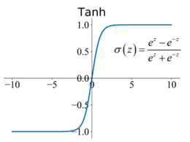 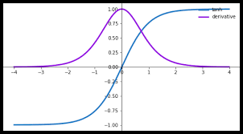

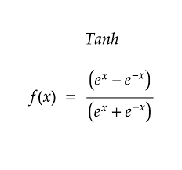

* The tanh function became preferred over the sigmoid function as it gave better performance for multi-layer neural networks. But it did not solve the vanishing gradient problem that sigmoid suffered, which was tackled more effectively with the introduction of ReLU activations.
* Tanh function is very similar to the sigmoid/logistic activation function, and even has the same S-shape with the difference in output range of -1 to 1. In Tanh, the larger the input (more positive), the closer the output value will be to 1.0, whereas the smaller the input (more negative), the closer the output will be to -1.0.

**Pros:**

* Non-Linear
* Differentiable
* Zero-Centered (Having Normalized values, and thus faster training compared to sigmoid)

**Cons:**

* Saturating/squashing function.
* Computationally expensive due to exponential term.
* Leads to “**Vanishing gradient**” problem

**3. Relu (aka Rectified Linear unit):**

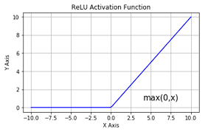

* Relu is a Non-linear function due to max component, even if it seems to be linear.
* Mathematically expressed as *f(x) = max (0, x)*

**Pros:**

* Non-Linear
* Not saturated in positive region
* Computationally Inexpensive

**Cons:**

* Saturating/squashing function for negative inputs.
* Not differentiable at 0, thus, if x >= 0, f(x) = 1, else, f(x) = 0
* Not zero centered. (to avoid this, we use batch normalization)
* Leads to “**Dying Relu**” problem

**4. Leaky Relu :**

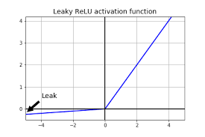

**5. PReLU :**

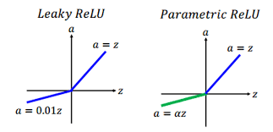

**6. eLU :**

**7. SeLU :**

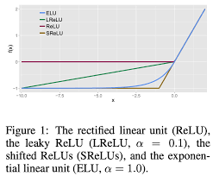

**8. Sigmoid:**

