**Performance Metrics Explained**

* Performance metrics is a measure to evaluate our model.
* Performance metrics are divided as follows:
  + Classification metrics
  + Regression metrics
* Classification **metrics** are as follows:

1. Confusion Matrix
2. Accuracy
3. Precision
4. Recall
5. Specificity
6. F1-Score
7. AUC

* Classification **Performance charts** are as follows:

1. ROC Curve
2. Precision-Recall Curve

* Regression metrics are as follows:

1. MAE
2. MSE
3. RMSE

**Classification Metrics**

1. **Confusion Matrix:**

* True Positive, True Negative, False Positive and False Negative are usually presented in a tabular format in the so-called Confusion Matrix.
* Type I error: aka FP, if type I error is dangerous use precision metrics (spam does not spam email)
* Type II error: aka FN, if type II error is dangerous use recall metrics (person having cancer or not)

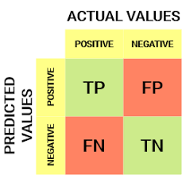

1. **Accuracy:**

* Accuracy is the fraction of predictions our model got right.
* Accuracy ranges between 0 and 1.
* Accuracy is misleading for imbalanced datasets.

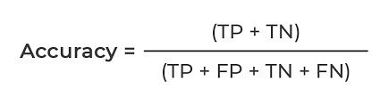

1. **Precision:**

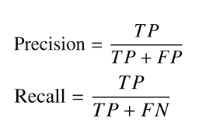

* Precision is defined as **What proportion of predicted positives are truly positive.**
* Used where FP is dangerous and required this value less than FN (e.g.: email spam or not)

1. **Recall: (aka sensitivity/ True positive rate/ Hit rate)**



* Recall is defined as **What proportion of actual positives are correctly classified.**
* Used where FN is dangerous and required this value less than FP (e.g.: person having cancer or not)

1. **Specificity: (aka False positive rate/ Selectivity)**

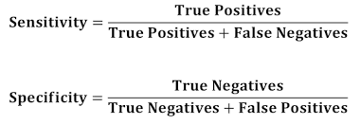

* Specificity is defined as **What proportion of actual negatives are correctly classified.**

1. **F1-Score:**

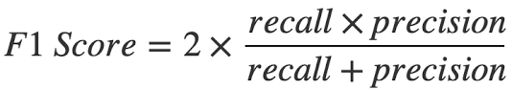

* F1-Score is **harmonic mean** of Precision and Recall

1. **AUC: (Area Under ROC Curve)**