Game Design Document

Fill up the following document

1. Write the title of your project.

**RESCUE THE MOTHER ELEPHANT**

1. What is the goal of the game?

**THE GOAL OF THE GAME IS FOR THE BABY ELEPHANT TO CROSS A NUMBER OF OBSTACLES AND RESCUE HIS MOTHER.**

1. Write a brief story of your game.

**THERE IS A BABY ELEPHANT AND HIS MOTHER GETS KIDNAPPED BY SOME HUNTERS. THE BABY ELEPHANT DECIDES TO RESCUE HIS MOTHER AND SETS OUT ON A VERY DANGEROU MISSION.**

1. Which are the playing characters of this game?

* Playing characters are the ones who respond to the user based on the input from the user.
* Cars, monkeys, dinos, wizards, etc., are the playing characters in the game.

|  |  |  |
| --- | --- | --- |
| Number | Character Name | What can this character do? |
| 1 | BABY ELEPHANT | CAN CONTOL MOVEMENTS, GETS SPECIAL POWERS ON THE WAY |
| 2 |  |  |
| 3 |  |  |
| 4 |  |  |
| 5 |  |  |
| 6 |  |  |
| 7 |  |  |
| 8 |  |  |

1. Which are the Non-Playing Characters of this game?

* Non-Playing characters are the ones that don't have an action or behavior when the user interacts with the game.
* Hurdles, stones, bananas, coins, etc., are non-playing characters in the game.

|  |  |  |
| --- | --- | --- |
| Number | Character Name | What can this character do? |
| 1 | MOTHER ELEPHANT | NO |
| 2 | HUNTERS | CAN TRY AND DESTROY THE BABY ELEPHANT |
| 3 | OBSTACLES | CAN STOP THE BABY ELEPHANT |
| 4 |  |  |
| 5 |  |  |
| 6 |  |  |
| 7 |  |  |
| 8 |  |  |

Draw your imagination of this game. What does this game look like?

* Draw the game either on your computer or on paper.
* Add images of the game scenes to show each of the playing and non-playing characters at least once.

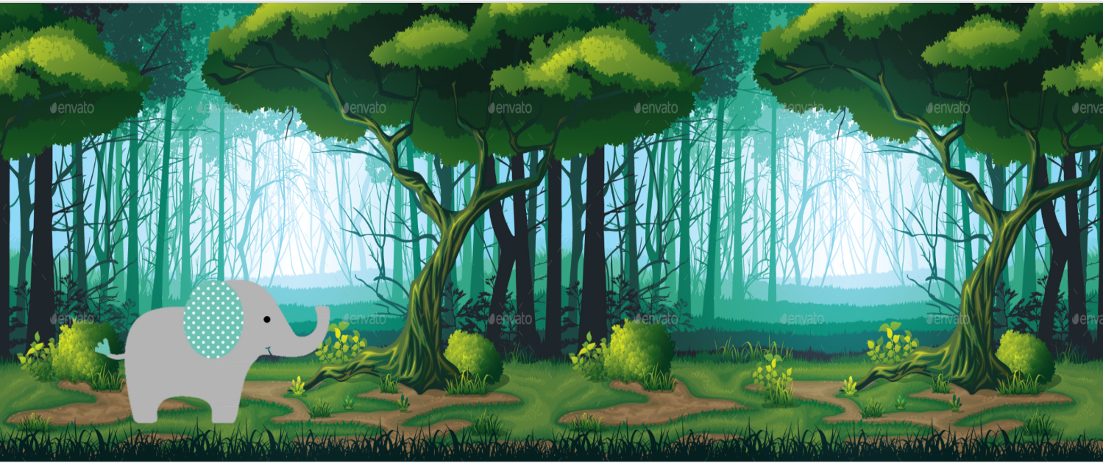

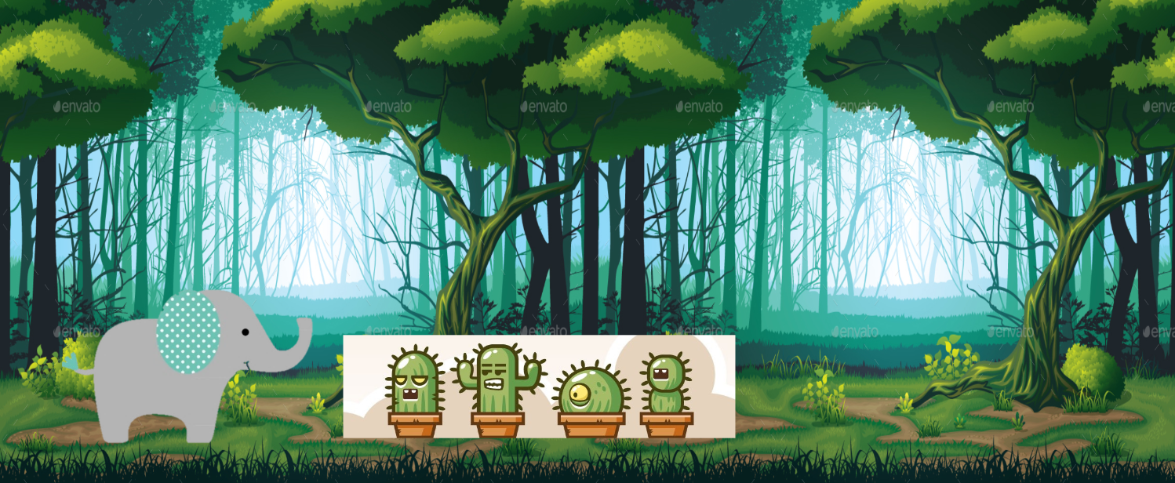

How do you plan to make your game engaging?

**I PLAN TO MAKE MY GAME ENGAGING BY ADDING LEVELS TO THE GAME AND GIVING CERTAIN POWERS TO THE ELEPHANT ON ITS WAY. THERE WOULD ALSO BE MANY OBSTACLES THAT THE PLAYER WOULD HAVE TO CROSS OR DESTROY.**