1. **Start Hadoop single node on AcadGild VM. The command is start-all.sh.**

**Ans:** Started a single node using command start-all.sh, when I

type start-dfs.sh all the file system related daemons

started. But,when I start-all.sh,I could identify from the

logs that namenode,data-node, secondary namenode,

resource manager, node manager have started, i.e.it started

both yarn daemons and file system daemons.

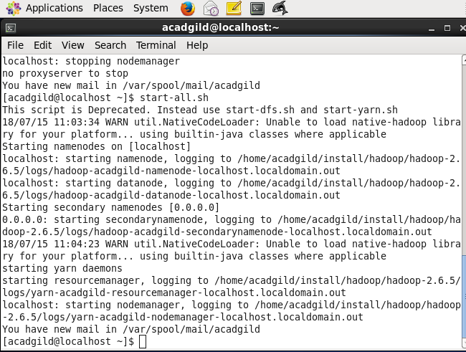

1. **Run a JPS command to see if all Hadoop daemons are running.**

**Ans:**  It shows all the daemons running.

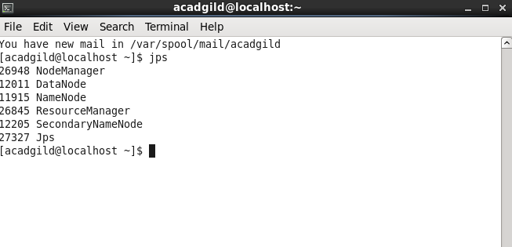

1. **Run few Unix commands like pwd, ls -ls, etc.**

**Ans:** pwd is showing the present working directory in file system and ls –ls shows list of all files.

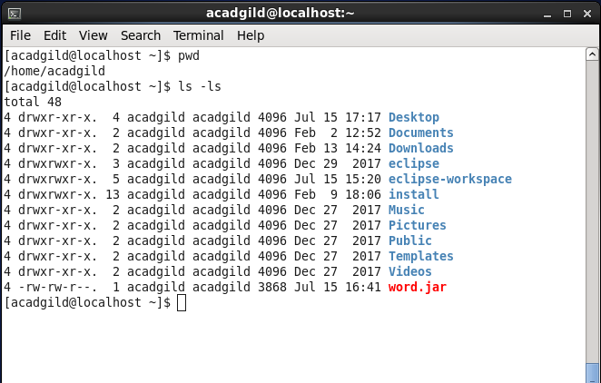

1. **Create a file from the terminal using nano editor (example: nano test.txt), and add some content in it. Cat it to see if the content is saved.**

**Ans:** I created a file using nano editor from the command line and used “i” to insert text into the file and used cat command to review the content of the file.

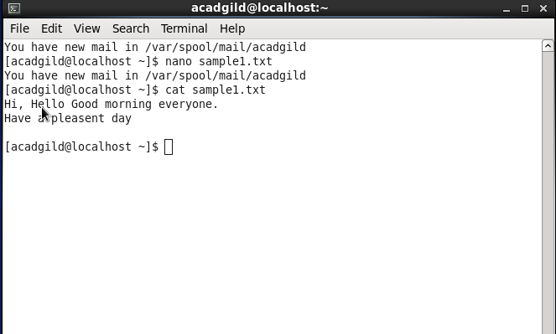

1. **Open the HDFS web page by typing localhost:50070 in the browser. Check all the details of the HDFS.**

**Ans: 50070 is the port number of local host.**

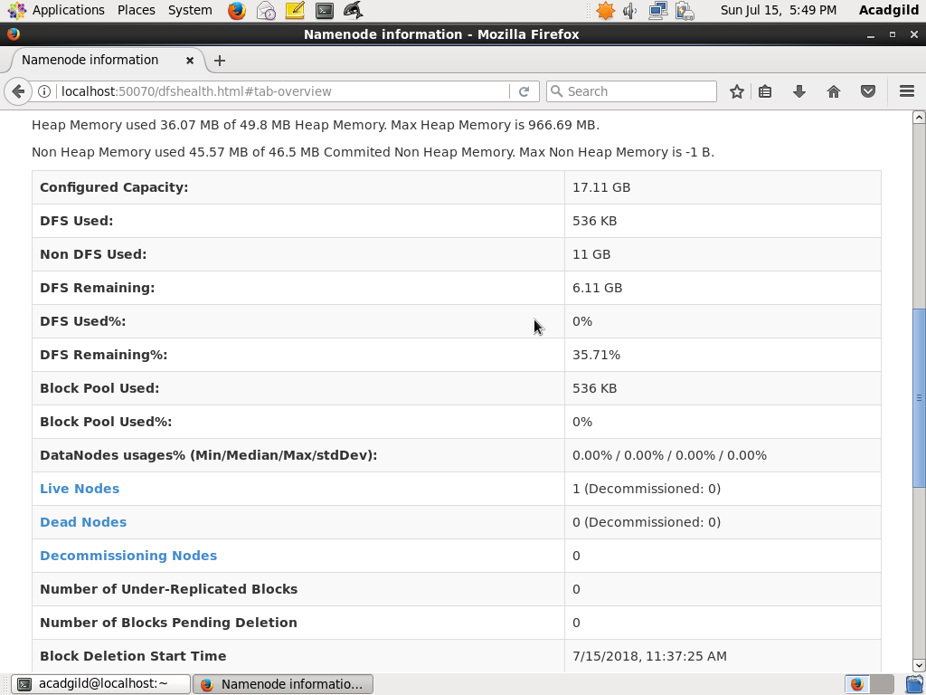

**Task 2: Check whether /user/acadgild directory exists or not in the**

**HDFS, If it doesn't exist, then create this. Create a directory**

**/user/acadgild/hadoop.**

**Ans:** when I typed **hdfs dfs –ls /user/acadgild/hadoop,** it has thrown an

error message as no such directory found. So created new directories that are

both acadgild and hadoop in recursive mode along with the path. Command

used is **hdfs dfs –mkdir –p /user/acadgild/hadoop.** The list of all the

directories could be found out by giving command **, hdfs dfs –ls**

**/user/acadgild/hadoop** and could find the hadoop directory**.**

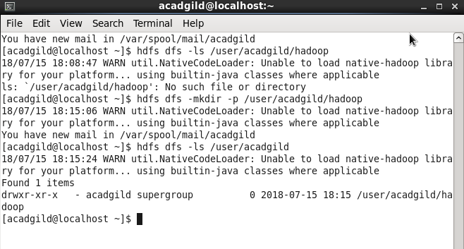

**Task 3: Create a file in HDFS under directory /user/acadgild/hadoop,**

**with name word-count.txt. Whatever we type on screen**

**should get appended to the file. Try to type (on screen) few**

**lines from any online article or textbook.**

**Ans:** Created a file named word-count.txt in base machine file system

then copied it to HDFS in above mentioned directory. Added

some more lines file in local copy and used “appendToFile”

command toedit the file in HDFS**.**

**1)**Copied file from fs to HDFS and used cat command to check the content **.**

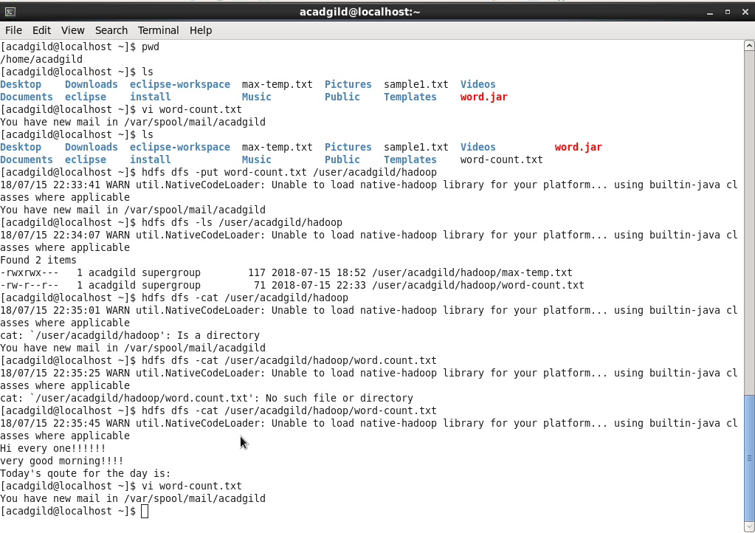

**2)** Edited the Word-count file in local file system.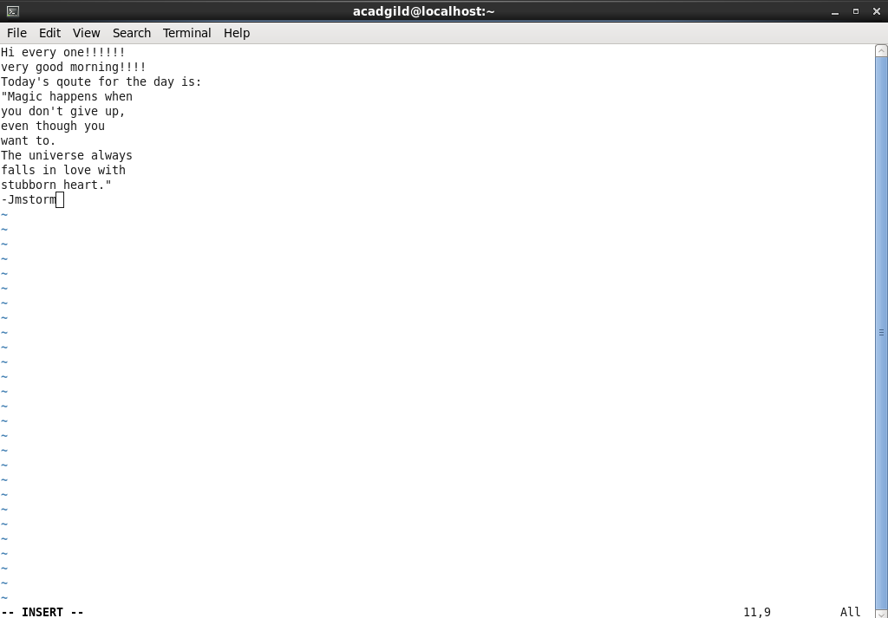

3) Now used “appendFileTo” for HDFS file and checked the new content using cat command.

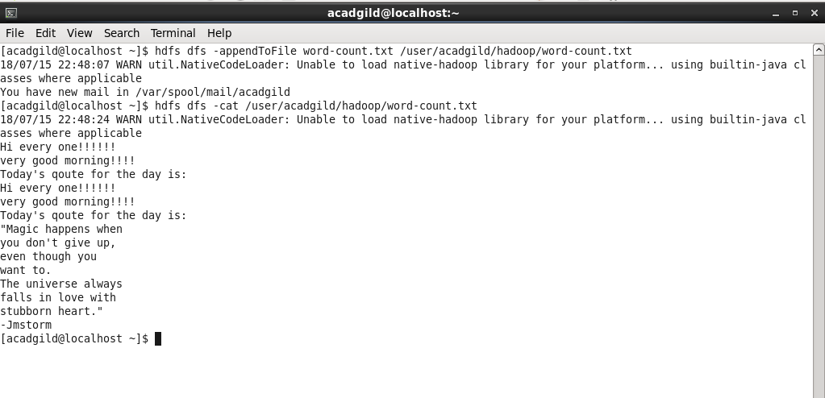

**Task 4: Create a file max-temp.txt in local FS.Put some 10-15 records of date and temperature example: dd-mm-yyyy, temperature. Move this file to HDFS at /user/acadgild/hadoop.**

**Example:**

**10-01-1990,10**

**10-02-1991,20**

**Ans:**

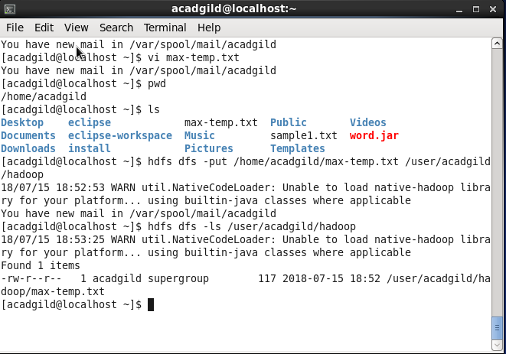

**Task 5: Change the permission of the file /user/acadgild/hadoop/max-temp.txt, such that only the owner and the group members have full control over the file.Others do not have any control over it.**

**Ans**: As checked the permissions for owner, group member and others were read-write ,read, read respectively. So used chmod command with permissions set as 770 i.e. for both owner and group user are given full access where as others have no control.

