**Problem Statement-**

Dataset Description: ID,Case Number,Date,Block,IUCR,Primary Type,Description,Location Description,Arrest,Domestic,Beat,District,Ward,Community Area,FBICode,X Coordinate,Y Coordinate,Year,Updated On,Latitude,Longitude,Location.

**INPUT FILE-**

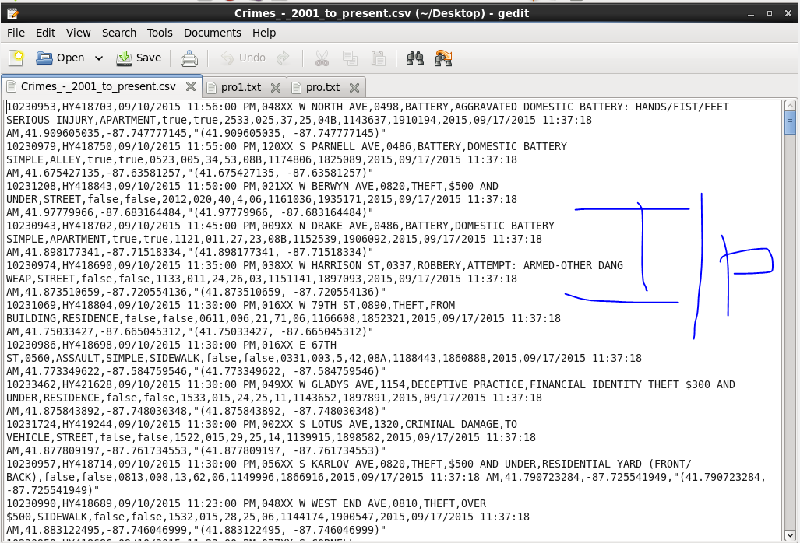

1. **Write a mapreduce and pig program to calculate the number of cases investigated under each FBI code.**

**Solution with Map Reduce-**

**Driver Class-**

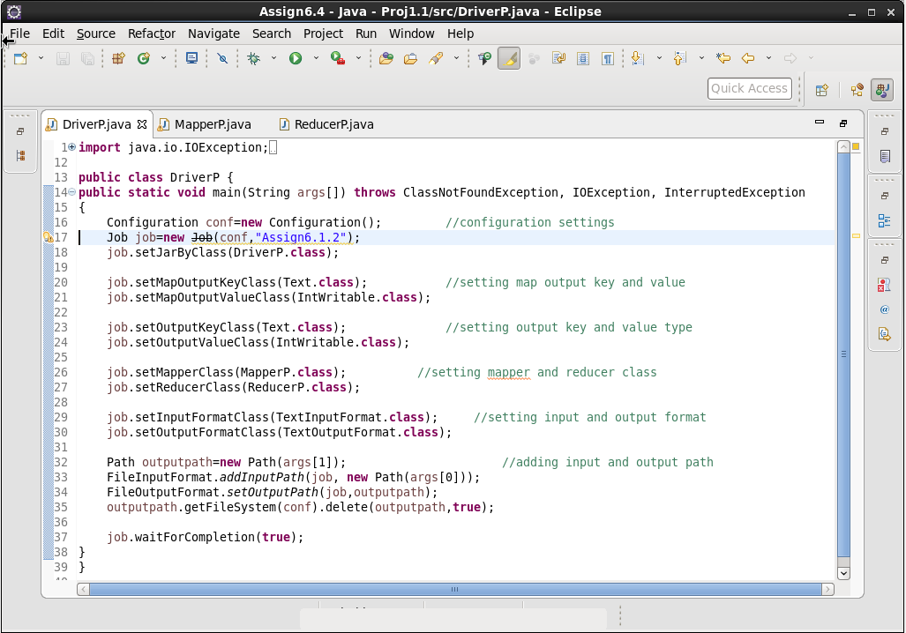

**Mapper Class-**

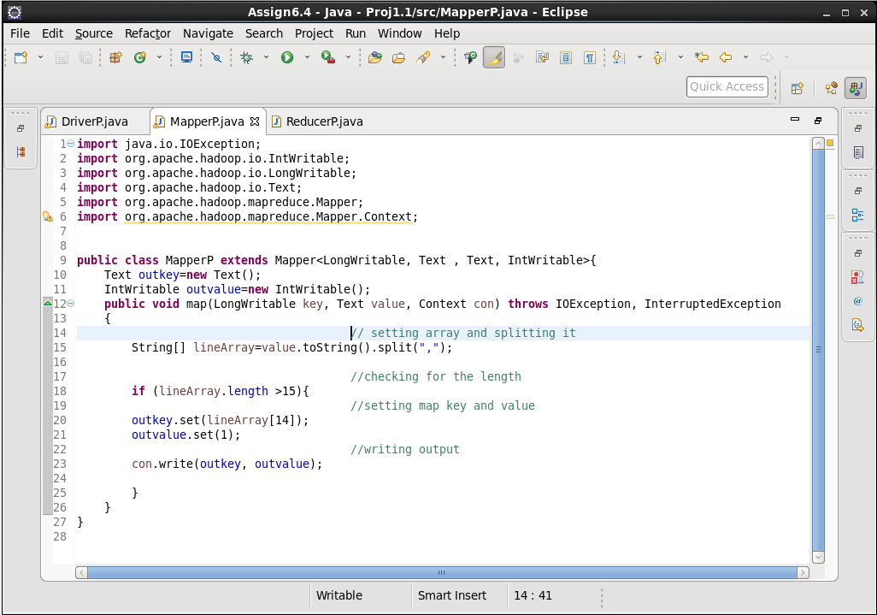

**Reducer Class-**

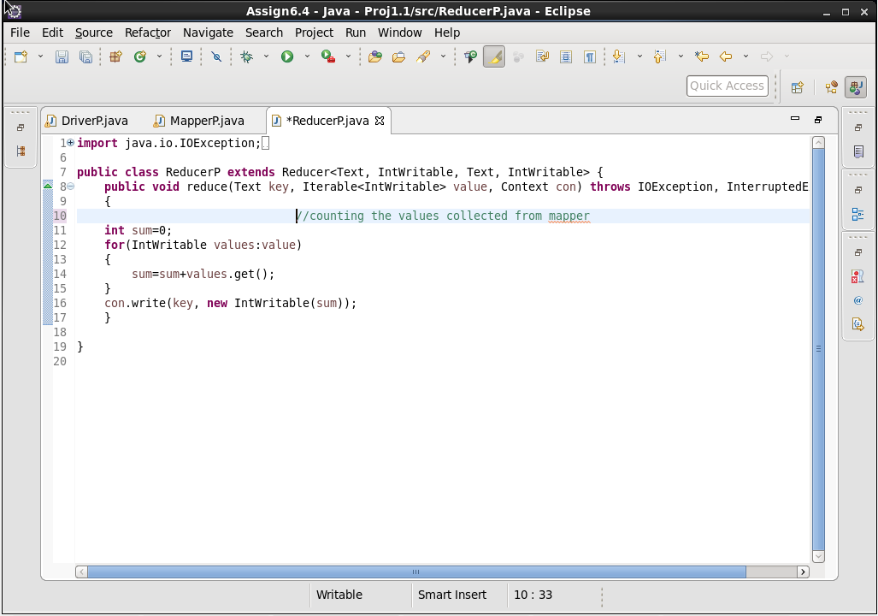

**Output-**

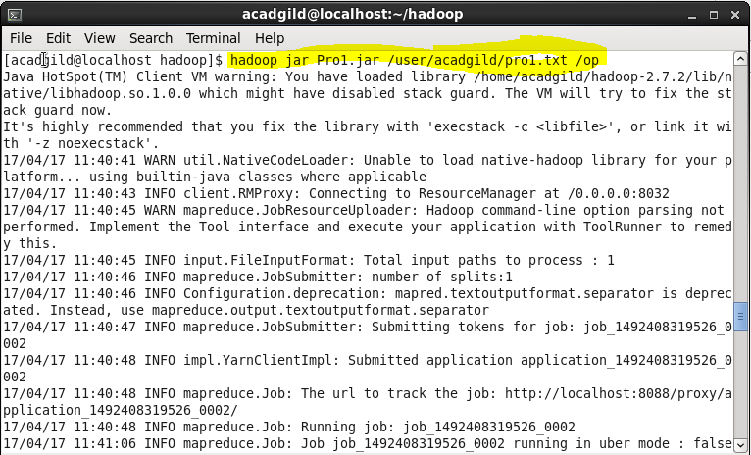

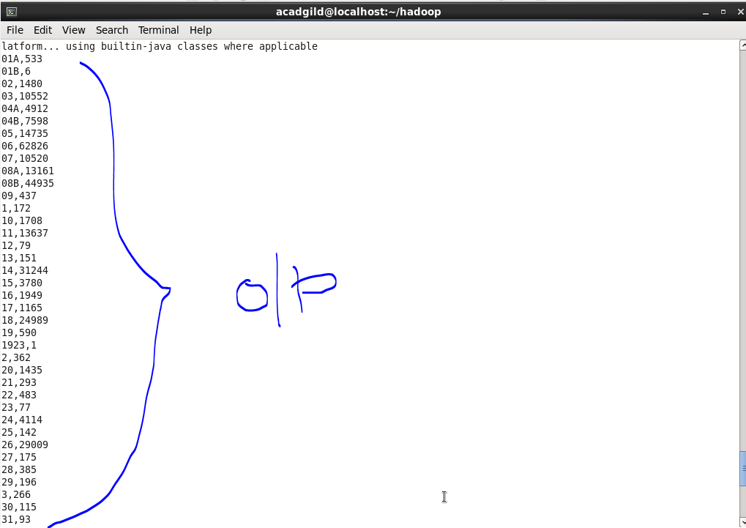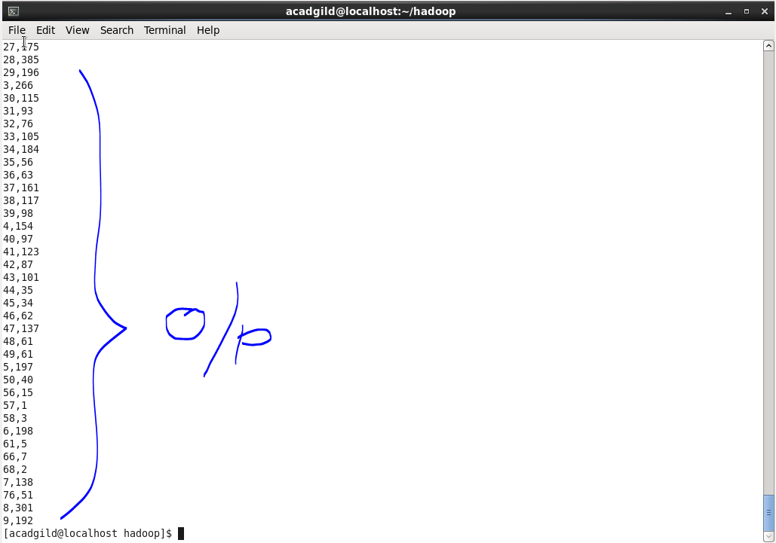

**Solution with PIG-**

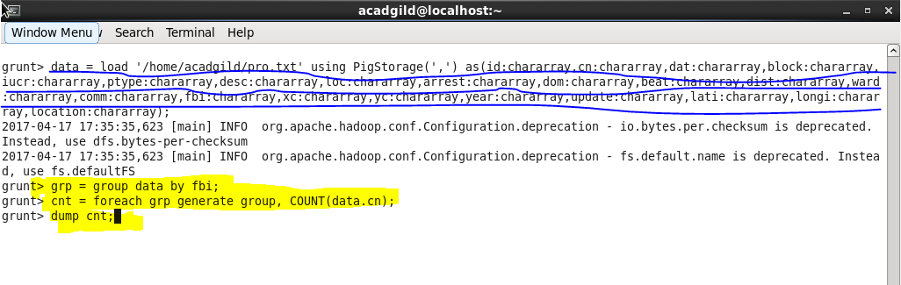

**Output-** Output is same as we got by Map Reduce.

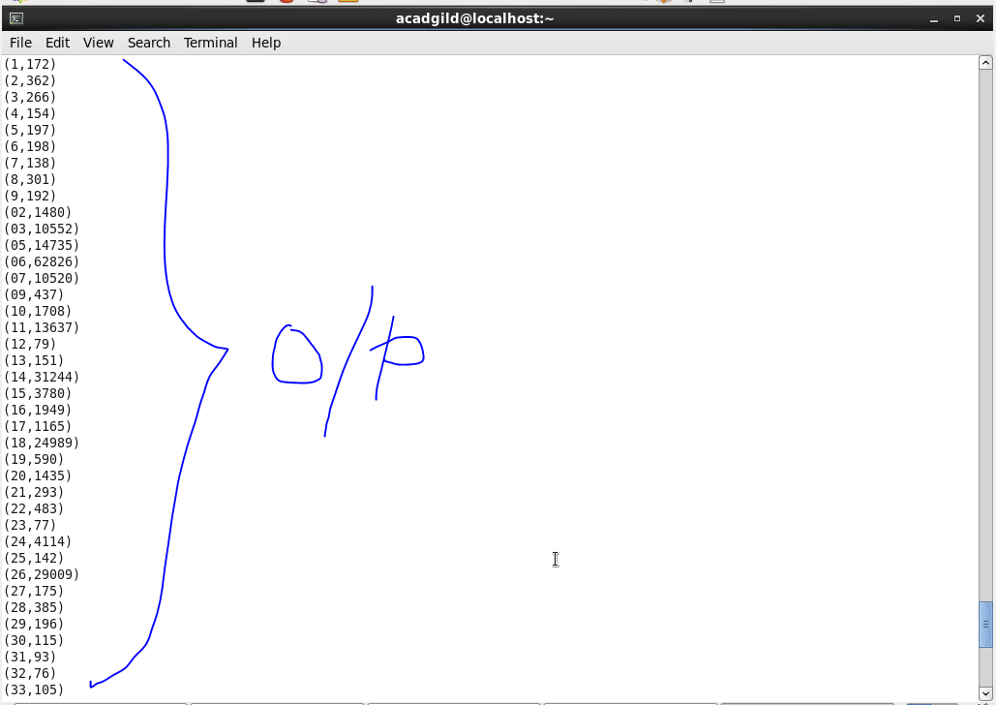

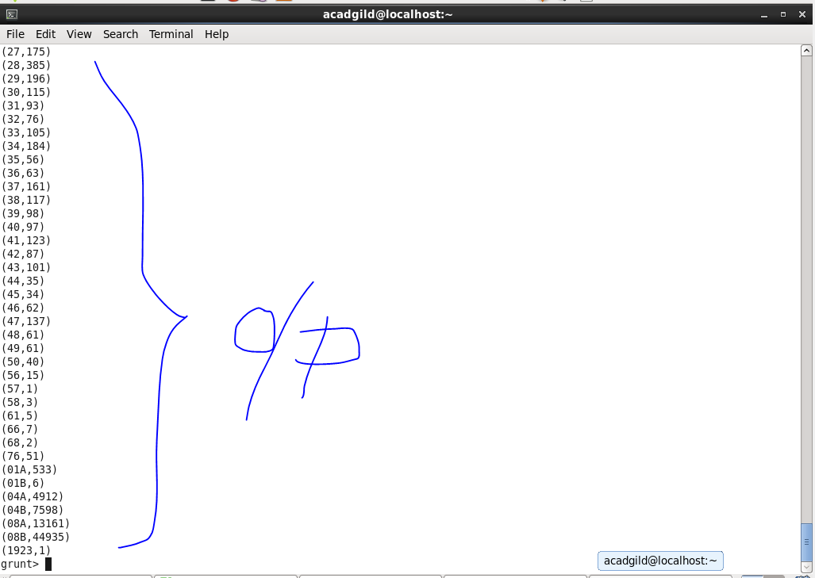

1. **Write a mapreduce and pig program to calculate the number of cases investigated under FBI code 32.**

**Solution by Map Reduce-**

**Driver Class-**

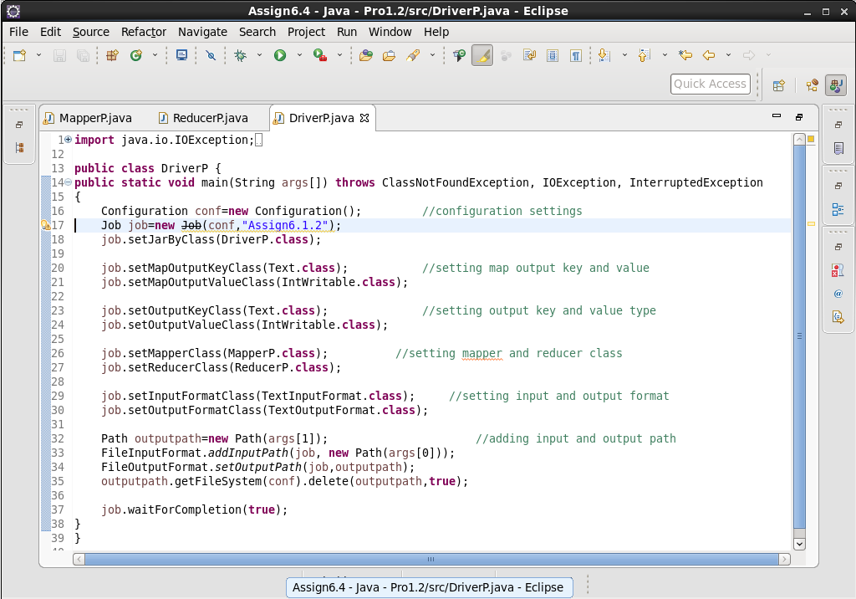

**Mapper Class-**

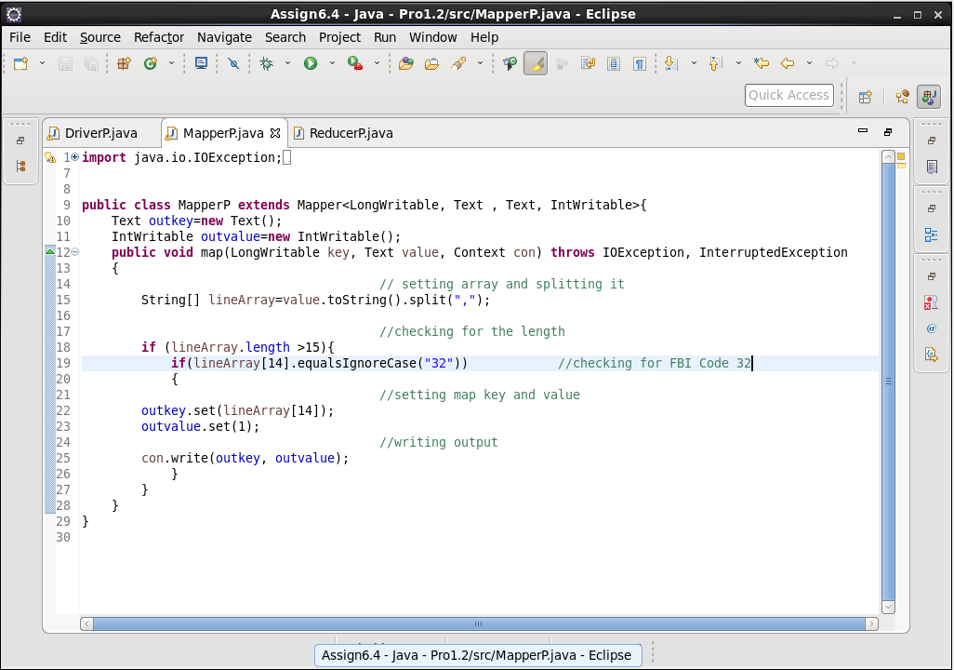

**Reducer Class-**

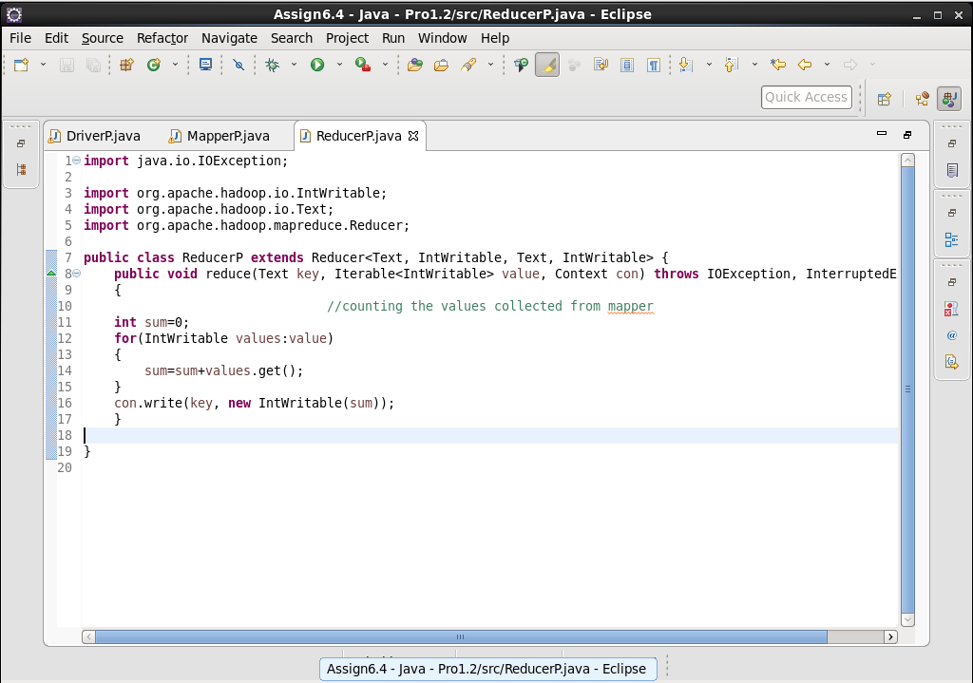

**Output-**

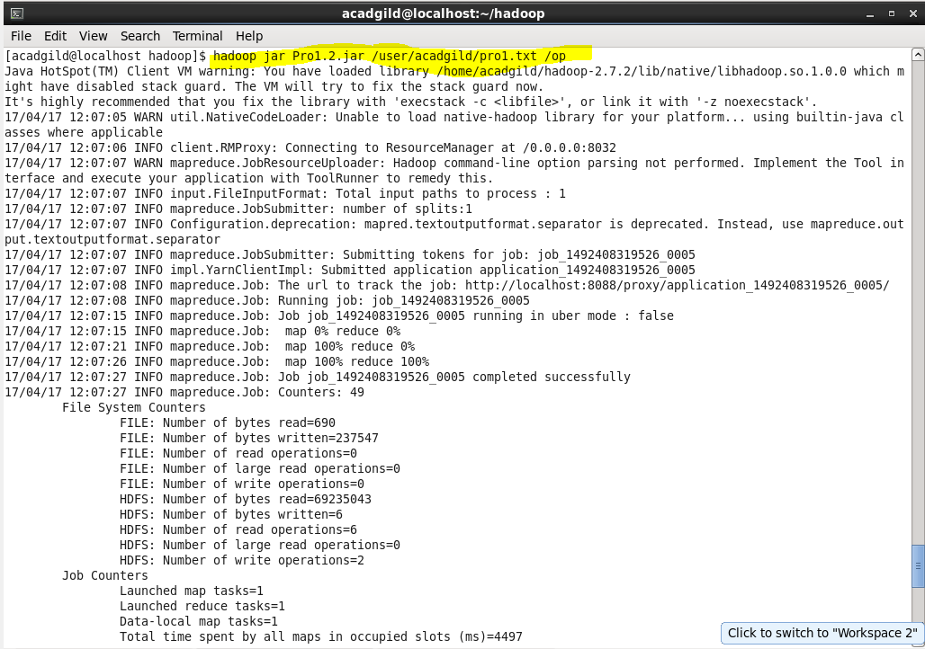

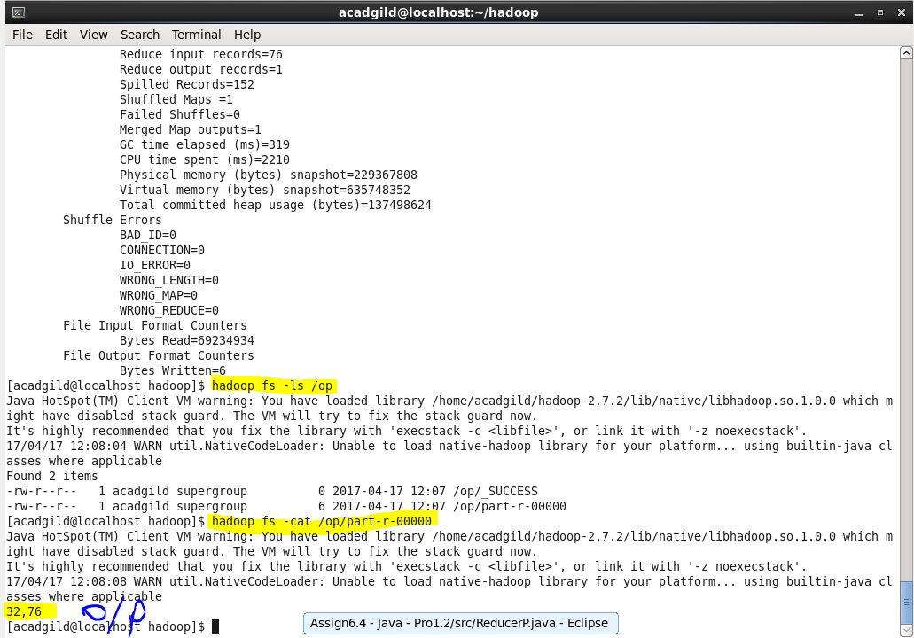

**Solution by PIG-**

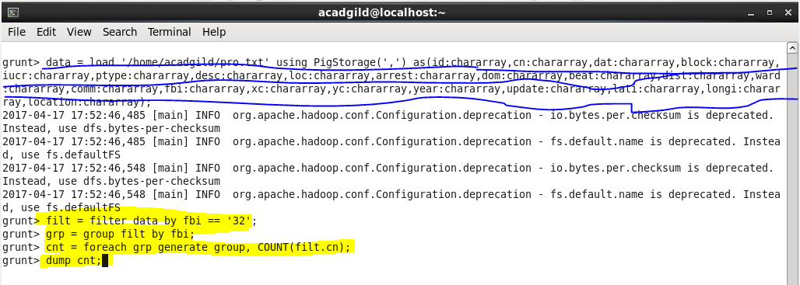

**Output-**

Output is same as by Map Reduce.

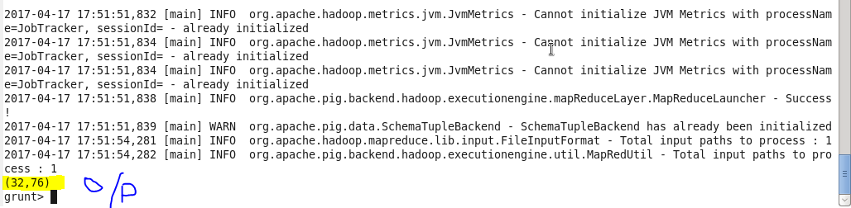

1. **Write a mapreduce and pig program to calculate the number of arrests in theft district wise.**

**Solution by Map Reduce-**

**Driver Class-**

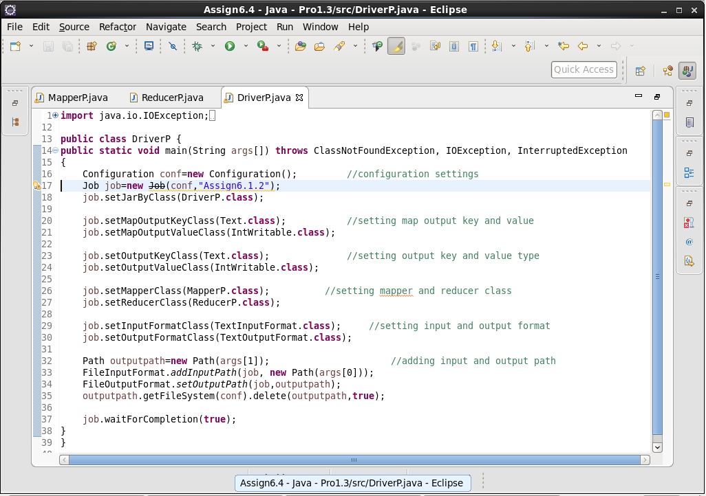

**Mapper Class-**

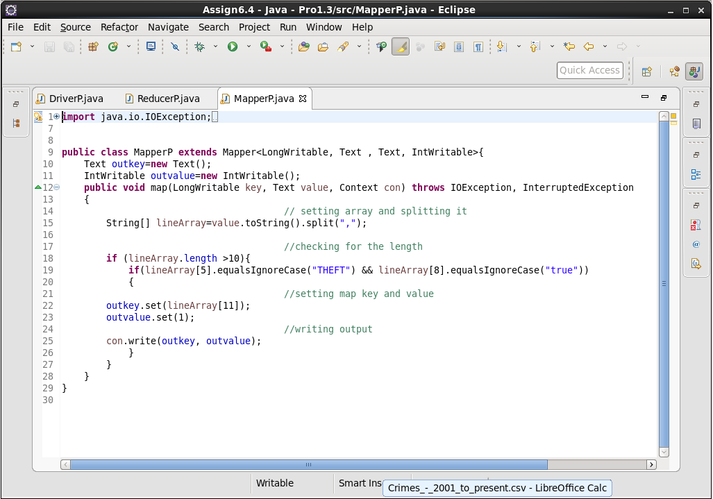

**Reducer Class-**

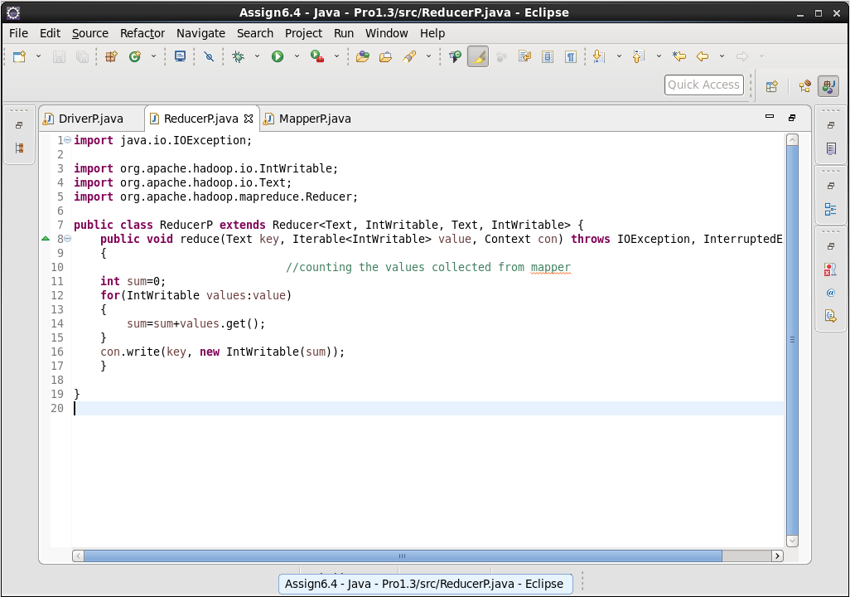

**Output-**

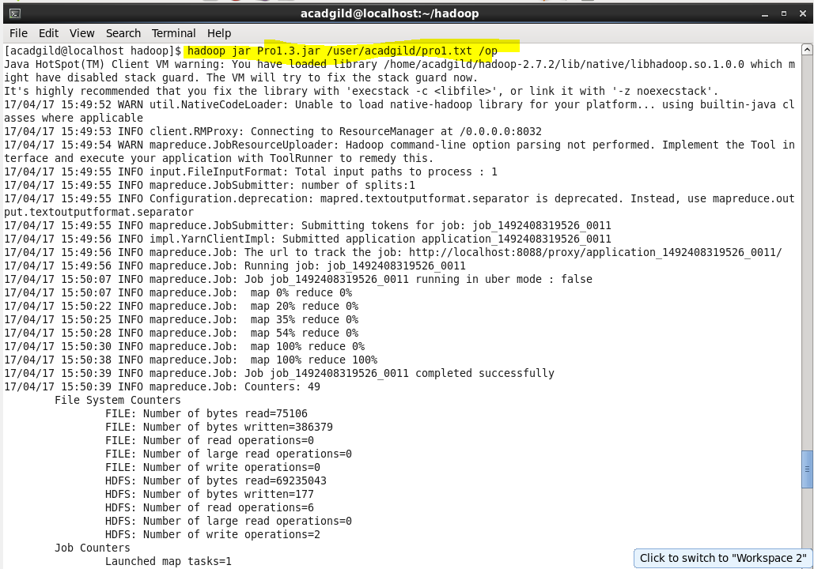

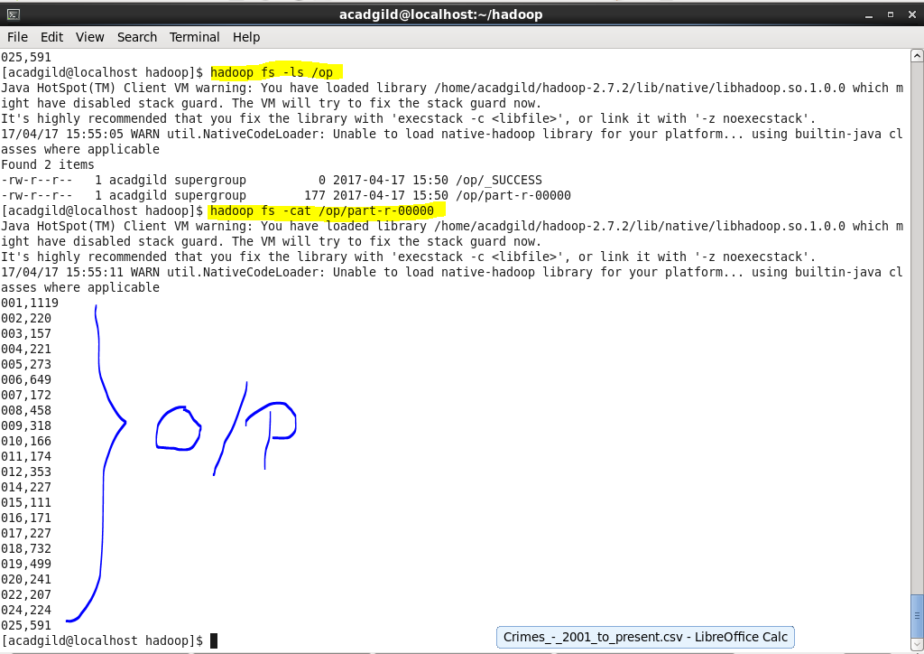

**Solution by PIG-**

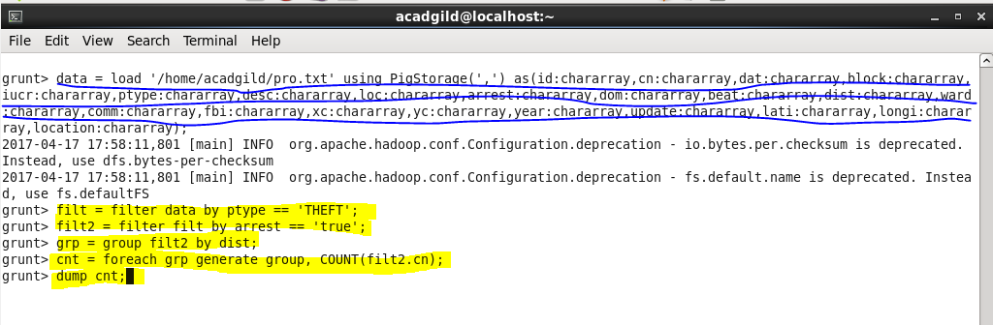

**Output-**

Output is same as by MapReduce.

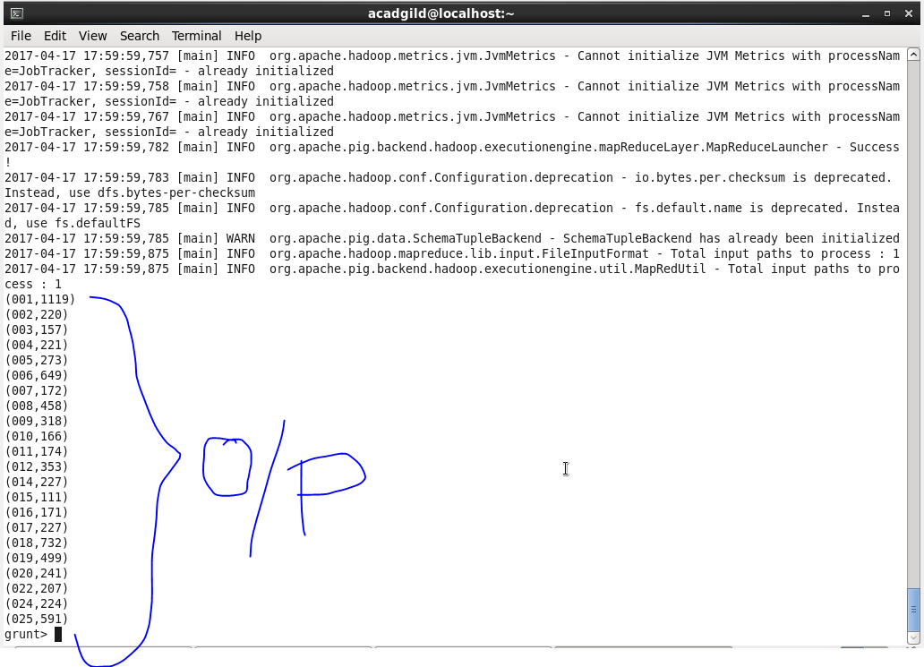

1. **Write a mapreduce and pig program to calculate the number of arrests done between October 2014 and October 2015.**

**Solution by MapReduce-**

**Driver Class-**

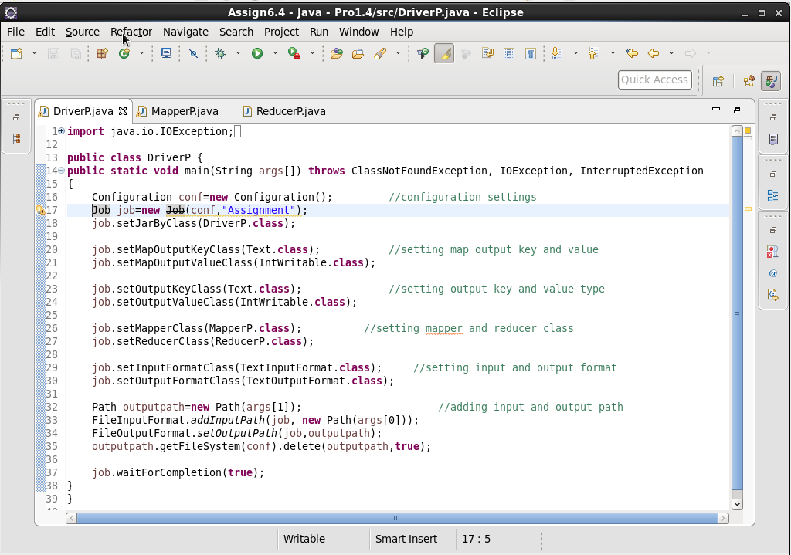

**Mapper Class-**

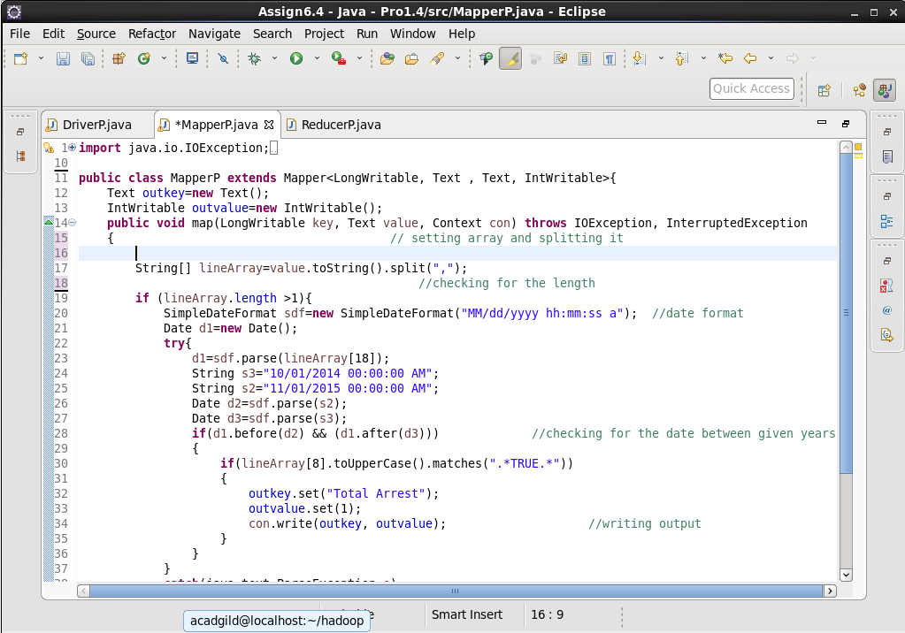

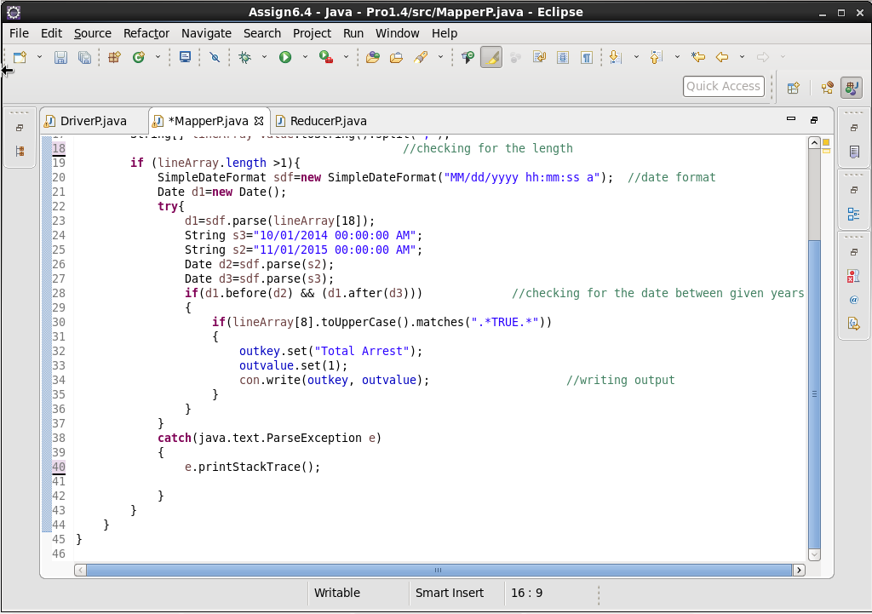

**Reducer Class-**

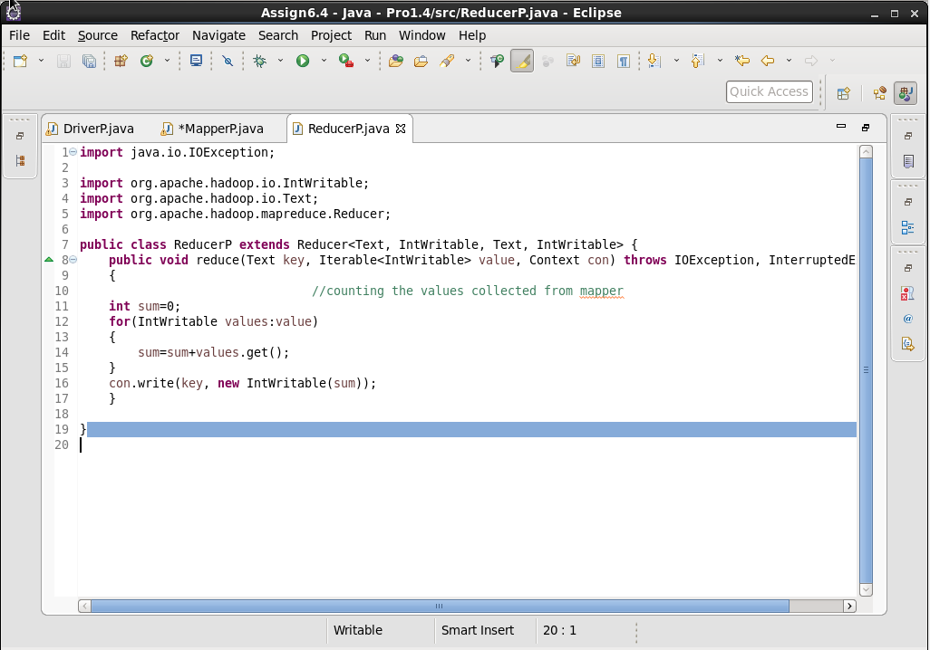

**Output-**

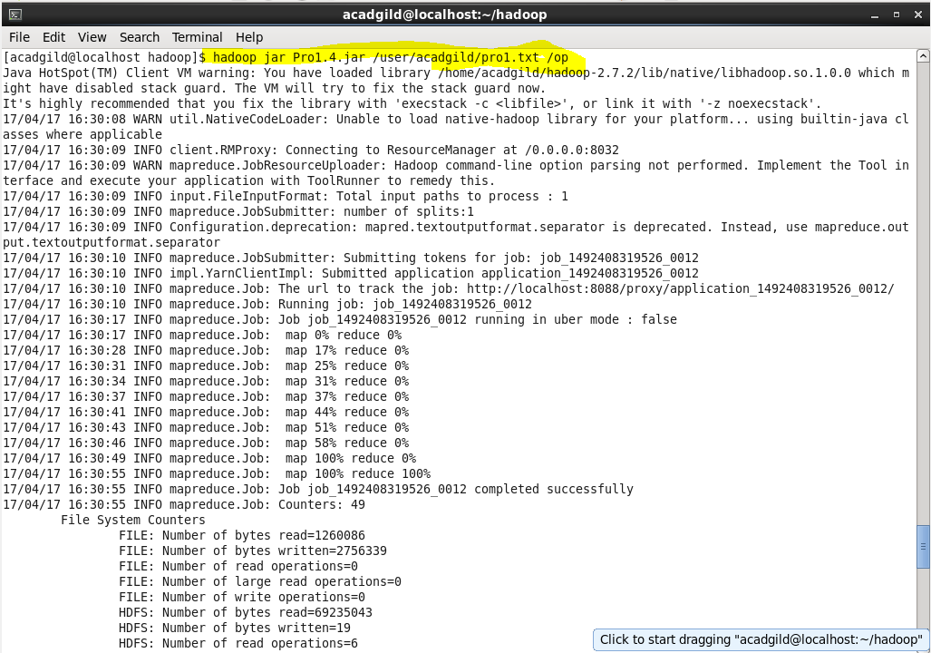

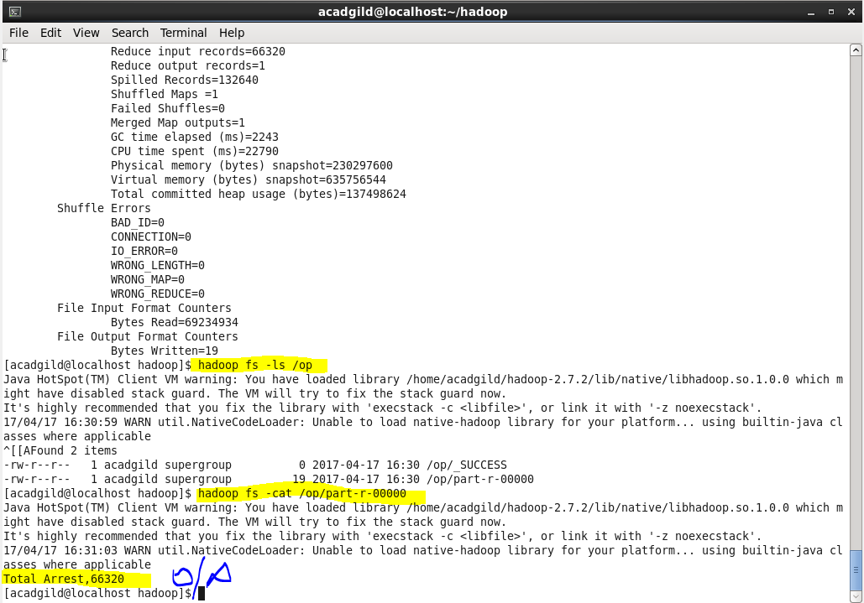

**Solution by PIG-**

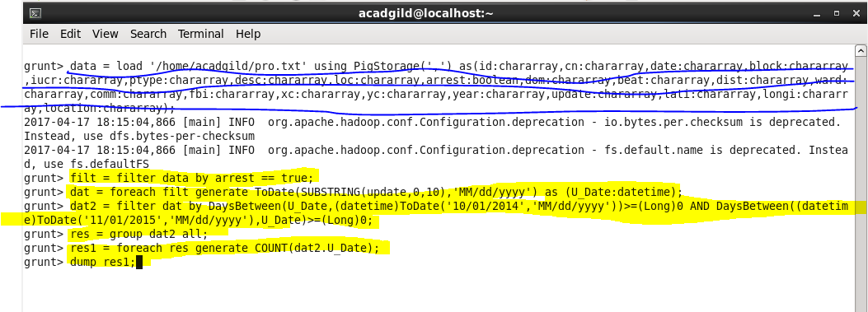

**Output-**

Output is same as by MapReduce-

