**Problem Statement-**

Dataset Description-

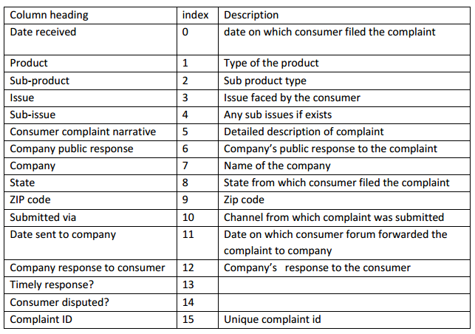

**INPUT FILE-**

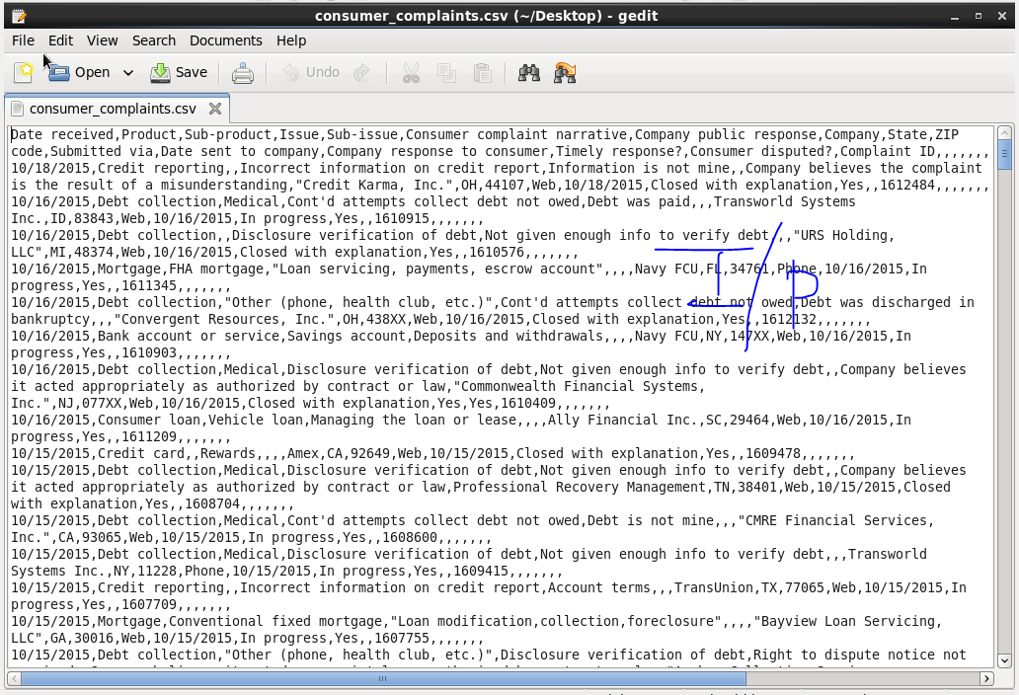

**1. Write a mapreduce program to remove commas present inside the double quotes.**

**Driver Class-**

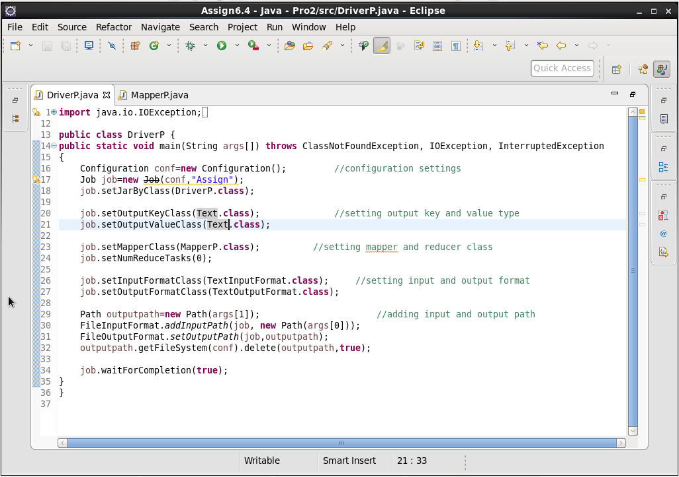

**Mapper Class-**

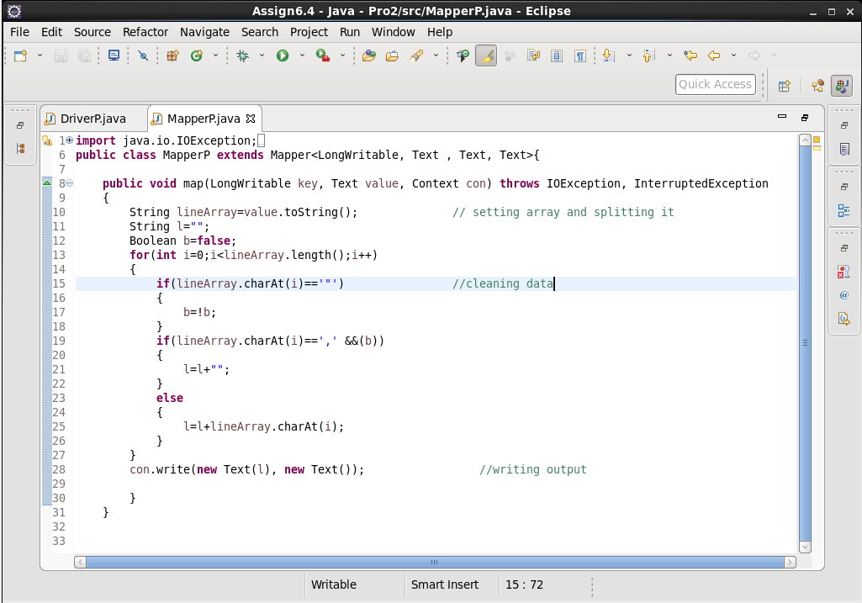

**Output-**

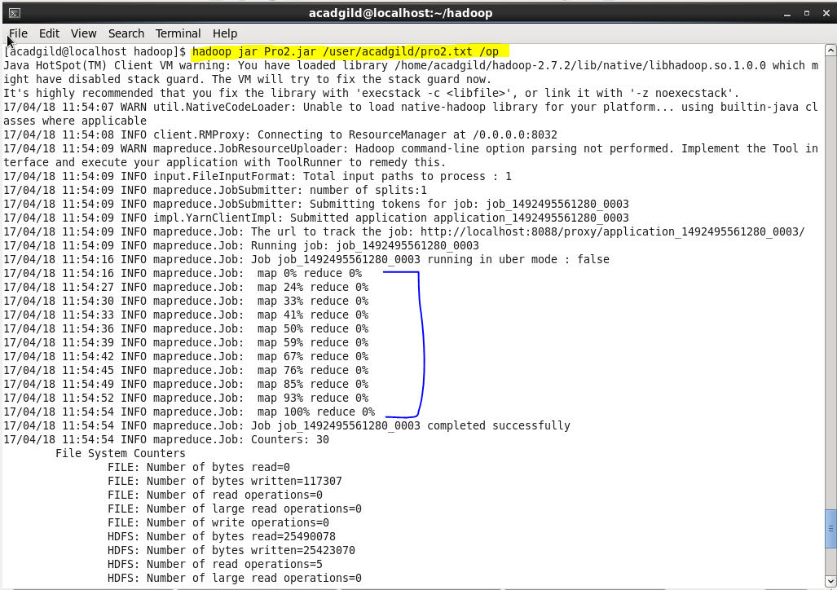

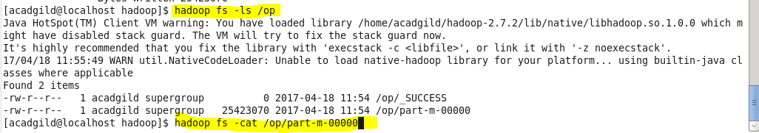

1. **Write a pig script to find no of complaints which got timely response**

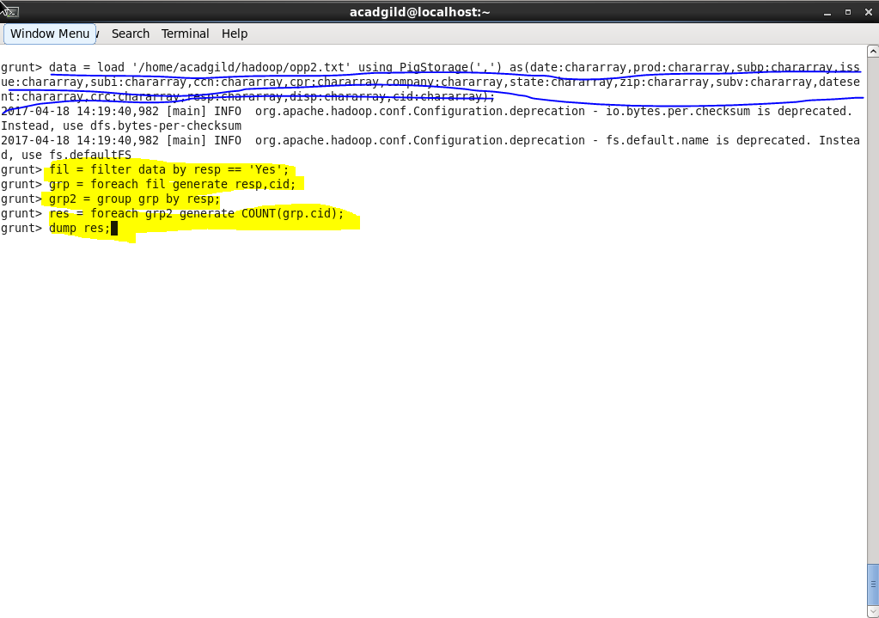

**Output-**

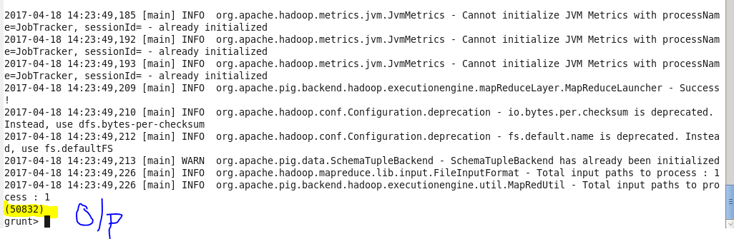

**2. Write a pig script to find no of complaints where consumer forum forwarded the complaint same day they received to respective company**

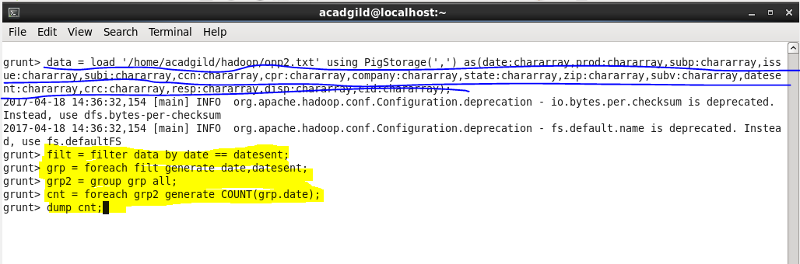

**Output-**

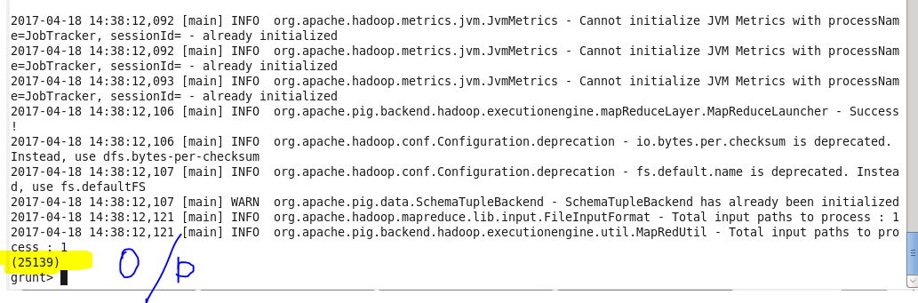

**3. Write a pig script to find list of companies topping in complaint chart (companies with maximum number of complaints)**

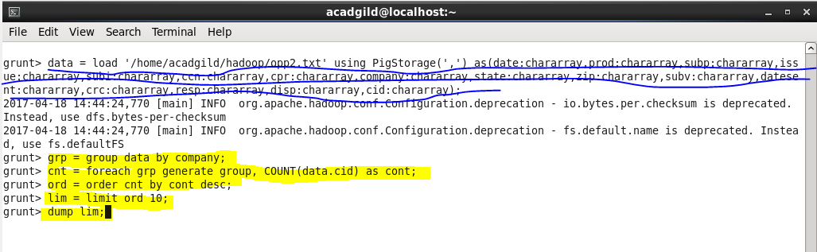

**Output-**

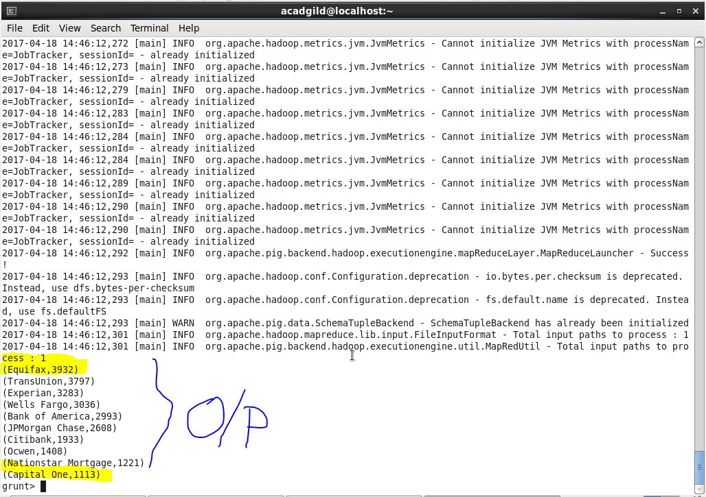

**4. Write a pig script to find no of complaints filed with product type has "Debt collection" for the year 2015**

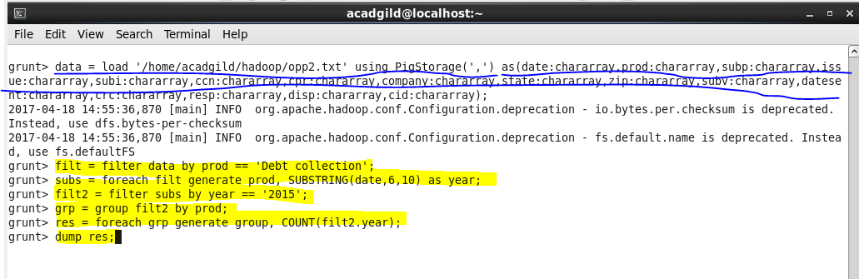

**Output-**

