**Problem Statement**

Write a program to implement Word Count using Pig.

1. Input File-

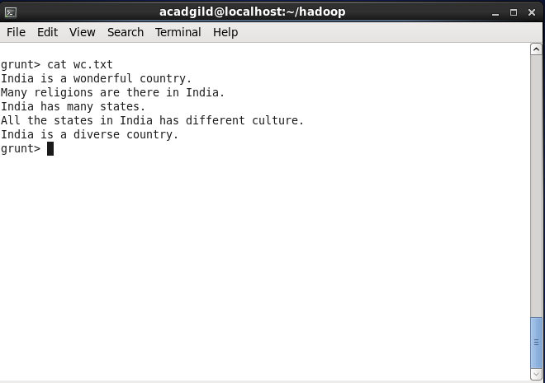

1. Loading data from text file and convert sentence into words-

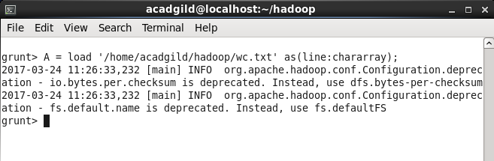

1. Tokenize to get individual words by converting a tuple in a bag of words-

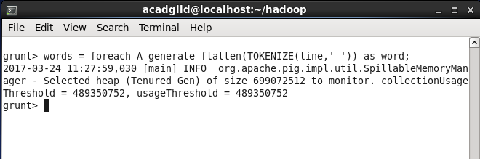

1. Group the bag of words and count the words-

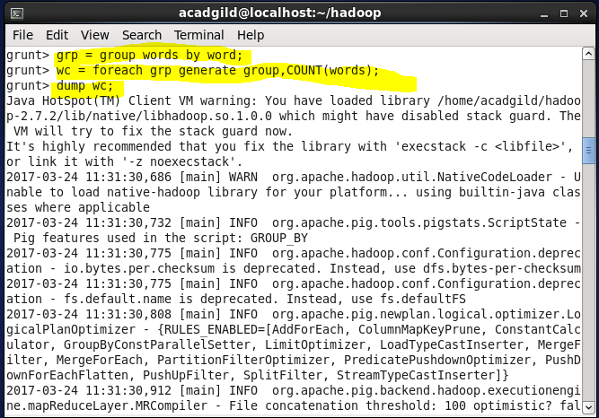

1. Output-

