**Problem Statement**

**DATA SET DESCRIPTION**

Column 1 : PassengerId Column 2 : Survived (survived=0 & died=1) Column 3 : Pclass Column 4 : Name Column 5 : Sex Column 6 : Age Column 7 : SibSp Column 8 : Parch Column 9 : Ticket Column 10 : Fare Column 11 : Cabin Column 12 : Embarked

**Input File-**

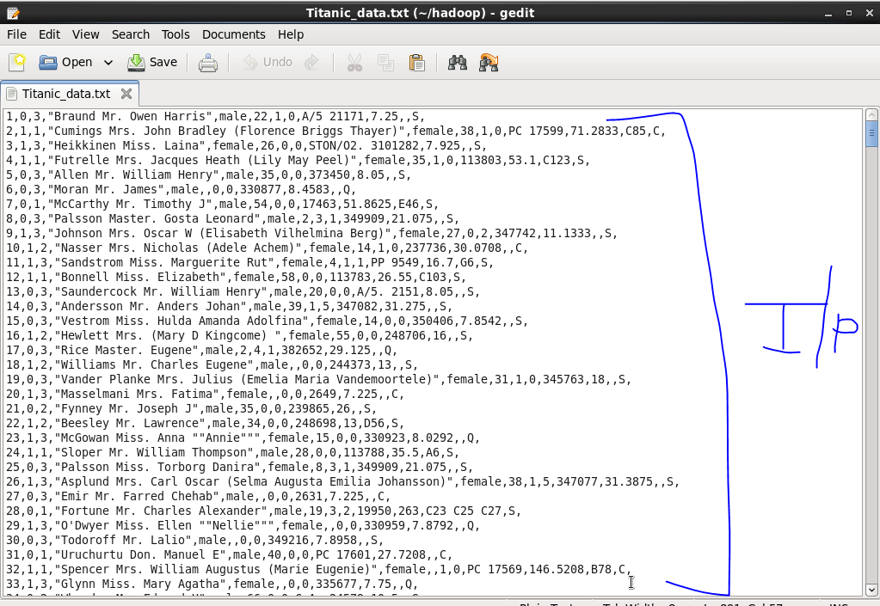

**1.Write a pig script find the average age of male and female persons died in the titanic tragedy.**

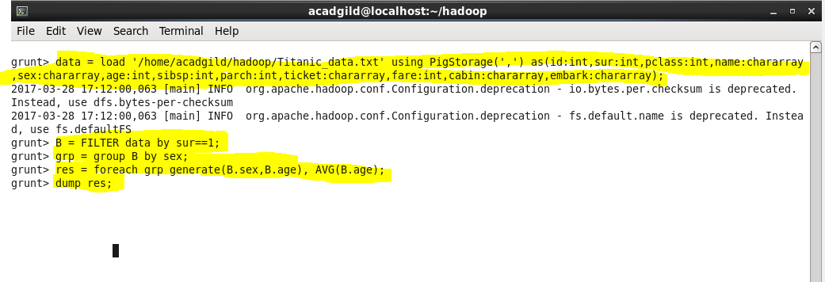

**Output-**

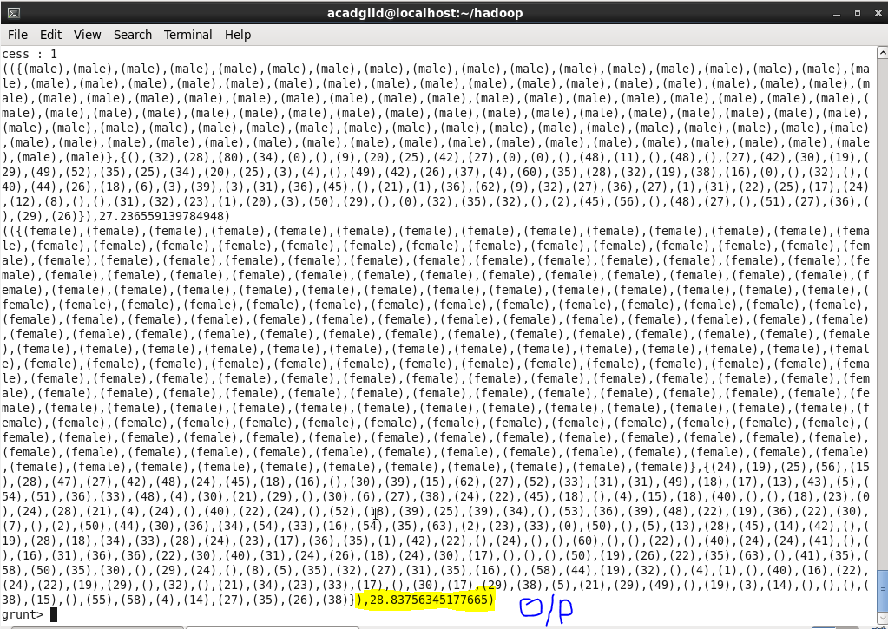

**2.Write a pig script to find the number of people died and survived in each class.**

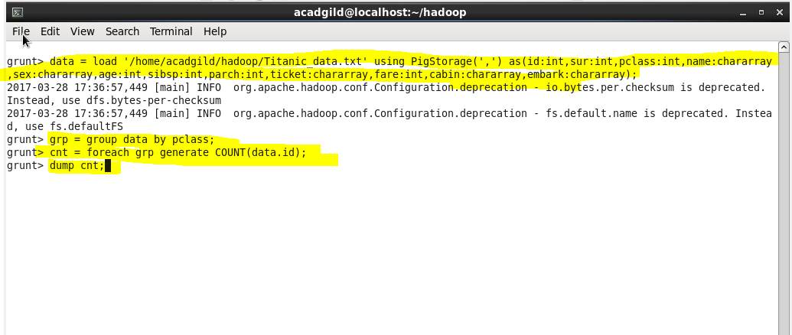

**Output-**

