**Problem Statement-11.2**

Write the Pig codes to analyze the Student data set.

**Data Definition:**

1. Name : chararray

2. Col.Undertaken : chararray

3. Dob : chararray

4. Stream : chararray

5. Grade : float

6. State : chararray

7. City : chararray

**Input File-**

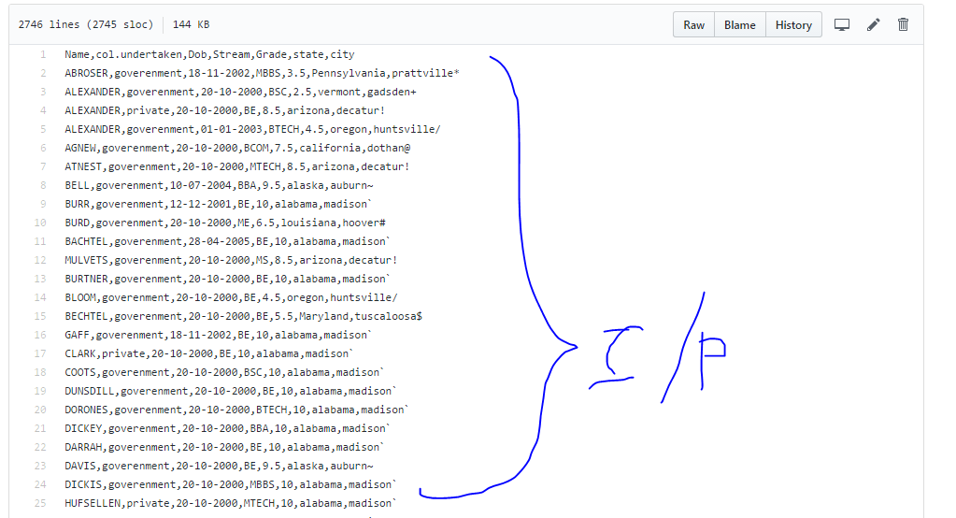

1. **Find the number of students who scored less than 5(50%).**

**Solution-**

1. Load data from input file.
2. Filter data to find students who scored less than 5.
3. Group them and count the students.
4. Display count of students.

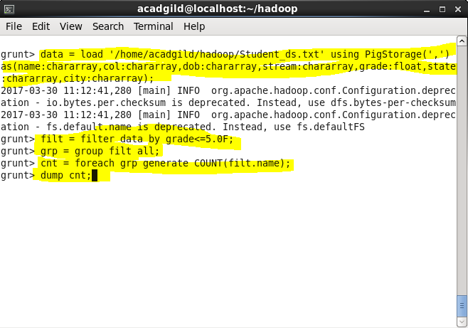

**Output-**

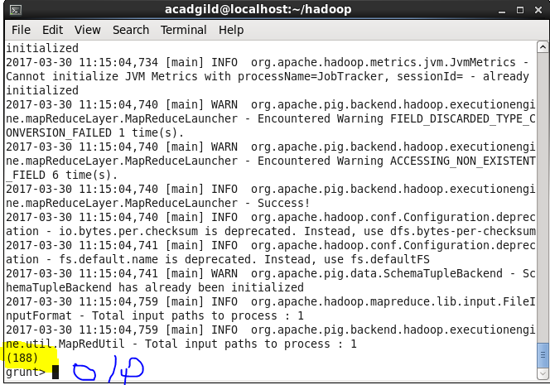

1. **List the name of students who are from Alaska.**

**Solution-**

1. Load data from input file.
2. Filter data to find students from Alaska.
3. Display the names of those students.

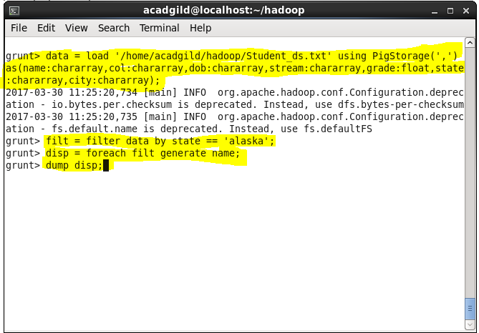

**Output-**

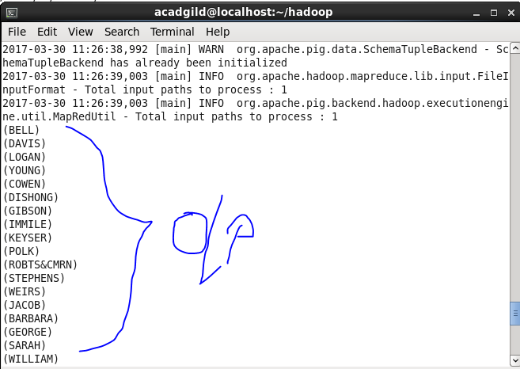

1. **How many government colleges are there in Alabama?**

**Solution-**

1. Load data from input file.
2. Filter data to find students from Alabama and the college is government.
3. Group them and count the number.
4. Display the data.

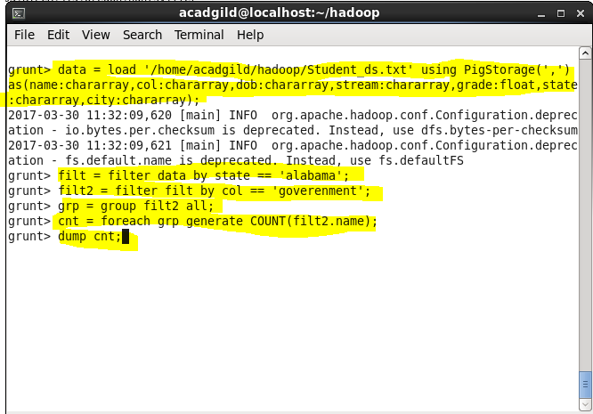

**Output-**

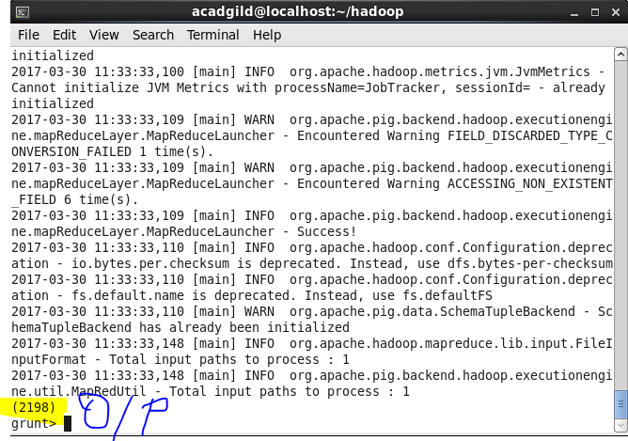

**4. List the name of students who are from Oregon and persuing BE.**

**Solution-**

1. Load data from input file.
2. Filter data to find the students from Oregon and pursuing BE.
3. Display the names of such students.

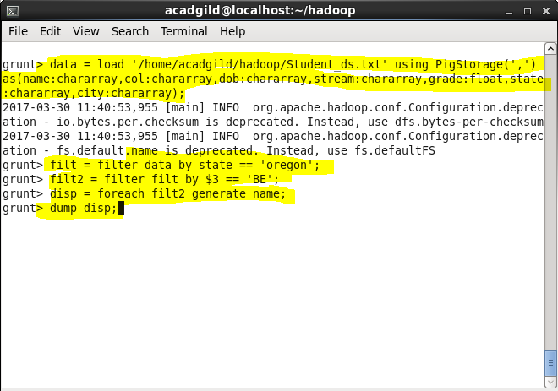

**Output-**

