**Assignment 16.4**

Write a mapreduce program use map side join to join the two datasets and find What kind of problems are prevalent, and in which state?

**Driver class:**

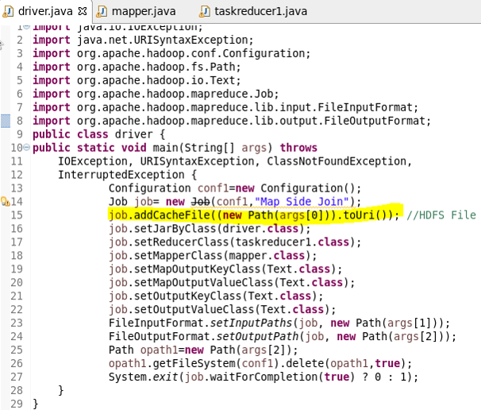

**Mapper class:**

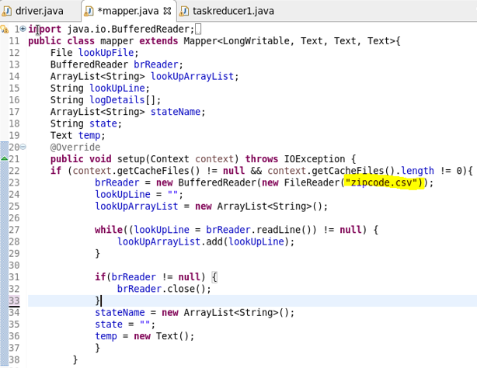

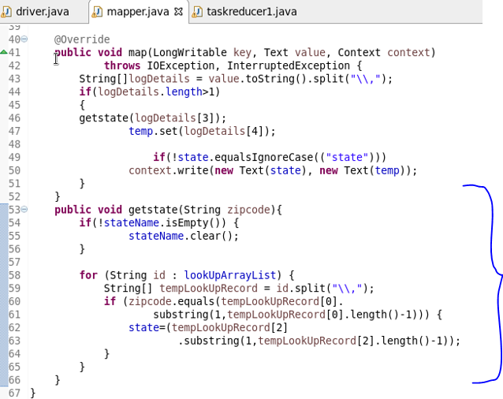

**Reducer class:**

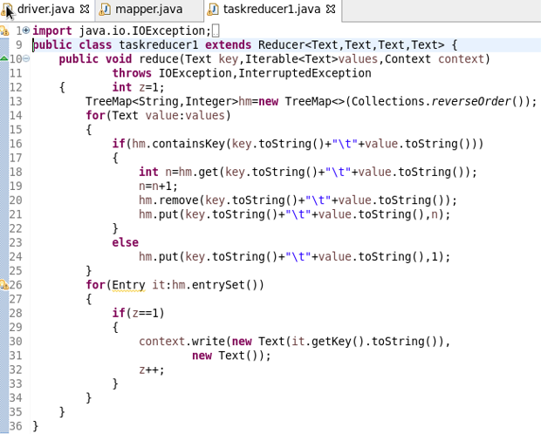

**Running jar:**

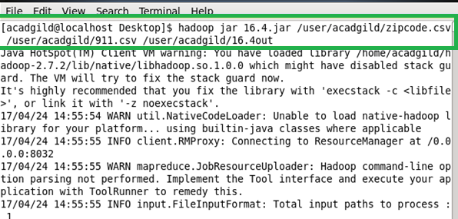

**Output:**

