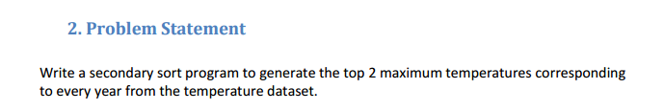

**Driver Class-**

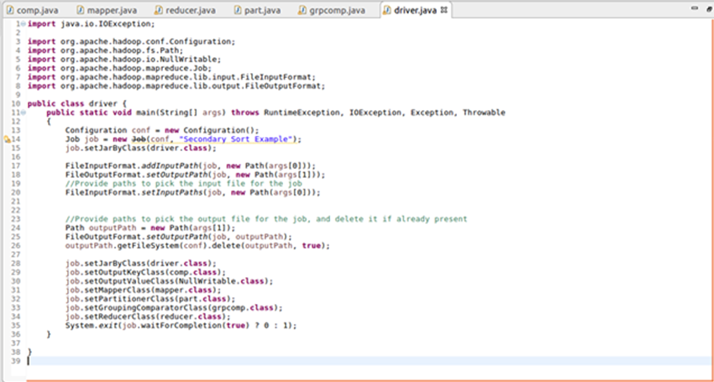

**Mapper Class-**

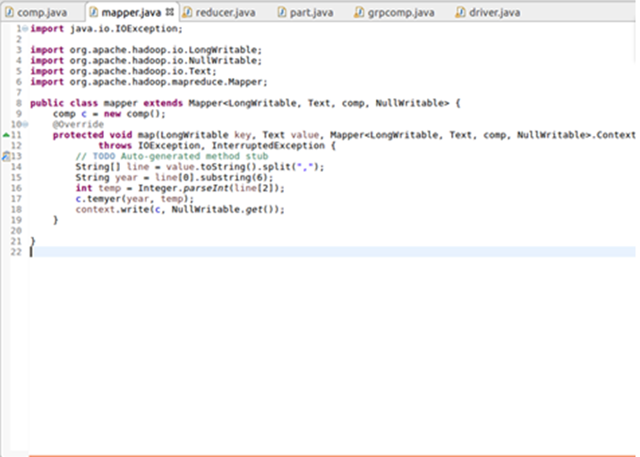

**Comparable Writer-**

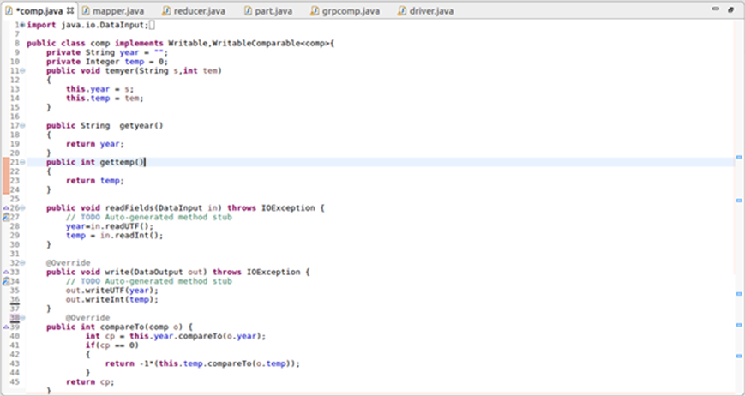

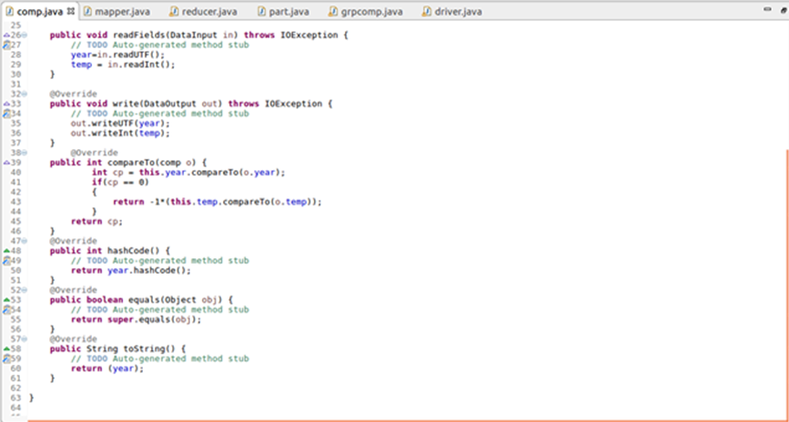

**Partitioner Class-**

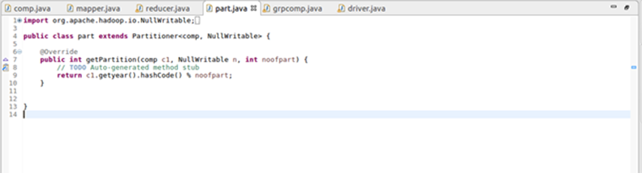

**Group Comparator-**

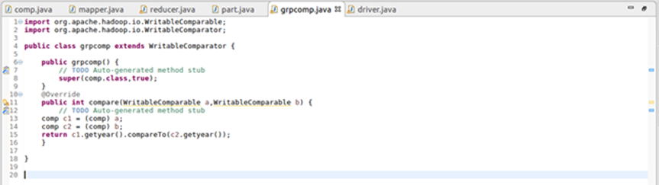

**Reducer Class-**

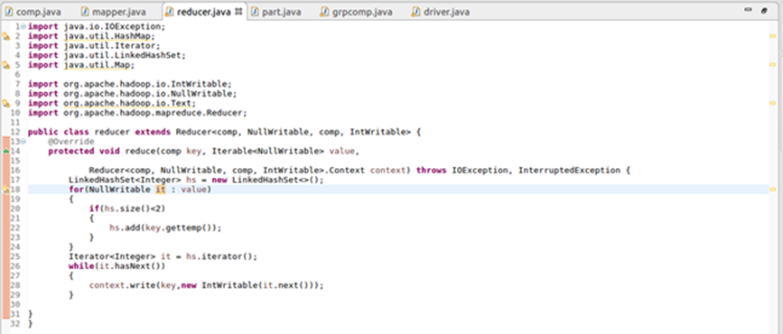

**Output-**

