**Problem Statement**

**Create a database named 'custom'.**

**Create a table named temperature_data inside custom having below fields:**

**1. date (mm-ddyyyy) format**

**2. zip code**

**3. temperature**

**The table will be loaded from comma-delimited file. Load the dataset.txt (which is ',' delimited) in the table.**

**Input File-**

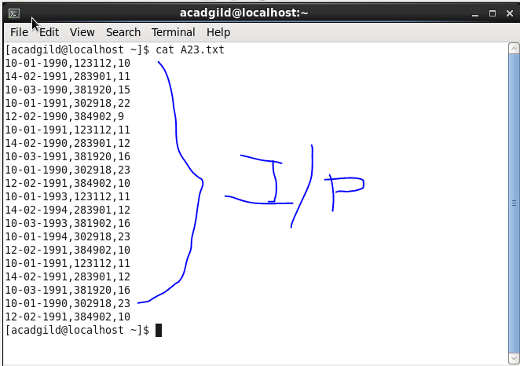

**Solution-**

1. **Creating a Database named custom.**

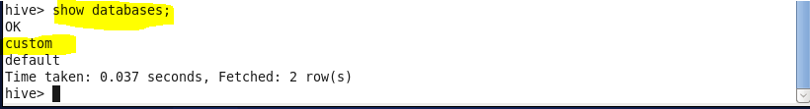

1. **Creating table named temperature_data.**

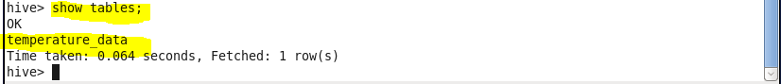

1. **Loading Data in temperature_data table.**

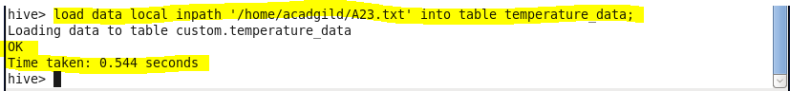

1. **Displaying data from table temperature_data.**

