**Problem Statement**

**Input File-**

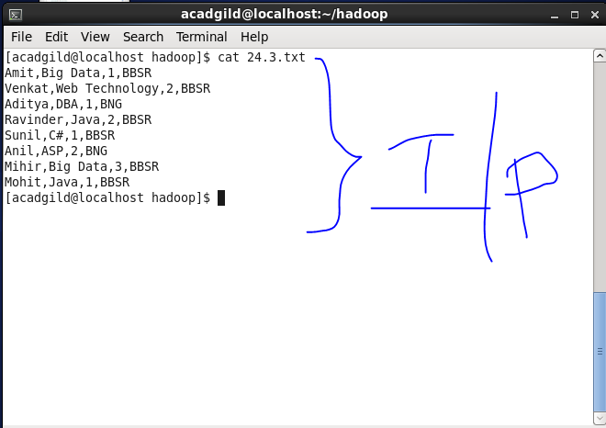

1. **Calculate the number of employees corresponding to each skill from the table 'employee' which is loaded in the Demo.**

