**Problem Statement**

**Input File-**

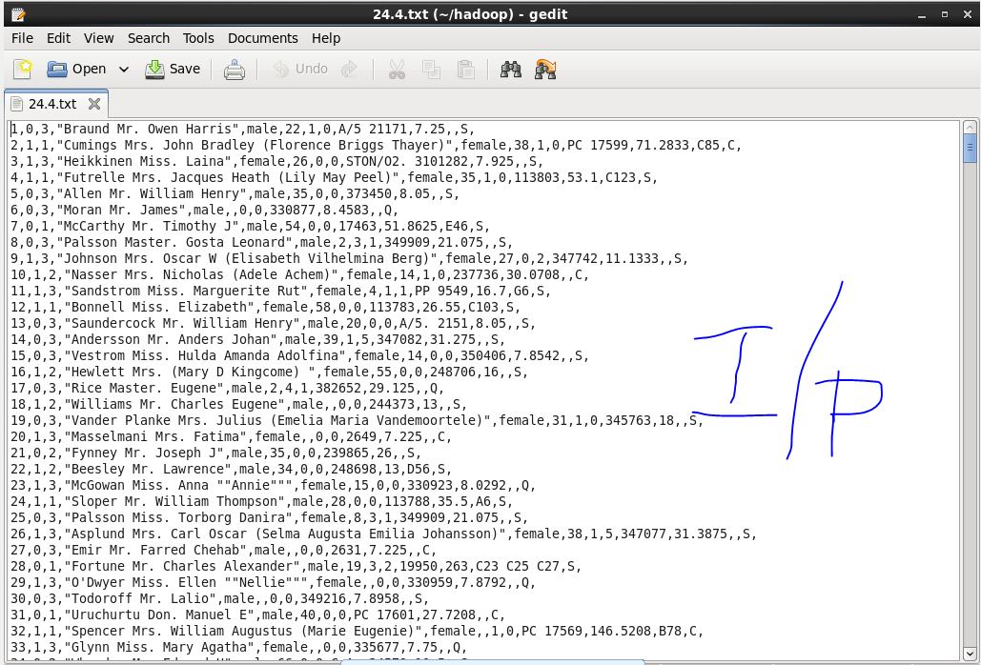

1. **Write a hive query find the average age of male and female persons died in the titanic tragedy.**

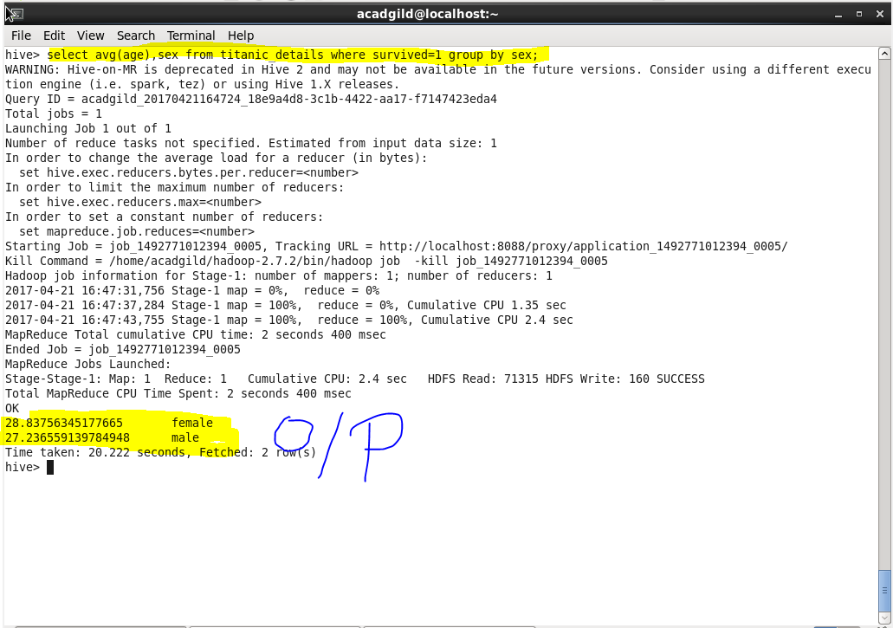

1. **Write a hive query to find the number of people died and survived in each class.**

