**Assignment-26.3**

**Problem Statement-**

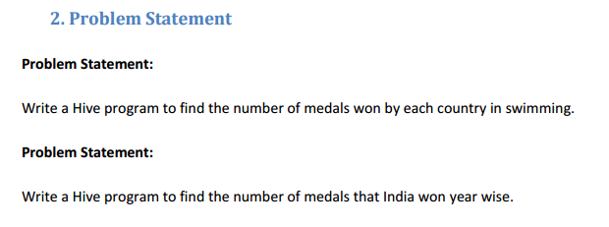

**Input File-**

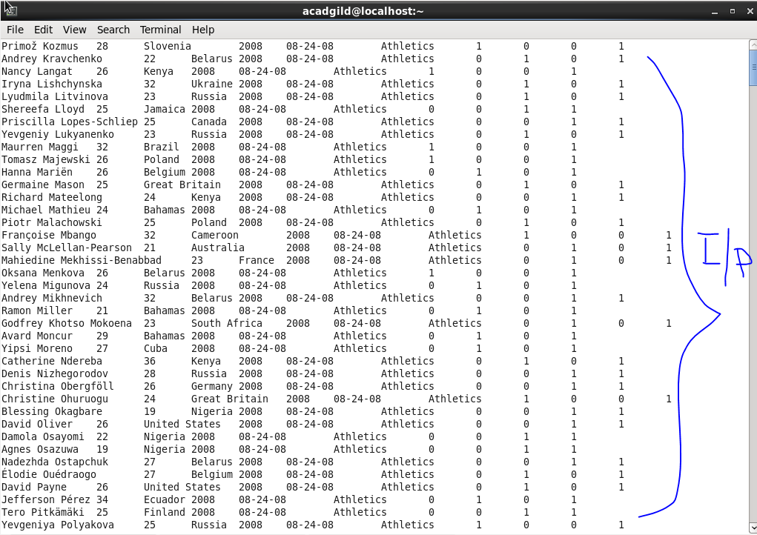

**Solution 1-**

* Created a table named olympic and loaded data in it.
* Select query to select data where we counted total number of medals where sports is swimming.
* We want data from every country so we grouped it on the basis of country.

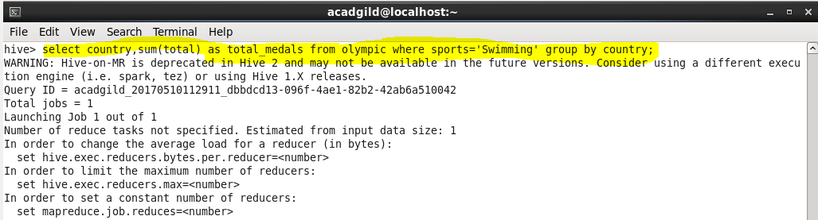

**Output-**

**There is much more output data, only a few are included.**

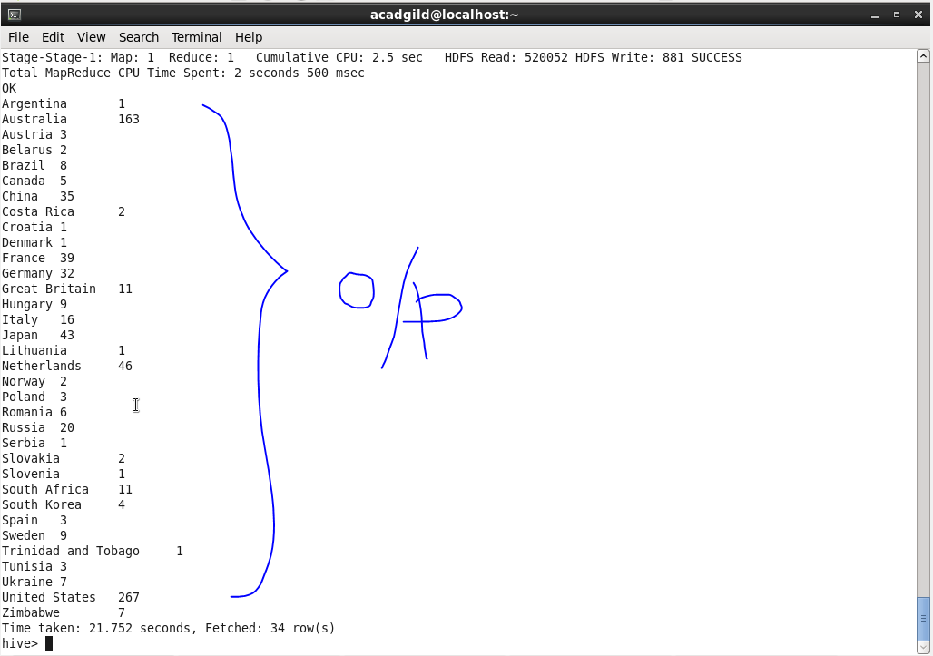

**Solution 2-**

* Select query to select data where we counted total number of medals where country is india.
* We want data from every year so we grouped it on the basis of year.

