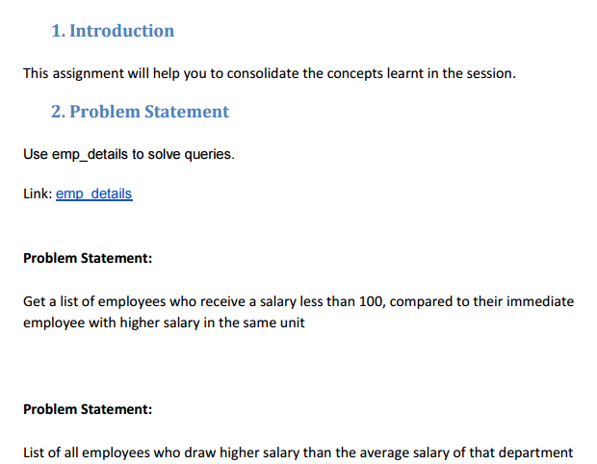

**Q1- Get a list of employees who receive a salary less than 100, compared to their immediate employee with higher salary in the same unit**

**Query & Output**

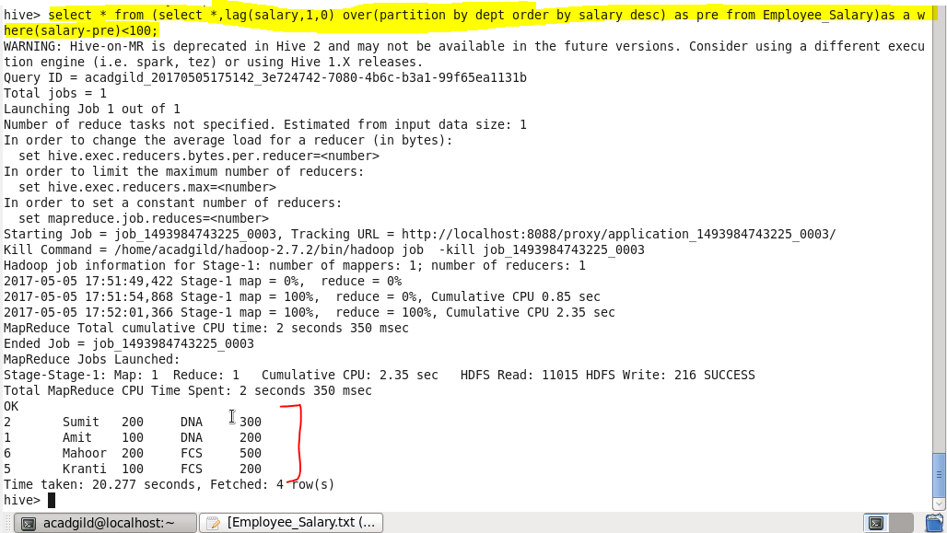

**Q2-** **List of all employees who draw higher salary than the average salary of that department**

**Query & Output**

