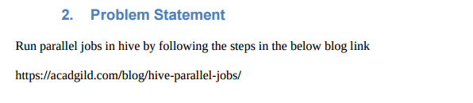

**Solution-**

* Hive sometimes can take lot of time to complete a job.
* The jobs may have many different stages to get completed. By default, Hive executes these stages one at a time.
* Different stages may include a Map stage, Reduce stage, a sampling stage, a merge stage, a limit stage, or other possible tasks Hive needs to do.
* A particular job may consist of some stages that are not dependent on each other and could be executed in parallel, possibly allowing the overall job to complete more quickly.
* Hive can converts a query into one or more stages and to save time executes multiple jobs parallely.
* If the query is optimized and more stages are run simultaneously, the job may complete much faster.
* However,If a job is running more stages in parallel, it will increase its cluster utilization.
* Following properties must be set to run the jobs parallely.

Set hive.exec.parallel=true;

Set hive.exec.parallel.thread.number=8;

**Example-**

**Input file-**

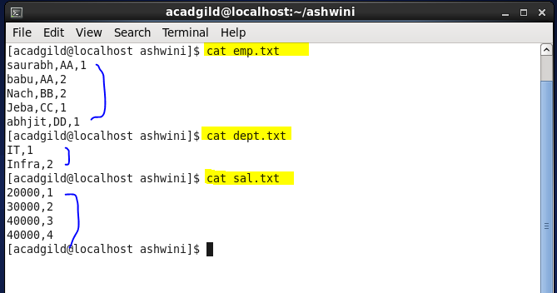

**Solution-**

* Creation of three tables emp and dept and sal.
* Inserting data in all the tables.

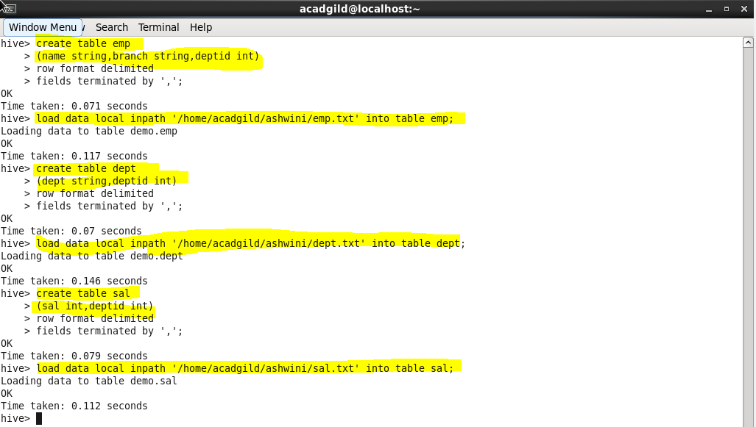

* Setting hive properties to run jobs in parallel.
* Select query fired to select data by joining three tables and we can see by the screenshot that the job is performed in multiple stages.

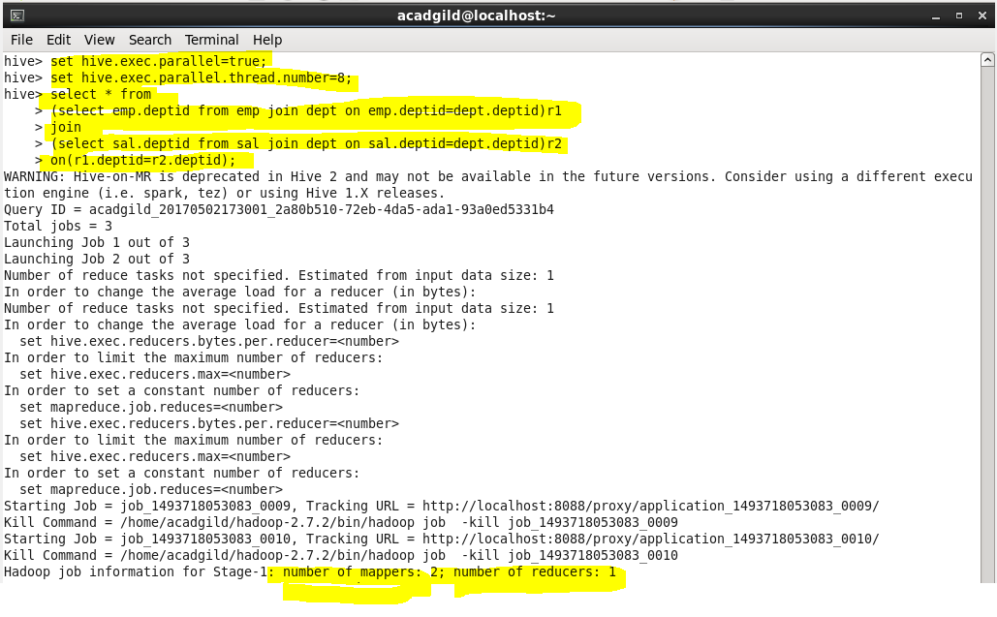

**Output-**

